PERSONAL INFORMATION | Martin Mitrovski
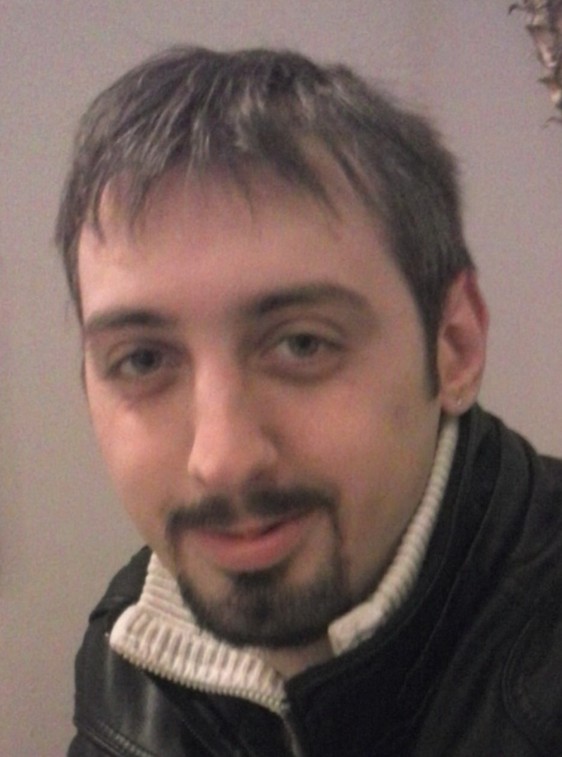 |   Arsenij Jovkov 8a, Gjorche Petrov, Skopje (Republic of Macedonia)

+389 2 20 38 312  +389 77 51 71 20

mitrovskimartin@hotmail.com

mitrovskimartin.azurewebsites.net

Skype: martin.mitrovski8
 | Sex Male | Date of birth 23/03/1989 | Nationality Macedonian

WORK EXPERIENCE

07.07.2014 – 08.11.2014 | Salesman
07.07.2014 – 08.11.2014 | Elektroelement, Pero Nakov St. No.25, Skopje
07.07.2014 – 08.11.2014 | - In this company I gained extensive experience in retail, where through direct sales and client contact I have achived successful sales contracts and also had the opportunity to gain further understanding of the marketing engine and its application.
07.07.2014 – 08.11.2014 | Business or sector Electrotechnical

01.10.2012 – 31.12.2013 | Equipment installer and on terrain technical support
01.10.2012 – 31.12.2013 | Fornet Computers, Kuzman Josifovski Pitu Blvd. No.2, Skopje
01.10.2012 – 31.12.2013 | - In this company I gained extensive experience in retail, where through direct sales and client contact I have achived successful sales contracts and also had the opportunity to gain further understanding of the marketing engine and its application.
01.10.2012 – 31.12.2013 | Business or sector Electrotechnical

19.01.2011 – 24.03.2011 11.04.2014 – 25.05.2014 | Worker in manufacturing
19.01.2011 – 24.03.2011 11.04.2014 – 25.05.2014 | Neohem Plast,
19.01.2011 – 24.03.2011 11.04.2014 – 25.05.2014 | - In a period of two months working in this company I have acquired knowledge in the field of the production of plastic bottles of different packaging.
19.01.2011 – 24.03.2011 11.04.2014 – 25.05.2014 | Business or sector Plastic

20.04.2005 – 01.07.2010 05.05.2011 – 12.07.2012 | Editor and assistant light technician
20.04.2005 – 01.07.2010 05.05.2011 – 12.07.2012 | DVD PET, Andon Dukov St. No.5, Skopje
20.04.2005 – 01.07.2010 05.05.2011 – 12.07.2012 | - I have spent 5 years period as a part – time worker in the position of editor and assistant light technician. I encountered many issues in this area, thus perfecting the already acquired knowledge. Some of the distinguished projects I have worked on are: concerts of Pet Shop Boys, Duran Duran, 50 cent (in Kosovo), Zdravko Colic, Bjelo Dugme, Ceca, quiz shows "Millionaire", "Wheel of Fortune", also "Macedonian Idol" (in collaboration with A1 television) and many other festivals, rallies and catering parties.
20.04.2005 – 01.07.2010 05.05.2011 – 12.07.2012 | Business or sector Electrotechnical

30.07.2010 – 24.12.2010 | Editor and light technician
30.07.2010 – 24.12.2010 | Studio BT, Debarca St. No.41, Skopje
30.07.2010 – 24.12.2010 | - In this company I worked as a part-time worker in the position of editor and light technician. Some of the distinguished projects I've worked on are: the festival "Balkan Music Square" and projects for hotel - casino "Apollonia" – Gevgelija.
30.07.2010 – 24.12.2010 | Business or sector Electrotechnical
01.06.2008 – 01.11.2008 10.10.2010 – 25.11.2010 | Editor and light technician
01.06.2008 – 01.11.2008 10.10.2010 – 25.11.2010 | Infomedia Systems, Vasko Karangelevski St. No. 27/10, Skopje
01.06.2008 – 01.11.2008 10.10.2010 – 25.11.2010 | - In this company I worked as a part-time worker in the position of editor and light technician. Some of the distinguished projects I have worked on are: Microsoft Vision, projects for European University, projects for the tourist agency "Shor Turist", catering parties, graduation celebrations etc.
01.06.2008 – 01.11.2008 10.10.2010 – 25.11.2010 | Business or sector Electrotechnical

01.07.2010 – 16.09.2010 | Editor and light technician
01.07.2010 – 16.09.2010 | Baggi Communications, Albert Einstein St. No.4, Skopje
01.07.2010 – 16.09.2010 | - In this company I worked as a part-time worker in the position of editor and light technician. Some of the distinguished projects I have worked on are: concerts of David Morales, Aco Pejovic, Synthesis, catering projects for tourist agency "Orfej", opening the winery "Stobi".
01.07.2010 – 16.09.2010 | Business or sector Electrotechnical

08.10.2003 – 29.12.2010 | Editor and light technician
08.10.2003 – 29.12.2010 | Univerzalna Sala – Skopje, Partizanski Odredi Blvd. , Skopje
08.10.2003 – 29.12.2010 | - In this company I worked as a part-time worker in the position of editor and light technician. Some of the distinguished projects I have worked on are: concerts of David Morales, Aco Pejovic, Synthesis, catering projects for tourist agency "Orfej", opening the winery "Stobi".
08.10.2003 – 29.12.2010 | Business or sector Electrotechnical

EDUCATION AND TRAINING

01.09.2004 –10.06.2008 | Electrical technician - electrician for electronics and telecommunications
01.09.2004 –10.06.2008 | SUGS "Vlado Tasevski" – Skopje
01.09.2004 –10.06.2008 | General subjects covered  - Macedonian, Mathematics, English, Physics  Principal subjects covered  - Computer science, Digital electronics, Fundamentals of Electrical Engineering, Telecommunication assemblies and devices, Technical drawing

PERSONAL SKILLS

Mother tongue(s) | Macedonian
Other language(s) | UNDERSTANDING |  | SPEAKING |  | WRITING
Other language(s) | Listening | Reading | Spoken interaction | Spoken production
English | С2 | С1 | В2 | В1 | В1
Levels: A1/2: Basic user - B1/2: Independent user - C1/2 Proficient user
Common European Framework of Reference for Languages

Communication skills | - Good communication and negotiation skills acquired through work as a salesman and on terrain worker.

Computer skills | - Acid  - AutoCAD  - Corel Draw  - Cubase  - Daslight ( X Control )  - GrandMA  - Martin Light Jockey, M1  - MATLAB  - Microsoft Office applications ( Word, Excel, Power Point, Visio … )  - Nero ( Nero Tools )  - Solid Works  - Xilisoft

Driving licence | - B – category

REFERENCES

- Suzana Cvetanovska  Head of Market at Elektroelement  +389 78 42 55 67 | - Sasha Ognjanovski  CEO at Fornet Computers  +389 75 39 90 07
- Zdravko Kochishki  CEO at DVD PET  +389 70 24 44 36 | - Blagoja Trpkovski  SEO at Studio BT  +389 70 21 73 51

