

Functional Safety Concept Lane Assistance

**Document Version: [Version]**

**Template Version 1.0, Released on 2017-06-21**



# Document history

**[Instructions: Fill in the date, version and description fields. You can fill out the Editor field with your name if you want to do so. Keep track of your editing as if this were a real world project.**

**For example, if this were your first draft or first submission, you might say version 1.0. If this is a second submission attempt, then you'd add a second line with a new date and version 2.0]**

|  |  |  |  |
| --- | --- | --- | --- |
| Date | Version | Editor | Description |
| 02/03/2018 | 0.1 | Michael Scharf | Initial attempt |
| 02/03/2018 | 0.2 | Michael Scharf | Start filling out document |
|  |  |  |  |
|  |  |  |  |
|  |  |  |  |

# Table of Contents

**[Instructions: We have provided a table of contents. If you change the document structure, please update the table of contents accordingly. The table of contents should show each section of the document and page numbers or links. Most word processors can do this for you. In** [**Google Docs**](https://support.google.com/docs/answer/116338?co=GENIE.Platform%3DDesktop&hl=en)**, you can use headings for each section and then go to Insert > Table of Contents.** [**Microsoft Word**](https://support.microsoft.com/en-us/help/285059/how-to-create-a-table-of-contents-by-marking-text-in-word) **has similar capabilities]**

Document history

Table of Contents

Purpose of the Functional Safety Concept

Inputs to the Functional Safety Analysis

Safety goals from the Hazard Analysis and Risk Assessment

Preliminary Architecture

Description of architecture elements

Functional Safety Concept

Functional Safety Analysis

Functional Safety Requirements

Refinement of the System Architecture

Allocation of Functional Safety Requirements to Architecture Elements

Warning and Degradation Concept

# Purpose of the Functional Safety Concept

**[Instructions: Answer what is the purpose of a functional safety concept?]**

To achieve the overall goal of functional safety to avoid accidents by reducing risk to an acceptable level, the FSC is

* Identifying subsystems containing high level of risk
* Identifying countermeasure to reduce risks and therefore prevent accidents.

# Inputs to the Functional Safety Concept

## Safety goals from the Hazard Analysis and Risk Assessment

**[Instructions:**

**REQUIRED:**

**Provide the lane departure warning and lane keeping assistance safety goals as discussed in the lessons and derived in the hazard analysis and risk assessment.**

**OPTIONAL:**

**If you expanded the hazard analysis and risk assessment to include other safety goals, include them here.**

**]**

|  |  |
| --- | --- |
| **ID** | **Safety Goal** |
| Safety_Goal_01 | The oscillating steering torque from the lane departure warning function shall be limited. |
| Safety_Goal_02 | The lane keeping assistance function shall be time limited, and the additional steering torque shall end after a given time interval so that the driver cannot misuse the system for autonomous driving. |

## Preliminary Architecture

**[Instructions: Provide a preliminary architecture for the lane assistance item. Hint: See Lesson 3: Item Definition]**

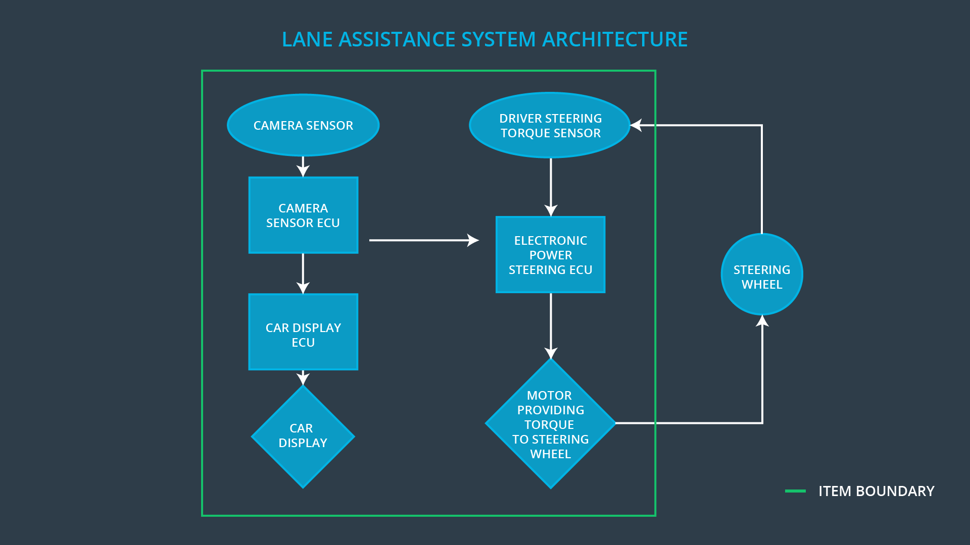

### Description of architecture elements

**[Instructions: Provide a description for each of the item elements; what is each element's purpose in the lane assistance item? ]**

|  |  |
| --- | --- |
| **Element** | **Description** |
| Camera Sensor | Grab surrounding/ camera images of the road |
| Camera Sensor ECU | Lane Sensing: identifies if the vehicle departs its lane. Torque request generator: sends messages to the Car Display ECU in order to react on the situation the car departed from its lane. |
| Car Display | Display status of the Lane Assistance. If the Lane Assistance is activated or not and if the Lane Assistance is actually “active” in sense of triggering correction of the steering torque |
| Car Display ECU | Manages the state and loopback of the Lane Assistance On/Off status as well as the Lane Assistance Active/ Inactive status. The Car Display ECU will switch on/off corresponding indication in Car Display depending on the state of the Lane Assistance. |
| Driver Steering Torque Sensor | Sensing steering wheel torque |
| Electronic Power Steering ECU | Is the “Lane Assistance Functionality” itself. It analyzes Driver Steering torque and reacts on the triggers from Camera Sensor ECU in order to generate a final electronic power steering torque output. This output signal is send to the Motor then.  Depending on the status of the EPS ECU, a feedback is send to the Car Display ECU to indicate the active/ inactive state of the Lane Assistance (if it is currently influencing the steering wheel). |
| Motor | Providing torque to steering wheel |

# Functional Safety Concept

The functional safety concept consists of:

* Functional safety analysis
* Functional safety requirements
* Functional safety architecture
* Warning and degradation concept

## Functional Safety Analysis

**[Instructions: Fill in the functional safety analysis table below.]**

|  |  |  |  |
| --- | --- | --- | --- |
| **Malfunction ID** | **Main Function of the Item Related to Safety Goal Violations** | **Guidewords (NO, WRONG, EARLY, LATE, MORE, LESS)** | **Resulting Malfunction** |
| Malfunction_01 | Lane Departure Warning (LDW) function shall apply an oscillating steering torque to provide the driver a haptic feedback | The lane departure warning function applies an oscillating torque with very high torque amplitude MORE than the above limit. |  |
| Malfunction_02 | Lane Departure Warning (LDW) function shall apply an oscillating steering torque to provide the driver a haptic feedback | The lane departure warning function applies an oscillating torque with very high torque frequency MORE than the above limit. |  |
| Malfunction_03 | Lane Keeping Assistance (LKA) function shall apply the steering torque when active in order to stay in ego lane | The lane keeping assistance function has NO limit in time duration which leads to misuse as an autonomous driving function. |  |

## Functional Safety Requirements

**[Instructions: Fill in the functional safety requirements for the lane departure warning ]**

Lane Departure Warning (LDW) Requirements:

|  |  |  |  |  |
| --- | --- | --- | --- | --- |
| **ID** | **Functional Safety Requirement** | **ASIL** | **Fault Tolerant Time Interval** | **Safe State** |
| Functional  Safety  Requirement  01-01 | 1. The lane keeping item shall ensure that the lane departure oscillating torque amplitude is below Max_Torque_Amplitude | C | 50 mS | Set amplitude to zero. |
| Functional  Safety  Requirement  01-02 | 1. The lane keeping item shall ensure that the lane departure oscillating torque frequency is below Max_Torque_Frequency | C | 50 mS |  |

Lane Departure Warning (LDW) Verification and Validation Acceptance Criteria:

|  |  |  |
| --- | --- | --- |
| **ID** | **Validation Acceptance**  **Criteria and Method** | **Verification Acceptance**  **Criteria and Method** |
| Functional  Safety  Requirement  01-01 |  |  |
| Functional  Safety  Requirement  01-02 |  |  |

**[Instructions: Fill in the functional safety requirements for the lane keeping assistance]**

Lane Keeping Assistance (LKA) Requirements:

|  |  |  |  |  |
| --- | --- | --- | --- | --- |
| **ID** | **Functional Safety Requirement** | **ASIL** | **Fault Tolerant Time Interval** | **Safe State** |
| Functional  Safety  Requirement  02-01 | 1. The lane keeping item shall ensure that the lane keeping assistance torque is applied for only Max_Duration | B | 500 mS | Shut off lane keeping. |

Lane Keeping Assistance (LKA) Verification and Validation Acceptance Criteria:

|  |  |  |
| --- | --- | --- |
| **ID** | **Validation Acceptance**  **Criteria and Method** | **Verification Acceptance**  **Criteria and Method** |
| Functional  Safety  Requirement  02-01 |  |  |

## Refinement of the System Architecture

**[Instructions: Include the refined system architecture. Hint: The refined system architecture should include the system architecture from the end of the functional safety lesson including all of the ASIL labels.]**

## Allocation of Functional Safety Requirements to Architecture Elements

**[Instructions: Mark which element or elements are responsible for meeting the functional safety requirement. Hint: Only one ECU is responsible for meeting all of the requirements.]**

|  |  |  |  |  |
| --- | --- | --- | --- | --- |
| **ID** | **Functional Safety Requirement** | **Electronic Power Steering ECU** | **Camera ECU** | **Car Display ECU** |
| Functional  Safety  Requirement  01-01 | 1. The electronic power steering ECU shall ensure that the lane departure oscillating torque amplitude is below Max_Torque_Amplitude | **X** |  |  |
| Functional  Safety  Requirement  01-02 | 1. The electronic power steering ECU shall ensure that the lane departure oscillating torque frequency is below Max_Torque_Frequency | **X** |  |  |
| Functional  Safety  Requirement  02-01 | the electronic power steering ECU shall ensure that the lane keeping assistance torque is applied for only Max_Duration | **X** |  |  |

## Warning and Degradation Concept

**[Instructions: Fill in the warning and degradation concept.]**

|  |  |  |  |  |
| --- | --- | --- | --- | --- |
| **ID** | **Degradation Mode** | **Trigger for Degradation Mode** | **Safe State invoked?** | **Driver Warning** |
| WDC-01 |  |  |  |  |
| WDC-02 |  |  |  |  |