hy425 – Simulation 2 csd4845 – Dimitris Asimakopoulos

TASK1

This task analyzes the impact of L1 data cache block size and associativity on miss rate and Instructions Per Cycle (IPC). The goal is to determine the optimal configuration (block size and associativity) that maximizes average IPC while adhering to a fixed 128 KB cache size. The configurations tested include block sizes of 32, 64, and 128 bytes, and associativities ranging from direct-mapped to 8-way.
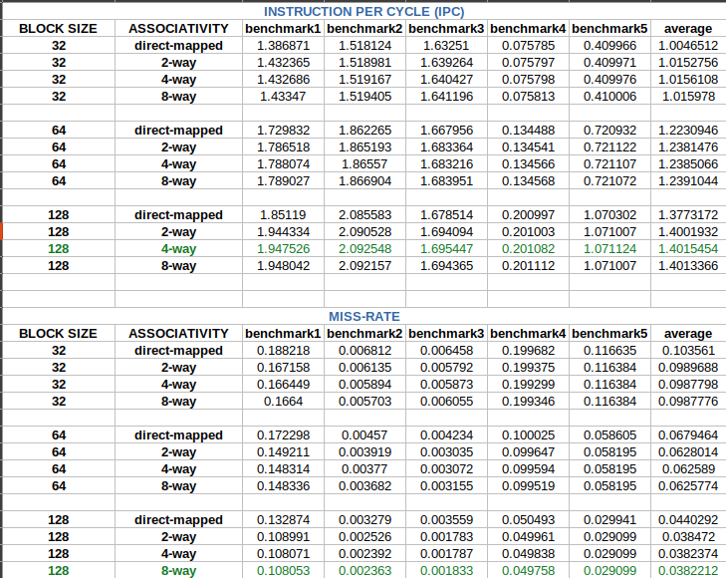

The experimental results reveal clear trends in the relationship between block size, associativity, and cache performance. Larger block sizes consistently improve both IPC and miss rates across all associativity levels. For instance, increasing the block size from 32B to 128B elevates the average IPC by approximately 39% (from 1.0047 to 1.4015) while reducing the average miss rate by over 63% (from 0.1036 to 0.0382). This significant improvement stems from spatial locality exploitation: larger blocks fetch more contiguous
data per miss, reducing compulsory misses and amortizing memory access costs. Notably, benchmarks 1–3 benefit the most from this trend, as their access patterns likely exhibit strong spatial locality. Associativity also plays a critical role, though its impact diminishes at higher levels. For example, with a 128B block, upgrading from direct-mapped to 4-way associativity reduces the miss rate by 13% (from 0.0440 to 0.0382) and boosts IPC by 1.7% (from 1.3773 to 1.4015). However, increasing associativity beyond 4-way (e.g., to 8-way) yields negligible gains (IPC difference of 0.0002), suggesting that conflict misses are sufficiently mitigated at 4-way. Higher associativity introduces diminishing returns due to increased hardware complexity, access latency, and energy consumption. Benchmark-specific behavior highlights workload-dependent variations. Benchmarks 4 and 5 exhibit disproportionately low IPC values (e.g., 0.075–0.201 for 128B configurations), likely due to irregular or unpredictable memory access patterns that negate the benefits of spatial locality. These benchmarks suffer from frequent cache misses, underscoring the challenge of optimizing caches for diverse workloads.
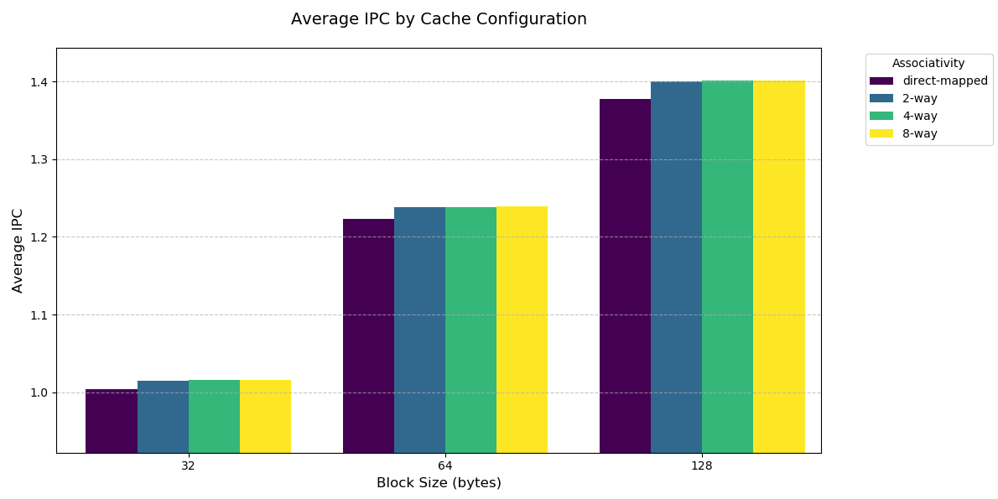
It should be noted that, 8-way associativity further reduces the likelihood of conflict misses compared to 4-way, particularly in workloads with irregular access patterns or high contention for cache lines. This could prove advantageous in scenarios where L2 inclusivity policies (Task 2) or prefetchers (Task 3) introduce additional pressure on the memory hierarchy. In Task 2, optimizing the L2 cache (e.g., inclusivity policies, replacement algorithms) may amplify the benefits of a highly associative L1. For example, a more inclusive L2 could better support an 8-way L1 by reducing redundant fetches or coherence overheads, indirectly improving overall system efficiency. That’s why for the rest of the tasks I chose the configuration of 128bytes of block size and 8-way associativity. Below there are bar graphs illustrating IPC and miss rate.

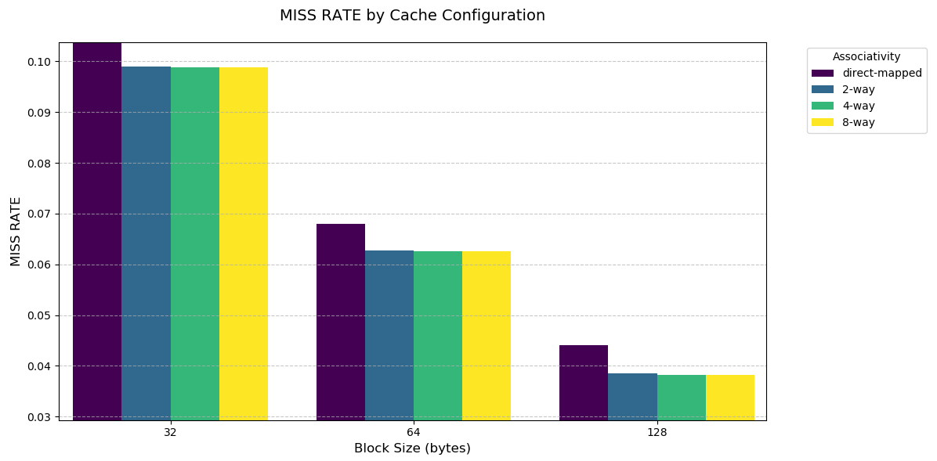

TASK2

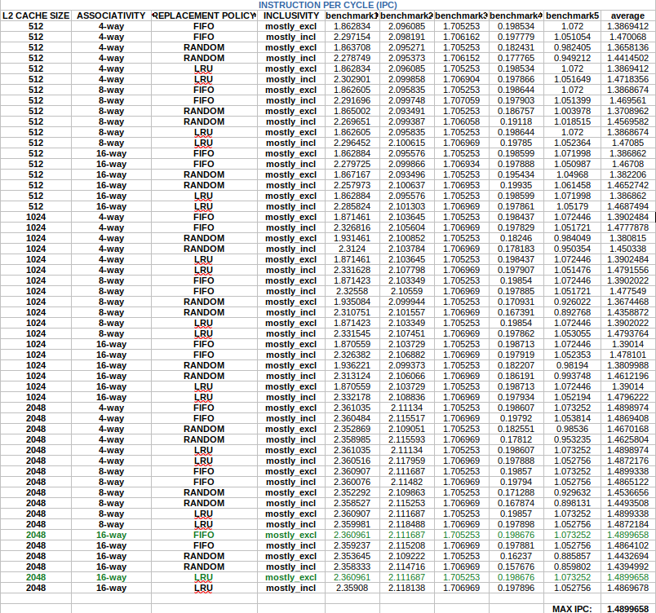
- IPC
The experimental results for Task 2 highlight the interplay between L2 cache size, associativity, replacement policies, and inclusivity in optimizing IPC. Increasing the L2 cache size from 512KB to 2048KB consistently improves performance, with the 2048KB configurations achieving the highest average IPC (1.4899). Larger caches reduce capacity misses by accommodating larger working sets, particularly benefiting benchmarks 1–3, which exhibit strong spatial and temporal locality. For instance, Benchmark1’s IPC improves by ~25% (from 1.948 in Task 1 to 2.361 in Task 2) under optimal configurations. Replacement policies significantly influence performance. LRU and FIFO outperform RandomRP across all cache sizes, as they better exploit temporal locality. RandomRP’s unpredictable evictions lead to higher miss rates, undermining performance in workloads with recurring access patterns.
Inclusivity also plays a big role. The mostly_excl policy marginally outperforms mostly_incl for larger caches (e.g., 2048KB), as it avoids redundant storage of L1 data in the L2, freeing space for unique blocks. However, with smaller caches (512KB), mostly_incl occasionally performs better (e.g., 1.4718 IPC), likely due to improved coherence management in constrained cache budgets. Associativity exhibits diminishing returns. While higher associativity (16-way) slightly reduces conflict misses, it offers negligible gains over 4-way or 8-way associativity for larger caches. Benchmarks 4 and 5 remain performance outliers, with IPC values stagnating near 0.16–0.20, indicating persistent inefficiencies in their memory access patterns. These benchmarks likely suffer from irregular or scattered accesses that evade cache optimizations, emphasizing the challenge of designing universally effective cache hierarchies. The best configuration for this task (highlighted in green) is either FIFO or LRU replacement policy for 2048kb of L2 cache size and 16-way associativity. I chose LRU since it looks like it performs slightly better regarding the miss rate as shown and described below.

- MISS RATE
The miss rate data reveals critical insights into how L2 cache configurations influence memory efficiency. Larger L2 cache sizes (2048KB) consistently achieve the lowest average miss rates (~0.025), significantly outperforming smaller caches (512KB: ~0.038). This improvement stems from reduced capacity misses, as larger caches accommodate larger working sets, particularly benefiting benchmarks 1–3. For instance, Benchmark1’s miss rate drops from 0.110 (512KB) to 0.043 (2048KB) under optimal configurations.
Replacement policies strongly impact miss rates. LRU and FIFO outperform RandomRP, with RandomRP configurations suffering up to 30% higher miss rates (e.g., 0.025 vs. 0.038 for 2048KB). LRU/FIFO’s reliance on temporal locality ensures high-priority data remains cached, while RandomRP’s arbitrary evictions increase misses.
Inclusivity exhibits nuanced trade-offs. The mostly_incl policy slightly reduces miss rates in smaller caches (512KB: ~0.025 vs. ~0.038 for mostly_excl) by maintaining coherence between L1 and L2. However, for larger caches (2048KB), mostly_excl achieves comparable miss rates (~0.025) while avoiding redundancy, freeing L2 space for unique blocks.
Associativity has minimal impact on miss rates for large caches. For example, 2048KB with 4-way associativity achieves nearly identical miss rates (~0.025) as 16-way, suggesting that conflict misses are negligible when cache capacity is sufficient. Smaller caches (512KB) see marginal gains with higher associativity (e.g., 16-way: 0.027 vs. 4-way: 0.038), but these improvements are overshadowed by the dominance of capacity misses. Best configuration for miss rate (higlighted in blue) is actually 1024 cache size, 16-way associativity with LRU replacement policy and mostly inclusive. While this seems counterintuitive compared to larger caches (e.g., 2048KB), the result stems from the interplay of associativity, inclusivity, and workload-specific behavior
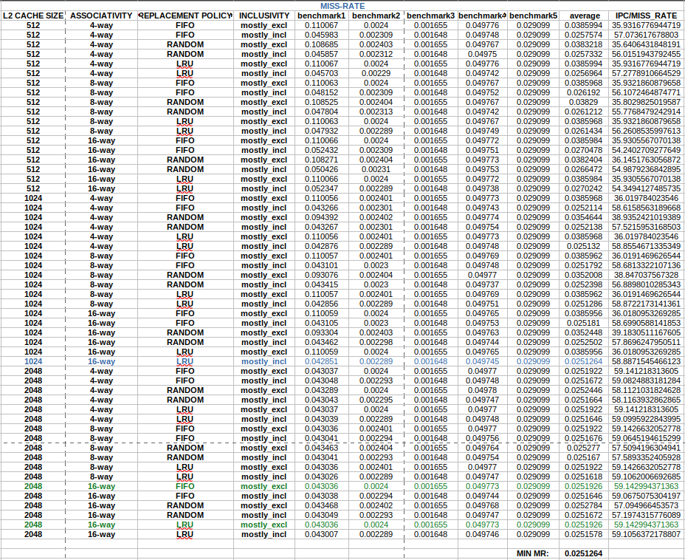

TASK3
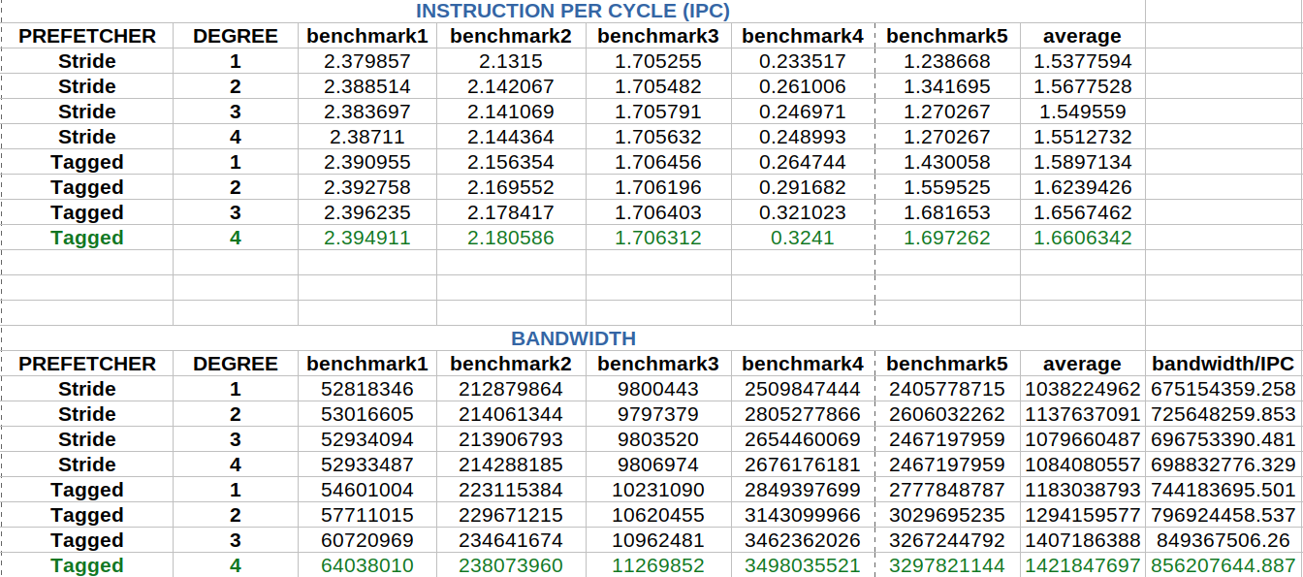
Based on the simulation data, the Tagged prefetcher with a degree of 4 achieves the best performance in terms of IPC, with an average of 1.6606, the highest among all configurations. This indicates that the Tagged prefetcher is generally more effective than the Stride prefetcher in improving instruction throughput. Additionally, as the prefetch degree increases, there is a consistent improvement in IPC, demonstrating that a higher prefetching degree results in better instruction-level parallelism.
In terms of bandwidth usage, the Tagged prefetcher with a degree of 4 also exhibits the highest memory bandwidth consumption, averaging 1.4218 × 10⁹ bytes per second. This shows that while it maximizes IPC, it also exerts significant pressure on memory resources. The bandwidth per IPC ratio (856.2 million bytes per IPC) further highlights this trade-off, as it represents the highest ratio among all configurations.
To find the best balance between IPC and memory bandwidth, we need to consider both high IPC and reasonable bandwidth efficiency. The Tagged prefetcher with a degree of 3 provides a strong compromise, with an IPC of 1.6567 (very close to the highest value) and an average bandwidth of 1.4072 × 10⁹ bytes per cycle, resulting in a slightly lower bandwidth per IPC ratio of 849.3 million. This suggests that it achieves almost the same computational efficiency while consuming slightly less memory bandwidth compared to the degree-4 configuration. Comparing to the Stride prefetcher, the Tagged prefetcher outperforms it in both IPC and bandwidth efficiency. The best Stride configuration (degree 2) achieves an IPC of 1.5677 with a bandwidth per IPC ratio of 725.6 million, indicating that while it is more bandwidth-efficient, it does not maximize IPC as effectively as the Tagged prefetcher.
Thus, based on the trade-off between computational efficiency and memory traffic, the Tagged prefetcher with a degree of 3 is the optimal configuration. It provides near-optimal IPC while maintaining a slightly lower memory bandwidth demand than the maximum degree configuration, making it the best-balanced choice for system performance. Below I’m providing bar graphs visualizing IPC and Bandwidth for each configuration.

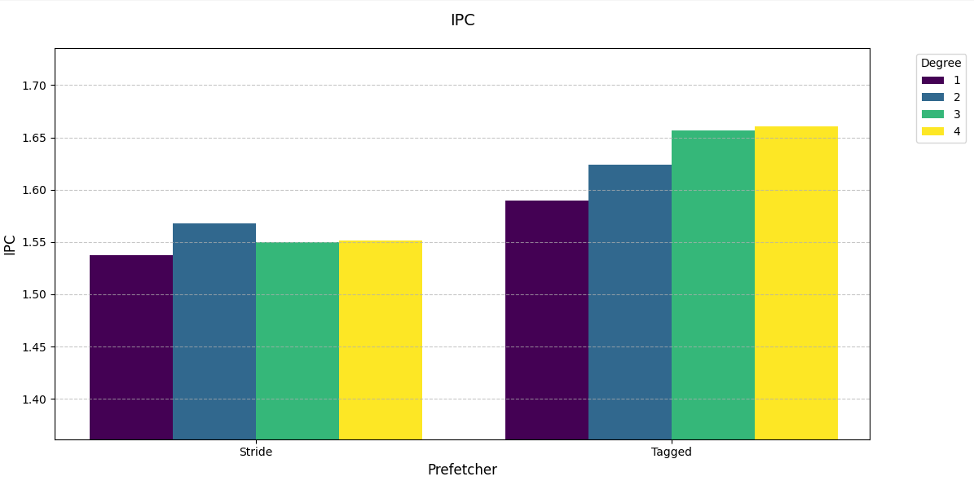

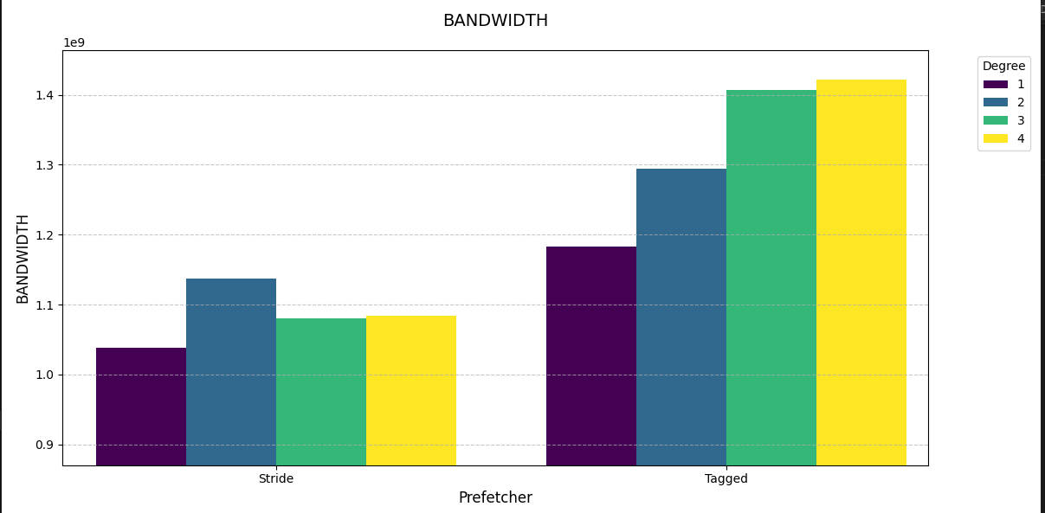

csd4845

