Report: Garbage Collector Tuning Harness for DaCapo-Chopin

hy446 – Managed Runtime Systems csd4845 – Dimitrios Asimakopoulos

Introduction

This project measures and compares the performance of three different Java garbage collectors (ParallelGC, G1, and ZGC) across a suite of DaCapo-Chopin benchmarks. For each collector I ran multiple configurations, varying heap size, pause-time goals, and numbers of GC and concurrent threads and harvested key metrics (total run time, GC time, pause statistics, event counts, CPU usage, memory footprint) into a CSV. Under the hood, I use simple shell wrappers to launch each benchmark with the desired -XX: flags, record the output, and parse out the metrics. A set of Python tools then aggregates these raw runs into per-configuration summaries, computes derived values like a “lower-bound overhead” (estimated best-case no-GC runtime), and visualizes trade-offs via Pareto-frontier and bar-chart scripts. What I want to showcase is (1) how GC tuning decisions affect both throughput and pause behavior, (2) how close each collector comes to its theoretical zero-GC limit, and (3) which configurations strike the best balance for different application needs.
I undertook this project because I wanted to see how simple JVM flags can dramatically change performance outcomes, and to pinpoint the true “sweet spots” for each garbage collector. I chose the state-of-the-art DaCapo-Chopin suite to test real-world Java workloads and along the way I sharpened my scripting and automation skills (using shell scripts and regular expressions to parse logs). By digging into those GC logs, I gained a deeper understanding of each collector’s architecture and I built an evaluation plan that follows statistical and reporting rules so my conclusions are both accurate and reproducible.

Flags
In the table below are listed some of the most significant flags that I researched and used in this project along with a short explanation on what they control and which garbage collectors they affect. These flags tune significant parameters in garbage collectors and provide us with customization and adaptability in our configuration. This way, and in combination with the versatility that DaCapo-Chopin benchmarks offer, we can understand deeply the mechanisms behind their operation.
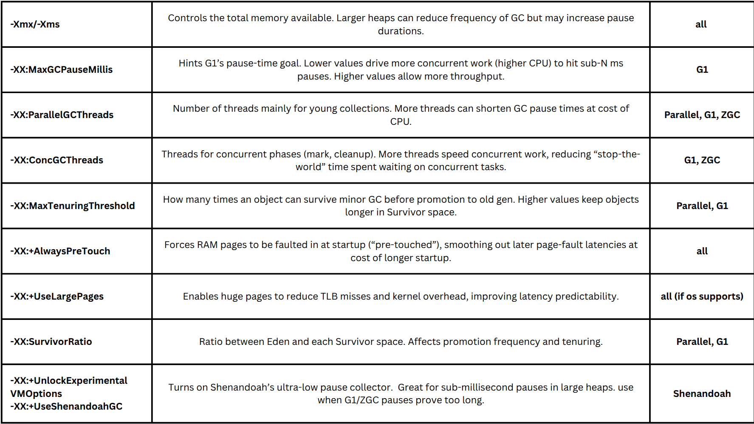

Methodology

- Choose garbage collectors
I selected three JVM GCs to cover the spectrum of design goals. I used ParallelGC as my throughput-optimized baseline, G1 as the modern default that balances pause goals with overall speed via concurrent marking and regionized heaps, and ZGC as the ultra-low-latency, concurrent collector built for large heaps with sub-millisecond pauses.

- Select benchmarks
I ran all 22 DaCapo-Chopin workloads to exercise diverse real-world Java code: web and middleware (Tomcat, Tradebeans, Spring), compilers (Eclipse, PMD), graphics engines (Batik, Sunflow, jMonkeyEngine), databases (Cassandra, H2, Kafka), machine-learning libraries (H2O, BioJava), and more.

- Define the workload matrix
I created a configs.yaml that enumerates the key JVM flag combinations for each GC—varying heap sizes, pause-time targets, and thread counts in a Cartesian product to cover all meaningful permutations.
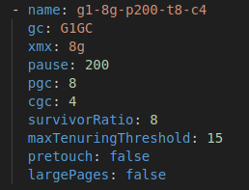

- Automate the execution harness
I created run_benchmarks.sh to loop over every <benchmark, config> pair, launch dacapo-chopin.jar for ten iterations each, capture standard output to output.txt and GC traces to gc.log, and ran everything on OpenJDK-21, Ubuntu 20.04 with 16 GB RAM and an Intel i7-3820 × 8.

- Parse logs and extract metrics
Using regular expressions, I scanned each gc.log for pause statistics (min, median, p99, max), total GC time, GC event counts, CPU usage and memory data, and I pulled total runtime from output.txt. I debugged, reran all cases three times, then saved all metrics into results/metrics.csv and wrote a Python script to group by configuration and compute averages. For example some of the regular expressions used appear below.

In the output.tx file we have: ===== DaCapo eclipse PASSED in 12345 msec =====
pass_re = re.compile(r'^===== DaCapo.* PASSED in (\d+) msec =====$')
Matches the line in the output log that indicates the benchmark finished successfully and extracts the total run time in milliseconds.

In zgc gc.log files we have: Collector: Garbage Collection Cycle 1 / 123,45
zgc_re = re.compile(r'Collector: Garbage Collection Cycle\s+[0-9,]+\s*/\s*([0-9,]+)')
Matches ZGC log lines that report a GC pause and extracts the pause duration.

Pause Young (G1 Evacuation Pause) (0.123s) 12,345ms
gc_time_re = re.compile(r'[)]\s*([0-9]+,[0-9]+)ms')
Matches GC log lines for non-ZGC collectors to extract the pause time in milliseconds.

The metrics that I extract from these logs are the most useful ones to give us insight on the performance of each configuration. Analytically:

- total_time_ms
I record the end-to-end runtime of the benchmark to measure overall throughput and see how GC tuning impacts total application speed.
- total_gc_ms
I capture the cumulative time spent in all GC work to quantify how much of the total runtime is devoted to garbage collection.
- pct_gc_time
This is total_gc_ms / total_time_ms × 100; it normalizes GC cost so I can compare collectors or configs regardless of absolute runtime.
- min_pause_ms
I note the shortest stop-the-world pause to understand the best‐case latency impact under that configuration.
- p50_ms
The median pause time tells me the “typical” GC latency that applications will experience most of the time.
- p99_ms
High‐percentile pause shows the worst‐of‐the‐usual GC hiccups—critical for latency-sensitive services that can’t risk long stalls.
- max_pause_ms
I track the single longest pause to catch any extreme outliers that degrade user experience.
- young_gc_count
Counting how often minor collections occur helps me gauge how aggressively the collector is reclaiming short-lived objects.
- full_gc_count
Recording major/full collections indicates how often the collector falls back to a costly, full-heap stop-the-world pass.
- cpu_time_s
Measuring process-level CPU time separates time spent computing from time spent waiting, revealing if GC threads are monopolizing cores.
- mem_footprint_mb
I log peak memory usage to understand each configuration’s heap efficiency and its impact on system resource consumption. Basically, RSS tells you how much real RAM your process is using right now.

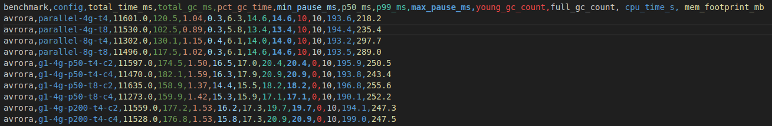

- Perform quantitative analysis
I derived additional metrics (GC overhead percentage) then generated plots of pause distributions and overhead comparisons per GC and heap size. I identified the Pareto‐optimal configurations and traced out the Pareto frontier to highlight the best trade-offs.
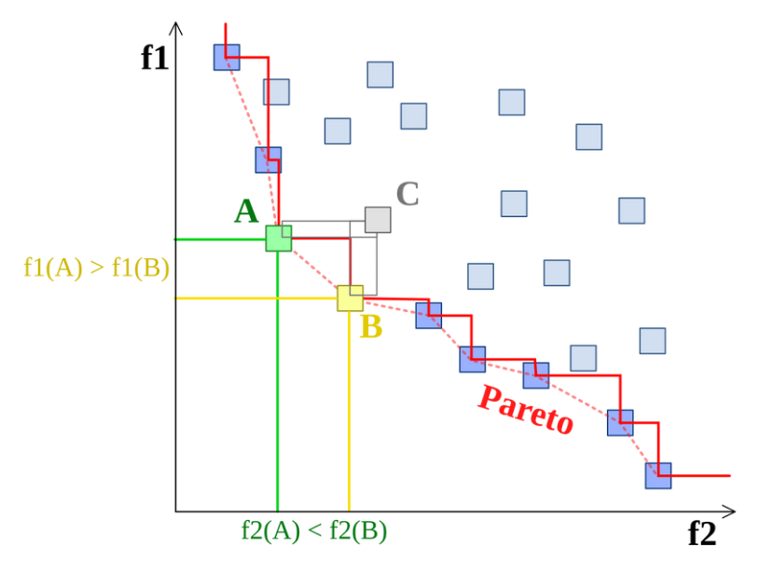

A point is Pareto-optimal if you cannot improve one metric (e.g. runtime) without worsening the other (e.g. pause time). The Pareto frontier is the set of all such non-dominated points. It traces out the best trade-offs you can achieve.

G1 Results

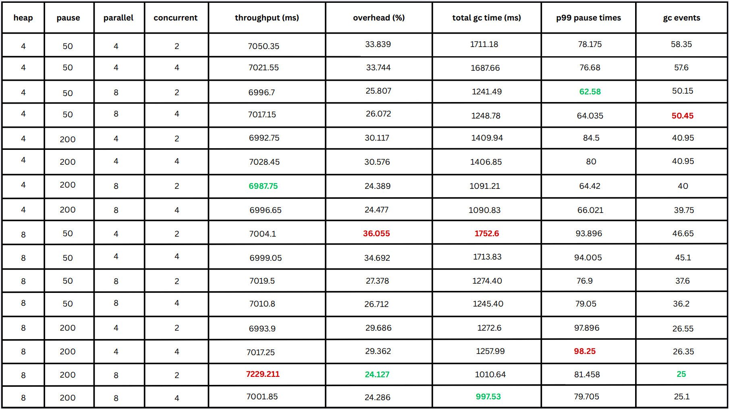
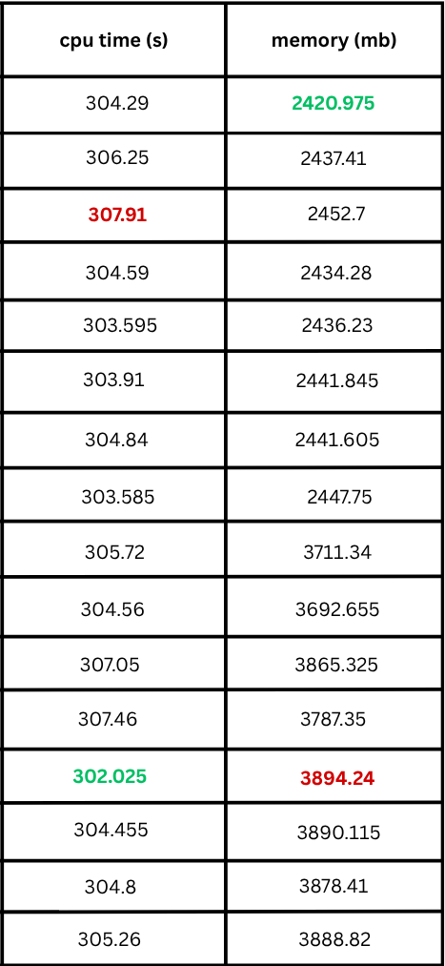

The detailed results for the G1 configurations are shown in the table above. The best performing configurations for each metric are shown in green and the worst ones in red. The conclusions that we can make from these data and for this particular garbage collector are:

- More parallel threads consistently deliver better throughput and lower GC overhead.

- A tighter pause goal (50 ms) reduces high-percentile pauses noticeably, at only a small cost in overall runtime.

- Increasing the heap to 8 GB does not improve throughput in this test range—it actually slows some runs despite mildly lowering GC%.

- Varying the number of concurrent threads (c2 vs c4) has only a minor effect on both latency and speed.

- In the bar chart, the 16 G1 configs naturally fall into four performance clusters:

Worst: 50 ms pause with 4 parallel threads
Next: 200 ms pause with 8 parallel threads
Next: 50 ms pause with 8 parallel threads
Best: 200 ms pause with 8 parallel threads

This grouping shows that the combination of a relaxed pause-time goal and high parallelism yields the strongest throughput, while strict pause goals with low parallelism suffer most

- 4 GB heap configurations perform better under the 50 ms pause goal—tighter control pays off on a smaller heap.

- 8 GB heap configurations do best with the 200 ms pause goal—the extra memory reduces pressure, so a looser goal unlocks higher throughput.

- CPU usage is remarkably stable across all G1 configurations, varying by only a few percent.
- Tighter pause goals sometimes edge CPU time slightly upward, reflecting extra work to meet latency constraints.
- Increasing parallel or concurrent thread counts has minimal impact on overall CPU consumption.
- Doubling the heap from 4 GB to 8 GB raises the memory footprint by roughly half again, with only marginal CPU‐time benefits.
- Pause‐time and thread adjustments tune latency without significantly altering compute or memory costs.
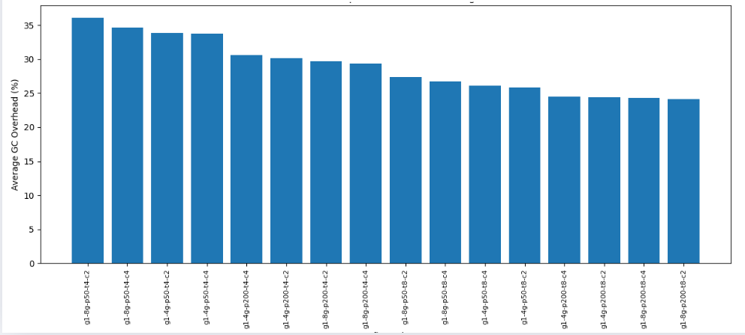
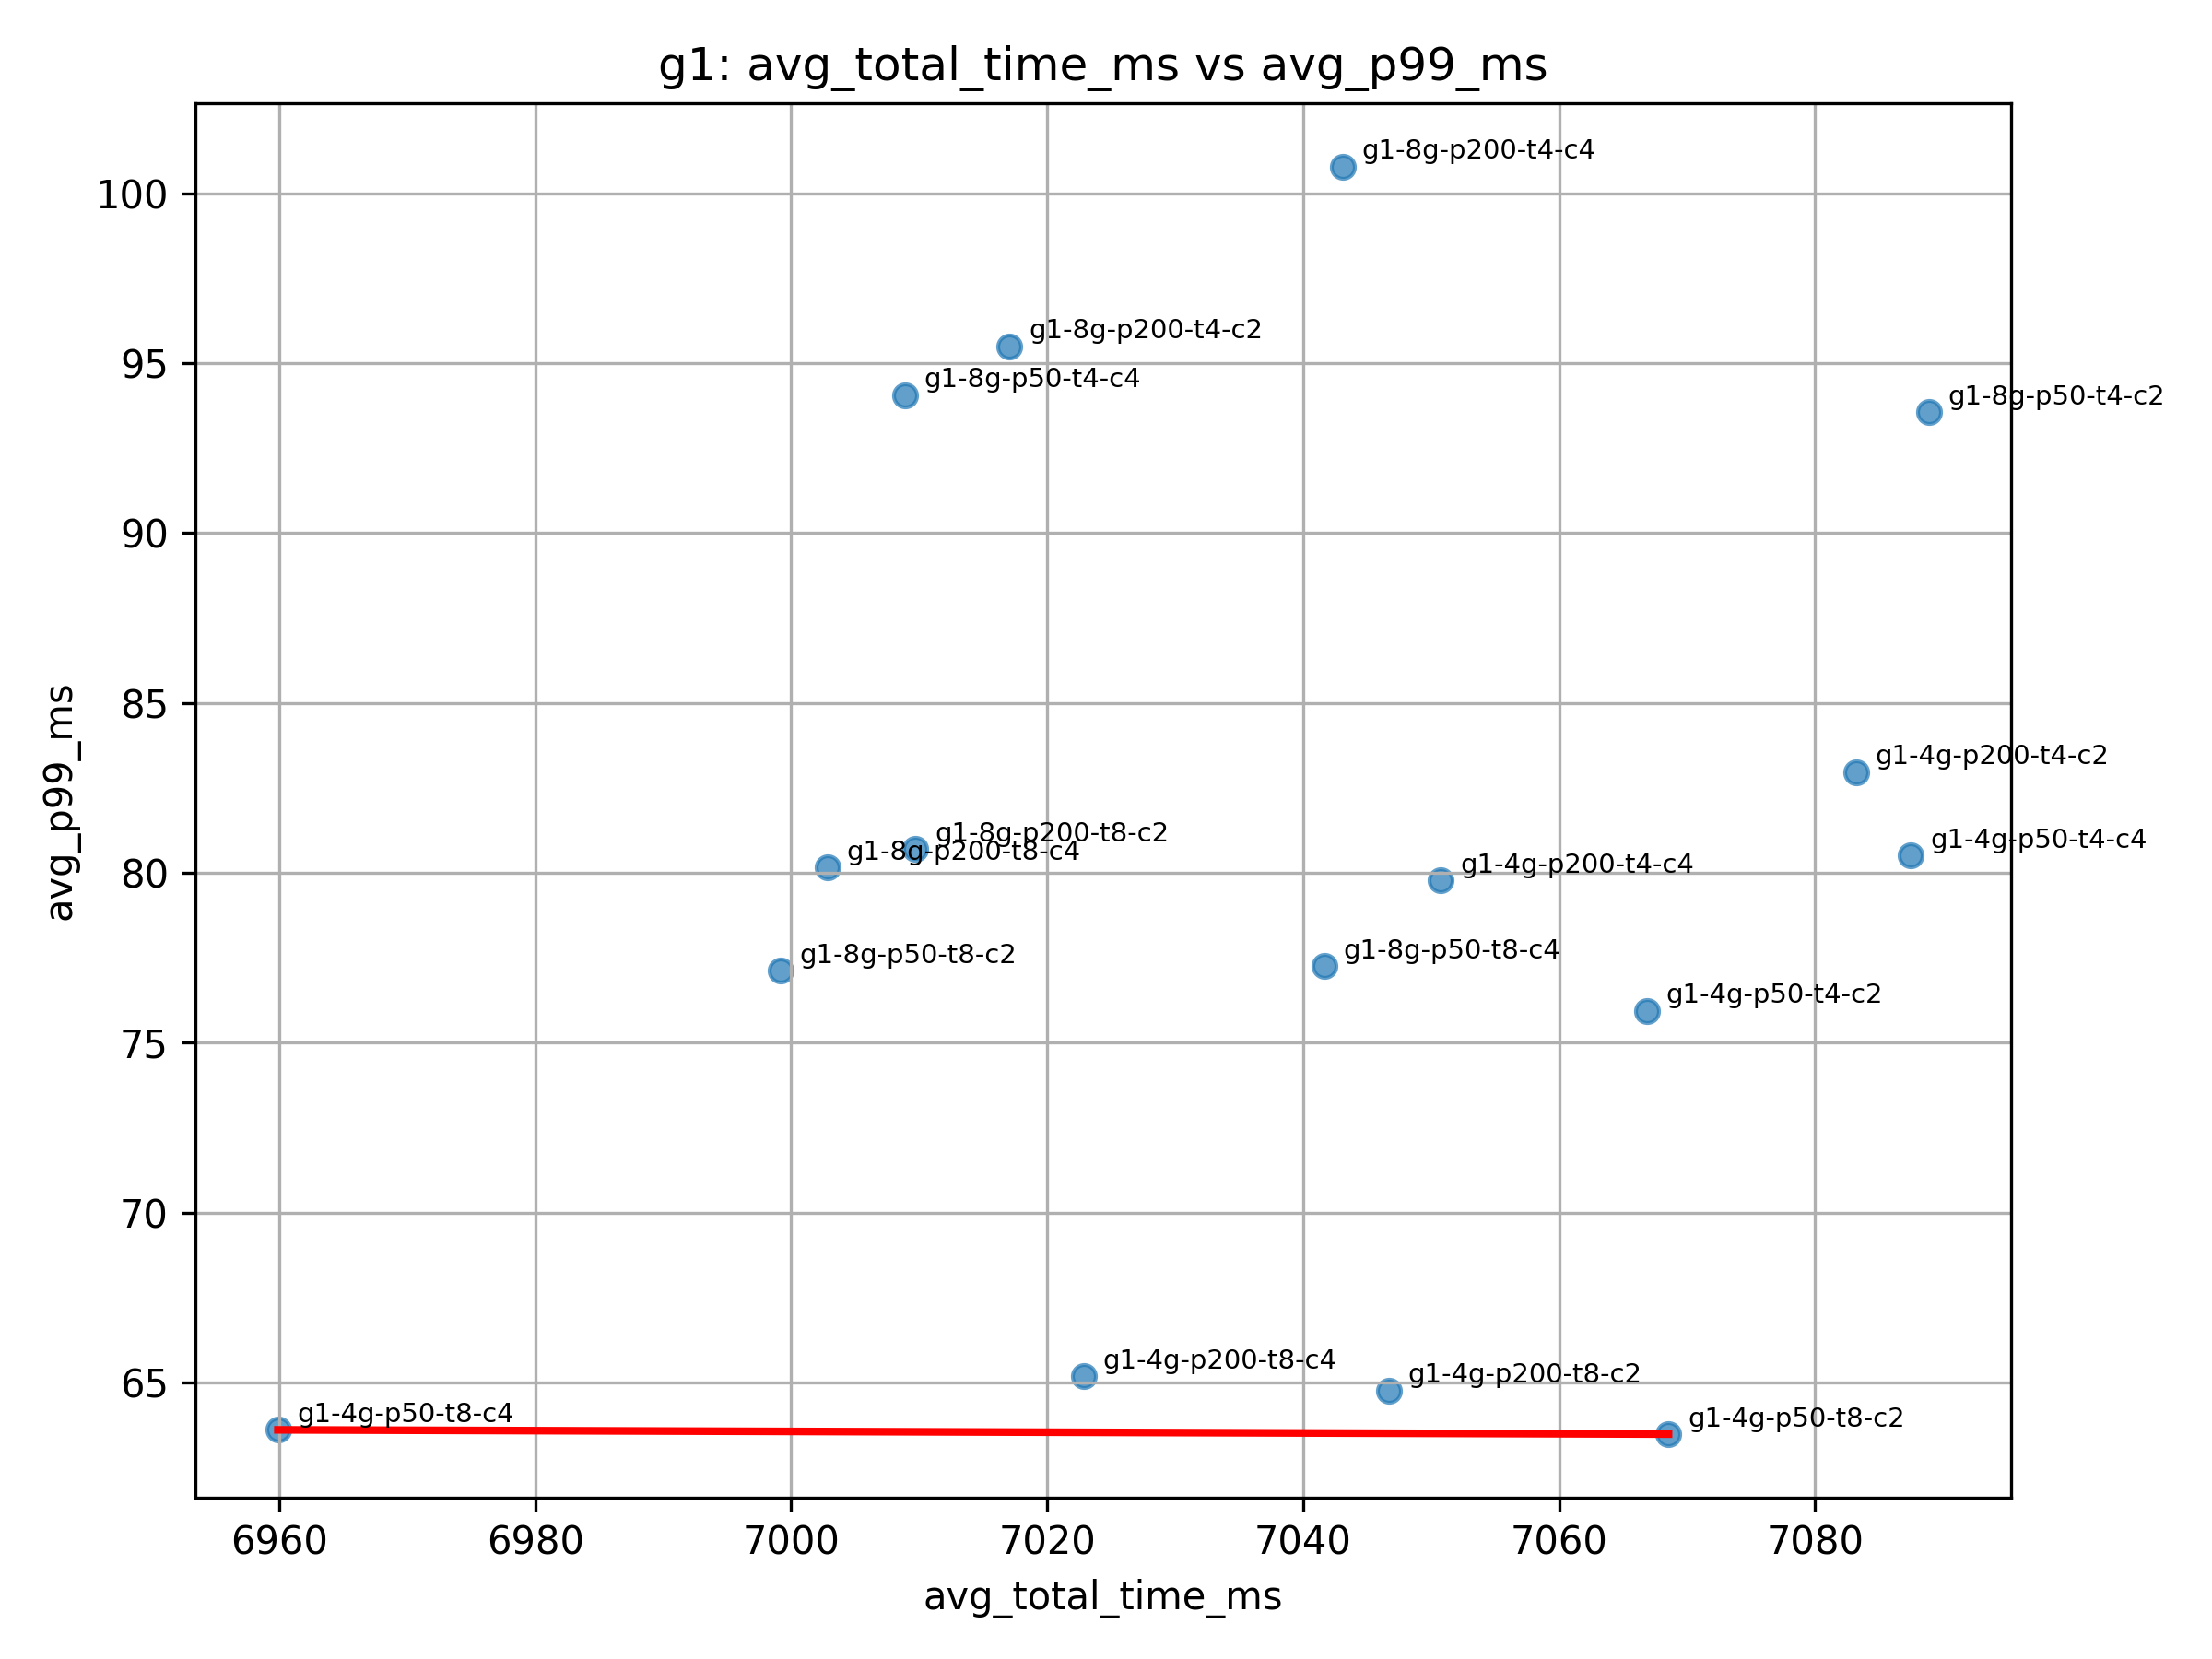
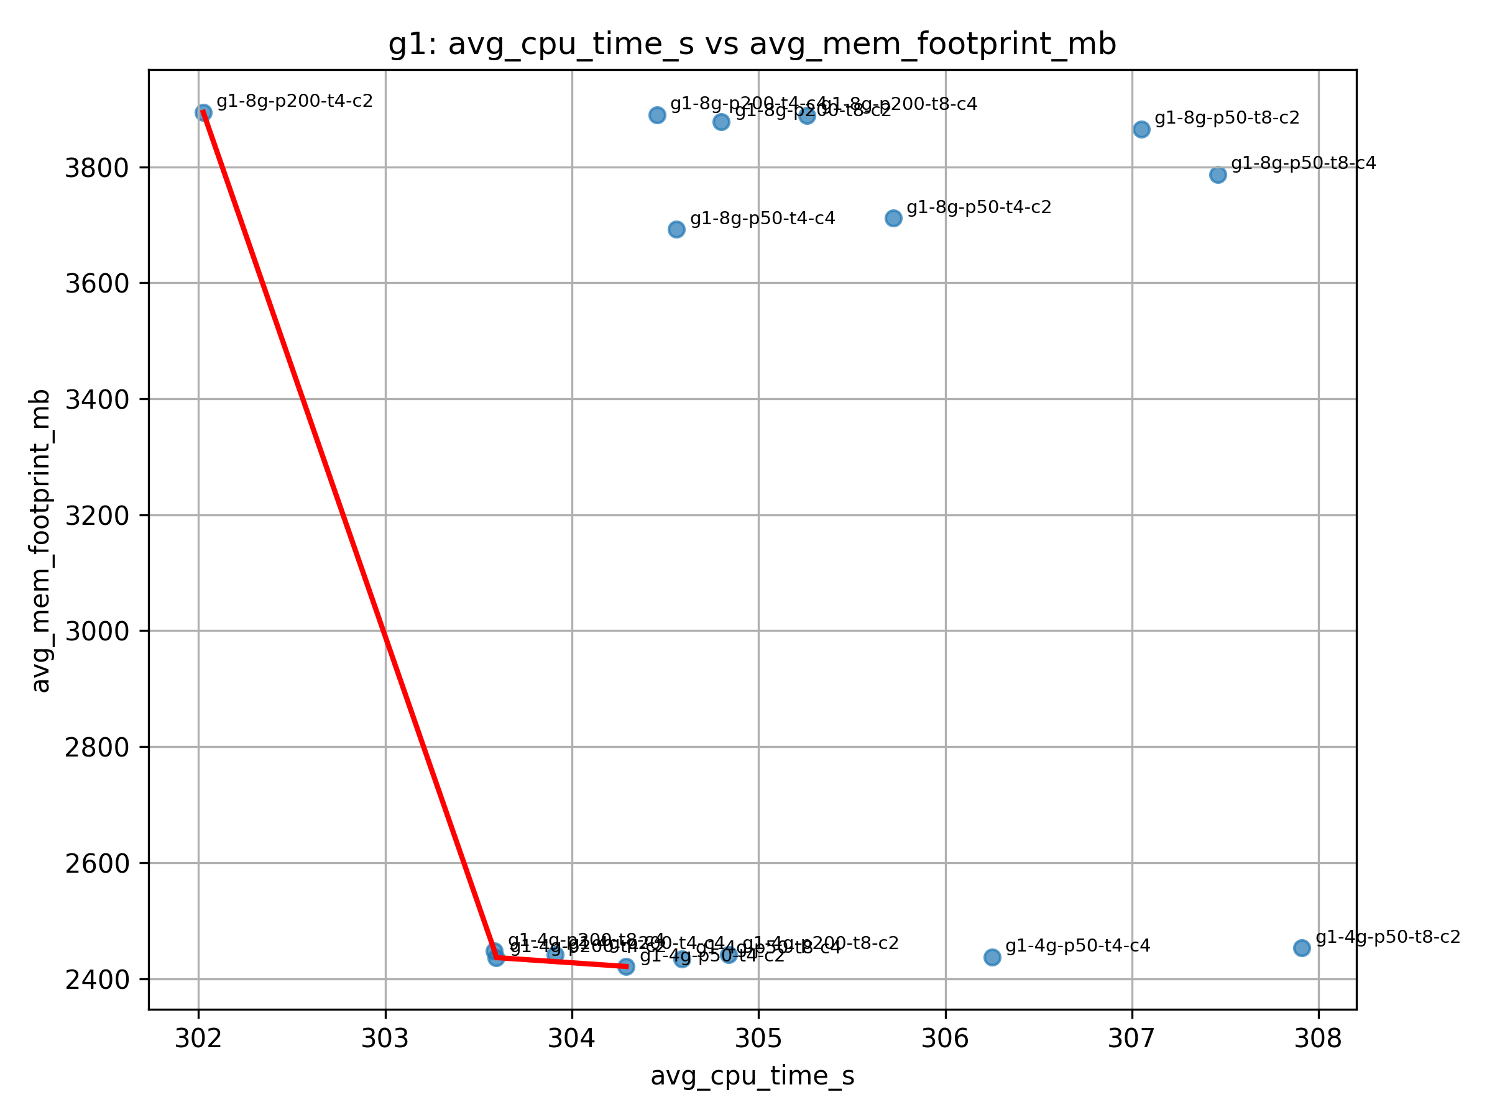

ZGC Results

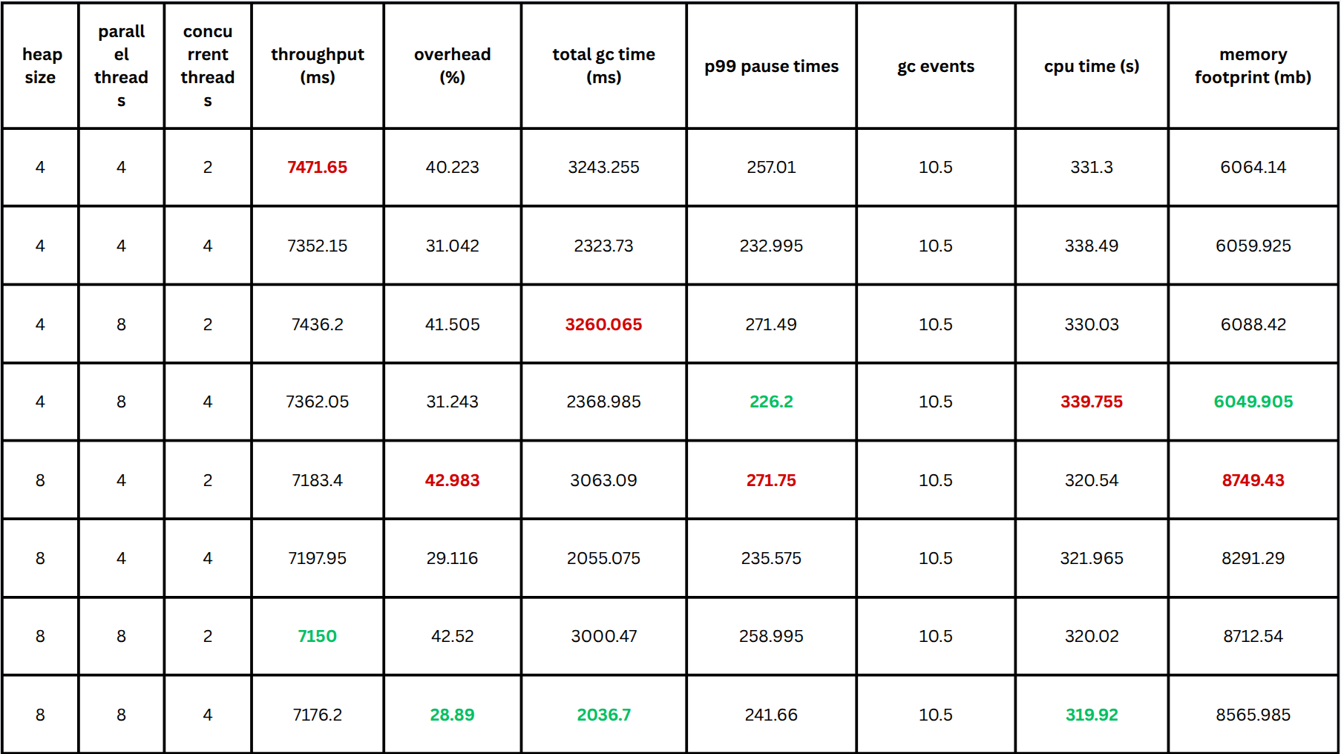

Similar to the G1, here we can see the results of the ZGC configurations in detail. We notice that:

- Across both heap sizes and parallel‐thread counts, bumping ZGC’s concurrent workers from 2 to 4 drops GC overhead and reduces p99 pauses, matching ZGC’s design to shift more work into concurrent phases. This can easily be visualized in the bar graph where the best performing configurations are those with 4 concurrent threads.

- Switching parallel GC threads from 4 to 8 barely moves throughput or overhead, reflecting ZGC’s emphasis on concurrent rather than parallel stop-the-world work.

- Growing from 4 GB to 8 GB gives a modest drop in overhead and total GC time—consistent with ZGC’s regionized heap reducing frequency of remapping work.

- Memory usage scales with heap size, confirming ZGC’s resident set tracks the configured heap.
- Smaller heaps drive up overall CPU consumption compared to larger heaps.
- Adding more concurrent threads only slightly shifts CPU load, with effects varying by heap size.
- ZGC relies heavily on CPU cycles relative to wall-clock time to achieve its low-pause design.

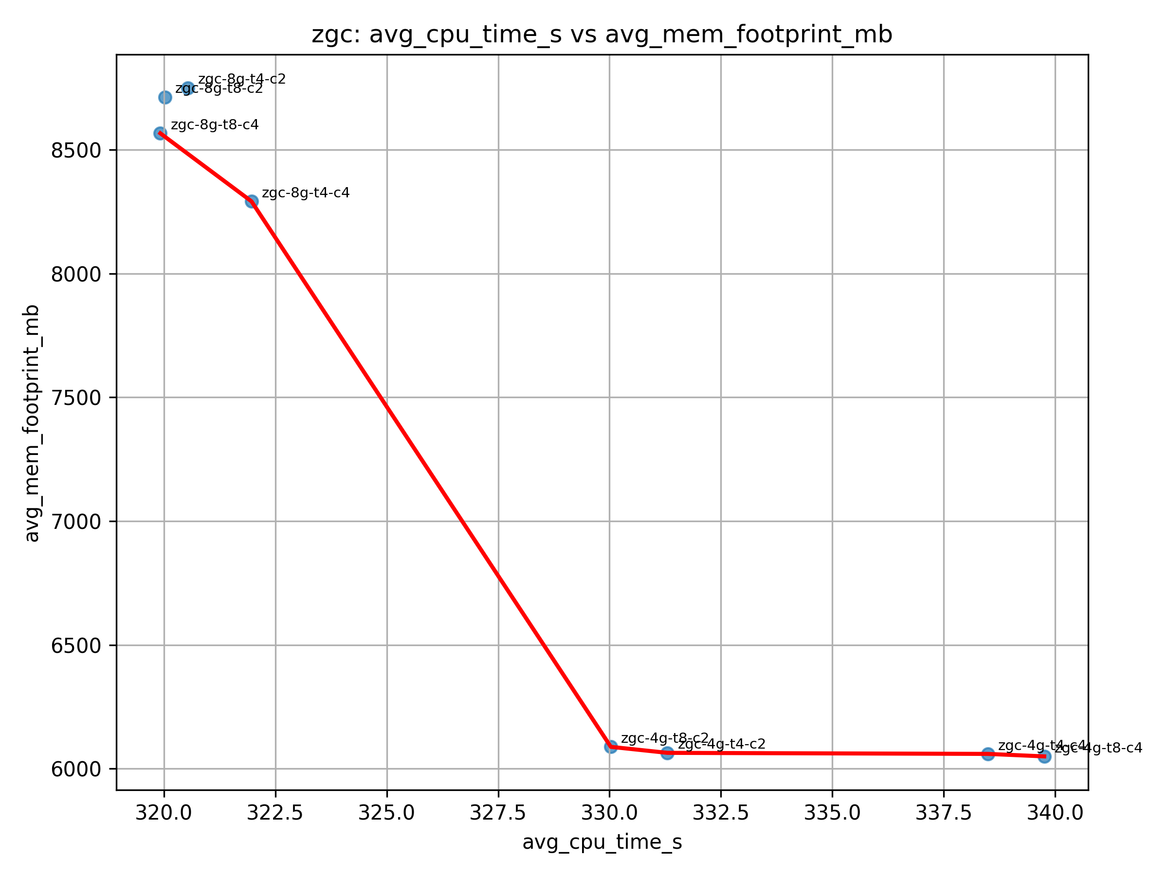

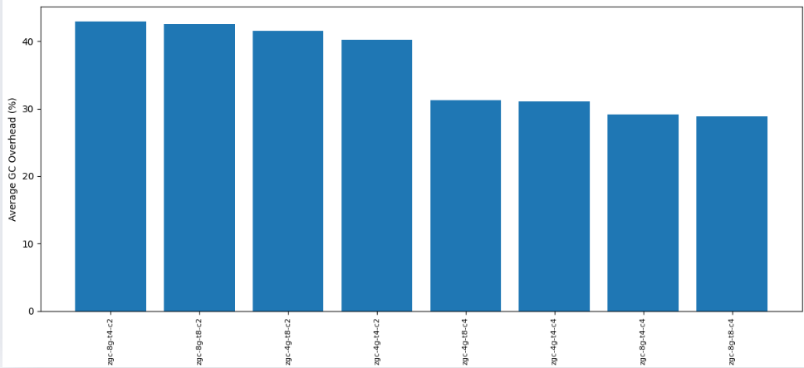
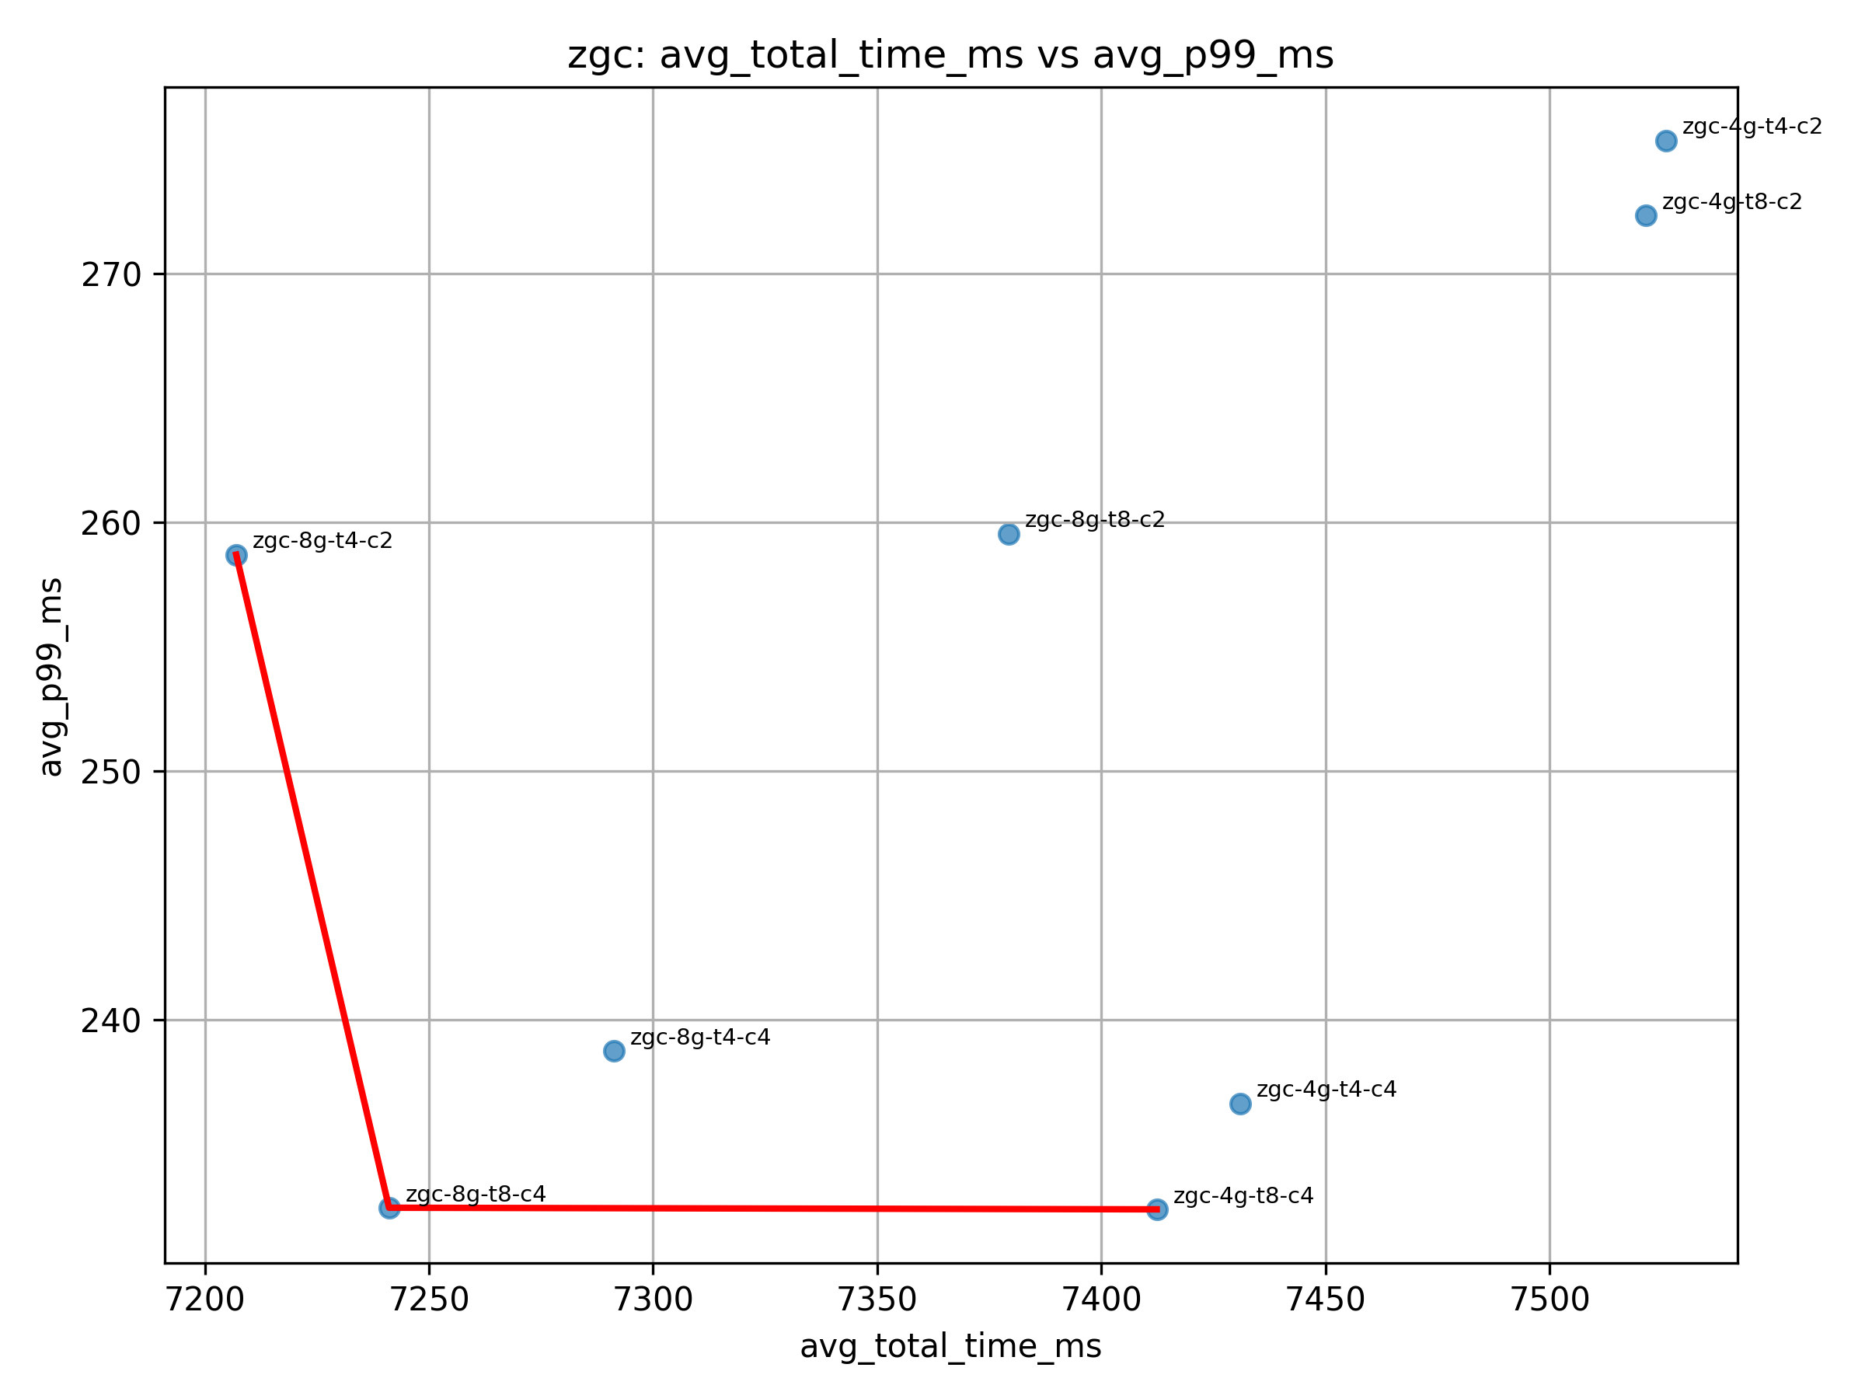

ParallelGC Results

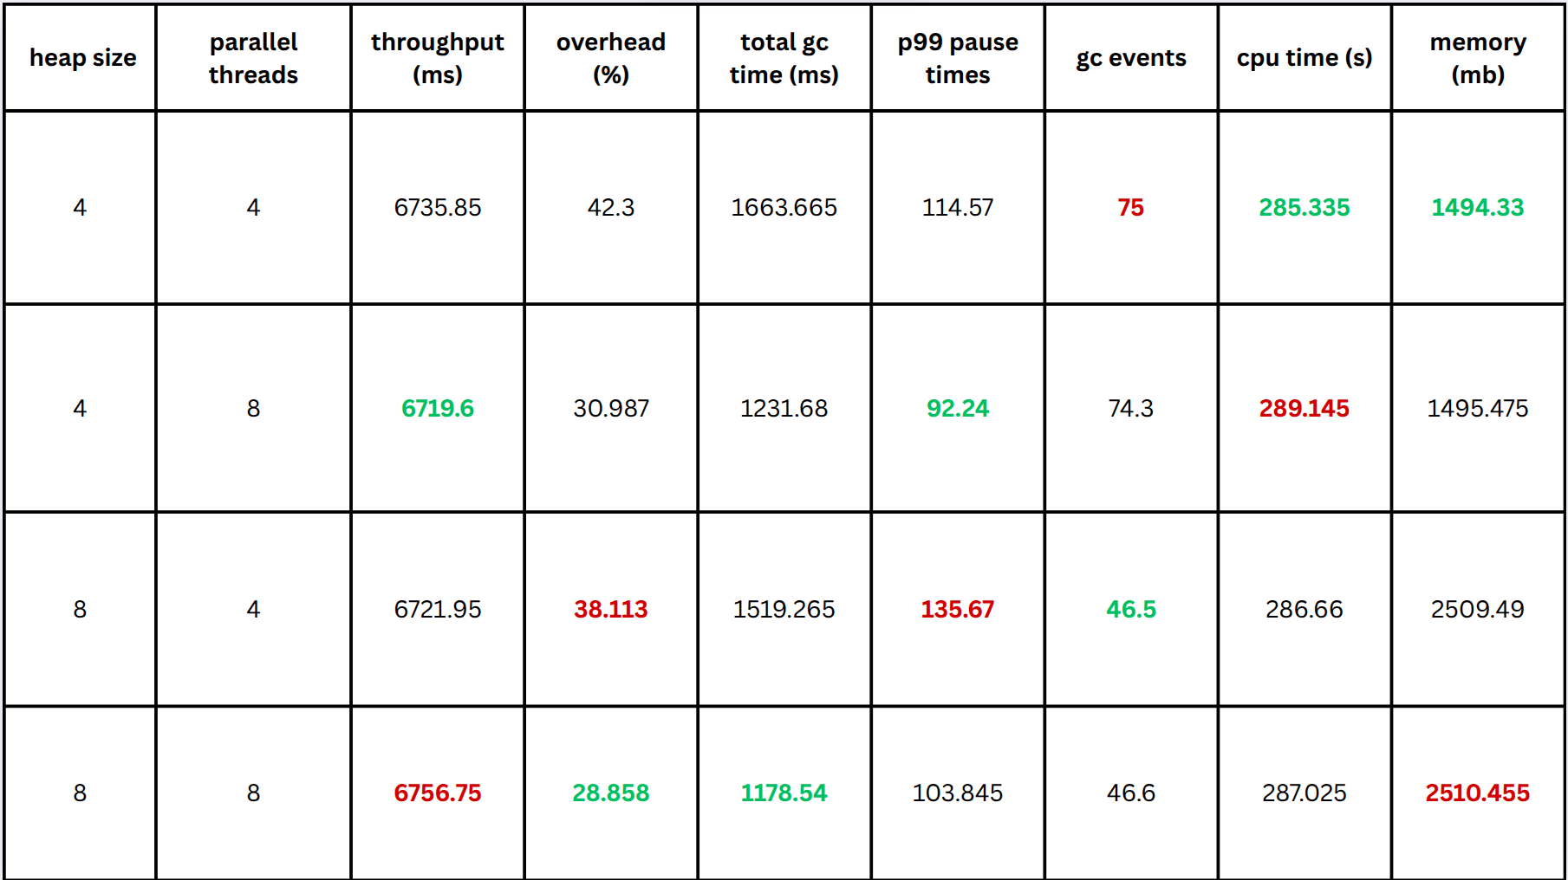

For the ParallelGC we make these conclusion from the metrics above: Adding parallel GC threads improves both speed and pause times

- Moving from 4 to 8 threads on a 4 GB heap cuts average runtime, lowers GC overhead and reduces p99 pauses, exactly as the ParallelGC design predicts: more collector threads shorten both collection duration and overall stall time.

- Larger heap reduces GC frequency and overhead, but can lengthen individual pauses. Doubling from 4 GB to 8 GB with 4 threads drops GC overhead from 42.3 % to 38.1 % and cuts event count from 75 to 46.5, showing fewer collections consistent with the fact that each stop-the-world scan must touch a bigger heap.

- Best latency–throughput trade-off comes from high threads on moderate heap. The fastest, lowest-pause run is 4 GB + 8 threads. This matches theory: ample collector threads on a right-sized heap give maximum throughput with minimal pause.

- Changing the number of GC threads has virtually no effect on application CPU time.
- Doubling the heap size roughly doubles the memory footprint while leaving CPU time nearly unchanged.
- GC configuration tweaks shift memory usage far more than they shift compute cost.
- Keeping a smaller heap delivers similar compute performance at a significantly lower memory cost.

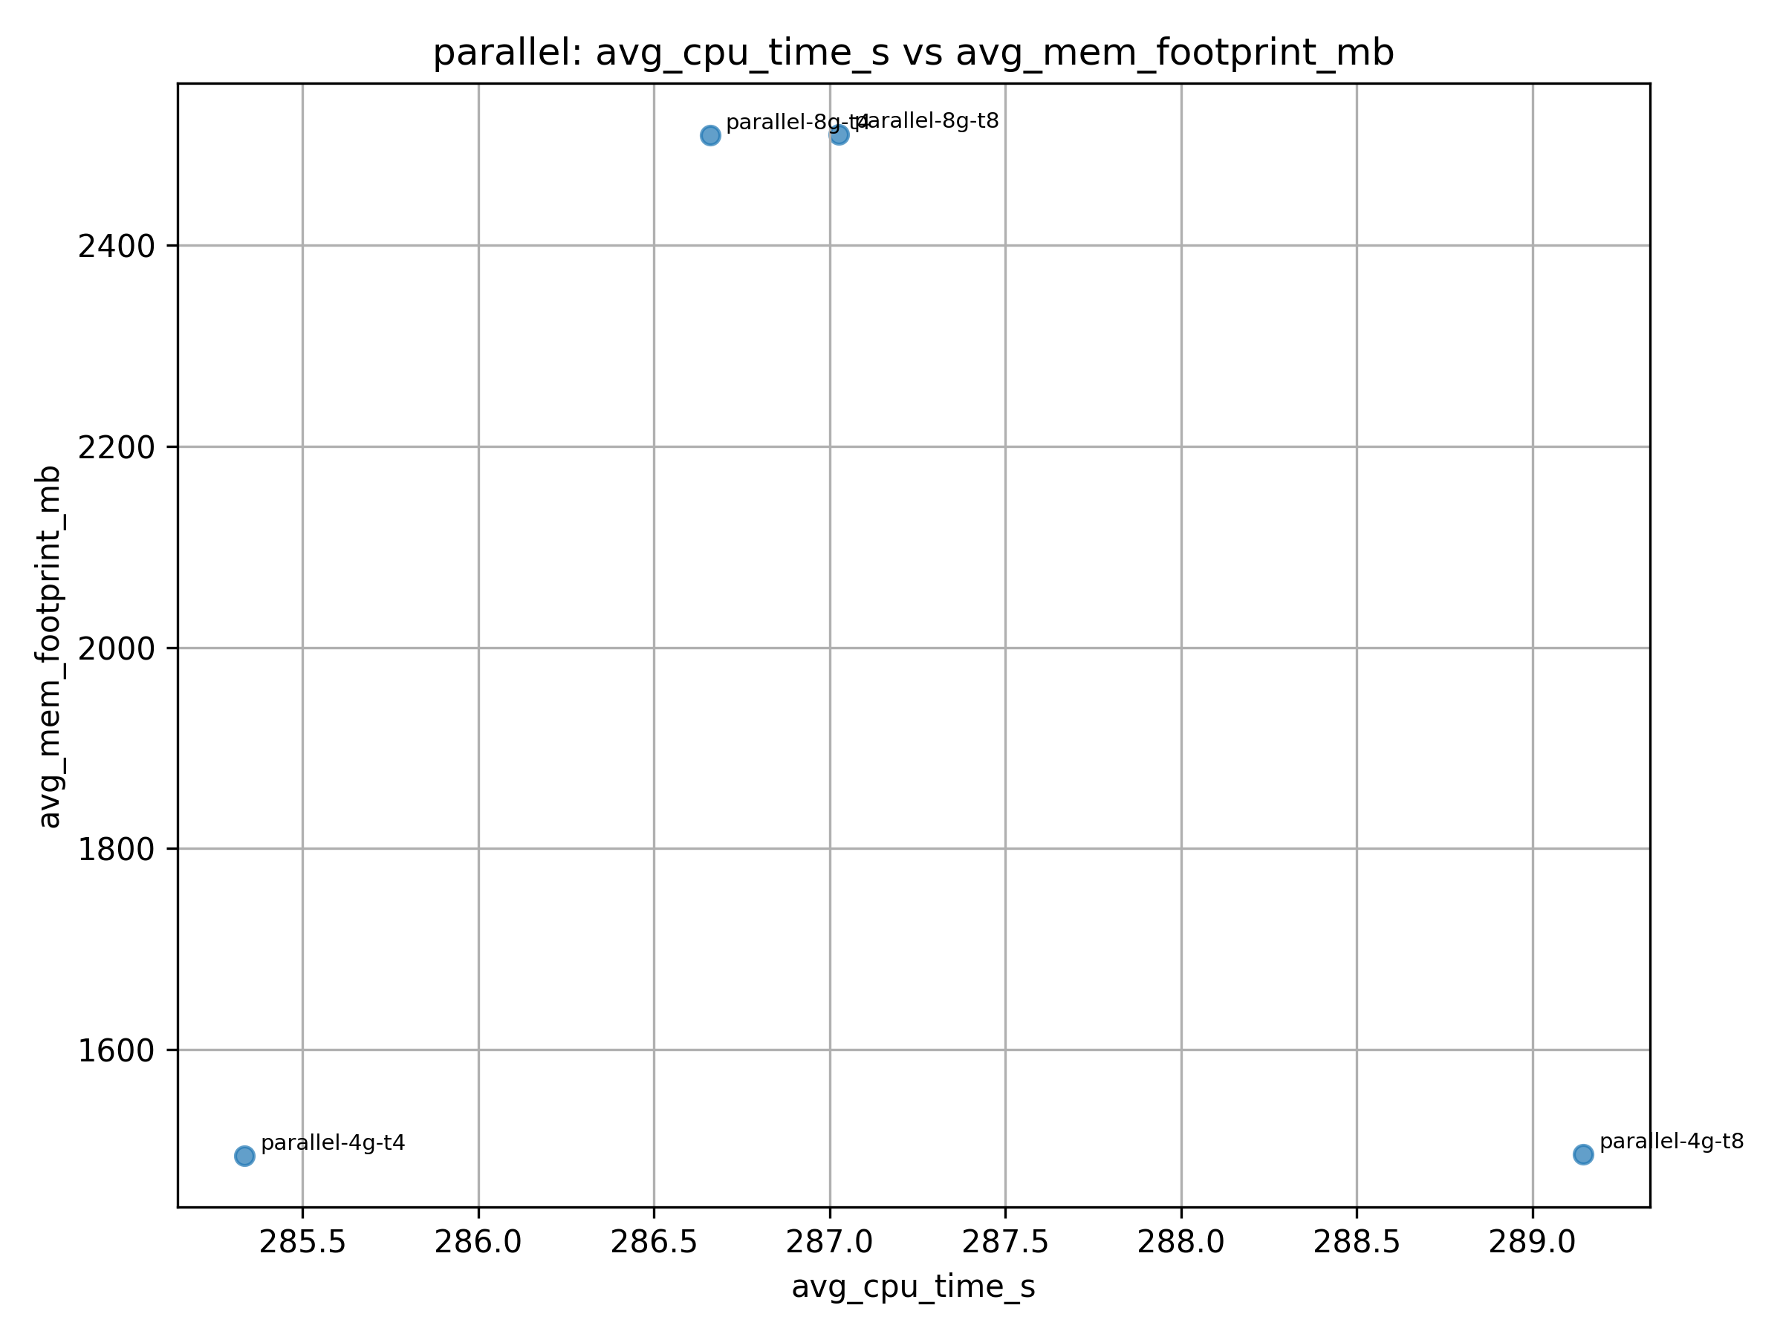

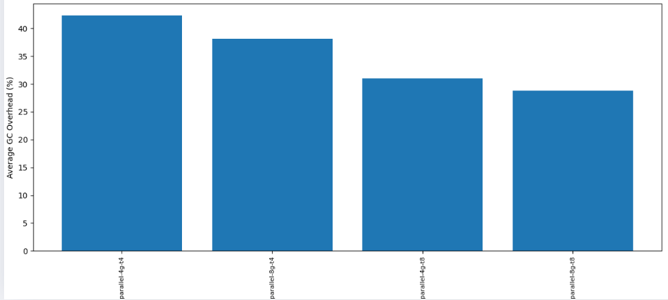
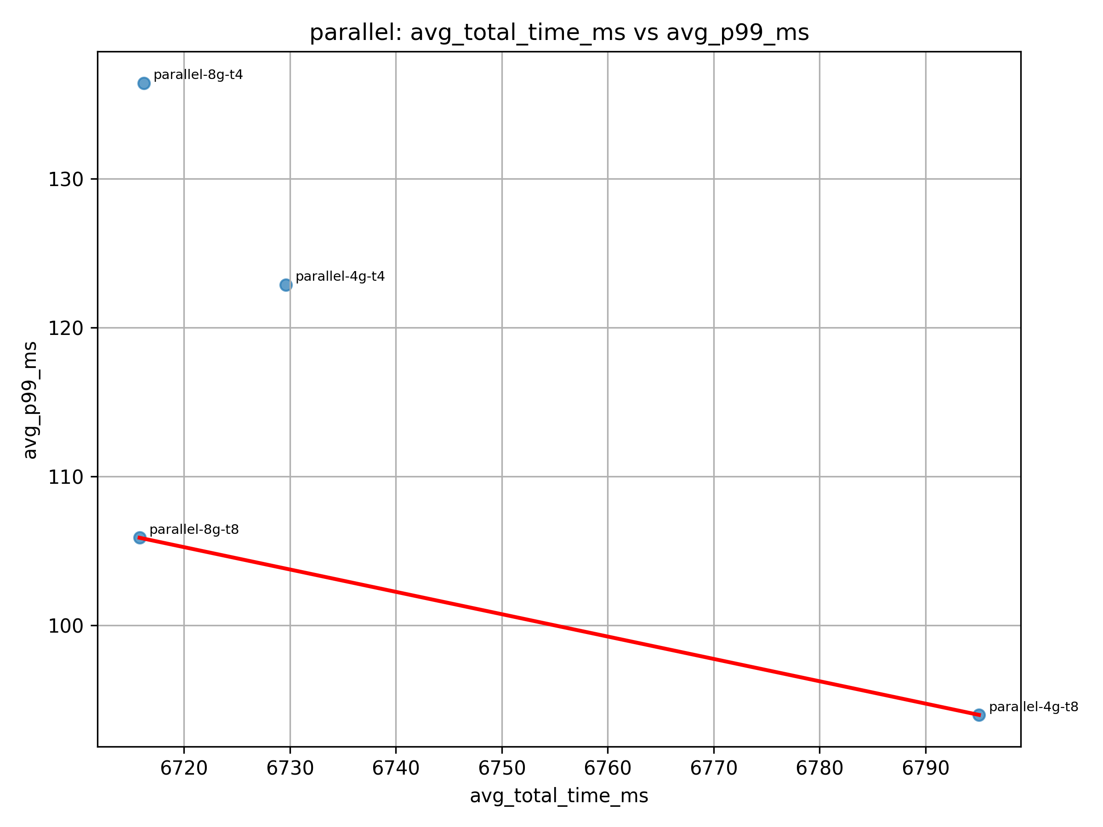

Benchmark Observations

By analyzing the original metrics.csv file which categorizes each configuration by benchmark I made some interesting observations.

- In H2, zgc-4g-t4-c2 spends 42 050.6 ms in GC, showing ZGC can be inefficient when allocation rates or heap sizing overwhelm its concurrent model.
- For Avrora (zgc-4g-t4-c2), min_pause_ms is 0.0, matching ZGC’s ultra-low-latency design. In FOP, this gives ZGC a clear edge in latency-sensitive tasks.
- ZGC excels on FOP but performs poorly on Tradebeans, highlighting that its benefits depend on each application’s memory behavior and access patterns.
- PMD runs with ParallelGC show high full_gc_count and p99 pauses around 82 ms, underscoring ParallelGC’s weakness with fragmented heaps.
- Lusearch sees a young_gc_count of 173 but few full GCs, indicating efficient young-gen reclamation but potential old-gen churn and many small pauses.
- In BioJava, g1-4g-p50-t4-c2 vs. g1-4g-p200-t4-c2 show almost identical runtimes, suggesting that tighter pause targets don’t always change performance for some workloads.
- ZGC configurations (e.g., zgc-8g) consistently show extreme memory usage (up to 24.5 GB in H2 and 13.5 GB in Tradesoap), often 3-10x higher than Parallel/G1, with no proportional CPU time improvement.
- For Batik, ZGC (zgc-4g-t8-c4) reduces CPU time to 16.13s (vs. 121-144s for G1/Parallel) but consumes 2.1 GB memory, highlighting a CPU-memory trade-off.
- H2’s ZGC configurations use 24+ GB memory and 1,200+ CPU seconds, far exceeding Parallel’s 3.6 GB / 746s, indicating ZGC’s unsuitability for memory-heavy workloads.
- For benchmarks like Avrora and FOP, Parallel GC maintains low CPU time (~193s and ~47s) with moderate memory (~200-800 MB), showing efficiency for lighter workloads.
- ZGC-8g configurations in Biojava spike memory to 10.8+ GB (vs. 2.8 GB for Parallel) while increasing CPU time (121-133s vs. 110-116s), suggesting ZGC adds overhead without gains.
- G1 often balances CPU and memory (e.g., Tomcat: 455s CPU / 2.8 GB vs. ZGC’s 447s / 3.8 GB), making it a safer default for mixed workloads.

Lower Bound Overhead

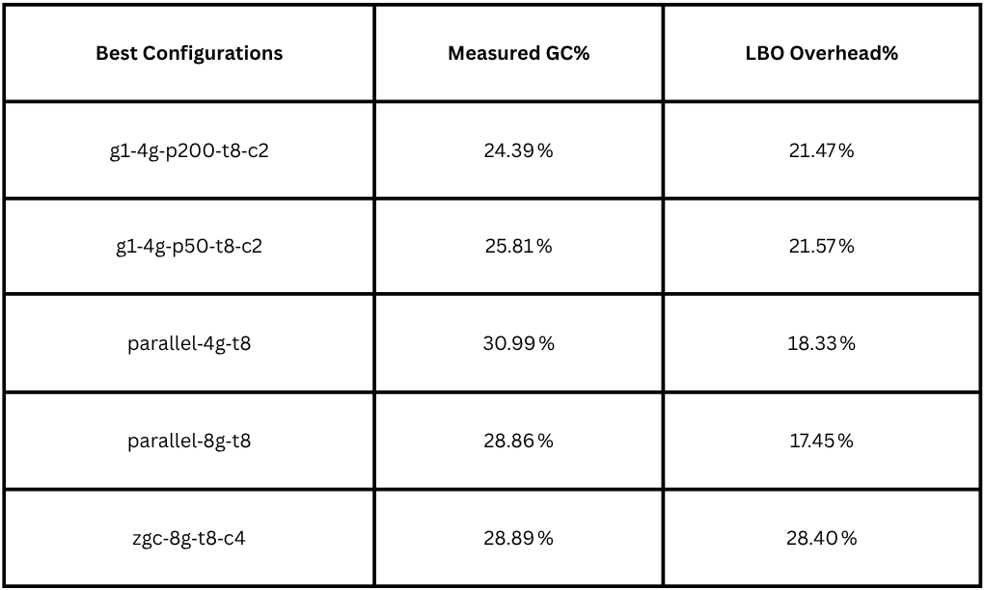
I calculate the lower‐bound overhead (LBO) to understand how much of each run’s time is truly “unavoidable” work versus GC overhead. To do this, I first compute each run’s application‐only time as app_time = avg_total_time_ms – avg_total_gc_ms, then find the smallest app_time across all configs (my proxy for a zero-GC run). For any configuration, I express its overhead relative to that ideal minimum by LBO_overhead_pct = 100 × (avg_total_time_ms – min_app_time) / avg_total_time_ms. When I apply this to the top performers, I see that the G1 champions (g1-4g-p200-t8-c2 and g1-4g-p50-t8-c2) sit about 21,5% overhead, indicating they’re within ~3 pp of their measured GC% and close to the theoretical best. The ParallelGC winners (parallel-4g-t8 and parallel-8g-t8) show even more headroom (18.3 % and 17.5 %), meaning a larger fraction of their runtime is devoted to GC work that could, in principle, be optimized away. ZGC’s best (zgc-8g-t8-c4) barely improves over its measured 28.9 %, confirming it already operates near its zero-GC limit.

