Final Round AI vs LockedIn AI: Which AI Interview Tool Is Better in 2025?
Preparing for job interviews has changed dramatically in the last few years. Instead of relying only on mock interviews with friends or reading common questions online, candidates can now use AI-powered interview platforms that simulate real interviews, analyze responses, and provide instant feedback.
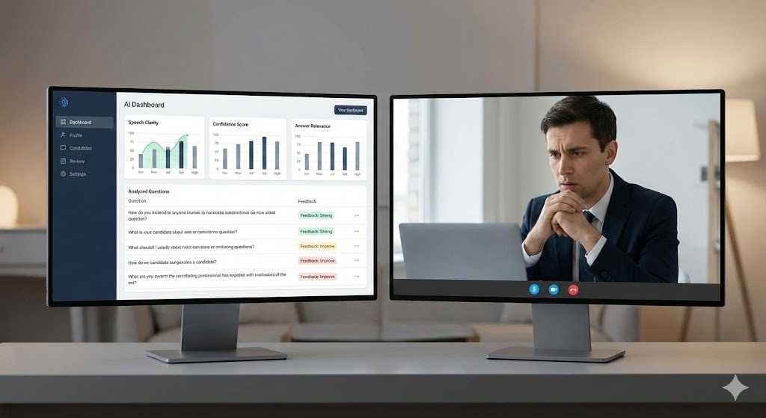

Two of the most talked-about tools in this space are Final Round AI and LockedIn AI.
Both platforms aim to help job seekers improve interview performance, but they focus on different strengths. One emphasizes structured feedback and analytics, while the other prioritizes realistic interview pressure and confidence building.
In this detailed comparison, we’ll break down:
- How each tool works
- Their key features
- Strengths and limitations
- Who each tool is best for
By the end, you’ll know exactly which AI interview tool fits your career goals.

What Is Final Round AI?
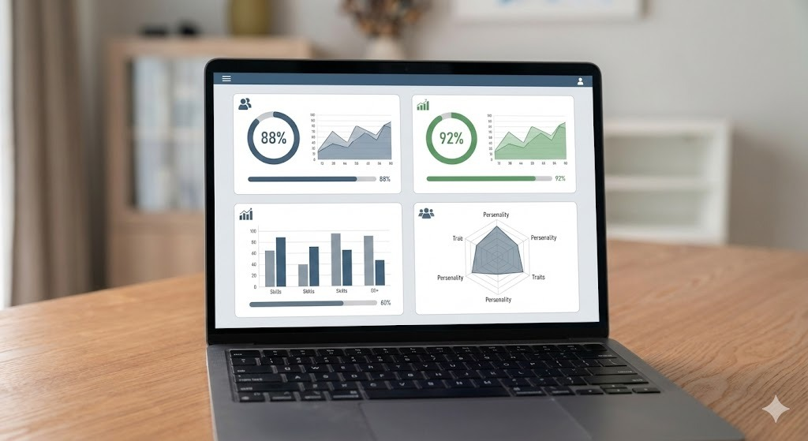

Final Round AI is an AI-powered interview preparation platform designed to replicate structured job interviews and provide data-driven feedback.
It focuses on:
- Improving the quality of answers
- Refining technical and behavioral responses
- Tracking progress over time
Instead of just practicing randomly, Final Round AI helps candidates systematically improve with measurable insights.
Key Features of Final Round AI
1. AI-Driven Interview Simulations
Final Round AI generates interview questions based on:
- Job role
- Industry
- Experience level
- Difficulty (entry-level to senior roles)
This makes practice sessions highly relevant to real interviews.
2. Instant, Structured Feedback
After each answer, the platform analyzes:
- Content quality
- Clarity of response
- Tone and confidence
- Technical accuracy
- Behavioral alignment (STAR method, impact, clarity)
You don’t just get a score—you get actionable suggestions on how to improve.
3. Progress Tracking & Analytics
Final Round AI tracks performance across sessions, helping you see:
- Where you’re improving
- Which areas still need work
- Patterns in your responses over time
This is especially useful for long-term interview preparation.
4. Clean, Beginner-Friendly Interface
The platform is web-based and mobile-friendly, making it easy to practice anytime without setup complexity.
Who Should Use Final Round AI?


Final Round AI is best for:
- Job seekers who want structured improvement
- Candidates preparing for technical or role-specific interviews
- Users who like analytics, feedback, and measurable progress
- People preparing over weeks, not just days
If you care about answer quality, clarity, and skill progression, Final Round AI is a strong choice.

What Is LockedIn AI?

LockedIn AI takes a different approach. Instead of focusing mainly on analytics, it emphasizes immersive interview simulations that feel close to real-life interview pressure.
The goal is not just to answer correctly—but to perform confidently under stress.
Key Features of LockedIn AI
1. Realistic Interview Simulations
LockedIn AI recreates real interview conditions, including:
- Timed responses
- Situational and behavioral questions
- Conversational flow similar to live interviews
This helps users get comfortable with pressure and unpredictability.
2. Focus on Communication & Confidence
The platform pays close attention to:
- Tone of voice
- Delivery style
- Communication clarity
- Emotional control during answers
This is especially useful for candidates who struggle with nervousness.
3. Behavioral & Situational Practice
LockedIn AI shines at:
- Behavioral interviews
- Situational judgment questions
- HR and culture-fit rounds
It helps candidates think clearly and respond naturally.
4. Gamified, Interactive Experience
The experience feels more interactive and engaging compared to traditional mock interviews, which helps maintain consistency in practice.
Who Should Use LockedIn AI?
LockedIn AI is ideal for:
- Candidates who feel anxious in interviews
- People who want real-life interview pressure simulation
- Users focused on confidence, communication, and presence
- Non-technical or mixed-role interview preparation
If your main challenge is nerves, hesitation, or communication, LockedIn AI can make a big difference.

Feature-by-Feature Comparison
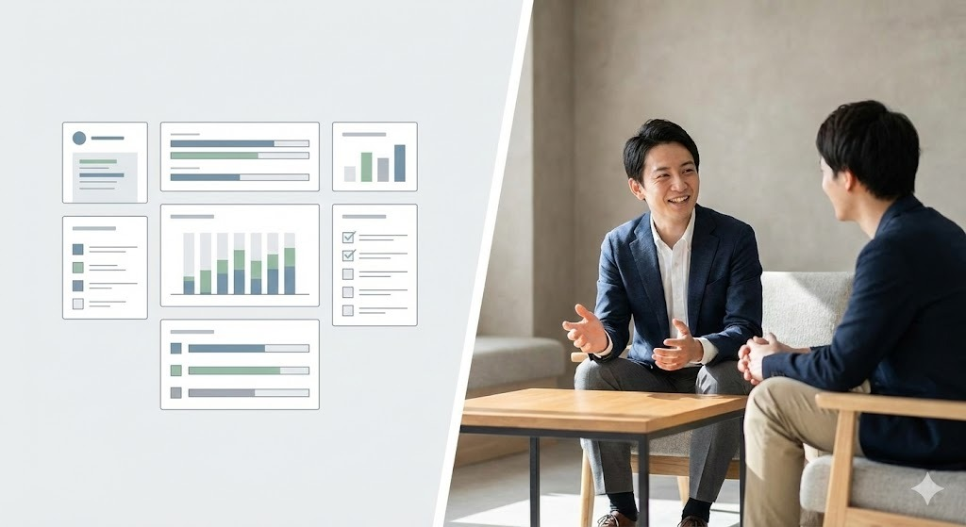

Interview Style
- Final Round AI: Structured, role-based, analytical
- LockedIn AI: Immersive, situational, pressure-focused
Feedback Type
- Final Round AI: Detailed metrics, improvement suggestions
- LockedIn AI: Performance-based insights and confidence cues
Best For
- Final Round AI: Skill refinement and answer quality
- LockedIn AI: Confidence building and real-world readiness
Learning Approach
- Final Round AI: Progressive improvement over time
- LockedIn AI: Repeated realistic exposure

Final Round AI vs LockedIn AI: Quick Verdict


Choose Final Round AI if:
- You want structured, data-driven interview practice
- You care about improving answer quality and clarity
- You want to track progress over time
- You’re preparing for technical or role-specific interviews
Choose LockedIn AI if:
- You struggle with confidence or interview anxiety
- You want realistic interview simulations
- You want to improve communication and situational handling
- You’re preparing for behavioral or HR interviews

Final Thoughts
Both Final Round AI and LockedIn AI are powerful interview preparation tools—but they solve different problems.
- Final Round AI helps you become better at answering questions
- LockedIn AI helps you perform better under real interview pressure
If possible, some candidates may even benefit from using both:
- Final Round AI for structured improvement
- LockedIn AI for confidence and realism
Ultimately, the right tool depends on what you need most right now—better answers or better performance.

