***MainActivity.java***

***package com.example.km.web_browser;***

***import android.app.DownloadManager;***

***import android.content.Intent;***

***import android.graphics.Bitmap;***

***import android.net.Uri;***

***import android.os.Handler;***

***import android.os.PersistableBundle;***

***import android.support.v4.widget.SwipeRefreshLayout;***

***import android.support.v7.app.AppCompatActivity;***

***import android.os.Bundle;***

***import android.view.Menu;***

***import android.view.MenuInflater;***

***import android.view.MenuItem;***

***import android.view.View;***

***import android.view.inputmethod.InputMethodManager;***

***import android.webkit.CookieManager;***

***import android.webkit.CookieSyncManager;***

***import android.webkit.DownloadListener;***

***import android.webkit.WebChromeClient;***

***import android.webkit.WebSettings;***

***import android.webkit.WebView;***

***import android.webkit.WebViewClient;***

***import android.widget.Button;***

***import android.widget.EditText;***

***import android.widget.ImageView;***

***import android.widget.LinearLayout;***

***import android.widget.ProgressBar;***

***import android.widget.Toast;***

***public class MainActivity extends AppCompatActivity {***

***ProgressBar pgb;***

***ImageView imgv;***

***WebView webv;***

***LinearLayout linearlayout;***

***EditText input_URL;***

***Button visit_URL;***

***SwipeRefreshLayout swipeRefreshLayout;***

***String myCurrentURL;***

***@Override***

***protected void onCreate(Bundle savedInstanceState) {***

***super.onCreate(savedInstanceState);***

***setContentView(R.layout.activity_main);***

***//Initialisation***

***pgb = (ProgressBar)findViewById(R.id.myProgressBar);***

***imgv = (ImageView)findViewById(R.id.myImgView);***

***webv = (WebView)findViewById(R.id.myWebView);***

***linearlayout = (LinearLayout)findViewById(R.id.linear_layout);***

***swipeRefreshLayout = (SwipeRefreshLayout)findViewById(R.id.mySwipeLayout);***

***input_URL = (EditText)findViewById(R.id.inputURL);***

***visit_URL = (Button)findViewById(R.id.visitURL);***

***WebSettings webSettings = webv.getSettings();***

***pgb.setMax(100);***

***onVisitURLPressed();***

***webv.loadUrl("https://www.google.com");***

***if(savedInstanceState != null){***

***webv.restoreState(savedInstanceState);***

***}***

***else {***

***webv.getSettings().setJavaScriptEnabled(true);***

***webv.getSettings().setLoadWithOverviewMode(true);***

***}***

***//Improve WebView Performance***

***webSettings.setSupportZoom(true);***

***webv.getSettings().setLoadsImagesAutomatically(true);***

***webv.getSettings().setBuiltInZoomControls(true); //Zoom Control***

***webv.getSettings().setDisplayZoomControls(true);***

***webv.getSettings().setDefaultZoom(WebSettings.ZoomDensity.FAR);***

***webv.getSettings().setRenderPriority(WebSettings.RenderPriority.HIGH);***

***webv.getSettings().setCacheMode(WebSettings.LOAD_CACHE_ELSE_NETWORK);***

***webv.getSettings().setAppCacheEnabled(true);***

***webv.setScrollBarStyle(View.SCROLLBARS_INSIDE_OVERLAY);***

***webSettings.setDomStorageEnabled(true);***

***webSettings.setLayoutAlgorithm(WebSettings.LayoutAlgorithm.SINGLE_COLUMN);***

***webSettings.setUseWideViewPort(true);***

***webSettings.setSavePassword(true);***

***webSettings.setSaveFormData(true);***

***webv.getSettings().setAppCacheEnabled(false);***

***webSettings.setEnableSmoothTransition(true);***

***webSettings.setDatabaseEnabled(true);***

***webv.getSettings().setPluginState(WebSettings.PluginState.ON);***

***webv.setWebViewClient(new WebViewClient(){***

***@Override***

***public void onPageStarted(WebView view, String url, Bitmap favicon) {***

***linearlayout.setVisibility(View.VISIBLE);***

***super.onPageStarted(view, url, favicon);***

***}***

***@Override***

***public void onPageFinished(WebView view, String url) {***

***linearlayout.setVisibility(View.GONE);***

***swipeRefreshLayout.setRefreshing(false);***

***myCurrentURL = url;***

***super.onPageFinished(view, url);***

***}***

***@Override***

***public boolean shouldOverrideUrlLoading(WebView view, String url) {***

***webv.loadUrl(url);***

***CookieManager.getInstance().setAcceptCookie(true);***

***return true;***

***}***

***});***

***webv.setWebChromeClient(new WebChromeClient(){***

***@Override***

***public void onProgressChanged(WebView view, int newProgress) {***

***super.onProgressChanged(view, newProgress);***

***pgb.setProgress(newProgress);***

***}***

***@Override***

***public void onReceivedTitle(WebView view, String title) {***

***super.onReceivedTitle(view, title);***

***getSupportActionBar().setTitle(title);***

***}***

***@Override***

***public void onReceivedIcon(WebView view, Bitmap icon) {***

***super.onReceivedIcon(view, icon);***

***imgv.setImageBitmap(icon);***

***}***

***});***

***//Download Manager to enable download of files***

***webv.setDownloadListener(new DownloadListener() {***

***@Override***

***public void onDownloadStart(String s, String s1, String s2, String s3, long l) {***

***DownloadManager.Request myRequest = new DownloadManager.Request(Uri.parse(s));***

***myRequest.allowScanningByMediaScanner();***

***myRequest.setNotificationVisibility(DownloadManager.Request.VISIBILITY_VISIBLE_NOTIFY_COMPLETED);***

***DownloadManager myManager = (DownloadManager)getSystemService(DOWNLOAD_SERVICE);***

***myManager.enqueue(myRequest);***

***Toast.makeText(MainActivity.this, "Download Started",Toast.LENGTH_SHORT);***

***}***

***});***

***swipeRefreshLayout.setOnRefreshListener(new SwipeRefreshLayout.OnRefreshListener() {***

***@Override***

***public void onRefresh() {***

***webv.reload();***

***}***

***});***

***}***

***public void onVisitURLPressed(){***

***visit_URL.setOnClickListener(new View.OnClickListener() {***

***@Override***

***public void onClick(View view) {***

***//Hide Keyboard***

***InputMethodManager inputManager = (InputMethodManager) getSystemService(INPUT_METHOD_SERVICE);***

***inputManager.hideSoftInputFromWindow(getCurrentFocus().getWindowToken(), InputMethodManager.HIDE_NOT_ALWAYS);***

***webv = (WebView)findViewById(R.id.myWebView);***

***String URL = "https://" + input_URL.getText().toString();***

***webv.loadUrl(URL);***

***input_URL.setText("");***

***input_URL.clearFocus();***

***}***

***});***

***}***

***@Override***

***public boolean onCreateOptionsMenu(Menu menu) {***

***MenuInflater menuInflater = getMenuInflater();***

***menuInflater.inflate(R.menu.super_menu, menu);***

***return super.onCreateOptionsMenu(menu);***

***}***

***@Override***

***public void onSaveInstanceState(Bundle outState) {***

***super.onSaveInstanceState(outState);***

***webv.saveState(outState);***

***}***

***//Menu Options***

***@Override***

***public boolean onOptionsItemSelected(MenuItem item) {***

***switch(item.getItemId()){***

***case R.id.menu_back:***

***onBackPressed();***

***break;***

***case R.id.menu_forward:***

***onForwardPressed();***

***break;***

***case R.id.menu_refresh:***

***webv.reload();***

***break;***

***case R.id.home:***

***webv.loadUrl("https://www.google.com");***

***input_URL.setText("");***

***break;***

***case R.id.clear_data:***

***clearData();***

***Toast.makeText(MainActivity.this, "History Cleared", Toast.LENGTH_SHORT).show();***

***break;***

***case R.id.share:***

***Intent shareIntent = new Intent(Intent.ACTION_SEND);***

***shareIntent.setType("text/plain");***

***shareIntent.putExtra(Intent.EXTRA_TEXT,"Hey, Check this out: \n"+myCurrentURL);***

***shareIntent.putExtra(Intent.EXTRA_SUBJECT, "Title: ");***

***startActivity(Intent.createChooser(shareIntent,"Share URL"));***

***break;***

***case R.id.exit:***

***onExitPressed();***

***break;***

***}***

***return super.onOptionsItemSelected(item);***

***}***

***private void onForwardPressed(){***

***if(webv.canGoForward()){***

***webv.goForward();***

***}***

***else{***

***Toast.makeText(this, "Can't Go Further" , Toast.LENGTH_SHORT).show();***

***}***

***}***

***private void clearData(){***

***webv.clearCache(true);***

***webv.clearHistory();***

***webv.clearFormData();***

***CookieSyncManager.createInstance(this);***

***CookieManager cookieManager = CookieManager.getInstance();***

***cookieManager.removeAllCookie();***

***}***

***private void onExitPressed(){***

***Toast.makeText(this, "Internet Khatam BC?", Toast.LENGTH_SHORT).show();***

***finish();***

***}***

***@Override***

***public void onBackPressed(){***

***if(webv.canGoBack()){***

***webv.goBack();***

***}***

***else{***

***finish();***

***}***

***}***

***}***

***Splash_Screen.java***

***package com.example.km.web_browser;***

***import android.content.Intent;***

***import android.support.v7.app.AppCompatActivity;***

***import android.os.Bundle;***

***public class Splash_Screen extends AppCompatActivity {***

***@Override***

***protected void onCreate(Bundle savedInstanceState) {***

***super.onCreate(savedInstanceState);***

***setContentView(R.layout.activity_splash_screen);***

***Thread th = new Thread(){***

***@Override***

***public void run() {***

***try {***

***sleep(3000);***

***Intent intent = new Intent(getApplicationContext(),MainActivity.class);***

***startActivity(intent);***

***finish();***

***} catch (InterruptedException e) {***

***e.printStackTrace();***

***}***

***}***

***};***

***th.start();***

***}***

***}***

***activity_main.xml***

***<?xml version="1.0" encoding="utf-8"?>***

***<android.support.v4.widget.SwipeRefreshLayout xmlns:android="http://schemas.android.com/apk/res/android"***

***xmlns:app="http://schemas.android.com/apk/res-auto"***

***xmlns:tools="http://schemas.android.com/tools"***

***android:layout_width="match_parent"***

***android:layout_height="match_parent"***

***android:orientation="vertical"***

***android:id="@+id/mySwipeLayout"***

***tools:context="com.example.km.web_browser.MainActivity">***

***<LinearLayout***

***android:orientation="vertical"***

***android:layout_width="match_parent"***

***android:layout_height="match_parent">***

***<LinearLayout***

***android:id="@+id/linear_layout"***

***android:layout_width="match_parent"***

***android:layout_height="5dp"***

***android:orientation="horizontal">***

***<ProgressBar***

***android:id="@+id/myProgressBar"***

***style="@style/Base.Widget.AppCompat.ProgressBar.Horizontal"***

***android:layout_width="match_parent"***

***android:layout_height="wrap_content"***

***android:layout_weight="0.1" />***

***</LinearLayout>***

***<LinearLayout***

***android:id="@+id/link"***

***android:layout_width="match_parent"***

***android:layout_height="40dp"***

***android:orientation="horizontal">***

***<ImageView***

***android:id="@+id/myImgView"***

***android:layout_width="match_parent"***

***android:layout_height="match_parent"***

***android:layout_weight="0.525"***

***android:src="@mipmap/ic_launcher" />***

***<EditText***

***android:id="@+id/inputURL"***

***android:layout_width="359dp"***

***android:layout_height="match_parent"***

***android:layout_alignParentLeft="true"***

***android:layout_centerVertical="true"***

***android:layout_weight="0.112"***

***android:hint="Enter URL Here :D (website.com)"***

***android:inputType="text" />***

***<Button***

***android:id="@+id/visitURL"***

***style="@android:style/Widget.Holo.Button.Borderless.Small"***

***android:layout_width="match_parent"***

***android:layout_height="wrap_content"***

***android:layout_weight="0.495"***

***android:background="@android:color/black"***

***android:text="▶"***

***android:textSize="19dp" />***

***</LinearLayout>***

***<WebView***

***android:id="@+id/myWebView"***

***android:layout_width="match_parent"***

***android:layout_height="match_parent"/>***

***</LinearLayout>***

***</android.support.v4.widget.SwipeRefreshLayout>***

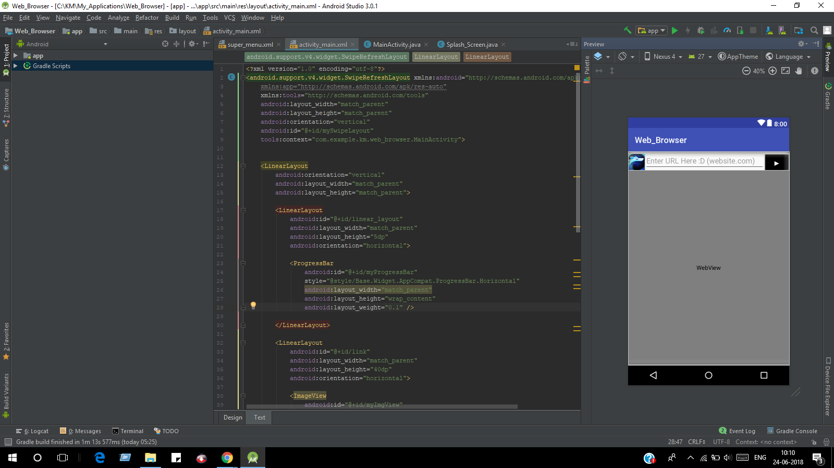

***activity_splash_screen.xml***

***<?xml version="1.0" encoding="utf-8"?>***

***<RelativeLayout xmlns:android="http://schemas.android.com/apk/res/android"***

***xmlns:app="http://schemas.android.com/apk/res-auto"***

***xmlns:tools="http://schemas.android.com/tools"***

***android:layout_width="match_parent"***

***android:layout_height="match_parent"***

***tools:context="com.example.km.web_browser.Splash_Screen">***

***<TextView***

***android:id="@+id/textView"***

***android:layout_width="wrap_content"***

***android:layout_height="wrap_content"***

***android:layout_alignParentTop="true"***

***android:layout_centerHorizontal="true"***

***android:layout_marginTop="160dp"***

***android:text="Welcome"***

***android:textAppearance="@style/TextAppearance.AppCompat.Display2"***

***android:textColor="#150a66" />***

***<ImageView***

***android:id="@+id/imageView"***

***android:layout_width="100dp"***

***android:layout_height="100dp"***

***android:layout_below="@+id/textView"***

***android:layout_centerHorizontal="true"***

***android:layout_marginTop="25dp"***

***android:adjustViewBounds="false"***

***android:contentDescription="browser_image"***

***android:cropToPadding="false"***

***android:src="@drawable/internet" />***

***<TextView***

***android:layout_width="match_parent"***

***android:layout_height="wrap_content"***

***android:layout_above="@+id/textView2"***

***android:layout_alignParentStart="true"***

***android:text="This is not a fucking VPN."***

***android:textAlignment="center"/>***

***<TextView***

***android:layout_width="match_parent"***

***android:layout_height="wrap_content"***

***android:layout_alignParentBottom="true"***

***android:layout_alignParentStart="true"***

***android:textAlignment="center"***

***android:text="Do not access Porn Sites or Dark Web."***

***android:id="@+id/textView2" />***

***</RelativeLayout>***

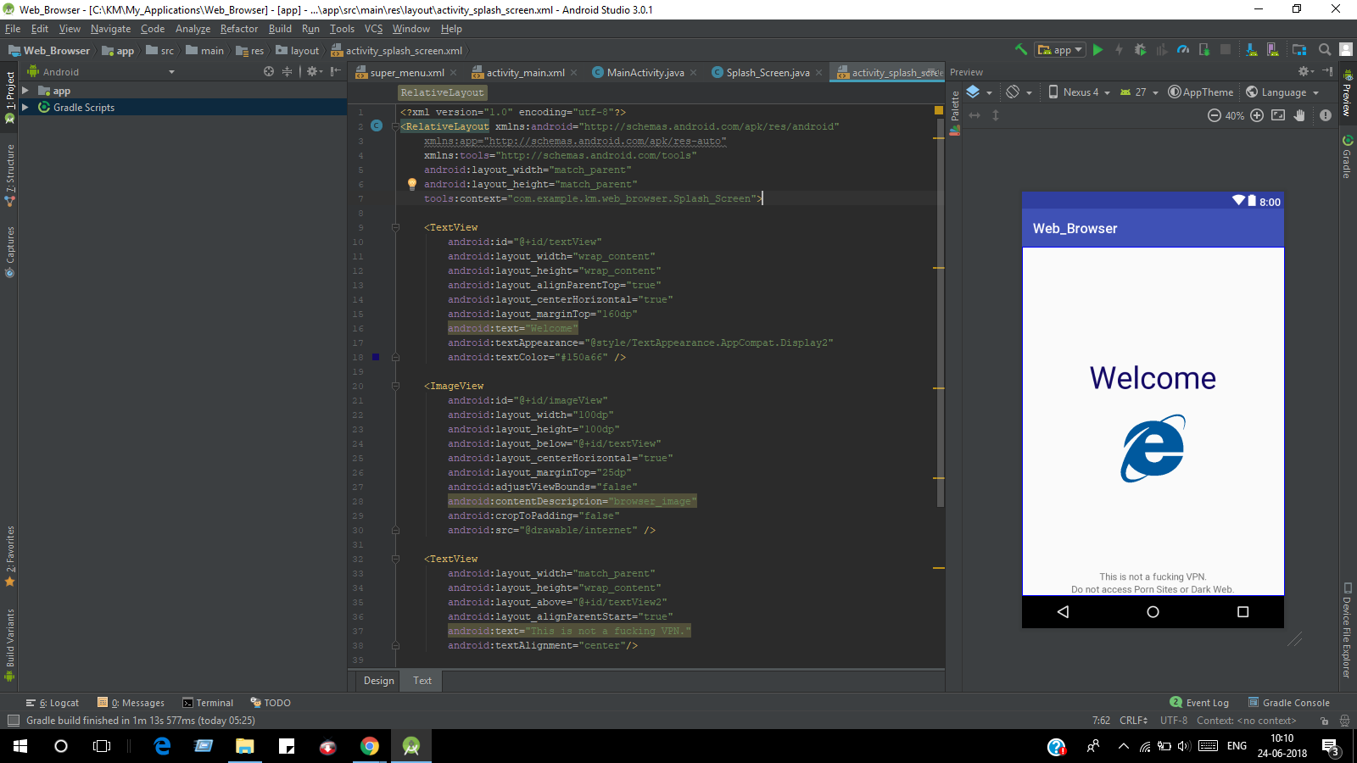

***AndroidManifest.xml***

***<?xml version="1.0" encoding="utf-8"?>***

***<manifest xmlns:android="http://schemas.android.com/apk/res/android"***

***package="com.example.km.web_browser">***

***<uses-permission android:name="android.permission.INTERNET" />***

***android:hardwareAccelerated="true"***

***<application***

***android:allowBackup="true"***

***android:icon="@mipmap/ic_launcher"***

***android:label="@string/app_name"***

***android:roundIcon="@mipmap/ic_launcher_round"***

***android:supportsRtl="true"***

***android:theme="@style/AppTheme">***

***<activity android:name=".Splash_Screen">***

***<intent-filter>***

***<action android:name="android.intent.action.MAIN" />***

***<category android:name="android.intent.category.LAUNCHER" />***

***</intent-filter>***

***</activity>***

***<activity android:name=".MainActivity"></activity>***

***</application>***

***</manifest>***

***super_menu.xml :***

***<?xml version="1.0" encoding="utf-8"?>***

***<menu xmlns:app="http://schemas.android.com/apk/res-auto"***

***xmlns:android="http://schemas.android.com/apk/res/android">***

***<item***

***android:id="@+id/home"***

***app:showAsAction="always"***

***android:icon="@drawable/ic_home_black_24dp"***

***android:title="Home" />***

***<item***

***android:id="@+id/menu_back"***

***app:showAsAction="always"***

***android:title="Back"***

***android:icon="@drawable/ic_keyboard_arrow_left_black_24dp"/>***

***<item***

***android:id="@+id/menu_forward"***

***app:showAsAction="always"***

***android:title="Forward"***

***android:icon="@drawable/ic_keyboard_arrow_right_black_24dp"/>***

***<item***

***android:id="@+id/menu_refresh"***

***android:icon="@drawable/ic_refresh_black_24dp"***

***android:title="Refresh" />***

***<item***

***android:id="@+id/clear_data"***

***android:icon="@drawable/ic_delete_forever_black_24dp"***

***android:title="Clear Browsing Data" />***

***<item***

***android:id="@+id/share"***

***android:icon="@drawable/ic_share_black_24dp"***

***android:title="Share Page" />***

***<item***

***android:id="@+id/exit"***

***android:icon="@drawable/ic_share_black_24dp"***

***android:title="Exit" />***

***</menu>***

