***MainActivity.java***

package com.example.km.basiccalculator;

import android.content.DialogInterface;

import android.content.Intent;

import android.support.v7.app.AlertDialog;

import android.support.v7.app.AppCompatActivity;

import android.os.Bundle;

import java.io.*;

import android.util.Log;

import android.view.View;

import android.view.inputmethod.InputMethodManager;

import android.widget.Button;

import android.widget.EditText;

import android.widget.TextView;

import android.widget.Toast;

import java.text.Format;

public class MainActivity extends AppCompatActivity {

TextView t1,t2,t3;

EditText e1,e2;

Button close_b,history_b;

@Override

protected void onCreate(Bundle savedInstanceState) {

super.onCreate(savedInstanceState);

setContentView(R.layout.*activity_main*);

e1 = (EditText)findViewById(R.id.*num1*);

e2 = (EditText)findViewById(R.id.*num2*);

t1 = (TextView)findViewById(R.id.*result*);

t2 = (TextView)findViewById(R.id.*emoji*);

t3 = (TextView)findViewById(R.id.*equation*);

history_b = (Button)findViewById(R.id.*history*);

close_b = (Button)findViewById(R.id.*close*);

onClickClose();

onButtonClickHistory();

}

public void onButtonClickAdd(View v) {

InputMethodManager inputManager = (InputMethodManager) getSystemService(this.*INPUT_METHOD_SERVICE*);

inputManager.hideSoftInputFromWindow(getCurrentFocus().getWindowToken(), InputMethodManager.*HIDE_NOT_ALWAYS*);

try{

if (e1 != null && e2 != null) {

double num1 = Double.*parseDouble*(e1.getText().toString());

double num2 = Double.*parseDouble*(e2.getText().toString());

double ans = num1 + num2;

t1.setText(Double.*toString*(ans));

t2.setText(":D");

t3.setText(num1 + " + " + num2);

}

else {

throw new IllegalArgumentException("");

}

}

catch(IllegalArgumentException e){

Toast.*makeText*(this,"Enter Values",Toast.*LENGTH_SHORT*).show();

t1.setText("Empty Input");

t2.setText("-_-");

}

}

public void onButtonClickSub(View v){

InputMethodManager inputManager = (InputMethodManager) getSystemService(this.*INPUT_METHOD_SERVICE*);

inputManager.hideSoftInputFromWindow(getCurrentFocus().getWindowToken(), InputMethodManager.*HIDE_NOT_ALWAYS*);

try {

if ((e1 != null && e2 != null)) {

double num1 = Double.*parseDouble*(e1.getText().toString());

double num2 = Double.*parseDouble*(e2.getText().toString());

double ans = num1 - num2;

t1.setText(Double.*toString*(ans));

t2.setText(":D");

t3.setText(num1 + " - " + num2);

}

else {

throw new IllegalArgumentException("");

}

}

catch(IllegalArgumentException e){

Toast.*makeText*(this,"Enter Values",Toast.*LENGTH_SHORT*).show();

t1.setText("Empty Input");

t2.setText("-_-");

}

}

public void onButtonClickMul(View v){

InputMethodManager inputManager = (InputMethodManager) getSystemService(this.*INPUT_METHOD_SERVICE*);

inputManager.hideSoftInputFromWindow(getCurrentFocus().getWindowToken(), InputMethodManager.*HIDE_NOT_ALWAYS*);

try {

if (e1 != null || e2 != null) {

double num1 = Double.*parseDouble*(e1.getText().toString());

double num2 = Double.*parseDouble*(e2.getText().toString());

double ans = num1 * num2;

t1.setText(Double.*toString*(ans));

t2.setText(":D");

t3.setText(num1 + " * " + num2);

} else {

throw new IllegalArgumentException("");

}

}

catch(IllegalArgumentException e){

Toast.*makeText*(this,"Enter Values",Toast.*LENGTH_SHORT*).show();

t1.setText("Empty Input");

t2.setText("-_-");

}

}

public void onButtonClickDiv(View v){

InputMethodManager inputManager = (InputMethodManager) getSystemService(this.*INPUT_METHOD_SERVICE*);

inputManager.hideSoftInputFromWindow(getCurrentFocus().getWindowToken(), InputMethodManager.*HIDE_NOT_ALWAYS*);

try {

if (e1 != null || e2 != null) {

double num1 = Double.*parseDouble*(e1.getText().toString());

double num2 = Double.*parseDouble*(e2.getText().toString());

double ans = 0;

try {

if (num2 == 0)

throw new ArithmeticException();

else {

ans = num1 / num2;

t1.setText(String.*format*("%.5f", ans));

t2.setText(":D");

t3.setText(num1 + " / " + num2);

}

} catch (ArithmeticException e) {

t1.setText("DivideByZero");

t2.setText("-_-");

t3.setText("Arithmetic Error");

}

}

else {

throw new IllegalArgumentException("");

}

}

catch(IllegalArgumentException e){

Toast.*makeText*(this,"Enter Values",Toast.*LENGTH_SHORT*).show();

t1.setText("Empty Input");

t2.setText("-_-");

}

}

public void onButtonClickClear(View v){

e1.setText("");

e2.setText("");

e2.clearFocus();

t1.setText("0000");

t2.setText(":D");

t3.setText("");

}

public void onClickClose(){

close_b.setOnClickListener(

new View.OnClickListener(){

@Override

public void onClick(View v){

AlertDialog.Builder a_builder = new AlertDialog.Builder(MainActivity.this);

a_builder.setMessage("Do you really want to exit?")

.setCancelable(false)

.setPositiveButton("Yes", new DialogInterface.OnClickListener() {

@Override

public void onClick(DialogInterface dialogInterface, int i) {

AppExit();

}

})

.setNegativeButton("No", new DialogInterface.OnClickListener() {

@Override

public void onClick(DialogInterface dialogInterface, int i) {

dialogInterface.cancel();

}

});

AlertDialog alert = a_builder.create();

alert.setTitle("Alert !!");

alert.show();

}

}

);

}

public void onButtonClickHistory(){

history_b.setOnClickListener(

new View.OnClickListener(){

@Override

public void onClick(View v){

Intent intent = new Intent("com.example.km.basiccalculator.HistoryActivity");

startActivity(intent);

}

}

);

}

public void AppExit()

{

this.finish();

Intent intent = new Intent(Intent.*ACTION_MAIN*);

intent.addCategory(Intent.*CATEGORY_HOME*);

intent.setFlags(Intent.*FLAG_ACTIVITY_NEW_TASK*);

startActivity(intent);

}

}

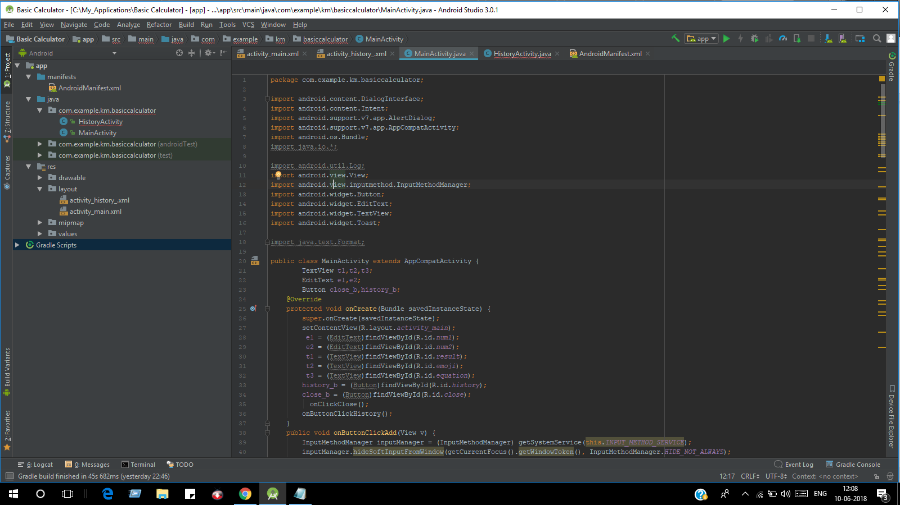

***HistoryActivity.java***

***package com.example.km.basiccalculator;***

***import android.content.DialogInterface;***

***import android.content.Intent;***

***import android.support.v7.app.AlertDialog;***

***import android.support.v7.app.AppCompatActivity;***

***import android.os.Bundle;***

***import android.view.View;***

***import android.widget.Button;***

***public class HistoryActivity extends AppCompatActivity {***

***Button close_b,back_b;***

***@Override***

***protected void onCreate(Bundle savedInstanceStatzze) {***

***super.onCreate(savedInstanceState);***

***setContentView(R.layout.activity_history_);***

***close_b = (Button)findViewById(R.id.close);***

***back_b = (Button)findViewById(R.id.back);***

***onClickClose();***

***onClickBack();***

***}***

***public void AppExit()***

***{***

***this.finish();***

***Intent intent = new Intent(Intent.ACTION_MAIN);***

***intent.addCategory(Intent.CATEGORY_HOME);***

***intent.setFlags(Intent.FLAG_ACTIVITY_NEW_TASK);***

***startActivity(intent);***

***}***

***public void onClickClose(){***

***close_b.setOnClickListener(***

***new View.OnClickListener(){***

***@Override***

***public void onClick(View v){***

***AlertDialog.Builder a_builder = new AlertDialog.Builder(HistoryActivity.this);***

***a_builder.setMessage("Do you really want to exit?")***

***.setCancelable(false)***

***.setPositiveButton("Yes", new DialogInterface.OnClickListener() {***

***@Override***

***public void onClick(DialogInterface dialogInterface, int i) {***

***AppExit();***

***}***

***})***

***.setNegativeButton("No", new DialogInterface.OnClickListener() {***

***@Override***

***public void onClick(DialogInterface dialogInterface, int i) {***

***dialogInterface.cancel();***

***}***

***});***

***AlertDialog alert = a_builder.create();***

***alert.setTitle("Alert !!");***

***alert.show();***

***}***

***}***

***);***

***}***

***@Override***

***public void onBackPressed()***

***{***

***super.onBackPressed();***

***}***

***public void onClickBack(){***

***back_b.setOnClickListener(***

***new View.OnClickListener(){***

***@Override***

***public void onClick(View v){***

***onBackPressed();***

***}***

***}***

***);***

***}***

***}***

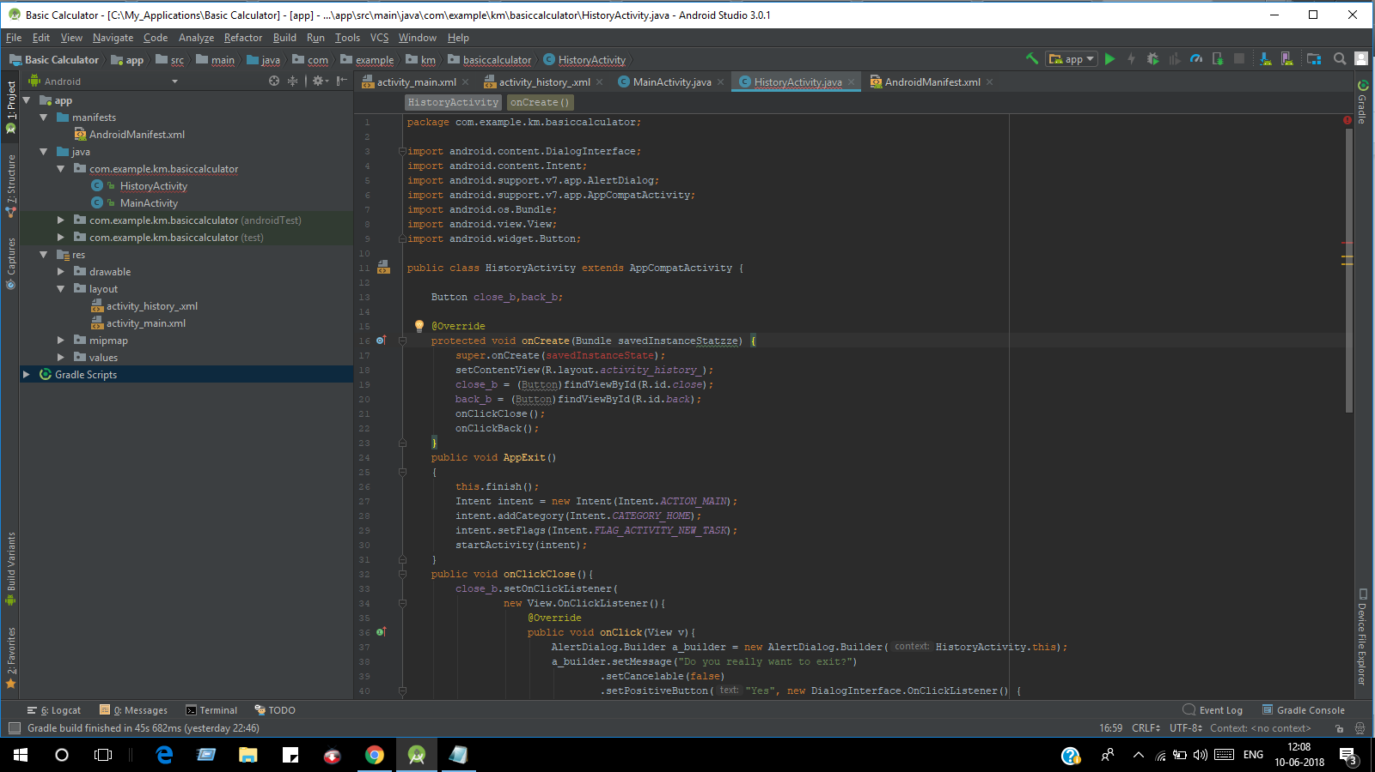

***activity_main.xml***

***<?xml version="1.0" encoding="utf-8"?>***

***<RelativeLayout xmlns:android="http://schemas.android.com/apk/res/android"***

***xmlns:app="http://schemas.android.com/apk/res-auto"***

***xmlns:tools="http://schemas.android.com/tools"***

***android:layout_width="match_parent"***

***android:layout_height="match_parent"***

***tools:context="com.example.km.basiccalculator.MainActivity">***

***<TextView***

***android:id="@+id/enter"***

***android:layout_width="314dp"***

***android:layout_height="43dp"***

***android:layout_below="@+id/close"***

***android:layout_centerHorizontal="true"***

***android:textStyle="italic|bold"***

***android:fontFamily="cursive"***

***android:includeFontPadding="true"***

***android:layout_marginTop="11dp"***

***android:gravity="center"***

***android:text=" Enter Two Numbers:"***

***android:textAlignment="textStart"***

***android:textColor="#560202"***

***android:textSize="32dp"***

***tools:layout_editor_absoluteX="16dp"***

***tools:layout_editor_absoluteY="28dp" />***

***<EditText***

***android:id="@+id/num1"***

***android:layout_width="110dp"***

***android:layout_height="wrap_content"***

***android:layout_below="@+id/enter"***

***android:layout_marginStart="20dp"***

***android:layout_marginTop="18dp"***

***android:layout_toEndOf="@+id/textView11"***

***android:hint="Number 1"***

***android:inputType="number|numberDecimal" />***

***<EditText***

***android:id="@+id/num2"***

***android:layout_width="110dp"***

***android:layout_height="wrap_content"***

***android:layout_alignBaseline="@+id/num1"***

***android:layout_alignBottom="@+id/num1"***

***android:layout_toEndOf="@+id/num1"***

***android:hint="Number 2"***

***android:inputType="number|numberDecimal" />***

***<Button***

***android:id="@+id/add"***

***android:layout_width="wrap_content"***

***android:layout_height="wrap_content"***

***android:layout_above="@+id/mul"***

***android:layout_alignStart="@+id/mul"***

***android:onClick="onButtonClickAdd"***

***android:text="Add" />***

***<Button***

***android:id="@+id/sub"***

***android:layout_width="wrap_content"***

***android:layout_height="wrap_content"***

***android:layout_below="@+id/clear"***

***android:layout_toEndOf="@+id/mul"***

***android:onClick="onButtonClickSub"***

***android:text="Subtract" />***

***<Button***

***android:id="@+id/history"***

***style="@style/Widget.AppCompat.Button.Borderless"***

***android:layout_width="wrap_content"***

***android:layout_height="wrap_content"***

***android:layout_above="@+id/editText8"***

***android:layout_alignParentStart="true"***

***android:onClick="onButtonClickHistory"***

***android:text="History" />***

***<Button***

***android:id="@+id/mul"***

***android:layout_width="wrap_content"***

***android:layout_height="wrap_content"***

***android:layout_alignBaseline="@+id/div"***

***android:layout_alignBottom="@+id/div"***

***android:layout_toStartOf="@+id/num2"***

***android:onClick="onButtonClickMul"***

***android:text="Multiply" />***

***<Button***

***android:id="@+id/div"***

***android:layout_width="wrap_content"***

***android:layout_height="wrap_content"***

***android:layout_alignEnd="@+id/sub"***

***android:layout_below="@+id/sub"***

***android:layout_toEndOf="@+id/mul"***

***android:onClick="onButtonClickDiv"***

***android:text="Divide" />***

***<TextView***

***android:id="@+id/ans"***

***android:layout_width="wrap_content"***

***android:layout_height="wrap_content"***

***android:layout_above="@+id/result"***

***android:layout_toEndOf="@+id/textView11"***

***android:ems="10"***

***android:gravity="center"***

***android:inputType="textPersonName"***

***android:text="Result : "***

***android:textAlignment="textStart"***

***android:textColor="#ab1313"***

***android:textSize="30dp" />***

***<TextView***

***android:id="@+id/result"***

***android:layout_width="225dp"***

***android:layout_height="wrap_content"***

***android:layout_above="@+id/history"***

***android:layout_marginBottom="19dp"***

***android:layout_toEndOf="@+id/textView11"***

***android:text="0000"***

***android:textAppearance="@style/TextAppearance.AppCompat.Display1"***

***android:textColor="#1f1889" />***

***<TextView***

***android:id="@+id/emoji"***

***android:layout_width="wrap_content"***

***android:layout_height="wrap_content"***

***android:layout_alignStart="@+id/close"***

***android:layout_below="@+id/ans"***

***android:text=":D"***

***android:textAlignment="textStart"***

***android:textColor="#560202"***

***android:textSize="56dp" />***

***<TextView***

***android:id="@+id/editText8"***

***android:layout_width="wrap_content"***

***android:layout_height="wrap_content"***

***android:layout_alignParentBottom="true"***

***android:layout_alignParentEnd="true"***

***android:layout_alignParentStart="true"***

***android:background="#000000"***

***android:ems="10"***

***android:inputType="textPersonName"***

***android:textColor="#000000" />***

***<TextView***

***android:id="@+id/textView10"***

***android:layout_width="match_parent"***

***android:layout_height="wrap_content"***

***android:layout_alignParentStart="true"***

***android:background="#000000"***

***android:layout_alignParentTop="true"***

***android:text="TextView" />***

***<TextView***

***android:id="@+id/textView11"***

***android:layout_width="wrap_content"***

***android:layout_height="match_parent"***

***android:background="#000000"***

***android:layout_below="@+id/textView10"***

***android:layout_marginEnd="16dp"***

***android:layout_toStartOf="@+id/enter"***

***android:text="TextView" />***

***<TextView***

***android:id="@+id/textView12"***

***android:layout_width="wrap_content"***

***android:layout_height="match_parent"***

***android:background="#000000"***

***android:layout_below="@+id/textView10"***

***android:layout_marginStart="15dp"***

***android:layout_toEndOf="@+id/enter"***

***android:text="TextView" />***

***<Button***

***android:id="@+id/clear"***

***style="@android:style/Widget.DeviceDefault.Button.Borderless.Small"***

***android:layout_width="wrap_content"***

***android:layout_height="wrap_content"***

***android:layout_alignEnd="@+id/emoji"***

***android:layout_alignTop="@+id/num2"***

***android:layout_marginTop="30dp"***

***android:onClick="onButtonClickClear"***

***android:text="CLEAR" />***

***<TextView***

***android:id="@+id/equation"***

***android:layout_width="187dp"***

***android:layout_height="37.2dp"***

***android:layout_alignTop="@+id/ans"***

***android:layout_marginEnd="14dp"***

***android:layout_toStartOf="@+id/textView12"***

***android:gravity="bottom"***

***android:text=""***

***android:textAlignment="gravity"***

***android:textAppearance="@style/TextAppearance.AppCompat.Display2"***

***android:textSize="16dp" />***

***<Button***

***android:id="@+id/close"***

***style="@android:style/Widget.DeviceDefault.Button.Borderless.Small"***

***android:layout_width="wrap_content"***

***android:layout_height="wrap_content"***

***android:layout_alignParentEnd="true"***

***android:layout_below="@+id/textView10"***

***android:layout_marginEnd="13dp"***

***android:onClick="onClickClose"***

***android:text="❌"***

***android:textSize="30dp" />***

***</RelativeLayout>***

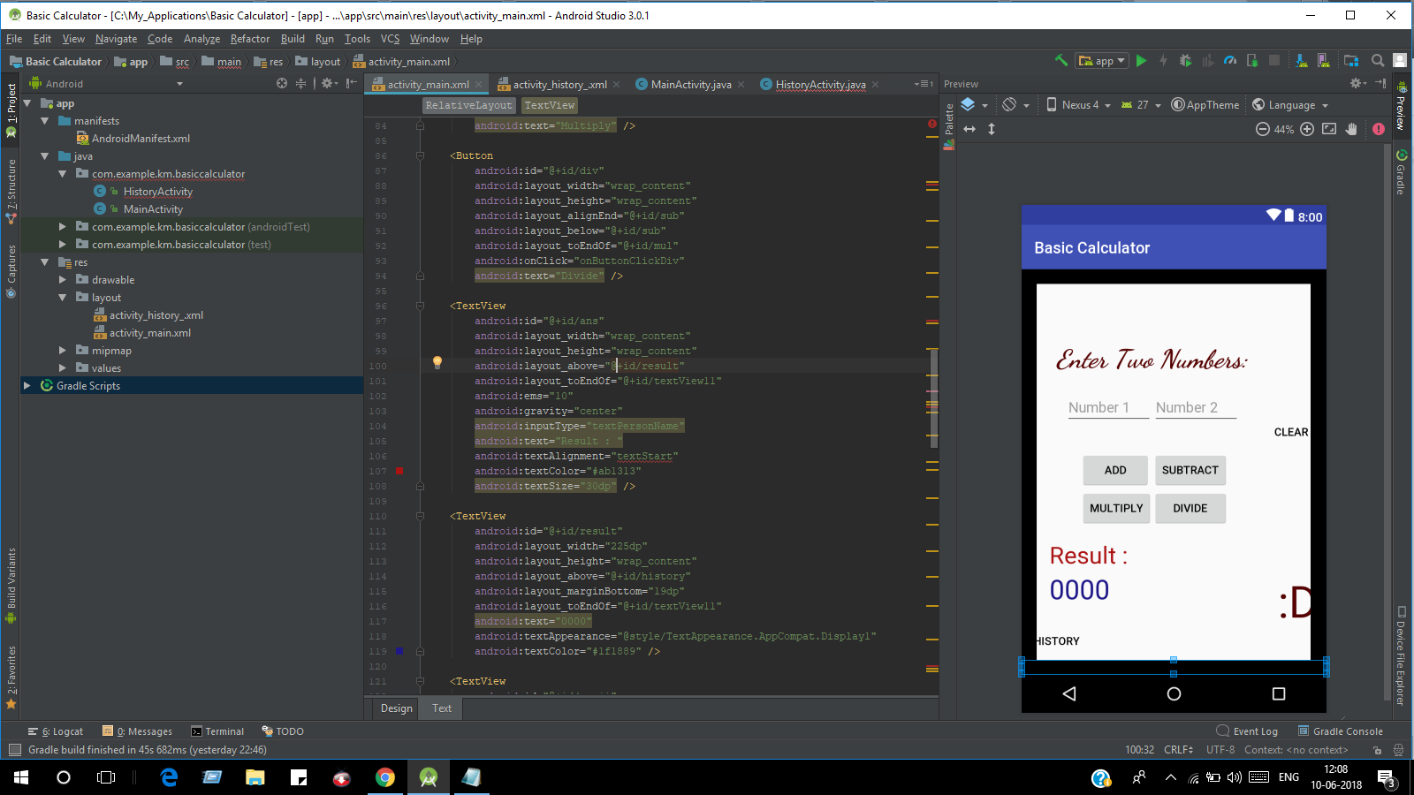

***activity_history.xml***

***<?xml version="1.0" encoding="utf-8"?>***

***<RelativeLayout xmlns:android="http://schemas.android.com/apk/res/android"***

***xmlns:app="http://schemas.android.com/apk/res-auto"***

***xmlns:tools="http://schemas.android.com/tools"***

***android:layout_width="match_parent"***

***android:layout_height="match_parent"***

***tools:context="com.example.km.basiccalculator.HistoryActivity">***

***<TextView***

***android:id="@+id/editText8"***

***android:layout_width="wrap_content"***

***android:layout_height="18dp"***

***android:layout_alignParentBottom="true"***

***android:layout_alignParentEnd="true"***

***android:layout_alignParentStart="true"***

***android:background="#000000"***

***android:ems="10"***

***android:inputType="textPersonName"***

***android:textColor="#000000" />***

***<TextView***

***android:id="@+id/textView10"***

***android:layout_width="match_parent"***

***android:layout_height="18dp"***

***android:layout_alignParentStart="true"***

***android:background="#000000"***

***android:layout_alignParentTop="true"***

***android:text="TextView" />***

***<TextView***

***android:id="@+id/textView11"***

***android:layout_width="9dp"***

***android:layout_height="match_parent"***

***android:background="#000000"***

***android:layout_below="@+id/textView10"***

***android:layout_marginEnd="16dp"***

***android:layout_toStartOf="@+id/enter"***

***android:text="TextView" />***

***<TextView***

***android:id="@+id/textView12"***

***android:layout_width="9dp"***

***android:layout_height="match_parent"***

***android:layout_alignParentEnd="true"***

***android:layout_centerVertical="true"***

***android:background="#000000"***

***android:text="TextView" />***

***<Button***

***android:id="@+id/close"***

***style="@android:style/Widget.DeviceDefault.Button.Borderless.Small"***

***android:layout_width="60dp"***

***android:layout_height="60dp"***

***android:layout_below="@+id/textView10"***

***android:layout_marginEnd="11dp"***

***android:layout_toStartOf="@+id/textView12"***

***android:text="❌"***

***android:textSize="30dp" />***

***<TextView***

***android:id="@+id/textView"***

***android:layout_width="300dp"***

***android:layout_height="wrap_content"***

***android:layout_below="@+id/close"***

***android:textStyle="italic"***

***android:layout_centerHorizontal="true"***

***android:layout_marginTop="119dp"***

***android:text="History Log Feature Coming Soon!! 📖 "***

***android:textColor="#000000"***

***android:textSize="30dp" />***

***<Button***

***android:id="@+id/back"***

***style="@android:style/Widget.DeviceDefault.Button.Borderless.Small"***

***android:layout_width="70dp"***

***android:layout_height="70dp"***

***android:layout_alignBaseline="@+id/close"***

***android:layout_alignBottom="@+id/close"***

***android:layout_alignParentStart="true"***

***android:layout_marginStart="13dp"***

***android:onClick="onClickBack"***

***android:text="🔙"***

***android:textSize="35dp" />***

***</RelativeLayout>***

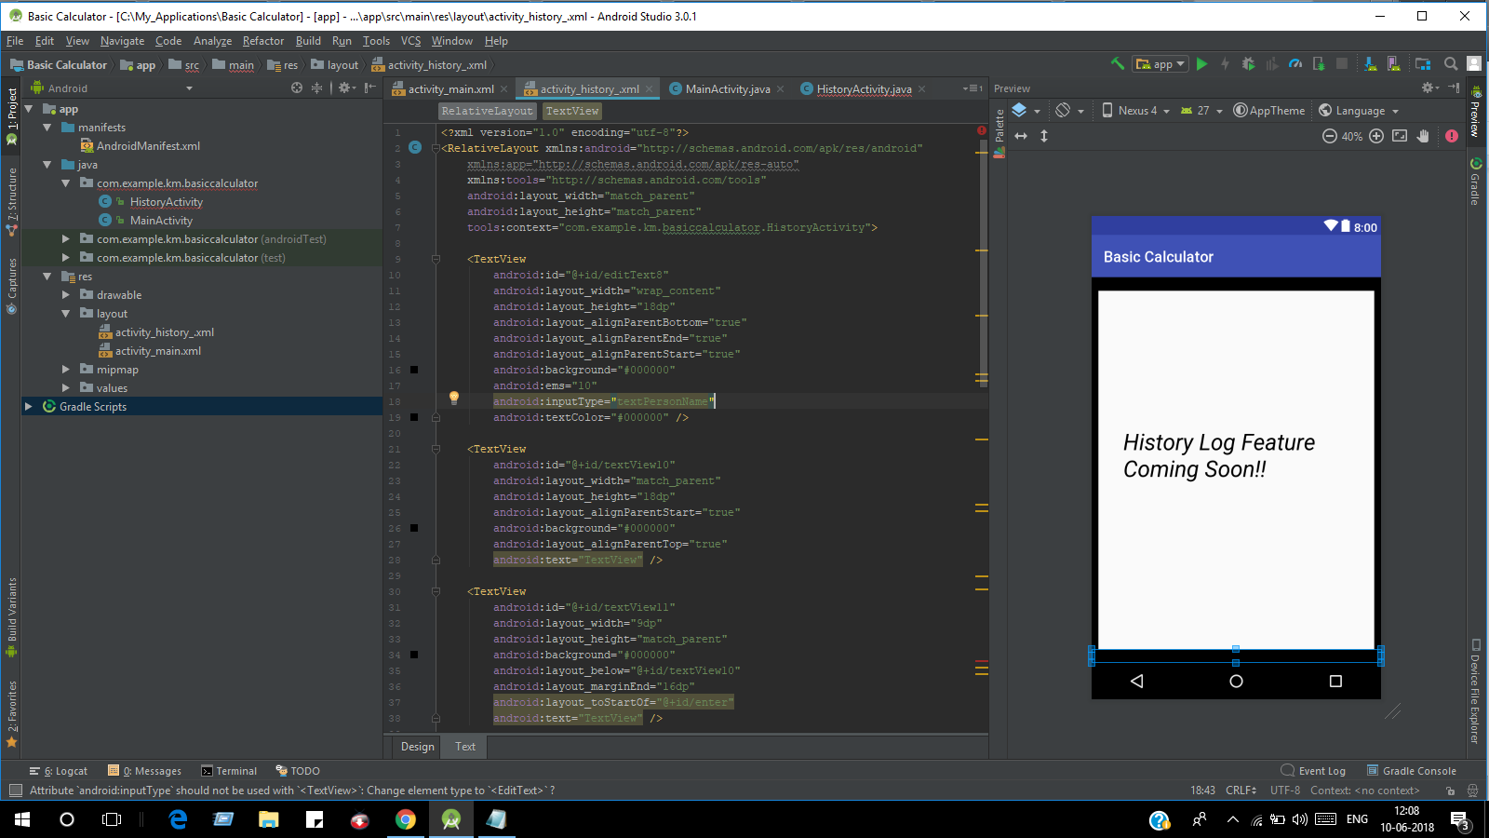

***AndroidManifest.xml***

***<?xml version="1.0" encoding="utf-8"?>***

***<manifest xmlns:android="http://schemas.android.com/apk/res/android"***

***package="com.example.km.basiccalculator">***

***<application***

***android:allowBackup="true"***

***android:icon="@drawable/calc"***

***android:label="@string/app_name"***

***android:roundIcon="@mipmap/ic_launcher_round"***

***android:supportsRtl="true"***

***android:theme="@style/AppTheme">***

***<activity android:name=".MainActivity">***

***<intent-filter>***

***<action android:name="android.intent.action.MAIN" />***

***<category android:name="android.intent.category.LAUNCHER" />***

***</intent-filter>***

***</activity>***

***<activity***

***android:name=".HistoryActivity">***

***<intent-filter>***

***<action android:name="com.example.km.basiccalculator.HistoryActivity" />***

***<category android:name="android.intent.category.DEFAULT" />***

***</intent-filter>***

***</activity>***

***</application>***

***</manifest>***

