CS303 : Operating Systems Lab
Lab 1
Prashant Mittal
2020CSB1113

Question 1

- pwd : Prints the path from the root to the working directory.
  - Options provided with the pwd command are :
    - pwd -L : Prints the symbolic path.
    - pwd -P : Prints the actual path.
  - In windows we can do the same using following commands :
    - SET var=%cd%
    - ECHO %var%

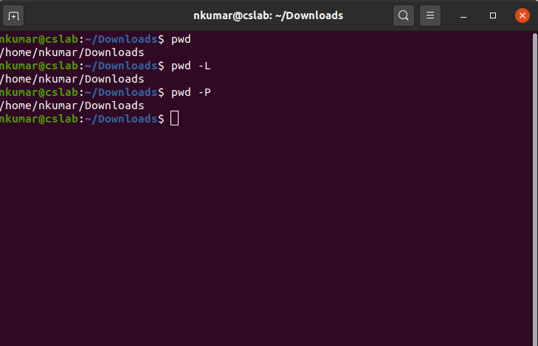

- cd : Used to change the current working directory.
  - Options provided with the cd command are :
    - cd / : Changes the current directory to the root directory.
    - cd ~ : Changes the current directory to the home directory.
    - cd .. : Changes the current directory to the parent directory.
  - In windows we can do the same using following commands :
    - cd
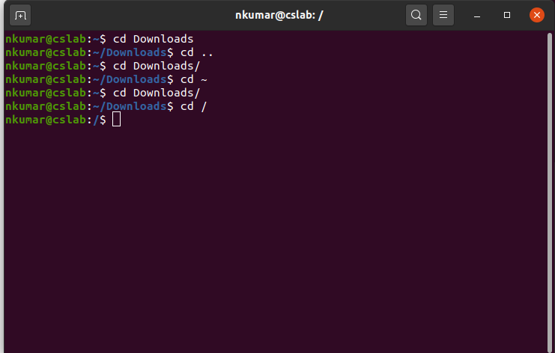

- ls : Lists all the files and directories inside the current directory.
  - Options provided with the ls command are :
    - ls -t : Shows the last edited file.
    - ls -1 : Displays one file per line.
    - ls -l : Shows long listing information about files.
  - In windows we can do the same using following commands :
    - dir

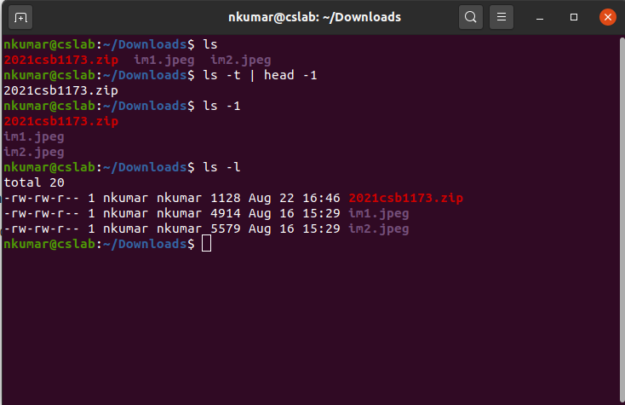

- mkdir : Makes a directory inside the current directory.
  - Options provided with the mkdir command are :
    - mkdir --version : Displays the version number of the licence.
    - mkdir --help : Displays the help related information for mkdir command.
    - mkdir -v [directories] : Displays a message for every directory created.
  - In windows we can do the same using following commands :
    - md

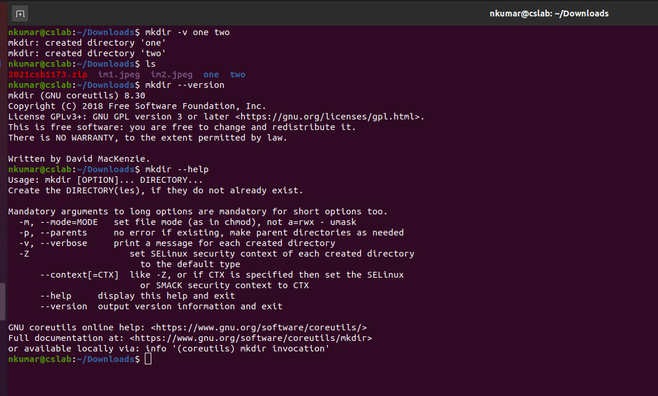

- rm : Used to remove objects such as files and directories.
  - Options provided with the rm command are :
    - rm -i : Asks the user for confirmation before removing the file.
    - rm -f : Overrides any protection on file while removing.
    - rm –version : Displays the version of the rm command.
  - In windows we can do the same using following commands :
    - rmdir

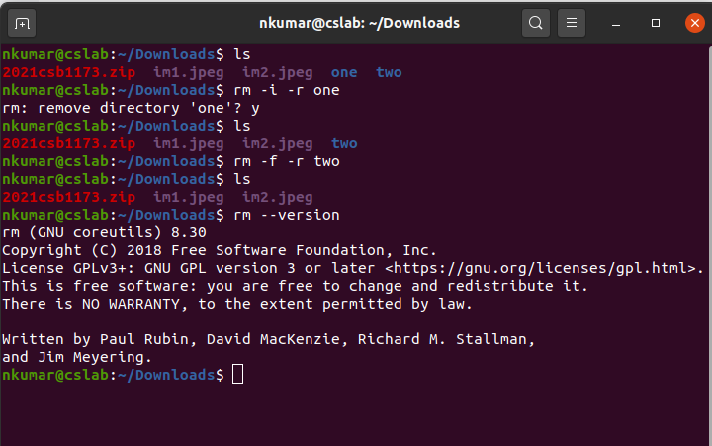

- chmod : Used to change the access mode of a file.
  - Options provided with the chmod command are :
    - u : owner.
    - g : group.
    - a : all.
  - In windows we can do the same using following commands :
    - icacls

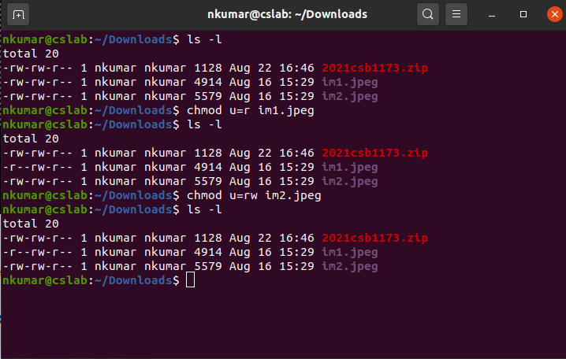

- find : Used to find files and directories and perform operations.
  - Options provided with the find command are :
    - -name “demo” : search for files named “demo”.
    - -print : prints the path name of the files found by rest of the criteria.
    - -empty : Search for empty files and directories.
  - In windows we can do the same using following commands :
    - find

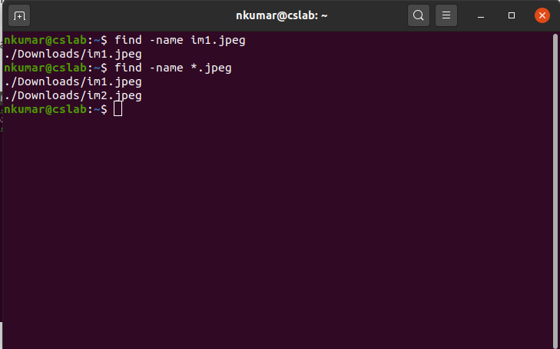

- tail : Print the last N number of data of the given input.
  - Options provided with the tail command are :
    - -n num: Prints the last ‘num’ lines.
    - -c num: Prints the last ‘num’ bytes from the file specified.
    - -v: Using this option, data from the specified file is always preceded by its file name.
  - In windows we can do the same using following commands :
    - Get -Content -Tail

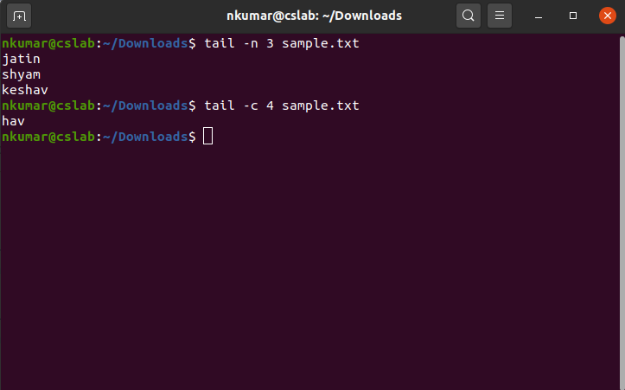

- top : Used to show the Linux processes
  - Options provided with the top command are :
    - -n num : Exit Top Command After Specific repetition
    - -h : Highlight Running Process in Top
    - -c : starts top with last closed state.
  - In windows we can do the same using following commands :
    - While(1) {ps | sort -des cpu | select -f 15 | ft -a; sleep 1; cls}

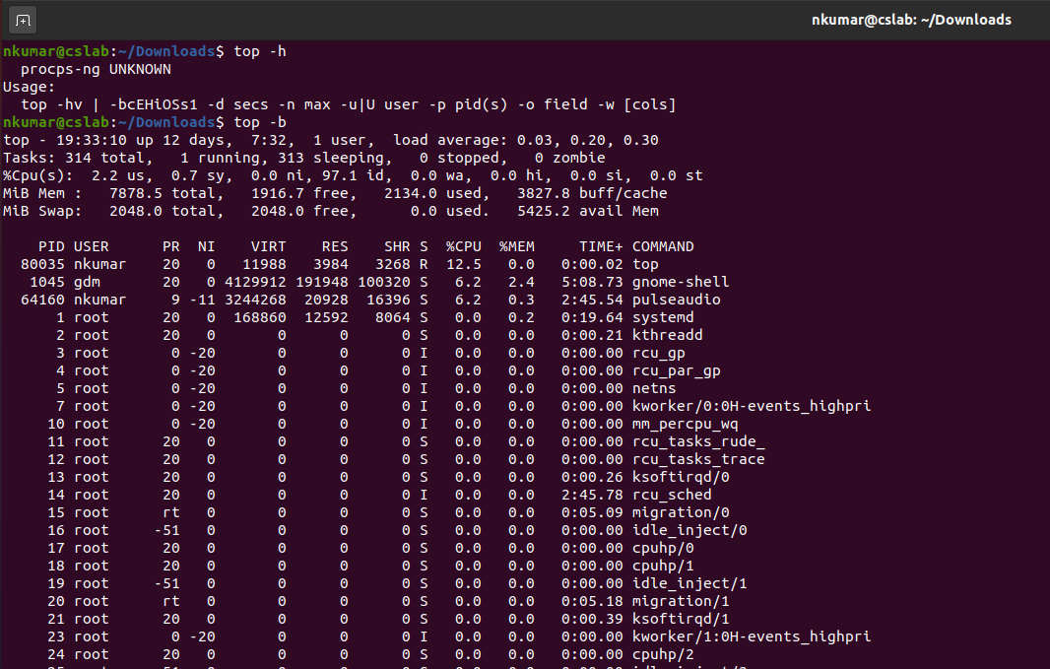

- wc : Used to find out number of lines, word count, byte and characters count in the files specified in the file arguments.
  - Options provided with the wc command are :
    - -l : Prints the number of lines present in a file.
    - -w : Prints the number of words present in a file.
    - -c : Prints count of bytes present in a file.
  - In windows we can do the same using following commands :
    - type *.txt | Measure-Object -line

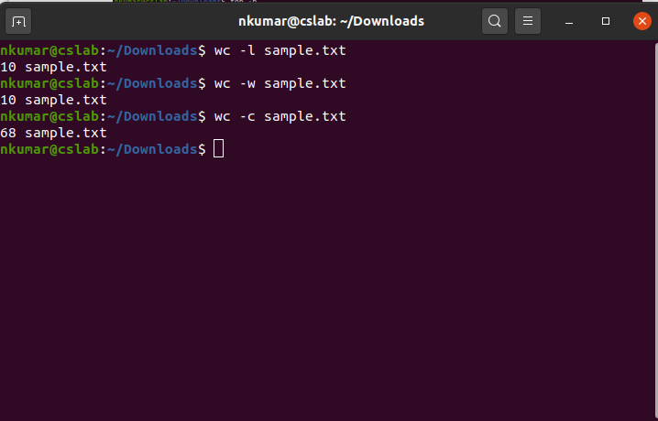

- diff : Used to display the differences in the files by comparing the files line by line.
  - Options provided with the diff command are :
    - -c : To view differences in context mode.
    - -u : To view differences in unified mode.
    - -i : To make diff command case insensitive.
  - In windows we can do the same using following commands :
    - FC
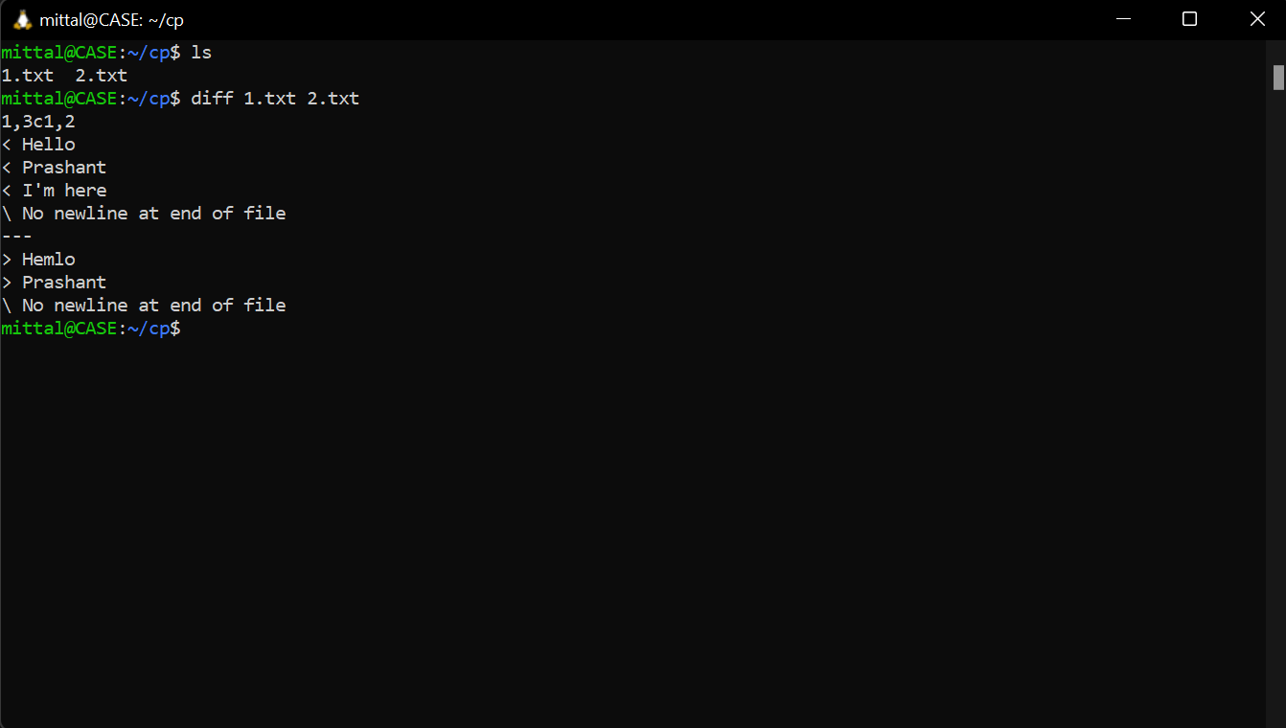

- kill : Used to terminate processes manually.
  - Options provided with the kill command are :
    - -l :To display all the available signals you can use the below command option.
    - pid : To show how to use a PID with the kill command.
    - -s : To show how to send signals to processes.
  - In windows we can do the same using following commands :
    - taskkill

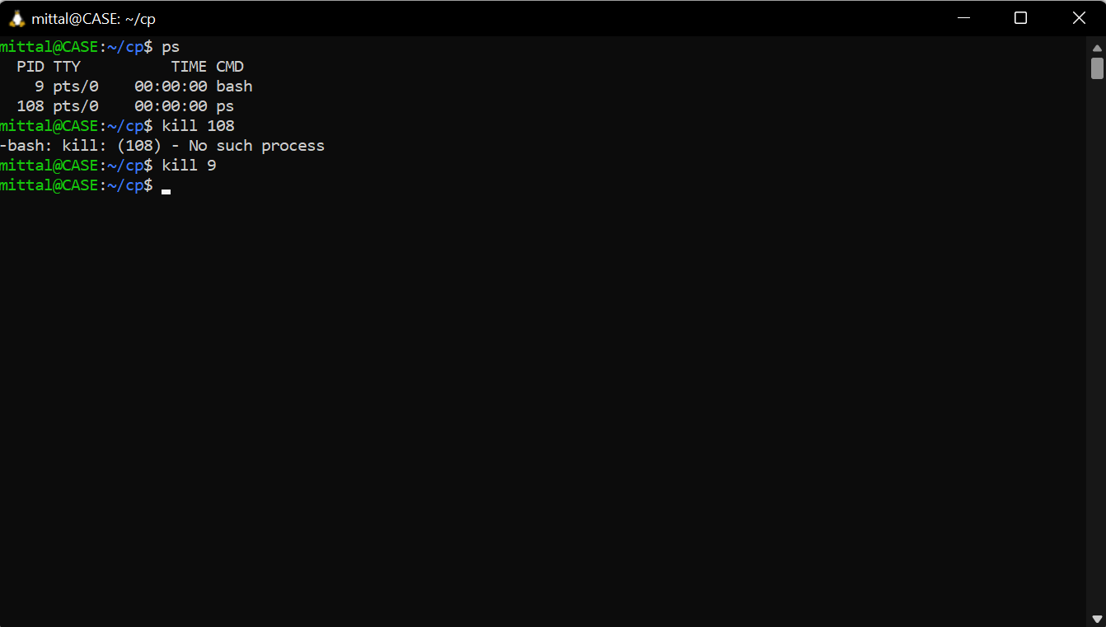

- which : Used to locate the executable file associated with the given command.
  - Options provided with the which command are :
    - which -a : Prints all matching pathnames of each argument.
    - info which : Displays help information when used with which as “info which”.
  - In windows we can do the same using following commands :
    - where

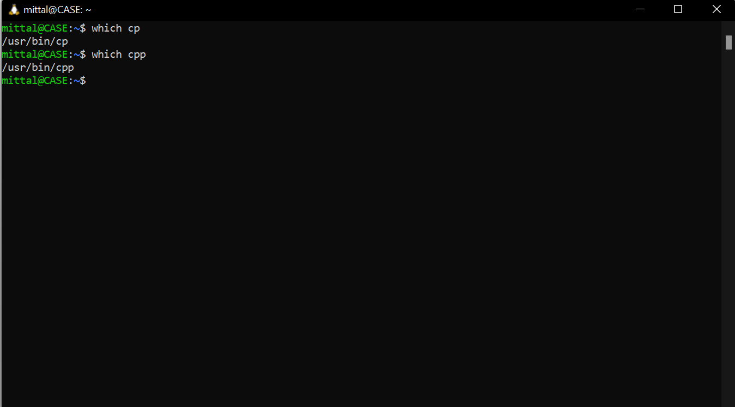

- cat : Reads data from the file and gives their content as output.
  - Options provided with the cat command are :
    - cat filename : shows content of given filename.
    - cat -n filename : shows content with line number
    - cat > newfile : creates a file named newfile
  - In windows we can do the same using following commands :
    - type

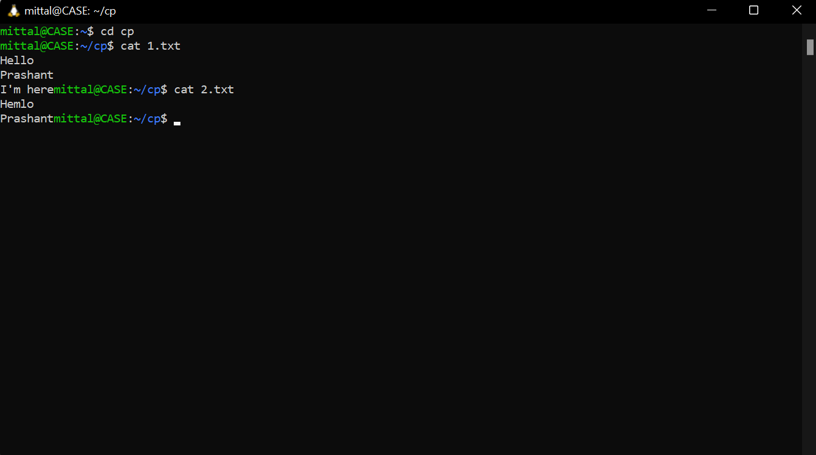

- mv : Used to move one or more files or directories from one place to another.
  - Options provided with the mv command are :
    - -i : asks the user for confirmation before moving a file.
    - -f : overwrites the destination file, forcefully overriding protection.
    - --version : used to display the version of mv.
  - In windows we can do the same using following commands :
    - mv

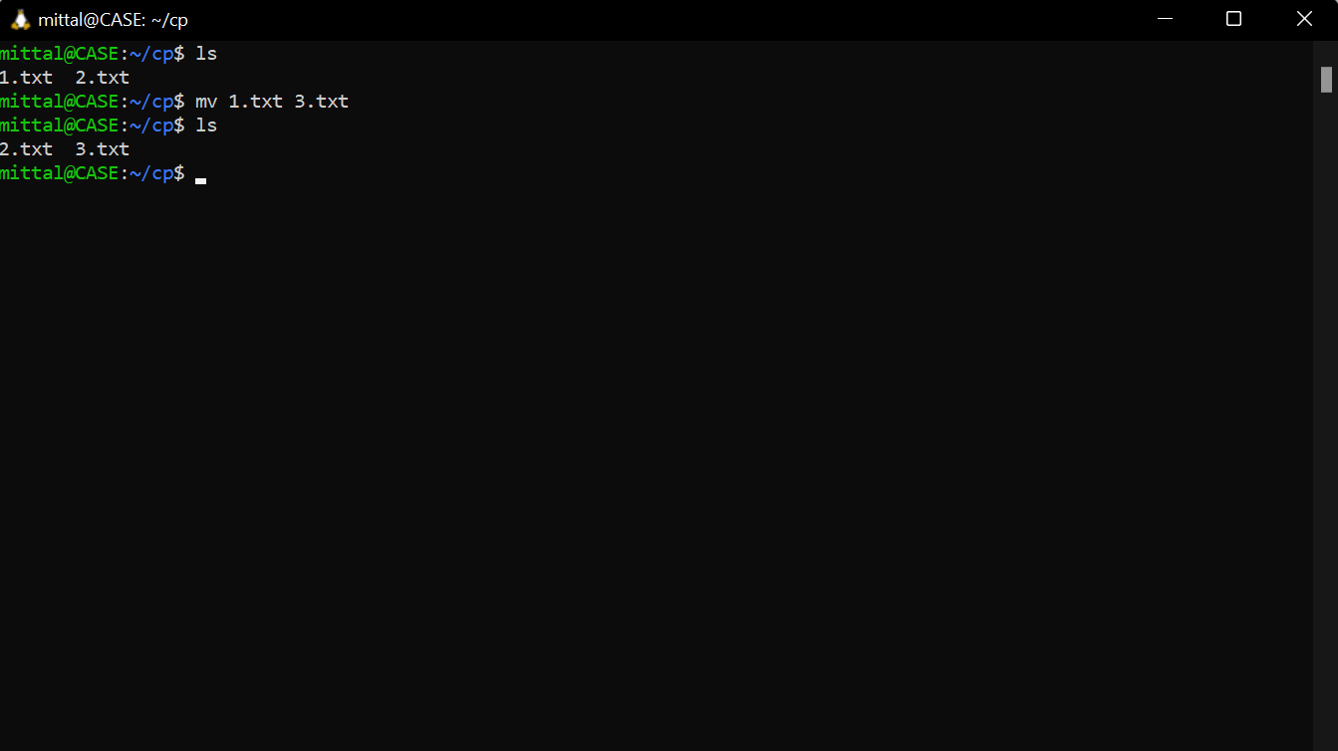

- grep : Searches a file for a particular pattern of characters, and displays all lines that contain that pattern.
  - Options provided with the grep command are :
    - -i : To make grep command case insensitive.
    - -c : To count the number of lines that match the pattern.
    - -l : To display the files which contain the given pattern
  - In windows we can do the same using following commands :
    - findstr

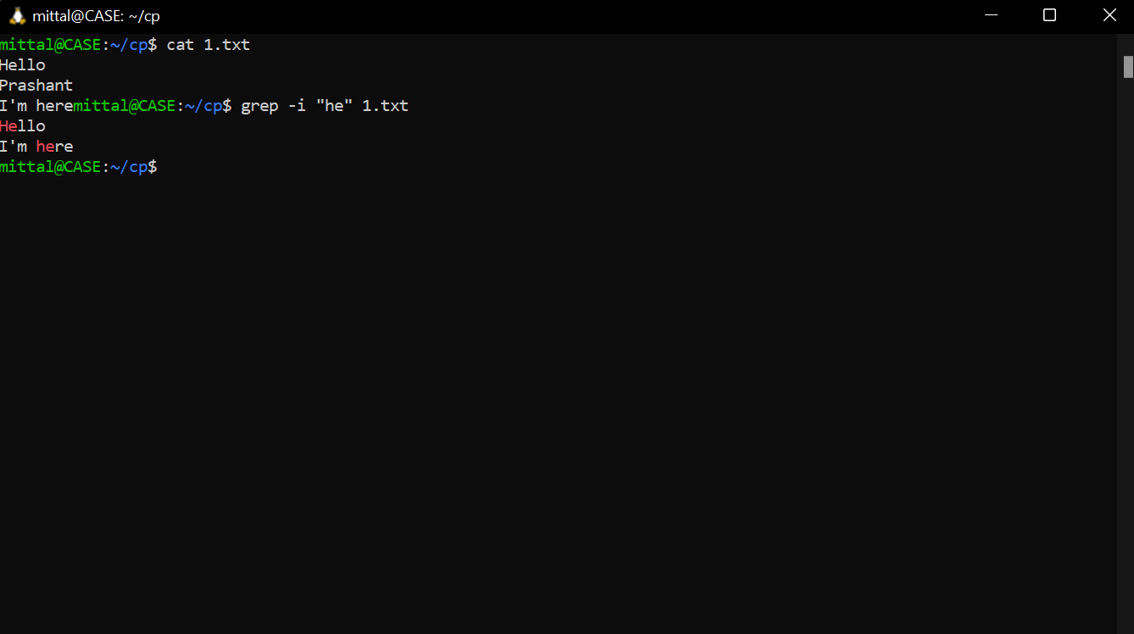

- cut : Used to cut out the sections from each line of files and write the result to standard output.
  - Options provided with the cut command are :
    - -b: used to extract the specific bytes.
    - -c : used to print specific position characters from a file.
    - --version : used to display the version of cut.
  - In windows we can do the same using following commands :
    - for /f

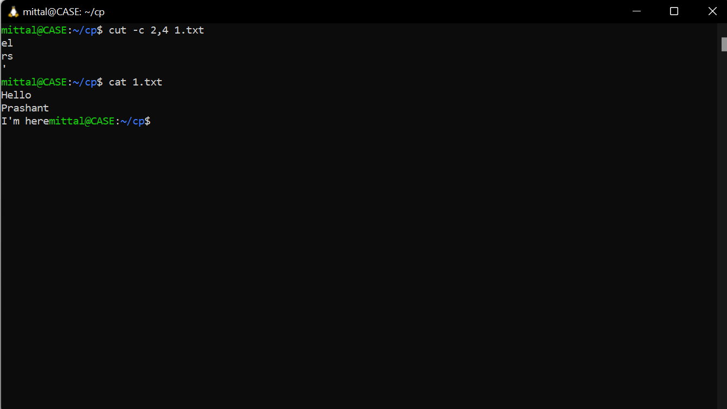

- history : Used to view all the previous executed commands..
  - Options provided with the history command are :
    - history | grep txt : used to view only commands containing a string txt.
    - history > sample.txt : sample.txt will be created and command history will be saved in it.
  - In windows we can do the same using following commands :
    - doskey /history

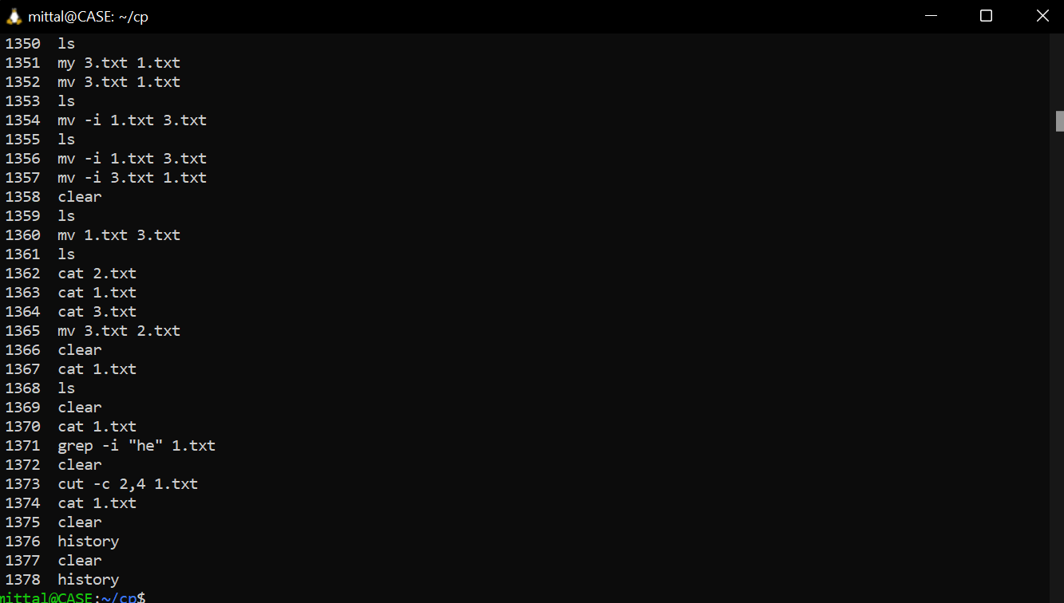

- echo : Used to display lines of text/string that are passed as an argument.
  - Options provided with the echo command are :
    - \b : Used to remove all the spaces in between the text.
    - \n : Used to create a new line from where it is used.
    - \t : Used to create horizontal tab spaces in text.
  - In windows we can do the same using following commands :
    - echo

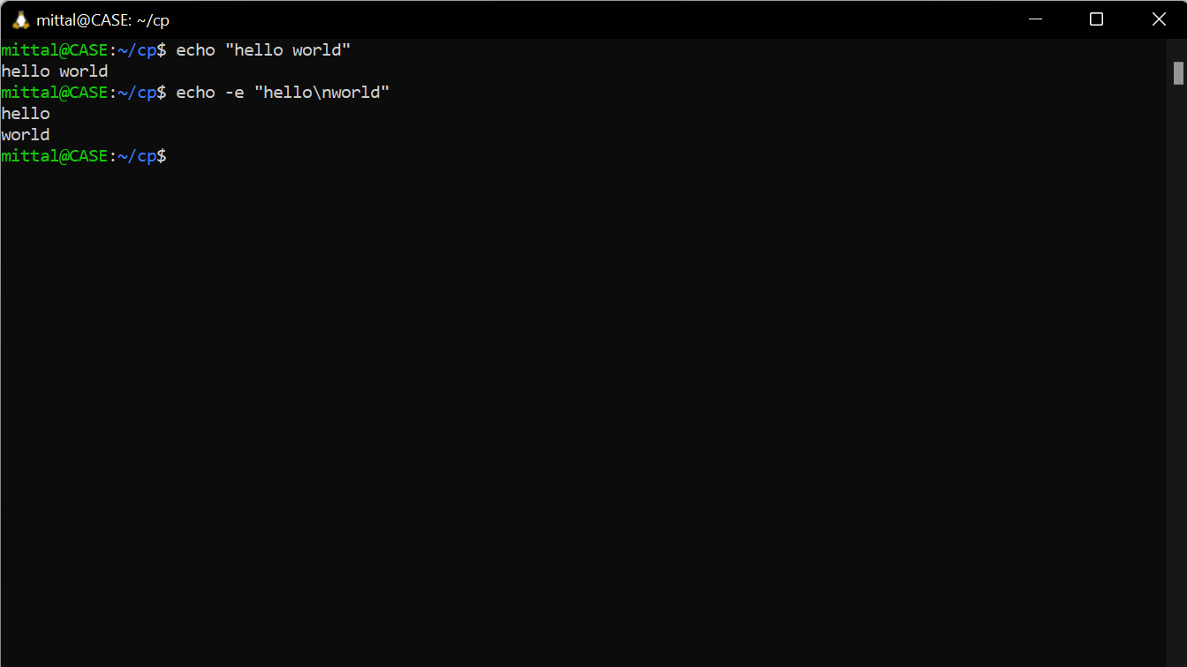

Question 2

Insert Mode :
- Entered the vi unix editor using the command “vi file_name” which opens a file with name file_name if there in the directory otherwise create a new one with name file_name.
- After writing certain text in the insert mode inside the file, pressed Escape to reach the Command mode.

Command Mode :
- In the command mode using the commands available in the editor to move the cursor in the file :
  - k : Moves the cursor up one line.
  - j : Moves the cursor down one line.
  - h : Moves the cursor to the left one character position.
  - l : Moves the cursor to the right one character position.
  - 0 or | : Positions cursor at beginning of line.
  - $ : Positions cursor at end of line.
  - W : Positions cursor to the next word.
  - B : Positions cursor to previous word.
  - ( : Positions cursor to beginning of current sentence.
  - ) : Positions cursor to beginning of next sentence.
  - CTRL+d : Move forward 1/2 screen.
  - CTRL+f : Move forward one full screen.
  - CTRL+u : Move backward 1/2 screen.
  - CTRL+b : Move backward one full screen.
  - CTRL+e : Moves screen up one line.
  - CTRL+y : Moves screen down one line.
  - i : Inserts text before current cursor location.
  - I : Inserts text at beginning of current line.
  - a : Inserts text after current cursor location.
  - A : Inserts text at end of current line.
  - o : Creates a new line for text entry below cursor location.
  - O : Creates a new line for text entry above cursor location.

Escape Mode :
- Entering the escape mode by pressing “:” from command mode and using the commands in escape mode :
  - q : Quit
  - q! : Quit without saving changes i.e. discard changes.
  - r fileName : Read data from a file called fileName.
  - wq : Write and quit (save and exit).
  - w fileName : Write to a file called fileName (save as).
  - w! fileName : Overwrite to file called fileName (save as forcefully).
  - !cmd : Runs shell commands and returns to Command mode.

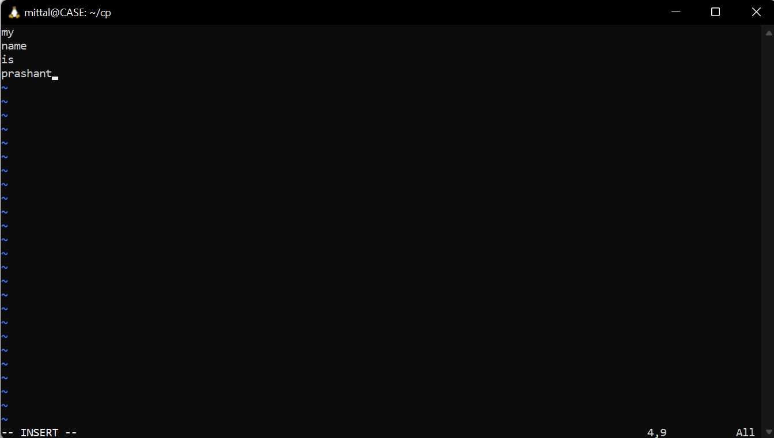

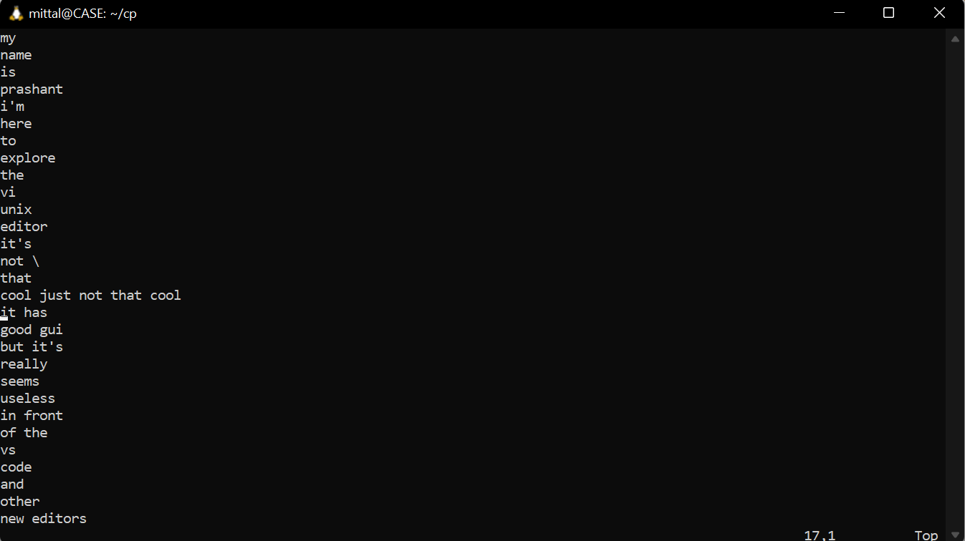

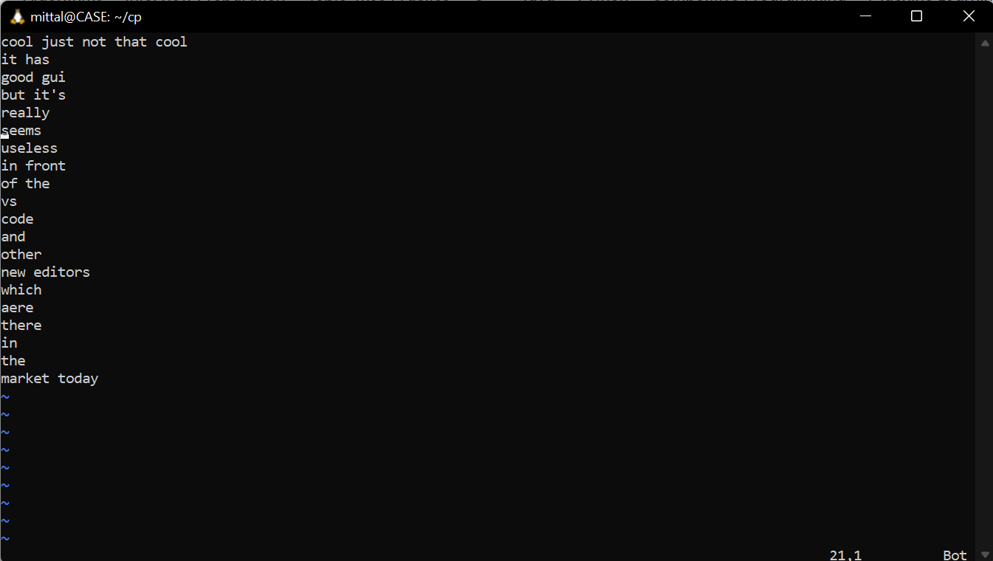

Question 3

  - Number of cores = 8
  - Model = AMD Ryzen 7 4700U with Radeon Graphics
  - Generation = 3rd Generation
  - Clock Frequency = 2 GHz

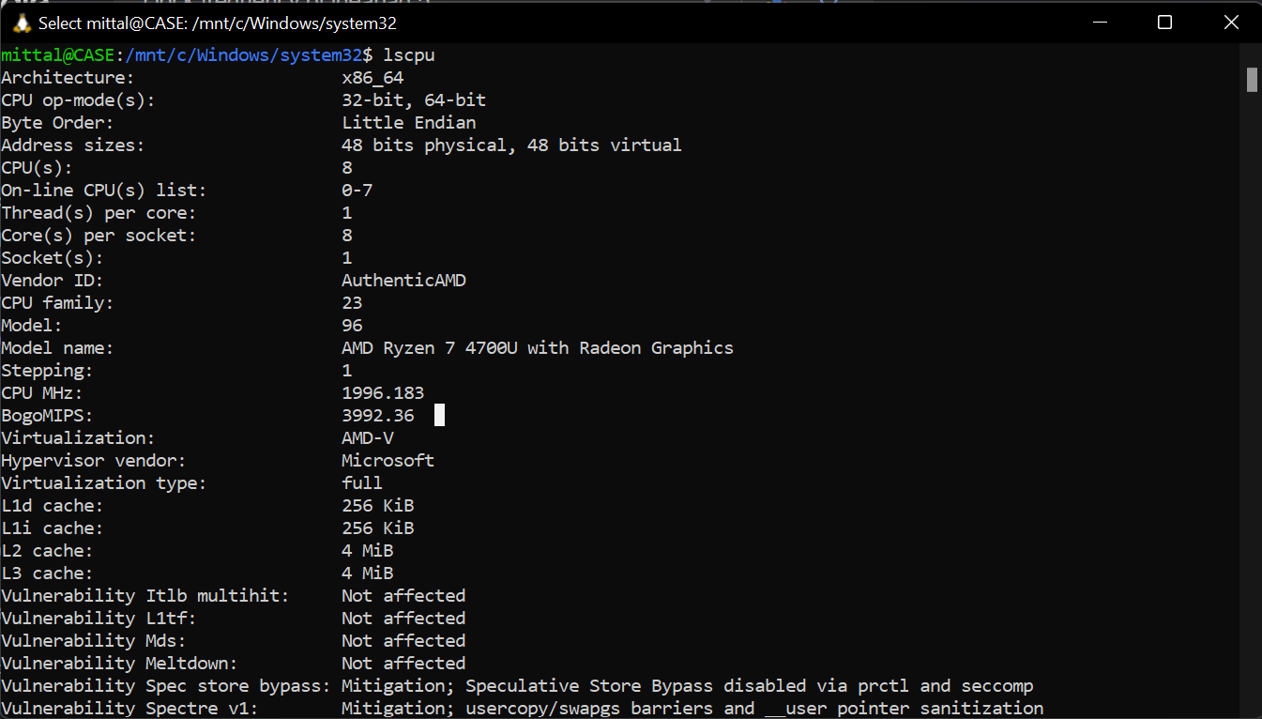
- More RAM increases the computer performance, but a good GPU increases the performance of programs that need a high amount of frames per second (FPS). Hence, it is preferred to get a better GPU rather than increasing the capacity of the RAM.

  - RAM : 3699196 kB
  - Hard Disk : 1.2 TB
  - Graphics Card : 4 GB

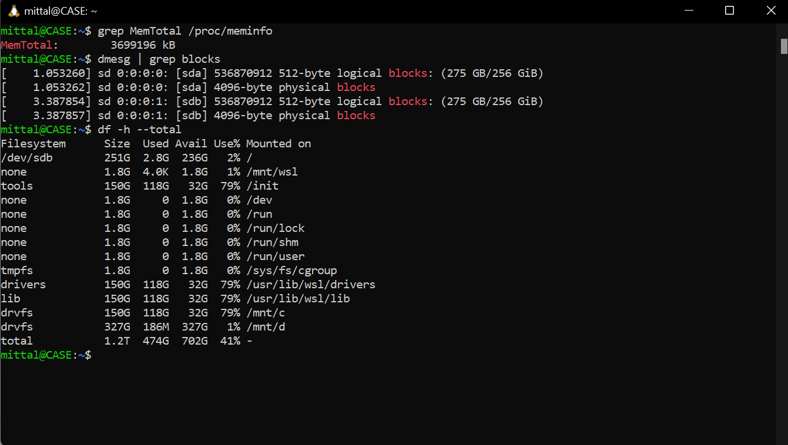

Question 4

- Total System Memory = 3699196 kB, Memory Free = 3586996 kB
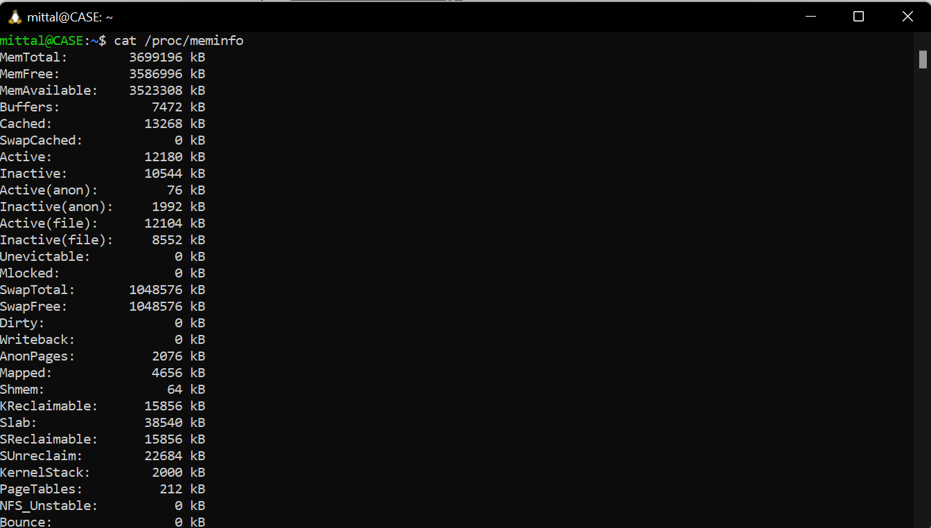

- Number of context switches = 27193

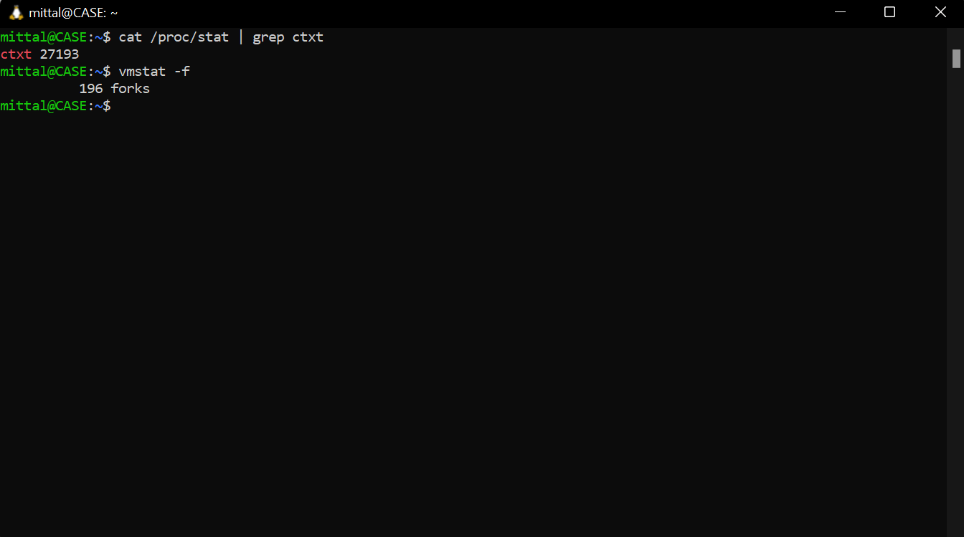

- Number of forks = 196

