# Techerudite_Test

* Customer registration

1. Added validation on field
2. According to backend response error display
3. Register as a customer

* Admin registration
* Login for admin only and lot more in code of frontend and backend
* Attaching screenshots of system

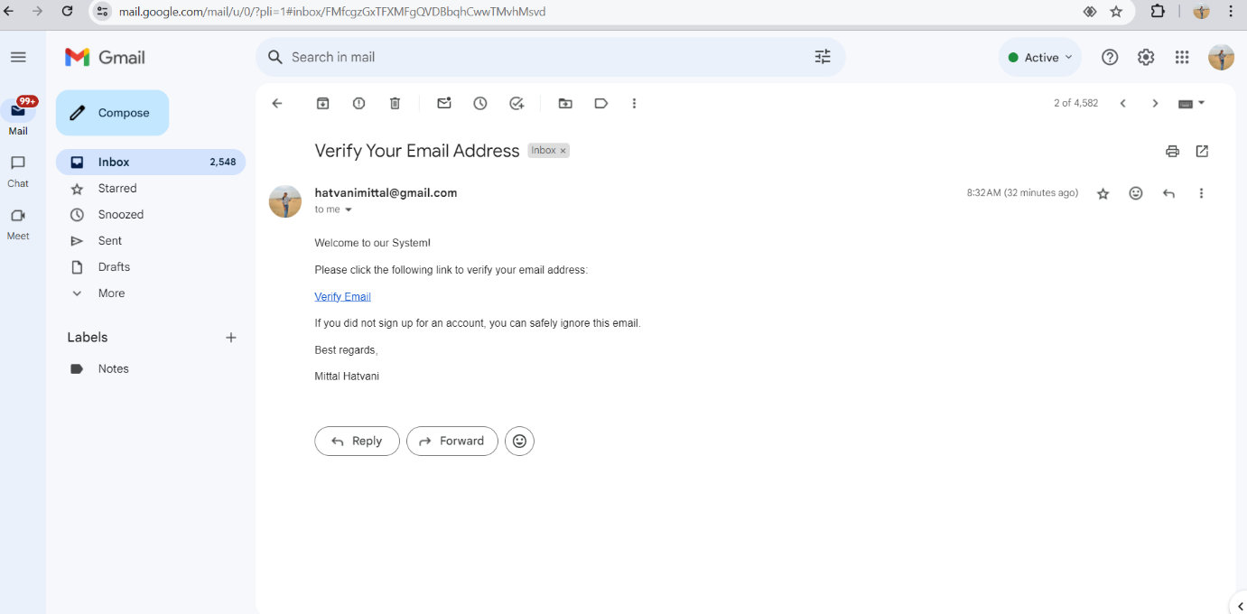

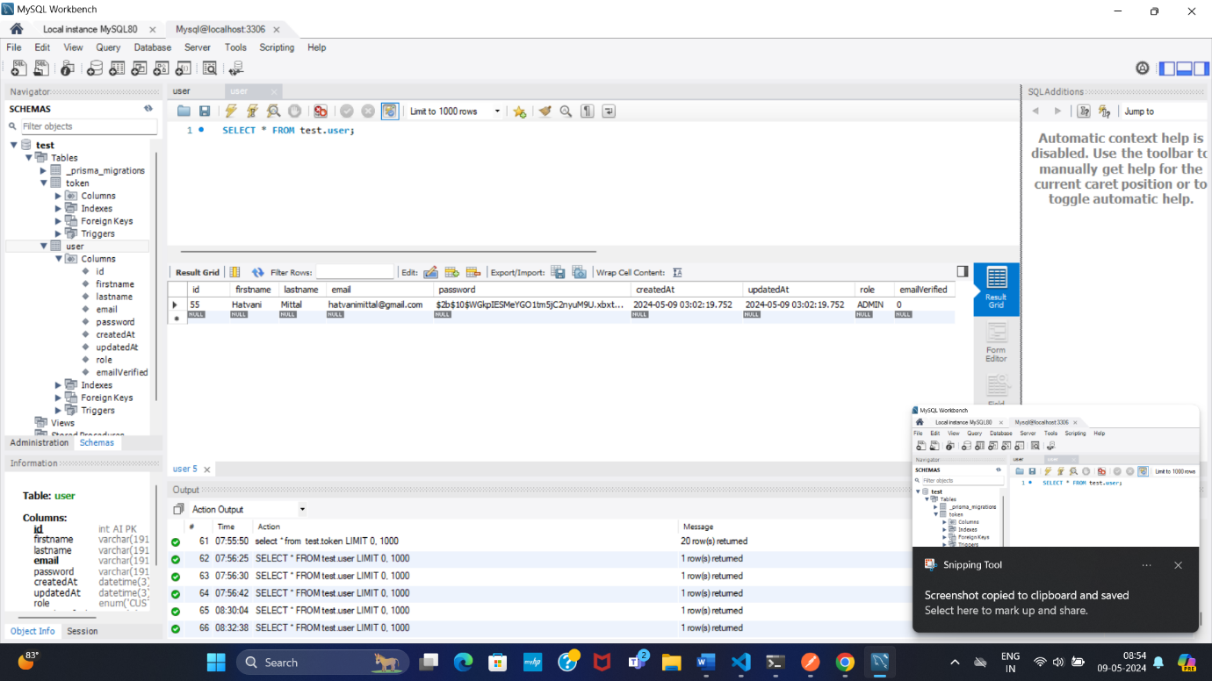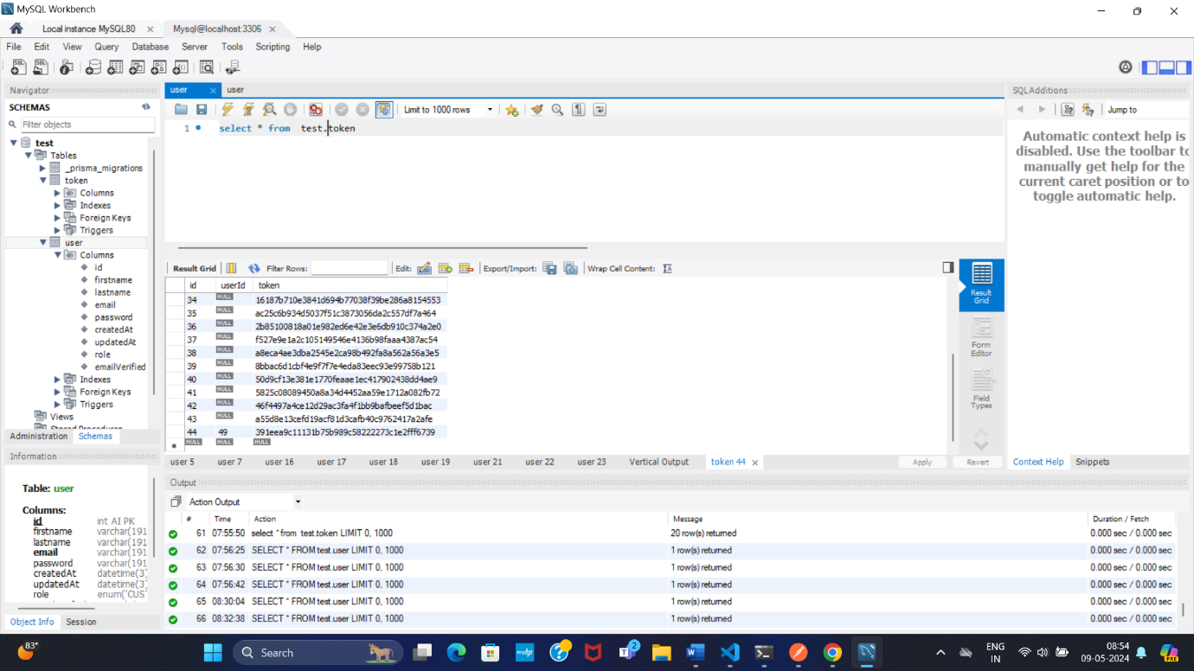

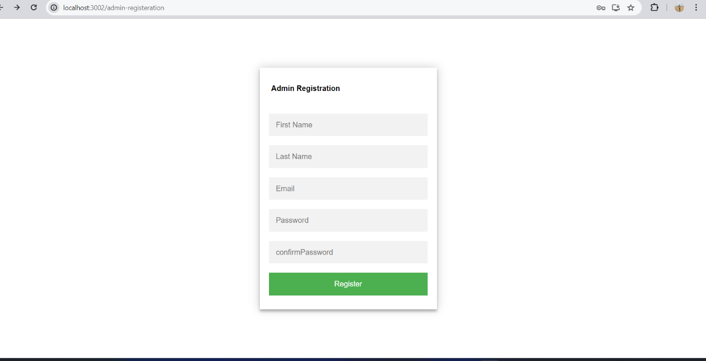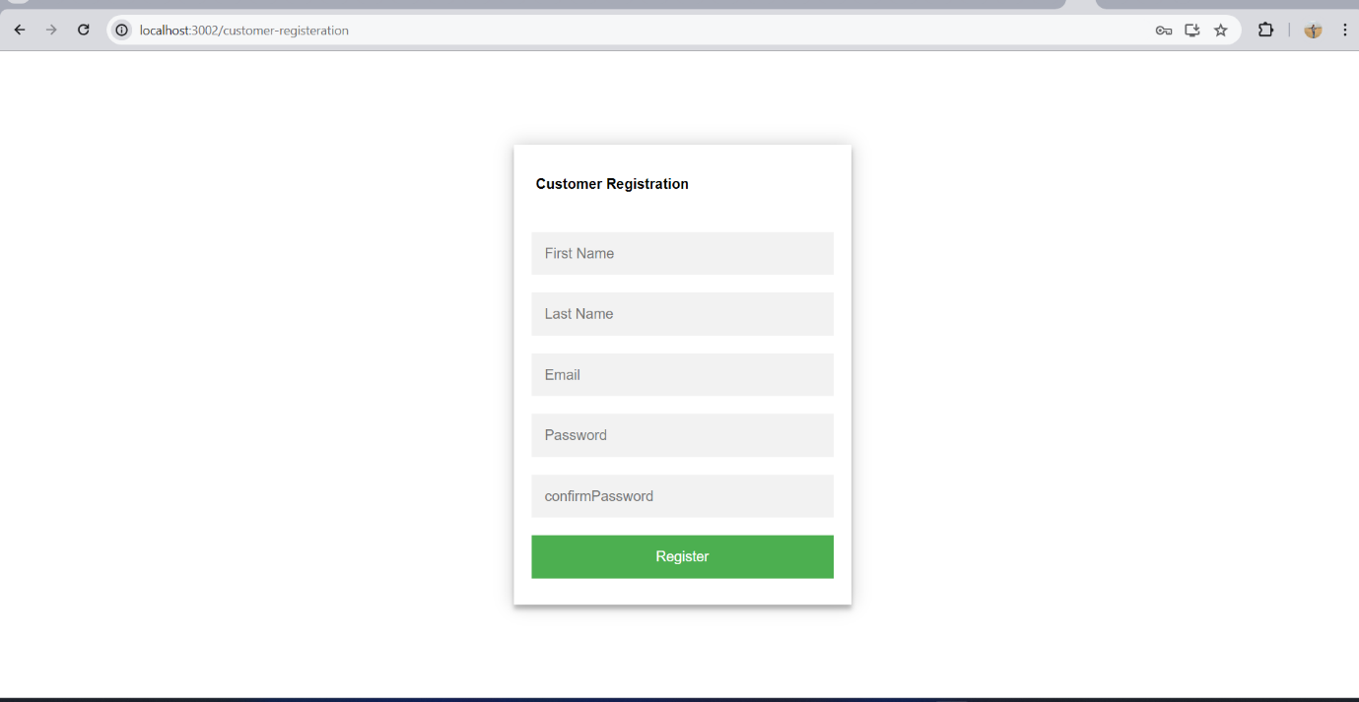

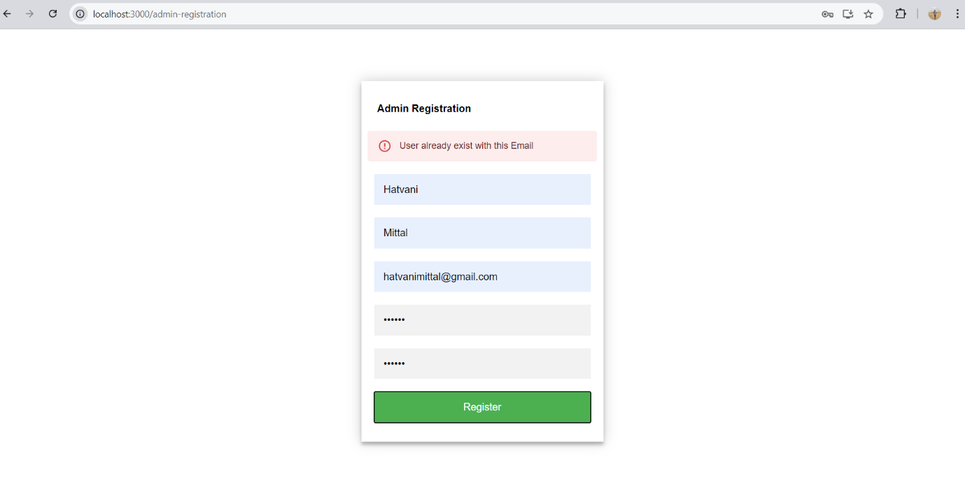

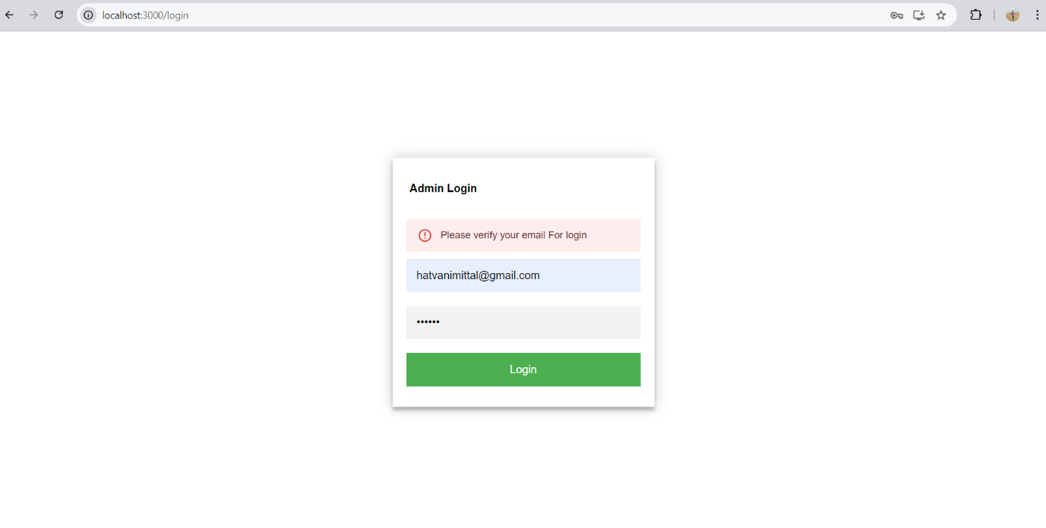

There is also improvement in it but according to keep in deadline I have keep this version   
Thank You