**Django Task-1**

1. **Task Description**

Generate a regular expression which Find words containing two times 'a' in it. str='Layla is a good data scientist'

1. **Task Output Screenshot**

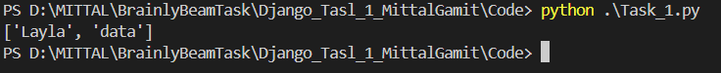

1. **Widget/Algorithm Used In Task**

**Algorithm Description**:

* **Regular Expression (Regex)**: To find words with two occurrences of the letter 'a', the regex pattern r'\b\w*a\w*a\w*\b' was used. This pattern matches any word boundary (\b) with zero or more characters before, between, and after two instances of 'a'.
* **Post-Processing**: After using the regex to match words with two or more occurrences of 'a', a filtering step ([word for word in matches if word.count('a') == 2]) was applied to ensure that only words with exactly two 'a's were included in the final result.