**Django Task-2**

1. **Task Description**

Build a logic which can save the data in database without using csrf token.

1. **Task Output Screenshot**

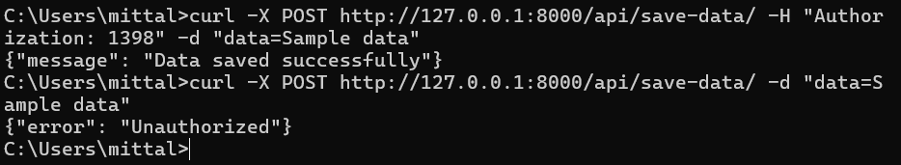

1. **Widget/Algorithm Used In Task**

**Widgets/Tools Used:**

* Django REST Framework (DRF): Utilized for building the API endpoint and handling the request-response cycle.
* Django View (APIView): Used to create a custom view that handles the POST request without requiring CSRF token validation.
* Custom Authentication Logic: Implemented directly in the view to check for the Authorization header instead of using standard Django CSRF middleware.
* Command-Line Tool (curl): Used to send HTTP POST requests with custom headers directly from the terminal, allowing testing without a GUI tool like Postman.

**Algorithm/Logic:**

1. Authorization Check: In the SaveDataView class, we check if the request contains the correct Authorization token before processing the request.
   * If the token is valid, proceed to save the data.
   * If the token is missing or incorrect, return a 401 Unauthorized response.
2. Data Handling: When a valid request is received, the data from the request body is saved to the database, and a success message is returned.
3. Error Handling: If the authorization check fails, the algorithm returns a 401 Unauthorized response, indicating access is denied.