**Django Task-3**

1. **Task Description**

Use JWT token authentication for login signup.

1. **Task Output Screenshot**

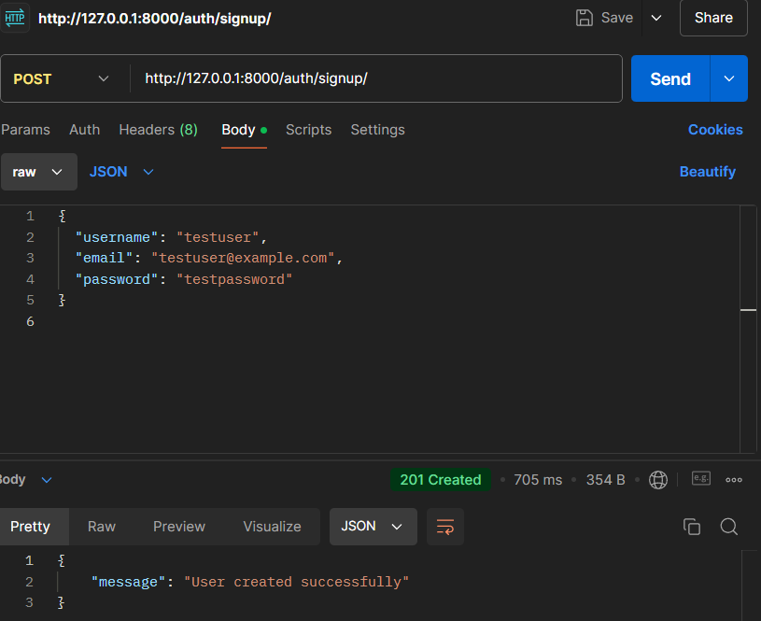

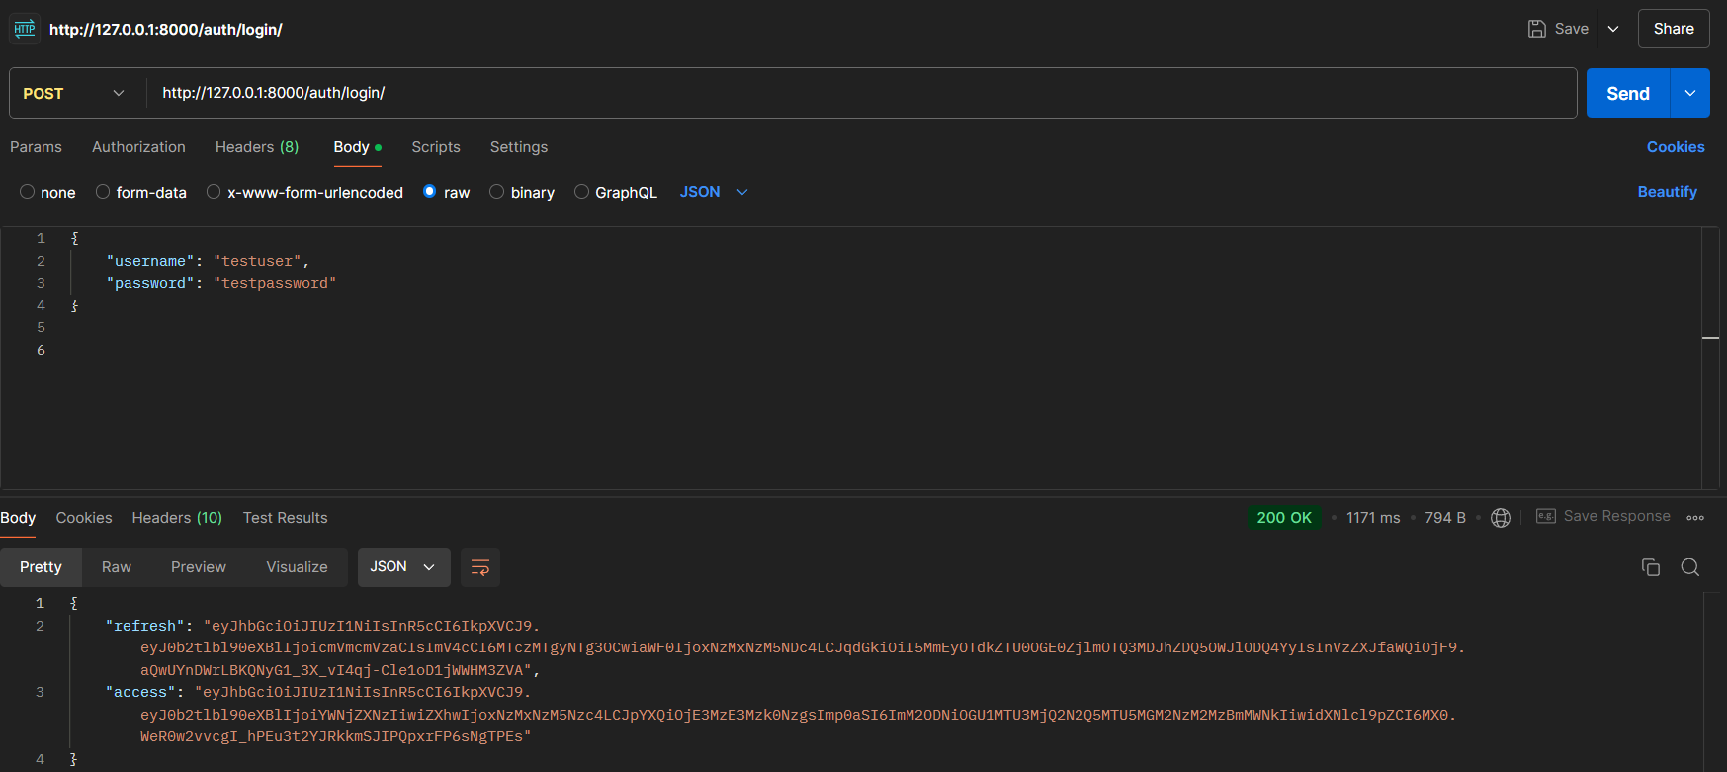

1. **Widget/Algorithm Used In Task**

**Widgets Used:**

* Django's Built-in Views: Used for handling HTTP requests such as GET and POST.
* Django REST Framework (DRF): Used for serializing data and handling API views.
* SimpleJWT: A package for handling JWT tokens in Django. It was used for generating access and refresh tokens during the login process.

**Algorithm Used:**

* JWT Token Authentication: The SimpleJWT package uses an algorithm called RS256 (or HS256 in some cases) to sign and verify JWT tokens. The token contains a payload with the user's information (e.g., username) and is signed with a secret key or RSA private key. The server uses the public key or secret to validate the token when the user tries to access protected resources.