**Django Task-4**

1. **Task Description**

Build a Quiz app in Django with a dynamic no. of options, e.g., a few questions have 2 options, a few may have 6 options, and must return the no. of right and wrong answers.

1. **Task Output Screenshot**

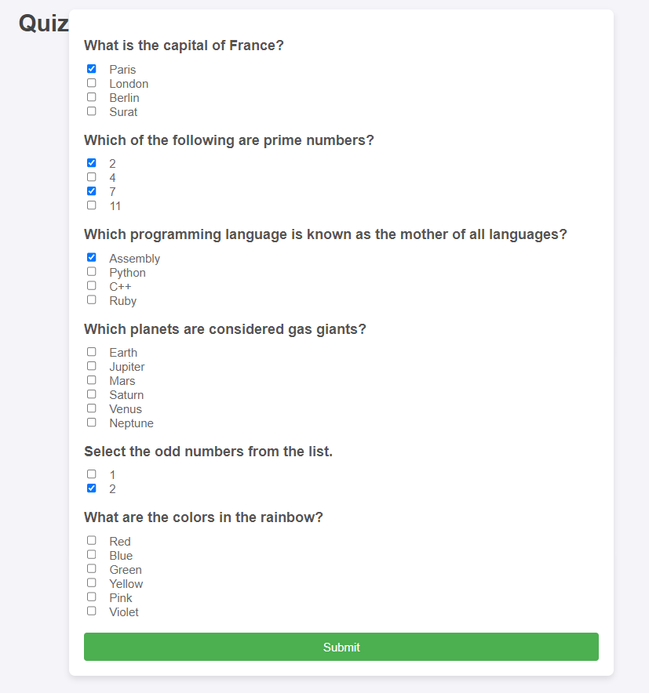

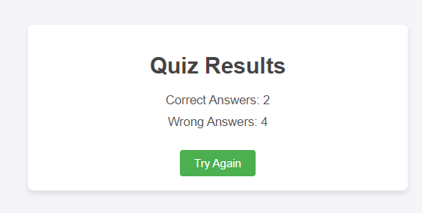

1. **Widget/Algorithm Used In Task**

**3.1 Models**

The data structure is organized using Django Models:

* Question Model: Stores the quiz question text.
* Option Model: Stores the options associated with each question and includes a boolean is_correct field to indicate if the option is correct.

**3.2 Views**

The main view logic (quiz_view) includes:

* Data Retrieval: Retrieves the questions and options from the database.
* Answer Evaluation: Iterates through the submitted answers, matches the selected options with the correct options, and calculates correct and incorrect responses.

**3.3 Templates**

Two HTML templates (quiz.html and result.html) are created using Django's template language:

* Checkboxes for Multiple Selections: Each question uses checkboxes for options, enabling multi-option selection per question.
* Result Display: The result template displays the counts of correct and incorrect answers.

**3.4 Algorithm: Answer Evaluation**

The algorithm checks each question’s selected options against the correct answers as follows:

1. Retrieve Selected Options: Fetches the IDs of the options selected by the user.
2. Compare with Correct Options: Check if the selected options match exactly with the correct ones.
3. Count Results: Increments counters for correct or incorrect responses based on the result of the comparison.