1) Develop a web application using Django framework to demonstrate the transfer of
multiple parameters between web pages. User should be presented with a dropdown
list containing car manufacturers, a text box which takes model name of the
manufacturer and a submit button. On submitting the web page, the user is forwarded
to a new page. This new page should display the selected car manufacturer name and
the model name.
demo/settings.py

# Application definition

INSTALLED_APPS = [
'django.contrib.admin',
'django.contrib.auth',
'django.contrib.contenttypes',
'django.contrib.sessions',
'django.contrib.messages',
'django.contrib.staticfiles',
'formapp'
]

formapp/urls.py

from django.urls import path
from . import views

urlpatterns = [
path('', views.home, name='home'),
path('result/', views.result, name='result'),
]

demo/urls.py

from django.contrib import admin
from django.urls import path, include

urlpatterns = [
path('admin/', admin.site.urls),
path('', include('formapp.urls')),
]

demo/urls.py

from django.contrib import admin
from django.urls import path, include

urlpatterns = [
path('admin/', admin.site.urls),
path('', include('formapp.urls')),
]

formapp/views.py

from django.shortcuts import render

def home(request):
manufacturers = ["Toyota", "Honda", "BMW", "Hyundai", "Tesla"]
return render(request, "home.html", {"manufacturers": manufacturers})

def result(request):
if request.method == "POST":
manufacturer = request.POST.get("manufacturer")
model = request.POST.get("model")

return render(request, "result.html", {
"manufacturer": manufacturer,
"model": model
})

return render(request, "home.html")

formapp/templates/result.html

<!DOCTYPE html>
<html>
<head>
<title>Result</title>
</head>
<body>

<h2>Car Details</h2>

<p>Manufacturer: {{ manufacturer }}</p>
<p>Model: {{ model }}</p>

<a href="/">Back</a>

</body>
</html>

formapp/templates/home.html

<!DOCTYPE html>
<html>
<head>
<title>Car Form</title>
</head>
<body>

<h2>Select Car</h2>

<form method="POST" action="{% url 'result' %}">
{% csrf_token %}

<label>Manufacturer:</label>
<select name="manufacturer">
{% for m in manufacturers %}
<option value="{{ m }}">{{ m }}</option>
{% endfor %}
</select>

<br><br>

<label>Model Name:</label>
<input type="text" name="model" required>

<br><br>

<button type="submit">Submit</button>

</form>

</body>
</html>

Output:

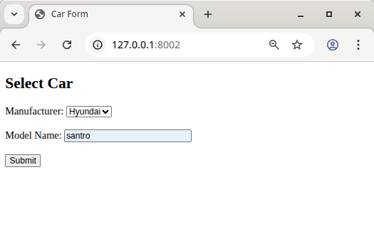
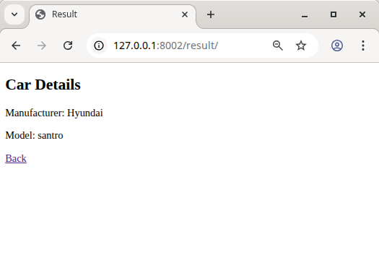

2) Create a page firstPage.html with two TextBoxes [Name, Roll], DropDownList
[Subjects], and a button. Create another page secondPage.html with a label and a
button. When the user clicks the button in first Page, he should be sent to the second
page and display the contents passed from first page in the label. The button in
second page should navigate the user back to firstPage. Use Django sessions to
transfer information

demo/settings.py

INSTALLED_APPS = [
'django.contrib.admin',
'django.contrib.auth',
'django.contrib.contenttypes',
'django.contrib.sessions',
'django.contrib.messages',
'django.contrib.staticfiles',
'formapp'
]

demo/urls.py

from django.contrib import admin
from django.urls import path, include

urlpatterns = [
path('admin/', admin.site.urls),
path('', include('formapp.urls')),
]

formapp/urls.py

from django.urls import path
from . import views

urlpatterns = [
path('', views.first_page, name='first'),
path('second/', views.second_page, name='second'),
]

formapp/views.py

from django.shortcuts import render, redirect

def first_page(request):

if request.method == "POST":
name = request.POST.get("name")
roll = request.POST.get("roll")
subject = request.POST.get("subject")

# Save data in session
request.session['name'] = name
request.session['roll'] = roll
request.session['subject'] = subject

return redirect('second')

return render(request, "firstPage.html")

def second_page(request):

name = request.session.get('name')
roll = request.session.get('roll')
subject = request.session.get('subject')

data = f"Name: {name}, Roll: {roll}, Subject: {subject}"

return render(request, "secondPage.html", {"data": data})

formapp/templates/firstPage.html

<!DOCTYPE html>
<html>
<head>
<title>First Page</title>
</head>
<body>

<h2>Student Form</h2>

<form method="POST">
{% csrf_token %}

Name:
<input type="text" name="name"><br><br>

Roll:
<input type="text" name="roll"><br><br>

Subject:
<select name="subject">
<option>Maths</option>
<option>Physics</option>
<option>Computer Science</option>
</select><br><br>

<button type="submit">Go to Second Page</button>

</form>

</body>
</html>

formapp/templates/secondPage.html

<!DOCTYPE html>
<html>
<head>
<title>Second Page</title>
</head>
<body>

<h2>Second Page</h2>

<label>{{ data }}</label>

<br><br>

<a href="/">
<button>Back to First Page</button>
</a>

</body>
</html>

Output:

