Develop a Web Application for Grocery Checklist Generation as shown in the figure
below. It must have checkboxes which must be populated on page load listing grocery
items. On clicking the Add Item button the selected Items and their prices have to be
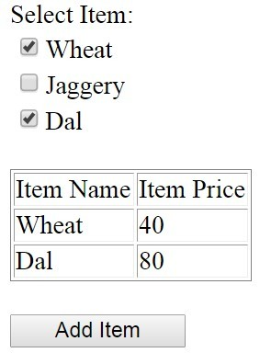
displayed in a Table. Set the borderstyle and border width for the table and its cells.

demo/settings.py

INSTALLED_APPS = [
'django.contrib.admin',
'django.contrib.auth',
'django.contrib.contenttypes',
'django.contrib.sessions',
'django.contrib.messages',
'django.contrib.staticfiles',
'formapp'
]

demo/urls.py

from django.contrib import admin
from django.urls import path, include

urlpatterns = [
path('admin/', admin.site.urls),
path('', include('formapp.urls')), # ✅ connect app
]

formapp/urls.py

from django.urls import path
from . import views

urlpatterns = [
path('', views.grocery, name='grocery'),
]

formapp/views.py

from django.shortcuts import render

# Grocery items with prices
ITEMS = {
"Wheat": 40,
"Jaggery": 60,
"Dal": 80
}

def grocery(request):

selected_items = {}

# When Add Item button is clicked
if request.method == "POST":
selected = request.POST.getlist("items")

for item in selected:
selected_items[item] = ITEMS[item]

context = {
"items": ITEMS,
"selected_items": selected_items
}

return render(request, "grocery.html", context)

formapp/templates/grocery.html

<!DOCTYPE html>
<html>
<head>
<title>Grocery Checklist</title>

<style>
table {
border-style: solid;
border-width: 2px;
border-collapse: collapse;
margin-top: 20px;
}

th, td {
border-style: solid;
border-width: 1px;
padding: 8px;
}
</style>
</head>

<body>

<h3>Select Item:</h3>

<form method="POST">
{% csrf_token %}

{% for item, price in items.items %}
<input type="checkbox" name="items" value="{{ item }}">
{{ item }} <br>
{% endfor %}

<br>
<button type="submit">Add Item</button>
</form>

{% if selected_items %}
<table>
<tr>
<th>Item Name</th>
<th>Item Price</th>
</tr>

{% for item, price in selected_items.items %}
<tr>
<td>{{ item }}</td>
<td>{{ price }}</td>
</tr>
{% endfor %}
</table>
{% endif %}

</body>
</html>

Output:
