Assignment : 6
Title: Build and Deploy a Java Web Application using Jenkins, Maven, and Apache Tomcat on AWS EC2
Objective: Set up a complete CI/CD pipeline where Jenkins automatically builds a WAR file using Maven and deploys it to an Apache Tomcat server running on a separate EC2 instance
Configuration:
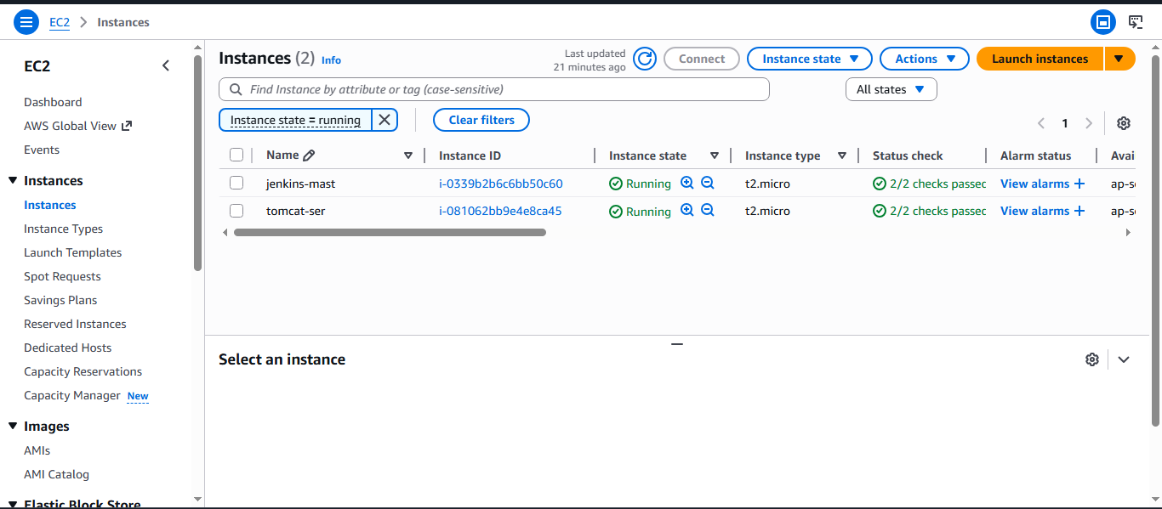
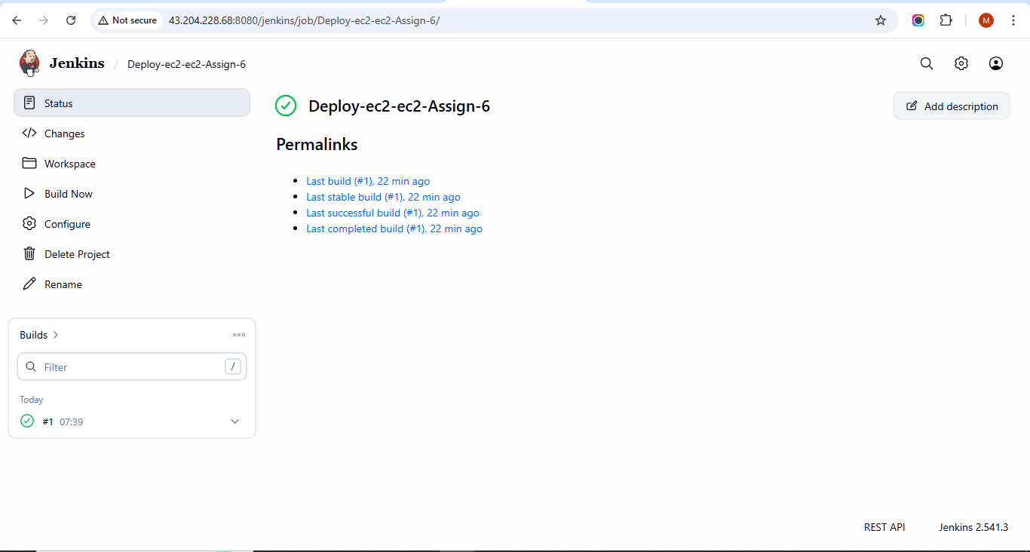
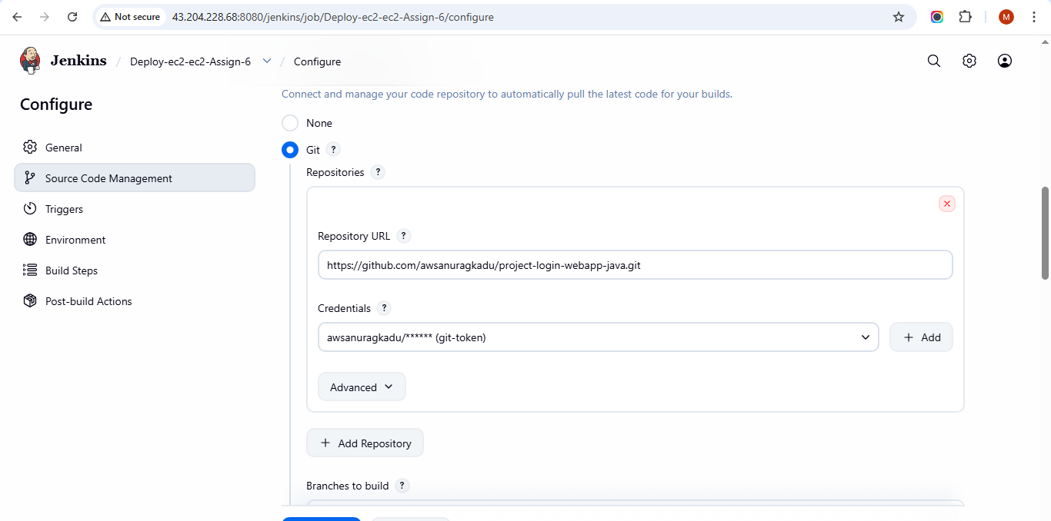
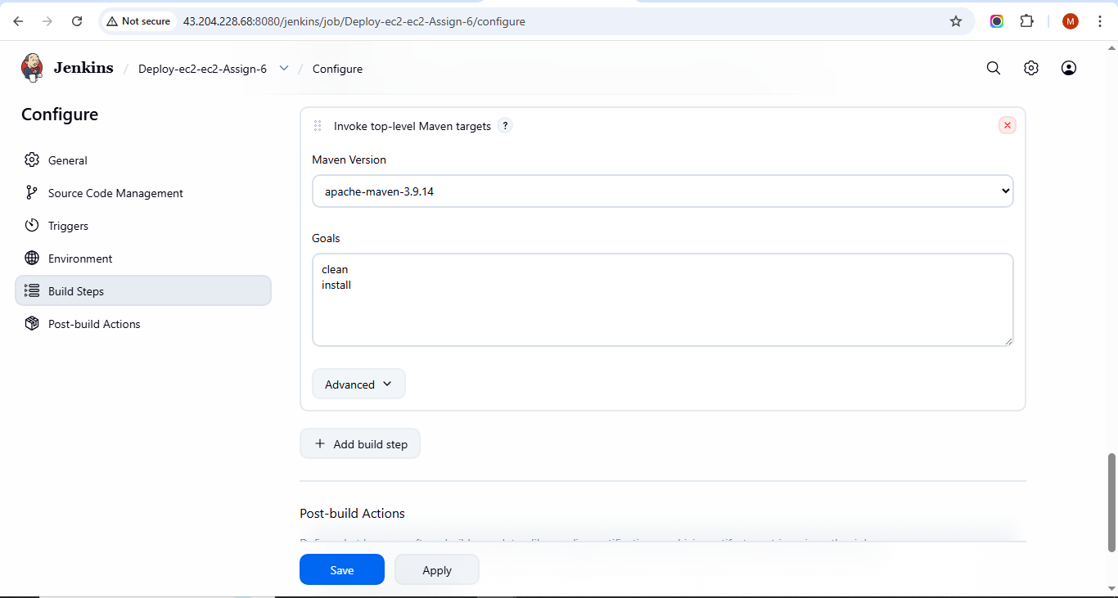
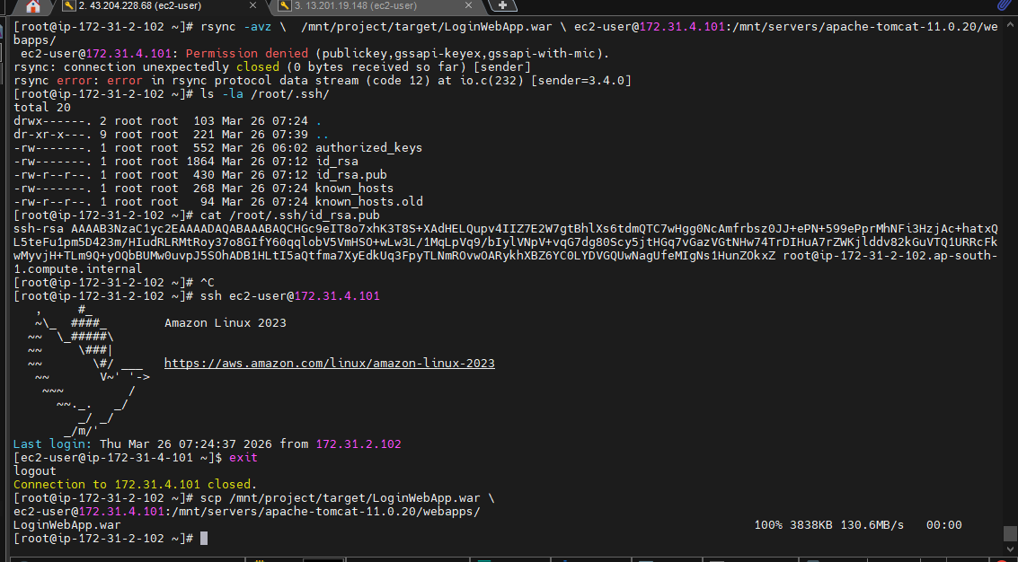
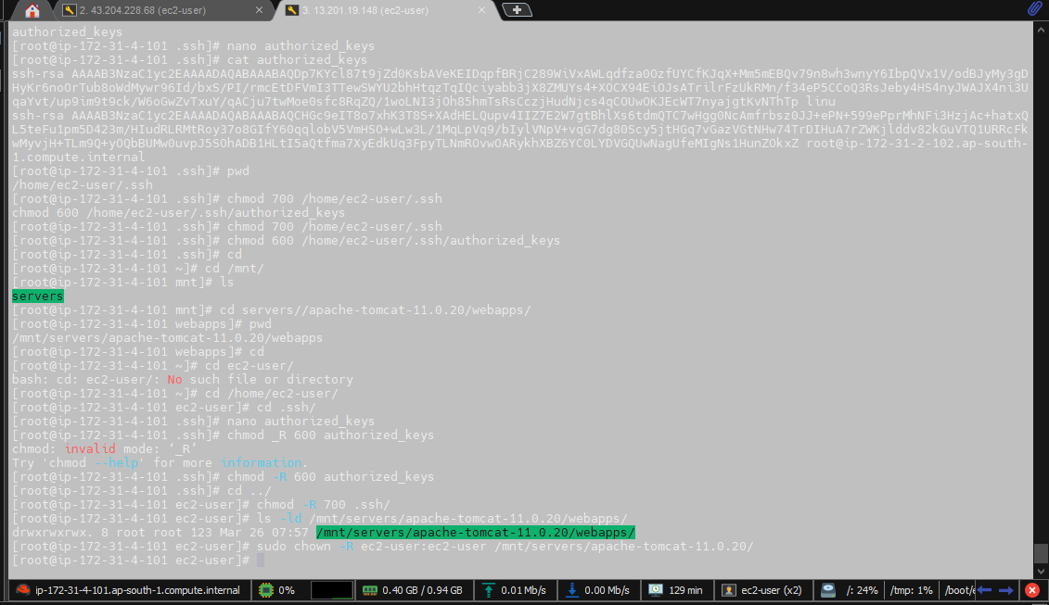
Console Output
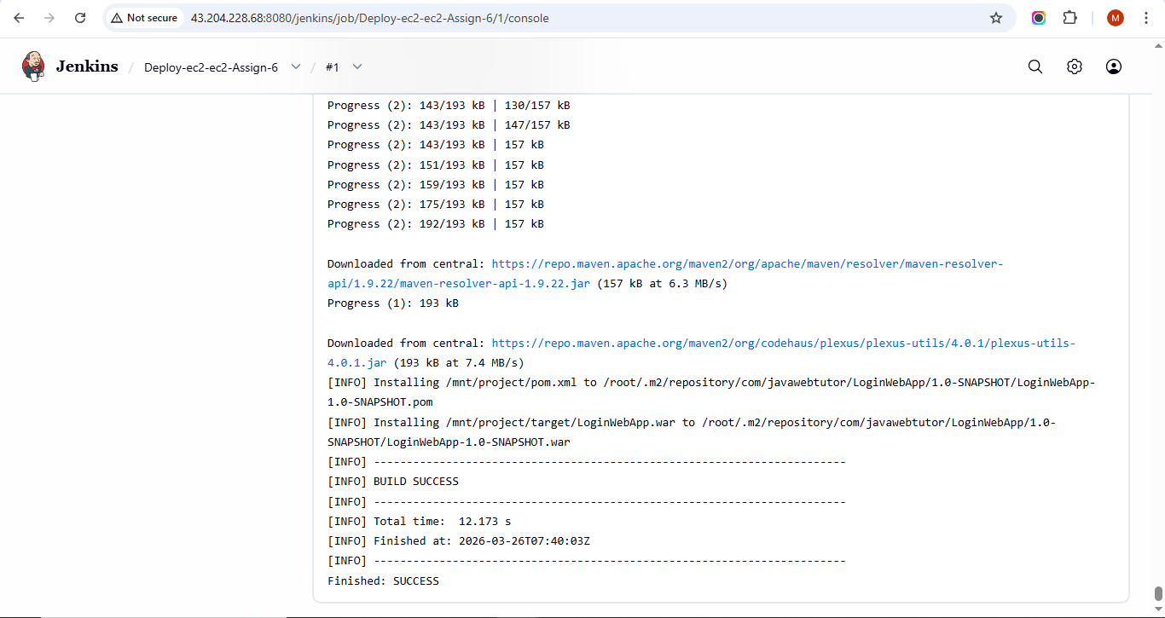
Out Put:
