Assignment : 7
Title: To Deploy automatically changes made to web application files across multiple Git repositories onto an Amazon EC2 Using Jenkins Freestyle Project(Multiple Jobs)
Objective: Design and implement a CI/CD pipeline using Jenkins Freestyle Project to automatically deploy changes made to web application files across multiple Git repositories onto an Amazon EC2 instance running Apache Tomcat.
Configuration:
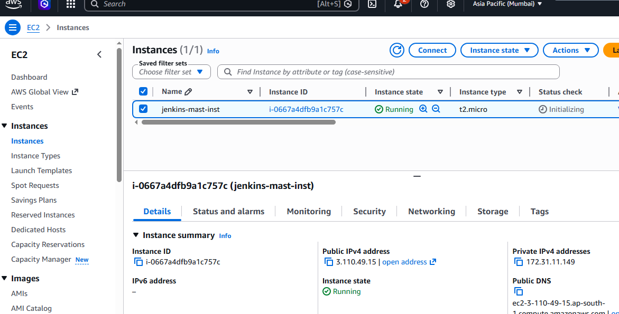
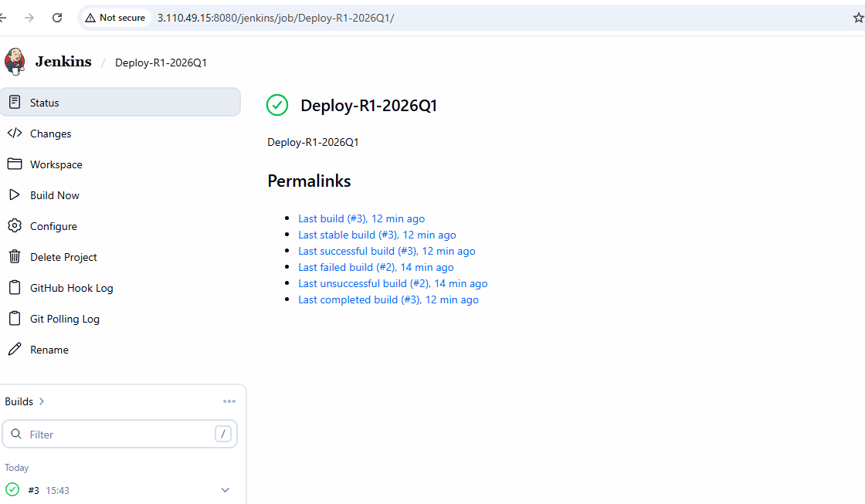
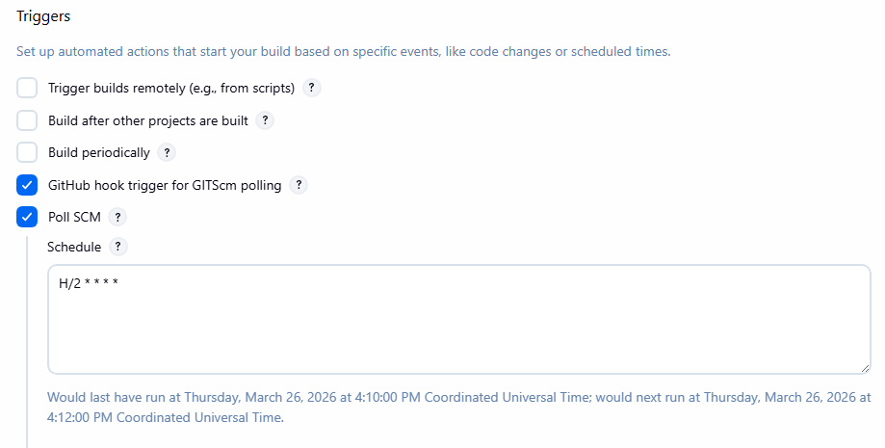
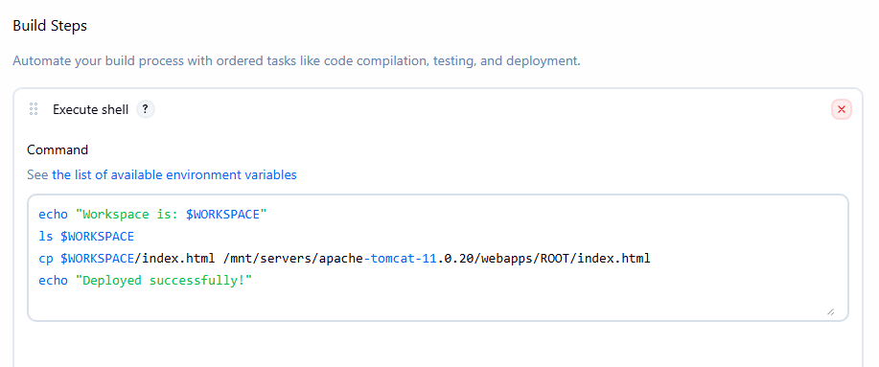
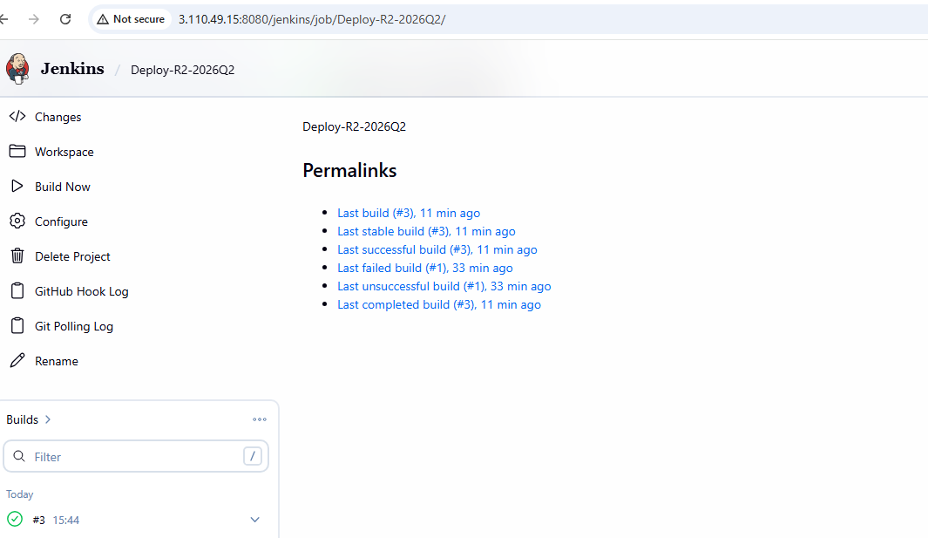


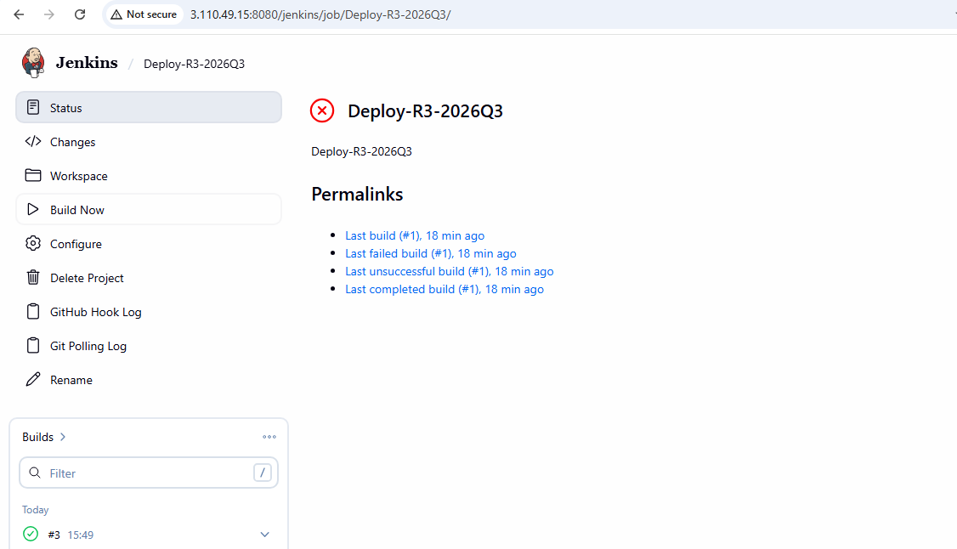


Repo 1 Out Put Before:
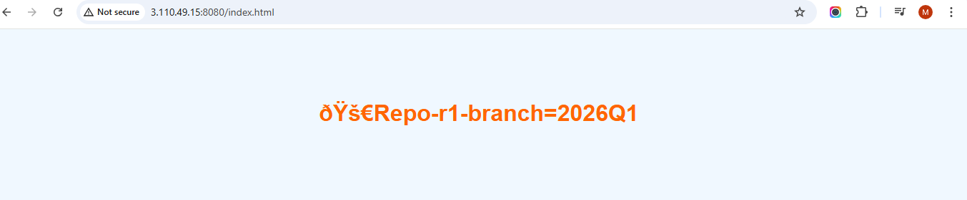
Repo 1 Out Put After:

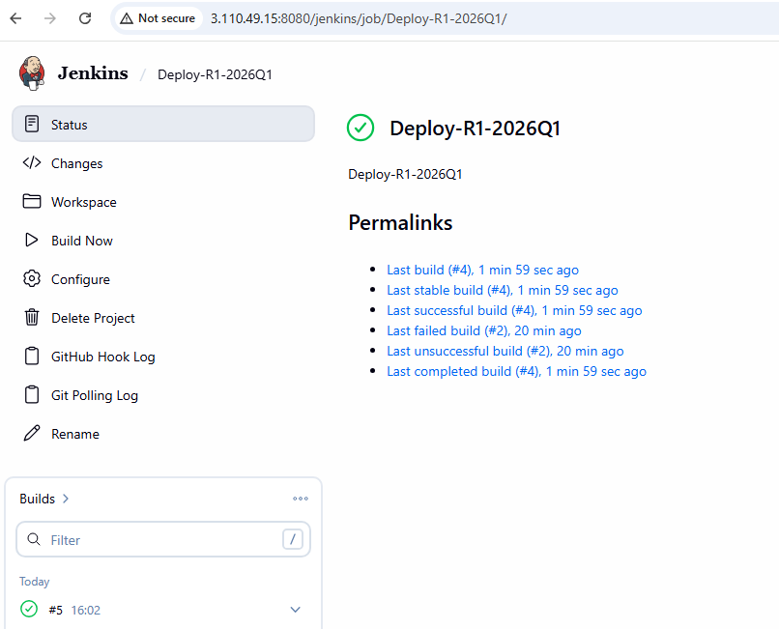
Repo 2 Out Put Before:

Repo 2 Out Put After:

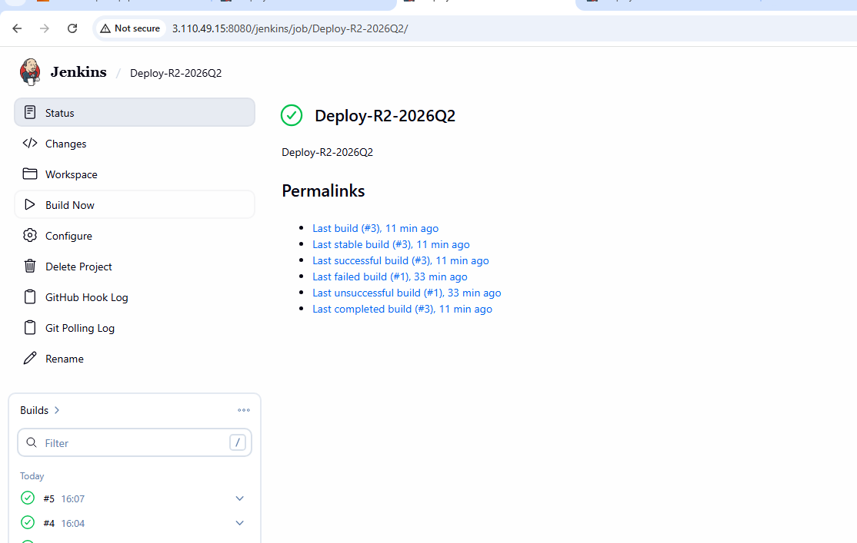
Repo 3 Out Put Before:
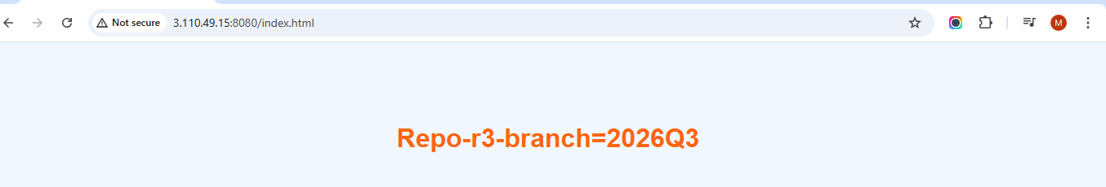
Repo 3 Out Put After:
