Assignment : 3
Create a 3 Jenkins job deploy the index.html file which is present under 3 Private repository with the branches 2026Q1, 2026Q2 and 2026Q3 on single httpd server
steps: install httpd, start httpd, for Job 1 pull index.html file from r1 private repo under 2026Q1 branch deploy and permission
Repeat for Job 2 pull index.html file from r2 private repo under 2026Q2 branch deploy and permission
Repeat for Job 3 pull index.html file from r3 private repo under 2026Q3 branch deploy and permission
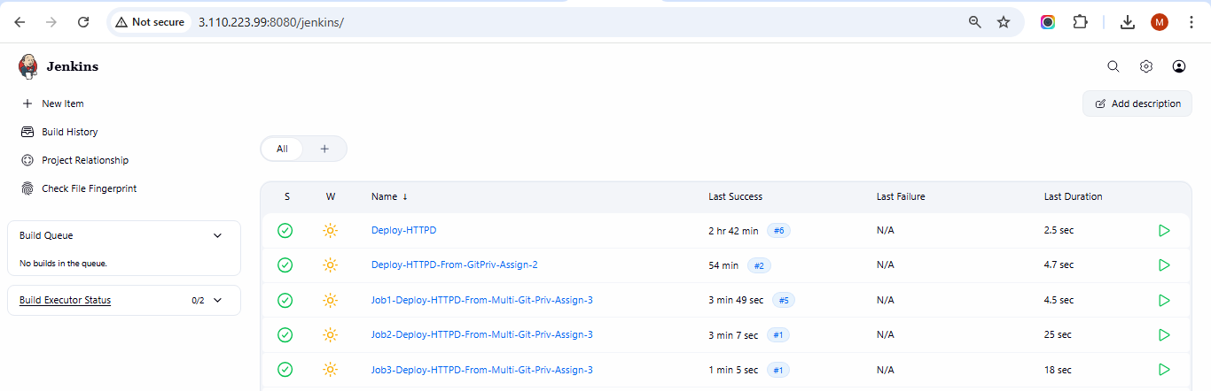
JOB 1:
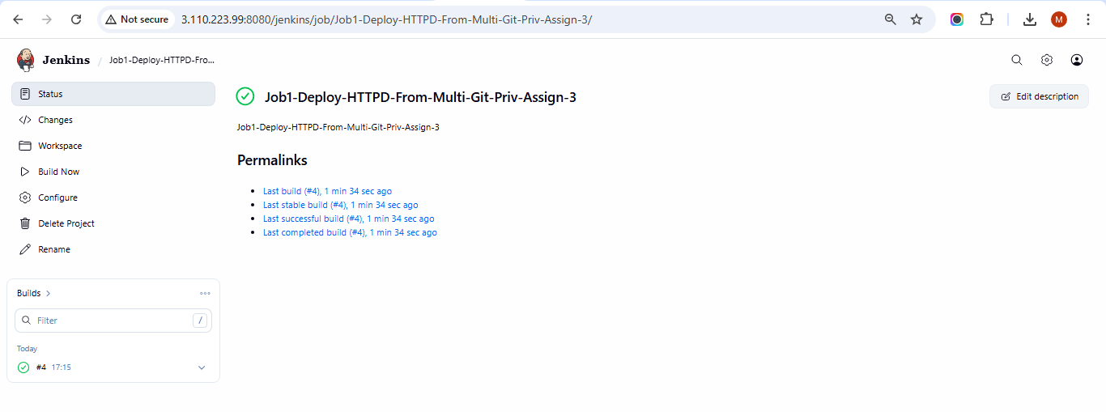
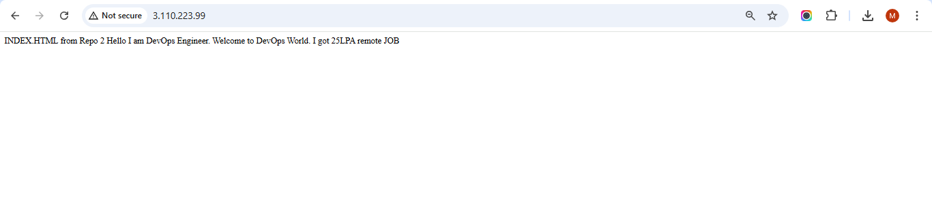
JOB 2:
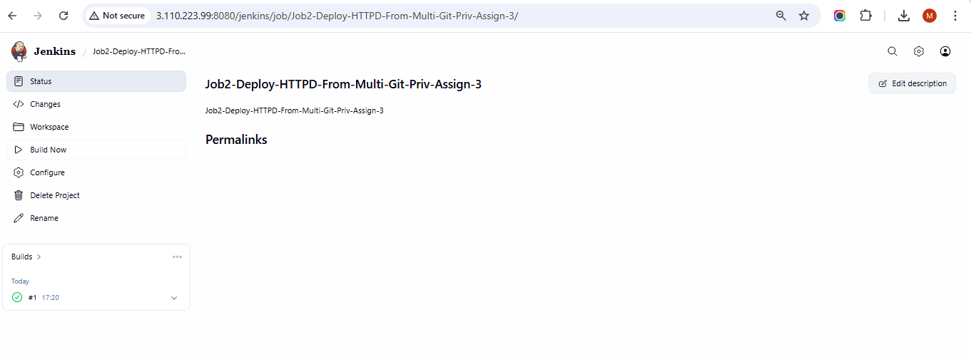
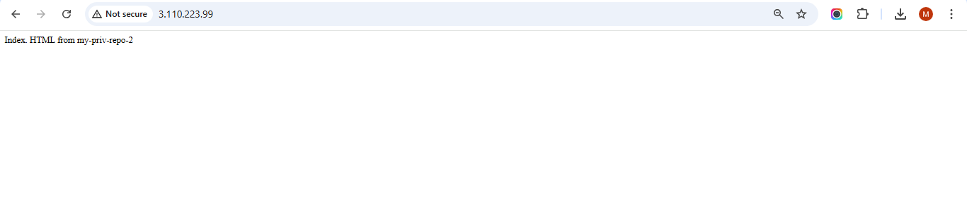
JOB 3:
