Assignment : 4
Title: Deploy Static Website to Amazon S3 Using Jenkins Freestyle Project
Objective: To automate the deployment of a static website (index.html) from a GitHub repository to an Amazon S3 bucket (with Static Website Hosting enabled) using a Jenkins Freestyle Project running on an Amazon Linux EC2 instance.
Configuration:
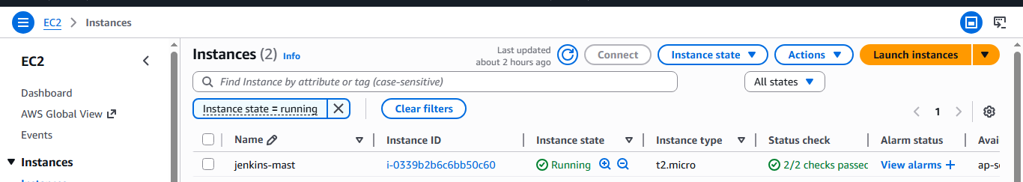
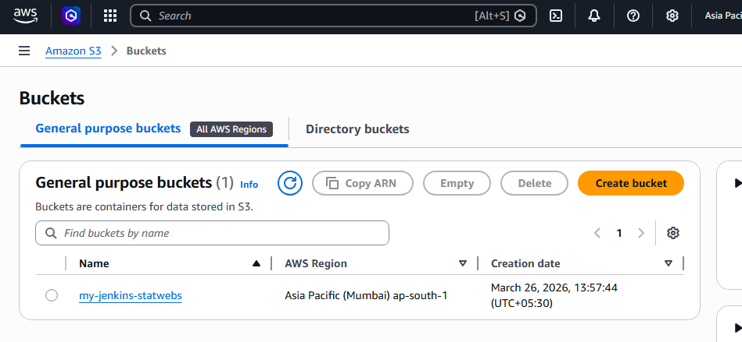
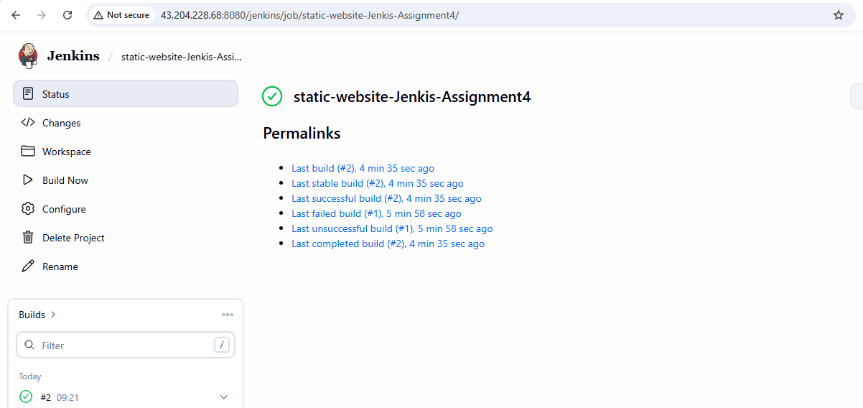
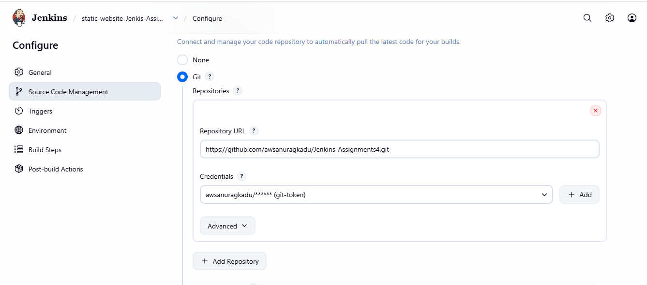
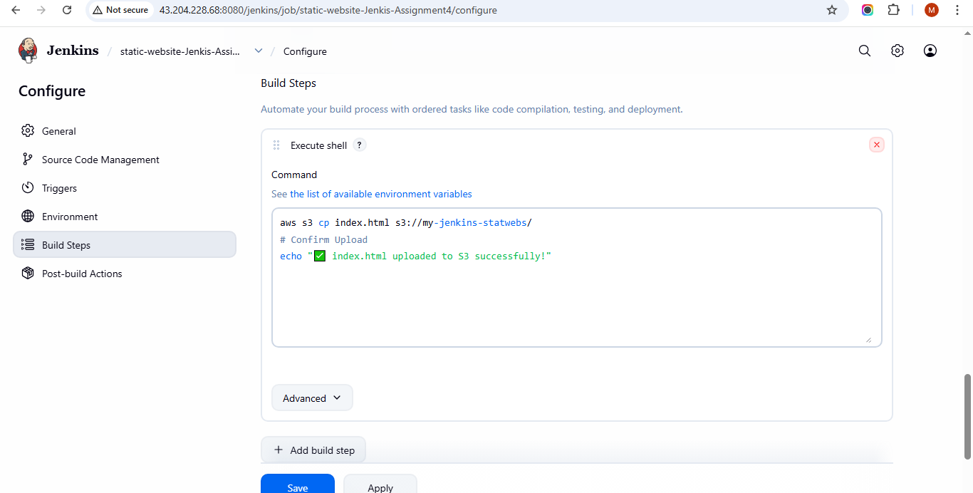
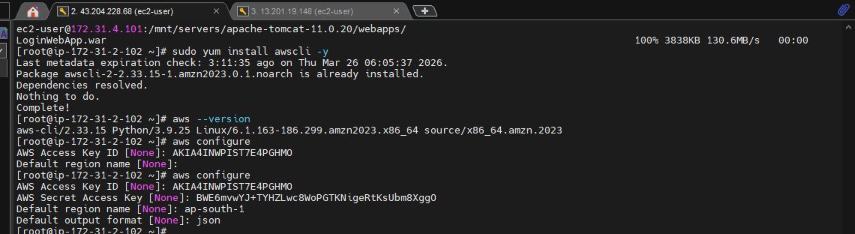
Console Output
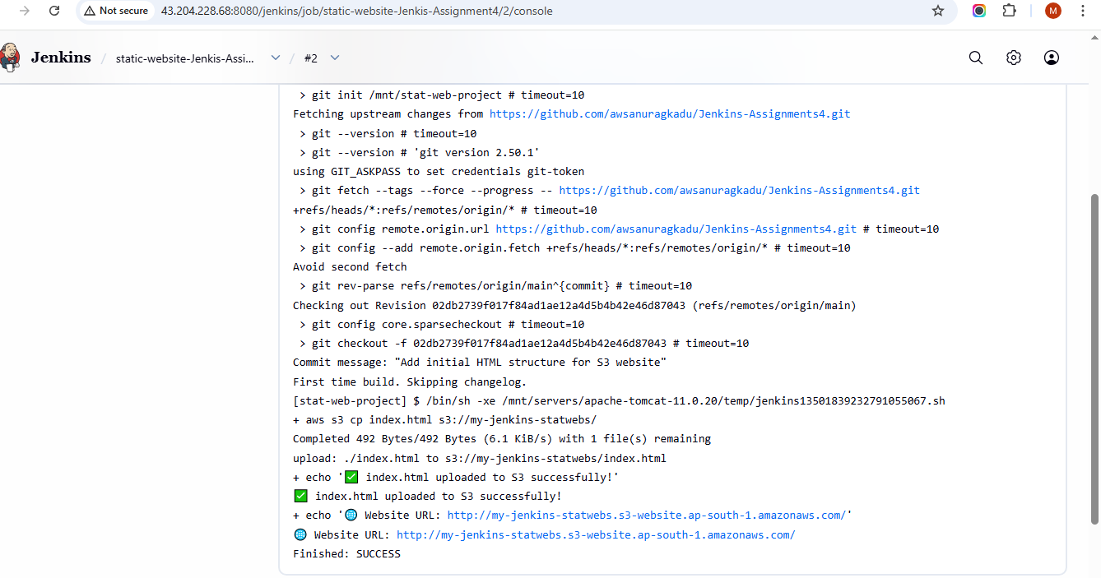
Out Put:
