
School of Computer Science Engineering and Information Systems
VIT, Vellore

DATABASE SYSTEMS
PROJECT REPORT

Smart Vehicle Rental Management System

Submitted by
Member 1: [Name] Member 2: [Name] Member 3: [Name]
Member 1: [Register number] Member 2: [Register number] Member 3: [Register number]

Academic Year: [Confirm academic year]
Full code link: [Add verified GitHub or Drive link if submitted]

CERTIFICATE
[Institution-approved certificate text to be inserted by the department.]
Project title: Smart Vehicle Rental Management System.
Student names and register numbers: [Fill all three].
Faculty guide: [Name and designation].
Place and date: [Fill].
Signature and seal: ______________________________

DECLARATION
We declare that the work described in this report is our Smart Vehicle Rental Management System project. [Review and replace this wording with the institution’s required declaration before signing.]
Member 1 signature: __________ Member 2 signature: __________ Member 3 signature: __________
Place and date: [Fill].

ACKNOWLEDGEMENT
[Write the team’s own acknowledgement of the faculty guide, department, institution and any permitted contributors. Add names only after confirming them.]

ABSTRACT
Smart Vehicle Rental Management System is a local Oracle-backed application for customer, fleet, rental and payment records. Its eight-table SVR_APP schema in XEPDB1 links customers and phones, vehicle types, branches, vehicles, employees, rentals and payments. A Java 21 HTTP server exposes JSON endpoints to a five-screen HTML/CSS/JavaScript frontend through JDBC. The database implements primary/foreign/unique/check constraints, three procedures, two functions, an explicit cursor, three triggers and two sequences. Guarded PL/SQL transactions preserve a rental’s daily-rate snapshot, synchronize vehicle availability and limit payments to the bill. SQL*Plus evidence includes 15 SELECT demonstrations, three member DML/query scripts, rollback checks and a real two-session lock test. In the normal browser, rental 7016 was started and returned, payment 8018 recorded ₹500 and a ₹701 overpayment rejected; fresh Oracle reads agreed with the UI and HTTP results. The final audit found no orphan, invalid, mismatched or overpaid records and confirmed all 81 original seed rows unchanged. Four fictional committed test records remain as protected history. Cycle VI evidence, faculty acceptance of the eight-table amendment and individual handwritten submission items remain outstanding.
Keywords: Oracle Database, ER Model, SQL, PL/SQL, JDBC, Transactions, Vehicle Rental

TABLE OF CONTENTS
Certificate
Declaration
Acknowledgement
Abstract
List of Figures
List of Tables
List of Abbreviations
Chapter 1 – Introduction
Chapter 2 – Requirements Analysis
Chapter 3 – DBMS Concepts and Architecture
Chapter 4 – Conceptual Database Design
Chapter 5 – Relational Database Design
Chapter 6 – Functional Dependencies and Normalization
Chapter 7 – SQL Implementation
Chapter 8 – Advanced Database Operations
Chapter 9 – Query Processing and Optimization
Chapter 10 – Database Security, Transactions and Recovery
Chapter 11 – Application Development and Connectivity
Chapter 12 – Testing and Results
Chapter 13 – Conclusion and Future Enhancements
References
Appendix A – SQL Scripts
Appendix B – Sample Data and Screenshots
Appendix C – Sample Test Case Table
Update this table of contents and figure/table page numbers in Word after final pagination. The template lists every required section below.

LIST OF FIGURES
Figure 2.1: Staff use-case draft — Section 2.6.
Figure 4.1: Amended eight-entity implementation ER diagram — Section 4.6.
Figure 5.1: Amended eight-table relational schema — Section 5.5.
Figure 11.1: Local application architecture — Section 11.1.
Figures 11.2–11.4: Committed browser rental, return and payment — Section 11.6. [Update page numbers after Word pagination.]

LIST OF TABLES
Table 12.1: Representative executed test cases — Appendix C. [Update page number after Word pagination.]

LIST OF ABBREVIATIONS
- DBMS – Database Management System
- RDBMS – Relational Database Management System
- SQL – Structured Query Language
- DDL – Data Definition Language
- DML – Data Manipulation Language
- DQL – Data Query Language
- DCL – Data Control Language
- TCL – Transaction Control Language
- ER – Entity–Relationship
- ACID – Atomicity, Consistency, Isolation, Durability
- CRUD – Create, Read, Update, Delete

CHAPTER 1: INTRODUCTION

1.1 Background
A vehicle rental business must relate customers, phone numbers, vehicles, type-based rates, branches, employees, rentals and payments. Separate spreadsheets or manual lists make it difficult to preserve those relationships and produce a reliable balance or availability view. This project uses Oracle XE to store the relationships and a local browser application to operate them. The implemented schema has eight tables in SVR_APP within XEPDB1 (schema-plan.md).

1.2 Problem Statement
The project problem is to track which customer rented which vehicle, when it was due and returned, what daily rate applied at the time, and how much was paid. Without controlled transactions, a vehicle can be double-booked, later rate changes can alter historical calculations, and payment totals can exceed bills. The system therefore needs constrained data, guarded rental/payment workflows and searchable displays.

1.3 Objectives
The objectives are to implement eight related Oracle tables with at least ten meaningful rows each; enforce keys and data checks; execute 15 varied SELECT demonstrations; implement procedures, functions, an explicit cursor and triggers; connect a Java/JDBC backend and browser frontend; and verify CRUD, rental, return, payment, revenue and overdue workflows with actual Oracle evidence (G1 p. 2; G2 pp. 1–2).

1.4 Scope
Scope includes customer/phone and fleet/organization CRUD, search, rental start/return, charge estimate, completed payment recording and overdue/revenue reports on trusted localhost. There is no application login, authorization, genuine cancellation or refund workflow. Historical rental/payment edits and deletions are not offered. The database holds fictional academic sample data.

1.5 Existing System
The supplied Review 1 describes the intended rental domain but does not provide measured evidence of an earlier deployed system (R1 pp. 2–4). For this report, a manual or spreadsheet process is a problem scenario, not a claim that one was observed. [If required by the faculty: add a verified description of the actual existing process and its users.]

1.6 Proposed System
The proposed and implemented solution stores master and transaction records in Oracle, serves five browser screens from a Java 21 local HTTP server, and uses JDBC prepared/callable statements. PL/SQL procedures lock the relevant row, apply business checks and change related rows within a caller-controlled transaction. The UI shows database-derived totals and validation outcomes.

1.7 Organization of the Report
Chapter 2 states requirements; Chapters 3–6 explain DBMS concepts and design; Chapters 7–10 cover SQL, PL/SQL, query processing and security/transactions; Chapter 11 describes the application; Chapter 12 reports actual tests; Chapter 13 concludes. Appendices identify executable source, representative evidence and test cases.

CHAPTER 2: REQUIREMENTS ANALYSIS

2.1 Stakeholders and User Roles
Operational users are rental staff who maintain records and carry out rentals, returns and payments. Customers are represented as records, not authenticated app users. EMPLOYEE.ROLE records duties but does not grant application permissions. The three student members present different modules. SYSTEM is an Oracle administrator account; SVR_APP is the dedicated project owner.

2.2 Functional Requirements
Implemented functions: create/search/view/update/delete unreferenced customers, phones, vehicle types, branches, vehicles and employees; filter/view rentals and payments; estimate a charge; start and return a rental; record a permitted payment; reject overpayment; show outstanding balance, overdue rentals, cash receipts and recognized rental charges. No login or cancellation/refund operation is implemented (api-reference.md; frontend-guide.md).

2.3 Non-Functional Requirements
Integrity relies on enabled PK/FK/UNIQUE/CHECK constraints, package checks, triggers and transactions. The server binds to 127.0.0.1 and uses a dedicated database account; passwords are entered through a hidden local prompt. Forms preserve entered data on errors and disable duplicate submissions during a pending write. Lists are bounded to 100; network requests have a documented timeout. No scalability or security benchmark was run.

2.4 Hardware and Software Requirements
Observed environment: Windows laptop; Oracle Database 21c XE, XEPDB1; SQL*Plus 21.3; Java 21.0.11; project-local Maven Wrapper/Maven 3.9.11; Oracle JDBC ojdbc11; Java HttpServer; HTML/CSS/JavaScript browser UI. Build command and local startup are in README.md. [Add verified minimum hardware specifications if the faculty requires them.]

2.5 Feasibility Study
Technical feasibility was demonstrated by the successful Maven build, live SVR_APP/XEPDB1 health check, browser CRUD and committed rental/return/payment workflow. Operational feasibility is supported for a small trusted-localhost academic demonstration; login, multi-user access policy and deployment are not included. No purchase, hosting or staff-cost study was supplied. [Add a cost estimate only if required.]

2.6 Use-Case Diagram and Descriptions
Use cases: maintain customer and phone; maintain fleet and staff; search records; estimate/start rental; record return; record payment; inspect outstanding, revenue and overdue reports. The browser actions map to API routes and SQL/PLSQL objects in member-demo-guide.md. A project-derived draft use-case diagram is inserted below; obtain faculty review if formal UML notation is required.
Figure 2.1 Draft staff use cases
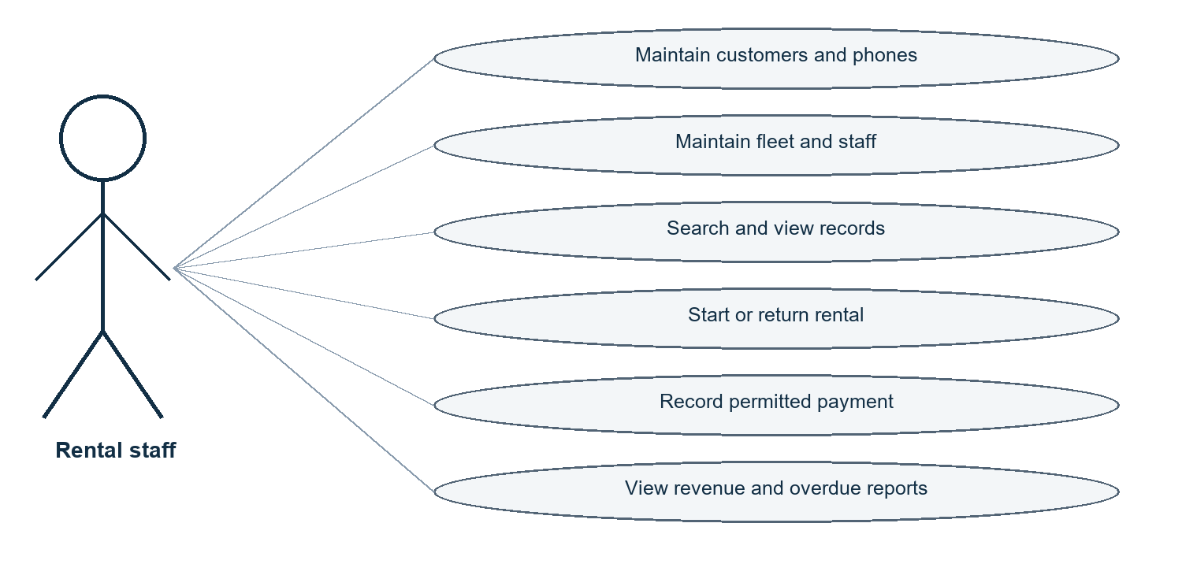

CHAPTER 3: DBMS CONCEPTS AND ARCHITECTURE

3.1 Introduction to DBMS
A database is an organized persistent collection of data; a DBMS manages storage, retrieval, constraints and concurrent access. Oracle is the RDBMS used here. Its tables, keys, constraints and transactions help keep rental, vehicle and payment data consistent. The DBMS does not replace application-level requirements such as user login.

3.2 File System versus DBMS
Files can duplicate customer, vehicle and payment facts across independent records and leave inconsistent versions. The relational schema stores each entity once and links children by FKs. Oracle supplies declarative constraints and transaction recovery, while SQL supports joins and reporting. This comparison is conceptual; no file-system prototype was tested.

3.3 Three-Schema Architecture
External level: five browser views and JSON API responses. Conceptual/logical level: the eight-table schema, relationships and business rules. Internal level: Oracle storage, indexes, transactions and execution plans. The application consumes the logical schema through JDBC rather than manipulating database files.

3.4 Data Independence
Physical data independence means Oracle can change storage or indexing without changing the logical tables exposed to the application, subject to performance effects. Logical independence means some schema changes can be hidden from views/APIs, but this project did not test a schema migration; removing RENTAL_STATUS required an explicit implementation amendment.

3.5 Data Models
The implemented model is relational: rows in eight tables are connected through FKs. Hierarchical and network models encode relationships differently; object and document models organize data around objects or documents. MongoDB lab material was inspected separately and was not substituted for the Oracle/JDBC implementation (lab-cycle-map.md).

3.6 Database Languages
DDL created the user, tables, constraints, sequences, package and triggers. DML inserted, updated and deleted fictional demonstration records. SELECT is used for retrieval (DQL). DCL granted only the required project privileges during setup. TCL includes SAVEPOINT, COMMIT and ROLLBACK; member demonstrations rolled back their disposable DML.

3.7 Users and Database Administrator
Staff are intended end users of the local interface. The student team designed SQL, PL/SQL, Java and browser modules. SYSTEM performed guarded account setup; normal project DDL/DML and application requests use SVR_APP. This separation avoids placing project tables in SYSTEM. DBA backup and broader account administration remain outside the app.

CHAPTER 4: CONCEPTUAL DATABASE DESIGN

4.1 Entity Identification
Eight implemented entities: CUSTOMER (renter), CUSTOMER_PHONE (multivalued contact), VEHICLE_TYPE (tariff), BRANCH (location), VEHICLE (asset), EMPLOYEE (staff), RENTAL (rental history) and PAYMENT (receipt history). The Review 1 nine-relation design included RENTAL_STATUS; the authorized implementation replaces it with checked RENTAL.Status_Name (design-changes.md).

4.2 Attributes and Attribute Types
Customer name is stored as First_Name and Last_Name. Phone is multivalued and therefore represented by CUSTOMER_PHONE. Rental_Duration and Late_Days are derived from timestamps, not stored. Daily_Rate_Snapshot is a stored historical rate. IDs, email and licence are single-valued attributes. The conceptual model follows the retained composite customer-phone key (R1 pp. 4, 6–7).

4.3 Relationships and Cardinality
All eight implemented relationships are 1:N: CUSTOMER→CUSTOMER_PHONE and RENTAL; VEHICLE_TYPE→VEHICLE; BRANCH→VEHICLE and EMPLOYEE; VEHICLE→RENTAL; EMPLOYEE→RENTAL; RENTAL→PAYMENT. The schema uses mandatory child FKs and no many-to-many bridge beyond the multivalued phone relation.

4.4 Participation Constraints
Every child FK is NOT NULL, so a phone, vehicle, employee, rental or payment participates in its parent relationship. A parent may have zero children: a customer may have no phone/rental, a branch no assigned vehicle/employee, and a rental no payment. Parent deletion is restricted when children exist.

4.5 Weak and Strong Entities
CUSTOMER, VEHICLE_TYPE, BRANCH, VEHICLE, EMPLOYEE, RENTAL and PAYMENT have their own surrogate or assigned primary key and behave as strong relations. CUSTOMER_PHONE is existence-dependent on CUSTOMER and uses composite PK (Customer_ID, Phone_No); it is weak in that identifying sense. It is still a full Oracle table.

4.6 ER Diagram
The eight-entity amended implementation diagram is inserted below and supplied separately as editable SVG/PNG/PDF in submission-step6b/diagrams. It is an implementation amendment, not a claim that the historical Review 1 PDF already showed eight relations. Faculty acceptance is outstanding.
Figure 4.1 Amended implementation ER diagram
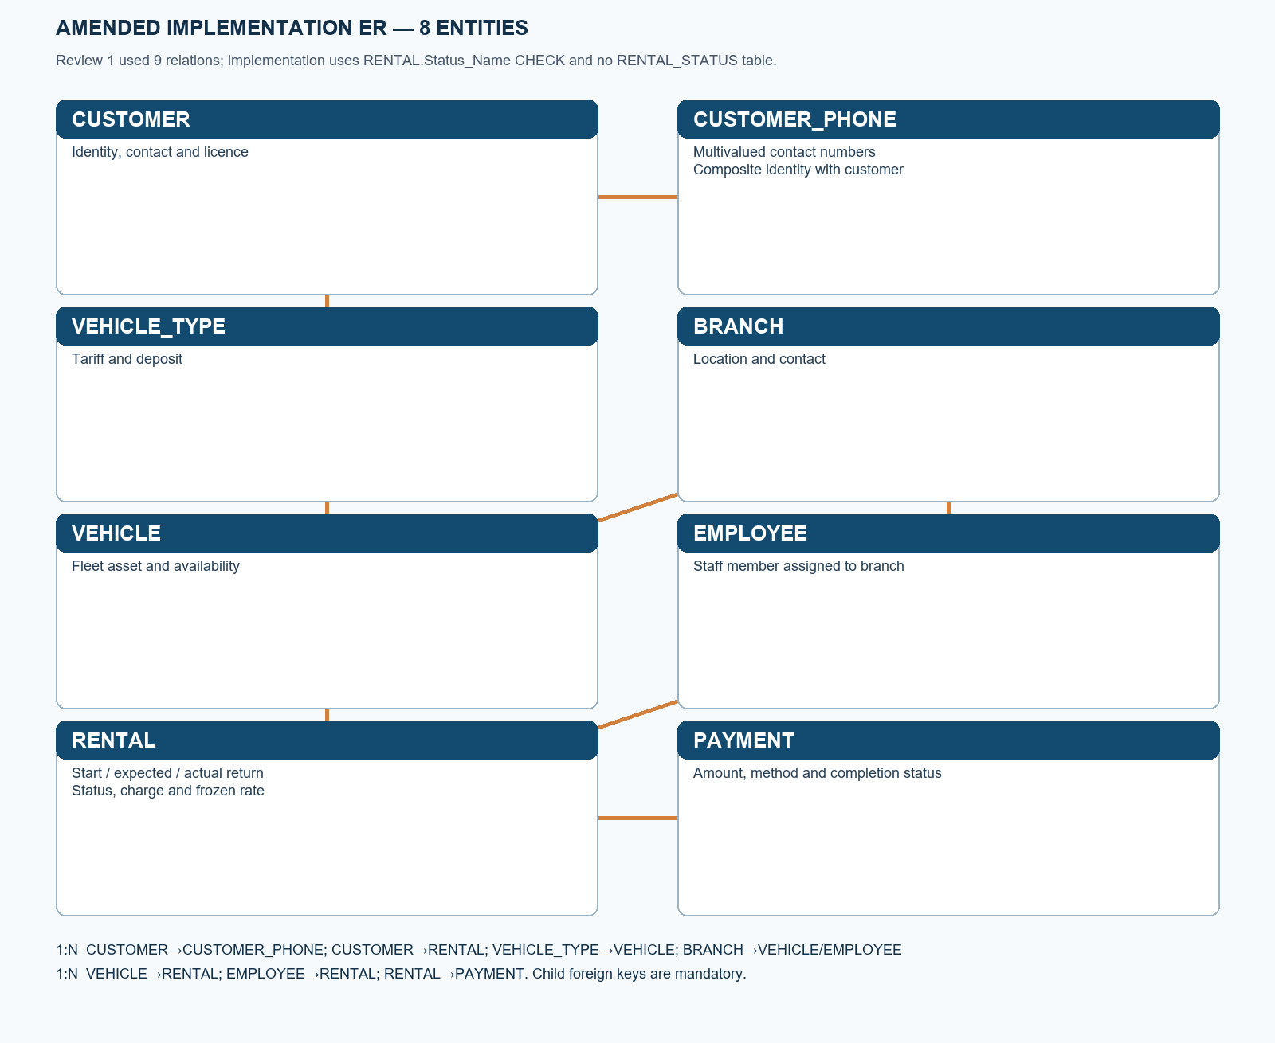

4.7 Design Assumptions
A vehicle can have only one Active rental; a start must find an Available vehicle and valid customer/employee. Completed rental charge uses the frozen rate and actual elapsed days, rounded up with a one-day minimum. Active charge is an estimate. Only Completed payments count toward paid balance, and payment total may not exceed the bill. Unsupported genuine cancellation/refund paths remain limitations.

CHAPTER 5: RELATIONAL DATABASE DESIGN

5.1 Relational Schema
CUSTOMER(Customer_ID PK, First_Name, Last_Name, Email UQ, License_No UQ, Address, Registration_Date); CUSTOMER_PHONE(Customer_ID PK/FK, Phone_No PK); VEHICLE_TYPE(Type_ID PK, Type_Name UQ, Daily_Rate, Security_Deposit); BRANCH(Branch_ID PK, Branch_Name, Location, Phone UQ); VEHICLE(Vehicle_ID PK, Registration_No UQ, Brand, Model, Purchase_Year, Availability_Status, Type_ID FK, Branch_ID FK); EMPLOYEE(Employee_ID PK, Name, Email UQ, Phone UQ, ROLE, Branch_ID FK); RENTAL(Rental_ID PK, Customer_ID FK, Vehicle_ID FK, Employee_ID FK, Status_Name, Start_Date, Expected_Return_Date, Actual_Return_Date, Total_Amount, Daily_Rate_Snapshot); PAYMENT(Payment_ID PK, Rental_ID FK, Payment_Date, Amount, Payment_Method, Payment_Status).

5.2 Table Definitions
The exact Oracle definitions appear in database/schema/02_tables.sql and docs/schema-plan.md. CUSTOMER: Customer_ID NUMBER(6); First_Name/Last_Name VARCHAR2(60); Email VARCHAR2(254); License_No VARCHAR2(24); Address VARCHAR2(240); Registration_Date DATE. CUSTOMER_PHONE: Customer_ID NUMBER(6), Phone_No VARCHAR2(15). VEHICLE_TYPE: Type_ID NUMBER(4), Type_Name VARCHAR2(60), Daily_Rate NUMBER(10,2), Security_Deposit NUMBER(10,2). BRANCH: Branch_ID NUMBER(4), Branch_Name VARCHAR2(80), Location VARCHAR2(160), Phone VARCHAR2(15). VEHICLE: Vehicle_ID NUMBER(6), Registration_No VARCHAR2(24), Brand/Model VARCHAR2(60), Purchase_Year NUMBER(4), Availability_Status VARCHAR2(16), Type_ID/Branch_ID NUMBER(4). EMPLOYEE: Employee_ID NUMBER(6), Name VARCHAR2(120), Email VARCHAR2(254), Phone VARCHAR2(15), ROLE VARCHAR2(40), Branch_ID NUMBER(4). RENTAL: Rental_ID NUMBER(8), Customer_ID/Vehicle_ID/Employee_ID NUMBER(6), Status_Name VARCHAR2(12), Start_Date/Expected_Return_Date/Actual_Return_Date TIMESTAMP(0), Total_Amount NUMBER(12,2), Daily_Rate_Snapshot NUMBER(10,2). PAYMENT: Payment_ID/Rental_ID NUMBER(8), Payment_Date TIMESTAMP(0), Amount NUMBER(12,2), Payment_Method VARCHAR2(20), Payment_Status VARCHAR2(12).

5.3 Keys
Each single-column ID is a primary key except CUSTOMER_PHONE, whose composite key is (Customer_ID, Phone_No). Unique candidate/alternate identifiers include CUSTOMER.Email, CUSTOMER.License_No, VEHICLE.Registration_No and VEHICLE_TYPE.Type_Name. FKs link children to parents as shown in the schema. A superkey contains a candidate key and possibly extra attributes.

5.4 Integrity Constraints
Domain constraints restrict positive rates and amounts, phone digit lengths, date order, status and payment method values. Entity integrity uses non-null primary keys. Referential integrity uses eight mandatory FKs and restrictive parent deletion. The final audit found 8 PK, 8 FK, 8 UNIQUE and 54 CHECK constraints enabled and validated, with zero orphans (step6a-committed-final-audit.log).

5.5 Schema Diagram
The amended relational schema figure is inserted below and supplied separately in editable SVG, PNG and PDF. It names all eight tables and their PK/FK links. The original Review 1 relation count was nine; the implemented RENTAL.Status_Name CHECK replaces its status lookup relation.
Figure 5.1 Amended relational schema
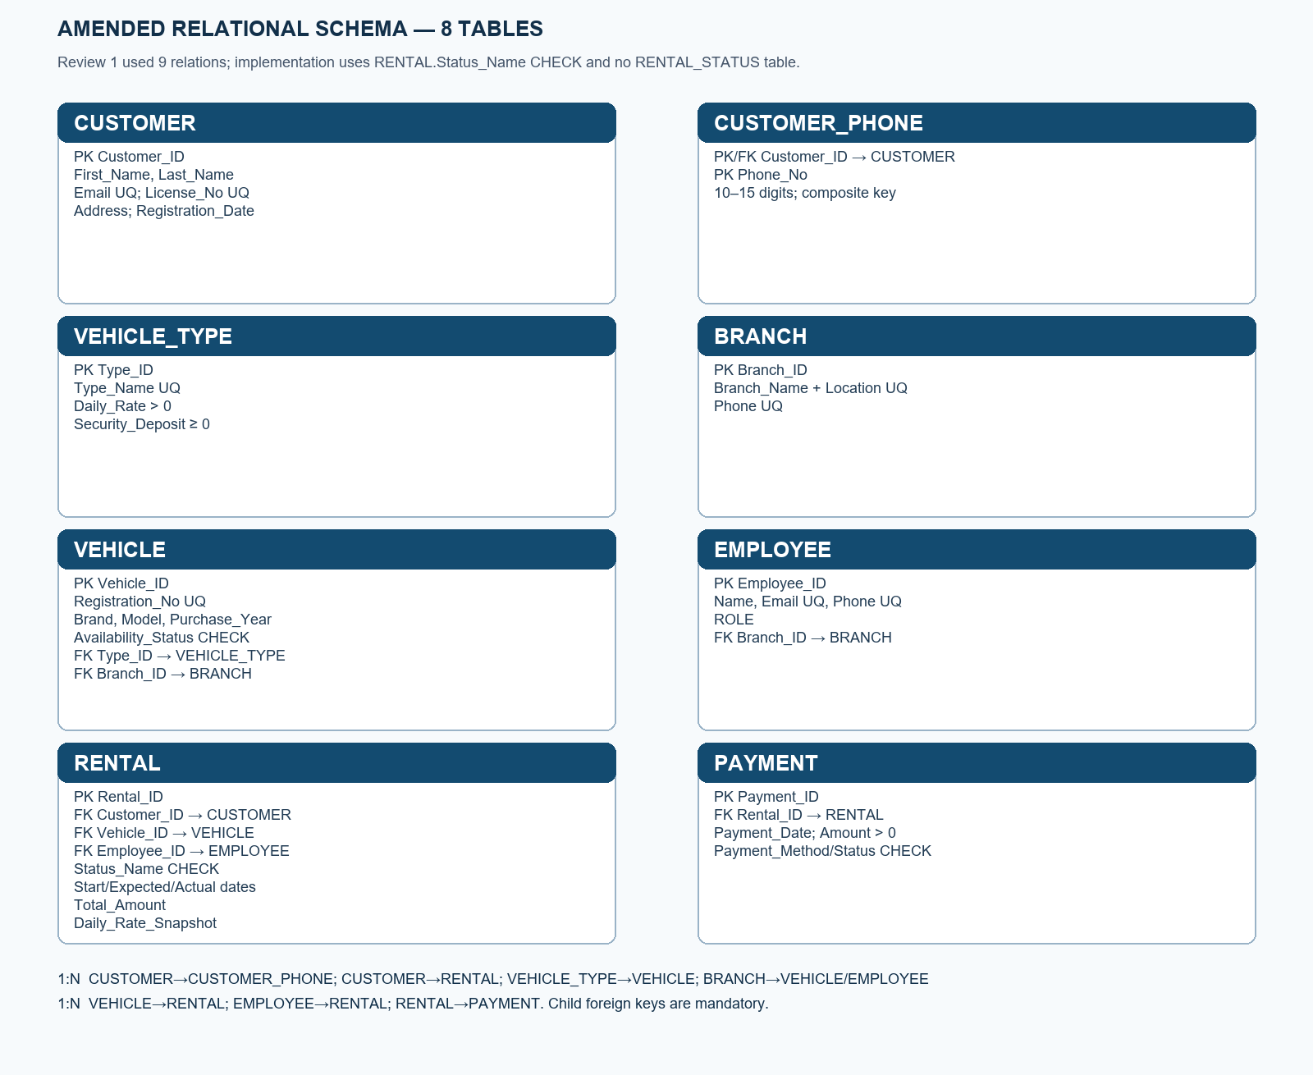

5.6 Data Dictionary
The data dictionary is summarized here and fully specified in docs/schema-plan.md: CUSTOMER identifies a licensed renter; CUSTOMER_PHONE stores each contact number; VEHICLE_TYPE stores category, daily tariff and deposit; BRANCH stores site identity and contact; VEHICLE stores registration, physical details, availability and type/branch links; EMPLOYEE stores staff identity, role and branch; RENTAL stores participants, state, dates, current/final bill and rate snapshot; PAYMENT stores receipt date, amount, method and status. Required/default/unique/check details are in database/schema/02_tables.sql. [If the examiner expects a field-by-field table with descriptions, expand from that file.]
Field purposes by table: CUSTOMER — Customer_ID identifies the renter; First_Name and Last_Name store the name; Email and License_No are unique contacts/credentials; Address stores the contact address; Registration_Date records enrolment. CUSTOMER_PHONE — Customer_ID links to the renter; Phone_No stores one 10–15-digit number and completes the composite key. VEHICLE_TYPE — Type_ID identifies the category; Type_Name labels it; Daily_Rate is the current daily tariff; Security_Deposit is reference deposit data. BRANCH — Branch_ID identifies a site; Branch_Name names it; Location gives its address/area; Phone is its unique contact. VEHICLE — Vehicle_ID identifies the asset; Registration_No is its unique registration; Brand, Model and Purchase_Year describe it; Availability_Status is Available/Rented/Maintenance; Type_ID and Branch_ID locate its tariff and branch. EMPLOYEE — Employee_ID identifies staff; Name, Email and Phone are contacts; ROLE describes duty; Branch_ID assigns the staff member. RENTAL — Rental_ID identifies history; Customer_ID, Vehicle_ID and Employee_ID link participants; Status_Name is Active/Completed/Cancelled; Start_Date and Expected_Return_Date set the planned interval; Actual_Return_Date records completion; Total_Amount is the current/final bill; Daily_Rate_Snapshot preserves the rate at start. PAYMENT — Payment_ID identifies the receipt; Rental_ID links the bill; Payment_Date records collection time; Amount is the positive payment; Payment_Method and Payment_Status classify it.

CHAPTER 6: FUNCTIONAL DEPENDENCIES AND NORMALIZATION

6.1 Functional Dependencies
Key FDs include Customer_ID→customer details; Type_ID→type details; Branch_ID→branch details; Vehicle_ID→vehicle attributes including Type_ID and Branch_ID; Employee_ID→employee attributes including Branch_ID; Rental_ID→participant IDs, dates, status, amount and snapshot; Payment_ID→rental ID and payment details. In CUSTOMER_PHONE, (Customer_ID, Phone_No) is the key; neither component alone identifies a row.

6.2 Attribute Closure and Candidate Keys
Closure examples under the stated FDs: {Customer_ID}+ yields every CUSTOMER attribute; {Vehicle_ID}+ yields VEHICLE attributes and, via referenced Type_ID and Branch_ID, the joined type/branch facts; {Customer_ID, Phone_No}+ identifies one CUSTOMER_PHONE row. Thus Customer_ID, Vehicle_ID and the composite phone pair are candidate keys in their respective relations. [For formal assessment, add a complete FD set and closure table approved by faculty.]

6.3 First Normal Form (1NF)
An initial customer record with multiple phone columns or a comma-separated list would contain a repeating group. CUSTOMER stores one value per field and CUSTOMER_PHONE stores one phone per row. The implemented tables therefore use atomic stored columns. Derived duration and late days are calculated instead of stored as a repeating summary.

6.4 Second Normal Form (2NF)
Most relations have a single-column key, so a non-key attribute cannot depend on only part of that key. The composite CUSTOMER_PHONE relation has no non-key attribute; Phone_No is part of its key. This addresses the relevant 2NF partial-dependency concern under the stated FDs.

6.5 Third Normal Form (3NF)
Type tariff remains in VEHICLE_TYPE rather than being repeated in each VEHICLE, and branch location remains in BRANCH rather than every VEHICLE/EMPLOYEE. Current type rate is not copied into VEHICLE; RENTAL.Daily_Rate_Snapshot is intentionally historical transaction data. These separations remove obvious transitive dependencies from the operational records.

6.6 Boyce–Codd Normal Form (BCNF)
Under the listed key-based FDs, each nontrivial determinant within a stored relation is a candidate key or unique identifier. That is consistent with BCNF for the described facts. A formal BCNF claim depends on all business FDs, which were not exhaustively elicited. [Add faculty-approved FD inventory and any required decomposition proof.]

6.7 Lossless Join and Dependency Preservation
The CUSTOMER/CUSTOMER_PHONE decomposition is lossless when joined on Customer_ID because CUSTOMER.Customer_ID is unique and CUSTOMER_PHONE.Customer_ID is a mandatory FK. Type, branch and vehicle decomposition follows the same PK/FK pattern. The key-based dependencies are enforced within their own tables; the cross-table historical-rate rule is enforced by the workflow, not an FD inside VEHICLE.

6.8 Before-and-After Example
Before example: CUSTOMER(Customer_ID, Name, Phone_1, Phone_2, Vehicle_Type_Name, Daily_Rate, Branch_Name, Rental_ID, Payment_Amount) repeats customer and tariff facts and cannot represent arbitrary phone/payment counts cleanly. After: separate CUSTOMER, CUSTOMER_PHONE, VEHICLE_TYPE, BRANCH, VEHICLE, EMPLOYEE, RENTAL and PAYMENT tables. This is an illustrative decomposition; the actual installed DDL is the source of truth.

CHAPTER 7: SQL IMPLEMENTATION

7.1 Database and Table Creation (DDL)
Guarded one-time SQL*Plus scripts created the SVR_APP schema in XEPDB1 and its eight project tables. Oracle DDL commits implicitly. The scripts reject unexpected accounts/containers and refuse a blind rerun on existing tables. Source: database/schema/00_admin_preflight.sql, 01_admin_setup.sql and 02_tables.sql. No automatic DROP/TRUNCATE or destructive reset was performed. [Add ALTER/DROP/TRUNCATE teaching examples only as separate non-destructive lab evidence if required.]

7.2 Data Manipulation (DML)
database/seed/01_seed.sql inserted 81 fictional rows after checks. Each member script demonstrates one INSERT, UPDATE and DELETE on disposable data, then ROLLBACK; the actual output is evidence/step3-members.log. Normal browser CRUD was also verified. Genuine rental and payment history is protected against ordinary UPDATE/DELETE.

7.3 Data Retrieval (DQL)
database/queries/01_select_demos.sql contains 15 labelled SELECT demonstrations. They include simple lists, filters, ordered results, joins, nested/correlated EXISTS, aggregates and functions. Actual results are in evidence/step2b-project.log. The browser exposes search/detail/report SELECTs through parameterized API routes.

7.4 Built-In and Aggregate Functions
The member scripts demonstrate UPPER, LENGTH, date and ROUND-style expressions; report queries use COUNT and SUM. The 15-query script and evidence logs contain the executed forms. [Add separate AVG, MIN and MAX outputs if the examiner requires every named aggregate rather than representative variety.]

7.5 GROUP BY and HAVING
Revenue reporting groups completed cash receipts and recognized rental charges by branch. Member 1 and Member 3 SELECTs also aggregate by branch/status. The actual executed query text is in database/queries/01_select_demos.sql and database/step3/member_*_demo.sql. [Add a standalone HAVING result if required by the assessment.]

7.6 Joins
Executed demonstrations join customer-phone, rental/customer/vehicle/type and vehicle/type/branch data. Member 2 includes an outer join and count. The application uses joins for revenue and overdue reports. [Separate RIGHT, CROSS and SELF JOIN evidence was not identified; leave space for an approved lab demonstration if required.]

7.7 Subqueries
Member SELECTs include nested and correlated EXISTS conditions; the 15-query script includes subquery forms. The evidence establishes those executed cases, not every textbook variant. [Add single-row, multi-row, NOT EXISTS, ANY/ALL examples and actual outputs if individually required.]

7.8 Set Operations
[No executed UNION, INTERSECT or MINUS result was identified in the verified project evidence. Add a safe read-only Oracle set-operation query and its actual SQL*Plus output if this template item is required.]

7.9 Views
[No installed Oracle view was verified in the final audit. A RENTAL_DETAILS_VIEW was discussed in lab mapping but is not claimed as implemented. Add an approved view definition, query output and updateability discussion only after executing and verifying it.]

7.10 Constraints
The installed tables use PK, FK, UNIQUE, NOT NULL, CHECK and DEFAULT. The Step 2B negative-constraint/rollback demonstration distinguished expected failures from unexpected SQL errors and left the seed unchanged. Final audit: all 78 named PK/FK/UQ/CHECK constraints enabled and validated, zero orphan records (evidence/step6a-committed-final-audit.log).

7.11 Data Control Language
Administrator setup granted limited privileges to SVR_APP, with a 20 MB USERS quota. Step 3 added only CREATE PROCEDURE, CREATE TRIGGER and CREATE SEQUENCE as needed. This is actual GRANT evidence (environment-check.md; transaction-and-concurrency.md). [A separate REVOKE demonstration was not executed; add it only in a safe disposable account exercise if required.]

7.12 SQL Output Evidence
Purpose, executable SQL and results are preserved in database/queries/01_select_demos.sql and evidence/step2b-project.log. The negative/rollback output is in evidence/step2b-negative-rollback.log. Appendix A identifies the script order. [Attach printed SQL output pages according to G1 pp. 1–2; this digital report does not replace them.]

CHAPTER 8: ADVANCED DATABASE OPERATIONS

8.1 Stored Procedures
SVR_WORKFLOW has three installed procedures: START_RENTAL, RECORD_RETURN and RECORD_PAYMENT. Start locks/checks a vehicle and captures its current rate; return calculates final charge and releases availability; payment checks bill and history. The complete definitions and calls are in database/step3/01_objects.sql and docs/plsql-workflows.md. Actual functional output is evidence/step3-functional.log.

8.2 User-Defined Functions
CALCULATE_CHARGE(start, end, rate) returns a one-day-minimum rounded charge. OUTSTANDING_BALANCE(rental ID) subtracts Completed payments from the stored bill. They are called through JDBC and tested with real database values. The committed rental 7016 had a ₹1,200 final charge and ₹700 outstanding after a ₹500 payment.

8.3 Triggers
TRG_SVR_RENTAL protects genuine rental state/history; compound TRG_SVR_PAYMENT validates and caps completed receipts while avoiding a mutating-table query; TRG_SVR_VEHICLE_STATUS guards direct inconsistent availability changes. All three were VALID with no compiler errors in the final audit. Trigger ownership is not a security boundary against SVR_APP-level DDL.

8.4 Cursors
SVR_WORKFLOW.OVERDUE_REPORT uses an explicit cursor over Active rentals past their expected return. It prints detail through DBMS_OUTPUT in SQL*Plus and returns count/estimated outstanding scalars for JDBC. Source: database/step3/01_objects.sql; execution: evidence/step3-functional.log.

8.5 Sequences and Auto-Generated Keys
SEQ_SVR_RENTAL and SEQ_SVR_PAYMENT allocate identifiers above the seed range. Sequence values can have gaps after rolled-back tests or failed requests; a gap does not imply a missing committed rental/payment. The final audit found both sequences VALID.

8.6 Transactions and ACID Properties
Atomicity: JDBC writes commit only after the full repository/package operation succeeds; failures roll back. Consistency: constraints, triggers and procedures reject invalid states. Isolation: row locks and the active-vehicle unique index guarded concurrent starts and payments in a real two-session test. Durability: normal browser rental 7016, return and payment 8018 persisted across refresh and fresh Oracle connections.

8.7 COMMIT, ROLLBACK, and SAVEPOINT
Procedures establish an entry SAVEPOINT and roll back only their own work on error, then re-raise; the JDBC caller controls final COMMIT/ROLLBACK. Step 3 functional/member scripts used disposable data and rollback. Step 6A normal browser tests committed and retained protected history. Oracle DDL is not rolled back in the same way as DML.

8.8 Concurrency Control
Two actual SVR_APP sessions contended for VEHICLE 3004: B waited until A rolled back, then B proceeded and rolled back its own disposable rental. A second payment-parent contention proceeded after lock release. Logs: evidence/step3-concurrency-a.log and -b.log. The test shows the observed lock order and release, not a general deadlock-proof claim.

8.9 Deadlocks
Deadlocks can arise if two sessions lock the same resources in inconsistent orders. The rental workflow chooses VEHICLE before RENTAL, and payment-only operations lock RENTAL. Oracle detects and aborts a deadlocked statement if one occurs. [No deliberate deadlock test was run; add actual evidence only if faculty requires it.]

CHAPTER 9: QUERY PROCESSING AND OPTIMIZATION

9.1 Query Processing Overview
Oracle parses SQL, validates names and privileges, optimizes a plan and executes it. The Java repository submits fixed parameterized statements or package calls. Query results are returned as JSON to the browser. This is an architectural description; plan/operator details require EXPLAIN PLAN or DBMS_XPLAN evidence.

9.2 Indexes
PK and UNIQUE constraints create supporting index structures; UQ_RENTAL_ACTIVE_VEH is a function-based unique index enforcing at most one Active rental per vehicle. CUSTOMER_PHONE has a composite PK. Index choice for a report query depends on data size and selectivity. [Record the actual USER_INDEXES inventory before claiming further indexes.]

9.3 Query Execution Plan
[No EXPLAIN PLAN or DBMS_XPLAN output was identified in the supplied actual evidence. Insert an executed, password-free Oracle plan for a representative join/report query here if this template requirement is assessed.]

9.4 Query Optimization
The application narrows lists with search filters and a bounded limit, and uses prepared SQL. A before/after SQL rewrite or index comparison was not measured. [Add both executed plans and identical-result evidence before claiming an optimization improvement.]

9.5 Performance Observations
The sample is small: final counts 11/11/10/10/11/10/11/11. Controlled network tests measured an approximately eight-second client timeout and a 1.8-second delayed write that produced one POST/row, but these are not Oracle query benchmarks. [Add repeatable plan/timing measurements and test conditions for a performance claim.]

CHAPTER 10: DATABASE SECURITY, TRANSACTIONS AND RECOVERY

10.1 Authentication and Authorization
SYSTEM administered setup; SVR_APP owns project objects in XEPDB1 with limited create privileges and quota. The local app has no individual login or authorization. EMPLOYEE.ROLE is descriptive data, not permission enforcement. Use the app only on trusted localhost; do not call the Oracle schema owner a secure multi-user application role.

10.2 SQL Injection Prevention
The Java repository uses PreparedStatement for master/search SQL and CallableStatement for package operations, so user values are bound rather than concatenated as SQL. API validation checks IDs, dates and amounts; Oracle constraints remain the final data-integrity guard. Browser text is rendered through textContent rather than inserted as HTML.

10.3 Backup Strategy
[No tested backup job or restoration artifact was supplied. A local academic backup plan could use an authorized Oracle logical export plus a protected copy of source/evidence, with periodic restore tests. Do not describe this as implemented until the export and restore are actually performed.]

10.4 Recovery
Application write failures roll back the current JDBC transaction; Oracle manages crash recovery through its own redo/undo mechanisms. The tested client does not implement a database restore workflow. A lost HTTP response may follow a committed write, so the UI instructs refresh/search before another attempt. [Add a tested backup restoration procedure if required.]

10.5 Integrity and Audit
Final read-only audit checked exactly eight tables; enabled/validated constraints; zero orphans, invalid objects, compilation errors, availability/charge mismatches and overpaid rentals; and a two-way comparison of all 81 original seed rows. Logs exclude passwords. This is consistency evidence, not a comprehensive audit trail of every application user.

10.6 Security Demonstration
Expected constraint failures, referenced-record delete rejection and overpayment rejection were observed. The project user/account guard rejected wrong container/account script execution. [No separate least-privilege denied-operation exercise using a disposable Oracle account was supplied; add only if faculty requires it.]

CHAPTER 11: APPLICATION DEVELOPMENT AND CONNECTIVITY

11.1 System Architecture
The browser loads HTML/CSS/JavaScript from a Java 21 HttpServer at http://127.0.0.1:8080/. Same-origin JSON routes validate requests and call Oracle through JDBC; the SVR_WORKFLOW PL/SQL package and triggers maintain transaction rules. Browser → HTTP API → service/repository → JDBC → SVR_APP in XEPDB1. The local architecture graphic below shows the implemented path.
Figure 11.1 Local application architecture
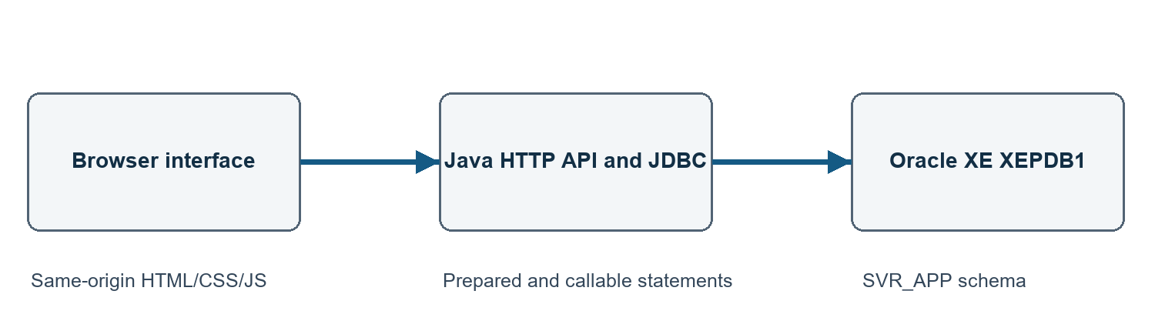

11.2 Technology Stack
Frontend: plain HTML, CSS and JavaScript with five screens. Backend: Java 21 HttpServer, Jackson JSON and project-local Maven build. Data layer: Oracle 21c XE XEPDB1, SQL*Plus, ojdbc11 and PL/SQL. The current machine uses Windows; the normal server binds only to 127.0.0.1.

11.3 Database Connectivity
The backend opens a short-lived JDBC connection per request to jdbc:oracle:thin:@//DESKTOP-FFIRV71:1521/xepdb1 as SVR_APP. The ignored local config stores only non-secret connection settings; the password is read at a hidden local prompt. GET /api/health checks Java, while GET /api/health/database performs a live Oracle read. Normal Step 6A evidence recorded testMode:false and SVR_APP/XEPDB1.

11.4 CRUD Operations
Customer, phone, vehicle type, branch, vehicle and employee forms support create/search/view/update/delete where references allow it. Rental/payment history is read-only except guarded start/return/payment actions. API routes and SQL/PLSQL mapping appear in docs/member-demo-guide.md. The normal committed browser test created customer 1981, vehicle 3981, rental 7016 and payment 8018.

11.5 Input Validation and Error Handling
Required fields and date order are checked before submission; the server validates and Oracle constraints/triggers reject invalid values. Forms preserve values after a rejected write. Pending submit buttons are disabled, and a controlled repeated-click/Enter test produced one POST and one row. On network timeout the UI warns that a write may have committed and directs a refresh/search before retrying.

11.6 Application Screenshots
Screenshots inserted below show actual normal-browser committed rental start, return and payment. Additional dashboard, mobile, validation, offline/recovery and member rehearsal screenshots are in evidence/step6a-*.jpg. There is no login screen because login is not implemented; do not insert a fictional login screenshot.
Figure 11.2 Committed rental start
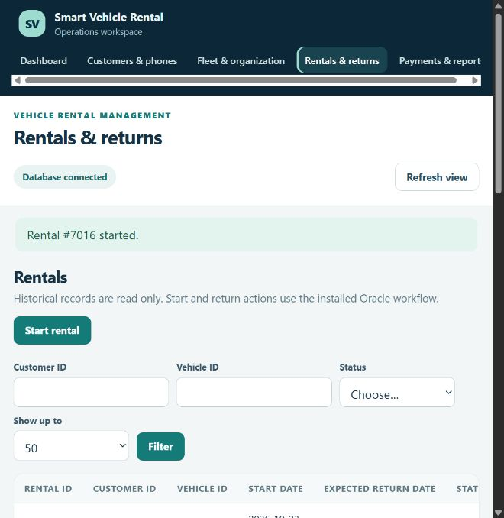
Figure 11.3 Committed return
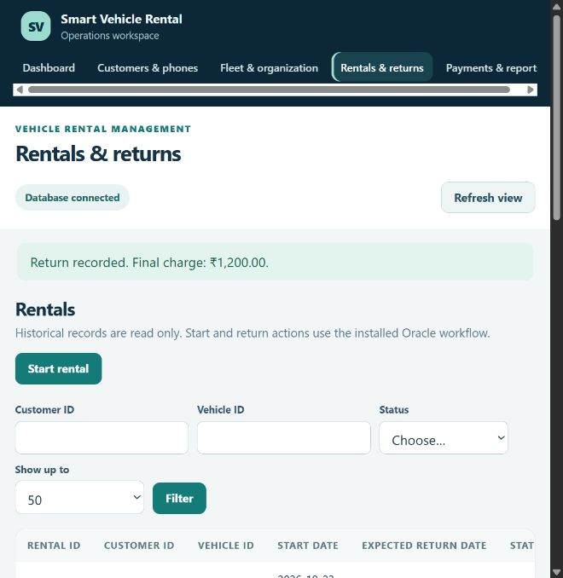
Figure 11.4 Committed payment
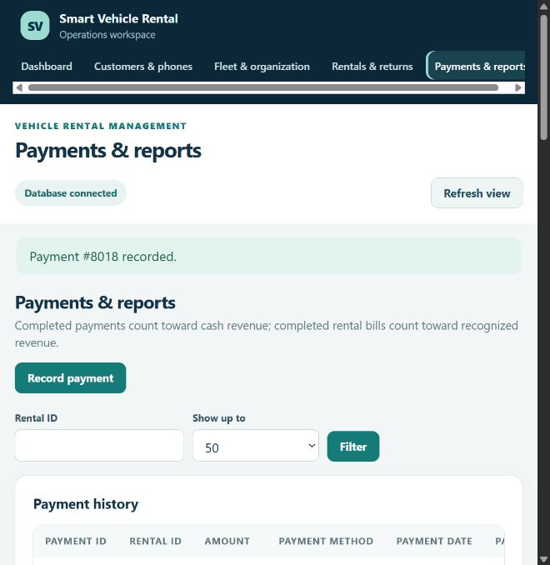

11.7 Relational/NoSQL Note
Not applicable to the implemented Oracle relational system. MongoDB assessment material in the supplied lab folder is a separate exercise and was not used as this project’s data store. The implemented relationships use PK/FK constraints and SQL joins, not document embedding/referencing.

CHAPTER 12: TESTING AND RESULTS

12.1 Testing Strategy
Testing combined guarded SQL*Plus verification, negative constraint/rollback checks, PL/SQL functional tests, two concurrent Oracle sessions, Maven build, HTTP integration, real browser walkthroughs and an independent Oracle audit. Controlled offline/stalled/dropped-response tests checked error handling without claiming every network failure mode. The cited database and browser observations were made on 24–25 October 2026; preparing this report on 2 November did not rerun the database audit.

12.2 Test Cases
Representative executed cases are in Appendix C. Full test detail is in docs/acceptance-test-results.md. The Step 6A matrix recorded 12 Passed, 0 Failed, 3 Blocked and 2 Not applicable academic/technical rows before this report draft. Blocked rows concern handwritten work, Cycle VI and Review 1 amendment, not a failed database transaction.

12.3 SQL Query Validation
All 15 prepared SELECT demonstrations returned results in evidence/step2b-project.log. Each member’s five varied SELECTs plus INSERT/UPDATE/DELETE completed in evidence/step3-members.log; disposable DML was rolled back. The report does not claim that these substitute for all missing Cycle VI lab exercises.

12.4 Constraint and Transaction Tests
Final constraints: 8 PK, 8 FK, 8 UNIQUE and 54 CHECK enabled/validated. Negative tests distinguished expected failures from unexpected SQL errors and left the seed unchanged. The fresh audit found zero orphan rows, invalid objects, compiler errors, availability mismatches, charge mismatches and overpaid rentals. A ₹701 attempted payment against a ₹700 balance was rejected.

12.5 Results and Discussion
The normal browser committed RENTAL 7016 Active at a ₹1,200 snapshot/₹2,400 estimate; refresh and fresh Oracle connection confirmed it. Return completed it at ₹1,200 and made VEHICLE 3981 Available. PAYMENT 8018 recorded ₹500 UPI and left ₹700 outstanding. HTTP, UI and Oracle checks agreed. Four fictional test records remain as protected history; all 81 original seed rows matched exactly.

12.6 Limitations
Missing/unverified Cycle VI coverage; historical Review 1 diagram still has nine relations and needs faculty approval of the eight-table amendment; individual handwritten analysis/ER/mapping/report and hard-copy SQL outputs remain; cancellation/refunds and application login/authorization are unsupported; no idempotency key for separate retries after a lost response; lists have no offset pagination; query-plan, backup/restore and broader performance evidence are not supplied.

CHAPTER 13: CONCLUSION AND FUTURE ENHANCEMENTS

13.1 Conclusion
The project demonstrates an eight-table Oracle schema, key/constraint enforcement, 15 SQL demonstrations, procedures/functions/cursor/triggers, JDBC integration and five browser screens. Actual committed rental, return and payment states were verified independently. Technical testing supports the implemented workflow; academic submission completeness still depends on the manual and faculty items listed in 12.6.

13.2 Learning Outcomes
The work illustrates how ER-to-relational mapping, composite/foreign keys, snapshots, transaction boundaries and row locks interact with an application UI. It also demonstrates the difference between a returned browser success, a rollback demonstration and a committed row confirmed by a fresh Oracle session. Member-specific SQL outputs support individual query practice.

13.3 Future Enhancements
Potential next steps are application login and authorization; genuine cancellation/refund workflows; idempotency keys for uncertain writes; pagination; a documented backup/restore rehearsal; query-plan and performance measurement; and deployment controls beyond localhost. These are future work, not features claimed as present.

REFERENCES
G1: BACSE202_Database_Systems_Project_Guidelines.pdf, pp. 1–2; G2: DatabaseSystems_CourseProject_Guidelines-1-1-2.pdf, pp. 1–2; R1: Smart_Vehicle_Rental_Management_Review1.pdf, pp. 2–7. Project design: docs/schema-plan.md, docs/design-changes.md and database/schema/02_tables.sql. Actual tests: docs/acceptance-test-results.md, docs/acceptance-matrix.md, evidence/step2b-project.log, evidence/step3-members.log, evidence/step3-concurrency-a.log and -b.log, evidence/step6a-committed-final-audit.log. [Add full bibliographic details if required by faculty.]

APPENDIX A: SQL SCRIPTS
Executable sources, in run order: database/schema/00_admin_preflight.sql, 01_admin_setup.sql, 02_tables.sql; database/seed/01_seed.sql; database/queries/01_select_demos.sql; database/verification/01_verify.sql and 02_negative_rollback.sql; database/step3/01_objects.sql and 01b_vehicle_status_trigger.sql; database/step3/member_1_demo.sql, member_2_demo.sql and member_3_demo.sql. Actual outputs are under evidence/. These project files are the complete source attachments; do not rerun one-time setup/schema/seed scripts. [Attach printed copies or an approved code archive as the instructor directs. No installed view or DROP/TRUNCATE demonstration is claimed.]

APPENDIX B: SAMPLE DATA AND SCREENSHOTS
The original 81 fictional seed rows remain unchanged. Final table counts: CUSTOMER 11, CUSTOMER_PHONE 11, VEHICLE_TYPE 10, BRANCH 10, VEHICLE 11, EMPLOYEE 10, RENTAL 11, PAYMENT 11. CUSTOMER 1981, VEHICLE 3981, RENTAL 7016 and PAYMENT 8018 are retained fictional committed demonstration records. Supporting password-free evidence includes step2b-project.log, step3-members.log, step6a-committed-http-final.json and step6a-committed-final-audit.log. Browser screenshots are included in Section 11.6. [Attach additional required printed query outputs and screenshots.]

APPENDIX C: SAMPLE TEST CASE TABLE
Test ID | Test / Input | Expected Result | Actual Result | Status
T01 | Start isolated rental 7016 | Active; snapshot ₹1,200; vehicle Rented | Persisted after refresh and fresh Oracle read | Passed
T02 | Return rental 7016 | Completed; ₹1,200; vehicle Available | UI, HTTP and Oracle agreed | Passed
T03 | Pay ₹500; then try ₹701 | ₹700 balance; overpayment rejected | Payment 8018 only; balance unchanged | Passed
T04 | Final database audit | Seed intact; valid constraints; no anomalies | 81 seed rows matched; zero anomalies | Passed

