**1. Introduction**

**1.1. Purpose**

This project is proposed for the betterment of society. This project aims to help the visually impaired people to be a part of growing digital India by using internet and also aims to make life of such people quite easy. Also, the success of this project will also encourage developers to build something more useful for visually impaired or illiterate people, who also deserves an equal standard in society.

**1.1.1.** **Scope for extension**

Voice could be extended to image attachments and other options such as indentation, fonts etc., that are available with normal E-Mail.

**1.1.2. Future Scope**

For people who can see, e-mailing is not a big deal, but for people who are not blessed with gift of vision it postures a key concern because of its intersection with many vocational responsibilities. This voice based email system has great application as it is used by blind people as they can understand where they are. E.g. whenever cursor moves to any icon on the website say Register it will sound like “Register Button”. There are many screen readers available. But people had to remember mouse clicks. Rather, this project will reduce this problem as mouse pointer would read out where he/she lies. This system focuses more on user friendliness of all types of persons including regular persons, visually compromised people as well as illiterate.

**1.2. Objective**

To provide facilities of communication for visually impaired persons.

2. To provide voice-based mailing service where they could read and send mail on their own.

3. To provide low cost system that will be able to automatically locate and read the text allowed to visually impaired persons.

4. To design and analyse the pre-processing modules for text recognition.

5. To design and analyse the segmentation process for extracting and resizing letters.

**2.SOFTWARE REQUIRMENT ANALYSIS**

**2.1. Define the Problem**

In today’s digital world, most of the works are dependent on internet such as official works are specially done through mails. But there are some other people also who are incapable of using these facilities and some of these incapable people there is also a lot of no. of Blind people. They cannot use smartphones new technology and even can’t use emails which is a basic thing as they can’t see the keyboards and keypads.

**2.2. Define the** **module and Functionality**

• **SPEECH_ TO_ TEXT Converter:** The system acquires speech at run time through a microphone and processes the sampled speech to recognize the uttered text. The recognized text can be stored in a file. We are developing this on Android platform using Eclipse workbench. Our speech to-text system directly acquires and converts speech to text. It can supplement other larger systems, giving users a different choice for data entry. A speech-to-text system can also improve system accessibility by providing data entry options for blind, deaf, or physically handicapped users. Speech recognition system can be divided into several blocks: feature extraction, acoustic models’ database which is built based on the training data, dictionary, language model and the speech recognition algorithm. Analog speech signal must first be sampled at time and amplitude axes, or digitized. Samples of the speech signal are analyzed in even intervals. This period is usually 20 ms because the signal in this interval is considered stationary. Speech feature extraction involves the formation of equally spaced discrete vectors of speech characteristics. Feature vectors from training database are used to estimate the parameters of acoustic models. The acoustic model describes properties of the basic elements that can be recognized. The basic element can be a phoneme for continuous speech or word for isolated words recognition.

• **TEXT_ TO_ SPEECH Converter:** Converting text to voice output using speech synthesis techniques. Although initially used by the blind to listen to written material, it is now used extensively to convey financial data, e-mail messages, and other information via telephone for everyone. Text-to-speech is also used on handheld devices such as portable GPS units to announce street names when giving directions. Our Text-to-Speech Converter‖ accepts a string of 50 characters of text (alphabets and/or numbers) as input. In this, we have interfaced the keyboard with the controller and defined all the alphabets as well as digits keys on it. The speech processor has an unlimited dictionary and can speak out almost any text provided at the input most of the times. Hence, it has an accuracy of above 90%. It is a microcontroller-based hardware coded in Embedded C language. Further research is to be done to optimize various methods of inputting the text i.e. Reading the text using optical sensor and converting it to speech so that almost all sorts of physical challenges faced by the people while communicating are overcome.

• **WORD RECOGNITION:** Voice recognition software (also known as speech to text software) allows an individual to use their voice instead d of typing on a keyboard. Voice recognition may be used to dictate text into the computer or to give commands to the computer. Voice recognition software allows for a quick method of writing onto a computer. It is also useful for people with disabilities who find it difficult to use the keyboard. This software can also assist those who have difficulty with transferring ideas onto paper as it helps take the focus out of the mechanics of writing. Word recognition is measured as a matter of speed, such that a word with a high level of recognition is read faster than a novel one. This manner of testing suggests that comprehension of the meaning of the words being read is not required, but rather the ability to recognize them in a way that allows proper pronunciation. Therefore, context is unimportant, and word recognition is often assessed with words presented in isolation in formats such as flash cards Nevertheless, ease in word recognition, as in fluency, enables proficiency that fosters comprehension of the text being read.

**3.SOFTWARE DESIGN**

**3.1.System Feature 1**

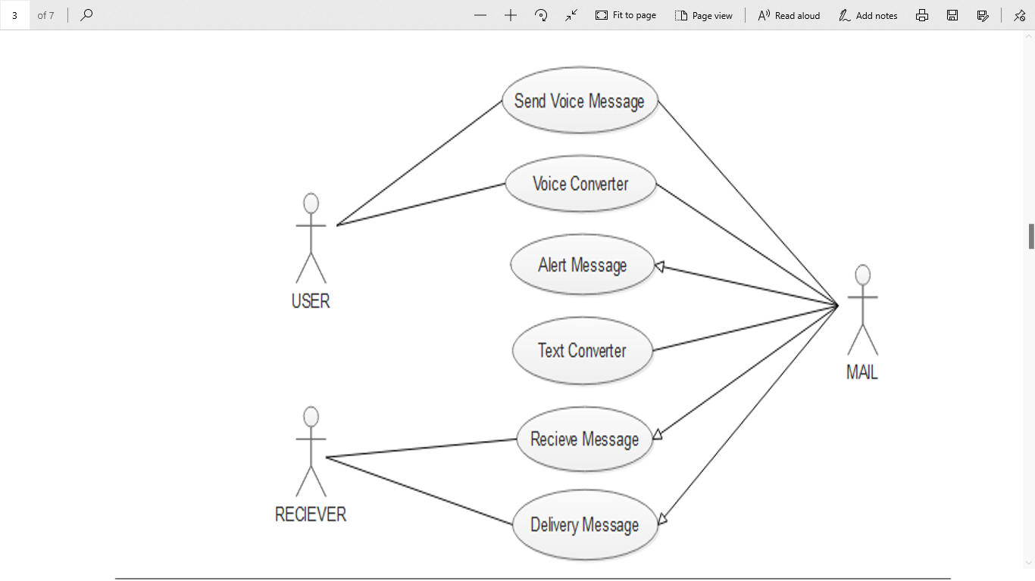

Fig 4.2: Use Case

**3.2. System Feature 2**

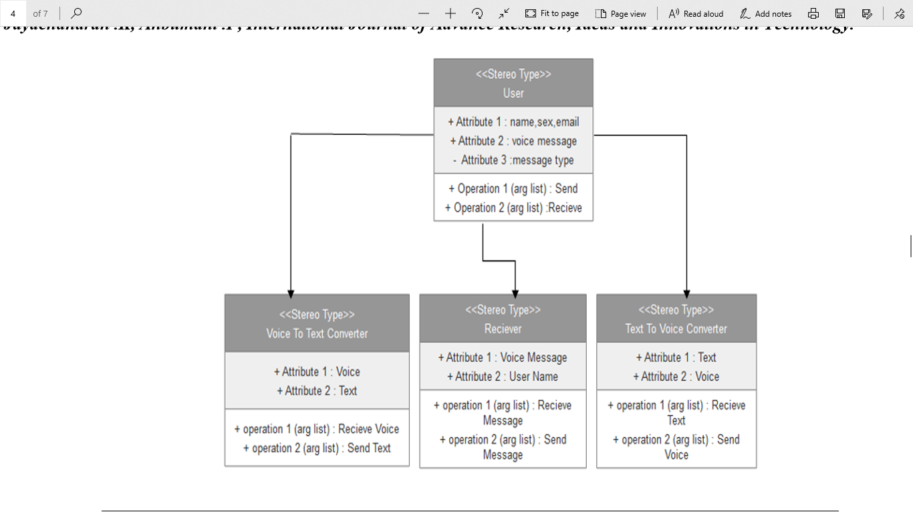

Fig 4.3: Class Diagram

# **3.3. System Feature 3**

# **C:\Users\SRIJAN MITTAL\Pictures\Screenshots\Screenshot (4).png**

Fig 4.4: Sequence Diagram

**4.Testing**

## **4.1.** **Performance Testing**

1. Sending message through internet connection and live streaming makes performance measures crucial.

2. For desired performance, transferred data size, speed of connection, response time, processing speed must be considered.

3. System should work real-time which means there should be an acceptable time delay such as max 4-5 seconds between request and response. Wearable device should have wifi adapter which is fast enough to transfer message to the web server.

4. Web server should be able to handle multiple device and user connection at the same time.

## **4.2.** **Safety Testing**

A standards-compliant SRS must list both the general safety functions and the task-specific functions required by all of the safety instruments that comprise the safety system. General safety functions described by the SRS include such information as the environment the safety system will need to function in and the standards that it must meet. Specific functions include the specific safety integrity level (SIL) at which each safety instrument must function and each safety function’s response time to a safety incident.

## **4.3.** **Security Testing**

The SRS should define the authentication requirements in detail. These include the preferred strategy for resolving forgotten passwords, addressing account lockouts, expiring inactive sessions, etc. If certain critical transactions should require re-authentication, this is the right time to specify that.

## 4.4. **Software Quality Attributes**

**4.4.1. Maintainability**

1. The ease with which a software system or component can be modified to correct faults, improve performance or other attributes, or adapt to a changed environment.

2.The ease with which a hardware system or component can be retained in, or restored to, a state in which it can perform its required functions.”

**4.4.2. Reliability**

The reliability of the wearable device essentially depends on the software tools (OpenCV, ESpeak Text-to-Speech etc.) and hardware tools (camera, ultrasonic sensor, Raspberry Pi etc.) used for the system development.

**5.4.3. Usability**

The system must be easy to learn for both users of the wearable device and helpers who are the users of the web interface.

The wearable device, expectedly a glass, will be an embedded system, so that it has three or four buttons for specific features. During the setup, there will be a voiced guidance for the users of the glass i.e. people with complete blindness or low vision. Throughout the voiced demo, positions of the buttons will be clearly stated.

The web interface elements (e.g. login, message display page) will be easy to understand. There will be a help page and complete user documentation which will explain how to achieve common tasks. Error messages must give the user specific instructions for recovery. The help system will explain all functions and how to achieve common tasks.

**5.IMPLEMENTATION AND USER INTERFACE**

**User Interface**

There will be a user interface for the helper of the user. This interface will be responsible for the communication between the blind person and his/her relative. There will be one page for login, and one page to watch the blind people. Under the watch screen there will be also a chat screen to give necessary directives to the user.

.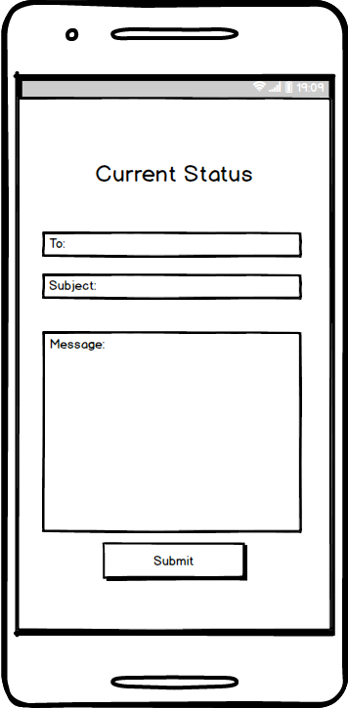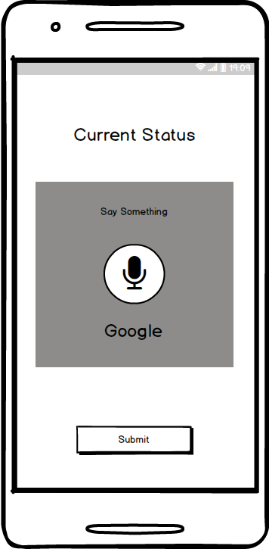

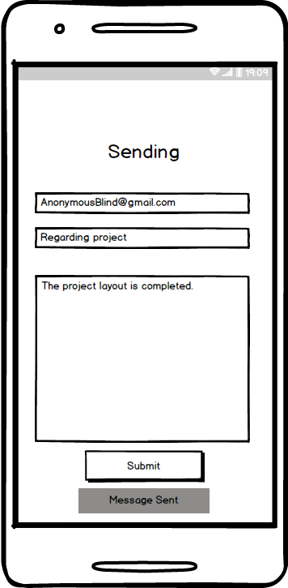

**Implementation**

**A. Registration:** This is the first module of the system. Any user who wishes to use the system should first register to obtain username and password. This module will collect complete information of the user by prompting the user as to what details needs to be entered. The user will need to speak up the details to which the system will again confirm by prompting alphabetically. If the information is not correct user can re-enter else the prompt will specify the operation to be performed to confirm.

**B. Login:** Once the registration is done the user can login to the system. This module will ask the user to provide the username and password. This will be accepted in speech. Speech conversion will be done to text and user will be told to validate whether the details are entered correctly or not. Once the entry is done correctly database will be checked for entry. If the user is authorized it will be directed to homepage.

**C. Forgot Password:** In case where an authorized user forgets the password and thus is not able to login, he/she can select forgot password module. In this module the user will be first told to enter username. According to username the security question will be searched in database. This is the question provided at time of registration. The question will be spoken out by the computer. The user should in turn specify the answer that was provided by him/her during registration. If both get matched, user is given option to change password.

**D. Home Page:** The user is redirected to this page once log in done successfully. From this page now the user can perform operations that the user wishes to perform. The options available are: 1. Inbox 2. Compose 3. Sent mail 4. Trash Prompting will provide the mouse click operation that needs to be performed for the required service. The double right click event is specifically reserved to log out of the system at any time the user wants to. This will be specified by the prompt right at the beginning after login. All these functionalities have been implemented. The modules given below are to be included in the system and will be implemented as a part of the proposed system. The complete walkthrough of this system is given as follows:

**E. Compose mail:** This is one of the most important options provided by the mail services. The functionality of compose mail option would not match the already existing mail system. Since the system is for visually challenged people and keyboard operations are completely avoided composing mail would only be done on voice input and mouse operations. No typed input will be required. User can directly record message that needs to be propagated and can send it. This voice massage will go in form of attachment. The receiver can hear the recording and get the message user wanted to send. User would not require attaching the file. Record option will be provided in the compose window itself. Once recorded it will confirm whether the recording is perfect or not by letting the user hear it and if the user confirms it will be automatically attached to the mail.

**F. Inbox:** This option helps the user view all the mails that has been received to his/her account. The user can listen to mails he/she wants to by performing the click operation specified by the prompt. In order to navigate through different mails prompt will specify which operations to perform. Each time the mail is selected the user will be prompted as whom the sender is and what is the subject of that particular mail. Accordingly, user can decide whether the mail needs to be read or not or it should be deleted. Deleted mails will be saved in trash section.

**G. Sent mail:** This option will keep a track of all the mails sent by the user. If the user wants to access these mails, this option will provide them with their needs. In order to access the sent mails user will need to perform the actions provided by the prompt to navigate between mails. When the control lands on particular mail user will be prompted as who the receiver was and what is the subject of the mail. This will help the user in efficiently understanding and extracting the required mail.

**H. Trash:** This option will keep a track of all the mails deleted by the user. Deleted mails could be the ones from inbox or sent mail. If at any time the user needs to retrieve a mail which was deleted it can be done from this option.

**6.REFERENCES**

* Android System Programming –Roger Ye
* ANDROID:[www.W3school.com](http://www.W3school.com)
* ANDROID: [www.Javatpoint.com](http://www.Javatpoint.com)
* Udemy Android Course.
* Wikipedia: www.wikipedia.com

Appendix A: Glossary

A M

Android Operating System Maintainability

Assumptions **N**

# **C** Nonfunctional Requirements

Class Diagram **P**

Communications Interfaces Performance Requirements

**D** Product Scope

Dependencies Purpose Product Functions

Design **R**

**E** Reliability

ER Diagram Reading Suggestion

**H S**

## Hardware Requirement Security Requirements

**I** Safety Requirements

Introduction System Feature

Implementation Constraints Sequence Diagram

Intended Audience Software Requirements References

**U** Scope for extension FutureScope

Usability Software Quality Attribute

Use Case

User Interface

User Documentation

User Classes

Appendix B: Analysis Models



Fig: Class Diagram