**1. Introduction**

**1.1. Purpose**

This project is proposed for the betterment of society. This project aims to help the visually impaired people to be a part of growing digital India by using internet and also aims to make life of such people quite easy. Also, the success of this project will also encourage developers to build something more useful for visually impaired or illiterate people, who also deserves an equal standard in society.

**1.1.1. Scope for extension**

Voice could be extended to image attachments and other options such as indentation, fonts etc., that are available with normal E-Mail.

**1.1.2. Future Scope**

For people who can see, e-mailing is not a big deal, but for people who are not blessed with gift of vision it postures a key concern because of its intersection with many vocational responsibilities. This voice based email system has great application as it is used by blind people as they can understand where they are. E.g. whenever cursor moves to any icon on the website say Register it will sound like “Register Button”. There are many screen readers available. But people had to remember mouse clicks. Rather, this project will reduce this problem as mouse pointer would read out where he/she lies. This system focuses more on user friendliness of all types of persons including regular persons, visually compromised people as well as illiterate.

**1.2 Document Conventions**

The document follows MLA format. Bold-faced text has been used to emphasize section and sub-section headings. Highlighting is to point out words in the glossary an italicized text is used to label and recognize diagrams.

**1.3 Intended Audience and Reading Suggestions**

This document is to be read by the development team, the project managers, marketing staff, testers and documentation writers. The SRS has been organized approximately in order of increasing specificity. The developers and project managers need to become intimately familiar with the SRS.

Others involved need to review the document as such:

**Overall Description –** Marketing staff have to become accustomed to the various product features in order to effectively advertise the product.

**System features –** Testers need an understanding of the system features to develop meaningful test cases and give useful feedback to the developers.

**1.4.Product Scope**

For people who can see, e-mailing is not a big deal, but for people who are not blessed with gift of vision it postures a key concern because of its intersection with many vocational responsibilities. This voice based email system has great application as it is used by blind people as they can understand where they are. E.g. whenever cursor moves to any icon on the website say Login it will sound like “Login Button”. This system focuses more on user friendliness of all types of persons including regular persons, visually compromised people as well as illiterate.

**1.5 References**

* Android System Programming –Roger Ye
* ANDROID:[www.W3school.com](http://www.W3school.com)
* ANDROID: [www.Javatpoint.com](http://www.Javatpoint.com)
* Udemy Android Course.
* Wikipedia: www.wikipedia.com

**2. OVERALL DESCRIPTION**

**2.1 Product Perspective**

To provide the user friendly system to all the visually challenged people. It is our one step towards helping those people to face the challenging world of internet today. To provide them the facility of technology through this they have the chance to overcome this disability.

**2.2 Product Functions**

This voice mail system is develop to help the visually impaired people to make feel them a normal user. Voice interactions can escape the physical limitations on keypad and help user to accessing mails easily. This system can used by both visually abled and disabled persons. The proposed system is an application that allows sending and receiving of mails via internet. We use artificial intelligence to benefit the blind to make use of the advanced technology for their growth and improvement. It is cost effective and easy to maintain.

**2.3 User Classes and Characteristics**

**2.3.1. Login:** This is the very first page and will ask user to enter login credentials. It will prompt user with voice command to enter user name. After receiving user name it will prompt again for password. After receiving all of the details from user, it will encrypt and check the validity of the details entered by user. If valid, then user will be redirected to dashboard else will be sent back to login page.

**2.3.2.Dashboard:** After successful login, user will be redirected to this page and this is the main page from where user can perform all the activities like, compose a new mail, check inbox, save to draft etc.

**2.3.3.** **Compose a Mail:** This module is used to compose a new mail.

**2.3.4.** **Inbox:** This page will store all of the mails received by user.

**2.3.5. Trash:** This folder will store all of mails deleted by the user.

**2.3.6. Sent Mail:** This folder will store all of the mails sent from the user.

**2.4 Operating Environment**

**Android Operating System**

Android is a comprehensive open source platform designed for mobile devices. It is championed by Google and owned by Open Handset Alliance. The goal of the alliance is to accelerate innovation in mobile computing and offer consumers a richer, less expensive, and better mobile experience. Android is the vehicle to do so. Android is a Linux-based operating system mainly used for running mobile devices such as smart phones and tablet computers. Its usability is not limited to mobile devices. Because of its open and customizable features, it is used in a wide range of electronics devices, like laptops, smart TV, cameras, headphones, wristwatches, game consoles, car CD and DVD players, home automations and many more [Marko Gargenta]. Android OS is hardware independent and runs on devices from different vendors, unlike other proprietary operating systems such as iOS (Apple Inc. products), Blackberry OS (Blackberry), S40 OS (Nokia), Windows OS (Windows Phone) etc., which are licensed and controlled by certain companies. As of May 2013, Android dominates the smartphone market accounting 74.4% of worldwide smartphone sales [Gartner].

Android is a full-fledged operating system and a complete software stack for mobile devices. Android APIs are a rich set of system services wrapped in an intuitive class files which provides easy access to several features like location, web, telephony, Wi-Fi, media, camera , and so on. All the tools, frameworks and software necessary to develop a mobile application are available for free.

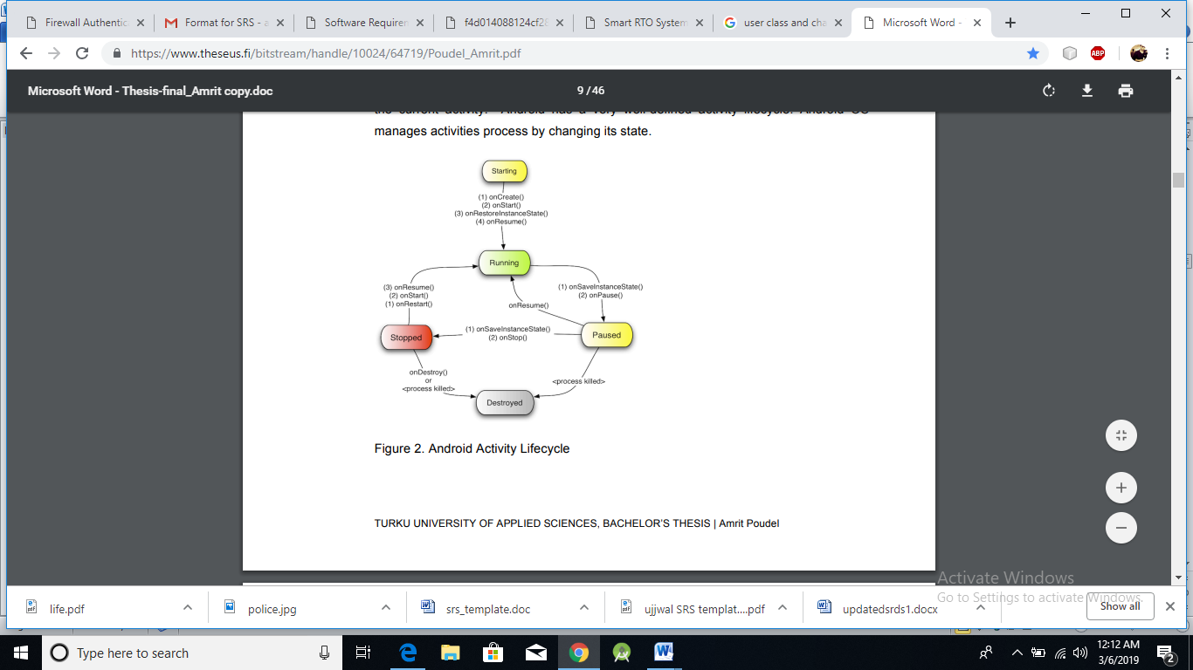

Fig 2.4: Life Cycle

**2.5 Design and Implementation Constraints**

The mobile application is constrained by the data provided by the website and the verification at the block level. If the data provided by the site is not accurate and the block officials don’t pay attention or do fraud then the system will have problem showing the stats.

The Internet connection is also a constraint for the application. Since the application fetches data from the database over the Internet, it is crucial that there is an Internet connection for the application to function. The mobile application will be constrained by the capacity of the database. The database may be forced to queue incoming requests and therefore increase the time it takes to fetch data.

**2.6 User Documentation**

The application’s user interface has been specifically designed with their customers in mind, giving them convenience while they travel. It makes sure at every point, that the customer spends most of the time using the device rather than figuring out how to use it.

The home screen offers a menu with a list of functions that the device performs. The user can select one of the options on the menu, and is taken to the respective screen. Every screen displays the menu on the bottom. The user can click on any one of the options and is taken to the screen of their choice.

The device offers easy scroll options to navigate the screens efficiently. To scroll down any screen, simply touch the scroll bar on the screen, and roll down. If the user does not know how to use any functionality or has any queries, the help option can be used. The help screen contains a text field to enter search terms. A list of search results pertaining to the query is displayed.

**2.7 Assumptions and Dependencies**

One assumption about the product is that the data on the database is accurate and the chances of fraud being done at block level are minimal. The user will have enough space in his/her phone to store the data fetched from the database as the application will store the data in memory so that in case of zero updation or slow network it can show the last successfully retrieved data.

**3. EXTERNAL INTERFACE REQUIREMENTS**

**3.1 User Interface**

There will be a user interface for the helper of the user. This interface will be responsible for the communication between the blind person and his/her relative. There will be one page for login, and one page to watch the blind people. Under the watch screen there will be also a chat screen to give necessary directives to the user.

.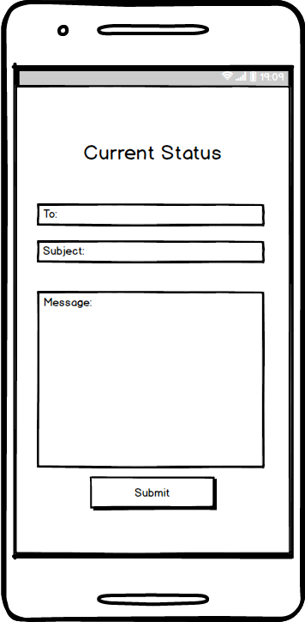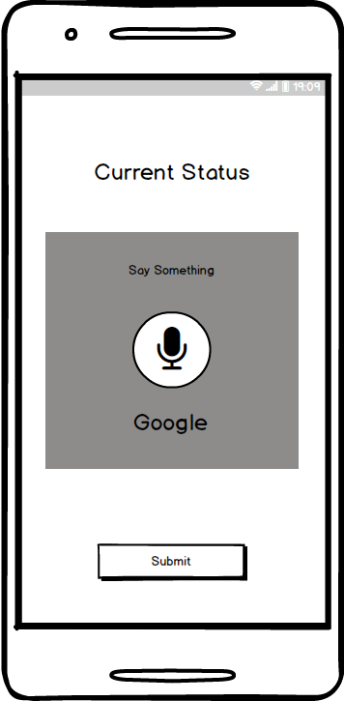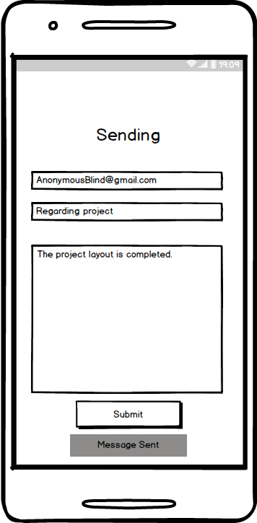

**3.2. Software Requirements**

1. Front End: JSP, Java

2. Back End: SQL

**3.3. Hardware Requirement**

1. Pentium Core processor

2. 512 MB RAM

**3.4 Communications Interfaces**

UDP/TCP client-server module will provide the communication between our hardware device and web application. Data will be sent to server using UDP module and response data is received by TCP module.

**4. SYSTEM FEATURES**

Our System is voice oriented. When user is over every legal space in website, it will receive voice messages where user is right now. If normal people don’t want this feature they can turn it off. This flow diagram will show the details of all the events like actions to be performed for an event.

**4.1.System Feature 1**

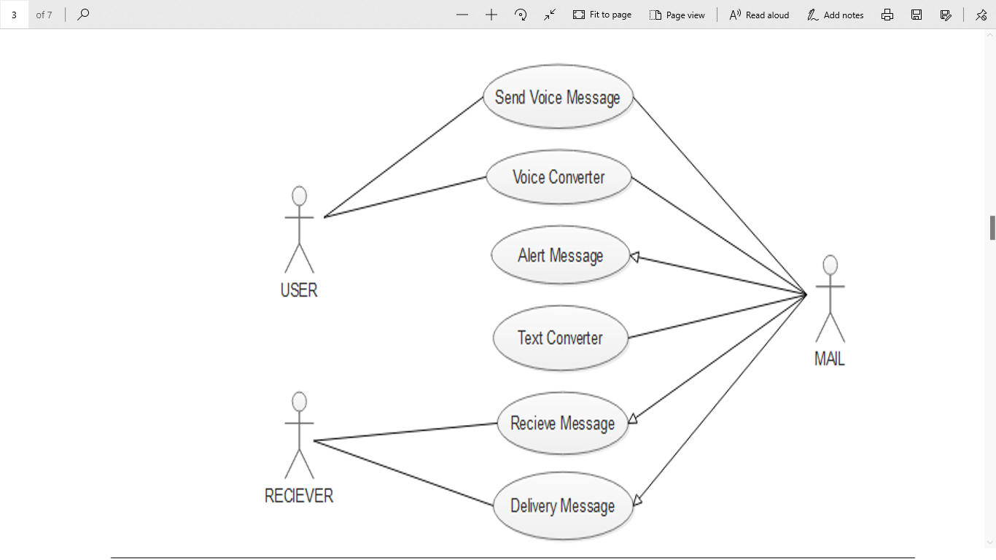

Fig 4.2: Use Case

**4.2. System Feature 2**

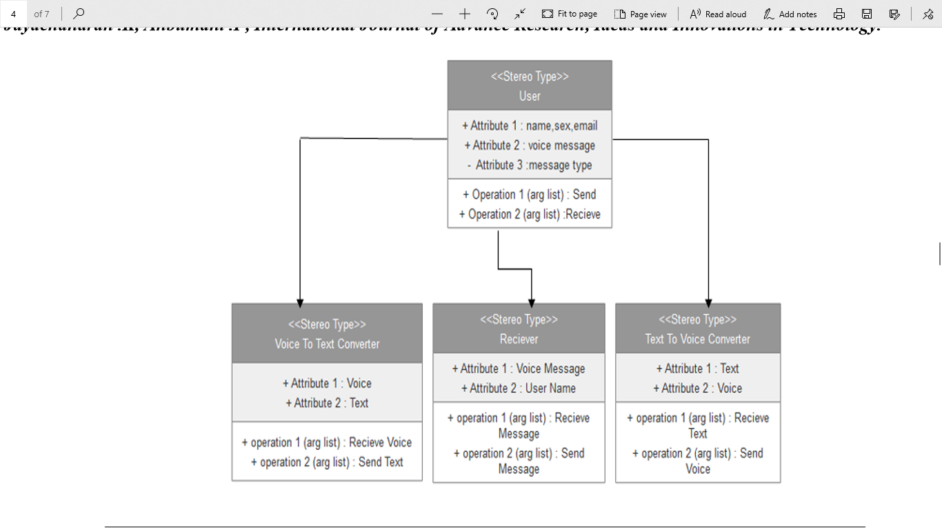

Fig 4.3: Class Diagram

# **4.3. System Feature 3**

# **C:\Users\SRIJAN MITTAL\Pictures\Screenshots\Screenshot (4).png**

Fig 4.4: Sequence Diagram

# **5. Other Nonfunctional Requirements**

## **5.1. Performance Requirements**

1. Sending message through internet connection and live streaming makes performance measures crucial.

2. For desired performance, transferred data size, speed of connection, response time, processing speed must be considered.

3. System should work real-time which means there should be an acceptable time delay such as max 4-5 seconds between request and response. Wearable device should have wifi adapter which is fast enough to transfer message to the web server.

4. Web server should be able to handle multiple device and user connection at the same time.

## **5.2.** **Safety Requirements**

A standards-compliant SRS must list both the general safety functions and the task-specific functions required by all of the safety instruments that comprise the safety system. General safety functions described by the SRS include such information as the environment the safety system will need to function in and the standards that it must meet. Specific functions include the specific safety integrity level (SIL) at which each safety instrument must function and each safety function’s response time to a safety incident.

## **5.3.** **Security Requirements**

The SRS should define the authentication requirements in detail. These include the preferred strategy for resolving forgotten passwords, addressing account lockouts, expiring inactive sessions, etc. If certain critical transactions should require re-authentication, this is the right time to specify that.

## 5.4. **Software Quality Attributes**

**5.4.1. Maintainability**

1. The ease with which a software system or component can be modified to correct faults, improve performance or other attributes, or adapt to a changed environment.

2.The ease with which a hardware system or component can be retained in, or restored to, a state in which it can perform its required functions.”

**5.4.2. Reliability**

The reliability of the wearable device essentially depends on the software tools (OpenCV, ESpeak Text-to-Speech etc.) and hardware tools (camera, ultrasonic sensor, Raspberry Pi etc.) used for the system development.

**5.4.3. Usability**

The system must be easy to learn for both users of the wearable device and helpers who are the users of the web interface.

The wearable device, expectedly a glass, will be an embedded system, so that it has three or four buttons for specific features. During the setup, there will be a voiced guidance for the users of the glass i.e. people with complete blindness or low vision. Throughout the voiced demo, positions of the buttons will be clearly stated.

The web interface elements (e.g. login, message display page) will be easy to understand. There will be a help page and complete user documentation which will explain how to achieve common tasks. Error messages must give the user specific instructions for recovery. The help system will explain all functions and how to achieve common tasks.

Appendix A: Glossary

A M

Android Operating System Maintainability

Assumptions **N**

# **C** Nonfunctional Requirements

Class Diagram **P**

Communications Interfaces Performance Requirements

**D** Product Scope

Dependencies Purpose Product Functions

Design **R**

**E** Reliability

ER Diagram Reading Suggestion

**H S**

## Hardware Requirement Security Requirements

**I** Safety Requirements

Introduction System Feature

Implementation Constraints Sequence Diagram

Intended Audience Software Requirements References

**U** Scope for extension FutureSccpe

Usability Software Quality Attribut

Use Case

User Interface

User Documentation

User Classes

Appendix B: Analysis Models



Fig: Class Diagram