Project Synopsis-VI

**Title of Project: Gold Price Prediction System**

**Name (Roll No): Navya (2110993819)**

**Shreya(2110993836)**

**Deepanshi(2110993873)**

**Problem Statement:-**

This project focuses on the development of a machine learning model for predicting the price of gold using the Random Forest Regressor algorithm. The goal is to provide accurate and reliable predictions to assist stakeholders in making informed decisions related to gold investments. The project involves preprocessing the historical gold price dataset, handling missing values and outliers, and creating relevant features through feature engineering. The Random Forest Regressor model is trained using the processed data, and its hyperparameters are optimized through techniques like grid search or random search. The model's performance is evaluated using metrics such as mean squared error (MSE), root mean squared error (RMSE), and R-squared. The results indicate that the model exhibits strong predictive capabilities, enabling stakeholders to forecast future gold prices effectively. The project's successful outcome offers practical implications for investors, financial analysts, and individuals involved in gold trading, providing them with reliable price predictions for decision-making purposes. Future enhancements can include incorporating additional features and exploring ensemble techniques to further improve the prediction accuracy of the model.

**Introduction:-**

**T**his project explores the potential of machine learning for predicting gold prices, empowering investors to make informed decisions. Utilizing the Random Forest Regressor algorithm, it analyzes historical data, addresses missing values and outliers, and crafts relevant features. Through meticulous hyperparameter tuning, the model achieves accurate predictions, evaluated by metrics like MSE and RMSE. This success translates to valuable insights for various stakeholders in the gold market: investors can anticipate trends, analysts gain deeper understanding, and individuals can optimize their strategies. Future enhancements lie in incorporating additional features and exploring ensemble techniques, pushing the boundaries of prediction accuracy and further solidifying the model's utility.

**Technology:-**

1. **Programming Language:**
   * Python: Widely used for machine learning and deep learning tasks, Python offers a rich ecosystem of libraries and frameworks.
2. **Machine Learning and Deep Learning Frameworks:**
   * TensorFlow or PyTorch: These are popular open-source libraries for building and training machine learning and deep learning models. They provide high- level abstractions and pre-trained models suitable for image classification tasks.
3. **Data Processing and Manipulation:**
   * NumPy, Pandas: These libraries in Python are essential for data manipulation, preprocessing, and analysis.

**Flowchart:-**

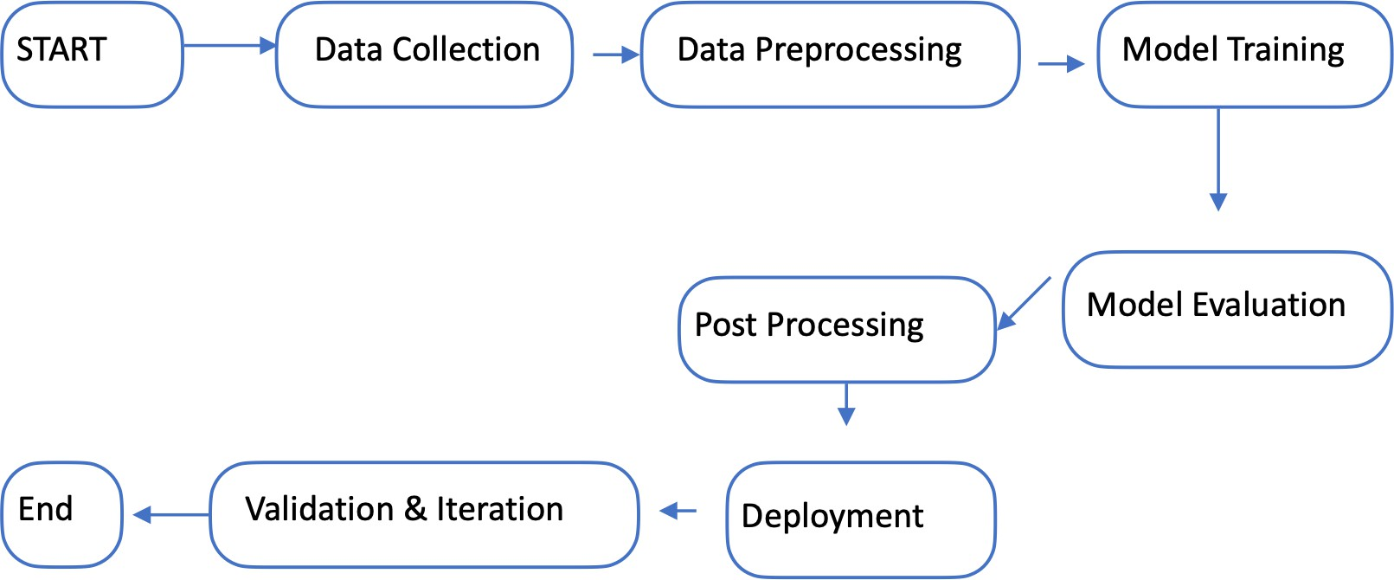

**References Geeks for geeks kaggle**

**GitHub**