VLSI Internship – Task 2 Report
Mitta Manoghna Reddy [MT5351]
Implementation and Verification of Logic Gates, Half Adder, and Full Adder using Verilog HDL
Objective
The objective of this task is to learn the fundamentals of Verilog HDL and implement basic combinational circuits such as logic gates, Half Adder, and Full Adder. The circuits were simulated and verified using Xilinx Vivado.
1. Logic Gates
Verilog Code
module logic_gates(
input A,
input B,
output AND_OUT,
output OR_OUT,
output NOT_A,
output NAND_OUT,
output NOR_OUT,
output XOR_OUT
);

assign AND_OUT = A & B;
assign OR_OUT = A | B;
assign NOT_A = ~A;
assign NAND_OUT = ~(A & B);
assign NOR_OUT = ~(A | B);
assign XOR_OUT = A ^ B;

endmodule
Simulation Output
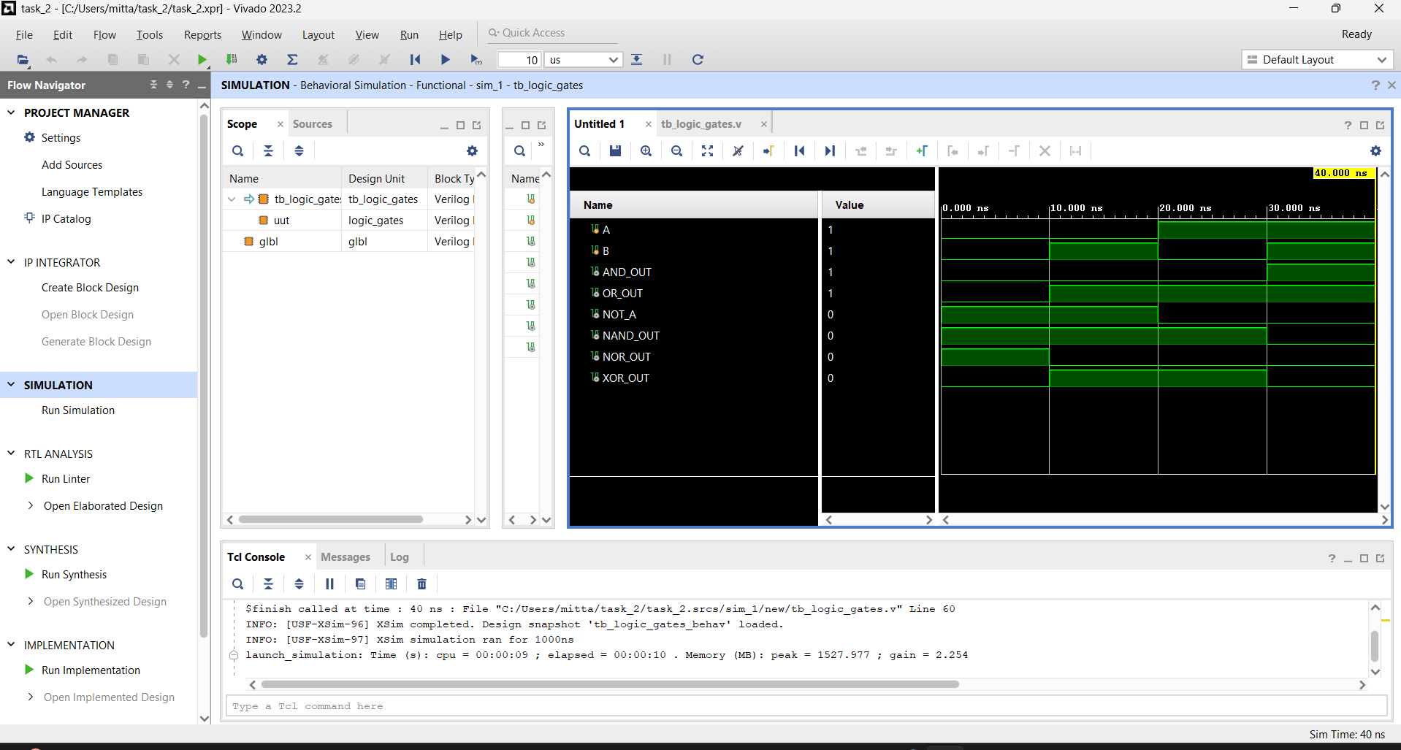

Observation
The outputs of AND, OR, NOT, NAND, NOR, and XOR gates were verified successfully for different combinations of inputs.

2. Half Adder
Verilog Code
module half_adder(
input A,
input B,
output Sum,
output Carry
);

assign Sum = A ^ B;
assign Carry = A & B;

endmodule
Truth Table
A | B | Sum | Carry
0 | 0 | 0 | 0
0 | 1 | 1 | 0
1 | 0 | 1 | 0
1 | 1 | 0 | 1
Simulation Output
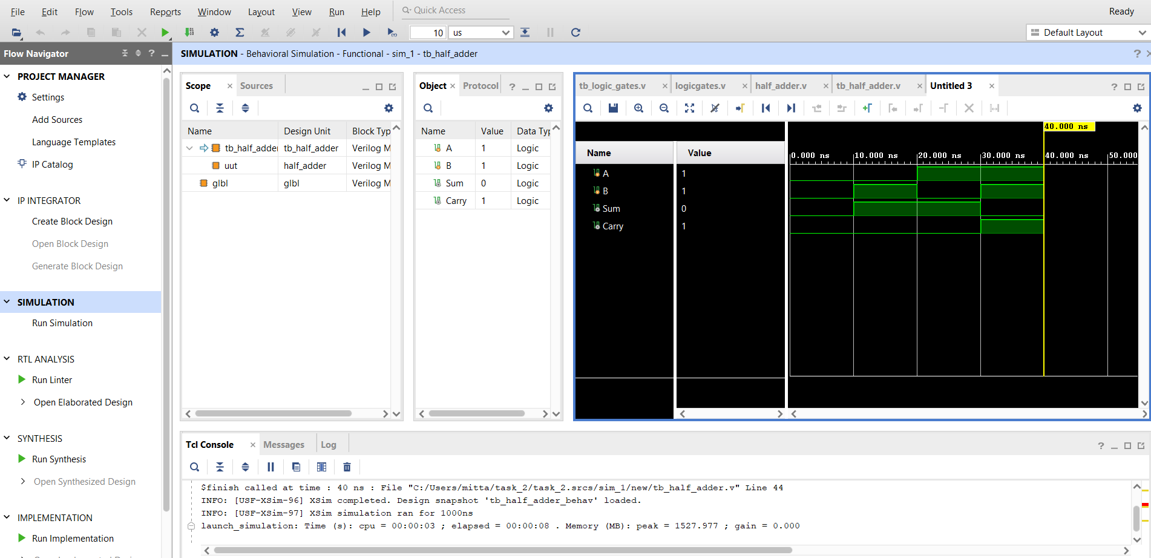

Observation
The Half Adder produced the correct Sum and Carry outputs according to the truth table.

3. Full Adder
Verilog Code
module full_adder(
input A,
input B,
input Cin,
output Sum,
output Cout
);

assign Sum = A ^ B ^ Cin;
assign Cout = (A & B) | (B & Cin) | (A & Cin);

endmodule
Truth Table
A | B | Cin | Sum | Cout
0 | 0 | 0 | 0 | 0
0 | 0 | 1 | 1 | 0
0 | 1 | 0 | 1 | 0
0 | 1 | 1 | 0 | 1
1 | 0 | 0 | 1 | 0
1 | 0 | 1 | 0 | 1
1 | 1 | 0 | 0 | 1
1 | 1 | 1 | 1 | 1

Simulation Output
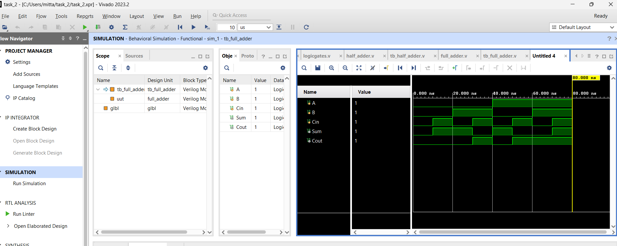

Observation
The Full Adder was successfully implemented and verified. The Sum and Carry outputs matched the expected truth table for all input combinations.

Conclusion
In this task, Verilog HDL was used to design and simulate logic gates, a Half Adder, and a Full Adder using Xilinx Vivado. The simulation results matched the expected outputs, confirming the correct functionality of all implemented circuits. This task provided practical experience in digital circuit design and Verilog-based hardware modeling.

