WHOIS

STEP 1:- OPEN WHOIS website in web browser

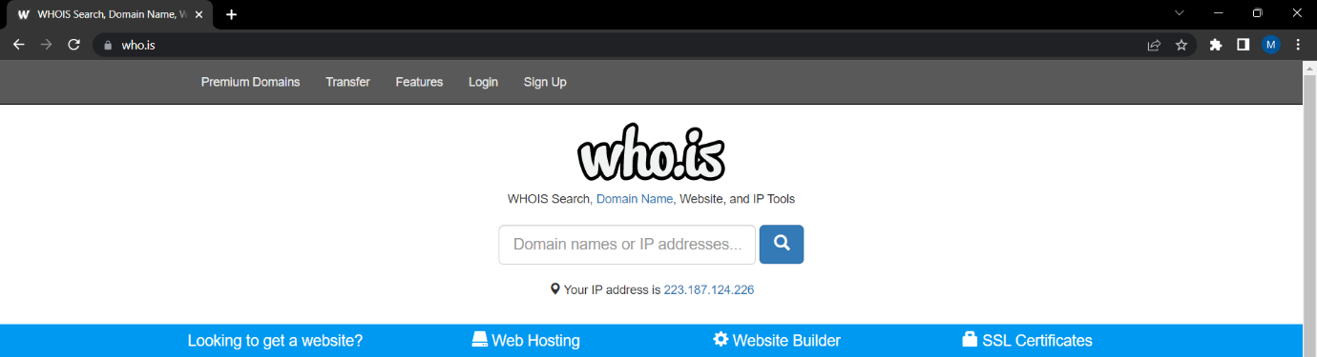

STEP2:- Enter website URL example [www.saveetha.com](http://www.saveetha.com)

STEP3:- Now it will show the information about saveetha.

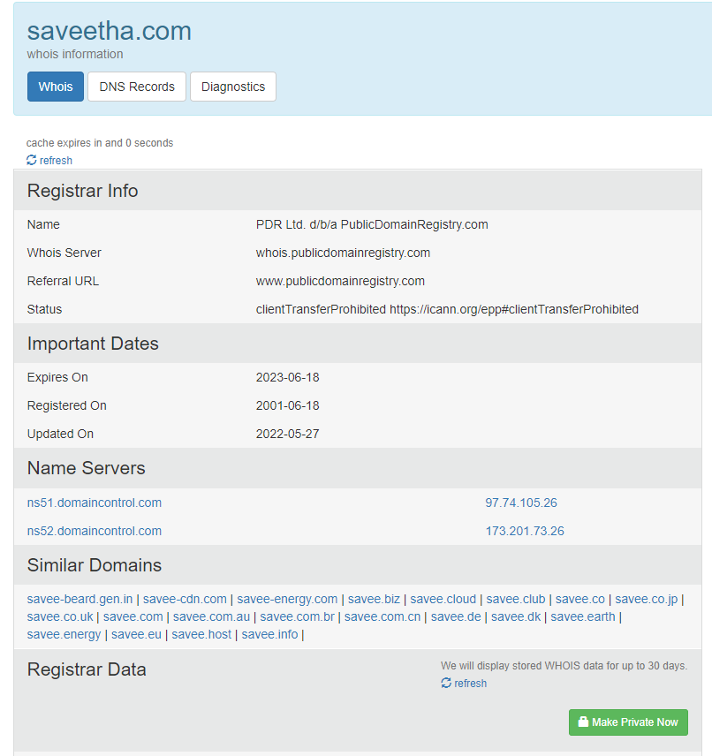

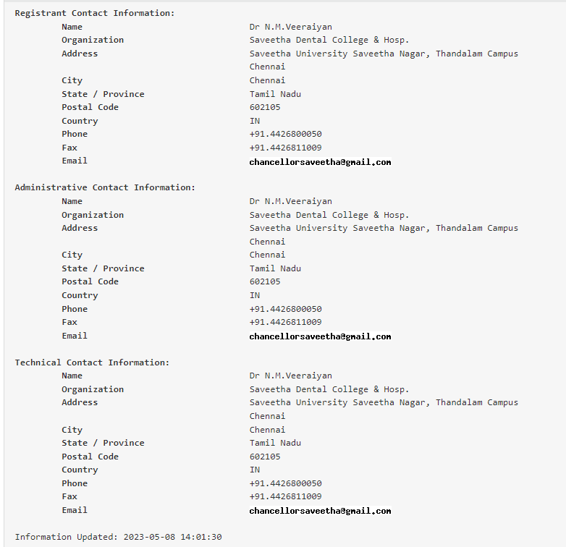

STEP4:- GOTO DNS Record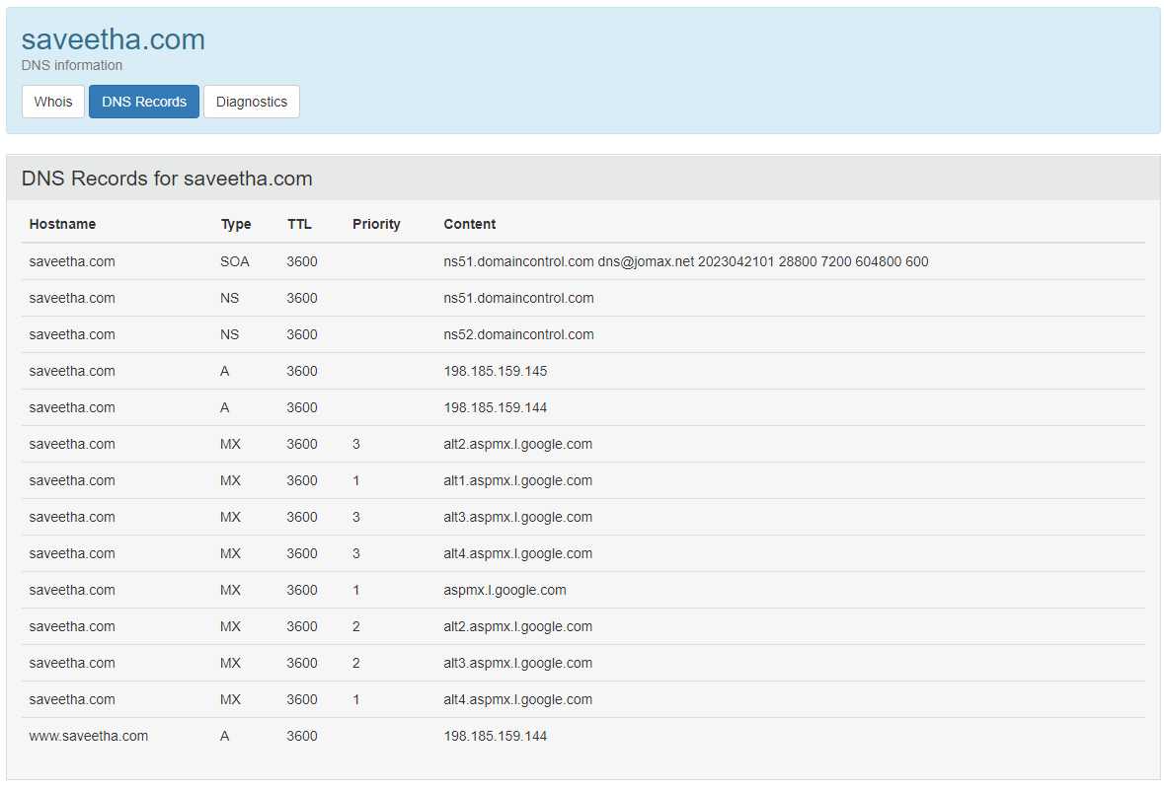

STEP 5:- GO TO DIAGNOSTICS

STEP6:- VERIFY IM not a ROBORT

