HAADS • SIH 26050
HIGH-ALTITUDE RUGGEDIZED ANTI-DRONE DETECTION
AND PRECISION TRACKING SYSTEM
with AI-Based Environmental Compensation
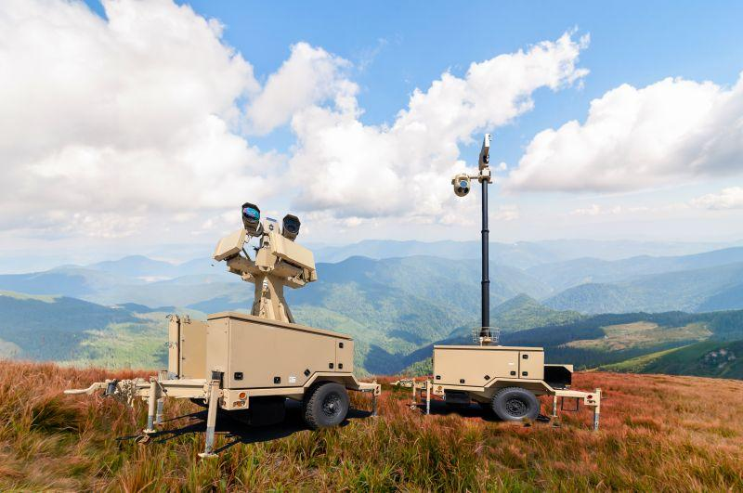
Concept reference image retained from the source project document.
PROJECT IDENTITY
Problem Statement: High-Altitude Performance Optimization and Robust Design of Anti-Drone System • Problem Statement ID: 26050 • Revision 1.0

Prepared: September 2026

Document Control & Engineering Status
Field | Value
Project | HAADS — High-Altitude Anti-Drone System
SIH Problem Statement | High-Altitude Performance Optimization and Robust Design of Anti-Drone System
PS ID | 26050
Primary innovation | Environmental-aware adaptive sensing and precision tracking
Current software prototype | Python + Streamlit + YOLO26n general object detection + environmental simulation + compensation + health monitoring
Hardware simulation | Wokwi ESP32 simulation with BME280, MPU6050, pan/tilt servos and environmental input controls
Physical hardware status | Not yet treated as fully deployed hardware; future prototype architecture remains proposed
RF scope | Receive-only monitoring concept; no RF jamming, disruption or interception
Response scope | Alert, operator notification, tracking handoff and simulated authorized workflow only
Team Name | DEVOPS

IMPORTANT CLAIMS POLICY
The source document contains illustrative values such as detection confidence, tracking error, system health and mission-readiness percentages. These are not presented here as measured field results unless independently validated. The current vision prototype is described as general object detection; drone-specific detection requires a suitable drone-trained/fine-tuned model and dataset.

Contents
The Word table of contents field below is intended to be updated in Microsoft Word using References → Update Table. The numbered sections are kept stable so the document can also be navigated manually.

1. Executive Summary
HAADS is an environmental-aware sensing, tracking and system-health architecture intended to maintain dependable target detection and precision pan-tilt tracking when high-altitude operating conditions degrade conventional electronic, mechanical and power-system performance.
The central engineering idea is to measure environmental state — temperature, pressure, humidity, wind and vibration — and feed that state into compensation and health-monitoring logic. Rather than treating environmental effects as external disturbances, the system uses them as control inputs for adaptive tracking, sensor correction, thermal management and performance assessment.
The proposed system combines an EO camera and edge AI pipeline with environmental sensing, a real-time control layer, pan-tilt actuation, thermal control, battery monitoring and a ground-control dashboard. The academic prototype is intentionally simulation-first: software behavior and embedded control concepts can be demonstrated before physical hardware is manufactured.
CORE VALUE PROPOSITION
Environment → estimate disturbance/degradation → compensate → stabilize → monitor health → inform operator.

2. Problem Statement & Context

2.1 Operational problem
An anti-drone system is commonly framed around four functions: Detect → Identify → Track → Respond. At high altitude, environmental conditions can reduce the reliability of sensing, actuation, power delivery and electronics.
- Extreme cold
- Low atmospheric pressure
- Strong winds
- Dust and snow
- Reduced battery performance
- RF performance variation
- Mechanical stiffness
- Sensor drift
The source document defines the main objective as monitoring environmental conditions and automatically compensating for their effects on detection, tracking, stabilization and system health. fileciteturn5file0L10-L25

2.2 Engineering interpretation
Condition | Potential system effect | HAADS response
Low temperature | Cable stiffness, sensor bias, battery degradation, electronics outside preferred operating range | Temperature-aware compensation, calibration, thermal management, health warnings
Strong wind | Pan-tilt disturbance and pointing error | IMU + wind estimate + encoder feedback + adaptive control
Low pressure / low air density | Changes in environmental state and cooling effectiveness | Pressure monitoring and environmental state model; thermal design accounts for reduced convective cooling
Dust / snow / moisture | Ingress and contamination risk | Rugged enclosure, sealed connectors, protective coating and maintenance strategy
Vibration | Tracking noise, sensor disturbance, mechanical stress | IMU monitoring, vibration isolation and health monitoring

3. Objectives, Requirements & Success Criteria

3.1 Primary objectives
- Continuously monitor environmental and system-health parameters.
- Detect and track visible targets using an edge-AI vision pipeline.
- Estimate environmental effects on tracking and system health.
- Apply temperature-, wind- and sensor-aware compensation.
- Maintain stable pan-tilt behavior using feedback.
- Expose system state through a live operator dashboard.
- Provide a simulation-first path to hardware validation.

3.2 Functional requirements
ID | Requirement | Verification approach
FR-01 | Camera/video input available to AI pipeline | Live stream / test video
FR-02 | Object detections include location and confidence | Bounding boxes and inference output
FR-03 | Tracking maintains target state across frames | Tracker continuity test
FR-04 | Environmental variables update continuously | Simulator/Wokwi telemetry
FR-05 | Compensation state changes with environmental conditions | Scenario tests
FR-06 | Health monitor reports subsystem state | Dashboard fault/status test
FR-07 | Pan/tilt commands respond to target error | Simulation or servo test
FR-08 | System distinguishes prototype facts from future capabilities | Documentation review

3.3 Engineering success criteria
For the student prototype, success should be demonstrated by repeatable behavior rather than invented absolute percentages. A strong demonstration is a before/after comparison under controlled simulated environmental conditions: nominal → cold → high wind → sensor drift, with observable changes in compensation mode, control parameters, health state and tracking behavior.

4. System Architecture
Layer | Main elements | Role
Sensing | EO camera, temperature, pressure, humidity, wind, IMU, optional dust sensing | Observe target and environment
Edge AI | YOLO-based detector, tracker, performance model | Extract target information and estimate state
Environmental engine | Condition classification and compensation logic | Convert environmental state into control/health adjustments
Real-time control | MCU, motor control, encoder feedback, heater control | Execute deterministic actuation and protection
Actuation | Pan axis, tilt axis, thermal actuator | Stabilize sensor and maintain operating temperature
Health & dashboard | Health monitor, Streamlit UI, alerts | Expose system condition and operator information

HAADS HIGH-LEVEL DATA & CONTROL FLOW
EO CAMERA → AI DETECTION → TARGET TRACKING
↓
ENVIRONMENT SENSORS → ENVIRONMENT ENGINE → ADAPTIVE COMPENSATION
↓
PAN-TILT + THERMAL CONTROL
↓
HEALTH MONITOR → DASHBOARD

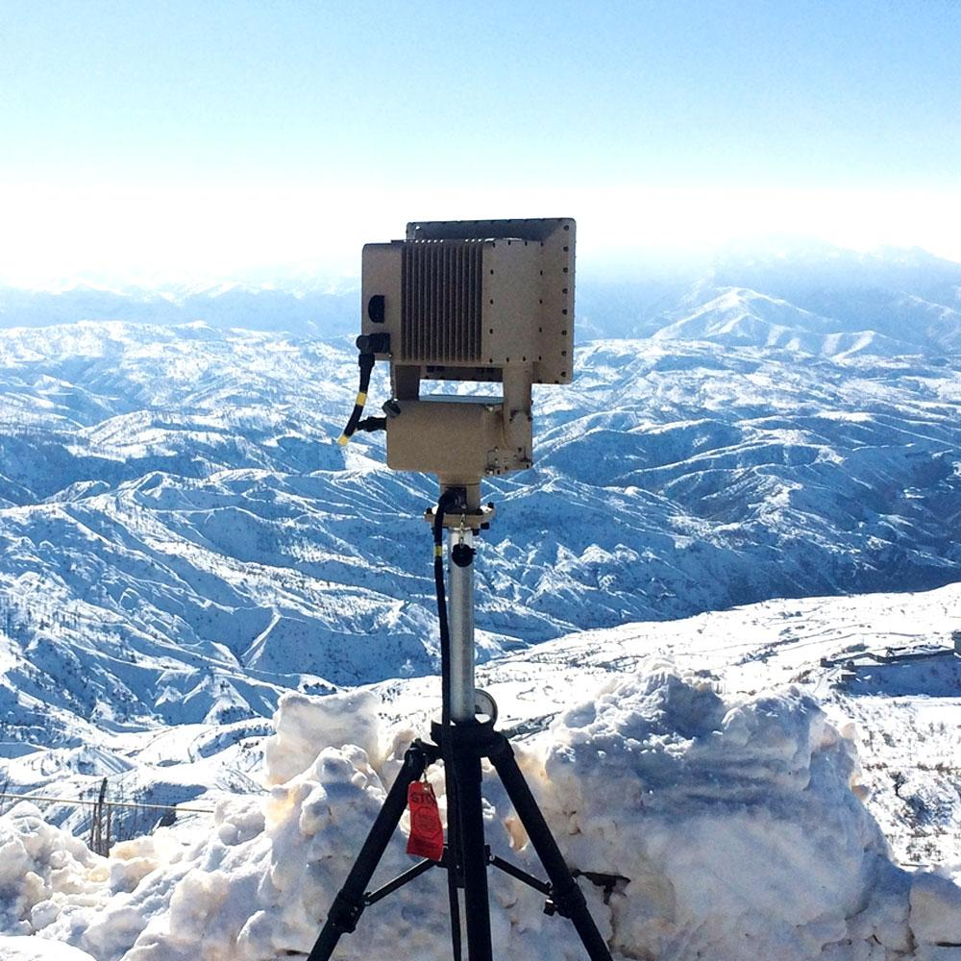
High-altitude sensing concept image from the supplied source document.

5. Detection, Identification & Tracking

5.1 EO vision pipeline
The source document proposes an EO camera pipeline of Camera → Video Frames → AI Detection Model → Candidate → Tracking Algorithm → Pan-Tilt Command. It also discusses drone/bird/aircraft/background discrimination as a future classification capability. fileciteturn5file5L688-L737
CURRENT SOFTWARE-ALIGNED VISION FLOW
CAMERA / VIDEO INPUT
↓
YOLO26n / SUITABLE DETECTOR
↓
OBJECT BOX + CONFIDENCE
↓
TRACKER: POSITION / MOTION STATE
↓
PAN-TILT ERROR
↓
CONTROL COMMAND

CURRENT PROTOTYPE STATUS
The current camera demonstration uses YOLO26n for general object detection. Do not describe the generic model as a validated drone detector. Drone-specific identification should be claimed only after a drone-trained/fine-tuned model and evaluation dataset are integrated.

5.2 RF monitoring concept
The source proposes RF detection as an optional sensing subsystem using an SDR receiver, antenna, signal processing and spectrum-monitoring software. Any RF implementation in this project is scoped to receive-only sensing and must follow applicable spectrum regulations. The placeholder values such as “XXXX MHz” and “XX dBm” from the source are intentionally removed from this final document because they are not actual measured project values. fileciteturn5file9L1114-L1115

5.3 Thermal sensing concept
A thermal camera is identified as a complementary option for low-light, night and poor-visibility conditions. For the student prototype, this can remain simulated or future hardware because the source document explicitly allows simulation when hardware cost is high. fileciteturn5file5L706-L711

6. Precision Pan-Tilt Tracking
The camera/sensor is mounted on a two-axis pan-tilt mechanism. The controller converts target image position into pan and tilt error and then drives the corresponding actuators. The source identifies pan-tilt tracking as one of the most important parts of the proposed system. fileciteturn5file8L937-L952
Signal | Origin | Control use
Target X/Y | Vision detector/tracker | Calculate image-center error
IMU attitude/vibration | IMU | Estimate platform disturbance
Wind estimate | Wind sensor / simulated input | Increase stabilization effort
Encoder position | Motor/gimbal feedback | Close the position loop
Temperature | Environmental sensor | Compensate mechanical/control behavior

7. Temperature-Dependent Cable Rigidity Compensation
At low temperature, cable assemblies can become stiffer and less flexible. If the cable routing exerts resistance on a pan-tilt axis, it can introduce unwanted torque, increasing pointing error, motor load and oscillation risk. This mechanism is explicitly described in the source document. fileciteturn5file8L953-L988
CABLE COMPENSATION CONCEPT
MEASURE TEMPERATURE
↓
TEMPERATURE-DEPENDENT CABLE STIFFNESS MODEL
↓
ESTIMATE DISTURBANCE TORQUE
↓
ADD COMPENSATION TO MOTOR COMMAND
↓
CHECK POSITION / CURRENT FEEDBACK

7.1 Conceptual model
A simplified conceptual relationship is τc ≈ k(T) · θ, where τc is estimated compensation torque, k(T) is temperature-dependent effective stiffness and θ is the relevant angular displacement. This is a model concept, not a validated mechanical identification result. The actual function should be identified experimentally from the selected cable routing, material and gimbal geometry.

7.2 Validation plan
- Measure axis error with flexible/nominal cable routing.
- Repeat at controlled temperature points or with a safe thermal simulation.
- Record motor effort/current and position error.
- Fit an empirical temperature-to-disturbance model.
- Compare tracking behavior with compensation disabled and enabled.

8. Wind Disturbance Compensation
Strong wind can disturb the camera and pan-tilt assembly. The proposed solution combines IMU measurements, wind information and motor encoder feedback so that the controller can estimate disturbance and correct pointing angle. fileciteturn5file8L989-L1004
WIND COMPENSATION LOOP
WIND DISTURBANCE
↓
IMU + WIND SENSOR + ENCODER
↓
ESTIMATE ATTITUDE / POSITION ERROR
↓
ADAPTIVE CONTROL
↓
PAN-TILT CORRECTION

8.1 Control behavior
At increasing wind levels, the controller can transition through operating modes such as NORMAL → HIGH-WIND → EXTREME-WIND. The exact thresholds should be configuration parameters validated during testing rather than treated as universal limits.

9. Adaptive Control System
Instead of keeping fixed controller parameters for every environment, the proposed architecture uses temperature, wind and pressure as context inputs to an adaptive controller. The source explicitly contrasts a fixed PID loop with an adaptive arrangement that changes parameters with environmental conditions. fileciteturn5file4L517-L538
Environment state | Possible controller response | Purpose
Nominal | Baseline gains / normal stabilization | Smooth tracking
Cold | Increase modeled disturbance compensation; monitor stiffness-related load | Counter temperature-induced resistance
High wind | Increase disturbance rejection / stabilization mode | Reduce pointing disturbance
High vibration | Increase filtering and health scrutiny | Avoid reacting to noise as target motion
Sensor drift warning | Apply calibrated correction / reduce confidence | Prevent biased feedback

10. Sensor Drift Compensation
The source document identifies temperature-related sensor drift as a potential source of error and proposes using calibration data to map measured temperature to a corrected sensor value. fileciteturn5file4L539-L553
SENSOR DRIFT CORRECTION
MEASURED SENSOR VALUE
+
MEASURED TEMPERATURE
↓
CALIBRATION TABLE / MODEL
↓
CORRECTED SENSOR VALUE
↓
CONTROL + HEALTH MONITOR

ENGINEERING NOTE
The source includes an illustrative IMU example with a +1.5° cold-environment error. That value is retained only as an example of the concept, not as a measured characteristic of the prototype.

11. Environmental Monitoring Subsystem
The source identifies temperature, atmospheric pressure, humidity, wind speed, vibration and optional dust ingress as environmental parameters. The purpose is to estimate how much the environment is affecting system performance. fileciteturn5file0L56-L70
Parameter | Prototype / proposed sensor | Used by
Temperature | Digital temperature sensor / BME280 for simulation | Thermal control, cable compensation, drift model, health
Pressure | Barometric pressure sensor / BME280 for simulation | Environmental state and performance model
Humidity | Humidity sensor / BME280 for simulation | Moisture/condensation risk
Wind | Anemometer or simulated wind input | Disturbance compensation
Vibration / attitude | IMU / MPU6050 for simulation | Stabilization and health
Dust ingress | Optional particulate / ingress sensor | Ruggedization and maintenance risk

12. Thermal Management
The source proposes insulated enclosure construction, controlled heaters, thermal pads, heat spreaders, temperature monitoring and low-temperature-rated components. It also notes that lower air density can reduce the effectiveness of ordinary air cooling. fileciteturn5file4L1043-L1064
CLOSED-LOOP THERMAL CONTROL
EXTERNAL / INTERNAL TEMPERATURE
↓
TEMPERATURE CONTROLLER
↙ ↘
HEATER MONITORING
↓
SAFE OPERATING RANGE
↓
REDUCE HEATER POWER

12.1 Heater control concept
The recommended architecture is closed-loop control rather than permanently energizing a heater. A future hardware implementation can use an MCU GPIO → MOSFET driver → power MOSFET → heater element chain with temperature/current limits and an independent hardware safety cutoff. This follows the source document’s proposed design approach.

13. Battery Performance & Power Health
Cold conditions can reduce available battery capacity, cause voltage drop and increase internal resistance. The proposed battery-management architecture monitors voltage, current and temperature and feeds those values into battery-health prediction. fileciteturn5file3L362-L382
Measurement | Why it matters | Dashboard output
Voltage | Detect sag / supply risk | Power status
Current | Estimate load and motor demand | Load / overload warning
Battery temperature | Identify cold stress | Thermal warning
Estimated capacity | Assess remaining usable energy | Battery health / runtime estimate

CLAIM CONTROL
The source contains example battery values (for example, 82% battery and 68% estimated capacity at −10°C). These are not presented as measured project results.

14. Ruggedized Mechanical & Environmental Design
The source proposes protecting the enclosure against dust, snow, moisture, vibration and cold, using an aluminium-alloy enclosure, sealed connectors, protective coating, low-temperature-rated bearings, appropriate lubrication, vibration isolators, reinforced mounting, conformal coating and wide-temperature components. fileciteturn5file3L383-L402
Design area | Proposed treatment
Enclosure | Aluminium alloy / rugged housing concept
Ingress protection | Sealed connectors, protective interfaces
Mechanical | Low-temperature bearings, suitable lubrication, reinforced mounting
Vibration | Isolation and mechanical damping
Electronics | Conformal coating where appropriate, wide-temperature components
Thermal | Insulation + controlled heating + monitored temperature

15. System Health Monitoring
The system health monitor is intended to continuously report the condition of key subsystems. The source lists CPU temperature, battery health, motor current, sensor status, camera status, RF receiver status and communication status. fileciteturn5file3L403-L416
Health signal | Example state | Action
CPU / AI temperature | NORMAL / WARNING | Reduce load or alert operator
Battery | NORMAL / WARNING / CRITICAL | Power-risk alert
Motor current | NORMAL / HIGH | Inspect load / compensation
Sensor communication | OK / LOST | Flag degraded subsystem
Camera | OK / LOST | Stop tracking / alert
Communication | OK / LOST | Operator warning
Thermal controller | ON / OFF / FAULT | Protect electronics

16. Predictive Performance Assessment
The source proposes predicting whether performance may degrade using temperature, wind, pressure, battery condition, motor current, sensor drift and vibration. Candidate algorithms include Random Forest, XGBoost and neural networks, with Random Forest suggested as a simpler initial prototype. fileciteturn5file3L417-L446
PREDICTIVE PERFORMANCE PIPELINE
TEMPERATURE • WIND • PRESSURE • BATTERY • MOTOR CURRENT • DRIFT • VIBRATION
↓
PERFORMANCE MODEL
↓
RISK / DEGRADATION SCORE
↓
OPERATOR STATUS + HEALTH WARNING

16.1 Recommended dataset structure
Input | Example representation | Target
Temperature | °C | Tracking error / health class
Wind speed | km/h or m/s | Tracking error / stabilization state
Pressure | hPa | Environmental state
Battery | Voltage/current/temp/estimated capacity | Power-health class
Motor current | A | Mechanical load
Vibration | IMU features | Stability class
Tracking error | degrees / pixels | Measured outcome

17. Software Architecture & Data Flow
The upgraded architecture aligns the source document’s conceptual pipeline with the current software structure: camera input, AI detection, tracking, environmental engine, compensation, health monitoring, performance assessment and Streamlit visualization.
Module | Responsibility
camera.py | Camera acquisition and stream lifecycle
detector.py | YOLO26n inference / general object detection
tracker.py | Target state and tracking logic
environment.py | Environmental state and simulation inputs
compensation.py | Environmental compensation rules/models
performance.py | Performance/degradation assessment
health_monitor.py | Subsystem health state
hardware_interface.py | Wokwi / embedded telemetry interface concept
data_manager.py | Shared system state / persistence
dashboard.py | Dashboard components
app.py | Application orchestration
system_data.json | Current system state / telemetry representation

CURRENT SOFTWARE PROTOTYPE FLOW
CAMERA
↓
YOLO26n DETECTION
↓
OBJECT LOCATION + CONFIDENCE
↓
TARGET TRACKING
↓
ENVIRONMENT ENGINE
↓
COMPENSATION + PERFORMANCE
↓
SYSTEM HEALTH
↓
STREAMLIT LIVE DASHBOARD

18. Wokwi Hardware Simulation
Wokwi is used as the simulation-first embedded layer so the control concept can be demonstrated before physical components are purchased. The current simulation architecture uses an ESP32, BME280, MPU6050, pan servo, tilt servo and potentiometer-driven environmental inputs.
Simulated element | Interface / role
ESP32 | Embedded controller / telemetry
BME280 | Temperature, pressure and humidity
MPU6050 | Acceleration / IMU feedback
Pan servo | Pan-axis actuator concept
Tilt servo | Tilt-axis actuator concept
Potentiometer inputs | Controlled temperature / pressure / wind / vibration scenarios

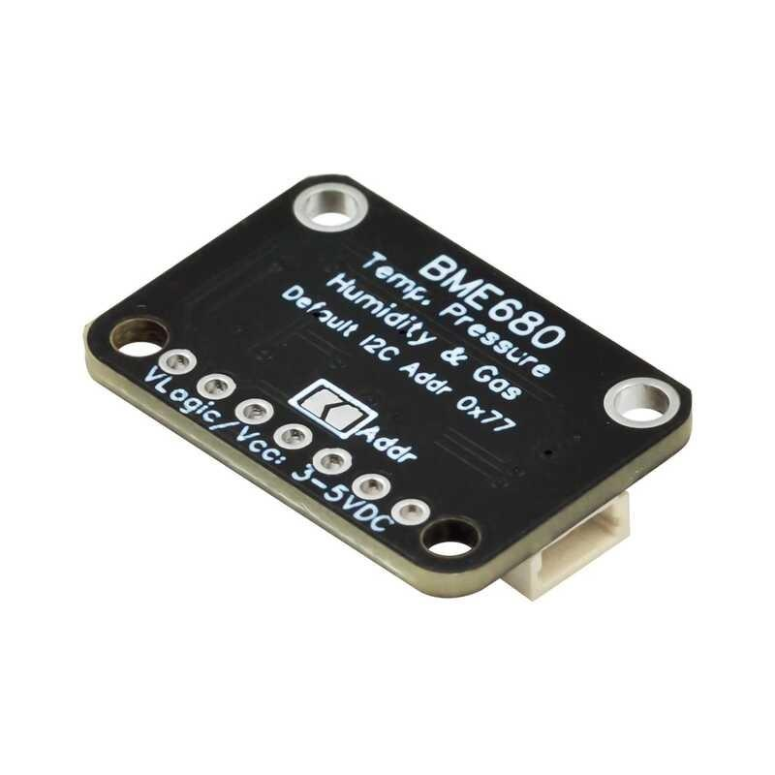
BME280 reference image from the supplied project document.
SIMULATION STATUS
Wokwi validates the embedded control concept and I/O behavior. It does not constitute field validation of high-altitude mechanical, thermal, RF or environmental performance.

19. Ground-Control Dashboard
The Streamlit dashboard is the operator-facing layer for system status, camera output, environmental state, compensation state, virtual pointing, performance and subsystem health. The source document proposes a dashboard with environmental readings, tracking state, compensation status and health indicators. fileciteturn5file6L1312-L1335
Dashboard panel | Recommended content
System Overview | Operational state, timestamp, major alerts
Live Camera / AI | Video, bounding boxes, object count, confidence
Environment | Temperature, pressure, humidity, wind, vibration
Compensation | Active modes, control gains/parameters, correction state
Virtual Pointing | Pan/tilt command, target error, simulated actuator state
Performance | Risk/degradation score, trends, test scenario
Hardware Simulation | Wokwi connection state and telemetry
Health | CPU/AI, camera, sensors, communications, power
Alerts | Cold, high wind, drift, high load, communication fault

DEMO LANGUAGE
Use “Object Detection & Tracking” for the current generic YOLO26n camera demo. Use “Drone Detection” only when a drone-specific model has actually been trained/fine-tuned and evaluated.

20. Proposed Hardware Architecture
The source recommends separating computationally intensive AI processing from deterministic real-time control. A proposed architecture uses an edge AI computer, a real-time MCU/control PCB, EO camera, pan-tilt with encoder feedback, environmental sensors, protected power, thermal control and UART/CAN communication. fileciteturn5file2L278-L291
Subsystem | Proposed architecture | Status
AI compute | Raspberry Pi CM5 + Hailo AI accelerator (proposed option) | Future hardware
Real-time control | STM32H7 series (proposed) | Future hardware
Vision | EO camera | Current camera demo / future rugged camera
Tracking | Encoder-feedback pan-tilt | Concept / Wokwi control simulation
Environment | Temperature + pressure + humidity + wind | Wokwi/simulated; future physical sensors
Stabilization | IMU-based feedback | Wokwi MPU6050 simulation
Thermal | Closed-loop heater control | Concept / future hardware
Communication | UART + CAN; Ethernet where required | Architecture proposal
Dashboard | Streamlit | Current software prototype

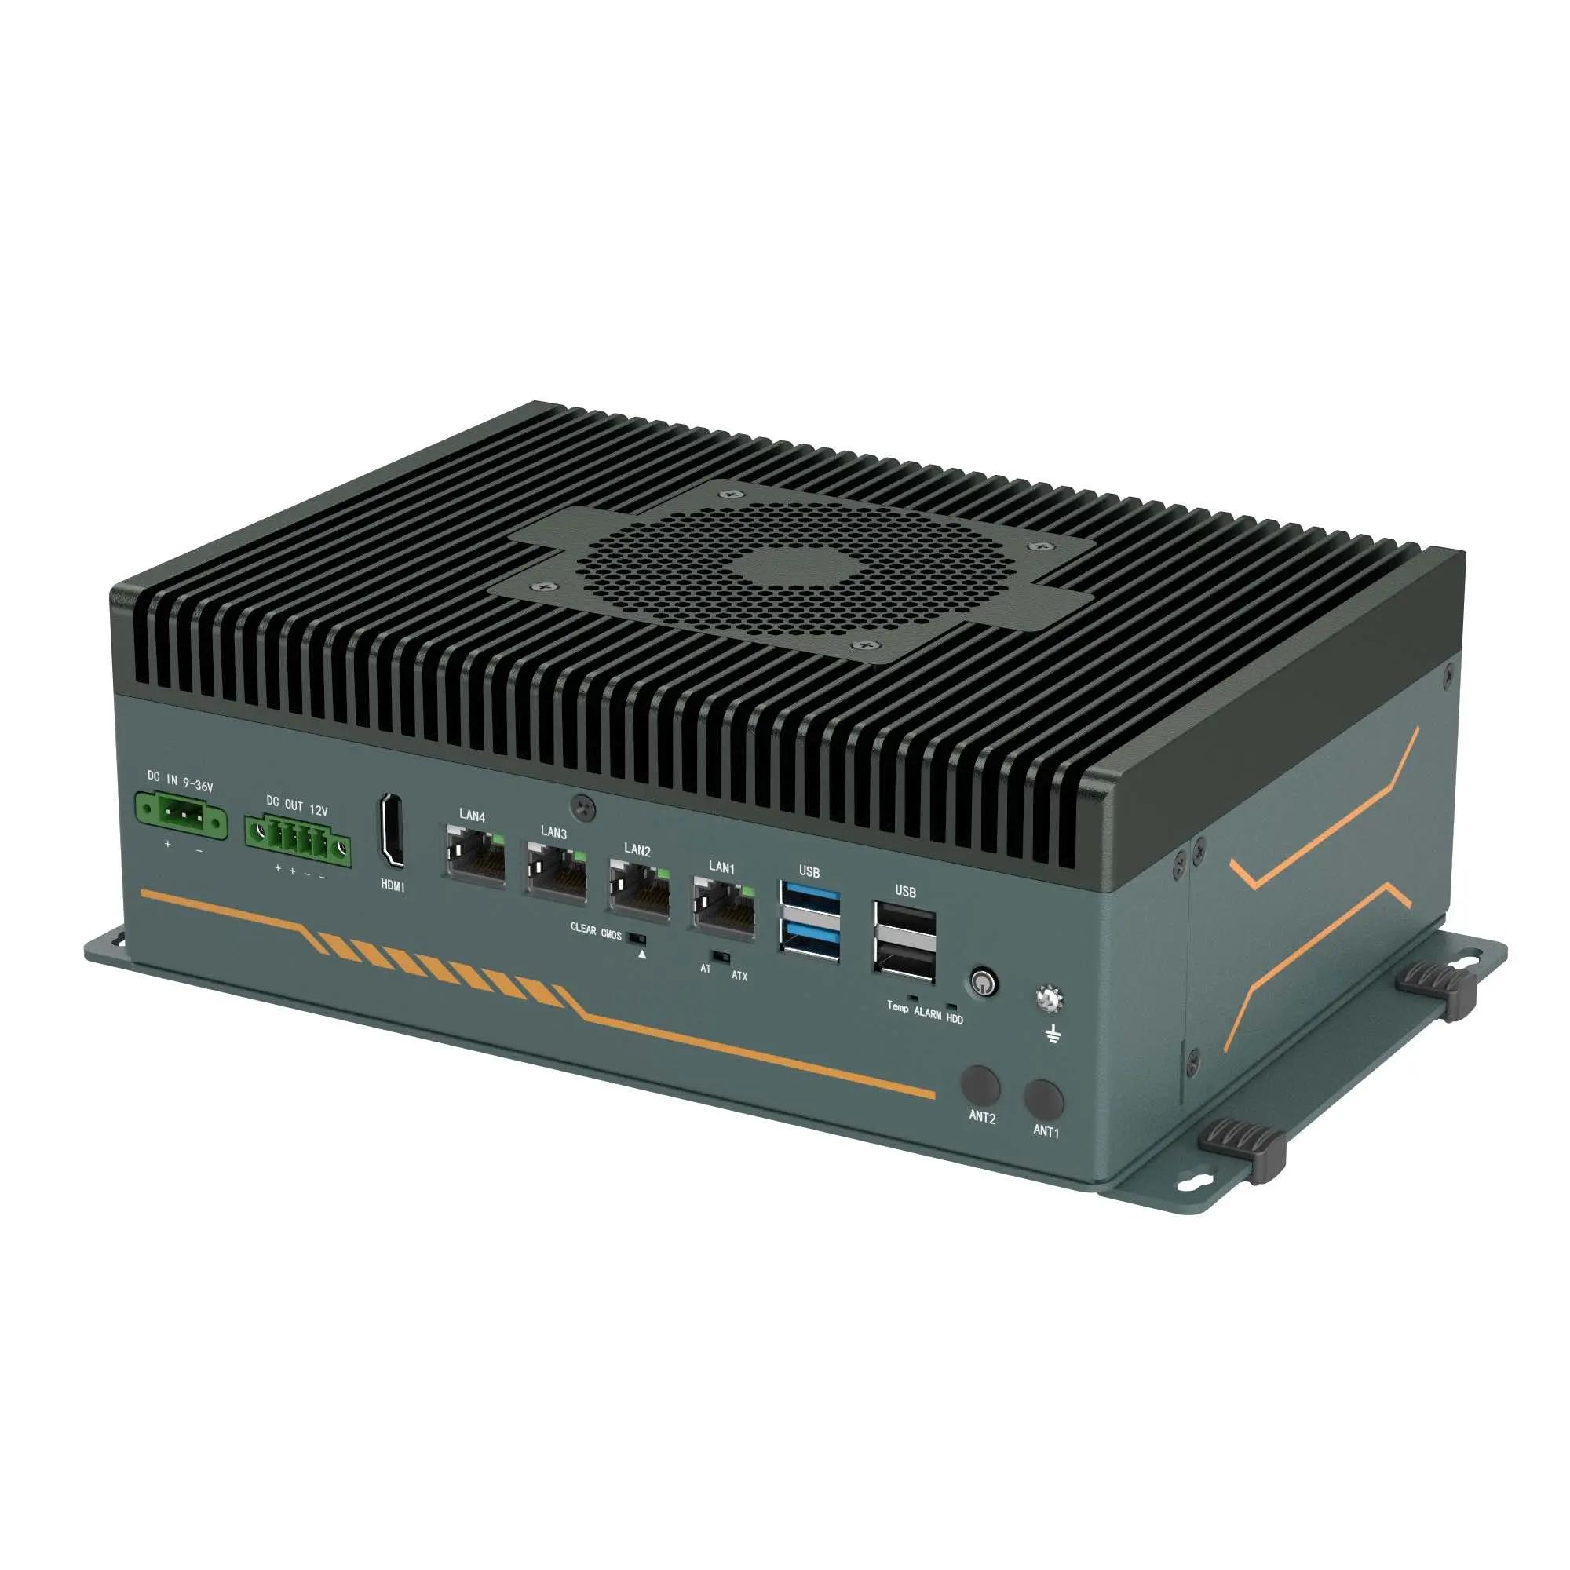
Edge-computing form-factor reference image retained from the source document.

21. High-Altitude Environmental Control PCB Concept
The source proposes a custom control PCB with power management, STM32 MCU, environmental sensors, motor control, heater control and AI interface. It recommends a 4-layer PCB with signal/component, solid ground, power and bottom-signal layers. fileciteturn5file6L801-L827
PROPOSED CONTROL PCB FUNCTIONAL FLOW
POWER INPUT
↓
POWER MANAGEMENT / PROTECTION
↓
STM32H7 REAL-TIME CONTROLLER
↙ ↓ ↘
SENSORS MOTOR CONTROL HEATER CONTROL
↓ ↓ ↓
I²C / SPI PWM / ENCODER MOSFET + FEEDBACK
↘ ↓ ↙
AI INTERFACE / UART / CAN / ETHERNET

21.1 PCB sections
- Power management: input protection, fuse/protection, reverse-polarity protection, surge protection and DC-DC conversion.
- MCU: STM32, clock/reset, SWD and decoupling.
- Sensor section: temperature, pressure, humidity and IMU; keep IMU away from high-current and noisy switching areas.
- Motor control: driver interface, encoder input, current sensing and protection.
- Heater control: MOSFET/gate control, temperature feedback and heater connector.
- Communication: UART, CAN and Ethernet as required.

22. Communication & Telemetry Architecture
Link | Purpose | Typical data
AI → MCU | Target/control commands | Target X/Y, confidence, tracking mode
MCU → AI | Telemetry | Environment, actuator state, health
I²C | Environmental sensors | Temperature, pressure, humidity
SPI | High-speed sensors where required | IMU / sensor data
PWM | Actuator command | Pan/tilt or heater control
CAN | Rugged distributed subsystem link | Health/command telemetry
Ethernet | High-rate network/video path where required | Video / system data

The source gives an example AI-to-MCU message containing target X, target Y, confidence and tracking mode, followed by coordinate conversion into pan and tilt error. fileciteturn5file6L1133-L1154

23. Environmental Compensation Engine
This engine is the core innovation layer. The source lists temperature, pressure, wind, IMU, motor current, encoder and battery as inputs, with outputs including motor-gain adjustment, sensor-drift correction, thermal control, performance prediction and health warning. fileciteturn5file6L1156-L1179
Input | Derived state | Compensation / output
Temperature | Cold / nominal / thermal risk | Cable stiffness model, control adjustment, heater state
Wind | Normal / high / extreme | Stabilization mode / gain adjustment
Pressure | Environmental state | Performance context
IMU | Attitude / vibration | Stabilization and drift monitoring
Motor current | Load estimate | Health warning / compensation evidence
Encoder | Actual axis position | Closed-loop position correction
Battery | Power-health state | Runtime / health warning

23.1 Rule-based prototype logic
A simple first implementation can use thresholded rules: if temperature is below a configured low-temperature threshold, enable cold compensation; if wind exceeds a configured threshold, enable stabilization mode; if estimated drift exceeds a limit, apply sensor correction; if motor current exceeds a limit, generate a health warning. The source explicitly proposes this style before replacing fixed rules with adaptive PID, Kalman filtering or machine-learning prediction. fileciteturn5file6L1181-L1197

24. Implementation Plan & Roadmap
Phase | Work package | Exit criterion
1 | Simulation foundation | Environment + tracking scenarios run repeatably
2 | AI vision | Camera + detector + tracking pipeline operational
3 | Environmental sensing | Temperature/pressure/IMU and other inputs integrated
4 | Pan-tilt prototype | Target error drives simulated/physical axis commands
5 | Compensation | Cold, wind and drift compensation demonstrated
6 | Health + prediction | Fault states and degradation score visible
7 | Hardware integration | Physical sensors/MCU integrated after software validation
8 | Custom PCB | Schematic/layout after subsystem validation
9 | Controlled validation | Repeatable before/after test data collected

This sequence consolidates the source document’s implementation plan, which starts with simulation, then AI detection, environmental sensors, pan-tilt, compensation and finally custom PCB integration. fileciteturn5file6L1337-L1379

25. Validation & Test Plan

25.1 Scenario matrix
Scenario | Inputs | Observe | Expected engineering behavior
Nominal | Moderate temperature, low wind | Tracking + health | Baseline behavior
Extreme cold | Low temperature | Compensation + motor effort + health | Cold mode activates; disturbance model changes
High wind | High wind input | Pointing error + stabilization | Adaptive stabilization activates
Sensor drift | Injected bias | Corrected sensor value | Calibration correction reduces bias
High vibration | Injected vibration | Tracker/control response | Filtering and health warning respond appropriately
Power stress | Reduced voltage / increased load | Battery and current health | Warning state appears before unsafe condition
Communication loss | Disconnect telemetry path | Health monitor | Subsystem fault reported

25.2 Metrics to record
- Detection latency / inference rate
- Tracking continuity and target-loss events
- Image-space or angular tracking error
- Pan/tilt settling behavior
- Motor command and current proxy
- Environmental state
- Compensation mode
- Health state transitions
- False-alarm behavior on representative non-target objects
- Power/thermal state

25.3 Before-vs-after comparison
The strongest demonstration should compare the same environmental scenario with compensation disabled and enabled. The source specifically recommends a before/after compensation demonstration for extreme cold and high wind. fileciteturn5file1L171-L190

26. Current Prototype Status & Evidence Policy
Area | Current status | How to present it
Streamlit dashboard | Implemented | Show live dashboard screenshots
Camera + YOLO26n | Implemented as general object detection | Say “general object detection & tracking”
Environmental simulation | Implemented | Show temperature/pressure/wind scenario changes
Compensation engine | Implemented as prototype logic | Show mode/parameter changes
System health | Implemented in dashboard | Show subsystem states and alerts
Wokwi | Implemented as embedded simulation concept | Show circuit and servo/sensor behavior
Physical hardware | Not yet validated as a complete deployed unit | Describe as proposed/future
Drone-specific AI | Not established by generic model alone | Mark as future fine-tuning/evaluation
High-altitude field validation | Not established | Do not claim field performance

WHAT COUNTS AS EVIDENCE
A screenshot proves the software/simulation state visible in it; it does not prove physical high-altitude performance. Keep screenshots, logs, configuration values and test datasets alongside measured results in the project repository.

27. Limitations & Risk Register
Risk / limitation | Impact | Mitigation
Generic detector not drone-specific | False target classification | Fine-tune/evaluate a drone dataset before claiming drone detection
No physical high-altitude test yet | Thermal/mechanical claims unverified | Use simulation + controlled chamber/wind tests before field trials
Cable model is conceptual | Compensation may be inaccurate | Identify model experimentally
Wind input may be simulated | Real disturbance may differ | Integrate calibrated wind sensing and controlled tests
Sensor drift coefficients unknown | Correction may be biased | Temperature-point calibration
Battery model not measured | Runtime prediction uncertainty | Collect voltage/current/temperature data
RF subsystem not implemented as a validated detector | No evidence of RF detection performance | Keep RF receive-only and future/optional
Wokwi differs from hardware physics | Simulation-to-hardware gap | Validate each subsystem on physical hardware before integration

28. Safety, Compliance & Prototype Scope
The project is framed as an academic sensing, tracking, environmental-compensation and health-monitoring system. The safe prototype scope in the source is Detection + Identification + Tracking + Environmental Compensation + Health Monitoring. For the response stage, the source recommends only alert generation, operator notification, tracking handoff and a simulated authorized response workflow. fileciteturn5file1L135-L143
SCOPE BOUNDARY
This documentation does not specify RF jamming, communication disruption, signal interception, weapon control or physical neutralization. Any future operational system would require appropriate legal, spectrum, aviation, safety and organizational authorization.

29. Prototype BOM — Simulation First, Hardware Later
Item | Role | Current state | Future note
ESP32 | Embedded control simulation | Wokwi | Physical MCU optional for first prototype
BME280 | Temperature / pressure / humidity simulation | Wokwi | Physical environmental sensor
MPU6050 | IMU simulation | Wokwi | Physical IMU / better-grade IMU later
Pan servo | Pan-axis simulation | Wokwi | Encoder-feedback actuator for rugged prototype
Tilt servo | Tilt-axis simulation | Wokwi | Encoder-feedback actuator for rugged prototype
Potentiometers | Controlled environment inputs | Wokwi | Replace with physical wind/other sensors
EO camera | Vision input | Current software prototype | Rugged camera / low-light or thermal option later
Edge AI computer | AI inference | Proposed | Raspberry Pi CM5 + Hailo is one proposed architecture
STM32H7 | Real-time control | Proposed | Future control PCB
Custom PCB | Integration | Proposed | After subsystem validation

30. Final Project Deliverables
- System architecture and block diagrams
- Environmental impact and compensation analysis
- EO AI detection and tracking prototype
- Environmental monitoring and simulation
- Pan-tilt control concept
- Adaptive compensation engine
- System health monitor
- Predictive performance model / risk score
- Streamlit ground-control dashboard
- Wokwi embedded simulation
- Hardware architecture and BOM
- PCB concept and integration roadmap
- Validation plan and measured test results
- Project source code and reproducibility documentation

31. Glossary
Term | Meaning
HAADS | High-Altitude Anti-Drone System
EO | Electro-Optical camera/sensing
IMU | Inertial Measurement Unit
MCU | Microcontroller Unit
BMS | Battery Management System
PID | Proportional–Integral–Derivative control
RF | Radio Frequency
SDR | Software-Defined Radio
NPU | Neural Processing Unit / AI accelerator
CAN | Controller Area Network
I²C | Inter-Integrated Circuit
SPI | Serial Peripheral Interface
PWM | Pulse-Width Modulation
SIH | Smart India Hackathon
PS ID | Problem Statement Identifier

32. References & Source Basis
This document is an upgraded engineering edition of the supplied “Indreasena Project.docx”. The source document establishes the problem framing, proposed architecture, environmental compensation concepts, hardware recommendations, implementation phases and safe prototype scope. Relevant source excerpts are preserved and reorganized rather than silently replaced. fileciteturn5file0L19-L28 fileciteturn5file2L265-L291
Reference | Use in project
Supplied project document — Indreasena Project.docx | Primary project concept, architecture, compensation methods, hardware proposal and implementation roadmap
Ultralytics YOLO26 documentation | AI model family / detection implementation reference
Wokwi ESP32 documentation | Embedded simulation and ESP32 peripheral reference
Raspberry Pi AI Camera documentation | Future edge-AI camera architecture reference
Smart India Hackathon PS 26050 | Problem-statement context and competition framing

Recommended online references for the final repository should be kept as clickable hyperlinks in the project README. Use the official documentation pages rather than third-party summaries.
- https://docs.ultralytics.com/models/yolo26
- https://docs.wokwi.com/guides/esp32
- https://docs.wokwi.com/guides/esp32-wifi
- https://www.raspberrypi.com/documentation/accessories/ai-camera.html
- https://sih.dsce.in/sih

33. Appendix A — Recommended Demonstration Script
- Start the Streamlit dashboard and show system overview.
- Show the live camera with general object detection and tracking.
- Open the environment panel and set a nominal condition.
- Increase wind input and show stabilization/compensation state changing.
- Lower temperature and show cold compensation / thermal status.
- Inject a sensor-drift condition and show corrected state.
- Open Wokwi and show ESP32 sensor/servo simulation.
- Show health-monitor status and generated alerts.
- Explain which functions are current prototype evidence and which are future hardware capabilities.
- Conclude with the environmental-aware feedback loop: sense → estimate → compensate → stabilize → monitor.

34. Appendix B — Recommended Repository Structure
A reproducible repository should separate application code, embedded simulation, hardware design and documentation. A recommended structure is:
HAADS_SIH_26050/
├── README.md
├── app/
│ ├── app.py
│ ├── detector.py
│ ├── tracker.py
│ ├── environment.py
│ ├── compensation.py
│ ├── performance.py
│ ├── health_monitor.py
│ ├── hardware_interface.py
│ ├── data_manager.py
│ └── dashboard.py
├── prototype/
│ └── wokwi/
│ ├── diagram.json
│ ├── wokwi.ino
│ └── libraries.txt
├── models/
├── data/
├── hardware/
│ ├── BOM.md
│ ├── wiring.md
│ └── pcb/
├── docs/
│ ├── architecture.md
│ ├── compensation.md
│ ├── testing.md
│ └── roadmap.md
└── results/
├── screenshots/
└── test-results/

35. Appendix C — Engineering Claim Checklist
Claim | Allowed wording now | Evidence needed for stronger claim
AI detection | YOLO26n general object detection | Drone dataset + metrics
Tracking | Target/object tracking in prototype | Controlled tracking accuracy study
Environmental compensation | Prototype compensation logic / simulation | Physical environmental test data
Cable compensation | Conceptual temperature-dependent model | Mechanical characterization
Wind compensation | Simulation/control concept | Controlled wind disturbance test
Thermal management | Proposed closed-loop architecture | Thermal chamber / cold test
Battery health | Monitoring/prediction concept | Battery test dataset
High-altitude robustness | Design objective / simulation concept | Altitude-representative validation
Mission readiness | Do not report unsupported percentage | Validated system-level test campaign

FINAL ENGINEERING POSITION
The project is strongest when it clearly separates what is already demonstrated in software/Wokwi from what is proposed for future physical validation. This upgraded document is structured around that distinction.

HAADS • SIH 26050
Sense the environment. Compensate the disturbance. Stabilize the track. Monitor system health.

