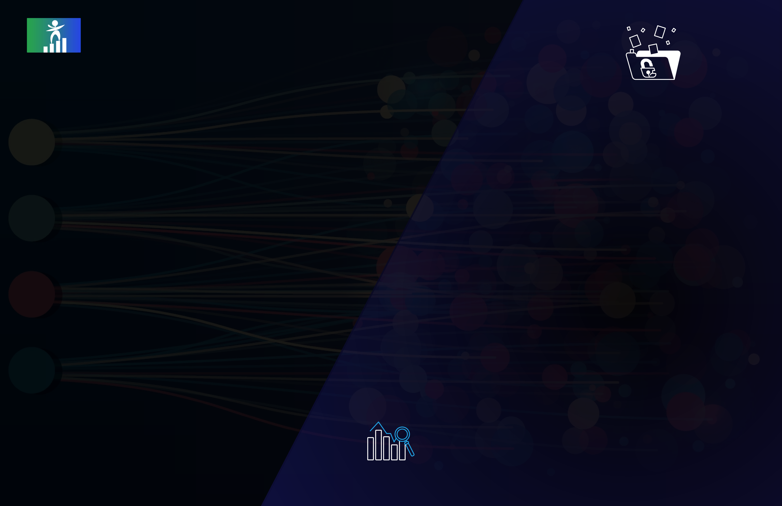

R E D E F I N E C A R E E R

**WHAT MAKES REDEFINE CAREER**   
**DIFFERENT FROM OTHERS?**

|  |  |  |  |  |  |  |  |  |  |
| --- | --- | --- | --- | --- | --- | --- | --- | --- | --- |
| Begin your journey toward your Begin your journey toward your  dream career transition at this dream career transition at this  exceptional launching pad! exceptional launching pad! | | | | Mentorship by Industry Experts | 7 day refund, No questions asked | | | | |
| At Redefine Career, mentorship by industry experts |
| is a key component of our career development |
| programs. We connect individuals with mentors | We understand that choosing the right training | | | | |
| who have extensive experience in their chosen field |
| program can be a significant investment of time and | | | | |
| and who can provide personalized guidance and |
| money. That's why we offer a 7-day refund policy | | | | |
| support to help them achieve their career goals. |
| with no questions asked. | | | | |
| **ABOUT US** | | | | Real time data live projects | If for any reason you're not satisfied with our training | | | | |
| programs, you can request a refund within the first 7 | | | | |
| days of the program start date. | | | | |
| Welcome to Redefine Career, an organization | | | | We offer real-time data live projects as part of our |
| founded by a group of accomplished alumni | | | | 1-1 mentorship | | | | |
| training programs to provide individuals with |
| from some of the top educational institutions in | | | |
| practical experience working with data. Our projects |
| India, including IIT Patna, IIM Calcutta, and ISB. | | | |
| are designed to simulate real-world scenarios and | At Redefine Career, we offer one-on-one mentorship | | | | |
| Our team shares a common passion for | | | |
| give individuals the opportunity to work with | as part of our training programs to provide | | | | |
| empowering individuals to achieve their full | | | |
| industry-standard tools and technologies. | individuals | with | personalized | guidance | and |
| potential and reach new heights in their careers. | | | |
| Live Online Classes | support. Our mentors are experienced professionals | | | | |
| At Redefine Career, we recognized that there | | | |
| with a deep understanding of their field, and they | | | | |
| was a significant gap between education and | | | | work closely with our students to help them achieve | | | | |
| industry. Many people struggled to find | | | | their career goals. | | | | |
| meaningful | employment | despite | having | We believe that a session is fruitful only if the |
| impressive academic credentials. That's why we | | | | students and mentors are able to engage in | Short Batches | | | | |
| set out to create a platform that could bridge | | | | discussions rather than “recorded videos”. Live |
| this gap and provide individuals with the tools, | | | | Our short batches are designed to be highly | | | | |
| online classes as part of our training programs |
| resources, and guidance needed to redefine | | | |
| provide individuals with flexible and accessible |
| focused and intensive, with hands-on learning | | | | |
| their careers. | | | |
| learning opportunities. Our live online classes are |
| experiences that help individuals build practical | | | | |
| Our team is committed to providing high-quality | | | | led by industry experts who use interactive tools, |
| skills quickly. We also keep our class sizes small to | | | | |
| such as live polls, quizzes, and breakout sessions, to |
| ensure personalized attention and engagement. | | | | |
| training programs, mentorship, and internship | | | |
| keep students engaged and help them master the |
| support to individuals seeking to upgrade their | | | | Placement Assistance | | | | |
| course content. We also provide access to |
| skills and gain practical experience in their | | | |
| recordings of the classes for students to review or |
| chosen field. We understand that every person's | | | |
| catch up if they miss a session. |
| journey is unique, and that's why we offer | | | | Placement assistance as part of our training | | | | |
| personalized guidance to help you achieve | | | |
| programs to help individuals transition to new | | | | |
| your career goals. | | | |
| careers or advance in their current field. Our | | | | |

Whether you're a recent graduate or a seasoned   
professional looking to pivot your career,   
Redefine Career is here to support you every   
step of the way. Join our community today and   
let us help you redefine your career.

placement assistance includes resume building, interview preparation, and job search guidance. We work with our network of industry partners to

|  |  |  |  |  |  |
| --- | --- | --- | --- | --- | --- |
| connect | our | students | with | relevant | job |

opportunities



|  |  |  |
| --- | --- | --- |
| **Building Blocks for Data Visualization and Analytics (Pre - Learning)** | **Data Visualization & Analytics (Excel)** | **OVERVIEW OF DASHBOARDS** |
| Quick Recap of Basics of Excel |
| Introduction to Bridge Course & Analytics Software |
| **DATA MANIPULATION USING FUNCTIONS** |
| **BASIC EXCEL** | Descriptive functions | What is dashboard & Excel dashboard |
| Excel Environment | Logical functions: IF, and, or, not | Adding icons and images to dashboards |
| Date and Time functions | Making dashboards dynamic |
| Key Terminologies |
| Text functions | **CREATE DASHBOARDS IN EXCEL - USING PIVOT CONTROLS** |
| Short Cuts |
| Array functions |
| Key Functionalities |
| Use and application of lookup functions | Concept of pivot cache and its use in creating interactive |
| Copy-paste-paste special |
| Limitations of lookup functions |
| Formatting & conditional Formatting | dashboards in excel |
| Using Index, Match, Offset, reverse vlookup |
| Basic Excel Functions - Types of Functions Relational | Pivot table design elements - concept of slicers and |
| operators | **DATA ANALYSIS AND REPORTING** | timelines |
| Data Sorting, Filtering and Data Validation | Designing sample dashboard using Pivot Controls |
| Understanding of Name Ranges | Data Analysis using Pivot Tables - use of row and column | Design principles for including charts in dashboards - do’s |
| Pivot tables - Charts | shelf, values and filters | and dont's |
| Basics of charts | Difference between data layering and cross tabulation, |
| **BUSINESS DASHBOARD CREATION** |
| **RDBMS & SQL (BASICS)** | summary reports, advantages and limitations |
| Change aggregation types and summarization |
| Management Dashboard for Sales & Services |
| Basic RDBMS Concepts | Creating groups and bins in pivot data |
| Best practices - Tips and Tricks to enhance dashboard |
| Concept of calculated fields, usage and limitations |
| Introduction to Relational Database management system. | designing |
| Changing report layouts-Outline,compact and tabular forms |
| Why SQL? |
| Show and hide grand totals and subtotals |
| A glance at the tool and its advantages and disadvantages |
| Creating summary reports using pivot tables |
| Understanding Schema, ERDs and Metadata |
| Introduction to MS SQL Server | **DATA VISUALIZATION IN EXCEL** |
| What is SQL — A Quick Introduction |
| Installing MS SQL Server for windows Introduction to SQL |
| Overview of chart types — column/bar charts, line/area , |
| Server Management Studio |
| pie, doughnut charts, scatter plots |
| Understanding basic database concepts |
| How to select right chart for your data |
| Getting started |
| Creating and customizing advance charts - thermometer |
| **INTRODUCTION TO ANALYTICS & DATA SCIENCE** | charts, waterfall charts, population pyramids |

What is analytics & Data Science?

Business Analytics vs. Data Analytics vs. Data Science   
Common Terms in Analytics   
Analytics vs. Data warehousing, OLAP, MIS Reporting   
Types of data (Structured vs. Unstructured vs. Semi-  
Structured)   
Relevance of Analytics in industry and need of the hour   
Critical success drivers   
Overview of analytics tools & their popularity   
Analytics Methodology & problem-solving framework   
Stages of Analytics



|  |  |  |
| --- | --- | --- |
| **Data Visualization & Analytics (SQL)** | **ADVANCED SQL** | **INTRODUCTION TO MATHEMATICAL FOUNDATIONS** |
| Creating table copy and database copy | Sets & Functions |
| Quick Recap of RDBMS & Basic SQL | Introduction to Linear Algebra |
| Views |
| Matrices Operations |
| Transactions |
| introduction to Calculus |
| **DATA BASED OBJECTS CREATION (DDL COMMANDS)** | Stored Procedures in SQL |
| Derivatives & Integration |
| Crud operations using stored procedures |
| Maxima, minima |
| Window functions in SQL |
| Creating databases and tables. Understanding data types | Area under the curve |
| Miscellaneous Topics: Rollup and cube |
| Inserting values into the table | **PYTHON FOR DATA SCIENCE** |
| Altering table properties | **Building Blocks for Python and ML (Pre-Learning)** |
| Introduction to Keys and constraints |
| Introduction to installation of Python |
| Creating, Modifying & Deleting Tables |
| Creating arrays and initializing |
| Create Table & Create Index statements |
| Introduction to Python IDE’s(Jupyter,/Ipython) |
| Drop & Truncate statements — Uses & Differences |
| **PROGRAMMING BASICS** | Reading arrays from files |
| DDL Statements with constraints |
| Concept of Packages - Important packages |
| Import and Export wizard to get the data in SQL server |
| Special initializing functions |
| from excel files or delimited files |
| NumPy, SciPy, scikit-learn, Pandas, |
| **DATA MANIPULATION (DML COMMANDS)** |
| Slicing and indexing Matplotlib, etc |
| Programming Basics | Reshaping arrays |
| Data Manipulation statements | Introduction to programming Computer programs and | Installing & loading Packages & Name Spaces |
| Insert, Update & Delete statements | business use | Combining arrays |
| Select statement — Sub setting, Filters, Sorting. Removing | Database and its requirement in the software applications. | Data Types & Data objects/structures (strings, |
| Duplicates, grouping and aggregations etc | What is an IDE - Integrated development environment. | NumPy Maths Tuples, Lists, Dictionaries) |
| Operators, predicates and built in functions(Top, distinct, | Different programming languages, High level vs Low level | List and Dictionary Comprehensions Overview of Pandas |
| Limit) | languages, | Variable & Value Labels — Date & Time Values |
| Where, Group By, Order by & Having clauses | Language translators - Compiler and Interpreter, Why | What is pandas, its functions & methods |
| SQL Functions — Number, Text, Date, etc | syntax rules? | Basic Operations — Mathematical/string/date |
| SQL Keywords — Top, Distinct, Null, etc | Programming basics: variables, INC rules: Identifier | Pandas Data Structures (Series & Data Frames) |
| SQL Operators - Relational (single valued and multi | Naming Conventions, Data Types, Operators. | Control flow & conditional statements |
| valued), Logical (and, or, not), Use of wildcard operators | Control flow statements: Conditional statements and | Creating Data Structures (Data import — reading |
| and wildcard characters, etc | Loops. | Debugging & Code profiling into pandas) |
| **ACCESSING DATA FROM MULTIPLE TABLES USING SELECT** | Functions and UDFS. | Python Built-in Functions (Text, numeric, date, |
| Logic building and Pseudo codes. | utility functions) |
| Cleansing Data with Python |
| Append and Joins | **INTRODUCTION TO BASIC STATISTICS** | User defined functions — Lambda functions |
| Understand the data |
| Union and Union All — Use & constraints | Introduction to Statistics |
| Concept of apply functions |
| Intersect and Except statements |
| Measures of central tendencies | Sub Setting / Filtering / Slicing Data |
| Table Joins - inner join, left join, right join, full join |
| Measures of variance | Python — Objects — OOPs concepts |
| Cross joins/cartisian products, self joins, natural joins etc |
| Measures of frequency |
| Inline views and sub-queries & it's types | **DATA ANALYSIS USING PYTHON** |
| Measures of Rank |
| Optimizing your work |
| Basics of Probability, distributions |
| Update operations with and without joins |
| Conditional Probability (Bayes Theorem) | Exploratory data analysis |

Descriptive statistics, Frequency Tables and summarization   
Uni-variate Analysis (Distribution of data & Graphical Analysis)   
Bi-Variate Analysis(Cross Tabs, Distributions & Relationships,   
Graphical Analysis)



|  |  |  |
| --- | --- | --- |
| **DATA VISUALIZATION WITH PYTHON** | **SUPERVISED LEARNING: CLASSIFICATION PROBLEMS** | **ADVANCED DATA PROCESSING AND VISUALIZATION** |
| Data Visualization with Python | Logistic Regression | Vectorization (Count, TF-IDF, Word Embedding's) |
| Sentiment analysis (vocabulary approach, based on |
| Introduction to Data Visualization | K-Nearest Neighbor |
| Bayesian probability methods) |
| Introduction to Matplotlib | Nai”ve Bayes Classifier |
| Name entity recognition (NER) |
| Basic Plotting with Matplotlib | Decision Trees |
| Methods of data visualization |
| Line Plots | Ensemble Learning - Bagging, Random Forest, Adaboost, |
| Grouping texts using different methods |
| **Predictive Modeling & Machine Learning** | Gradient Boost, XGBoost |
| Language Models and n-grams -- Statistical Models of |
| Support Vector Classifier |
| Unseen Data (Smoothing) |
| **UNSUPERVISED LEARNING** | **TEXT MINING — PREDICTIVE MODELING** |
| Principal Component Analysis |
| **INTRODUCTION TO PREDICTIVE MODELING** | K-Means Clustering | Semantic similarity between texts |
| Density-Based Clustering |
| Introduction to Predictive Modeling | **Text Mining using NLP** | Text Segmentation |
| Topic Mining (LDA) |
| Concept of model in analytics and how it is used? |
| Text Classification(spam detection, sentiment analysis, |
| Common terminology used in modeling process |
| Intent Analysis) |
| Types of Business problems - Mapping of Algorithms |
| Different Phases of Predictive Modeling |
| Data Exploration for modeling | **INTRODUCTION TO TEXT MINING** | **Introduction to AI & DL** |
| Exploring the data and identifying any problems |
| Forest, Adaboost, Gradient Boost, XGBoost with the data |
| (Data Audit Report) | Introduction to Text Mining | **INTRODUCTION TO ARTIFICIAL INTELLIGENCE (AI)** |
| Identify missing/Outliers in the data | Text Mining - characteristics, trends |
| **TIME SERIES FORECASTING** | Text Processing using Base Python & Pandas, Regular | Modern era of AI |
| Expressions |
| Role of Machine learning & Deep Learning in Al |
| Text processing using string functions & methods |
| Hardware for AI (CPU vs. GPU vs. FPGA) |
| Time Series Forecasting | Understanding regular expressions |
| Software Frameworks for AI & Deep Learning |
| Identifying patterns in the text using regular expressions |
| Key Industry applications of A |
| What is forecasting? | **TEXT PROCESSING WITH MODULES LIKE NLTK, SKLEARN** | **ARTIFICIAL NEURAL NETWORK** |
| Applications of forecasting |
| Time Series Components and Decomposition | Getting Started with NLTK |
| Types of Seasonality | Overview of Neural Networks |
| Introduction to NLP & NLTK |
| Important terminology: lag, lead, Stationary, stationary |
| Introduction to NLTK Modules (corpus, tokenize, Stem, |
| tests, auto correlation & white noise, ACF & PACF | Activation Functions, hidden layers, hidden units |
| collocations, tag, classify, cluster, tbl, chunk, Parse, ccg, |
| Visualize the data trends and patterns | Illustrate & Training a Perceptron |
| sem, inference, metrics, app, chat, toolbox etc) |
| Important Parameters of Perceptron |
| **INTRODUCTION TO MACHINE LEARNING** | **INITIAL DATA PROCESSING AND SIMPLE STATISTICAL TOOLS** | Understand limitations of A Single Layer Perceptron |
| Illustrate Multi-Layer Perceptron |
| Introduction to Machine Learning | Understand Backpropagation — Using Example |
| Reading data from file folder/from text file, from the |
| Implementation of ANN in Python- Keras |
| Applications of Machine Learning |
| Internet & Web scrapping, Data Parsing |
| Supervised vs Unsupervised Learning vs. Reinforcement | **INTRODUCTION TO CLOUD COMPUTING** |
| Cleaning and normalization of data |
| Learning |
| Sentence Tokenize and Word Tokenize, Removing |
| Overall process of executing the ML project |
| insignificant words(“stop words”), Removing special | Use Cases of Cloud computing |
| Stages of ML Project |
| symbols, removing bullet points and digits, changing |
| Overview of Cloud Segments: IaaS, PaaS, SaaS |
| Concept of Over fitting and Under fitting (Bias- Variance |
| letters to lowercase, stemming /Iemmatization, /chunking |
| Overview of Cloud Deployment Models |
| Trade off) & Performance Metrics |
| Creating Term-Document matrix |
| Overview of Cloud Security |
| Concept of feature engineering |

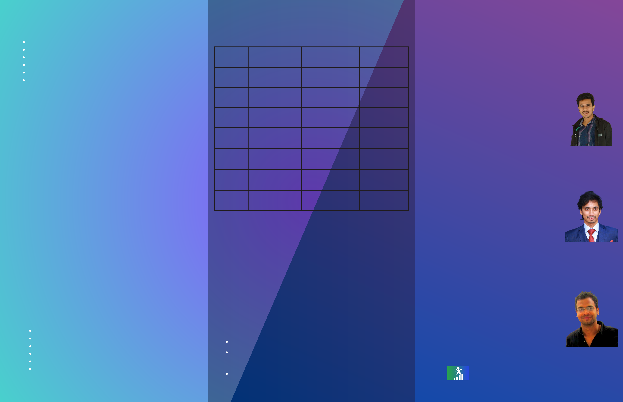

|  |  |  |
| --- | --- | --- |
| **INTRODUCTION TO DEEP LEARNING** | **Why Choose Us?** | **About Mentors** |
| What are the Limitations of Machine Learning? |

What is Deep Learning?

|  |  |  |  |
| --- | --- | --- | --- |
| Advantage of Deep Learning over Machine learning | Udemy | REDEFINE CAREER | Scaler |

Reasons to go for Deep Learning

|  |  |  |  |  |  |
| --- | --- | --- | --- | --- | --- |
| Real-Life use cases of Deep Learning | Course Type | Recorded | Live | Recorded + Live | **SIDDHARTHA DEVAPUJULA** |
| Overview of important python packages for Deep Learning |
| **Live Projects** | Instructors | No specific Criteria | IIT, IIM & ISB Alumni | No specific Criteria | **STAFF DATA SCIENTIST - MYNTRA, EX-MICROSOFT** |
| Live Projects | Yes | Yes | Yes | Given a list of factors and conditions we will |

discover if a prospective patient is susceptible to

|  |  |  |  |  |  |  |
| --- | --- | --- | --- | --- | --- | --- |
| **HEART DISEASE DETECTION:** | Portfolio | No | Yes | | No | heart disease. This information will be used to plan |
| awareness campaigns and health plans. |
| Project |
| Placement | No | Yes + Job Referral | | Yes | **SUNEEL GORANTLA** |
| Given a list of factors and conditions we will discover if a |
| Assistance |
| prospective patient is susceptible to heart disease. This |
| Total Course | 52,000 | | 35,000 | 3,69,000 |
| information will be used to plan awareness campaigns and |
| health plans. |
| Fee |
| **PRICE ANALYTICS FOR AN E-COMMERCE MAJOR** | Upfront Fee | 52000 | 5,000 | | 3,69,000 | **ASSOCIATE DIRECTOR - EY,**  **EX- CARELON, S&P GLOBAL** |
| We will analyze the pricing patterns for various products of an | **Contact Us** | | | | | Meet Suneel Gorantla, an accomplished data |
| scientist with over 10+ years of experience in the |
| ecommerce major and submit analytics to the upper |
| field. As an alumnus of both the IIT, Patna and the |
| management to take business calls. |
| ISB. |
| **Tools Covered** | Visit us on : https://redefinecareer.com/ | | | | | **KUMAR RAMENDRA** |
| Write us: info@redefinecareer.com | | | | |
| Discover the power of data with the tools. Learn how to use | Call us or WhatsApp Us: +91 6363 921 141 | | | | | **DATA SCIENTIST - TWILIO,** |
| industry standard tools such as Python, R and SQL and other |
| **EX-DOZEE, SAINT GOBAIN** |
| tools to make data driven decisions and excel in your career in |
| data science. | **Other Courses** | | | | | Kumar Ramendra is an accomplished Data |
| Scientist with a diverse range of skills and |
| Pandas | experiences. He holds a Bachelor's degree in |
| Data Analytics with Visualization tools | | | | | Computer Science and Engineering from the NIT |
| Numpy |
| Hamirpur. |
| PowerBI |
| SQL | Data Analytics FastTrack: A Comprehensive Course with | | | | | R E D E F I N E C A R E E R |
| Matplotlib | Internship Support | | | | |
| Excel |
| Data Analytics/ Data Science revision with interview prep | | | | |
| and placement assistance | | | | |