Brent Mitton (120 561)

CS 411 – Assignment 2

Qiang Ye

To test the three different algorithms (Hill Climbing, Random Restart Hill Climing and Simulated Annealing1), I ran each algorithm on a randomized selection of 1000 different boards. That is, each algorithm tried to solve the same 1000 initial board configurations.

Success Rates

|  |  |  |
| --- | --- | --- |
| **Algorithm** | **Number of Successes** | **Success Percentage** |
| Hill Climbing | 230 | 23% |
| Random Restart | 1000 | 100% |
| Simulated Annealing | 995 | 99.5% |

Average Number of Nodes Generated

|  |  |  |
| --- | --- | --- |
| **Algorithm** | **Average Node Count** | **Standard Deviation** |
| Hill Climbing | 329.112 | 58.032 |
| Random Restart | 3073.784 | 3627.960 |
| Simulated Annealing | 38326.767 | 19128.378 |

Graph of # of Nodes for first 250 Board Configurations (Linear Scale)

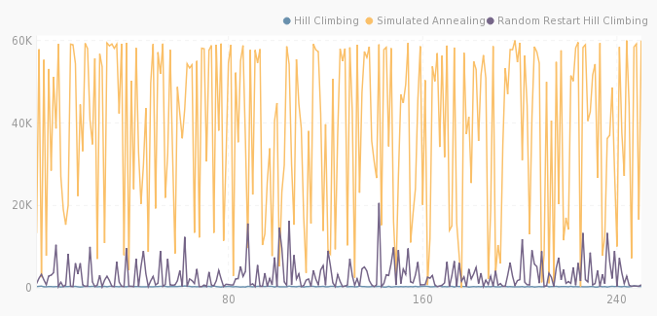

1. Simulated Annealing uses a starting temperature of 30 and decreases at 0.0005 degrees per iteration. Success rate can be expected to approach 100% as degrees per iteration gets smaller

Graph of # of Nodes for first 250 Board Configurations (Logarithmic Scale)

