Software Architecture Document - URL Shortener
Priyaanshu Mittra
Version 1.0
Contents
Software Architecture Document - URL Shortener 5
Document Control . . . . . . . . . . . . . . . . . . . . . . . . . . . . . . . . . . . . . . . . . 5
Executive Summary . . . . . . . . . . . . . . . . . . . . . . . . . . . . . . . . . . . . . . . . 5
- Architecture Goals and Scope 7
  - Business Goals . . . . . . . . . . . . . . . . . . . . . . . . . . . . . . . . . . . . . . . . . 7
  - Technical Goals . . . . . . . . . . . . . . . . . . . . . . . . . . . . . . . . . . . . . . . . 7
  - Non-Goals for Current Version . . . . . . . . . . . . . . . . . . . . . . . . . . . . . . . . 7
  - Quality Attributes . . . . . . . . . . . . . . . . . . . . . . . . . . . . . . . . . . . . . . . 8
- System Context 9
High Level Architecture . . . . . . . . . . . . . . . . . . . . . . . . . . . . . . . . . . . 9
  - Why This Split Was Selected . . . . . . . . . . . . . . . . . . . . . . . . . . . . . . . . . 9
  - Source of Truth Principle . . . . . . . . . . . . . . . . . . . . . . . . . . . . . . . . . . . 9
  - Runtime Dependencies . . . . . . . . . . . . . . . . . . . . . . . . . . . . . . . . . . . . 9
- Component Architecture 11
Component Diagram . . . . . . . . . . . . . . . . . . . . . . . . . . . . . . . . . . . . . 11
  - Controller Layer . . . . . . . . . . . . . . . . . . . . . . . . . . . . . . . . . . . . . . . . 11
  - Service Layer . . . . . . . . . . . . . . . . . . . . . . . . . . . . . . . . . . . . . . . . . 11
  - Repository Layer . . . . . . . . . . . . . . . . . . . . . . . . . . . . . . . . . . . . . . . 11
  - Strategy Layer . . . . . . . . . . . . . . . . . . . . . . . . . . . . . . . . . . . . . . . . . 11
  - Configuration Layer . . . . . . . . . . . . . . . . . . . . . . . . . . . . . . . . . . . . . . 12
  - Exception Layer . . . . . . . . . . . . . . . . . . . . . . . . . . . . . . . . . . . . . . . . 12
- Package Architecture 13
Package Diagram . . . . . . . . . . . . . . . . . . . . . . . . . . . . . . . . . . . . . . . 13
  - Package Responsibilities . . . . . . . . . . . . . . . . . . . . . . . . . . . . . . . . . . . 13
  - Dependency Direction . . . . . . . . . . . . . . . . . . . . . . . . . . . . . . . . . . . . . 13
  - Why This Matters in Interviews . . . . . . . . . . . . . . . . . . . . . . . . . . . . . . . 14
- REST API Design 15
  - API Base Path . . . . . . . . . . . . . . . . . . . . . . . . . . . . . . . . . . . . . . . . . 15
  - Endpoints . . . . . . . . . . . . . . . . . . . . . . . . . . . . . . . . . . . . . . . . . . . 15
  - Shorten URL Request . . . . . . . . . . . . . . . . . . . . . . . . . . . . . . . . . . . . . 15
  - Shorten URL Response . . . . . . . . . . . . . . . . . . . . . . . . . . . . . . . . . . . . 15
  - Redirect Response . . . . . . . . . . . . . . . . . . . . . . . . . . . . . . . . . . . . . . 15
  - Analytics Response . . . . . . . . . . . . . . . . . . . . . . . . . . . . . . . . . . . . . . 15
  - API Design Decisions . . . . . . . . . . . . . . . . . . . . . . . . . . . . . . . . . . . . . 16
- Spring Boot Request Lifecycle 17
Spring Boot Request Flow Diagram . . . . . . . . . . . . . . . . . . . . . . . . . . . . . 17
  - Browser to DispatcherServlet . . . . . . . . . . . . . . . . . . . . . . . . . . . . . . . . 17
  - Controller and Validation . . . . . . . . . . . . . . . . . . . . . . . . . . . . . . . . . . . 17

  - Rate Limiter Before Business Logic . . . . . . . . . . . . . . . . . . . . . . . . . . . . . 17
  - Service and Repository Flow . . . . . . . . . . . . . . . . . . . . . . . . . . . . . . . . . 17
  - Response Flow . . . . . . . . . . . . . . . . . . . . . . . . . . . . . . . . . . . . . . . . 17
- Spring Annotations Used 17
- Short Code Generation Architecture 20
  - Problem . . . . . . . . . . . . . . . . . . . . . . . . . . . . . . . . . . . . . . . . . . . . 20
  - Why Strategy Pattern Was Selected . . . . . . . . . . . . . . . . . . . . . . . . . . . . . 20
  - Strategy Pattern Benefits . . . . . . . . . . . . . . . . . . . . . . . . . . . . . . . . . . . 20
  - Generator Comparison . . . . . . . . . . . . . . . . . . . . . . . . . . . . . . . . . . . . 20
  - Collision Detection . . . . . . . . . . . . . . . . . . . . . . . . . . . . . . . . . . . . . . 21
- Database Architecture 22
Database Diagram . . . . . . . . . . . . . . . . . . . . . . . . . . . . . . . . . . . . . . 22
  - Entity Fields . . . . . . . . . . . . . . . . . . . . . . . . . . . . . . . . . . . . . . . . . . 22
  - Primary Key . . . . . . . . . . . . . . . . . . . . . . . . . . . . . . . . . . . . . . . . . . 22
  - Unique Constraint . . . . . . . . . . . . . . . . . . . . . . . . . . . . . . . . . . . . . . . 22
  - Indexes . . . . . . . . . . . . . . . . . . . . . . . . . . . . . . . . . . . . . . . . . . . . . 22
  - Normalization . . . . . . . . . . . . . . . . . . . . . . . . . . . . . . . . . . . . . . . . . 23
  - Existing URL Detection . . . . . . . . . . . . . . . . . . . . . . . . . . . . . . . . . . . . 23
  - Analytics Consistency . . . . . . . . . . . . . . . . . . . . . . . . . . . . . . . . . . . . . 23
- Redis Architecture 24
Redis Flow Diagram . . . . . . . . . . . . . . . . . . . . . . . . . . . . . . . . . . . . . 24
  - Redis Responsibilities . . . . . . . . . . . . . . . . . . . . . . . . . . . . . . . . . . . . 24
  - Why Redis Was Selected . . . . . . . . . . . . . . . . . . . . . . . . . . . . . . . . . . . 24
  - RedisTemplate . . . . . . . . . . . . . . . . . . . . . . . . . . . . . . . . . . . . . . . . 25
  - Serialization . . . . . . . . . . . . . . . . . . . . . . . . . . . . . . . . . . . . . . . . . 25
  - TTL and EXPIRE . . . . . . . . . . . . . . . . . . . . . . . . . . . . . . . . . . . . . . . 25
  - Atomic Operations . . . . . . . . . . . . . . . . . . . . . . . . . . . . . . . . . . . . . . 25
  - Cache Hit and Cache Miss . . . . . . . . . . . . . . . . . . . . . . . . . . . . . . . . . . 25
  - Redis Failure Handling . . . . . . . . . . . . . . . . . . . . . . . . . . . . . . . . . . . 25
- Rate Limiter Design 27
Rate Limiter Flowchart . . . . . . . . . . . . . . . . . . . . . . . . . . . . . . . . . . . 27
  - Algorithm . . . . . . . . . . . . . . . . . . . . . . . . . . . . . . . . . . . . . . . . . . . 27
  - Why Fixed Window Was Selected . . . . . . . . . . . . . . . . . . . . . . . . . . . . . . 27
  - IP-Based Limiting . . . . . . . . . . . . . . . . . . . . . . . . . . . . . . . . . . . . . . 27
  - Distributed Systems Behavior . . . . . . . . . . . . . . . . . . . . . . . . . . . . . . . . 27
- Request Flows 29
Shorten URL Sequence Diagram . . . . . . . . . . . . . . . . . . . . . . . . . . . . . . 29
  - Shorten URL Flow . . . . . . . . . . . . . . . . . . . . . . . . . . . . . . . . . . . . . . 29
Redirect Sequence Diagram . . . . . . . . . . . . . . . . . . . . . . . . . . . . . . . . . 29
  - Redirect Flow . . . . . . . . . . . . . . . . . . . . . . . . . . . . . . . . . . . . . . . . 29
Analytics Sequence Diagram . . . . . . . . . . . . . . . . . . . . . . . . . . . . . . . . 30
  - Analytics Flow . . . . . . . . . . . . . . . . . . . . . . . . . . . . . . . . . . . . . . . . 30
- Deployment Architecture 32
Deployment Diagram . . . . . . . . . . . . . . . . . . . . . . . . . . . . . . . . . . . . . 32
Docker Deployment Diagram . . . . . . . . . . . . . . . . . . . . . . . . . . . . . . . . 32
Production Infrastructure Diagram . . . . . . . . . . . . . . . . . . . . . . . . . . . . . 32
  - Deployment Flow . . . . . . . . . . . . . . . . . . . . . . . . . . . . . . . . . . . . . . 32
  - Dockerfile . . . . . . . . . . . . . . . . . . . . . . . . . . . . . . . . . . . . . . . . . . 32
  - Image vs Container . . . . . . . . . . . . . . . . . . . . . . . . . . . . . . . . . . . . . 32
  - Environment Variables . . . . . . . . . . . . . . . . . . . . . . . . . . . . . . . . . . . . 34
  - Localhost Removal . . . . . . . . . . . . . . . . . . . . . . . . . . . . . . . . . . . . . . 34

  - CORS and BASE_URL . . . . . . . . . . . . . . . . . . . . . . . . . . . . . . . . . . . . 34
- Security Architecture 35
  - Input Validation . . . . . . . . . . . . . . . . . . . . . . . . . . . . . . . . . . . . . . . 35
  - Rate Limiting . . . . . . . . . . . . . . . . . . . . . . . . . . . . . . . . . . . . . . . . . 35
  - CORS . . . . . . . . . . . . . . . . . . . . . . . . . . . . . . . . . . . . . . . . . . . . . 35
  - Environment Variables and Secrets . . . . . . . . . . . . . . . . . . . . . . . . . . . . . 35
  - Exception Handling . . . . . . . . . . . . . . . . . . . . . . . . . . . . . . . . . . . . . 35
  - Future Security Improvements . . . . . . . . . . . . . . . . . . . . . . . . . . . . . . . 35
- Error Handling, Logging, and Observability 36
  - Error Handling . . . . . . . . . . . . . . . . . . . . . . . . . . . . . . . . . . . . . . . . 36
  - Error Response Shape . . . . . . . . . . . . . . . . . . . . . . . . . . . . . . . . . . . . 36
  - Logging . . . . . . . . . . . . . . . . . . . . . . . . . . . . . . . . . . . . . . . . . . . . 36
  - Future Observability . . . . . . . . . . . . . . . . . . . . . . . . . . . . . . . . . . . . . 36
- Testing Architecture 37
  - Current Testing Stack . . . . . . . . . . . . . . . . . . . . . . . . . . . . . . . . . . . . 37
  - Recommended Unit Tests . . . . . . . . . . . . . . . . . . . . . . . . . . . . . . . . . . 37
  - Service Test Shape . . . . . . . . . . . . . . . . . . . . . . . . . . . . . . . . . . . . . . 37
  - Future Integration Tests . . . . . . . . . . . . . . . . . . . . . . . . . . . . . . . . . . . 37
- Challenges Faced and Resolutions 38
  - Spring Dependency Injection . . . . . . . . . . . . . . . . . . . . . . . . . . . . . . . . 38
  - Strategy Pattern Confusion . . . . . . . . . . . . . . . . . . . . . . . . . . . . . . . . . 38
  - Base62 Implementation . . . . . . . . . . . . . . . . . . . . . . . . . . . . . . . . . . . 38
  - Collision Detection . . . . . . . . . . . . . . . . . . . . . . . . . . . . . . . . . . . . . 38
  - Redis Serialization . . . . . . . . . . . . . . . . . . . . . . . . . . . . . . . . . . . . . 39
  - Redis Configuration . . . . . . . . . . . . . . . . . . . . . . . . . . . . . . . . . . . . . 39
  - Redis Fail-Open Design . . . . . . . . . . . . . . . . . . . . . . . . . . . . . . . . . . . 39
  - Redis Latency . . . . . . . . . . . . . . . . . . . . . . . . . . . . . . . . . . . . . . . . 39
  - Dockerfile Naming . . . . . . . . . . . . . . . . . . . . . . . . . . . . . . . . . . . . . 40
  - Docker Context . . . . . . . . . . . . . . . . . . . . . . . . . . . . . . . . . . . . . . 40
  - Docker Deployment . . . . . . . . . . . . . . . . . . . . . . . . . . . . . . . . . . . . 40
  - Railway MySQL . . . . . . . . . . . . . . . . . . . . . . . . . . . . . . . . . . . . . . 40
  - Railway Redis . . . . . . . . . . . . . . . . . . . . . . . . . . . . . . . . . . . . . . . 41
  - Environment Variables . . . . . . . . . . . . . . . . . . . . . . . . . . . . . . . . . . 41
  - Localhost Removal . . . . . . . . . . . . . . . . . . . . . . . . . . . . . . . . . . . . . 41
  - BASE_URL Configuration . . . . . . . . . . . . . . . . . . . . . . . . . . . . . . . . . 41
  - CORS . . . . . . . . . . . . . . . . . . . . . . . . . . . . . . . . . . . . . . . . . . . . 41
  - Double Slash API Bug . . . . . . . . . . . . . . . . . . . . . . . . . . . . . . . . . . . 42
  - Render Deployment . . . . . . . . . . . . . . . . . . . . . . . . . . . . . . . . . . . . 42
  - Netlify Deployment . . . . . . . . . . . . . . . . . . . . . . . . . . . . . . . . . . . . 42
  - Cold Starts . . . . . . . . . . . . . . . . . . . . . . . . . . . . . . . . . . . . . . . . . 42
  - Production Debugging . . . . . . . . . . . . . . . . . . . . . . . . . . . . . . . . . . . 42
- Scalability Architecture: 100 Users to 100 Million Users 43
  - Current Scale: 100 Users . . . . . . . . . . . . . . . . . . . . . . . . . . . . . . . . . . 43
  - Scaling to 10,000 Users . . . . . . . . . . . . . . . . . . . . . . . . . . . . . . . . . . . 43
  - Scaling to 1 Million Users . . . . . . . . . . . . . . . . . . . . . . . . . . . . . . . . . . 43
  - Scaling to 100 Million Users . . . . . . . . . . . . . . . . . . . . . . . . . . . . . . . . 43
  - Load Balancer and Horizontal Scaling . . . . . . . . . . . . . . . . . . . . . . . . . . . 43
  - Redis Cluster . . . . . . . . . . . . . . . . . . . . . . . . . . . . . . . . . . . . . . . . . 44
  - Database Replication and Read Replicas . . . . . . . . . . . . . . . . . . . . . . . . . . 44
  - Sharding . . . . . . . . . . . . . . . . . . . . . . . . . . . . . . . . . . . . . . . . . . . 44
  - Kafka and Async Analytics . . . . . . . . . . . . . . . . . . . . . . . . . . . . . . . . . . 44
  - CDN Considerations . . . . . . . . . . . . . . . . . . . . . . . . . . . . . . . . . . . . 44

- Future Improvements 45
  - AWS Migration Mapping . . . . . . . . . . . . . . . . . . . . . . . . . . . . . . . . . . 45
- Architecture Decision Records 46
ADR-001: Use Spring Boot . . . . . . . . . . . . . . . . . . . . . . . . . . . . . . . . . . . . 46
ADR-002: Use MySQL as Source of Truth . . . . . . . . . . . . . . . . . . . . . . . . . . . . 46
ADR-003: Use Redis for Cache and Rate Limiting . . . . . . . . . . . . . . . . . . . . . . . . 46
ADR-004: Use Strategy Pattern . . . . . . . . . . . . . . . . . . . . . . . . . . . . . . . . . . 46
ADR-005: Use Docker for Backend Deployment . . . . . . . . . . . . . . . . . . . . . . . . . 46
ADR-006: Use Environment Variables . . . . . . . . . . . . . . . . . . . . . . . . . . . . . . 46
- Interview Questions and Model Answers 47
  - Architecture . . . . . . . . . . . . . . . . . . . . . . . . . . . . . . . . . . . . . . . . . 47
Q1. Explain the end-to-end architecture of your URL Shortener. . . . . . . . . . . . . . 47
Q2. Why did you keep MySQL and Redis outside the backend container? . . . . . . . . 47
Q3. What is the most important path in a URL shortener and why? . . . . . . . . . . . . 47
  - Spring Boot . . . . . . . . . . . . . . . . . . . . . . . . . . . . . . . . . . . . . . . . . 47
Q4. Explain the request lifecycle for POST /api/v1/urls/shorten. . . . . . . . . . . . . 47
Q5. Why should controllers be thin? . . . . . . . . . . . . . . . . . . . . . . . . . . . . 47
Q6. Why use constructor injection instead of field injection? . . . . . . . . . . . . . . . 47
Q7. What is the role of @ControllerAdvice? . . . . . . . . . . . . . . . . . . . . . . . . 47
Q8. What is the difference between @Service, @Repository, and @Component? . . . . . . 47
  - Redis . . . . . . . . . . . . . . . . . . . . . . . . . . . . . . . . . . . . . . . . . . . . . 48
Q9. How exactly is Redis used in this project? . . . . . . . . . . . . . . . . . . . . . . . 48
Q10. What is cache-aside pattern? . . . . . . . . . . . . . . . . . . . . . . . . . . . . . 48
Q11. What happens if Redis is down? . . . . . . . . . . . . . . . . . . . . . . . . . . . . 48
Q12. Why use Redis instead of a Java HashMap? . . . . . . . . . . . . . . . . . . . . . . 48
Q13. Why is INCR important for rate limiting? . . . . . . . . . . . . . . . . . . . . . . . 48
Q14. What is the risk of using INCR and EXPIRE separately? . . . . . . . . . . . . . . . . 48
  - Rate Limiting . . . . . . . . . . . . . . . . . . . . . . . . . . . . . . . . . . . . . . . . 48
Q15. Which rate-limiting algorithm did you use? . . . . . . . . . . . . . . . . . . . . . . 48
Q16. What are the limitations of IP-based rate limiting? . . . . . . . . . . . . . . . . . . 48
Q17. How would you improve rate limiting in production? . . . . . . . . . . . . . . . . 48
  - JPA . . . . . . . . . . . . . . . . . . . . . . . . . . . . . . . . . . . . . . . . . . . . . . 49
Q18. Why is MySQL the source of truth? . . . . . . . . . . . . . . . . . . . . . . . . . . 49
Q19. Which indexes are important? . . . . . . . . . . . . . . . . . . . . . . . . . . . . . 49
Q20. Why not use shortCode as the primary key? . . . . . . . . . . . . . . . . . . . . . 49
Q21. What scaling issue exists with click count? . . . . . . . . . . . . . . . . . . . . . . 49
  - Docker . . . . . . . . . . . . . . . . . . . . . . . . . . . . . . . . . . . . . . . . . . . . 49
Q22. Explain your Dockerfile. . . . . . . . . . . . . . . . . . . . . . . . . . . . . . . . . 49
Q23. What is image vs container? . . . . . . . . . . . . . . . . . . . . . . . . . . . . . . 49
Q24. What is Docker build context? . . . . . . . . . . . . . . . . . . . . . . . . . . . . . 49
  - Deployment . . . . . . . . . . . . . . . . . . . . . . . . . . . . . . . . . . . . . . . . . 49
Q25. Why did localhost fail after deployment? . . . . . . . . . . . . . . . . . . . . . . . 49
Q26. Why is BASE_URL important? . . . . . . . . . . . . . . . . . . . . . . . . . . . . . 49
Q27. How did CORS affect the project? . . . . . . . . . . . . . . . . . . . . . . . . . . . 49
  - Caching . . . . . . . . . . . . . . . . . . . . . . . . . . . . . . . . . . . . . . . . . . . 50
Q28. How do you handle cache miss? . . . . . . . . . . . . . . . . . . . . . . . . . . . . 50
Q29. How do you prevent stale cache? . . . . . . . . . . . . . . . . . . . . . . . . . . . 50
  - Scalability . . . . . . . . . . . . . . . . . . . . . . . . . . . . . . . . . . . . . . . . . . 50
Q30. How would you scale to millions of users? . . . . . . . . . . . . . . . . . . . . . . 50
Q31. What is the biggest bottleneck at high traffic? . . . . . . . . . . . . . . . . . . . . 50
Q32. How would you shard data? . . . . . . . . . . . . . . . . . . . . . . . . . . . . . . 50
  - Design Patterns . . . . . . . . . . . . . . . . . . . . . . . . . . . . . . . . . . . . . . 50
Q33. Where is Strategy Pattern used? . . . . . . . . . . . . . . . . . . . . . . . . . . . 50
Q34. Which SOLID principle does this support? . . . . . . . . . . . . . . . . . . . . . . 50
  - Production Issues . . . . . . . . . . . . . . . . . . . . . . . . . . . . . . . . . . . . . 50
Q35. How did you debug Render deployment? . . . . . . . . . . . . . . . . . . . . . . . 50
Q36. What was the double slash API bug? . . . . . . . . . . . . . . . . . . . . . . . . . 50
Q37. What did you learn from Railway deployment? . . . . . . . . . . . . . . . . . . . . 50
- Production Readiness Checklist 51
- Final Architecture Summary 51

Software Architecture Document - URL Shortener
Project: URL Shortener
Document Type: Software Architecture Document (SAD)
Version: 1.0
Primary Audience: Senior Backend Engineers, Software Architects, DevOps Engineers, Technical Interviewers, Recruiters
Last Updated: 30 June 2026

Document Control
Attribute | Value
Project Name | URL Shortener
Backend | Java 17, Spring Boot 3.5.x, Maven, REST APIs
Frontend | HTML, CSS, JavaScript, Bootstrap
Frontend Hosting | Netlify
Backend Hosting | Render
Backend Packaging | Docker image / container
Database | MySQL hosted on Railway
Cache / Rate Limiter | Redis hosted on Railway
Testing | JUnit 5, Mockito
Source Control | GitHub
Core API Base Path | /api/v1/urls
Main Endpoints | POST /shorten, GET /{shortCode}, GET /analytics/{shortCode}
Main Package | com.priyaanshu.url_shortener

Executive Summary
URL Shortener is a production-grade backend system that converts long URLs into compact short URLs, redirects users to original destinations, and stores analytics such as click count and last accessed timestamp. The project is not designed as a simple CRUD demo. It includes multiple shortcode generation strategies, Redis caching, Redis-backed IP rate limiting, collision detection, duplicate URL detection, global exception handling, input validation, logging, environment-variable-based production configuration, and real deployment across Netlify, Render, Railway MySQL, and Railway Redis.
The architecture is intentionally split across independently hosted components. The static frontend is hosted on Netlify because it does not need server-side rendering or a Java runtime. The backend runs as a Dockerized Spring Boot service on Render because the API needs Java 17, Spring MVC, Spring Data JPA, Redis integration, validation, and runtime environment variables. MySQL on Railway stores the canonical URL mapping and analytics state. Redis on Railway acts as a low-latency cache and distributed counter store.
The most important design decision is that MySQL is the source of truth and Redis is an acceleration and coordination layer. Redis improves redirect performance through cache-aside lookup, and it protects the system through atomic IP-based rate limiting. However, Redis is not treated as durable canonical storage. If Redis is unavailable, the system can still resolve mappings from MySQL.
The project uses the Strategy Pattern for short-code generation. UUID, Random, Base62, and Hash generators are modeled as separate strategies rather than being placed in a large if-else block. This makes the service layer cleaner, improves testability, and follows the Open Closed Principle because future algorithms can be added without rewriting the core shortening workflow.
This document explains the system as it would be reviewed in a professional design review: architecture goals, component responsibilities, API flow, database model, Redis behavior, rate limiter algorithm, Spring Boot lifecycle, deployment model, security controls, production issues, scalability path, future roadmap, and interview-ready explanations.

1. Architecture Goals and Scope

1.1 Business Goals
Goal | Explanation
URL Shortening | Accept a long URL and return a short URL that can be shared.
URL Redirection | Resolve a short code and redirect the browser to the original URL.
Analytics | Track click count and last accessed timestamp.
Existing URL Detection | Avoid creating duplicate records for the same original URL.
Collision Safety | Ensure generated short codes do not conflict with existing codes.
Production Deployment | Run the project outside localhost using Render, Railway, and Netlify.
Portfolio Quality | Demonstrate backend engineering, Redis,  Docker, deployment, and scalability knowledge.
1.2 Technical Goals
Technical Goal | Design Response
Maintainable backend | Layered Spring Boot architecture with controller, service, repository, entity, config, exception, and strategy packages.
Extensible short-code generation | Strategy Pattern with UUID, Random, Base62, and Hash implementations.
Fast redirect path | Redis cache-aside pattern for short-code lookup.
Abuse protection | Redis IP-based rate limiter using atomic operations and TTL.
Durable data | MySQL as source of truth for URL mappings and analytics fields.
Cloud portability | Environment variables for database, Redis, base URL, frontend URL, and secrets.
Production debugging | Logging and centralized exception handling.
Container consistency | Dockerized backend image deployed on Render.

1.3 Non-Goals for Current Version
The first production version intentionally avoids features that would complicate the core architecture before the core flow is stable.

Non-Goal | Reason
User authentication | Current system supports anonymous shortening. JWT/OAuth is a future improvement.
Custom aliases | Requires additional validation, reserved words, and ownership rules.
Per-click event table | Current analytics are aggregate fields; event-level tracking can be added later.
Admin panel | Useful later after authentication and authorization exist.
Multi-region architecture | Not needed for current production traffic and hosting model.

Non-Goal | Reason
Kafka pipeline | Useful at high scale, but current synchronous analytics are acceptable for initial deployment.
1.4 Quality Attributes
Attribute | Current Implementation | Future Evolution
Availability | Render backend + managed Railway services + Netlify static frontend. | Multi-instance backend, load balancer, health checks, replicas.
Performance | Redis cache for redirects; Redis rate limiter. | Redis Cluster, CDN/edge strategy, async analytics.
Scalability | Stateless backend because state is external. | Horizontal scaling, read replicas, sharding, Kafka.
Security | Validation, CORS, env vars, exception handling, rate limiting. | JWT, OAuth, WAF, bot detection, URL safety scanning.
Maintainability | Layered package design and Strategy Pattern. | OpenAPI docs, CI/CD, integration tests, modules.
Operability | Logs and deployment-provider diagnostics. | Prometheus, Grafana, tracing, alerting.

2. System Context
The URL Shortener is deployed as a distributed but lightweight production system. The frontend, backend, database, and cache are hosted separately. This is closer to real enterprise application deployment than running everything in one local process.

High Level Architecture
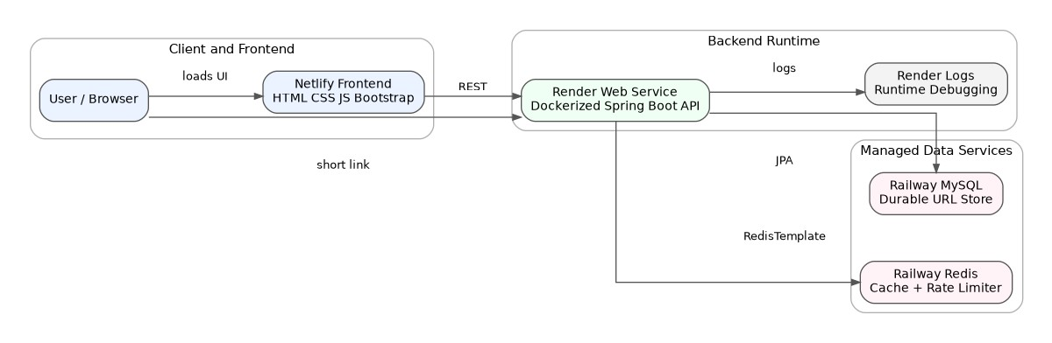
Figure 1: High Level Architecture

2.1 Why This Split Was Selected
The split between Netlify, Render, Railway MySQL, and Railway Redis was selected because each platform has a clear responsibility. Netlify is optimized for static frontend hosting. Render runs the Dockerized Java backend. Railway provides managed MySQL and Redis services. This keeps the backend container stateless and makes future horizontal scaling easier.
The frontend never talks directly to MySQL or Redis. This is a critical security and architecture boundary. Database credentials and Redis credentials must remain server-side. The browser interacts only with REST APIs exposed by the backend.

2.2 Source of Truth Principle
MySQL is the source of truth. Redis is not the source of truth. This means:
- A URL mapping is considered durable only after it is saved in MySQL.
- Redis cache loss does not lose the URL mapping.
- Redis cache miss triggers a MySQL lookup.
- Redis failure may reduce performance or rate-limit strictness, but should not corrupt persistent data.

2.3 Runtime Dependencies

Dependency | Purpose in This Project
Spring Web | REST controllers, Dispatcher Servlet, HTTP mapping.
Spring Data JPA | Repository abstraction for MySQL persistence.
Hibernate | ORM implementation used by Spring Data JPA.
MySQL Connector/J | JDBC driver for Railway MySQL.
Spring Data Redis | Redis Template and Redis operations.
Validation | DTO and input validation.

Dependency | Purpose in This Project
JUnit 5 | Unit testing framework.
Mockito | Mocking dependencies in service tests.

3. Component Architecture
The backend follows layered architecture. Each layer has a narrow responsibility, which makes the code easier to test, debug, and explain in interviews.

Component Diagram
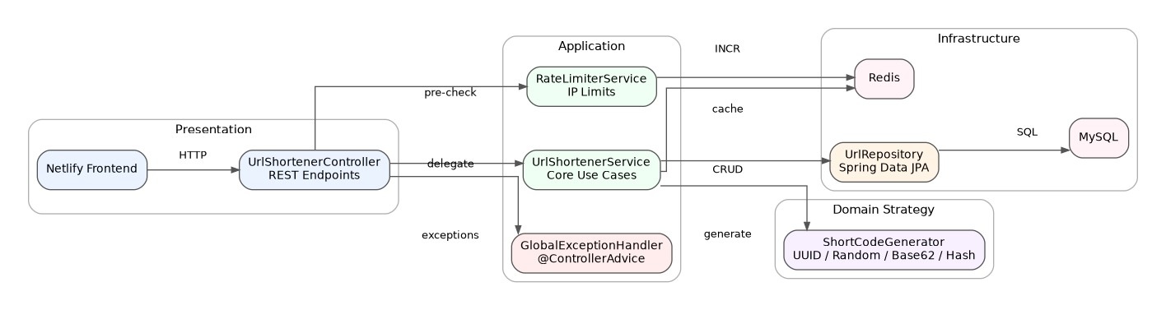
Figure 2: Component Diagram

3.1 Controller Layer
UrlShortenerController exposes the REST endpoints under /api/v1/urls. Its job is to map HTTP requests to use cases, bind request bodies, extract path variables, trigger validation, call rate limiter checks, delegate to the service layer, and return HTTP responses.
It should not contain the core short-code generation logic, repository queries, Redis operations, or analytics update logic. Keeping controllers thin prevents HTTP concerns from leaking into business logic.

3.2 Service Layer
UrlShortenerService is the main business orchestrator. It coordinates existing URL detection, generator selection, collision checks, MySQL persistence, Redis cache updates, and analytics updates.
Service classes are the correct place for business workflows because they can be unit tested with Mockito without starting the full web server or connecting to a real database.

3.3 Repository Layer
UrlRepository is a Spring Data JPA repository. It abstracts MySQL operations such as:
- find by original URL,
- find by short code,
- check if short code exists,
- save a new URL entity,
- update analytics fields.
The service layer should not directly manage JDBC connections or raw SQL for simple CRUD behavior.

3.4 Strategy Layer
Short-code generation is implemented using Strategy Pattern. UUID, Random, Base62, and Hash generation are separate implementations behind a common abstraction. This keeps algorithm-specific code away from the service workflow.

3.5 Configuration Layer
Configuration classes such as Redis configuration define infrastructure beans. This includes RedisTemplate setup, serialization decisions, CORS configuration, and environment-driven properties.

3.6 Exception Layer
Global exception handling uses @ControllerAdvice and @ExceptionHandler. This avoids repetitive trycatch blocks and ensures consistent API responses for validation errors, not found errors, rate-limit errors, and unexpected failures.

4. Package Architecture
The project package structure is based on com.priyaanshu.url_shortener. The package design maps directly to architectural responsibilities.

Package Diagram
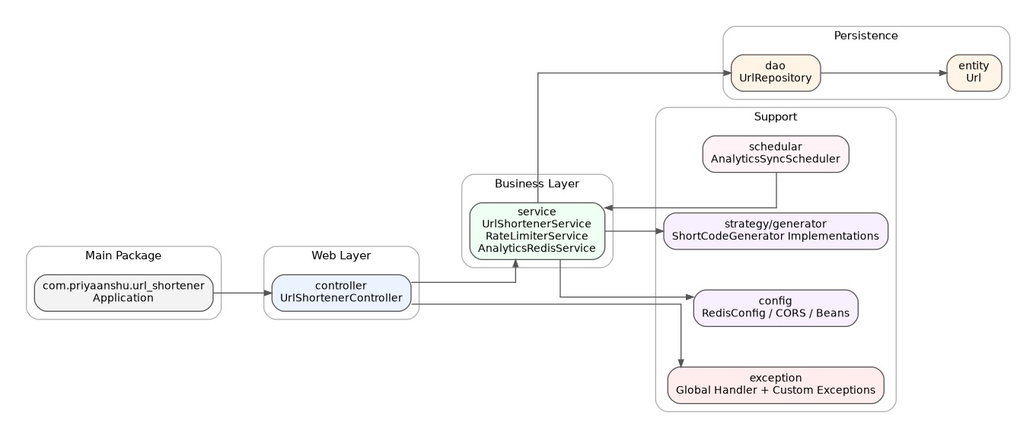
Figure 3: Package Diagram

4.1 Package Responsibilities
Package | Responsibility
controller | REST endpoint mapping and HTTP response handling.
service | Business workflows: shorten, redirect, analytics, rate limiting, Redis cache integration.
dao | Spring Data JPA repository interfaces.
entity | JPA entity model such as Url.
config | RedisTemplate, CORS, beans, and environment configuration.
exception | Custom exceptions and global exception handler.
schedular | Scheduler-related logic such as analytics synchronization if enabled.
strategy / generator package | Short-code generator implementations.

4.2 Dependency Direction
A clean dependency direction avoids circular dependencies:
controller -> service -> repository -> entity
-> strategy
-> Redis/config
Entities should not depend on controllers or services. Repositories should not call controllers. Strategies should not know about HTTP. This keeps each layer independent and reduces coupling.

4.3 Why This Matters in Interviews
Interviewers often check whether a project is only working code or a maintainable system. This package structure shows that the project separates transport logic, business rules, persistence, infrastructure, and exception handling. That is the difference between a student demo and production-oriented backend design.

5. REST API Design

5.1 API Base Path
The API base path is:
/api/v1/urls
Versioning the base path is intentional. Future breaking changes can be introduced under /api/v2/urls without immediately breaking the existing frontend or external clients.

5.2 Endpoints
Method | Endpoint | Purpose
POST | /api/v1/urls/shorten | Create or return a short URL for an original URL.
GET | /api/v1/urls/{shortCode} | Resolve the short code and redirect to the original URL.
GET | /api/v1/urls/analytics/{shortCode}Return analytics such as click count and last accessed timestamp.

5.3 Shorten URL Request
{
"originalUrl": "https://example.com/some/very/long/path",
"generatorType": "BASE62"
}

5.4 Shorten URL Response
{
"originalUrl": "https://example.com/some/very/long/path",
"shortCode": "aZ91bQ",
"shortUrl": https://your-render-domain.com/api/v1/urls/aZ91bQ
}
Returning the complete shortUrl is useful because the frontend should not reconstruct backend routing rules manually. The backend owns URL construction through BASE_URL.

5.5 Redirect Response
A redirect should use HTTP redirect semantics:
HTTP/1.1 302 Found
Location: https://example.com/some/very/long/path
Returning a JSON body with the original URL would force the frontend or browser to perform extra logic. A real short URL should work directly when opened in a browser.

5.6 Analytics Response
{
"originalUrl": "https://example.com/some/very/long/path",
"shortUrl": https://your-render-domain.com/api/v1/urls/aZ91bQ ,
"shortCode": "aZ91bQ",
"clickCount": 15,
"createdAt": "2026-06-30T21:30:00",
"lastAccessedAt": "2026-06-30T22:10:12"
}

5.7 API Design Decisions
Decision | Why It Was Made
POST for shortening | Creating a mapping changes server state.
GET for redirect | Browser-compatible and semantically correct for opening links.
GET for analytics | Analytics retrieval is read-oriented.
Path variable for short code | Short codes naturally belong in the URL path.
DTO responses | Avoid exposing internal entity structure directly.
Global error responses | Consistent production API behavior.

6. Spring Boot Request Lifecycle
This section explains what happens internally when a browser or API client calls the backend.

Spring Boot Request Flow Diagram

6.1 Browser to Dispatcher Servlet
The request first reaches the embedded servlet container started by Spring Boot. Spring MVC’s Dispatcher Servlet receives the request and acts as the front controller. It does not implement business logic. It finds the correct controller method using HTTP method and path mappings.
Example:
POST /api/v1/urls/shorten
maps to a controller class with @RequestMapping("/api/v1/urls") and a method with @PostMapping("/shorten").

6.2 Controller and Validation
Spring deserializes the JSON body into a request DTO using @RequestBody. Validation should run before the request reaches expensive service logic. Validation protects the database and Redis from invalid values.
Validation should cover blank URLs, malformed URLs, unsupported schemes, invalid generator type, and oversized values.

6.3 Rate Limiter Before Business Logic
The controller or filter-level flow calls RateLimiterService before expensive work. This protects URL creation and analytics endpoints from repeated calls. The limiter uses Redis atomic increments and TTL-based windows.

6.4 Service and Repository Flow
The service executes the use case. For shortening, it checks existing URL, selects the short-code generation strategy, detects collisions, saves the entity, and updates Redis. The repository delegates persistence to Hibernate, which translates entity operations into SQL executed against Railway MySQL.

6.5 Response Flow
For shorten and analytics, the controller returns JSON. For redirect, the controller returns an HTTP redirect. If an exception occurs, the global exception handler maps it to an appropriate HTTP status and structured response.

7. Spring Annotations Used

Annotation |  | Used For |  | Why It Matters
@RestController |  | REST controller class |  | Combines @Controller and @ResponseBody; returns JSON or response directly.
@RequestMapping |  | Base API path |  | Groups /api/v1/urls endpoints and supports versioning.
@PostMapping |  | Shorten endpoint |  | POST is appropriate for creating server-side state.
 | Annotation |  | Used For |  | Why It Matters
 | @GetMapping |  | Redirect and analytics |  | GET is appropriate for browser link access and read operations.
 | @RequestBody |  | Request DTO binding |  | Converts JSON payload into Java object.
 | @PathVariable |  | Short code extraction |  | Extracts {shortCode} from URL path.
 | @Service |  | Business logic classes |  | Marks URL, analytics, and rate limiter services as Spring beans.
 | @Repository |  | Persistence abstraction |  | Marks repository/data access responsibility and supports exception translation.
 | @Configuration |  | Bean configuration |  | Centralizes RedisTemplate, CORS, and infrastructure setup.
 | @Bean |  | Bean factory method |  | Creates Spring-managed infrastructure objects.
 | @Component |  | Generic Spring bean |  | Useful for strategy implementations or helper components.
 | @Value |  | Config injection |  | Reads values such as BASE_URL, TTL, and limits from properties/env vars.
 | Constructor injection |  | Dependency injection |  | Preferred because dependencies are explicit and testable.
 | @ControllerAdvice |  | Global error handling |  | Centralizes exception responses.
 | @ExceptionHandler |  | Specific exception mapping |  | Maps rate limit, not found, validation, and generic errors to HTTP responses.
Constructor injection is preferred over field injection. With constructor injection, the class clearly states what it needs to function. It also allows dependencies to be mocked in unit tests using Mockito.
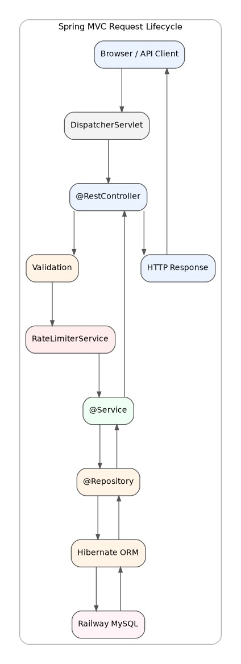
Figure 4: Spring Boot Request Flow Diagram

8. Short Code Generation Architecture

8.1 Problem
A URL shortener needs compact, URL-safe, and unique-enough identifiers. The generated code must be easy to store, easy to query, and safe to expose publicly.
The project supports four generators:
- UUID
- Random
- Base62
- Hash

8.2 Why Strategy Pattern Was Selected
Short-code generation is a variable algorithm. The service should not contain all algorithm logic in one method. Without Strategy Pattern, the service becomes a long conditional chain:
if (generatorType.equals("UUID")) { // UUID logic
} else if (generatorType.equals("RANDOM")) { // Random logic
} else if (generatorType.equals("BASE62")) {
// Base62 logic
} else if (generatorType.equals("HASH")) {
// Hash logic }
This violates the Open Closed Principle because every new generator requires modification of the main service. With Strategy Pattern, each algorithm becomes a separate class behind a common interface.

8.3 Strategy Pattern Benefits
Benefit |  |  | Explanation
Maintainability |  |  | Generator logic is isolated from service workflow.
Testability |  |  | Each generator can be unit tested independently.
Extensibility |  |  | Add a new generator without rewriting service logic.
Open Closed Principle |  |  | Existing code remains stable when new algorithms are added.
Interview value |  |  | Demonstrates real design thinking, not only working code.
8.4 Generator Comparison
Generator Strength |  |  | Trade-Off
UUID | Very easy and low collision risk when long enough. |  |  | Full UUID is too long; truncation increases collision probability.
Random | Simple and flexible length/alphabet. |  |  | Needs collision checks and good randomness.
Generator |  | Strength |  | Trade-Off
Base62 |  | Compact, URL-safe, common in URL shorteners. |  | Needs careful implementation and collision safety unless based on unique sequence.
Hash |  | Can be deterministic from original URL. |  | Truncated hashes can collide; repeatability may reveal patterns.

8.5 Collision Detection
Collision detection is required because none of the configured strategies should be blindly trusted. Collision handling happens at two levels:
- Application level: check if generated code already exists.
- Database level: enforce unique constraint on shortCode.
The database unique constraint is the final authority because concurrent requests can pass application-level checks at the same time.

9. Database Architecture
MySQL is the durable source of truth for URL mappings and aggregate analytics.

Database Diagram
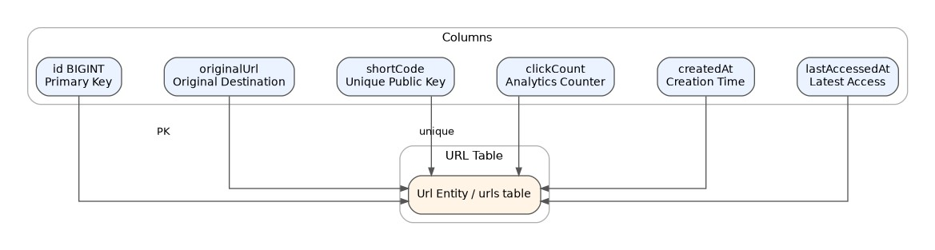
Figure 5: Database Diagram

9.1 Entity Fields
Field | Purpose
id | Internal primary key.
originalUrl | Long destination URL.
shortCode | Public URL-safe code.
clickCount | Number of redirects.
createdAt | Creation timestamp.
lastAccessedAt | Latest redirect timestamp.

9.2 Primary Key
id should be the internal primary key. The short code is a public business key and should be unique, but it does not need to be the internal primary key. Keeping them separate avoids coupling public URLs to database implementation details.

9.3 Unique Constraint
shortCode must be unique. If two rows share one code, redirect behavior becomes ambiguous and incorrect.
ALTER TABLE urls ADD CONSTRAINT uk_short_code UNIQUE (short_code);

9.4 Indexes
Index | Why
Unique index on shortCode | Required for redirect lookup and correctness.
Index/hash for original URL | Helps existing URL detection.
Future index on createdAt | Useful for cleanup and expiry workflows.
Future index on userId | Needed after authentication/dashboard features.

9.5 Normalization
The current single-table model is normalized enough for the first version because there are no users, campaigns, or per-click event records yet.
Current model:
Url(id, originalUrl, shortCode, clickCount, createdAt, lastAccessedAt) Future normalized model:
User(id, email, passwordHash, createdAt)
Url(id, userId, originalUrl, shortCode, clickCount, createdAt, lastAccessedAt, expiresAt) ClickEvent(id, urlId, ipHash, userAgent, country, clickedAt)

9.6 Existing URL Detection
Existing URL detection prevents duplicate rows for the same original URL. At small scale, direct lookup by original URL can work. At higher scale, a better design is to store a normalized URL hash such as originalUrlHash and index that hash.

9.7 Analytics Consistency
Current analytics are stored as aggregate fields on the URL row. This is simple and appropriate for current scale. At high traffic, every redirect updating the same row can become a write hotspot. The future design should publish click events asynchronously and aggregate them in batches.

10. Redis Architecture
Redis is used for caching and rate limiting. These are separate responsibilities and should use separate key namespaces.

Redis Flow Diagram
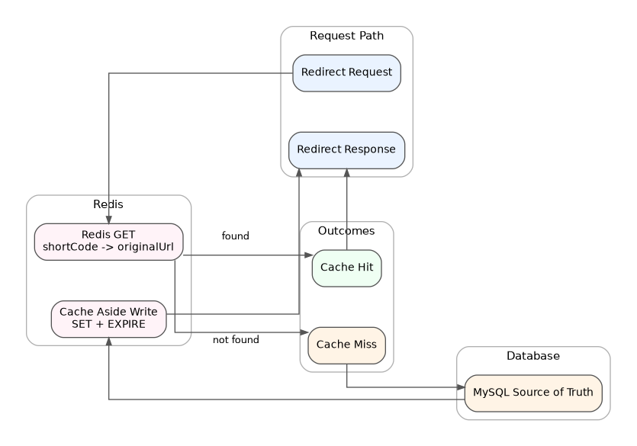
Figure 6: Redis Flow Diagram

10.1 Redis Responsibilities
Responsibility | Key Pattern Example
Redirect cache | url:shortCode:{code} url:shortCode:aZ91bQ
Rate limiter | rl:{type}:{ip} rl:SHORTEN:203.0.113.10
Future analytics cache | analytics:{code} analytics:aZ91bQ

10.2 Why Redis Was Selected
Redis provides low-latency key-value access, TTL, atomic increment operations, and shared state across backend instances. A Java HashMap would work only inside one JVM and would break under horizontal scaling. Redis is external and shared, making it suitable for distributed rate limiting and cache.

10.3 RedisTemplate
RedisTemplate is Spring’s abstraction for Redis operations. It supports value operations, increments, expiry, and serialization configuration.
Common operations:
redisTemplate.opsForValue().get(key); redisTemplate.opsForValue().set(key, value, ttl); redisTemplate.opsForValue().increment(key); redisTemplate.expire(key, duration);

10.4 Serialization
Redis stores bytes. For this project, string serialization is the safest default for redirect cache because the key and value are strings.
Data | Recommended Serializer
Redis keys | StringRedisSerializer
Original URL values | StringRedisSerializer
Future DTO/object values | Jackson JSON serializer
Avoid Java native serialization for simple cache values because it is harder to inspect and less portable.

10.5 TTL and EXPIRE
TTL prevents Redis from growing forever. Redirect cache entries should have TTL because MySQL remains the source of truth. Rate limiter counters must have TTL because the count must reset after the configured window.
Example:
INCR rl:SHORTEN:203.0.113.10 EXPIRE rl:SHORTEN:203.0.113.10 60

10.6 Atomic Operations
INCR is atomic in Redis. That is why it is useful for rate limiting. Multiple concurrent requests can increment the same IP key safely.
A future improvement is to combine INCR and EXPIRE in a Lua script so the increment and TTL assignment happen atomically as a single Redis operation.

10.7 Cache Hit and Cache Miss
Cache hit: Redis contains the short-code mapping. The backend can redirect quickly without reading MySQL for the mapping.
Cache miss: Redis does not contain the mapping. The backend queries MySQL, writes the mapping back to Redis with TTL, and redirects.

10.8 Redis Failure Handling
Redis failure should not corrupt data because Redis is not the source of truth. The system can fall back to MySQL for redirects. For rate limiting, the current design can fail open and allow traffic while logging the error. This prioritizes availability over strict enforcement during Redis downtime.

Scenario | Behavior
Redis cache unavailable | Query MySQL directly.
Redis rate limiter unavailable | Log error and fail open.
Redis write fails after MySQL save | Return response; future read can repopulate cache.
Redis latency high | Request latency may increase; use timeouts and connection pooling.

11. Rate Limiter Design
The rate limiter protects the backend from repeated requests by the same IP address. It uses Redis because Redis provides shared counters, TTL, and atomic operations.

Rate Limiter Flowchart

11.1 Algorithm
The current algorithm is a fixed-window counter.
String key = "rl:" + rateLimitType + ":" + clientIp;
Long count = redisTemplate.opsForValue().increment(key);
if (count != null && count == 1L) {
redisTemplate.expire(key, Duration.ofSeconds(windowSeconds));
}
if (count != null && count > maxRequests) { throw new RateLimitExceededException("Too many requests");
}

11.2 Why Fixed Window Was Selected
Fixed window is simple, easy to debug, and good enough for the current production version. It is not the most mathematically fair limiter, but it is practical for protecting a portfolio-grade backend.
Algorithm | Complexity | Fit
Fixed window | Low | Current implementation.
Sliding window log | Medium | More accurate but more Redis memory.
Sliding window counter | Medium | Better fairness.
Token bucket | Medium | Allows controlled bursts.
Leaky bucket | Medium | Smooths traffic output.

11.3 IP-Based Limiting
IP-based limiting is used because the current system does not have user login. After JWT/OAuth is added, rate limiting should include user-based quotas and IP-based protection together.
Limitations:
- Many users may share one IP.
- Attackers may rotate IPs.
- Proxy headers such as X-Forwarded-For must be handled carefully.
- Different endpoints should have different limits.

11.4 Distributed Systems Behavior
Redis makes the limiter distributed. If Render runs multiple backend instances in the future, each instance will increment the same Redis key for the same IP/type. This would not be possible with in-memory counters.
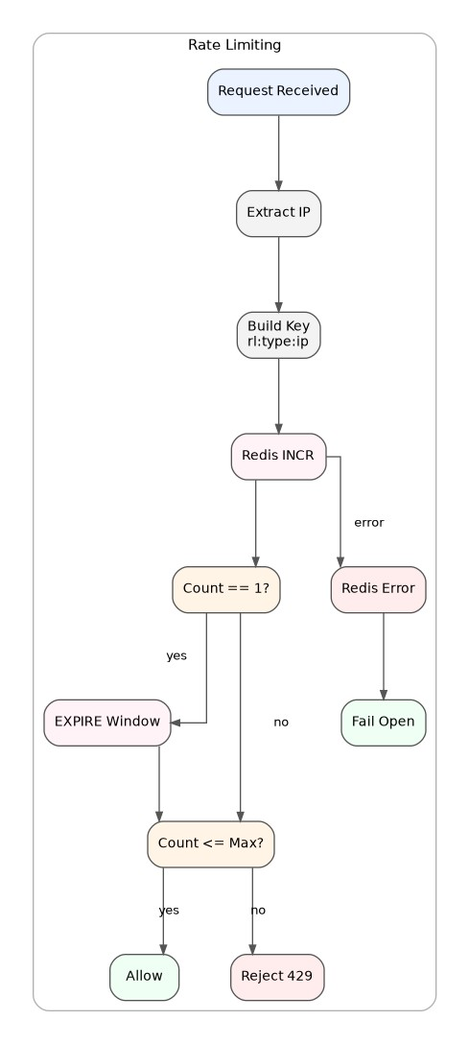
Figure 7: Rate Limiter Flowchart

12. Request Flows
This section explains the three most important use cases in detail.

Shorten URL Sequence Diagram
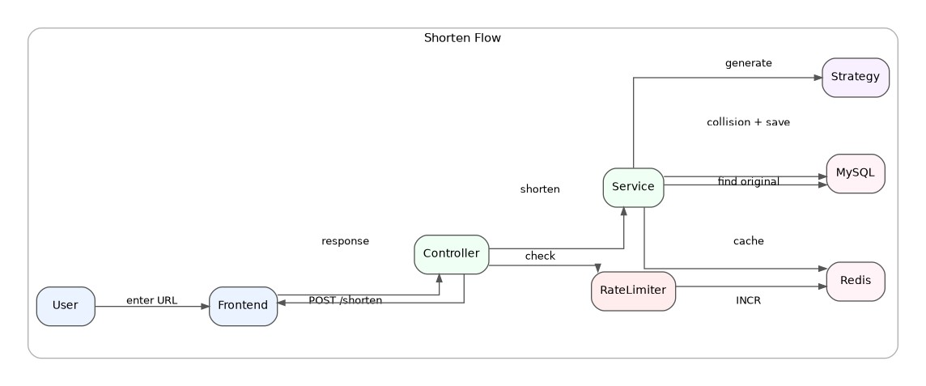
Figure 8: Shorten URL Sequence Diagram

12.1 Shorten URL Flow
- User enters a long URL in the Netlify frontend.
- Frontend sends POST /api/v1/urls/shorten to the Render backend.
- Controller receives the request and binds the JSON body.
- Validation checks original URL and generator type.
- Rate limiter increments the Redis IP key.
- Service checks whether the original URL already exists.
- If it exists, the existing short URL is returned.
- If it is new, the selected generator creates a short code.
- Service checks for collision using MySQL.
- Entity is saved in MySQL.
- Redis cache is updated with short-code mapping.
- Response DTO is returned to the frontend.
Existing URL detection happens before generation because it avoids duplicate rows and preserves analytics under one mapping.

Redirect Sequence Diagram

12.2 Redirect Flow
- Browser opens /api/v1/urls/{shortCode}.
- Backend extracts shortCode with @PathVariable.
- Backend checks Redis first.
- On cache hit, original URL is available immediately.
- On cache miss, backend queries MySQL.
- If not found, a not-found exception is thrown.
- If found, backend writes mapping to Redis with TTL.
- Backend increments click count and updates last accessed timestamp.
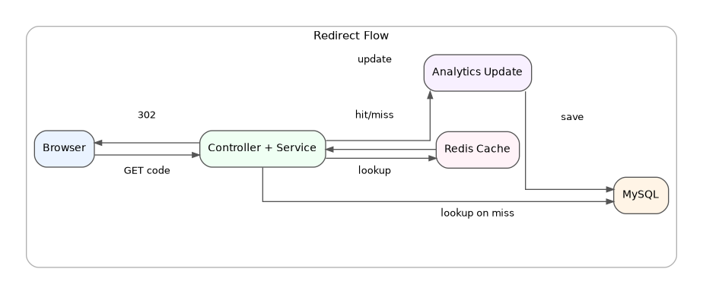
Figure 9: Redirect Sequence Diagram
- Backend returns HTTP 302 redirect.
Redis improves the read-heavy redirect path. MySQL preserves correctness.

Analytics Sequence Diagram
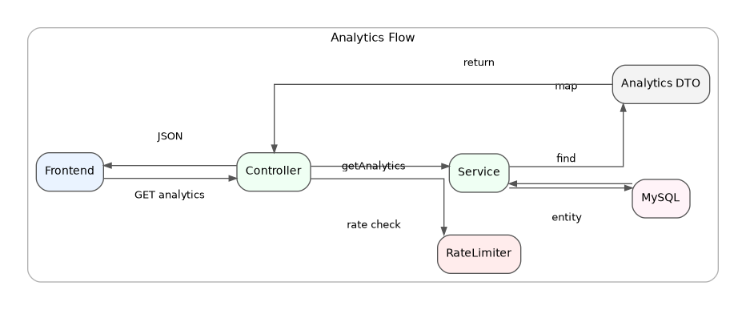
Figure 10: Analytics Sequence Diagram

12.3 Analytics Flow
- Frontend calls /api/v1/urls/analytics/{shortCode}.
- Controller extracts short code.
- Rate limiter checks IP-based quota.
- Service queries MySQL.
- Entity is mapped to analytics DTO.
- JSON response is returned.
Analytics are currently aggregate values on the URL row. This is simple and effective for the current version. At high traffic, click events should be processed asynchronously.

13. Deployment Architecture
Deployment uses GitHub, Docker, Render, Railway, and Netlify.

Deployment Diagram
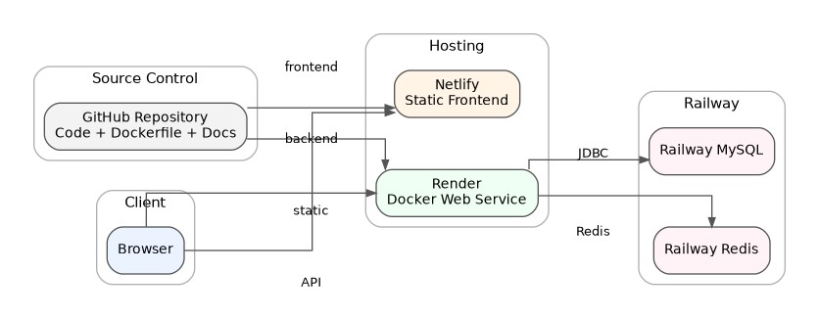
Figure 11: Deployment Diagram

Docker Deployment Diagram

Production Infrastructure Diagram

13.1 Deployment Flow
GitHub
-> Docker build
-> Render backend container
-> Railway MySQL
-> Railway Redis -> Netlify frontend

13.2 Dockerfile
The backend Dockerfile follows this known project pattern:
FROM eclipse-temurin:17-jre
WORKDIR /app
COPY target/url-shortener-0.0.1-SNAPSHOT.jar app.jar
EXPOSE 8080
ENTRYPOINT ["java", "-jar", "app.jar"]
EXPOSE documents the container port. In production platforms, the actual port behavior may also depend on provider environment variables. During local development, the application used port 8181 at one point, so production deployment must ensure that the backend listens on the port expected by Render.

13.3 Image vs Container
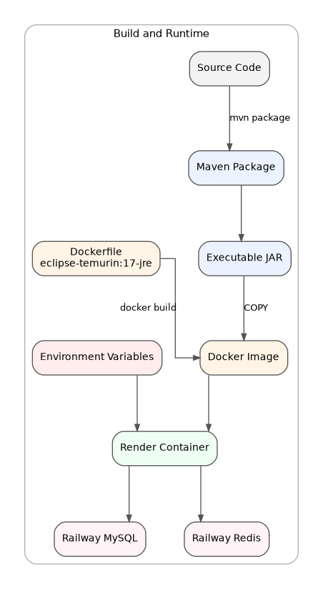
Figure 12: Docker Deployment Diagram
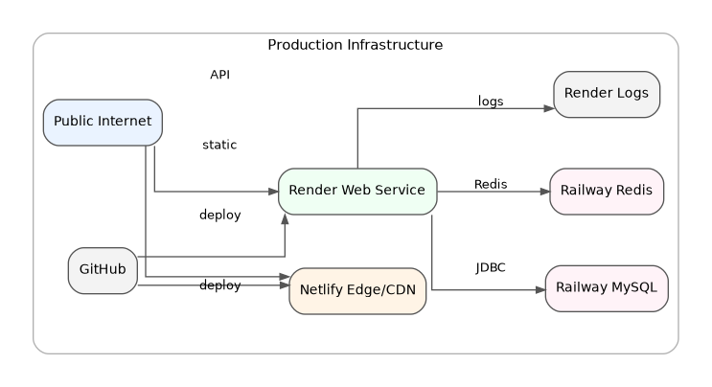
Figure 13: Production Infrastructure Diagram
Concept | Meaning
Image | Immutable packaged artifact built from Dockerfile.
Container | Running instance of that image on Render.

13.4 Environment Variables
Variable | Purpose
SPRING_DATASOURCE_URL | Railway MySQL JDBC URL.
SPRING_DATASOURCE_USERNAME | MySQL username.
SPRING_DATASOURCE_PASSWORD | MySQL password.
SPRING_DATA_REDIS_HOST | Railway Redis host.
SPRING_DATA_REDIS_PORT | Railway Redis port.
SPRING_DATA_REDIS_PASSWORD | Redis password if required.
BASE_URL | Render backend public base URL for generated short URLs.
FRONTEND_URL | Netlify frontend URL for CORS.

13.5 Localhost Removal
Localhost must not be used in production configuration. In browser JavaScript, localhost means the user’s device. In a backend container, localhost means the container. Railway MySQL and Redis must be reached through provider connection strings.

13.6 CORS and BASE_URL
CORS allows the Netlify frontend origin to call the Render backend. BASE_URL allows the backend to generate correct public short links. Both are production configuration concerns and should be environment-driven.

14. Security Architecture

14.1 Input Validation
Input validation protects the backend from invalid or abusive data. For the shorten endpoint, validation should check:
- original URL is not blank,
- URL format is valid,
- scheme is supported,
- value is not too long,
- generator type is recognized.

14.2 Rate Limiting
Redis IP rate limiting protects the system from spam submissions, accidental loops, repeated analytics polling, and basic abuse. It also reduces pressure on MySQL.

14.3 CORS
CORS is required because Netlify and Render are different origins. The backend should allow the Netlify frontend origin and required HTTP methods. Wildcard CORS should be avoided once authentication or admin APIs are added.

14.4 Environment Variables and Secrets
Secrets must not be committed to GitHub. Database passwords, Redis passwords, and future JWT secrets should live in provider environment variables. Local .env files should be ignored by Git.

14.5 Exception Handling
Global exception handling prevents stack traces, SQL errors, Redis connection details, and internal package names from leaking to users. Production error responses should be structured and safe.

14.6 Future Security Improvements
Improvement | Why
JWT authentication | User dashboards and ownership.
OAuth login | Easier sign-in with Google/GitHub.
URL safety scanning | Prevent phishing/malware redirects.
Bot detection/CAPTCHA | Protect public shortening endpoint.
WAF / API gateway | Edge protection at larger scale.
Per-user quotas | Stronger than IP-only limits.

15. Error Handling, Logging, and Observability

15.1 Error Handling
Error | Source | HTTP Status
Invalid URL | Validation layer | 400
Unknown short code | Service layer | 404
Collision after retries | Service/database layer | 409
Rate limit exceeded | RateLimiterService | 429
Database unavailable | Infrastructure | 503 or 500
Unexpected exception | Any layer | 500

15.2 Error Response Shape
{
"timestamp": "2026-06-30T21:30:00",
"status": 404,
"error": "Not Found",
"message": "Short URL not found",
"path": "/api/v1/urls/abc123"
}

15.3 Logging
Logging is important for production debugging. Useful log points include startup, datasource configuration success/failure, Redis connection issues, shorten requests, existing URL detection, generated short code, collision detection, cache hit/miss, rate-limit rejection, and redirect not found.

15.4 Future Observability
Metric | Why It Matters
Request count by endpoint | Understand traffic distribution.
Redirect latency | Most important user-facing path.
Cache hit ratio | Measures Redis effectiveness.
Rate-limit rejections | Detect abuse.
DB query latency | Detect database bottlenecks.
Redis latency | Detect cache/rate limiter problems.
5xx error rate | Production health.
Future stack: Prometheus, Grafana, structured logs, OpenTelemetry tracing, and alerting.

16. Testing Architecture

16.1 Current Testing Stack
Tool | Purpose
JUnit 5 | Unit testing and assertions.
Mockito | Mocking dependencies such as repository and RedisTemplate.

16.2 Recommended Unit Tests
Component | Tests
Base62 generator | Allowed characters, length, deterministic/uniqueness expectations.
Random generator | Length, alphabet, uniqueness expectations.
Hash generator | Same input behavior, collision risk.
UrlShortenerService | Existing URL detection, new URL creation, collision retry, cache write.
RateLimiterService | Allowed request, exceeded request, Redis failure fail-open.
GlobalExceptionHandler | Correct HTTP status and response body.

16.3 Service Test Shape
@ExtendWith(MockitoExtension.class) class UrlShortenerServiceTest {
@Mock
private UrlRepository urlRepository;
@Mock
private RedisTemplate<String, String> redisTemplate;
@InjectMocks
private UrlShortenerService urlShortenerService;
@Test
void shouldReturnExistingUrlWhenOriginalUrlAlreadyExists() {
// arrange
// act
// assert
}
}

16.4 Future Integration Tests
Test Type | Tool
Controller integration | MockMvc / SpringBootTest
MySQL integration | Testcontainers MySQL
Redis integration | Testcontainers Redis
End-to-end | Deployed frontend calling test backend
Contract tests | OpenAPI validation

22. Challenges Faced and Resolutions
This section documents actual implementation and deployment problems encountered while building the project. Each challenge is written in production incident-review format: problem, root cause, debugging process, solution, and lesson learned.

22.1. Spring Dependency Injection
Problem: Some services, repositories, and strategy implementations were not immediately clear from a wiring perspective.
Root Cause: Spring can inject only objects that are registered as beans through annotations such as @Service, @Component, @Repository, or @Configuration. Constructor injection also requires that all required dependencies are available in the application context.
DebuggingProcess: Checkedstartuplogs, verifiedpackagescanningundercom.priyaanshu.url_shortener, confirmed stereotype annotations, and replaced hidden field assumptions with explicit constructor dependencies.
Solution: Use constructor injection, keep dependencies explicit, and ensure strategy/config classes are Spring-managed beans.
Lessons Learned: Dependency injection should be treated as architecture wiring, not magic. A clean bean graph makes the system easier to test and explain.

22.2. Strategy Pattern Confusion
Problem: Supporting UUID, Random, Base62, and Hash generation initially looked like it could be implemented using if-else logic.
Root Cause: Short-code generation is a variable behavior. Putting every algorithm in the main service would mix workflow orchestration with algorithm-specific code.
Debugging Process: Compared a conditional service implementation with an interface-based design, identified the algorithm variation point, and separated each generator.
Solution: Created a common generator abstraction and separate strategy implementations. The service delegates generation instead of owning every algorithm.
Lessons Learned: Use design patterns when there is a real reason. Here, Strategy Pattern directly supports extensibility and the Open Closed Principle.

22.3. Base62 Implementation
Problem: Base62 required understanding how compact URL-safe codes are created using an alphabet of letters and digits.
Root Cause: Base62 is not just a random string. Depending on implementation, it may encode numeric values or generate random characters from a 62-character alphabet.
Debugging Process: Validated character set, output length, collision behavior, and how the generated value is checked before persistence.
Solution: Implemented Base62 as one strategy and combined it with collision detection.
Lessons Learned: A generation algorithm is not enough by itself. System-level uniqueness still requires collision handling.

22.4. Collision Detection
Problem: Generated short codes could conflict with an existing row.
Root Cause: Random, truncated UUID, hash truncation, and random Base62 do not provide absolute uniqueness.
Debugging Process: Added repository existence checks and reviewed database uniqueness as final enforcement.
Solution: Check for existing short code before save and enforce a unique constraint on shortCode in MySQL.
LessonsLearned: Applicationchecksimprovebehavior; databaseconstraintsguaranteecorrectness under concurrency.

22.5. Redis Serialization
Problem: Redis keys/values can become unreadable or fail to deserialize when serializers are not configured intentionally.
Root Cause: Redis stores bytes. Java default serialization is not ideal for simple string values such as original URLs.
Debugging Process: Inspected the expected key/value shape and aligned RedisTemplate serializers with string cache values.
Solution: Use StringRedisSerializer for keys and URL values; use JSON only for future object/DTO caching.
Lessons Learned: Serialization choice is an operational decision because it affects debugging, compatibility, and Redis CLI readability.

22.6. Redis Configuration
Problem: Local Redis worked with localhost, but production Redis is hosted on Railway.
Root Cause: localhost inside the Render container points to the container itself, not Railway Redis.
Debugging Process: Checked Redis connection errors in logs and compared local properties with production environment variables.
Solution: Moved Redis host, port, and password into environment variables on Render.
Lessons Learned: Never carry localhost assumptions into cloud deployment.

22.7. Redis Fail-Open Design
Problem: Redis failure could have caused the entire request path to fail.
Root Cause: Redis is an optimization/coordination dependency, not the source of truth. MySQL remains canonical for URL mappings.
Debugging Process: Separated Redis-critical behavior from durable correctness. Evaluated failopen versus fail-closed behavior.
Solution: Use fail-open behavior for cache/rate-limit failures where availability is preferred, while logging Redis errors.
Lessons Learned: Infrastructure dependencies should be classified by criticality. Not every dependency failure should become a full outage.

22.8. Redis Latency
Problem: Redis operations in production can be slower than local because Redis is external.
Root Cause: Render and Railway are separate networked services; every Redis command is a remote call.
Debugging Process: Compared local behavior with deployed behavior and identified the external network path.
Solution: Keep cache values small, avoid unnecessary Redis round trips, configure timeouts, and use TTL correctly.
Lessons Learned: A remote cache improves database pressure but is still a network dependency.

22.9. Dockerfile Naming
Problem: Build/deploy can fail when the Dockerfile is misnamed or placed in the wrong location.
Root Cause: Docker expects Dockerfile in the build context unless a custom path is configured.
Debugging Process: Checked project root, file name, Render build settings, and Docker build command.
Solution: Place the Dockerfile at the backend root or configure provider build settings explicitly.
Lessons Learned: Deployment systems rely heavily on conventions.

22.10. Docker Context
Problem: Docker could not always find the JAR or project files during build.
Root Cause: Docker build context controls which files are visible to the Docker daemon. Building from the wrong folder hides files.
Debugging Process: Verified target/ contents, JAR name, Maven build output, and build directory.
Solution: Run mvn clean package before image build and run Docker build from the correct project root.
Lessons Learned: The Dockerfile and build context must match.

22.11. Docker Deployment
Problem: The backend had to run correctly as a container, not only inside the IDE.
Root Cause: IDE runtime, Docker runtime, and cloud runtime have different ports, paths, environment variables, and network behavior.
Debugging Process: Read Render build logs and runtime logs, verified exposed port, checked Spring Boot startup, and validated API endpoints.
Solution: Packaged the app with Java 17 runtime image and configured environment variables in Render.
Lessons Learned: A project is production-ready only after it runs outside the local IDE.

22.12. Railway MySQL
Problem: Spring Boot needed to connect to Railway MySQL instead of local MySQL.
Root Cause: Production JDBC host, port, database, username, and password differ from local properties.
Debugging Process: Checked datasource errors, JDBC URL format, MySQL driver dependency, and Railway-provided credentials.
Solution: Use SPRING_DATASOURCE_URL, username, and password environment variables in Render.
Lessons Learned: Database issues are often configuration, credentials, or network problems.

22.13. Railway Redis
Problem: Redis connection failed when local Redis settings were used in production.
Root Cause: The backend container cannot reach the developer machine’s localhost Redis.
Debugging Process: Checked Redis stack traces, provider values, host, port, and password settings.
Solution: Use Railway Redis connection values through environment variables.
Lessons Learned: Cloud Redis is an external service and must be configured explicitly.

22.14. Environment Variables
Problem: Hardcoded local values worked locally but failed after deployment.
Root Cause: Local properties do not automatically exist on Render, Netlify, or Railway.
Debugging Process: Compared application.properties with Render environment configuration.
Solution: Externalize database, Redis, BASE_URL, and FRONTEND_URL values.
Lessons Learned: Environment-specific configuration belongs outside code.

22.15. Localhost Removal
Problem: The frontend/backend continued to call localhost after deployment.
Root Cause: localhost means the user’s machine in browser JavaScript and the container itself inside backend runtime.
Debugging Process: Used browser network tab and logs to identify calls still going to localhost.
Solution: Replace localhost with Render backend URL and Railway connection strings.
Lessons Learned: Localhost is a development-only assumption.

22.16. BASE_URL Configuration
Problem: Generated short URLs could point to the wrong host.
Root Cause: The backend constructs public URLs and needs the production Render base URL.
Debugging Process: Created a short URL, opened it, and verified whether the host/path were correct.
Solution: Use BASE_URL as an environment variable and normalize trailing slashes.
Lessons Learned: Public URL generation must be environment-aware.

22.17. CORS
Problem: Netlify frontend could be blocked from calling Render backend.
Root Cause: Browsers enforce origin policy. Netlify and Render are different origins.
Debugging Process: Checked browser console, network tab, request origin, and backend CORS config.
Solution: Allow the Netlify frontend origin and required HTTP methods/headers in backend CORS.
Lessons Learned: CORS is a browser security rule configured on the API server.

22.18. Double Slash API Bug
Problem: API URLs could contain // due to string concatenation.
Root Cause: Base URL ended with / and endpoint path started with /.
Debugging Process: Inspected browser network requests and compared requested URLs with expected endpoints.
Solution: Normalize base URL and centralize API path construction.
Lessons Learned: Small URL construction issues can break production even when backend logic is correct.

22.19. Render Deployment
Problem: Render deployment required correct Docker, port, and environment configuration.
Root Cause: Render runs a managed container; local assumptions about ports and config do not apply automatically.
Debugging Process: Reviewed build logs, runtime logs, service status, and environment variables. Solution: Configured Docker build, runtime variables, and backend service path correctly.
Lessons Learned: Cloud deployment debugging requires reading both build-time and runtime evidence.

22.20. Netlify Deployment
Problem: The static frontend deployed successfully but still needed to call the correct backend.
Root Cause: Static JavaScript runs in the user’s browser and must target a public API endpoint.
Debugging Process: Opened deployed site, used browser network tab, and validated API URL.
Solution: Set frontend API base URL to the Render backend URL.
Lessons Learned: Frontend deployment is not complete until browser-to-backend integration works.

22.21. Cold Starts
Problem: First request after inactivity can be slow.
Root Cause: Render free/low-tier services may sleep and wake on first request.
Debugging Process: Compared first request latency with subsequent request latency.
Solution: Document cold-start behavior and consider always-on hosting or health checks for production-grade use.
Lessons Learned: Hosting tier can be a real operational factor.

22.22. Production Debugging
Problem: Issues appeared only after production deployment.
Root Cause: Production introduces external networks, provider credentials, CORS, cold starts, and environment differences.
Debugging Process: Used Render logs, Railway details, browser console, network tab, and endpoint testing.
Solution: Debug systematically: reproduce, inspect logs, verify config, isolate dependency, fix, redeploy, validate.
Lessons Learned: Production debugging is a disciplined workflow, not guessing.

23. Scalability Architecture: 100 Users to 100 Million Users

23.1 Current Scale: 100 Users
The current architecture is appropriate for portfolio traffic and moderate usage:
- one Render backend service,
- one Railway MySQL database, • one Railway Redis instance,
- one Netlify frontend.
Redis improves redirect performance, and MySQL provides durable persistence.

23.2 Scaling to 10,000 Users
Improvements:
- tune database connection pool,
- confirm indexes on shortCode,
- configure Redis TTLs,
- add health checks,
- improve structured logging, • monitor latency and error rate.

23.3 Scaling to 1 Million Users
Area | Change
Backend | Run multiple instances behind a load balancer.
Redis | Use larger managed Redis or Redis Cluster.
MySQL | Add read replicas and tune indexes.
Analytics | Move click events to async processing.
Observability | Add Prometheus, Grafana, tracing, alerts.
Delivery | Add CI/CD with GitHub Actions.

23.4 Scaling to 100 Million Users
At 100 million users, the architecture must move toward distributed systems patterns:
Users
-> CDN / WAF
-> Load Balancer
-> Backend Instance Pool
-> Redis Cluster
-> MySQL Primary + Read Replicas
-> Kafka Click Event Pipeline
-> Analytics Consumers
-> Analytics Store / Warehouse

23.5 Load Balancer and Horizontal Scaling
The backend can scale horizontally because durable state is outside the container. A load balancer distributes traffic across multiple backend instances. All instances share the same MySQL and Redis systems.

23.6 Redis Cluster
Redis Cluster becomes useful when cache and rate-limit traffic exceed the capacity of a single Redis instance. Keys should be distributed well. Rate limiter keys should avoid hot partitions.

23.7 Database Replication and Read Replicas
Read replicas can serve analytics and dashboard reads. Writes such as URL creation and collision checks should go to the primary. Redirect cache misses may use primary if strong consistency is required.

23.8 Sharding
Sharding splits URL mappings across databases. A practical shard key is a hash of shortCode:
shard = hash(shortCode) % numberOfShards
Sharding improves capacity but increases operational complexity.

23.9 Kafka and Async Analytics
Synchronous click-count updates can become a write bottleneck. Future flow:
Redirect request
-> Resolve original URL
-> Publish ClickEvent
-> Return redirect
-> Consumer aggregates clicks
-> Batch update analytics store
This reduces redirect latency and protects MySQL from write hotspots.

23.10 CDN Considerations
CDN is safe for static frontend assets. Caching redirect responses at CDN edge must be considered carefully because backend may not see every click, which affects analytics. Edge logs or async analytics would be required.

24. Future Improvements
Improvement | Purpose
JWT | User authentication and protected dashboard.
OAuth | Login with Google/GitHub.
QR Codes | Generate QR code for short URLs.
Custom Alias | Let users choose meaningful short codes.
Expiry URLs | Auto-expire links after date/time.
User Dashboard | Manage links and view analytics.
Analytics Charts | Visualize click trends.
Admin Panel | Moderate abuse and manage users.
Prometheus | Metrics collection.
Grafana | Dashboards and alerts.
GitHub Actions | CI/CD automation.
Swagger/OpenAPI | API documentation and testing.
AWS Migration | ECS/EKS, RDS, ElastiCache, S3, CloudFront.

24.1 AWS Migration Mapping
Current Component | AWS Equivalent
Render backend | ECS Fargate, EKS, or Elastic Beanstalk
Railway MySQL | Amazon RDS MySQL
Railway Redis | Amazon ElastiCache Redis
Netlify frontend | S3 + CloudFront
Environment variables/secrets | AWS Secrets Manager or SSM Parameter Store
Logs | CloudWatch Logs
Metrics | CloudWatch / Prometheus

25. Architecture Decision Records

ADR-001: Use Spring Boot
Decision: Use Java 17 and Spring Boot 3.5.x for the backend.
Reason: Mature REST, validation, dependency injection, JPA, Redis integration, testing, and enterprise familiarity.
Consequence: Slightly heavier than minimal frameworks but stronger for production and interviews.

ADR-002: Use MySQL as Source of Truth
Decision: Store URL mappings and analytics in MySQL.
Reason: Requires durability, constraints, indexing, and transactional safety.
Consequence: Database scaling must be handled later with indexes, replicas, and sharding.

ADR-003: Use Redis for Cache and Rate Limiting
Decision: Use Redis for redirect cache and IP rate limiting.
Reason: Redis provides low-latency key-value access, TTL, and atomic INCR.
Consequence: Redis is an important external dependency, but not the source of truth.

ADR-004: Use Strategy Pattern
Decision: Implement UUID, Random, Base62, and Hash as short-code generation strategies.
Reason: Keeps algorithm variation outside the service workflow and follows Open Closed Principle. Consequence: More classes, but better maintainability and testability.

ADR-005: Use Docker for Backend Deployment
Decision: Package the backend as a Docker image.
Reason: Docker provides consistent runtime behavior across local and Render deployment.
Consequence: The build process must ensure the JAR exists and Docker context is correct.

ADR-006: Use Environment Variables
Decision: Configure database, Redis, BASE_URL, and FRONTEND_URL using environment variables.
Reason: Avoid hardcoded secrets and deployment-specific values.
Consequence: Deployment depends on correct provider configuration.

26. Production Readiness Checklist
Area | Checklist Item | Status / Recommendation
API | Versioned base path | Implemented with /api/v1/urls.
API | DTO-based request/response | Recommended and partly reflected in design.
Validation | Validate original URL | Required.
Database | Unique shortCode | Required.
Database | Index shortCode | Required for redirects.
Database | URL hash for duplicate detection | Future improvement.
Redis | Cache TTL | Required.
Redis | Rate limiter TTL | Required.
Redis | Fail-open fallback | Implemented/design documented.
Security | Secrets in env vars | Required.
Security | CORS restricted to frontend | Required.
Deployment | Dockerized backend | Implemented.
Deployment | Netlify frontend | Implemented.
Deployment | Render backend | Implemented.
Deployment | Railway MySQL/Redis | Implemented.
Observability | Logs | Implemented basic logging.
Observability | Metrics and dashboards | Future improvement.
CI/CD | GitHub Actions | Future improvement.
Docs | Swagger/OpenAPI | Future improvement.

27. Final Architecture Summary
The URL Shortener project demonstrates production-oriented backend engineering using Java 17, Spring Boot 3.5.x, Maven, MySQL, Redis, Docker, Render, Railway, and Netlify. The architecture is layered, cloud-deployed, and designed around clear responsibilities.
The most important engineering decisions are:
- MySQL is the durable source of truth.
- Redis is used for caching and distributed rate limiting.
- Strategy Pattern keeps short-code generation extensible.
- Collision detection is handled before save and should be enforced with database uniqueness.
- Environment variables remove localhost and secret hardcoding from production.
- Global exception handling makes API errors consistent.
- Docker packaging makes backend runtime repeatable.
- The backend is stateless and can scale horizontally.
This document can be used as GitHub documentation, portfolio architecture material, and interview preparation for backend, DevOps, Redis, Docker, Spring Boot, database, and system-design discussions.

