# ASSIGNMENT - 1

**1.Steps to download and install WordPress:**

Below are the step by step process to download and install WordPress.

**Step 1: Download WordPress**

Click on below link to download WordPress. <https://wordpress.org/download>

**Step 2: Extract zip file**

Now, you need to extract compressed (zipped) folders. Right click on zip file and click to “Extract All…”.

after successfully extract copy wordpress folder and paste in htdocs.

C:\xampp\htdocs\wordpress

**Step 3: Create the Database**

Now, you need to create the Database.

<http://localhost/phpmyadmin/>

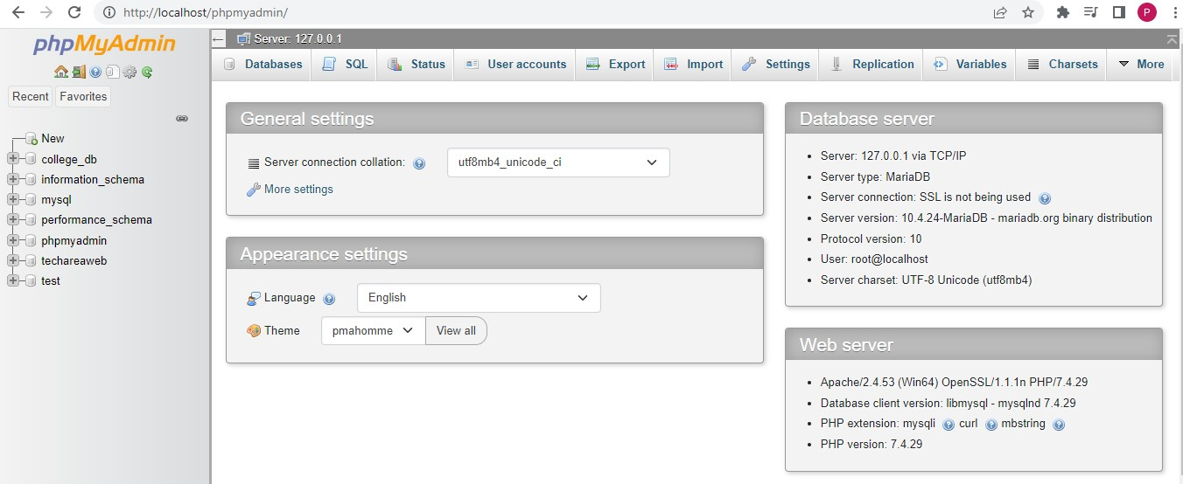

Click on “New” enter “database name” and click on “Create” as shown in figure.

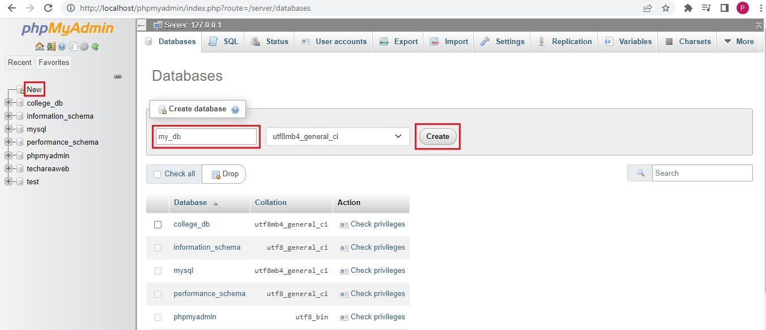

The database “my_db” has been created successfully.

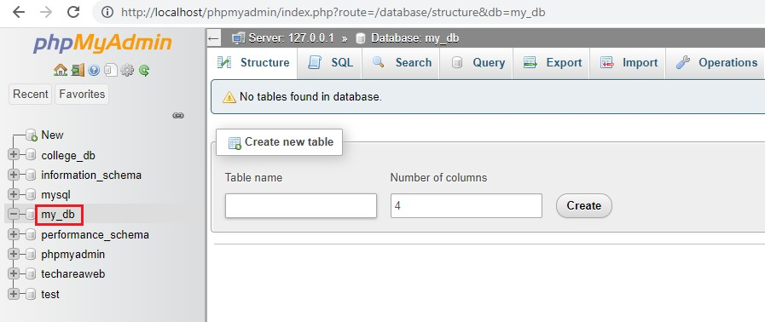

**Step 4: Run Installation**

Use below url to run the installation.

<http://localhost/wordpress>

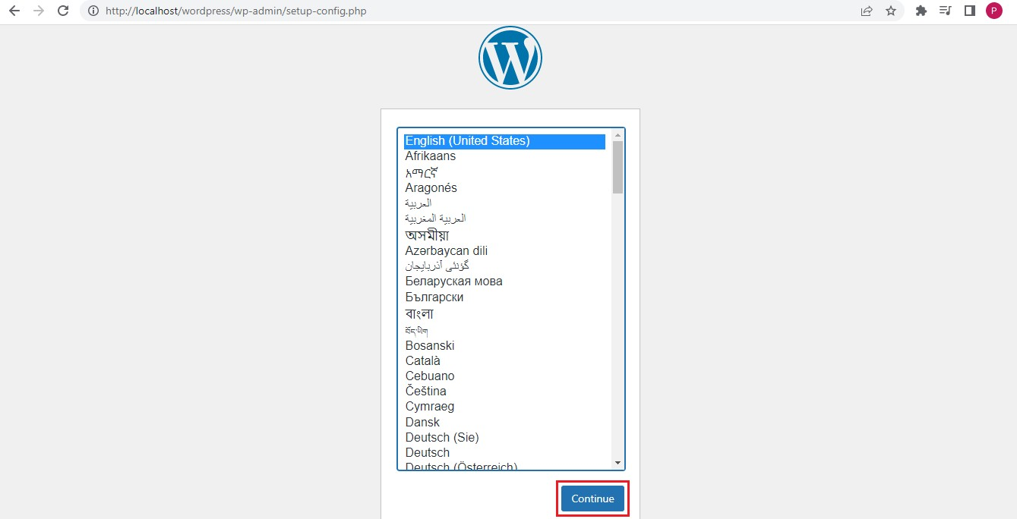

Choose language then click on “Continue” to start installation.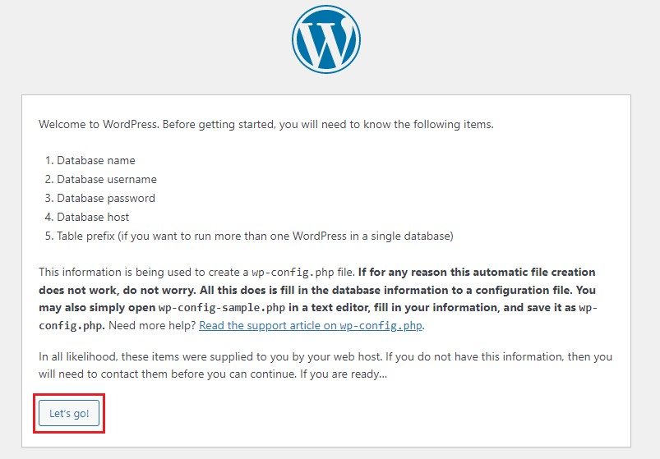

Click on “Let’s go!”.

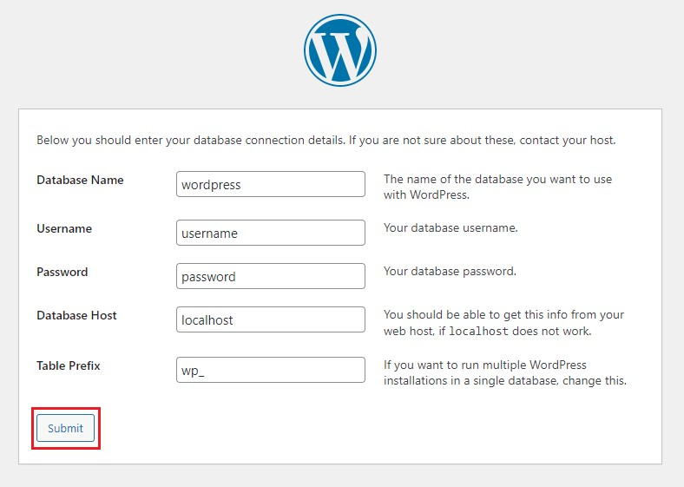 Now, you need to enter your database details. **Database name:** The name of the database. **Username:** Your database username.

**Password:** Your database password. **Database Host:** localhost (Default) **Table Prefix:** wp_ (Default)

After filling all database details click on “Submit” button.

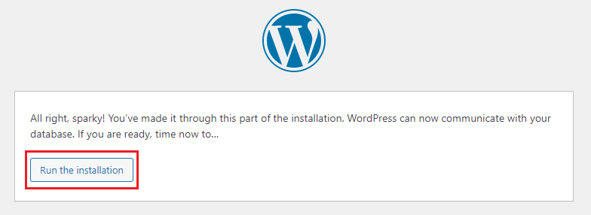

Click on “Run the installation” to continue.

You need to provide the following information. You can always change these settings later.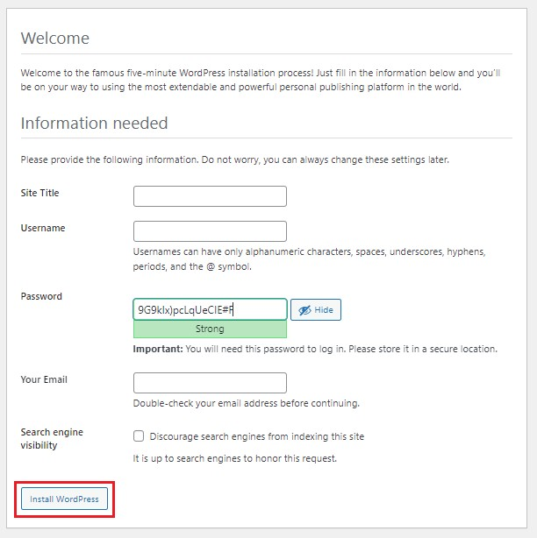

After filling all information click on “Install WordPress” to continue. Congratulations WordPress has been installed.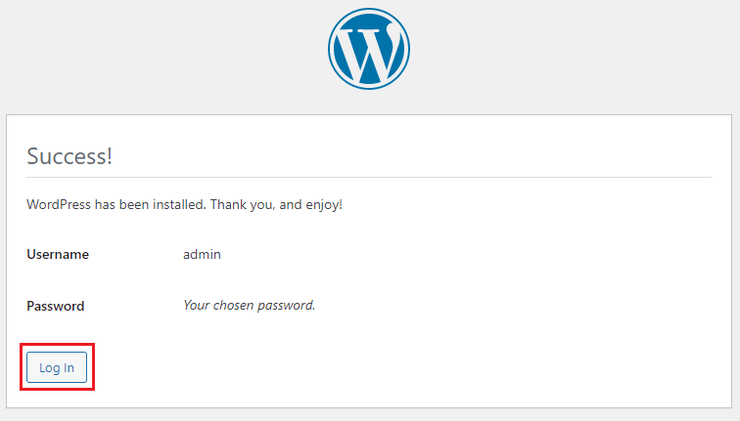

Click on “Log In” button to continue.

After successfully login you will see WordPress dashboard.

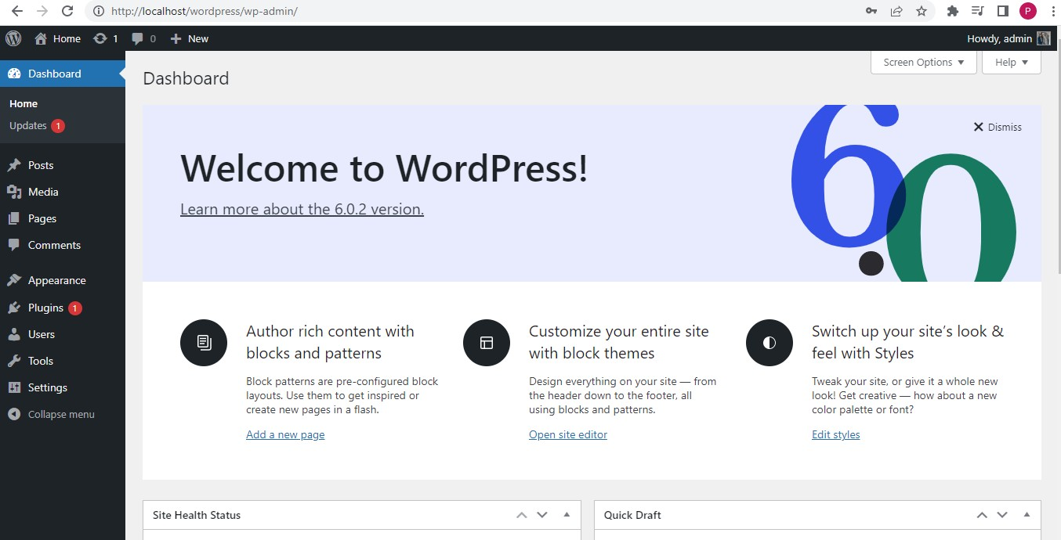

## 2.create post any five you are selected any website.

**Add new post**

[To add posts in WordPress, follow these steps:](https://www.bing.com/ck/a?!&&p=abcfe5c032e935d1JmltdHM9MTcyMzUwNzIwMCZpZ3VpZD0yYmQ1MmE4My1lMWU0LTZmZmEtMWRiMC0zZTRmZTA1MTZlZjcmaW5zaWQ9NTA0MQ&ptn=3&ver=2&hsh=3&fclid=2bd52a83-e1e4-6ffa-1db0-3e4fe0516ef7&u=a1aHR0cHM6Ly93d3cuaG9zdGluZ2VyLmNvbS90dXRvcmlhbHMvaG93LXRvLWFkZC1hLXBvc3QtdG8tYS1wYWdlLWluLXdvcmRwcmVzcw&ntb=1)

1. Navigate to Posts → Add 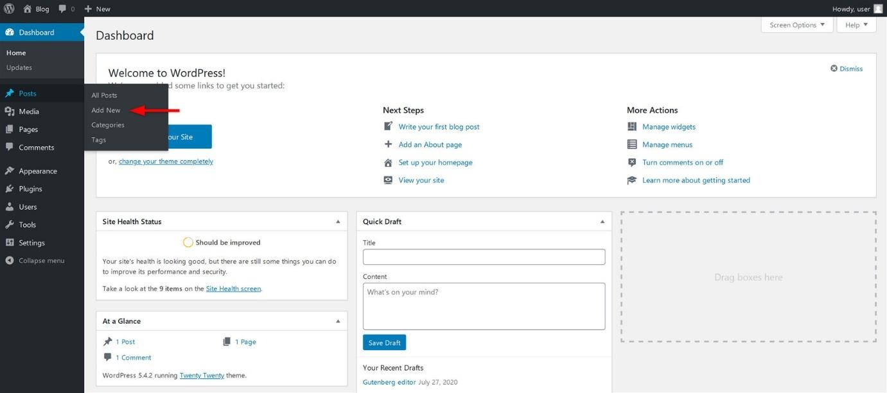New.
2. Write the post title and 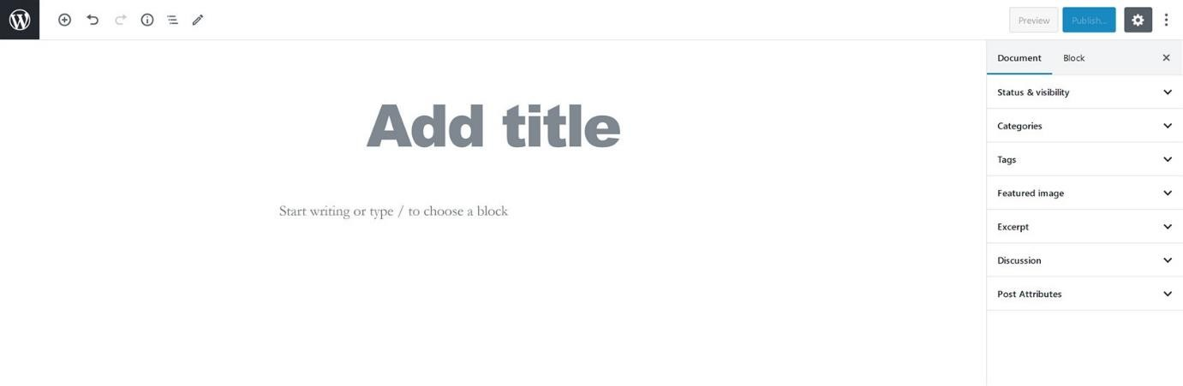content.
3. Click Publish.

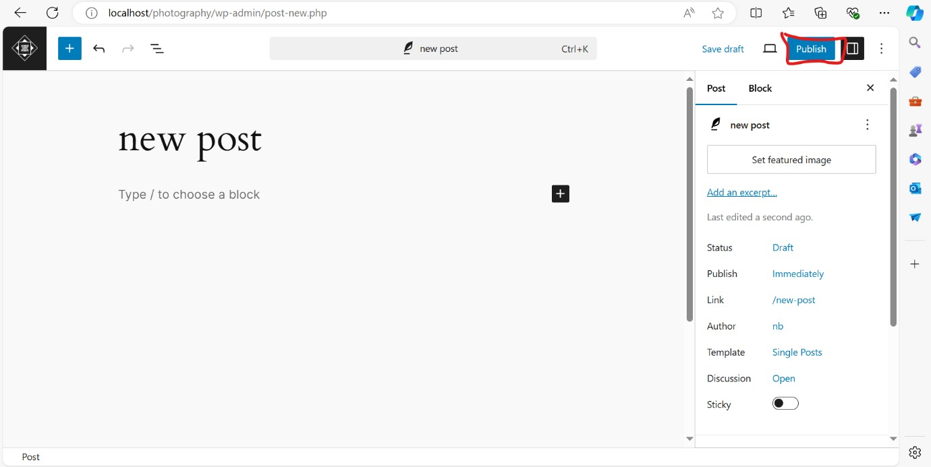

## create pages on website

To create a new *Page*:

* 1. Log in to your [WordPress admin screen](https://wordpress.org/documentation/article/administration-screens/).
  2. Click the **Pages** > **Add New** in the left sidebar.
  3. Alternatively, you can also click the *Add New* button in the Pages screen.

