1. Get the secret number from user(Admin):

* It would not allow user to add 5 digits only
* **You can change this number limit from code, Line no 3: “numberLength”**

It would not allow to repeating numbers

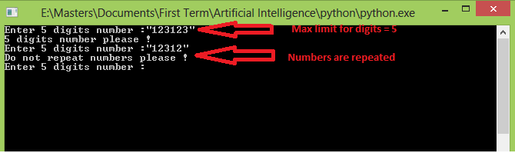

2)

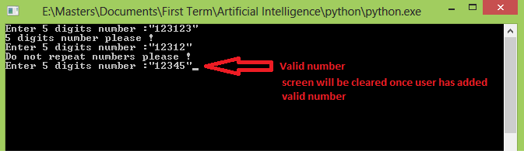

3)

* **This number is dynamic, you can change it to other number from code, Line no 5: “stop”**
* **Number of attempts are dynamic same like stop game, Line no 4: “maxGuessVal”**

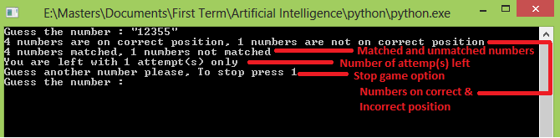

4) Stop the game

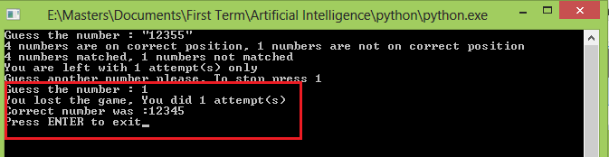

5) Lost the game, Completed maximum attempts

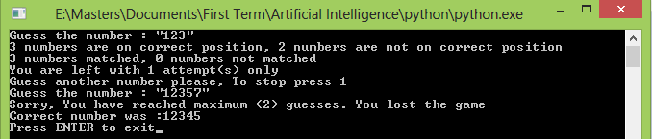

6) Won the game

