GSOC 2014: Vector Network Analyzer (VNA)

[Mitul Vekariya](https://github.com/mitul93)

[vekariya93@gmail.com](mailto:vekariya93@gmail.com)

[10bec062@nirmauni.ac.in](mailto:10bec062@nirmauni.ac.in)

**University**: Nirma University

**Branch**: Electronics and Communication Engineering

**Github:** <https://github.com/mitul93>

**IRC Nick Name:** mitul93

**Time-zone:** UTC + 5:30

Contents

Abbreviation 3

Introduction 4

Benefits to the community 4

Working principle of VNA 4

Source 4

Detector 4

Analyzer module 5

GNU Radio and USRP 5

Work during GSOC 14 5

Device setup 5

Magnitude and Phase measurement Block 6

Calibration Block 6

Dynamic range improvement Block 6

Display Block 7

Future scope 7

Deliverables 8

Timeline 9

Personal Background 9

Conclusion 10

Components required 10

Reference 10

# Abbreviation

DUT Device Under Test

FFT Fast Fourier Transform

IF Intermediate Frequency

LO Local Oscillator

MIMO Multiple Input Multiple Output

RF Radio Frequency

RX Receiver

SDR Software Defined Radio

SWR Standing Wave Ratio

TX Transmitter

UHD USRP Hardware Driver

USRP Universal Software Radio Peripheral

VNA Vector Network Analyzer

# Introduction

A Vector Network Analyzer is useful instrument to characterize electrical network. At high frequencies; it is not possible to monitor voltage and current to determine h or z parameters and if output of some two port device is short circuited to measure h or z parameters, then it may damage the device. Scattering parameters are measured at high frequency to overcome these limitations. This is where the VNA becomes useful. There are many novel applications of s-parameter like measurement of reflection coefficient, input impedance and insertion loss to design matching network to ensure maximum transfer of RF power. This project aims to design a simple two port VNA suitable to characterize RF devices that operates between 70 MHz to 6 GHz. With few external RF components it is possible to design VNA using SDR. The heart of instrument lies in its software that will do signal processing, calibrate the device and display measurement information using charts.

# Benefits to the community

* **Open source VNA:** Open source hardware and software is definitely a plus point of the project. Even after GSOC, with the help of enthusiastic developers and large community – this project will continue to deliver new features and improvements in the existing project.
* **Low cost device:** with release of this project, a powerful instrument covering range up to 6 GHz will be available at low cost. With calibration technique available, this device can measure as accurate as many VNA available in the market.
* **GNU Radio & USRP at Universities and Organizations:** A low cost device covering wide frequency range would be the perfect choice for many educational and small organizations for study and research purpose.

# Working principle of VNA

At high frequency, behavior of the device is quite different. When a stimulus signal is applied to the device, some part of signal will travel through the device (transmitted signal) and some part will reflect back (reflected signal). VNA measures transmitted and reflected signal accurately. There are mainly three blocks of VNA i.e. source, detector and analyzer module.

## Source

A pure tone sinusoidal wave is generated by VNA. This provides a stimulus to the DUT. It may either frequency sweep or power sweep source [1]. This GSOC project will focus on frequency sweep only. DUT should operate in minimum and maximum frequency range of source.

## Detector

A Homodyne receiver that downconverts the RF frequency to zero IF will be used in this project. Harmonics associated with source are also down-converted, but they’ll be outside the passband of IF filter. A narrow band IF filter will rejects the noise outside the bandwidth of filter. This will improve the sensitivity and dynamic range of VNA. Other methods to improve dynamic range are explained in later part of the document.

## Analyzer module

The analyzer module receives the transmitted and reflected signal along with reference signal. It will detect the phase difference of incoming signal and reference signal. From this information scattering parameters are calculated [1]. It is possible to calculate return loss, SWR, reflection coefficient, impedance, insertion loss, transmission coefficient from S-parameters [2]. However, this discussion is out of the scope of this proposal.

The final arrangement will look like figure 1. Where A, B and R are reflected signal, transmitted signal and reference signal respectively. The power splitter splits the power in two branches – one of which will be given to DUT while another is used as reference signal. Transfer switch is used to automate the four S-parameter measurements [1]. It changes the direction of reflected and transmitted signal.

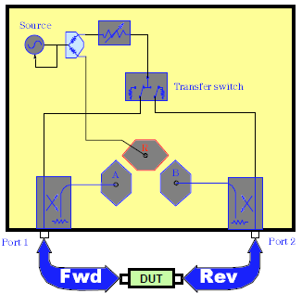

Figure Block diagram of VNA

# GNU Radio and USRP

GNU Radio is open source software which is based on the dataflow model. It provides powerful modules for advance signal processing. USRP is a good hardware solution for rapid prototyping of algorithms in hardware. Using gr_uhd of GNU Radio; one can interface with USRP devices. For this project USRP B210 is suitable because it has a wide frequency range from 70 MHz to 6 GHz which provides stable signal source for VNA, 2X2 MIMO capability and coherent detection of transmitted and received channel [3]. At least two receiving channel is needed for the design of VNA (explained later in this document)

# Work during GSOC 14

## Device setup

The actual implementation of VNA will be a little different from arrangement shown in fig 1. The USRP B210 has only two receiver channels, but VNA needs at least three. The USRP B210 shares transmitter and receiver path (TXRX1) using a switch (U805 – study the schematics) [7]. Due to the nature of a RF switch, some portion of power will leak from transmitter (TX1) path to the receiver (TXRX1) path. This leakage signal will be used as the reference signal and this eliminates need of separate channel. To use it as the reference signal, proper calibration must be required. Terminating DUT with matched load will guarantee that reflections from that port will be at its minimum. Transmitted signal and reflected signal measured from channel RX1 and RX2 respectively along with reference signal, measurement of S11 and S12 is possible. Similarly other two parameters - S22 and S12 can be measured by interchanging the connection of the device and repeat the measurement.

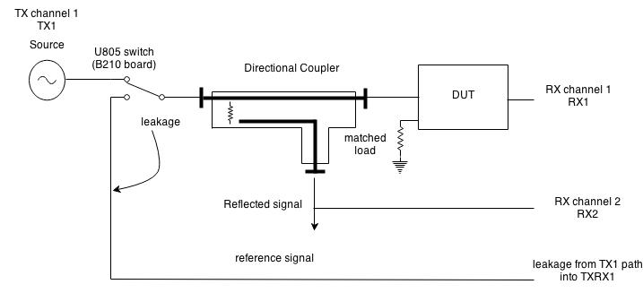

Figure Block diagram of proposed VNA using USRP

## Magnitude and Phase measurement Block

The main difference between spectrum analyzer and VNA is phase measurement. A signal processing block mag_phase_measurement will measure phase difference between transmitted/reflected signal and reference signal. As RX channel 1 is switched between reflected signal and transmitted signal, this block will interpret data coming from ADC accordingly. Using I and Q samples phase can be measured using arctan(Q/I) function. To cover frequency range from 70MHz to 6GHz, LO frequency must be swept for signal generator (TX channel) and signal receiver (both RX channels). [**usrp_spectrum_sense.py**](https://github.com/gnuradio/gnuradio/blob/master/gr-uhd/examples/python/usrp_spectrum_sense.py) in gr_uhd modulecan be used for frequency sweeping and IF bandwidth control. usrp_sink_impl**::**set_center_freq() function will be helpful to tune the frequency to cover desire frequency range.

## Calibration Block

There are several methods available to calibrate VNA like TRM, TRL, SOLT etc [4]. The SOLT method is easy to perform and removes directivity error, source mismatch error and Tracking error [1]. A conventional way to perform measurement is to calibrate device first then connect DUT. Another way is to perform the test first, save data to a file and then perform calibration. Based on calibration result, user can calibrate the data stored in the file. So a python script **calibrate_frm_file.py** will be useful for this post measurement calibration.

## Dynamic range improvement Block

Dynamic range defines the difference of the maximum power a receiver can accurately measure and the receiver noise floor. There are three ways to improve dynamic range of VNA: exponential averaging, reduction of IF bandwidth and increasing in the input power [5]. However, there is a tradeoff between improving dynamic range and system speed. For this reason all three parameters will be user controllable. As per the application requirement, user can choose between measurement speed and dynamic range. Averaging has to be done on normalized vector data otherwise it won’t increase dynamic range and introduce phase error [5]. To calibrate the phase error a coaxial cable of good quality is used as a reference. It has linear phase change with frequency. So replacing it with DUT and measuring phase, calibration of phase can be performed [6].

## Display Block

GNU Radio does not have support for Smith Chart. Smith chart is useful to display S – parameters (S11, S12, S21 and S22), Input impedance, SWR and reflection coefficient. Along with smith chart it will display parameters like gain, insertion loss, return loss, Group delay etc. For this purpose [**freq_sink_c_impl.cc**](https://github.com/gnuradio/gnuradio/blob/master/gr-qtgui/lib/freq_sink_c_impl.cc)will be useful as a reference. Code to plot smith chart using qt is available [here](http://sourceforge.net/p/qzplot/code/HEAD/tree/). Another way to plot graph is taking data from file like [**gr_plot_fft.py**](https://github.com/gnuradio/gnuradio/blob/master/gr-utils/python/utils/gr_plot_fft) does.

The final connections of blocks will look as below

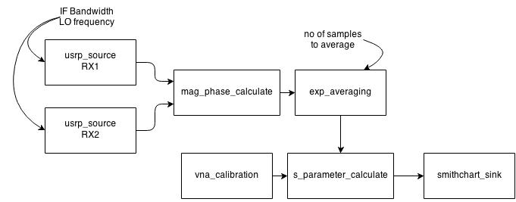

Figure 3 connection between different blocks

# Future scope

The proposed project only measures two s-parameters at a time. To measure all four parameters, we have to disconnect the DUT and reverse the connection and perform the experiment. This can result in systematic errors. To achieve fully automatic measurement, two USRP B210 with switch and two directional couplers can be used as shown in fig 3. Now with four receiver channel simultaneous measurement of all S parameters is possible [1].

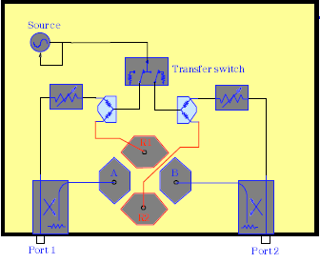

Figure Block diagram of VNA with four ports

However this is not a part of gsoc proposal.

# Deliverables

There are mainly five blocks associated with gr_vna: exp_averaging, mag_phase_calculate, vna_calibrate, s_para_calculate and smithchart_sink. Each block will have implementation file (C++ code) and a test file (python code). Python application will come in handy when user want to analyze data saved in a file. Like [**hf_explorer**](https://github.com/gnuradio/gnuradio/blob/master/gr-uhd/apps/hf_explorer/hfx.py)application under gr_uhd, a final script usrp_vna.py will be the end application of project that will provide user interface just like VNA for calibration, perform measurement, display data, save measurement data to file etc.

Apart from coding during GSOC, a blog will be created to post the updates about the project. Documentation necessary to explain working theory of VNA, tutorial about USRP B210, creating custom block on gnuradio and explanation of code will be provided.

* **gr_vna:** out of the tree module using gr_modtool.
* **exp_averaging_vcc_impl.cc (C++), qa_exp_averaging_vcc.py (python):** performs exponential averaging on data, number of elements to average will be given by user
* **mag_phase_calculate_cc_imp.cc (C++), qa_mag_phase_calculate_cc.py (python):** signal processing block that detects phase difference between input and reference signal
* **vna_calibration_c_imp.cc (C++), qa_vna_calibration_c.py (python):** perform SOLT calibration and save data of calibration to the file
* **s_para_calculate_cc_impl.cc (C++), qa_s_para_calculate.py (python):** calculate s parameters, calibration data feed as an input so output from this block will be calibrated output
* **smithchart_sink_c_impl.cc (C++):** Qt based gui similar to plot_fft to display data
* **usrp_vna.py (python):** incorporates all the previous blocks and final application that calibrates and uses usrp as vna
* **calibrate_frm_file.py (python):** app to calibrate measurement data stored in file
* **plot_smith_chart.py, plot_scatter_para.py, plot_insertion_loss.py, plot_impedance.py, plot_swr.py (python):** apps for plotting smith chart, scattering parameter, insertion loss, impedance and swr respectively from data saved in files.
* Comparison of results with Agilent E5062A available in college laboratory.
* Documentation

# Timeline

As per the curriculum of Nirma University, a final year student is supposed to work on projects only – no class and no exam. I don’t have any other commitments or plan to go on vacation during summer. I have one goal only - to complete this project successfully. Since there is no class or exam, I will dedicate myself at least 45-50 hours per week for this project.

* **Before GSOC (21st April, 2014 to 18th May, 2014):** Get to know the community. Learn more about VNA – the theory behind the calibration, mathematical equations for it, familiarized with USRP B210 board and RF components, calibration the VNA available in lab
* **Week 1:** get hand on experience with on USRP B210. Practice couple of programs to familiarize with USRP board. Setup device as shown in figure 2
* **Week 2 & 3:** exponent averaging and magnitude and phase measurement block, Test files for the same
* **Week 4 to 6:** calibration of VNA block; prepare for midterm evaluation
* **Week 7 to 8:** block to calculate s-parameters with calibration algorithm
* **Week 9 to 11:** implementation of final script **-** usrp_vna.py by integration of all blocks, methods to improve dynamic range
* **Week 12:** write utility programs to plot smith chart, s-parameters, insertion loss, impedance, swr etc. using data from file
* **Week 13:** perform test on various devices available, prepare documentation and comparison of results with Agilent E5062A available in university and prepare for final evaluation

# Personal Background

I am final year under graduate student of Electronics and Communication at Nirma University, India. It amazes me how VNA works – a single measurement device to solve many engineering problems. That and my interest in SDR, open source software and digital signal processing have motivated me to choose this project. I came across GNU Radio during my fifth semester when I was studying Digital communication systems. During my internship at National Instruments this year, I came across USRP platform. I learned a lot about NI’s USRP platform. It is attractive because of the fact that single piece hardware can be used for variety of applications. I am looking forward to work with Ettus research’s USRP device.

My interest in open source programming developed after interacting with ns3 and beagleboard.org community during last year (I didn’t have actual project back then). For more than a year, I am engaged with open source programming. The support and strength of community helped me to learn many new things. I finally feel confident enough to float my own proposal and complete this project.

I have good experience of coding using C, C++, bash shell script and VHDL. During last semester, I have also designed portable ECG device using Beaglebone running Linux and GUI using QT. I am pretty confident in my coding skills as well as my ability to understand the technical details of VNA.

# Conclusion

VNA is considered as most delicate and useful device among RF engineers. This proposal shows the fundaments to design VNA out of SDR. With wide frequency span of USRP B210, advance calibration methods and methods to improve dynamic range – VNA made out of USRP can compete some VNA available in market. Besides that student will have chance to use VNA as well as continue to contribute in the field of software defined radio.

# Components required

* USRP B210 board
* Directional coupler
* Power splitter
* Co-axial cable
* Filter for testing
* Calibration kit

# Reference

1. [Agilent Network Analyzer Basics](1)%09http:/www2.ee.cityu.edu.hk/~sklmmw/apmtt/B2BJan14/day1/Agilent_VNA_AN_Basics_5965-7917E.PDF), August 31, 2004.
2. [Reflection coefficient transformation](http://www.ittc.ku.edu/~jstiles/723/handouts/The_Reflection_Coefficient_Transformation.pdf), January 26, 2005.
3. [USRP B210](https://www.ettus.com/product/details/UB210-KIT), Ettus Research.
4. [Vector Network Analzer calibration : The Basics](http://cas.web.cern.ch/cas/Denmark-2010/Caspers/RS0908-22VNAWhitePaperV2%20on%20VNA%20calibration%20methods%20CAS%202009%20and%20CAS2010.pdf), White Paper, Rohde and Schwarz,2008.
5. [Understanding and Improving VNA dynamic range](http://cp.literature.agilent.com/litweb/pdf/5980-2778EN.pdf), Application note 1363-1, Agilent
6. [A low cost 100 MHz Vector Network Analyzer with USB interface](https://www.google.co.in/url?sa=t&rct=j&q=&esrc=s&source=web&cd=1&cad=rja&uact=8&ved=0CDsQFjAA&url=http%3A%2F%2Fwww.tapr.org%2F~n5eg%2Findex_files%2Ffinal_QEX_mcdermott.pdf&ei=NsshU-beC43ikAWGuIG4Cg&usg=AFQjCNHVPkRGGAVZ9VYq_a6KlbDbARtiWg&bvm=bv.62922401,d.), Tom McDermott
7. [Schematics of USRP B210](http://files.ettus.com/schematics/b200/b200.pdf), Ettus Research