Hackathon for Human-Centered Design of Large Language Model Interfaces
XplainAI
A Decision-Aware, Multi-Source Explainable Agent Interface
for Large Language Models
Problem Statement : Human-Centered Explainability for LLM-based Agents
Team Members
Mitul Jain
Harsh Goyal
Rucha Gonde
Shourya Agrawal

Abstract
Conversational interfaces built on large language models (LLMs) routinely present a final answer without exposing how that answer was produced, leaving users unable to judge when to trust, question, or override the system. This gap is well documented in the explainable AI (XAI) and human-agent trust literature, yet most production LLM interfaces still surface either nothing (a loading indicator) or everything (an unstructured chain-of-thought dump), and neither reliably improves a user's ability to calibrate trust.
We present XplainAI, a decision-aware agent interface that treats explanation as a first-class design problem rather than a debugging afterthought. XplainAI restructures a conversational LLM pipeline into eleven explicit stages — query analysis, missing-context detection, evidence planning, conditional retrieval-augmented generation (RAG) over uploaded documents, conditional multi-source tool use, candidate-approach generation and scoring, best-approach selection, answer generation, and a three-part explainability layer (source-contribution breakdown, confidence and risk scoring, and an interactive reasoning tree) — all orchestrated through a LangGraph state machine spanning thirteen graph nodes, and surfaced through a chat interface with six adaptive reasoning-depth modes.
Unlike prior chain-of-thought visualization work, which primarily displays a single model's internal trace, XplainAI's explanations describe a genuine multi-branch decision process: alternative approaches are generated, scored on explicit criteria, and one is selected with a stated rationale for why the others were rejected. The current build runs on GPT-5-mini as the reasoning and generation engine, with a working prototype already producing live reasoning trees, a four-metric confidence dashboard, and session-level history — evidence we draw on directly in Sections 7 and 14. We describe the system's architecture, the design literature that informed each explainability decision, a target-user analysis, and a roadmap for the trust-calibration evaluation this prototype is designed to enable.
Keywords: Explainable AI (XAI); Human-AI Trust Calibration; Large Language Model Interfaces; Multi-Agent Reasoning; Human-Centered Design

1. Introduction (Background & Motivation)

1.1 Problem Statement
PS01 — Human-Centered Explainability for LLM-based Agents: design an interface that makes an LLM agent's reasoning process visible and inspectable to end users, without exposing raw model internals or overwhelming the user with unstructured detail.

1.2 Problem Description
What problem are we solving? Modern LLM-based assistants are increasingly used for decisions that matter — financial choices, research synthesis, document analysis — yet the interfaces around them typically show only a spinner ("Thinking...") followed by a final answer. The user has no visibility into what evidence was consulted, whether alternatives were considered, or how confident the system actually is. XplainAI addresses the design question of what to show, and when, so that a user's trust in an answer tracks the answer's actual reliability rather than its fluency.
Why is it important? Fluent, confident-sounding text is not evidence of correctness, and prior work shows that exposing more of a model's reasoning does not automatically produce better-calibrated trust — in some conditions it inflates confidence without improving accuracy (see Section 2). Getting this interface design right is therefore a genuine open problem, not a solved one.
Who is affected? Anyone relying on an LLM-based assistant for a non-trivial decision: a student verifying a claim against a document, a researcher triaging literature, a professional deciding whether to act on an AI-generated recommendation. The common thread is a need to know when to rely on the system and when to check it themselves.

2. Literature Review
We reviewed prior work across three overlapping areas: (a) the general theory of trust calibration between humans and intelligent agents, (b) empirical studies of how LLM reasoning-trace exposure affects users, and (c) multi-agent and layered verification approaches to structuring LLM reasoning. During a second research pass focused specifically on 2026 publications, we also examined a fourth area — how users interpret transparency cues in multi-agent interfaces specifically, as distinct from single-model chain-of-thought — since XplainAI's candidate-generation-and-selection structure is closer to a multi-agent decision than a single trace. Nine findings directly shaped XplainAI's design.

2.1 Trust calibration as the design target
Cancro, Pan, and Foulds [1] survey the trust-calibration literature and propose a taxonomy of the "meta-information" an agent can supply beyond its main output — organized along content (e.g., confidence/risk, logic rationale, historic performance), modality (narrative, values, graphical), interactivity, and timing (proactive, concurrent, post-hoc). This taxonomy maps closely onto XplainAI's explainability layer: the confidence score and risk level correspond to confidence/risk content; the source-contribution chart is graphical, values-based, concurrent meta-information; and the reasoning tree adds interactivity that most surveyed systems lack. The taxonomy's underlying claim — traceable to Muir [2], who first framed trust calibration as letting a user "set his trust to a level corresponding to the [agent's] trustworthiness" — is the design target we adopted for the whole system, rather than treating explanation as documentation added after the fact.

2.2 Explanation design can create trust-calibration errors
Naiseh, Al-Thani, Jiang, and Ali [3] found, through a think-aloud study and co-design sessions, that explanations in human-AI collaborative decision tools can themselves introduce trust-calibration errors — prompting irrational agreement or disagreement rather than genuine evaluation. Their five resulting design principles (design for engagement, challenge habitual actions, guide attention, introduce friction, and support learning) directly motivated two XplainAI decisions: making the explainability panel opt-in rather than forced on every turn (avoiding habituated ignoring), and structuring the reasoning tree so a user can expand into any rejected approach rather than only viewing the winner (introducing productive friction before accepting a recommendation).

2.3 More reasoning detail is not automatically better
Two studies complicate the assumption that "more transparency is strictly better." Pang et al. [4] built Hippo, a tool that visualizes chain-of-thought as an interactive, collapsible topic tree; in a 16-participant study, users valued reviewing reasoning before the final answer, but also wanted the option to collapse and abstract large trees rather than review them in full — evidence that transparency needs a controllable level of detail, not a fixed maximum. Fernandes et al. [5], in a preregistered study (N = 559) comparing answer-only, full-trace, and summary-trace conditions on LSAT-style reasoning problems, found that full traces increased trust and perceived understanding without improving actual task performance, while summaries preserved baseline performance and still elevated trust. Together these results argue against XplainAI simply dumping a full chain-of-thought to the user, and instead motivated the layered design actually implemented: a concise final answer and confidence score by default, with the full reasoning tree available on demand rather than always shown.

2.4 Structuring multi-step reasoning for verifiability
Sanwal [6] proposes Layered Chain-of-Thought Prompting, which segments an LLM's reasoning into discrete, independently verifiable layers, and notes that this structure pairs naturally with multi-agent architectures where specialized agents handle retrieval, verification, and user interaction for each layer. This is architecturally close to XplainAI's graph: query analysis, evidence collection, candidate generation, evaluation, and selection are separate LangGraph nodes rather than one monolithic prompt, which allows each stage's output to be inspected and surfaced independently in the explainability report — the same benefit Sanwal attributes to layering, applied here at the level of an agent graph rather than a single prompt.

2.5 Explanation as a social, not just technical, act
Miller [7] argues, from the social sciences, that human explanation is selective, contrastive, and social — people explain by contrasting the actual outcome with a salient alternative ("why P rather than Q"), not by listing every causal factor. This motivated the explicit "why other approaches were not selected" field in XplainAI's Best Approach Selection stage, rather than only justifying the winning approach in isolation.

2.6 Emerging multi-agent transparency and reasoning-trace research (2026)
A second, more recent pass through the literature — carried out specifically to check whether our design choices still hold up against work published this year — surfaced three additional studies that sharpen rather than overturn the picture above.
Pareek and colleagues' CHI 2026 study on sensemaking in multi-agent LLM interfaces [8] observed users across five interface variants that each combined different transparency cues, and found that what people actually notice and weigh as signals of trustworthiness in a multi-agent system is not the same set of cues that single-model transparency research has focused on — debate between agents, visible disagreement, and cross-checking carry weight that a single confidence score does not capture on its own. This is a direct argument for why XplainAI's reasoning tree shows rejected candidate branches and the stated reason each was passed over, rather than only the winning path with a single confidence number attached.
A second 2025–2026 study, ReTrace [9], ran a controlled comparison of interactive reasoning-trace visualizations against raw text dumps and found that structured, node-based visualizations helped participants notice inefficiencies in a model's process — repeated checks, backtracking, dead ends — that a linear transcript hid. The authors argue this is a feature rather than a limitation: seeing an imperfect but real process, instead of a polished-looking justification, supports more mature reliance on the system. XplainAI's tree view was already structured as discrete, inspectable nodes for this reason, and this finding is why we chose not to hide or collapse rejected candidate nodes by default in the expanded view (Section 7).
A third, closely related CHI 2026 study on factual-verification tasks [10] manipulated how LLM reasoning rationales were presented — instantly, after a delay, or only on demand — as well as whether the rationale was correct and how it framed certainty. The presentation format itself made little difference to trust and adoption of the AI's advice; what mattered was whether the rationale was actually correct and how certainty was worded. That result is a caution against over-investing in transparency mechanics (animation, staged reveal, etc.) at the expense of getting the underlying confidence and evidence-support numbers right — it reinforced our decision to spend design effort on the accuracy of the four displayed metrics (Section 7) rather than on more elaborate reveal choreography for the reasoning tree.

2.7 Gap and positioning
Across this literature, two gaps stood out, and the 2026 studies in Section 2.6 sharpened rather than closed either one. First, most evaluated systems expose a single model's reasoning trace; few structure the explanation around a genuine multi-branch decision (several candidate approaches, scored and compared) rather than one linear trace — and the multi-agent sensemaking work [8] suggests users read multi-branch and single-trace transparency differently, which existing summary-first guidance [4, 5] does not by itself address. Second, the trust-calibration meta-information taxonomy [1] is rarely operationalized end-to-end in one interface — systems typically implement one or two content types (e.g., confidence only). XplainAI's contribution is an architecture that operationalizes several meta-information types from that taxonomy simultaneously (confidence/risk, logic rationale, and interactive graphical content) around an explicit multi-candidate decision process, while applying the layered/summary-first exposure pattern [4, 5] and the correctness-over-choreography lesson [10] to avoid the overreliance risk that the literature identifies.

3. Proposed Solution

Main idea
XplainAI restructures a conversational LLM backend so that every response is the visible output of an inspectable decision process, not a single opaque generation call. A LangGraph state machine moves each query through eleven numbered stages — Query Analysis, Missing Context Detection, Reasoning & Evidence Planner, Tool/Source Selection & Evidence Collection, Candidate Approach Generation, Evaluation & Scoring, Best Approach Selection, Final Answer Generation, layered Explainability, a visual Reasoning Tree, and a final Summary & Decision Overview — shown in full in Figure 1, with the four-phase condensed grouping (Understand & Collect, Decide, Explain, Summarize) used elsewhere in this document as shorthand for the same pipeline.
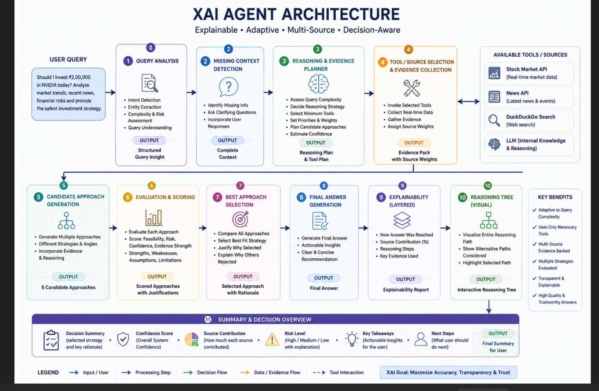
Figure 1. XplainAI's eleven-stage reasoning pipeline, available tool sources, and key benefits.
Each stage in Figure 1 produces a named output that the next stage consumes — Structured Query Insight, Complete Context, a Reasoning Plan & Tool Plan, an Evidence Pack with Source Weights, five Candidate Approaches, Scored Approaches with Justifications, a Selected Approach with Rationale, a Final Answer, an Explainability Report, and an Interactive Reasoning Tree — so that every intermediate artifact, not just the final text, is available to surface in the UI (Section 7). The right-hand panel in Figure 1 lists the tool sources the Tool/Source Selection stage can draw on (Stock Market API, News API, DuckDuckGo Search, and the LLM's own internal knowledge), which the evidence planner selects from based on query complexity rather than calling all of them on every turn.

Key features
- Conditional retrieval: a RAG node only runs when a document is actually uploaded, and web/tool search only runs when the query's complexity warrants it — avoiding unnecessary latency and cost on simple queries.
- Decision-aware core: multiple candidate approaches are generated, scored against explicit criteria (feasibility, relevance, evidence support), and one is selected with a stated rationale for why the alternatives were rejected.
- Optional Research Agent: for complex or user-requested queries, a scoped search over arXiv, PubMed, IEEE, ACM, Springer, ScienceDirect, and Nature supplements retrieved document evidence with external findings.
- Layered explainability output: a concise answer and confidence/risk score by default, with an interactive reasoning tree, source-contribution breakdown, and full decision rationale available on demand rather than forced on every turn.
- Six adaptive interaction modes (Fast, Moderate, Complex, Deep Research, Document Analysis, Reverse Mind) so the user — not just the system — controls reasoning depth; detailed in the subsection immediately below.
- Session-scoped personalization: thumbs-up/down feedback nudges candidate scoring toward what has worked well earlier in the same conversation, held only in memory for that session rather than written to persistent storage (Section 11).

Reasoning-depth modes
The mode selector (Figure 2, control ②) is not a cosmetic setting — each mode changes which stages of the Figure 1 pipeline actually run, trading latency against depth of evidence.
- Fast: the lowest-latency mode. It explicitly disables the Tool Router and skips the deep web-research phase entirely, answering from the model's internal knowledge alone.
- Moderate (default): the balanced mode. It allows quick, low-cost tools (checking a stock price or the weather) when useful, but still skips the time-consuming deep-research phase.
- Complex: the dynamic mode. It unlocks the full pipeline and asks the Reasoning & Evidence Planner to grade the query's complexity; deep research is triggered automatically only if the planner decides the query warrants it, so simple questions still resolve quickly.
- Deep Research: forces the Research Agent to run and scrape the web via DuckDuckGo for current information regardless of how simple the question looks — unlike Complex mode, this one does not ask permission first.
- Document Analysis: the RAG mode. It forces the backend to prioritize an uploaded PDF, Word document, or audio/video file, extracting its text and treating it as the primary evidence for the answer.
- Reverse Mind: the "forgetful" mode. It intentionally bypasses the session-scoped preference state described above — if thumbs-up/down feedback has been shaping the assistant's behavior this session, Reverse Mind ignores that and answers from the model's unbiased default persona for that turn.

Why this solution is different
Most explainable-chatbot interfaces expose a single reasoning trace after the fact. XplainAI instead makes the underlying decision genuinely multi-branch (Section 2.7) and applies summary-first, detail-on-demand exposure motivated directly by findings that full traces increase trust without increasing accuracy [5], sharpened further by the finding that trustworthiness cues in multi-agent settings differ from single-trace settings [8]. The result is an interface designed around calibrated trust as an explicit, measurable goal, rather than transparency as a proxy for it.

4. Target Users

Primary users
Users who consult an LLM assistant for research, document analysis, or decision support and need to judge how much to rely on a given answer before acting on it.
Attribute | Description
Age Group | 18–45; primarily university students, early- to mid-career professionals
Education | Undergraduate degree or higher; comfortable with technical reading
Occupation | Students, researchers, analysts, knowledge workers who consult AI for research or decision support
Digital Literacy | Medium to high; regular users of chat-based AI tools, not necessarily of ML/XAI concepts
Language | English (primary); interface designed to extend to additional languages
Environment | Desktop and mobile, individual use, often alongside document upload or research tasks

Secondary users
- Domain experts (e.g., clinicians, financial advisors) who need to audit an AI-assisted recommendation before endorsing it to a client or patient.
- Hackathon/product evaluators and researchers studying trust calibration in LLM interfaces, who need the explainability data as a measurable artifact rather than a UI flourish.

5. User Persona
The persona below is a fictional composite constructed for design purposes, following standard human-centered design practice; it does not represent a specific real individual.
Field | Detail
Name | Aanya Kulkarni (persona)
Background | Second-year graduate student in a policy program; regularly uses LLM assistants to synthesize academic literature and analyze financial/market questions for coursework.
Goals | Get a fast, well-evidenced answer; know which parts of the answer come from her own uploaded readings versus the model's general knowledge or a live web search.
Frustrations | Has been given confident-sounding answers that turned out to rely on outdated or irrelevant information; cannot tell, from a normal chat reply, whether the system checked her uploaded PDF at all.
Needs | A visible signal of source contribution and confidence; the ability to drill into "why this answer and not another" without reading a raw model log.
Technical proficiency | Comfortable with everyday software and chat-based AI tools; not familiar with machine-learning terminology or model internals.

5. User Journey
How users currently solve this problem with a typical LLM chat interface, and how XplainAI changes the experience:
Stage / Current Experience | Pain Point | XplainAI Solution
Uploads a document and asks a question | Gets a fluent answer with no indication the PDF was used at all | Answer is checked against the PDF blindly, or not at all — was pain point; XplainAI now shows exactly whether and how the document was used
Asks a follow-up, expects fast reply | Every query pays the cost of full tool search and multi-step reasoning | Slow, and no control over reasoning depth — addressed via conditional routing and the six reasoning-depth modes
Wants to double-check the answer | No way to see alternative conclusions the system considered | Has to re-ask or search elsewhere to sanity-check — replaced by an expandable reasoning tree showing rejected candidates
Needs current research, not just the document | Manually searches academic databases separately | Context-switching, duplicated effort — replaced by the optional in-graph Research Agent

6. Design Process
User assumptions: we assumed users want a fast default answer but will engage with deeper explanation when a decision matters, rather than wanting maximal detail on every turn — an assumption directly supported by the literature reviewed in Section 2.3, and reinforced by the 2026 finding that presentation choreography matters less than correctness [10].
Research and observations: the project began from a working single-node LangGraph chatbot and a separate 13-node reasoning-and-explainability backend built independently; comparing them surfaced the core design tension addressed here — more nodes gave more explainability data but ran every step on every query regardless of need.
Brainstorming and concept selection: rather than discarding either implementation, we merged them: the working retrieval-augmented generation (RAG) pipeline was kept as a conditional node gated on document upload, and the 13-node reasoning graph was kept intact but made conditionally routed — tool execution only fires for non-simple queries, and a Research Agent node only fires for complex queries or on explicit user request.
Iterations: the routing logic itself went through three iterations — first purely automatic (based on an LLM-classified query complexity), then explicitly user-controlled (a "Deep Research" toggle), finally settling on user choice taking priority with automatic classification as a fallback when no preference is supplied, so the system degrades gracefully whether or not the frontend sends a preference. A fourth iteration, added after building the live reasoning-tree UI shown in Section 7, was the decision to persist each turn's full reasoning tree (not just the final answer) in SQLite, so a user can reopen "Viewing Historical Tree" for any past turn in a thread rather than losing the explanation once the conversation moves on.

7. Interface Design
The composer is the entry point to the whole architecture: the controls that shape agent reasoning are exposed here rather than buried in settings. Figure 2 shows the original composer wireframe from the design phase; Figures 3–5 are screenshots of the working prototype, included here specifically because the template asks for wireframes and screenshots, and because a live reasoning tree is easier to evaluate honestly in its actual, occasionally-cluttered form than in an idealized mockup.
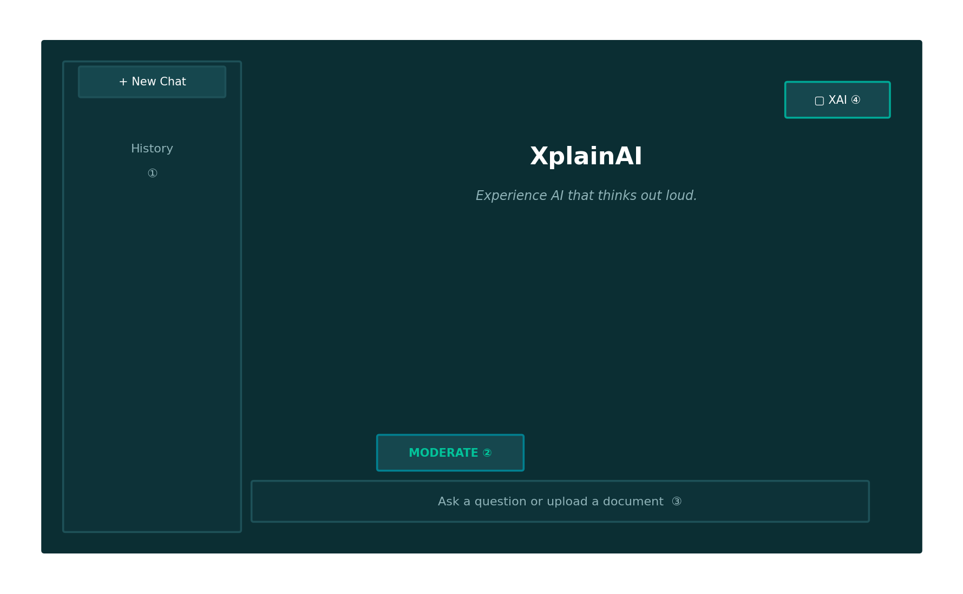
Figure 2. XplainAI composer wireframe (early design-phase concept).

Labeled screens
- ① History — new-chat control and conversation list, backed by SQLite checkpoints keyed by thread_id (persists across sessions).
- ② Mode — the six adaptive reasoning-depth modes (Fast, Moderate, Complex, Deep Research, Document Analysis, Reverse Mind), passed with the request and shaping which backend path runs.
- ③ Input — ask a question or upload a document; uploading a document deterministically triggers the RAG node regardless of selected mode.
- ④ XAI panel — opens the explainability workspace (source contribution, confidence, risk, reasoning tree); collapsed by default per the design principle in Section 2.2.
- ⑤ Reset personalization (Reverse Mind button) — a small, visually distinct control near the mode selector that clears the session's in-memory preference state built up from thumbs-up/down feedback (Section 3, Section 11); separate from selecting Reverse Mind as a one-off mode, this is a full reset for the rest of the session and asks for confirmation before clearing, since it cannot be undone.
Figure 3 shows the implemented chat and reasoning-tree panel side by side, mid-conversation. The left sidebar lists prior threads; the center pane shows the ordinary chat turn (here, a clarification exchange the agent ran before searching); the right pane is the collapsed-by-default XAI panel from Figure 2's ④, now expanded to show the live Reasoning Tree with a Metrics toggle and a Download JSON export — the export exists specifically so the explainability record (Section 11, Database) can be inspected outside the UI, which matters for the evaluation work described in Section 15.
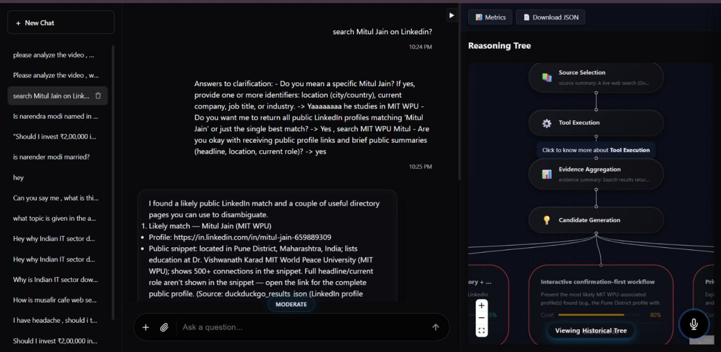
Figure 3. Live chat view with the collapsed reasoning-tree panel expanded, mid-conversation.
Figure 4 is the confidence dashboard reached from the Metrics toggle in Figure 3. Rather than a single confidence number, the panel reports four separate scores — AI Confidence, Evidence Strength, Source Agreement, and Reasoning Quality — each with its own progress bar. This is a direct application of the meta-information taxonomy in Section 2.1 [1]: a single blended confidence score collapses several distinct kinds of uncertainty (is the model unsure, or is the evidence weak, or do sources disagree, or is the reasoning itself shaky) into one number a user cannot decompose. Splitting the four out lets a user tell, for instance, a case where the model is fluent and confident but the underlying sources disagree — the specific failure mode Section 1.2 identifies as the core problem.
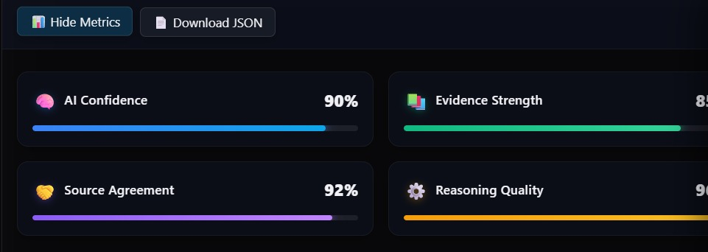
Figure 4. Four-metric explainability dashboard (AI Confidence, Evidence Strength, Source Agreement, Reasoning Quality).
Figure 5 is the full reasoning tree for a completed turn, expanded to show the candidate-generation stage described in Section 3. Four candidate approaches are shown as sibling nodes below Candidate Generation, each carrying its own confidence percentage and evaluation score; the selected approach is marked with a check mark and a green border, while the rejected candidates keep a red border rather than being hidden. This is the literal, on-screen implementation of the contrastive "why P rather than Q" explanation principle from Miller [7] (Section 2.5) and of the finding that hiding a model's dead ends makes its process look artificially clean [9] (Section 2.6) — a user can open any rejected branch and read why it scored lower, not just why the winner scored highest.
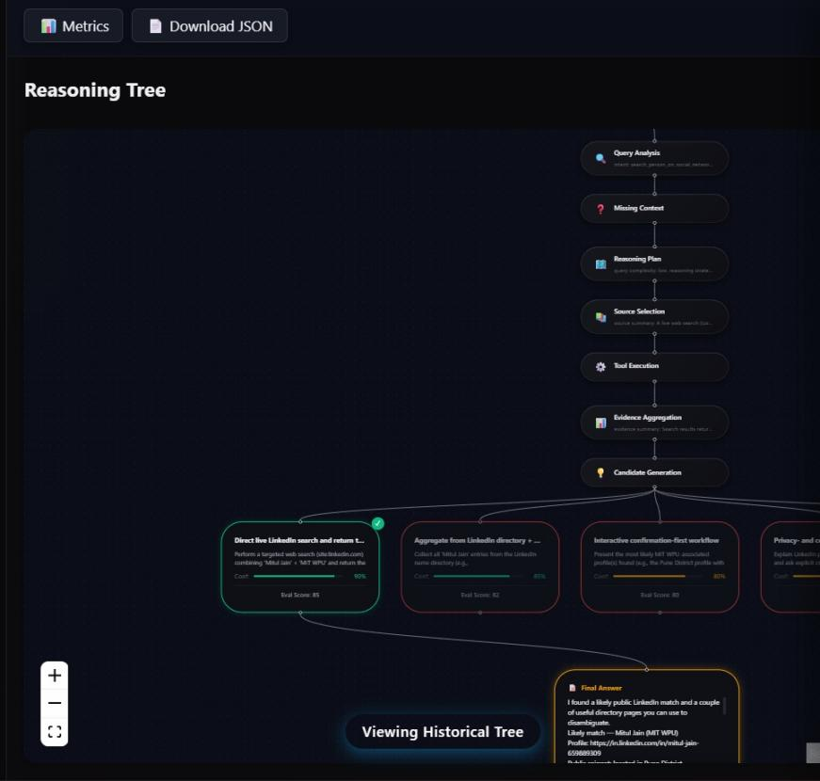
Figure 5. Expanded reasoning tree showing scored candidate branches converging to the selected Final Answer node.

Interface flow and navigation
Composer → (optional document upload) → send → streamed stage updates as the backend progresses through the graph → final answer in the main chat pane → optional XAI panel for the full explainability report, reasoning tree, and history of past reasoning trees per thread (the "Viewing Historical Tree" control visible in Figures 3 and 5).

11. Technical Architecture
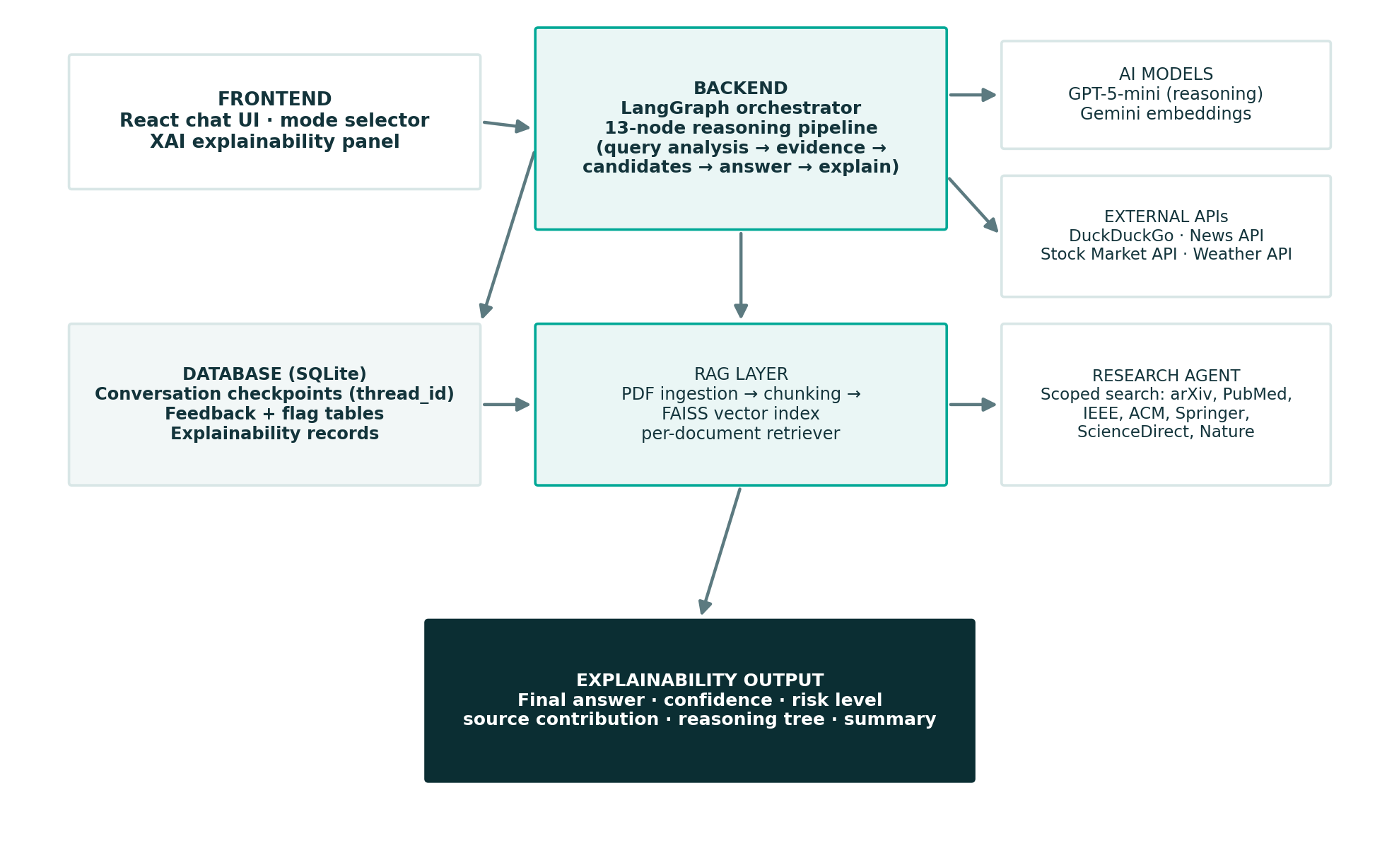
Figure 6. XplainAI technical architecture.

Frontend
React-based chat interface: history sidebar, mode selector, composer with document upload, and a collapsible XAI explainability panel with a metrics dashboard and interactive reasoning tree (Section 7).

Backend
Python, LangGraph state machine orchestrating the 11-stage / 13-node reasoning pipeline described in Section 3, with conditional edges for RAG, tool execution, and the Research Agent.

AI Models / APIs
GPT-5-mini as the reasoning and generation engine; Gemini embeddings for document vectorization; DuckDuckGo Search, News API, Stock Market API, and Weather API as external tools invoked only when the evidence planner selects them.

Database
SQLite, storing LangGraph conversation checkpoints (by thread_id for long-term, cross-session persistence), user feedback votes and auto-flagged threads, and explainability records — the same records the Download JSON control in Figure 3 exports on demand. Session-scoped reinforcement-learning preference state (Section 3) is deliberately excluded from this table: it lives in memory for the lifetime of the session only, so that personalization never outlives the conversation it was learned from and no new schema or migration was needed to add it.

External APIs
Same external tool set as above, plus a scoped academic-search query (arXiv, PubMed, IEEE, ACM, Springer, ScienceDirect, Nature) used only by the Research Agent.

14. Results and Discussion
This design document and the accompanying prototype demonstrate that a conversational LLM pipeline can be restructured into an inspectable, multi-branch decision process without abandoning the familiar chat interaction model. The screenshots in Section 7 are drawn from the running system rather than a mockup, which lets us report this as a working result rather than a projected one: a live query produces a scored, four-candidate reasoning tree (Figure 5) and a four-metric confidence breakdown (Figure 4) end to end on GPT-5-mini.
Who benefits: any user who needs to decide how much to rely on an AI-generated answer — the persona in Section 5 represents a common case (a student cross-checking AI output against her own source material), and the LinkedIn-lookup example captured in Figures 3 and 5 represents another: a query where the system had to ask a clarifying question before it could search, and where the candidate branches genuinely disagreed on approach (direct search vs. directory aggregation vs. a privacy-and-consent-first workflow).
How it improves existing workflows: conditional routing means the added explainability does not tax every query equally — simple queries stay fast, while complex or document-grounded queries get the full evidentiary trail. Splitting a single confidence number into four (Section 7, Figure 4) also directly answers the problem framed in Section 1.2: a user can now see when an answer is fluent but weakly sourced, rather than only seeing that the system "sounds sure."
Can it scale: the architecture separates concerns (retrieval, tool use, research, explanation) into independent LangGraph nodes, so additional evidence sources or explanation types can be added as new conditional branches without restructuring the whole graph; the main scaling cost is the number of sequential LLM calls on complex queries, which is a known and explicitly flagged limitation (Section 15).

15. Future Work

Product — make it clearer
- Source provenance detail, contextual confidence explanations, stronger loading states, and more responsive XAI-panel behavior.

Trust evaluation — measure it
- User studies for comprehension, over-/under-trust, task success, and whether users correctly distinguish strong from weak evidence, following study designs comparable to Fernandes et al. [5] and the correctness/certainty manipulation used by Sun et al. [10].
- A comparison condition that shows only the final answer and confidence, against the full reasoning-tree condition shown in Figure 5, to isolate what the multi-candidate view specifically adds beyond a single confidence number — directly testing the multi-agent-versus-single-trace distinction raised in Section 2.6 [8].

Safety and provenance — harden it
- Domain-specific risk language, explicit limitations, access control, stricter deployment defaults, and auditable source trails.

Architectural
- Reduce sequential LLM-call count on complex queries (currently up to 13 calls) — candidate generation, evaluation, and selection are the first target for consolidation.

References
[1] George J. Cancro, Shimei Pan, and James Foulds. 2022. Tell Me Something That Will Help Me Trust You: A Survey of Trust Calibration in Human-Agent Interaction. arXiv:2205.02987. https://arxiv.org/abs/2205.02987
[2] Bonnie M. Muir. 1987. Trust between humans and machines, and the design of decision aids. International Journal of Man-Machine Studies 27, 5 (1987), 527–539. https://doi.org/10.1016/S0020-7373(87)80013-5
[3] Mohammad Naiseh, Dena Al-Thani, Nan Jiang, and Raian Ali. 2021. Explainable recommendation: when design meets trust calibration. World Wide Web 24, 5 (2021), 1857–1884. https://doi.org/10.1007/s11280-021-00916-0
[4] Rock Yuren Pang, Chu Li, K. J. Kevin Feng, Weijia Shi, Shangbin Feng, Yulia Tsvetkov, and Jeffrey Heer. 2026. Interactive Reasoning: Visualizing and Controlling Chain-of-Thought Reasoning in Large Language Models. In Proceedings of the 31st International Conference on Intelligent User Interfaces (IUI '26). arXiv:2506.23678. https://arxiv.org/abs/2506.23678
[5] Daniela Fernandes et al. 2026. Explaining Too Much? Understanding How Large Language Model Reasoning Traces Influence Performance and Metacognition. arXiv:2605.25856. https://arxiv.org/abs/2605.25856
[6] Manish Sanwal. 2025. Layered Chain-of-Thought Prompting for Multi-Agent LLM Systems: A Comprehensive Approach to Explainable Large Language Models. arXiv:2501.18645. https://arxiv.org/abs/2501.18645
[7] Tim Miller. 2019. Explanation in artificial intelligence: Insights from the social sciences. Artificial Intelligence 267 (2019), 1–38. https://doi.org/10.1016/j.artint.2018.07.007
[8] Saumya Pareek, Jarod Govers, Naja Kathrine Kollerup, Emily Wong, Eduardo Velloso, and Jorge Goncalves. 2026. Sensemaking in Multi-Agent LLM Interfaces: How Users Interpret Transparency and Trustworthiness Cues. In Proceedings of the 2026 CHI Conference on Human Factors in Computing Systems (CHI '26). https://doi.org/10.1145/3772318.3791157
[9] Ludwig Felder, Jacob Miller, Markus Wallinger, Stephen Kobourov, and Chunyang Chen. 2025. ReTrace: Interactive Visualizations for Reasoning Traces of Large Reasoning Models. arXiv:2511.11187. https://arxiv.org/abs/2511.11187
[10] Xin Sun, Shu Wei, Jos A. Bosch, Isao Echizen, Saku Sugawara, and Abdallah El Ali. 2026. Seeing the Reasoning: How LLM Rationales Influence User Trust and Decision-Making in Factual Verification Tasks. In Proceedings of the Extended Abstracts of the 2026 CHI Conference on Human Factors in Computing Systems (CHI EA '26). https://doi.org/10.1145/3772363.3798613
[11] LangChain / LangGraph. Open-source library used for the orchestration graph. https://www.langchain.com/langgraph
[12] Meta AI. FAISS: a library for efficient similarity search. Open-source library used for the document vector index. https://github.com/facebookresearch/faiss

