(Frontend Process) Reservation Booking System
- Front End Dashboard.
Need to book the procedure through a restaurant, table/party, or have an idea.
- Booking from the restaurant dashboard through POS and Admin and paying the booking amount to the restaurant through cash or UPI. (As per discussion).
- Accountant or waiter will handle these screens or as per your suggestion.
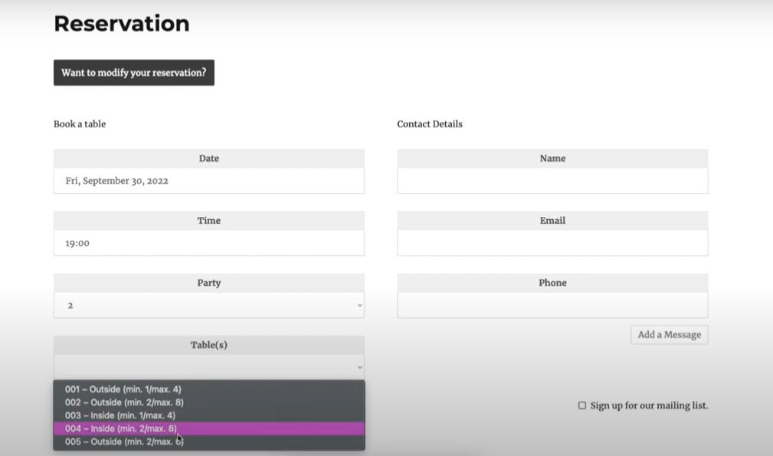
View Reservation from staff dashboard.
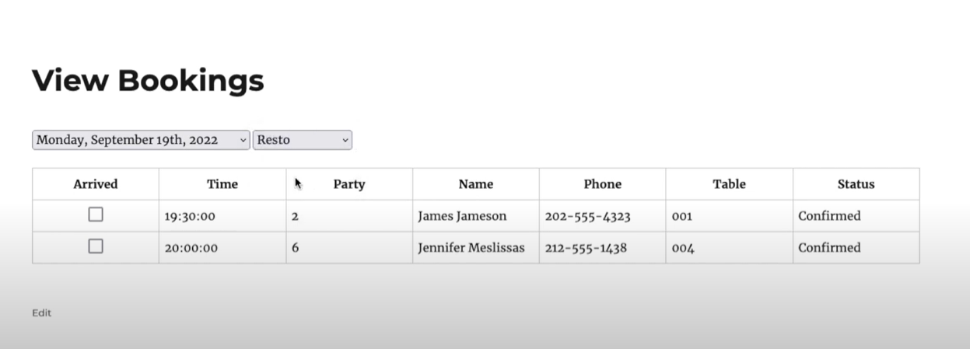
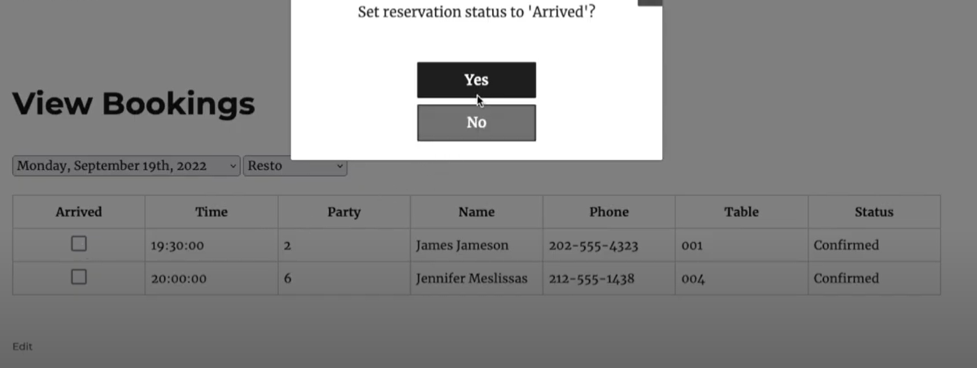
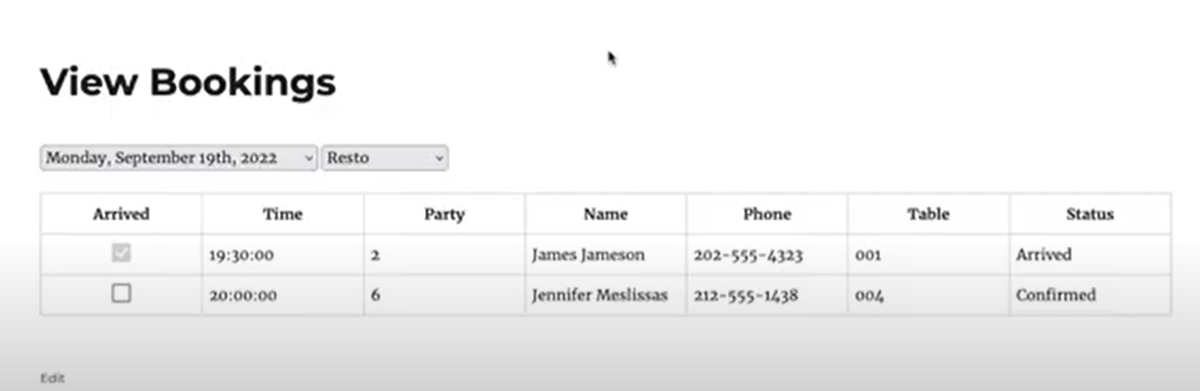

- Back End View Reservation Booking to Admin.
Note: - This dashboard is only show to restaurants admin. (Overall Controller)
Nevertheless, the restaurant admin can handle all the functionalities of this.
- Closed Booking: - Payment completed and customer Arrived.
- Confirmed Booking: - Customers are arriving in the future. And payment completed.
- Pending Booking: - Customer not arrived.
- Booking Payment Pending: - Customers are arriving in the future. But pending due payment.

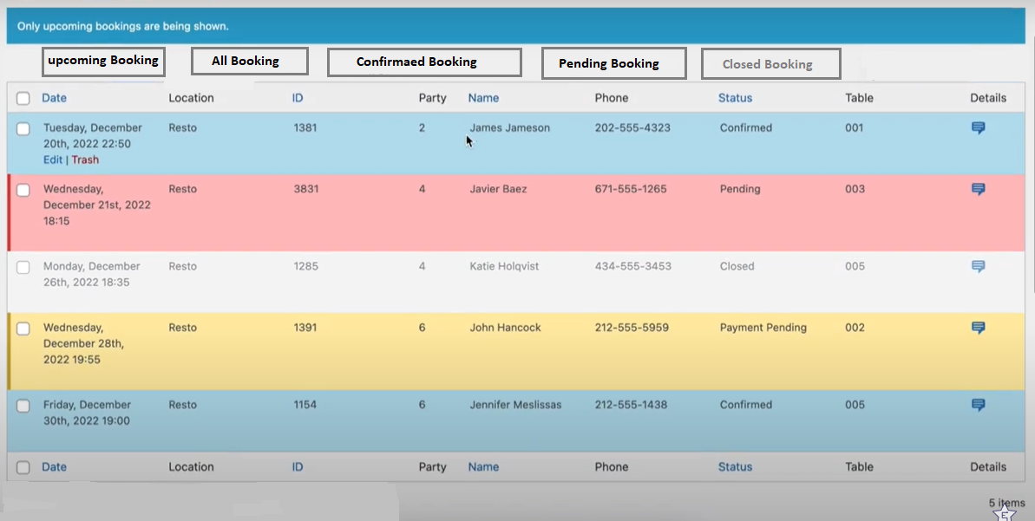
- Notification. (Suggestion: create the email template dynamic or static)
- Send email to customer and Restaurant VIP when reservation time.
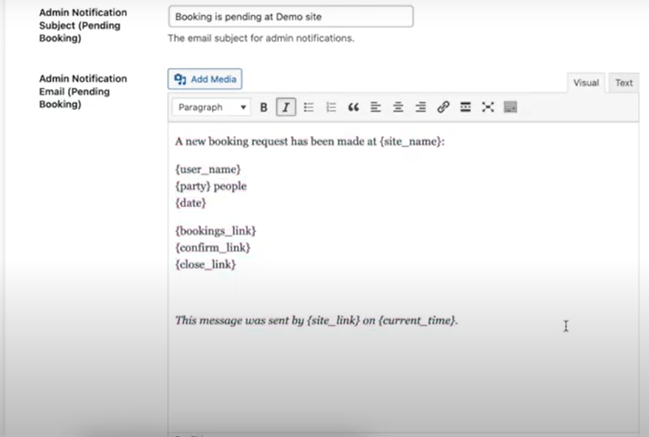
- Send email to customer and restaurant VIP if customer makes payment. With Total Amount or Due Amount.
- If the customer arrives on the booking date, we will send a mail to the customer and restaurant VIP while changing the status of the ticket.
- After the customer pays the bill and stay, we will send an email to the customer for thanks and feedback.
- Reminder by email to customer.
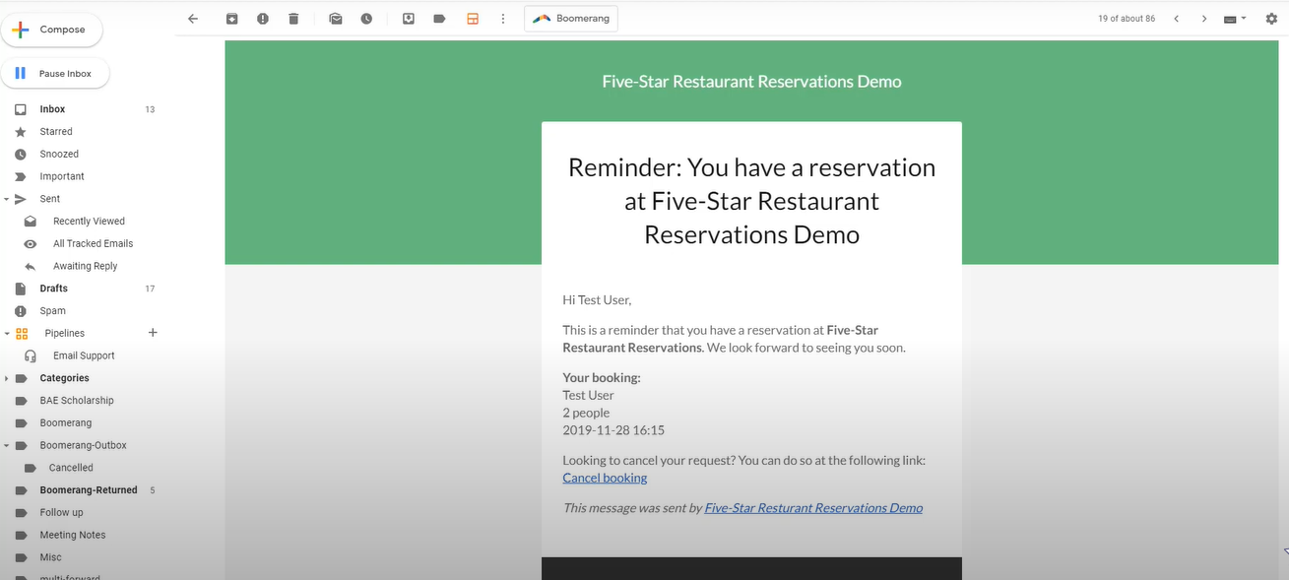
- Show the feedback from admin dashboard and from customer dashboard.
- Payment History.
- Connection to payment.
- Card details save to customer.
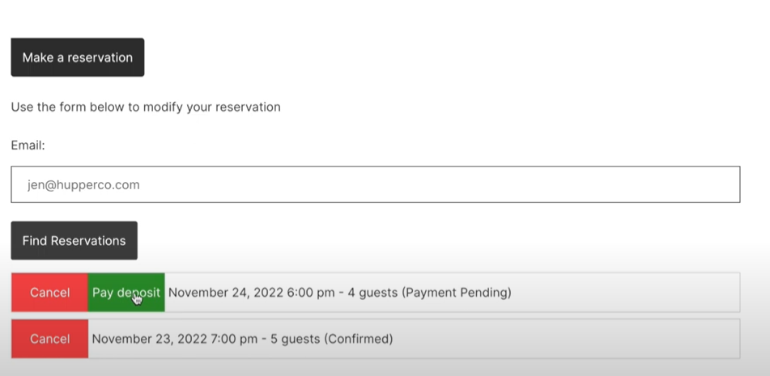
Show card details. For details fullfill.
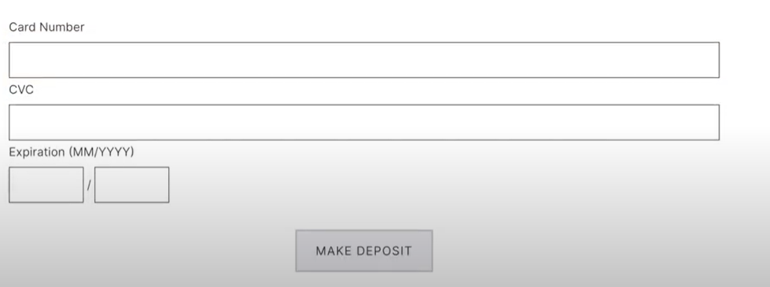
- Show the invoice details.
Type: - i) UPI, ii) Case, iii) Debit Card, iv)
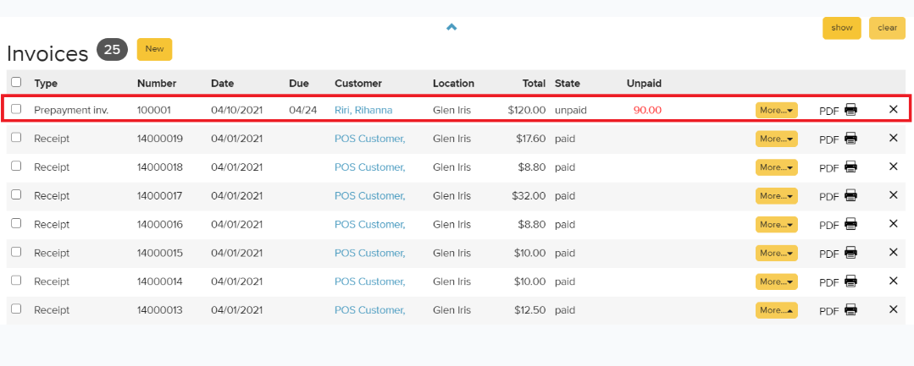
- Show payment details (transition details show).
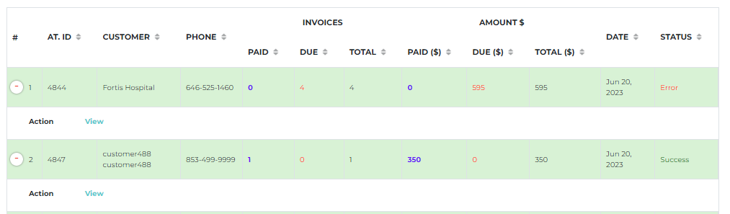
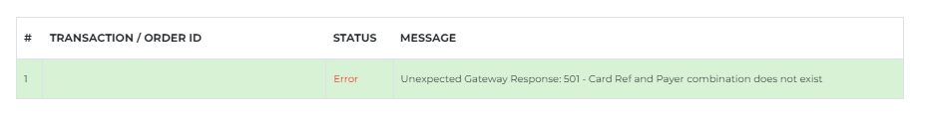
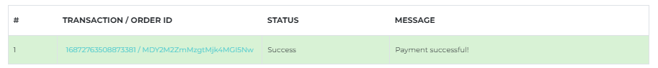

(Backend Process) Reservation Booking System
- Booking Schedule (Time difference to booking Such as: 11:00 AM to 8:00 PM)
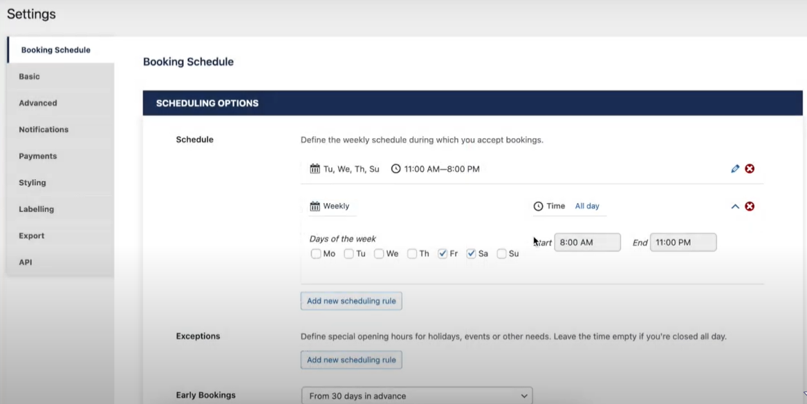
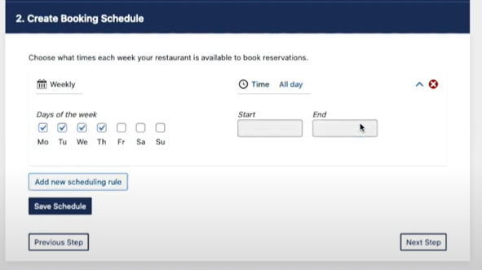
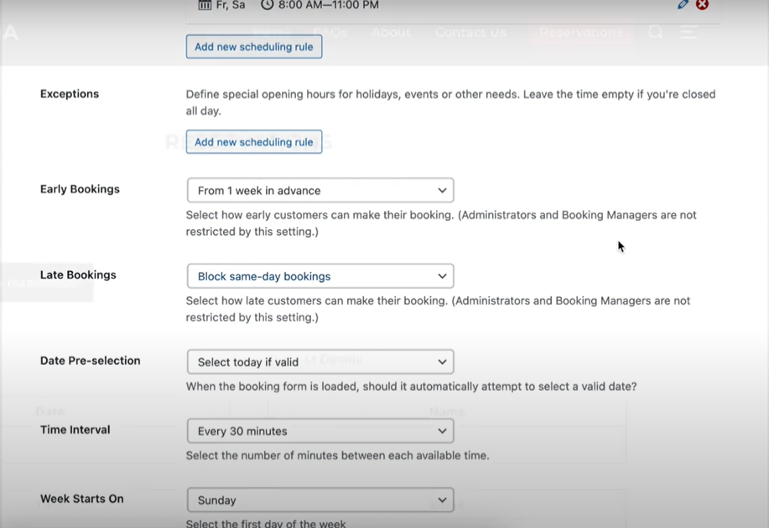
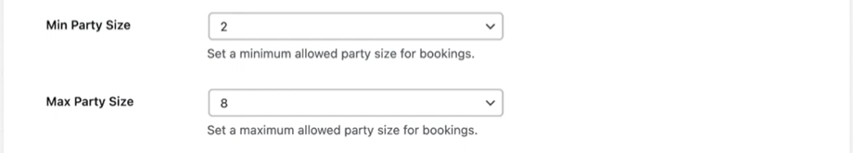

For Example: - Please below the calendar screen shot.
