##### **U.V.PATEL COLLEGE OF ENGINEERING**

### uvpcelogo_0

### 

Nov - Dec 2018

### CERTIFICATE

TO WHOM SO EVER IT MAY CONCERN

This is to certify that Mr Mitul G Patel student of B. Tech Semester V Information Technology has submitted a seminar report titled “Chatbots” in the year 2018.

Supervisor keyur jani Head of IT Department

Sign:\_\_\_\_\_\_\_\_\_\_\_\_\_\_\_\_\_ Sign:\_\_\_\_\_\_\_\_\_\_\_\_\_\_\_\_\_

Date: \_\_\_/\_\_\_/2018

A

Seminar Report on

|  |
| --- |
|  |
| CHATBOTS |
|  |
| [Type the document subtitle] |

**Submitted By,**

MITUL PATEL

16012021040

B. Tech Semester – V Information Technology

Nov – Dec 2018

**Supervisor**

Prof. Keyur Jani



**Submitted To,**

Department of Information Technology

Ganpat University - U. V. Patel College of Engineering

GanpatVidyanagar - 384012

**ABSTRACT**

With the improvement of living standards , stores are growing bigger with variety of available products. Therefore, building a simple, fast and convenient shopping guide system has become a concern for both merchants and customers. Security has become a major concern for the consumer providing credit card details. Major threats are reported at both onsite and online transactions. So it is important to create a system to establish secured payment method. Proposed system is the implementation of a secured operational model for mobile payment in which access control is based on Service-Oriented architecture. A consumer uses his/her mobile device to get authorization and generate a QR code as the payment certificate to pay for the products to purchase. Using REST web service for communication between different applications would help in instant messaging, which increase in performance of the system. User details are encrypted using HMAC encryption technique.

**Table Of Content**

**Topic Page No.**

**I ABSTRACT 3**

**II TABLE OF FIG. 4**

**1.INTRODUCTION OF CHATBOTS 6**

**1.1 INTRODUCTION 6**

**1.2 HISTORY OF CHATBOTS 7**

**1.3 EXAMPLE OF CHATBOTS 7**

**2. HOW CHATBOTS WORK? 8**

**2.1 HOW CAN CHATBOT PROCESS HUMAN LANGUAGE 8**

**2.2 HOW CHATBOT WORKS? 8**

**2.3 HOW IS THE CHATBOT TRAINED ?**

**2.4 HOW DOES CHATBOT LEARN AFTER IT IS LIVE ? 11**

**2.5 WHAT IS NLU ? 11**

**2.6 WHAT IS NLP ? 11**

**3. APPLICATION OF CHATBOTS 13 3.1 PRODUCT SUGGESTATION 13**

**3.2. ORDER A PIZZA 13**

**3.3. CUSTOMER SUPPORT 13**

**3.4. WEATHER 14**

**3.5. PERSONAL FINANCE ASSISTANCE 14**

**4. HOW TO USE QR-CODE 15**

**5. ADVANTAGES AND DISADVANTAGES 17**

**5.1 ADVANTAGES 17**

**5.2 DISADVANTAGES 17**

**6. CONCLUSION 18**

**REFRENCES 19**

**CHAPTER-1**

**INTRODUCTION**

**1.1 INTRODUCTION OF CHATBOTS**

Chatbots are “online human-computer dialog system with natural language.” The first conceptualization of the chatbot is attributed to Alan Turing, who asked “Can machines think?” in 1950. Since Turing, chatbot technology has improved with advances in natural language processing and machine learning. Likewise, chatbot adoption has also increased, especially with the launch of chatbot platforms by Facebook [93], Kik [94], Slack [95], Skype [96], WeChat [97], Line [98], and Telegram [99]. By September 2016, Facebook Messenger hosted 30,000 bots and had 34,000 developers on its platform. [100] The Kik Bot Shop announced in August 2016 that the 20,000 bots created on its platform had “exchanged over 1.8 million messages.”

**1.2 HISTORY OF CHATBOTS**

In 1950, Alan Turing asked the question “Can machines think?” Turing conceptualized the problem as an “imitation game” (now called the Turing Test), in which an “interrogator” asked questions to human and machine subjects, with the goal of identifying the human. If the human and machine are indistinguishable, we say the machine can think. In 1966, Joseph Weizenbaum at MIT created the first chatbot that, arguably, came close to imitating a human: ELIZA. Given an input sentence, ELIZA would identify keywords and pattern match those keywords against a set of pre-programmed rules to generate appropriate responses.

Since ELIZA, there has been progress in the development of increasingly intelligent chatbots. In 1972, Kenneth Colby at Stanford created PARRY, a bot the impersonated a paranoid schizophrenic. In 1995, Richard Wallace created A.L.I.C.E, a significantly more complex bot that generated responses by pattern matching inputs against (input) (output) pairs stored in documents in a knowledge base. These documents were written in Artificial Intelligence Markup Language (AIML), an extension of XML, which is still in use today. ALICE is a three-time winner of the Loebner prize, a competition held each year which attempts to run the Turing Test, and awards the most intelligent chatbot.

**1.3 EXAMPLES OF CHATBOTS?**

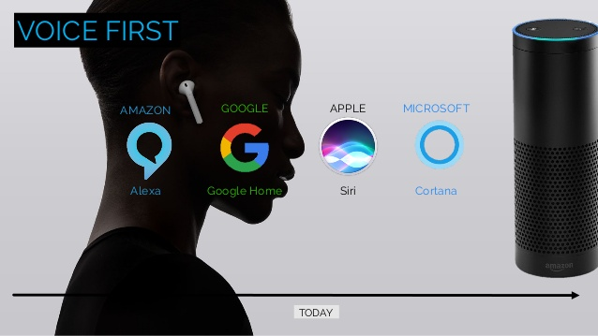

Fig 2.1 Example of Chatbots

**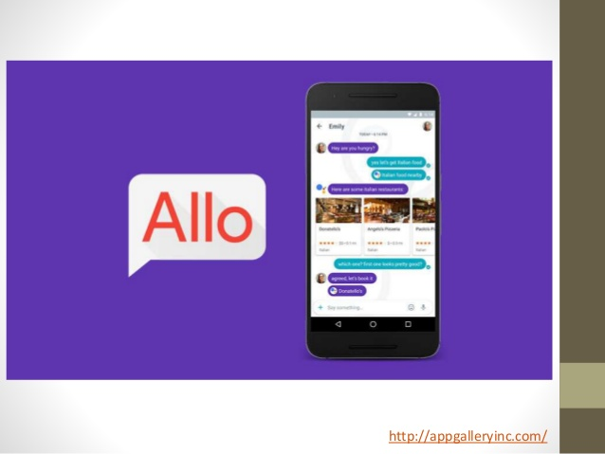**

Fig 2.2 Example of Chatbots

**CHEPTER-2**

**HOW IT’s WORKS?**

**2.1 How Can CHATBOTS Process Human Language ?**

At first, Chatbot can look like a normal app. There is an application layer, a database and APIs to call external services. In a case of the chatbot, UI is replaced with chat interface. While Chatbots are easy to use for users, it adds complexity for the app to handle.

There is a general worry that the bot can’t understand the intent of the customer. The bots are first trained with the actual data. Most companies that already have a chatbot must be having logs of conversations. Developers use that logs to analyze what customers are trying to ask and what does that mean. With a combination of [Machine Learning](https://www.marutitech.com/artificial-intelligence-and-machine-learning/) models and tools built, developers match questions that customer asks and answers with the best suitable answer. For example: If a customer is asking “Where is my payment receipt?” and “I have not received a payment receipt”, mean the same thing. Developers strength is in training the models so that the chatbot is able to connect both of those questions to correct intent and as an output produces the correct answer. If there is no extensive data available, different APIs data can be used to train the chatbot.

**2.2 How do CHATBOTS work?**

The chatbots work by adopting 3 classification methods:

### Pattern Matchers:

Bots use pattern matching to classify the text and produce a suitable response for the customers. A standard structure of these patterns is “Artificial Intelligence Markup Language” (AIML).

A simple pattern matching example:

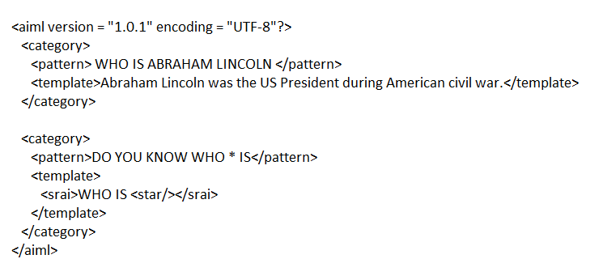

The machine then gives and output:

**Human**: Do you know who Abraham Lincoln is?

**Robot**: Abraham Lincoln was the US President during American civil war.

Chatbot knows the answer only because his or her name is in the associated pattern. Similarly, chatbots respond to anything relating it to the associated patterns. But it can not go beyond the associated pattern. To take it to an advanced level algorithms can help.

### Algorithms

For each kind of question, a unique pattern must be available in the database to provide a suitable response. With lots of combination on patterns, it creates a hierarchical structure. We use algorithms to reduce the classifiers and generate the more manageable structure. Computer scientists call it a “Reductionist” approach- in order to give a simplified solution, it reduces the problem.

Multinational Naive Bayes is the classic algorithm for text classification and NLP. For an instance, let’s assume a set of sentences are given which are belonging to a particular class. With new input sentence, each word is counted for its occurrence and is accounted for its commonality and each class is assigned a score. The highest scored class is the most likely to be associated with the input sentence.

For example Sample Training set

class: greeting  
“How you doing?”  
“good morning”  
“hi there”

Few sample Input sentence classification:

input: “Hello good morning”  
term: “hello” (no matches)  
Term: “good” (class: greeting)  
term: “morning” (class: greeting)  
classification: greeting (score=2)

With the help of equation, word matches are found for given some sample sentences for each class. Classification score identifies the class with the highest term matches but it also has some limitations. The score signifies which intent is most likely to the sentence but does not guarantee it is the perfect match. Highest score only provides the relativity base.

### Artificial Neural Networks

Neural Networks are a way of calculating the output from the input using weighted connections which are calculated from repeated iterations while training the data. Each step through the training data amends the weights resulting in the output with accuracy.

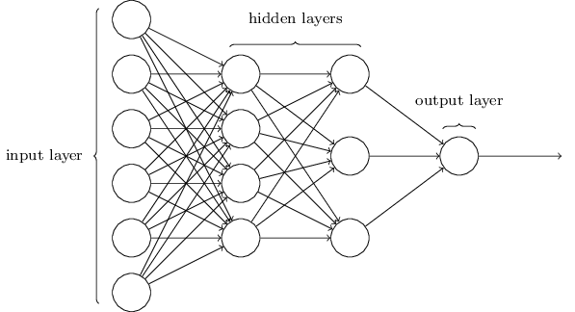

Fig 2.2 Neural Networks

As discussed earlier here also, each sentence is broken down into different words and each word then is used as input for the neural networks. The weighted connections are then calculated by different iterations through the training data thousands of times. Each time improving the weights to making it accurate. The trained data of neural network is a comparable algorithm more and less code. When there is a comparably small sample, where the training sentences have 200 different words and 20 classes, then that would be a matrix of 200×20. But this matrix size increases by n times more gradually and can cause a huge number of errors. In this kind of situations, processing speed should be considerably high.

There are multiple variations in neural networks, algorithms as well as patterns matching code. Complexity may also increase in some of the variations. But the fundamental remains the same, and the important work is that of classification.

**2.3 HOW IS THE CHATBOT TRAINED ?**

Training a chatbot happens at much faster and larger scale than you teach a human. Humans Customer Service Representatives are given manuals and have them read it and understand. While the [Customer Support Chatbot](https://www.facebook.com/Customer-Support-Bot-1857341381220252/)is fed with thousands of conversation logs and from those logs, the chatbot is able to understand what type of question requires what type of answers.

**2.4 HOW DOES THE CHATBOT LEARN AFTER IT IS LIVE ?**

Once the chatbot is ready and is live interacting with customers, smart feedback loops can be implemented. During the conversation when customers ask a question, chatbot smartly give them a couple of answers by providing different options like “Did you mean a,b or c”. That way customers themselves matches the questions with actual possible intents and that information can be used to retrain the machine learning model, hence improving the chatbot’s accuracy.

Despite, there are limitations in place assuring that the model should not change based on new replies where users are not driving the bot in right direction. Chatbot will also not just rephrase what the people say in the chat but it is indeed taught to answer things that the bot’s owner wants it to answer.

**2.3 WHAT IS NLU (NATURAL LANGUAGE UNDERSTANDING) ?**

It has 3 specific concepts like:

**Entities**: Entity basically represents a concept in your Chatbot. It might be a payment system in your Ecommerce Chatbot.

**Intents**: It is basically the action chatbot should perform when the user say something. For instance, intent can trigger same thing if user types “I want to order a red pair of shoes”, “Do you have red shoes? I want to order them” or “Show me some red pair of shoes”, all of these user’s text show trigger single command giving users options for Red pair of shoes.

**Context**: When a NLU algorithm analyzes a sentence, it does not have the history of the user conversation. It means that if it receives the answer to a question it has just asked, it will not remember the question. For differentiating the phases during the chat conversation, it’s state should be stored. It can either be flags like “Ordering Pizza” or parameters like “Restaurant: ‘Dominos’”. With context, you can easily relate intents with no need to know what was the previous question.

**2.3 WHAT IS NLP (NATURAL LANGUAGE PROCESSING) ?**

[Natural Language processing (NLP)](https://www.marutitech.com/how-is-natural-language-processing-applied-in-business/) Chatbot takes some combination of steps to convert the customer’s text or speech into structured data that is used to select the related answer. Some of the Natural Language Processing steps are:

**Sentiment Analysis**: Tries to learn if the user is having a good experience or if the after some point the chat should be forwarded to the human.

**Tokenization:** The NLP divides a string of words into pieces or tokens that are linguistically symbolic or are differently useful for the application.

**Named Entity Recognition**: The chatbot program model looks for categories of words, like the name of the product, the user’s name or address, whichever data is required.

**Normalization**: The Chatbot program model processes the text in an effort to find common spelling mistakes or typographical errors that might the user intent to convey. This gives more human like effect of the Chatbot to the users.

**Dependency Parsing**: The Chatbot looks for the objects and subjects- verbs, nouns and common phrases in the user’s text to find dependent and related phrases that users might be trying to convey.

Like most of the Applications, the Chatbot is also connected to the Database. The knowledge base or the database of information is used to feed the chatbot with the information needed to give a suitable response to the user. Data of user’s activities and whether or not your chatbot was able to match their questions, is captured in the data store. NLP translates human language into information with a combination of patterns and text that can be mapped in the real time to find applicable responses.

There are NLP services and applications programming interfaces that are used to build the chatbots and make it possible for all type of businesses, small. Medium and large scale. The main point here is that [Smart Bots](https://chatbotsmagazine.com/which-are-the-best-intelligent-chatbots-or-ai-chatbots-available-online-cc49c0f3569d)have the potential to help increase your customer base by improving the customer support services and as a result boosts the sales as well as profits. They are an opportunity for many small and mid-sized companies to reach a huge customer base.

**CHEPTER-3**

**APPLICATION OF CHATBOTS**

**3.1.PRODUCT SUGGESTATIONS**

Many consumers know they want to buy some shoes, but might not have a particular item in mind. You can use chatbots to offer product suggestions based on what they want (color, style, brand, etc.)

It’s not just shoes. You can replace “shoes” with any other item. It could be clothes, groceries, flowers, a book, or a movie. Basically, any product you can think of.

For example, tell H&M’s Kik chatbot about a piece of clothing you have and they’ll build an outfit for you.

**3.2. ORDER A PIZZA**

It’s ridiculously easy to order pizza with the help of chatbots. You can order by texting, tweeting, voice, or even from your car.

Domino’s was one of the early adopters of chatbots. Today, Domino’s lets you easily build a new pizza (or reorder your favorite pizza) and track your order all from Facebook Messenger.

3.3**. CUSTOMER SUPPORT**

Last year, brands including AirBnB, Evernote, and Spotify started using chatbots on Twitter to provide 24/7 customer service.

The goal of these customer support chatbots is to quickly provide answers and address customer complaints, or simply track the status of an order.

.

**3.4. WEATHER**

There are numerous weather bots to choose from. Most are pretty basic, though a few are designed to be a bit more fun.

You can use these to ask about the current conditions in your area and find out whether you should bring the umbrella before you leave for work. Some bots allow you to set regular reminders for a certain time of day.

**3.5. PERSONAL FINANCE ASSISTANCE**

Chatbots make it easy to make trades, get notifications about stock market trends, track your personal finances, or even get help finding a mortgage.

Banks have created chatbots to let you check in on your account, such as your current balance and most recent transactions. And there are tax bots that help you track your business and deductible expenses.

**3.6. SCHEDULE A MEATING**

With so many schedules to juggle, setting up meetings can be a pain. Unless you let a chatbot do the work for you.

Meekan is one such example. Simpy request a new meeting and this Slack chatbot will look at everyone’s calendars to find times when everyone is available.

**3.6. SEARCH FOR A TRACH & FLIGHT**

You can use chatbots to get some vacation inspiration. Others will let you search for and compare flights based on price and location. Kayak’s chatbot even lets you book your flights and hotels entirely from inside Facebook Messenger.

Once you’re all booked, there are other chatbots that will let you track current flights, wait times, delays, and more.

**3.7.NEWS**

Chatbots help you stay up to date on the news or topics that matters to you.

You can get the latest headlines from mainstream media sources like CNN, Fox News, or the Guardian. Or you can get the latest tech headlines from TechCrunch or Engadget.

**3.8.FIND LOVE**

A match made by chatbots? It could happen.

Instead of swiping left or right on an app, you could use Foxsy. This Messenger bot promises to help you find a “beautiful and meaningful connection with the right person.”

**3.9.SEND MONEY**

You can easily send payments to your team or friends with chatbots. All you have to do to send money on the Slack PayPal account is type /paypal send $X to @username.

That’s it. Crazy simple, right?

**3.10.FIND RESTAURANT**

Where do you want to eat tonight? Not sure? Ask a chatbot.

Much like the product recommendation chatbots, restaurant chatbots can provide recommendations based on cuisine, location, and price range. Some chatbots will even make reservations for you or take your order online.

**CHAPTER-5**

**ADVANTAGES AND DISADVANTAGES**

**5.1 ADVANTAGES**

Following are[4] the benefits or advantages of CHATBOTS:

Reduced Costs –

chatbots eliminate the requirement of any manpower during online interaction and are hence seen as a big advantage by companies receiving multiple queries at once. This also presents companies with the opportunity to save on costs while aligning chatbots with their goals and hence presenting customers with a particular type of interaction leading to conversion.

24-7 availability –

Unlike humans, chatbots once installed can attend queries at any time of the day. Thus, the customer doesn’t have to wait for the company executive to help them. This also lets companies keep an eye on the traffic during the non-working hours and reach out to them later. On the other hand, while hiring people, there would be no access to these potential customers and could lead to loss of business.

Learning and Updating –

AI-based chatbots are capable of learning from interactions and updating themselves on their own. This is a big benefit when it comes to investing time in educating the executives about the same. Due to machine learning and algorithms capable of updating themselves, the need for same is eliminated while using a Chatbot.

Multiple Customer Handling –

Humans have a limit to the number of clients they can handle at once. However, with chatbots, there is no such constraint and they can handle as many queries as required at once. This is a major benefit of using chatbots as no customer stays unattended and everyone’s problem is being resolved. Developers are trying to come up with new features which can work on voice assisted services and help in guided sales. However, this is still expected to take some time, but will be a major breakthrough in the Chatbot and AI industry.

**5.2 DISADVANTAGES**

Following Are The Disadvantages Of The Chatbots .

Complex Interface –

Chatbots are often seen to be complicated and require a lot of time to understand user’s requirement. It is also the poor processing which is not able to filter results in time that can annoy people.

Inability to Understand –

Due to fixed programs, chatbots can be stuck if an unsaved query is presented in front of them. This can lead to customer dissatisfaction and result in loss. It is also the multiple messaging that can be taxing for users and deteriorate the overall experience on the website.

Time-Consuming –

Chatbots are installed with the motive to speed-up the response and improve customer interaction. However, due to limited data-availability and time required for self-updating, this process appears more time-taking and expensive. Therefore, in place of attending several customers at a time, chatbots appear confused about how to communicate with people.

Zero decision-making –

Chatbots are known for being infamous because of their inability to make decisions. A similar situation has landed big companies like Microsoft etc. in trouble when their chatbot went on making a racist rant. Therefore, it is critical to ensure proper programing of your chatbot to prevent any such incident which can hamper your brand

Poor Memory –

Chatbots are not able to memorize the past conversation which forces the user to type the same thing again & again. This can be cumbersome for the customer and annoy them because of the effort required. Thus, it is important to be careful while designing chatbots and make sure that the program is able to comprehend user queries and respond accordingly.

**CHAPTER-6**

**CONCLUSION**

The best conversations are the ones where a lot is yet to be said. Chatbots are at that stage of their journey right now.

The conversation will continue. The ones that will create a great conversation will have a few building blocks in place. A defined, memorable character and clear design will remain the first test of the chatbot. The ones without these building blocks will not be able to survive long. Companies will continue to create Helper, Solver, Seller, Teacher and Storyteller chatbots for both enterprise and direct-to-consumer use cases. Apart from the Solvers, Helpers and even Sellers that will find success, we will see more Teacher and Storyteller chatbots with defined personalities emerging. Across the categories, performance metrics will become the key differentiator for chatbots and drive increased adoption and investments

**REFERENCES**

**[1]en.wikipedia.org**

**[2]https://www.expertsystem.com**

**[4]**[**http://www.marutitexh.com**](http://www.marutitexh.com)

**[5]** **http://sci.tamucc.edu**