E- Yantra Project Documentation

**Swarm Robotics: Information Sharing By Multirobot System Using Distributed Control And Cooporative Manipulation**

**TEAM : 13**

Shailesh Jain

Mitul Tailor

Paras Gosalia

**VIDYAVARDHINI`S COLLEGE OF ENGINEERING AND TECHNOLOGY, VASAI**.

**Table of Contents**

1. Introduction 3

2. Problem Statement 4

3. Requirements 5

4. Implementation 6

5. Testing Strategy and Data 10

6. Discussion of System 13

7. Challenges faced and innovation....................................................16

8. Conclusion 17

9. Future Work 18

10. References 19

1. **INTRODUCTION**:

Swarm robotics is a new approach to the coordination of multirobot systems which consist of large numbers of mostly simple physical robots. It is supposed that a desired collective behavior emerges from the interactions between the robots and interactions of robots with the environment. Swarm robotics is a relatively new field that focuses on controlling large-scale homogeneous multirobot systems.

In this project, we have outlined aspects of the field of swarm distributed intelligence, focusing on the types of interactions that can occur in such systems. To explore the challenges, we have outlined a general platform considering the various design and protocol aspects that can be used to develop any specific application in the field of swarm robotics. The challenge as system designers is to create and make use of the appropriate system that best address the specific constraints and challenges of the application at hand.

**2. PROBLEM STATEMENT:**

Developing multi-agent systems with self interested agents with a large behavioral repertoire is a great challenge. In this system, we have described a design and implementation of an information sharing system performed by autonomous robots. . Various phases of the algorithm have been implemented to be run on swarms of robots. Some provide basic functionality, such as dispersion, localization and mapping, information sharing and task distribution. In these system autonomous robots follows the grid as per the algorithm to pick the object or block kept at any random co-ordinates without colliding by communicating with each other and place it in the desired position.

Experimental results showed that the robot system with our path finding ,object sensing and grid solving along with communicating algorithm can effectively collect information about the arena they explore and objects of their interest. They simultaneously perform pick and place operation in complex ground environment and avoid collision with the obstacles.

1. **REQUIREMENTS**

The system has following hardware and software requirements:

* ***Hardware***

|  |  |
| --- | --- |
| **Hardware** | **Use in system** |
| SPARK V robot | The Robot will communicate with each other and perform the required task. |
| Zigbee modules | The communication between the robots id done using Zigbee modules |
| Servo motors | Gripper has been designed using servos to pick up the object found in its path. |

* ***Software***

|  |  |
| --- | --- |
| **Software** | **Use in system** |
| AVR Studio | An IDE used to develop the program for the robot, build the program, simulate the program. |
| AVR Boot Loader | The hex code of the program is burnt into the microcontroller using this software. |
| X-CTU | It is used to monitor the robot activity and check the transfer of data for the purpose of debugging. |

1. **IMPLEMENTATION**

* 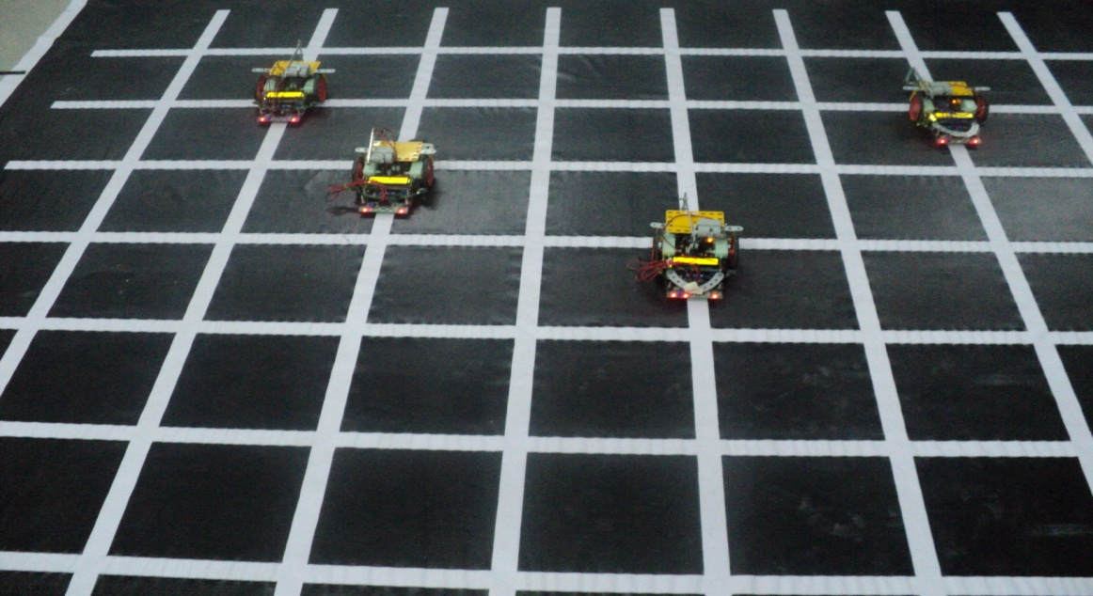***Proposed System***

Consider a square black and white grid of square as region of exploration (arena).Here in this project we consider the objects (plates) placed randomly on the arena. The task begins initially with the bots placed randomly in the environment (grid).To complete the given task we have used selected number of swarm robotics algorithms. For each steps of algorithm we discuss how well they conformed to the ideals of swarm robotics.

* ***Algorithm***

The algorithms are based on the idea that complex macro-level behaviors can emerge from simple local interactions between agents. A variety of algorithms have been implemented to be run on swarms of robots. Some provide basic functionality, such as dispersion, while others demonstrate seemingly complex teamwork, such as chain formation . Although the algorithms all produce different emergent behavior, they all have many features in common.

* *Dispersion in Environment*

One of the first algorithms deployed on a swarm robot is uniform dispersion. This algorithm is broken into two algorithms: one that disperses robots uniformly and one that explores boundaries. In this phase, each robot figures out if it is a wall node, a object node or an robot as obstacle. After this phase is done, the algorithm is switched back to the dispersion component.

Initially robots will be placed on any random node of the grid. In this phase the robot travels to the extreme of the grid in each direction.

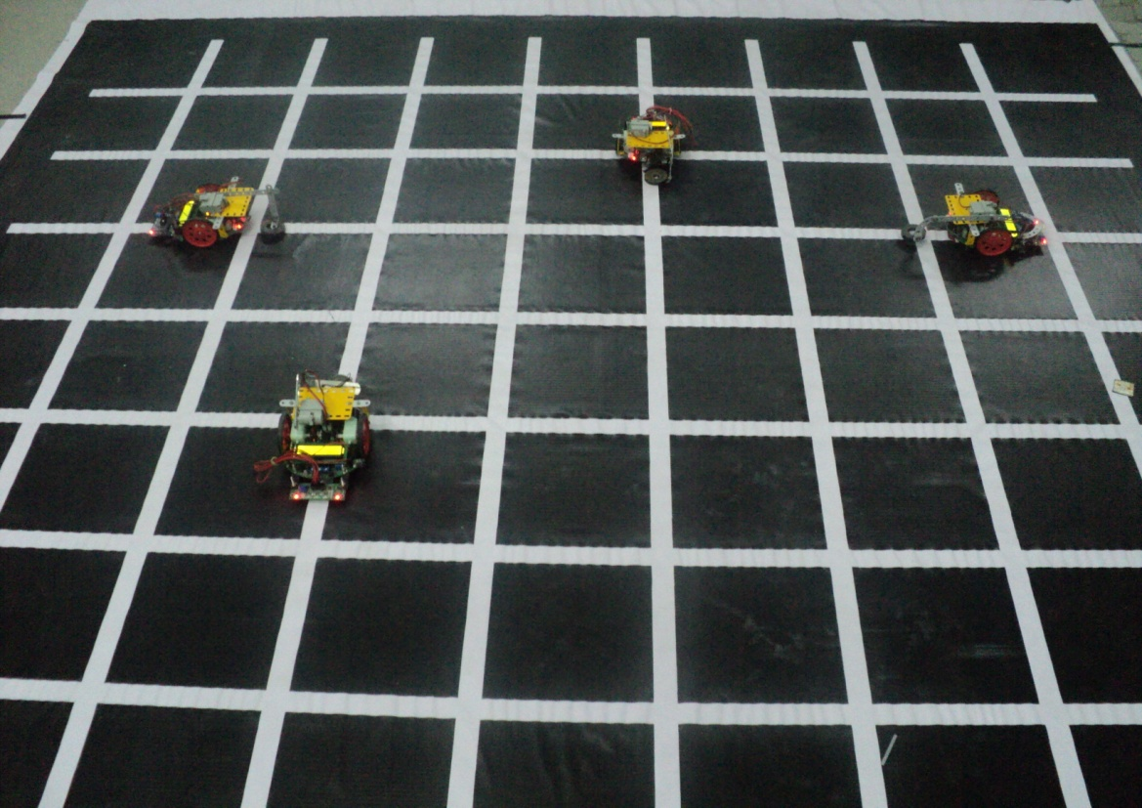

The robots are detecting the boundary to get the dimensions of the environment.So they are traversing at the extreme ends of the working arena (grid).

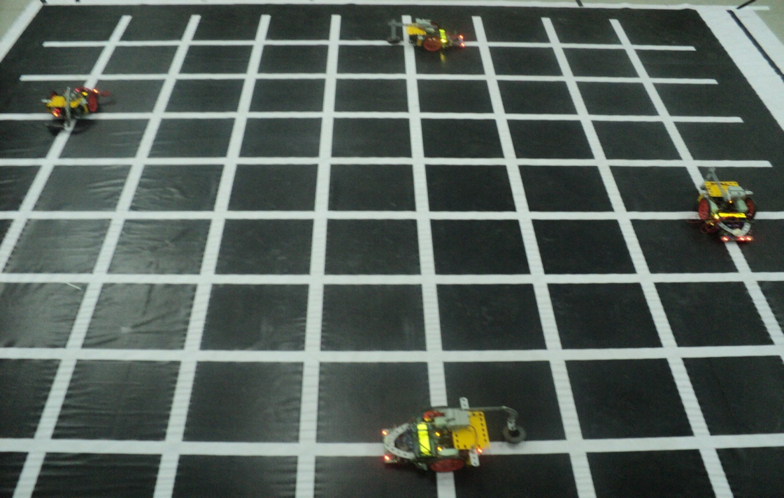

* *Distributed Localization and Mapping*

A very common robot task is to explore a building, generate a map for human use and perhaps find items of interest. They devise a clever algorithm that moves the Swarm through an environment and generates a map with the constraint that the swarm must stay close together so that no communication links are lost. Therefore, the only way to map a large area is to move through it as a group.The robot must know where it is and its orientation to be able to map current sensor readings to a map. While these robots are moving about the environment, they will be generating maps individually. Since all robots are using the same frame of reference in the global environment, all maps are identical in scale and orientation.

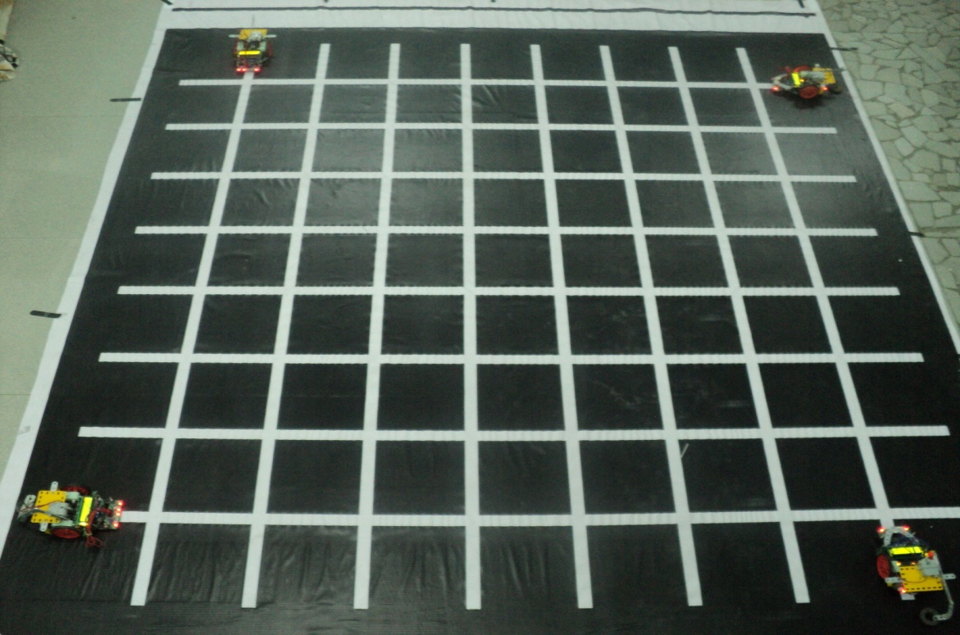

* *Task Distribution*

The next phase of algorithm for interaction in systems of distributed intelligence occurs when robots have individual goals, they are aware of their teammates, and their actions do help advance the goals of others. This part of the domain space is typically called collaborative, and is characterized by entities helping each other to achieve their individual, yet compatible goals.

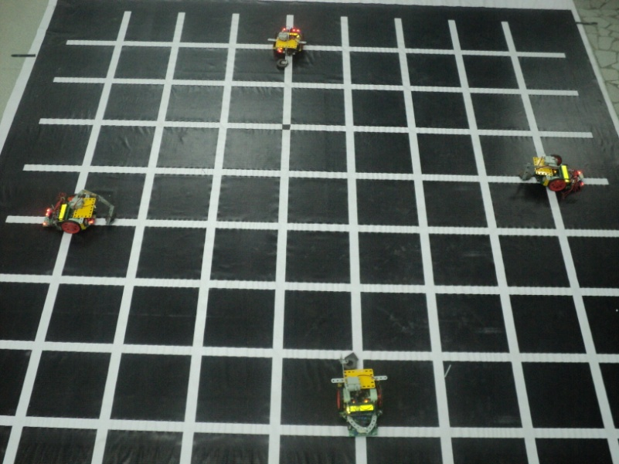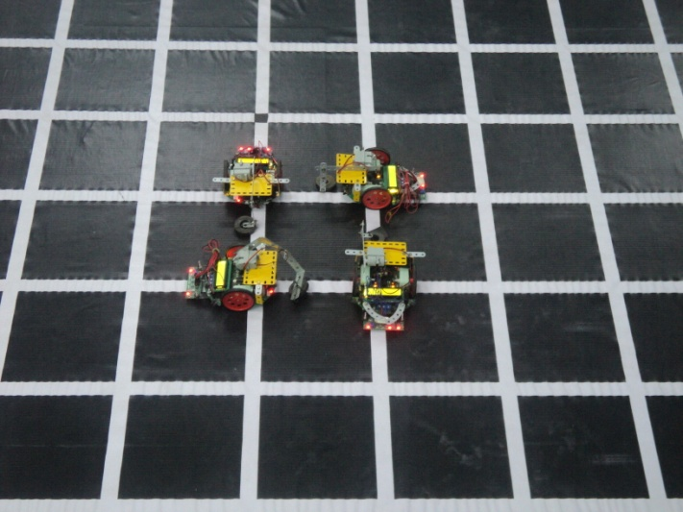

* *Information Sharing*

A multi-robot example of a collaborative team is a group of robots that each must reach specified goal positions that are unique to each member. The robots must work to coordinate their actions to minimize the amount of interference between themselves and other objects. In these systems, entities are aware of each other and share their respective goal of searching objects in given environment, thus by working together and sharing the information with each other can help the other members better achieve their given tasks

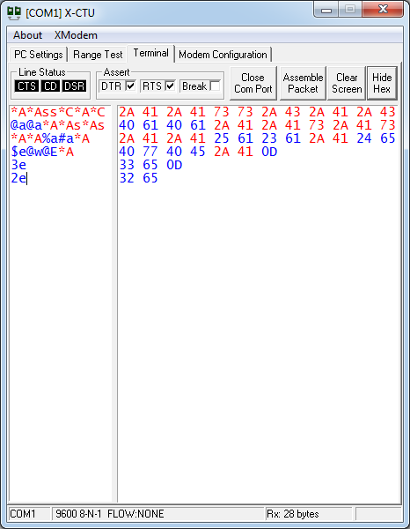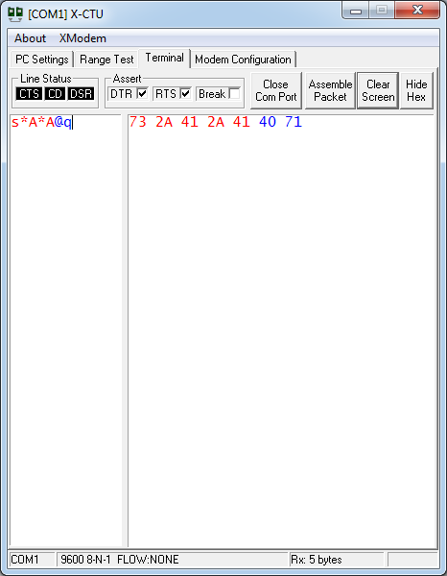

1. **TESTING STRATEGY AND DATA**

* ***Robot/Communication Testing***

|  |  |  |  |
| --- | --- | --- | --- |
| *Test Case number* | *Test case name* | *Test Case description* | *Testing*  *Strategy* |
| 1 | Packet transmission via Zigbee Module | Sending and receiving the packets via the Zigbee module at the two ends of the communication line i.e. the server side and robot side modules communicate by sending and receiving the packets. | X-CTU can be used for testing the packet transmission via the Zigbee module. |
| 2 | Motion configuration | To test the port at which the motors are connected. | 2 Motion configuration To test the port at which the motors are connected. The PORT values can be set for the robot and tested with simple functions to test the motion configuration. The functions are forward, backward, left, right. |
| 3 | ADC configuration | To test the port at which the ADC is connected. | The sensor values are converted by the ADC. This can be tested by checking the sensor values printed on the interface. |
| 4 | TIMER configuration | To test the timer configuration  of the robot. | Robots start their task is using the timer. So if the robots goes in the correct directions then the timer is configured perfectly.  Velocity of robots is also controlled using the timer. |
| 5 | Object Sensing | During Grid traversal robot need to sense the object placed at the nodes. This sensing is done using combinations of IR sensors. | Start the robots , during localization it wont sense any object and then during searching when it sense the object using sensors, it pick up the object. |
| 6 | Collision free path planning | When all the four robots start their task simultaneously, there are chances of robots being collided. So each robot is started in such a way that it does not collided with each other and it also has TSOP sensors to detect the robot on its path. | This can be tested by starting the robot from any random position on the grid. |
| 7 | Gripping mechanism multiple bots | Gripper is made using servo for picking up the object found in its path | This can be tested by just keeping plated at the node so that robot can pick it up |

1. **DISCUSSION OF SYSTEM:**

* ***Gripper Mechanism***

We used one servo motor to develop picking mechanism. The mechanism is very simple. The mechanism consists of the servo motor being mounted on the Spark V robot using the mechrano parts and mounting plate. The mechanism functions by sequential control of the motors using which the linear displacement of the gripper is possible in the vertical direction. The objects to be gripped using the gripper are small square shaped metallic plates which gets attracted to the ring magnet attached to the lower end of the gripper. The figure below illustrates the functioning of the gripper.

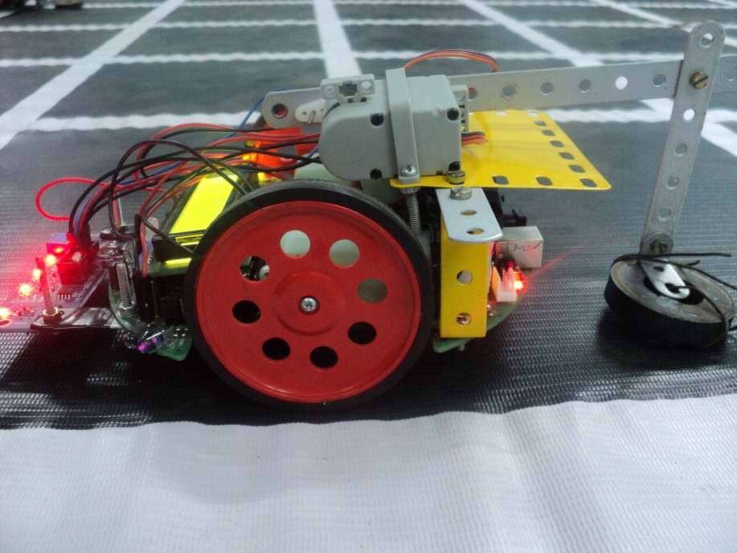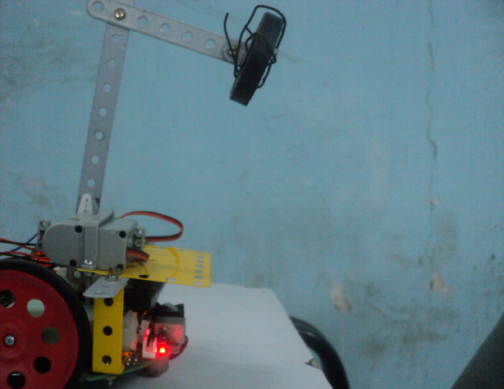

* ***Object***

The object used in our system consists of square metallic plates of dimension 3x3 cm.

The metallic plates are made of iron so that they get attracted to the ring magnet attached to the robot. The plates are also shaded to differentiate between the objects.

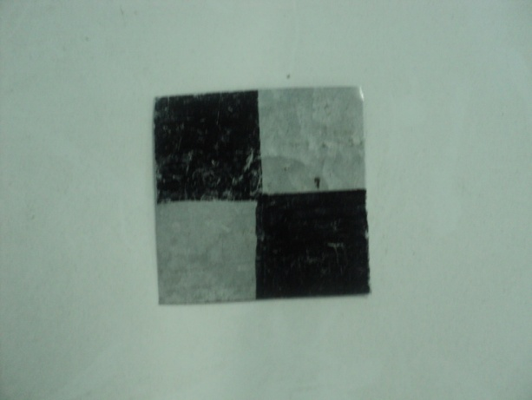

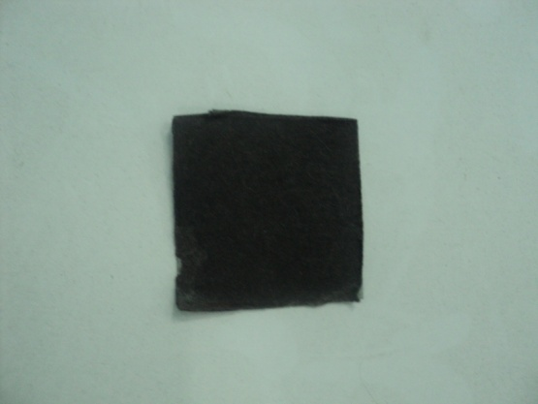

* ***Architecture of System:***

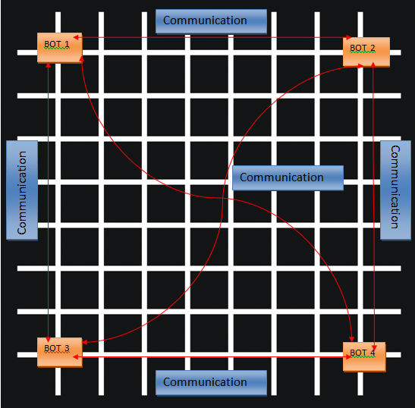

The above figure represents the architecture for the proposed system. As seen in the figure, there are 4 robots in the working arena which are continuously communicating with each other to share the information obtained by each of them. All robots communicate with each other using Zigbee module . The data packet is then propagated to the robot via designed protocol. The practical implementation has been conceived by using Zigbee as the protocol of choice while communicating between robots

Robots need to exchange certain information such as location and status in order to make global decision. In this case, maintaining continuous connectivity of a swarm is critical for the successful collaboration among robots within a swarm.

* ***What are worked as per plan?***
* *Task distribution*

In this project the task is to explore the unknown environment and to achieve this , the distribution of task has been done amongst the robots (i.e 4)

* *Pick and place operation*
* *Decentralized control*
* *Zigbee communication*
* ***What we added more than discussed in SRS?***
* *Dynamic approach*

Initially we decided of making a predefined start and deposition of the robots. Instead of making a centralized system, we took the dynamic approach. In this approach , the robot zone will be decided on the initial positions of robot.

* *Localized and mapping*

The robots are mapping the area of exploration and localizing themselves with respect to the positions of other robots.

* ***Changes made in plan***
* *Centralized Server*

We have made a complete decentralized system and have used a central Server(PC with Zigbee) for the purpose of monitor and debugging the communication flow between the robots.

* *Object*

The object has been changed from a block of dimension of 10*10*10 cm to a metallic plate of dimension 3*3 cm.

* *Gripper design*

We used 1 servo motor instead of 2 to develop picking mechanism. The mechanism is very simple. The mechanism consists of the servo motor being mounted on the Spark V robot using the mechrano parts and mounting plate.

1. **CHALLENGES FACED AND INNOVATION**

* ***Sending and receiving different data between four robots***

For this we used a communication pattern as described earlier. All data being transmitted by

bots are transmitted in packet of 2 bytes, i.e. 2 bytes are sent one by one.

* ***Poor quality and response of sparkV line following sensors***

Our project is totally dependent on line following sensors, so we opted for adding another type of sensor which give good response to distinguish between black and white

* ***Architecture of robot***

The alignment of the motors is such that it gave us problem during path navigation and sharp 90 turns, so proper weight balancing was done to make it perfect.

* ***Lightning condition problem***

The sensor array we used for our project had good response on the grid but were very much sensitive to light as well. So the sensors were calibrated in such a way that it suited the environment and also uniform light conditions were provided to avoid it.

* ***Communcation topology***

As it is decentralized system , it was not possible to create a peer to peer topology, so we operated the robot in broadcast mode. So it becomes difficult for each robot to analyze the data and there were also some packet loss.

1. **CONCLUSION**

In this project, we have outlined aspects of the field of swarm distributed intelligence, focusing on the types of interactions that can occur in such systems. To explore the challenges, we have outlined a general platform considering the various design and protocol aspects that can be used to develop any specific application in the field of swarm robotics. The challenge as system designers is to create and make use of the appropriate system that best address the specific constraints and challenges of the application at hand.

1. **FUTURE WORK**

We believe this time of inventing “neat robot tricks” for robot swarms is over. It is time for researchers to take swarm robotics to the next level and develop robust frameworks for developers to take full advantage of previous work.

* + In our current implementation we have used grid as a working arena but in future it can be generalized to operate on the normal ground surface.
  + Also we have used IR-Sensors to sense the environment (to distinguish between white and black surface), but in future we can use cameras and multi domain sensors to sense the environment in the real world task.

The results of the research are excellent and the advantages of swarm robots over traditional individual robots are clear. It is peculiar that this research has not been picked up more as a tool in practical applications. More research should be done to discover which real world scenarios swarm robots are actually effective in. In conclusion, we believe that swarm robotics is leaving its infancy and new research should focus more on applications of previous work.

1. **REFERENCES**

* ***WEBSITES***

1) (2011) Swarm Robotics [Online] Available:

http://en.wikipedia.org/wiki/Swarm_robotics

2) (2011) Ants Colony [Online] Available:

http://www.swarm-bots.org

3) (2011) Electronic components [Online] Available:

www.datasheetcatalog.com

* ***IEEE PAPERS***

1) Fiona Higgins, Allan Tomlinson and Keith M. Martin,” Survey on Security Challenges for Swarm Robotics”, Autonomic and Autonomous Systems, 2009. ICAS '09. 10.1109/ICAS.2009.62.

2) Feng, K.; Hoberock, L.L.; “An optimal scheduling of pick place operations of a robot-vision-tracking system by using back-propagation and Hamming networks”, Robotics and Automation, 1992,10.1109/ROBOT.1992.220085

3) Jason M. Fox and Michael McCurdy, “, Activity Planning for the Phoenix Mars Lander Mission,” in Aerospace Conference, 2007 IEEE.

4) Manish Sawlani, Vijay Kumar Chandwani,”, Ad-hoc Swarm Robotics Optimization in Grid based Navigation,” in 11th Int. Conf. Control, Automation, Robotics and Vision Singapore, 78-1-4244-7815-6/10 IEEE.

5) Anhui CAI, Toshio FUKUDA, Fumihito ARAI, Koji YAMADA, Shiro MATSUMURA,”Path Planning and Environment Understanding Based on Distributed Sensing in Distributed Autonomous Robotic System”, 0- 7803- 3219- 9/96/$5.00 0 1996 IEEE.

* ***MANUALS***

1) Spark V ATMEGA16 Hardware Manual

2) Spark V ATMEGA16 Software Manual

3) ATMEGA16 Datasheet

4) Zigbee RF Module Datasheet