INTERNSHIP / UDP / TRAINING REPORT
(Monthly Progress Report)
1. Student Information
Student Name | MITUL VANIYA
Enrollment Number | 23SE02IE055
Program/Branch | B.Tech – Information Technology & Engineering
Semester | 7th Semester
Contact Number | 9875286595
Email ID | 23se02ie055@ppsu.ac.in

2. Internship / UDP / Training Details
Type | UDP
Company/Organization | Self-Initiated Academic Project (PPSU)
Department/Domain | Full-Stack Web Development (MERN Stack)
Mentor Name (Company) | Mr.Ravirajsingh Chauhan
Mentor Name (Institute) | Mr.Ravirajsingh Chauhan
Start Date | 15/05/2026
End Date | 15/10/2026

3. Work Progress Summary
- Project Title:
Khoj — An Intelligent, High-Performance Discovery and Analytics Platform for Home Service Providers

- Problem Statement:
In developing nations and urban communities, finding verified, skilled, and reliable local service providers (such as plumbers, electricians, carpenters, tutors, and cleaners) remains highly fragmented. Customers rely on word-of-mouth or legacy ad-heavy websites that compromise private data and display generic listings without visual feedback. On the other side, local independent service providers (merchants) lack a simple, free digital platform to list their skills, show availability, and attract clients. There is a critical need for an ad-free, secure, user-friendly discovery system that visualizes availability charts, filters providers by micro-location (City / State / Category), and manages service profiles safely.
- Objectives:
• Aesthetic User Experience: Build a premium front-end using Tailwind CSS and Ant Design elements with smooth CSS transitions, interactive hover cards, and a glassmorphism theme to enhance customer trust.
• Unified Discovery & Search: Implement multi-level query filters supporting dynamic search by service category, state/city location, and brand name.
• Service Visualization: Create real-time chart interfaces displaying service category distributions and density analytics using React Recharts.
• Secure Auth & Role Separation: Construct a modular authentication route supporting standard users and Merchants (Service Providers) with secure password hashing (Bcrypt) and session validation (JSON Web Tokens).
• Automated Client Notifications: Set up Nodemailer-driven backend mailers to send automated OTPs and registration confirmations
- Proposed Methodology:
The project is built on the MERN (MongoDB, Express, React, Node.js) architecture, divided into the following layers:
1. Presentation Layer (Frontend): Developed as a Single Page Application (SPA) using React.js. Utilizes Tailwind CSS for advanced visual styling, custom gradients, and glassmorphic modules, and Ant Design for form structures and notification components.
2. Application Layer (Backend API): Built with Node.js and Express.js, featuring helper middlewares (CORS, Morgan logger, Multer for media uploads) and RESTful route handlers.
3. Data Layer (Database): Implemented MongoDB (NoSQL) with Mongoose object modelling to handle records for Users, Categories, States, Cities, and Services.
4. Authentication Flow: Uses bcrypt for secure password hashing on registration and issues standard JWT tokens stored securely on login for session validation.

- Expected Outcomes:
• A fully functional, production-ready discovery application with a modern, high-fidelity responsive user interface.
• Users can filter, search, locate, and read detailed listings of local merchants and service providers.
• Merchants can successfully sign up, list their services, upload credentials, and customize service descriptions.
• Interactive analytics charts illustrating service densities and category distributions across states.
• Zero-crash fallback mechanisms for local MongoDB offline environments ensuring graceful error handling.
- Future Scope:
• Real-time Chat Integration: Incorporating WebSockets to allow instant messaging between service seekers and providers.
• Geolocation Mapping: Embedding Google Maps or OpenStreetMap APIs to display provider locations dynamically on a map interface.
• Rating and Review System: Allowing verified clients to rate and review providers to foster accountability and trust.
• Secure Payment Gateways: Integrating Razorpay or Stripe to allow direct transactions through the platform.
4. Tasks Accomplished

- Formulated the project architecture and initialized the workspace environment.
- Configured core metadata, responsive document headers, web-app manifest descriptors, and structural routes for the platform.
- Built and designed the landing interface layout using premium dark indigo gradients, modern vector SVG icons, Outfit fonts, and glassmorphic user-interface elements.
- Developed dynamic Category Grid modules with custom hover-zoom CSS animations to display services.
- Set up local environment variables (.env) and configuration models (config.js) to support fallback server configurations.
- Verified the client build compilation and successfully ran production compilation builds on local servers.

5. Tasks in Progress / Next Plan
• Set up a cloud database instance on MongoDB Atlas to enable remote access and persistent storage.
• Build automated seed scripts to populate mock merchants and services across key regions (plumbers, electricians, cleaners, tutors, etc.).
• Prepare deployment configurations for hosting the Khoj application on Vercel (frontend) and Render (backend).
6. Learnings / Skills Acquired

• Full-stack application architecture using the MERN stack (MongoDB, Express.js, React.js, Node.js) for end-to-end web development.
• Advanced UI design systems using Tailwind CSS, glassmorphism layout modules, and custom typography configurations for professional interfaces.
• Component-driven development with Ant Design and state management patterns inside React, including prop management and hooks.
• Environment variable structuring, configuration file management, and graceful error boundaries for connection dropouts and fallback handling.
• Git version control best practices including branching, committing, and project packaging for deployable builds.

7. Gantt Chart — Project Schedule
The following Gantt chart illustrates the planned project timeline across 14 weeks. Each phase is mapped to its corresponding week range. Blue bars represent completed phases, orange denotes the current in-progress phase, and light-blue bars represent planned future work.

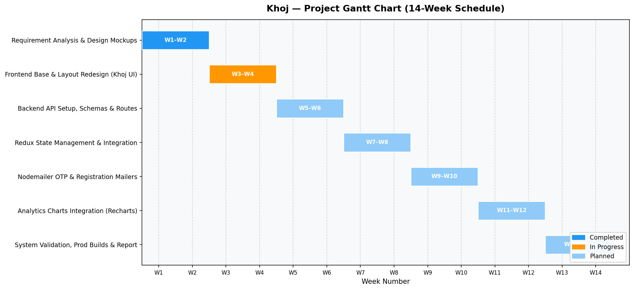

8. PERT Chart — Critical Path Analysis
The PERT (Project Evaluation and Review Technique) chart below maps all project activities and their dependencies. Red nodes and solid arrows indicate the Critical Path: A → B → C → E → F → G, with a minimum total project duration of 11 weeks.
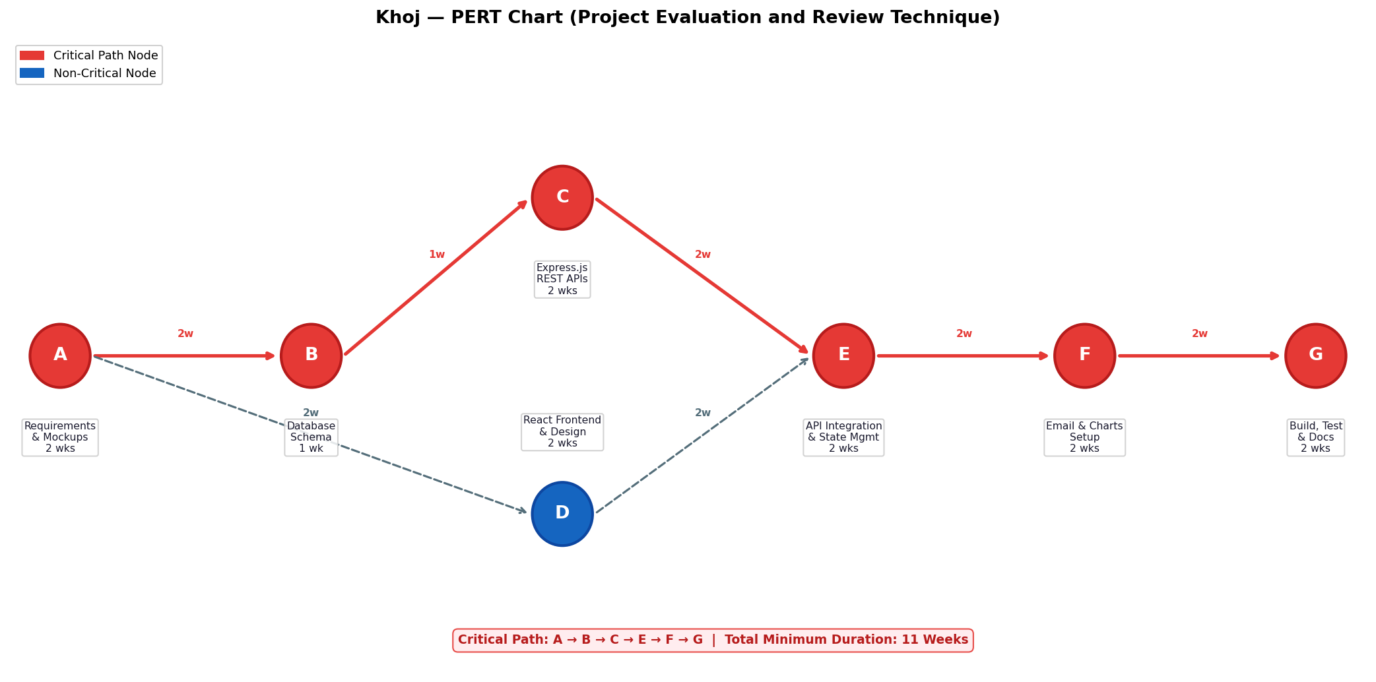
Figure 2: PERT Chart — Critical Path A → B → C → E → F → G (11 Weeks)

Evaluation (To be filled by Mentor (Institute))
Criteria | Bloom’s Level | Excellent (20) | Good (15) | Average (10) | Poor (5) | Marks Obtained (Out of 20)
Problem Definition | L4–Analyze | Clearly defined, justified real-world problem | Defined but lacks depth | Vague problem | No clear problem
Project Title Relevance | L2–Understand | Highly precise and aligned | Mostly relevant | Partially relevant | Misleading
Scope of Work | L5–Evaluate | Well-defined scope, deliverables, constraints | Defined with minor gaps | Broad/unclear | No scope
Literature Study | L4–Analyze | 3–5 sources analyzed critically | Sources listed | Minimal references | No study
Clarity & Presentation | L3–Apply | Structured, professional | Minor issues | Some confusion | Poor
Total Marks

Evaluation
Student Signature | Mentor (Company)  Signature | Mentor (Institute)  Signature

Mentor (Institute) Remarks
________________________________________________________________________________________________________________________________________________________________________________________________________________________________________________________________________________________________________________________________________________________________________________________________________________________________________________________________________________________________________________________________________________________________________________________________________________________________________________________________________________________________________________________________________________________________________________________________________________________________________________________________________________________________________________________________________________________________________________________________________________________________________________________________________________________________________________________________________________________________________________________________________________________________________________________________________________________________________________________________________________________________________

