INTERNSHIP / UDP / TRAINING REPORT – REPORTING 2
(Project Design and Implementation Progress Report)
1. Student Information
Student Name | MITUL VANIYA
Enrollment Number | 23SE02IE055
Program/Branch | B.Tech – Information Technology & Engineering
Semester | 7th Semester
Contact Number | 9875286595
Email ID | 23se02ie055@ppsu.ac.in

2. Internship / UDP / Training Details
Type | UDP
Company/Organization | Self-Initiated Academic Project (PPSU)
Department/Domain | Full-Stack Web Development (MERN Stack)
Mentor Name (Company) | Mr. Ravirajsingh Chauhan
Mentor Name (Institute) | Mr. Ravirajsingh Chauhan
Start Date | 15/05/2026
End Date | 15/10/2026

3. Work Progress Summary
- Project Title:
Khoj — An Intelligent, High-Performance Discovery and Analytics Platform for Home Service Providers

b) Brief Overview of Work Completed After Reporting 1
During Month 2 (Post-Reporting 1), the Khoj platform moved from basic scaffolding to a production-ready, transactional service marketplace with interactive mapping, verified customer reviews, and a zero-latency backend failover mechanism. Major work completed includes the full-stack booking lifecycle engine with a 3-step ticket confirmation wizard, a dual-role My Bookings dashboard (customer status tracker and merchant request management), an OpenStreetMap/Leaflet.js geolocation explorer centered on Surat, Gujarat, a verified customer ratings and reviews engine, a redesigned multi-step merchant onboarding flow, an executive profile and account settings hub, and interactive Recharts-based category/geographic analytics. The Razorpay payment gateway integration is currently in progress, with checkout API payloads and signature verification being debugged.
c) System Architecture / Workflow Diagram
The architecture continues to follow the layered MERN structure from Reporting 1. Key additions this month are a State Machine pattern governing booking status transitions (Pending -> Confirmed -> Completed/Cancelled), a Mongoose readyState connection-check layer that falls back to an in-memory RAM store for sub-60ms responses during cloud DB latency, and a spatial offset algorithm used to plot Leaflet map markers around Surat's coordinates (21.1702N, 72.8311E). The updated architecture is shown below.
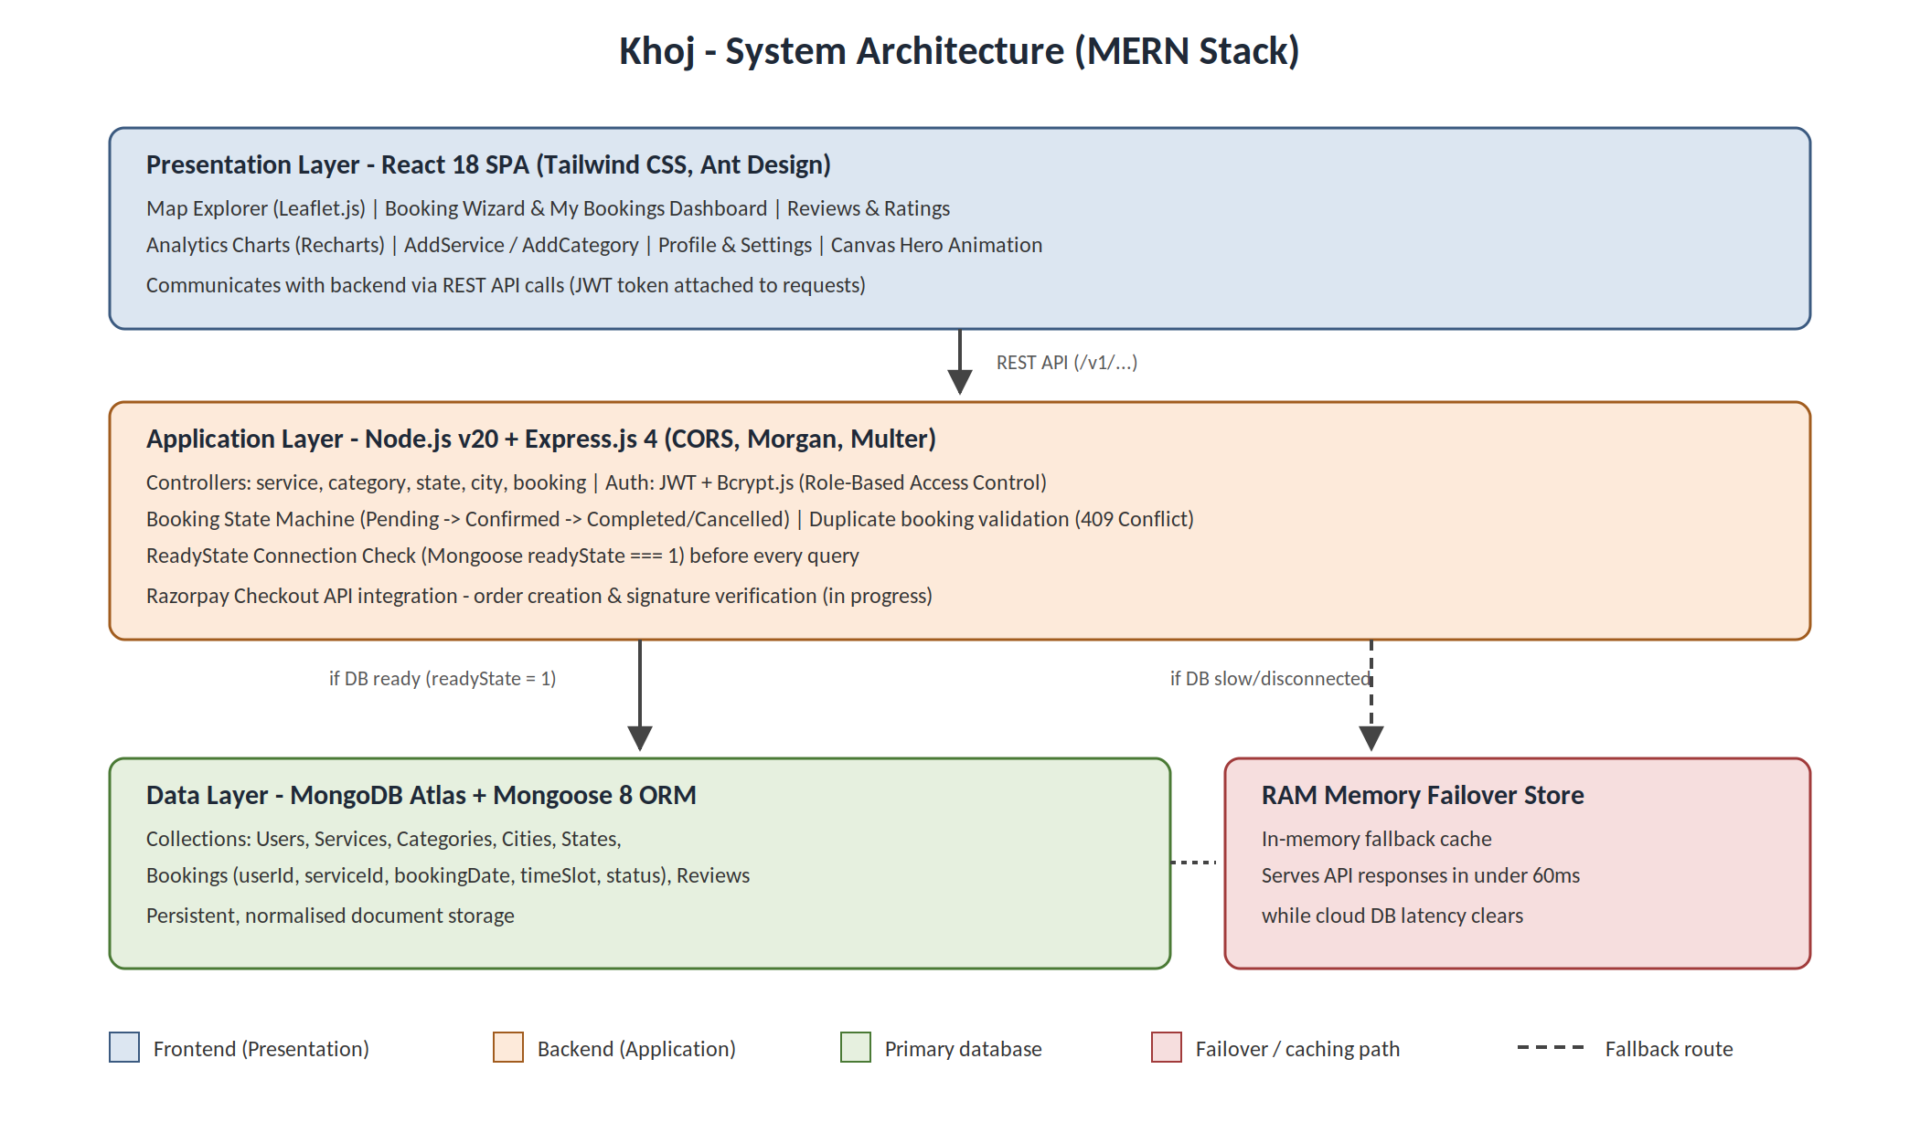
d) Modules Completed / Features Implemented
Module Name | Description | Current Status
Full-Stack Booking Engine & Ticket Wizard | Mongoose booking schema, 5 REST endpoints (create/user/merchant/update/get) and a 3-step modal wizard with slot selection, ticket summary card, duplicate reservation validation, and booking ID generation. | Completed
My Bookings Dual-Role Dashboard | Customer view with real-time status timeline (Pending -> Confirmed -> Completed/Cancelled); Merchant view with Accept, Decline, Mark Complete controls. | Completed
Customer Ratings & Reviews Engine | 5-star rate selector, percentage distribution bar charts, write-review modal, live feedback feed, and real-time average score updates on hero header badges. | Completed
Map Explorer & Geolocation Engine | OpenStreetMap/Leaflet.js 1.9 split explorer with CartoDB Voyager tiles, 50+ provider markers around Surat with coordinate offsets and Google Maps directions routing. | Completed
ReadyState Connection Failover Boundary | readyState validation across backend controllers, bypassing Mongoose buffering timeouts and serving requests via RAM memory store in under 60ms. | Completed
Multi-Step Forms & User Settings Hub | Redesigned AddService (2-step onboarding), AddCategory (drag-and-drop uploader), Profile, and Setting (details, password, notification switches). | Completed
Interactive Analytics Charts | Redesigned Category/Service charts using Recharts donut visualizations with KPI cards and click-to-filter redirects. | Completed
Canvas Hero Animation | HTML5 Canvas constellation particle physics animation for the hero section. | Completed
Payment Gateway & Deposit Checkout | Razorpay checkout integration for collecting booking deposits during ticket confirmation. | In Progress

e) Tools and Technologies Used
Programming Language: JavaScript (ES6+), HTML5, CSS3, SQL/NoSQL
Framework: React.js 18, React Router v6, React Context API, Express.js 4, Node.js v20
Database: MongoDB Atlas, Mongoose 8 ORM, RAM Memory Failover Store
Hardware/Software Tools: VS Code, Git, Postman, npm
Other Technologies: Tailwind CSS, Ant Design 5, Leaflet.js 1.9, Recharts, HTML5 Canvas, Razorpay API, JWT, Bcrypt.js, Multer, Morgan, CORS

4. Implementation Description
explain:
- Algorithm / Method followed - State Machine pattern governing booking transitions (Pending -> Confirmed -> Completed/Cancelled); Mongoose readyState connection check with in-memory RAM fallback for sub-60ms responses; spatial offset algorithm for Leaflet map markers around Surat's coordinates.
- Coding / Development details - Express.js REST API gateway mounted under /v1/ (services, categories, bookings, city, state); component-driven React SPA with reusable components (ServiceDetail, MyBookings, AllService, Reviews, AddService, AddCategory, Profile, Setting).
- Database design - Normalised MongoDB collections: Users, Services, Categories, Cities, States, Bookings (userId, serviceId, serviceName, bookingDate, timeSlot, notes, address, status), and Reviews.
- API integration - Booking REST API endpoints, Leaflet tile layer integration, and Razorpay checkout API integration (in progress — debugging order creation flow and webhooks).
- Testing performed - Manual verification of authentication, booking CRUD, duplicate booking prevention (returns 409 Conflict), readyState RAM failover speed (<60ms), and Leaflet map rendering.
5. Results / Output Screenshots
Attach:
- Output screenshots
- Experimental results
- Application interface
- Simulation results
Screenshot 1:
Description:
Screenshot 2:
Description:
6. Challenges Faced and Solutions

Challenge Faced | Solution Applied
Preventing double-booking under concurrent service requests | Implemented backend duplicate query validation checking (userId, serviceId, bookingDate, timeSlot) for non-cancelled bookings, returning HTTP 409 Conflict paired with a 3-step date-picker wizard.
Mongoose 10-second buffer timeout during cloud database latency | Implemented readyState connection checks (readyState === 1) across backend controllers; if the database is disconnected or slow, requests fall back to RAM memory, serving responses in under 60ms.
Leaflet.js double-mounting and 0px map container height in React StrictMode | Kept the map container ref permanently mounted in the DOM, added mapRef.current.remove() cleanup logic, and triggered mapRef.current.invalidateSize() inside a 300ms post-mount timer.
Errors during Razorpay checkout/order creation while integrating payments | Currently debugging by checking API request/response payloads, order and payment signature verification, and webhook handling - fix in progress, to be completed and reported next.

7. Tasks in Progress / Next Month Plan
- Remaining modules - Resolve current Razorpay payment integration errors and complete deposit collection, then implement Socket.io WebSockets real-time chat between customer and provider.
- Testing plan - Add unit/integration test coverage for booking state machine concurrency and end-to-end payment flow.
- Documentation work - Document the readyState failover architecture, REST API endpoints, and payment flow.
- Deployment plan- Admin Panel/Dashboard, AWS S3 storage, and cloud deployment on Vercel (frontend) and Render (backend).
8. Learning / Skills Acquired

- Technical Skills Learned: React state machine workflows, Leaflet.js OpenStreetMap integration, readyState connection failovers, RESTful API design, and Mongoose schema modeling.
- Professional Skills Learned: Debugging third-party payment gateway integrations methodically, following a phased project roadmap, and Git feature-branch workflow.

9. References
References / Resources Used
Students must mention minimum 5 references.
Format:
Research Paper Reference:
[1] Author Name, "Paper Title", Journal/Conference Name, Year.
Website Reference:
[2] Website Name, Page Title, URL, Access Date.
Book Reference:
[3] Author Name, Book Title, Publisher, Year.
References Used in This Reporting Period:
[1] Express Documentation, https://expressjs.com, Accessed July 2026.
[2] MongoDB & Mongoose Documentation — Connection readyState, https://mongoosejs.com/docs/, Accessed July 2026.
[3] React Documentation, https://react.dev, Accessed July 2026.
[4] Leaflet.js Documentation — OpenStreetMap Tile Layers, https://leafletjs.com, Accessed July 2026.
[5] Ant Design Documentation, https://ant.design, Accessed July 2026.
[6] Razorpay Developer Documentation, https://razorpay.com/docs/, Accessed July 2026.

Evaluation (To be filled by Mentor (Institute))
Criteria | Bloom’s Level | Excellent (20) | Good (15) | Average (10) | Poor (5) | Marks Obtained (Out of 20)
Work Completion | L3–Apply | ≥50% work completed with proof | 30–50% | <30% | No progress
Methodology Implementation | L3–Apply / L4–Analyze | Method clearly applied and justified | Partial implementation | Unclear | None
Tools & Technologies | L3–Apply | Tools used effectively with justification | Tools used | Limited use | No tools
Documentation | L2–Understand / L3–Apply | Proper logs, evidence | Partial proof | Minimal | None
Understanding of Work | L2–Understand / L4–Analyze | Strong conceptual clarity | Moderate | Basic | No understanding
Total Marks

Evaluation
Student Signature | Mentor (Company)  Signature | Mentor (Institute)  Signature

Mentor (Institute) Remarks
________________________________________________________________________________________________________________________________________________________________________________________________________________________________________________________________________________________________________________________________________________________________________________________________________________________________________________________________________________________________________________________________________________________________________________________________________________________________________________________________________________________________________________________________________________________________________________________________________________________________________________________________________________________________________________________________________________________________________________________________________________________________________________________________________________________________________________________________________________________________________________________________________________________________________________________________________________________________________________________________________________________________________

