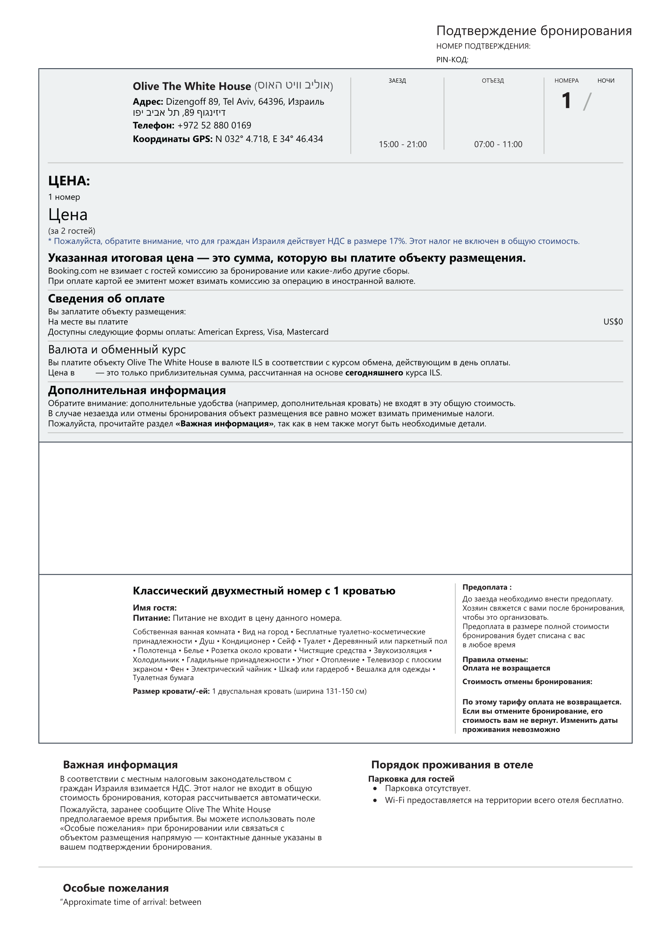

{{inTimeArival}} and {{toTimeArival}}”

*{{toWeekday}}*

**{{toDate}}**

**{{toMonth}}**

*{{inWeekday}}*

**{{inDate}}**

**{{INMONTH}}**

**{{pin}}**

**{{bookN}}**

**{{night}}**

{{val}}{{sum}}

около {{val}}{{sum}}*

₪ {{sumShek}}

{{val}}{{sum}}

{{USDval}}

с {{datePred}}. 23:59 [IST]: ₪ {{sumShek}}

{{name}} / за максимум 2 человека



{{mail}}).