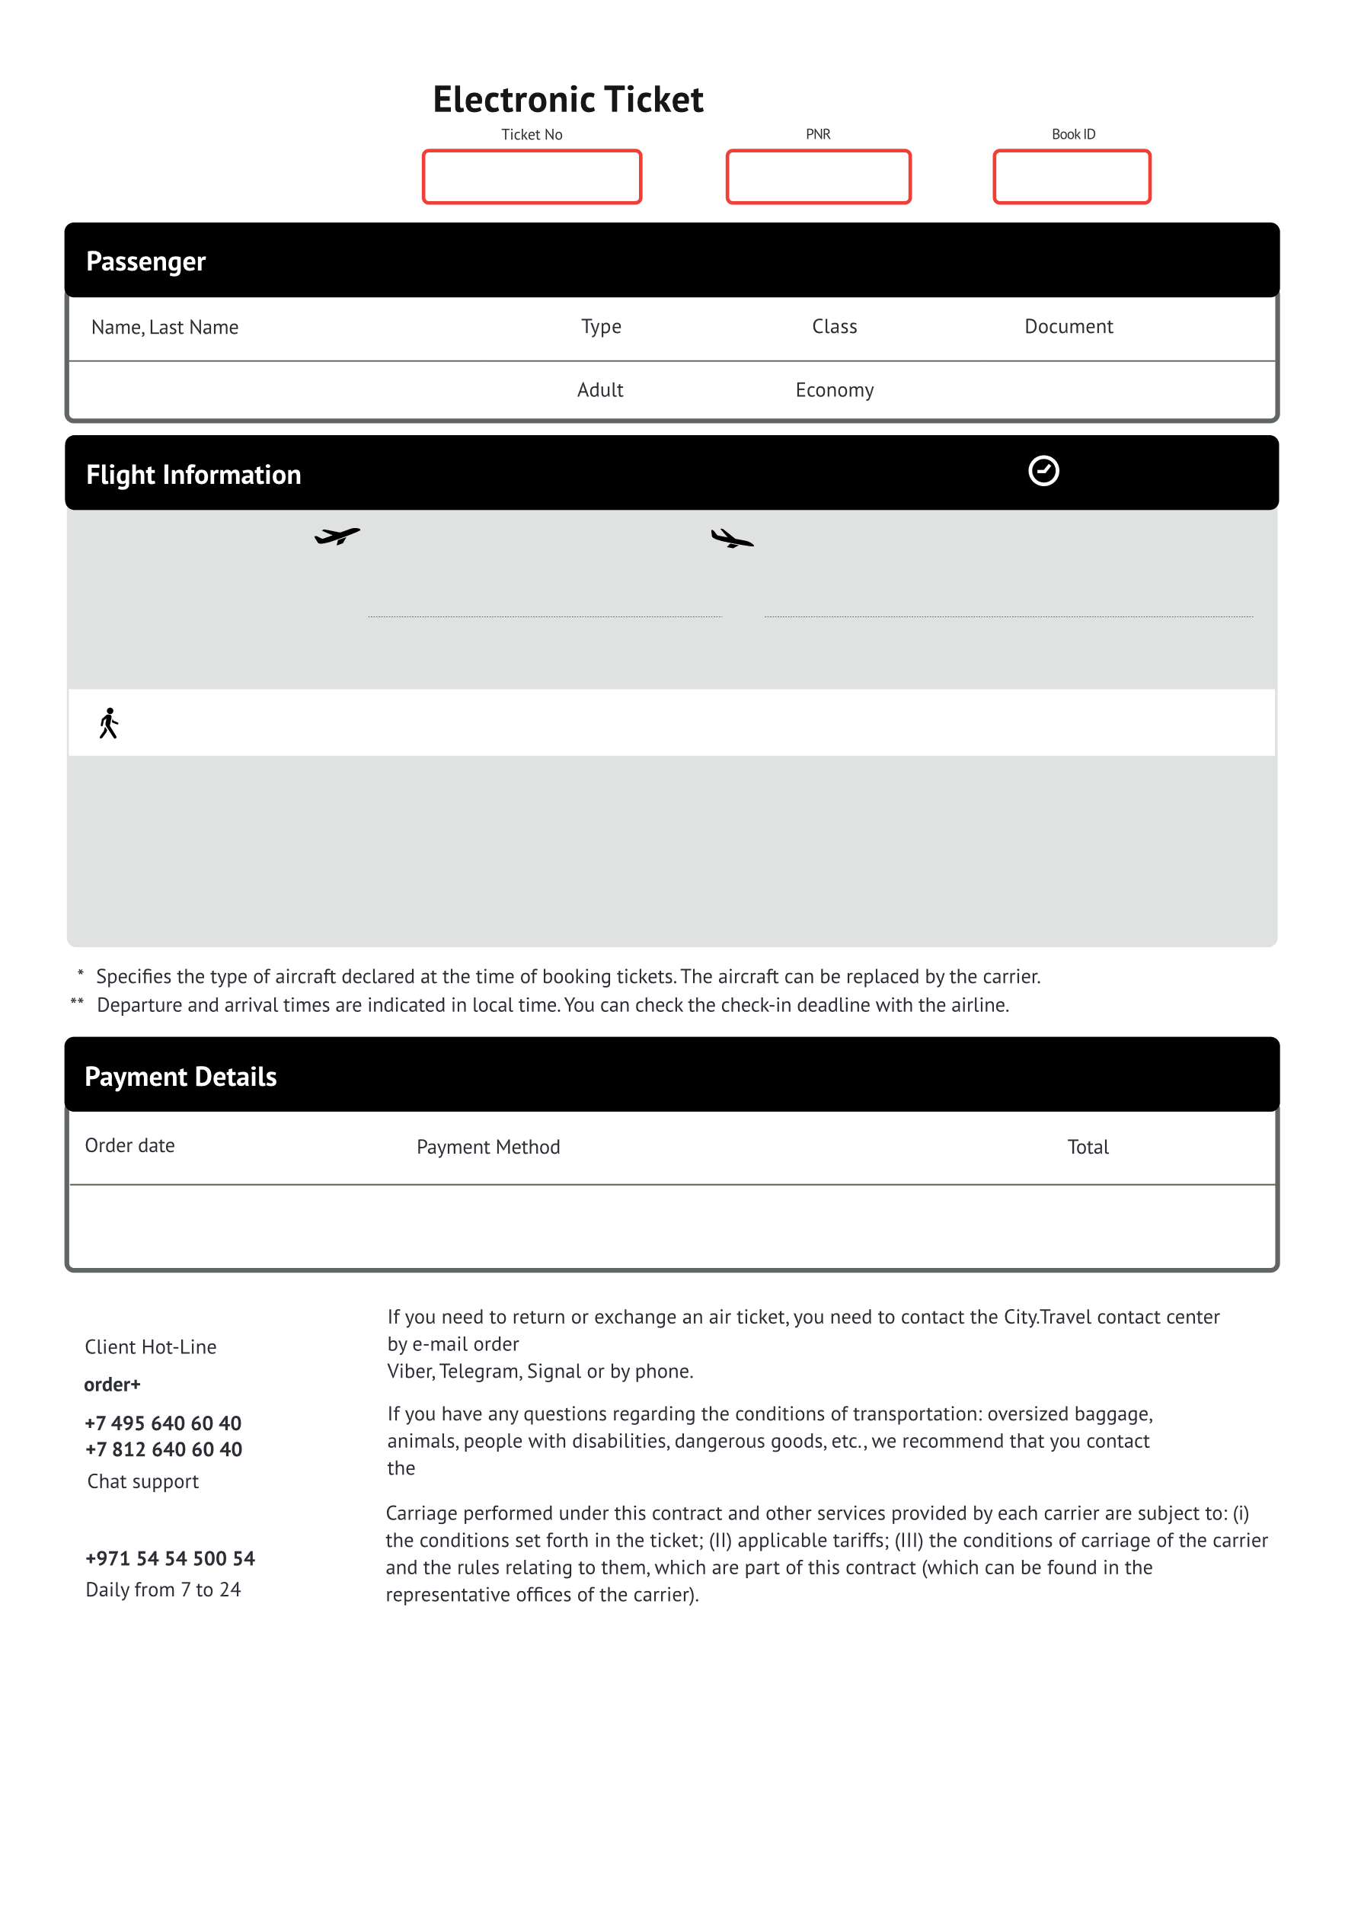

**{{orderN}}@city.travel**

{{aviaComp}} by phone: {{aviaPhone}}

{{orderN}} @city.travel in free form, chat customer support via WhatsApp,

**{{orderN}}**

**{{tickN}}**

**{{aviaN}}**

{{orderDate}} {{orderTime}}

**{{sum}} {{val}}**

Card

**{{planeN2}}**

**{{aviaComp2}}**

*{{planeType2}}*

{{baggage}}

**{{portNameS2}}**

***{{portName2}}***

{{city2}}, {{coutry2}}

**{{inTime2}} {{inDate2}}\*\***

*To the city center {{distance2}} km*

**{{portNameS}}**

***{{portName}}***

{{city}}, {{coutry}}

**{{outTime2}} {{outDate2}}\*\***

*Check-in until {{regTime2}}\*\**

{{transferType}} в {{portTransferName}} – {{timeTransfer}}.

**{{planeN}}**

**{{aviaComp}}**

*{{planeType}}*

{{baggage}}

**{{portNameS}}**

***{{portName}}***

{{city}}, {{coutry}}

**{{inTime}} {{inDate}}\*\***

*To the city center {{distance}} км*

**TLV**

***Ben Gurion***

Tel Aviv, Israel

**{{outTime}} {{outDate}}\*\***

*Check-in until {{regTime}}\*\**

**{{passportN}}**

**{{timeFly}} on the way**

**{{name}}** {{bornDate}}