TODO APP  
Use Cases

# Login

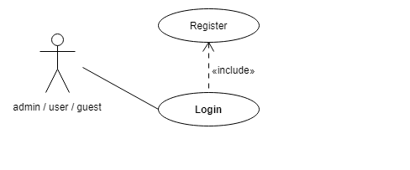

|  |  |
| --- | --- |
| **Use Case 1** | Login |
| **Actor** | user/guest/admin |
| **Basic Flow** | A user enters to the app introducing user and password, depends on the role it redirects to list of users or list of TODOs. This action only occurs when the user/admin/guest is previously registered. |

# Role Admin

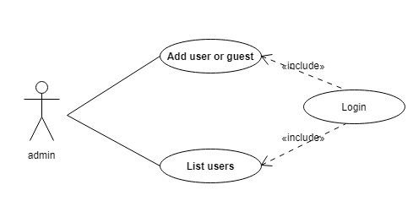

|  |  |
| --- | --- |
| **Use Case 2** | Add user/guest |
| **Actor** | admin |
| **Basic Flow** | The admin is the unique user that can register another user, this could happen after the admin is logged in. |

|  |  |
| --- | --- |
| **Use Case 3** | List users |
| **Actor** | admin |
| **Basic Flow** | After the addition of the new user it shows the new user added. |

# Role User/guest

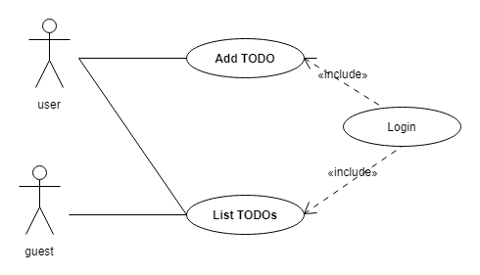

|  |  |
| --- | --- |
| **Use Case 4** | Add TODO |
| **Actor** | user |
| **Basic Flow** | When user is in the app, the user can add new TODO item only if the user has the role user. |

|  |  |
| --- | --- |
| **Use Case 5** | List TODOs |
| **Actor** | user / guest |
| **Basic Flow** | When List TODOs is selected by the user/guest it shows the list of TODOs. |