TODO APP  
Use Case

# Login

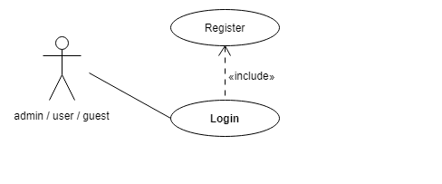

|  |  |
| --- | --- |
| **Use Case 1** | Login |
| **Actor** | User/guest/sadmin |
| **Basic Flow** | A user enters to the app introducing user and password, depends on the role it redirects to list off user or list of TODOs |

# Role Admin

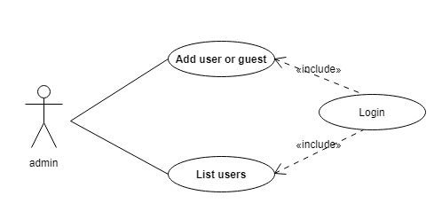

|  |  |
| --- | --- |
| **Use Case 2** | Add user |
| **Actor** | Admin |
| **Basic Flow** | The admin is the unique user that can register another user, this could happen after the admin is logged. |

|  |  |
| --- | --- |
| **Use Case 3** | List users |
| **Actor** | Admin |
| **Basic Flow** | After the addition of the new user it redirects to the list of users. |

# Role User/guest

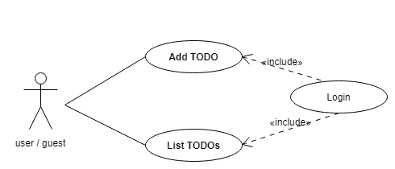

|  |  |
| --- | --- |
| **Use Case 4** | Add TODO |
| **Actor** | User / guest |
| **Basic Flow** | When user is in the app, the user can add new TODO item only if the user has the role off full access. |

|  |  |
| --- | --- |
| **Use Case 5** | List TODOs |
| **Actor** | User / guest |
| **Basic Flow** | After the user make an action is redirect to the list of TODOs |