# Homework

# Sikuli

Below are some sample workflows. Create Sikuli tests with basic framework.

* Go to [www.google.com](http://www.google.com) and search for “Telerik academy” and assert that it exists in the search results.
* Go to <http://www.dhtmlgoodies.com/scripts/drag-drop-custom/demo-drag-drop-3.html> and make a test for dragging and dropping elements. Make the action of positioning the capitals to their corresponding countries and verify that each country contains its own capital.
* Make a test that minimized all active windows. For example the Firefox tabs.

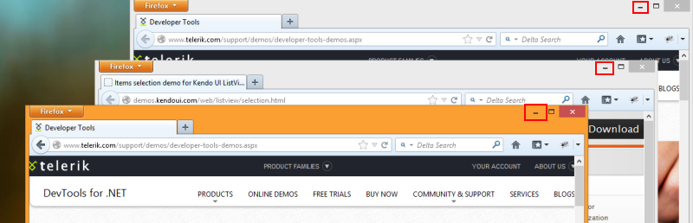

* Make a test that sends a message to a friend via Skype.
* Go to <http://www.facebook.com/> and make a test that sends a message to a friend.

Expand the test by sending multiple messages consequently.

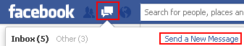

* Open **Windows Calculator** from the Star menu. Check the operations of addition, subtraction, multiplication and division. Make sure that dividing by zero is not allowed.