Stress-Strain Behavior of Strengthened RC Slabs
Mykhailo Ivaneiko ¹, Andrii Klym ¹, Yaroslav Blikharskyy ¹, Roman Khmil ¹, Zinoviy
Blikharskyy ^{1,2}
¹Lviv Polytechnic National University, 12 st. S. Bandera, Lviv, 79013, Ukraine
²Czestochowa University of Technology, Faculty of Civil Engineering yaroslav.z.blikharskyy@lpnu.ua
Abstract. The paper presents the results of an experimental study of the stress-strain state of a single-span reinforced concrete (RC) floor slab strengthened by installing an additional RC layer with combined mechanical and adhesive bonding between the layers. The strengthening was implemented using Ø8 mm shear keys arranged over the interface area at a spacing of 400×200 mm, along with thorough surface preparation of the lower slab, which ensured efficient force transfer between the upper and lower parts of the composite cross-section. The experimental tests were carried out under a uniformly distributed load, with the specimens loaded up to complete failure. To determine the stress-strain state, an integrated approach was employed using sub-micron measuring gauges and the non-contact digital image correlation method, which enabled reliable determination of deflections, concrete and reinforcement strains, as well as spatial strain fields within the interlayer contact zone. The study results indicate that the code-based limit deflection fu = 20 mm was reached at an average bending moment MULS = 6.21 kN·m, whereas the maximum bending moment of the strengthened slab was Mmax = 17.28 kN·m, demonstrating a substantial reserve of load-bearing capacity. The maximum relative strains of the lower tensile reinforcement reached εlow,max = 1350·10⁻⁵, those of the upper reinforcement were approximately 530-550·10⁻⁵, and the strain of the most compressed concrete fibre reached εcu,max = 325·10⁻⁵. The discrepancy between the results obtained by the two independent measurement methods did not exceed 5-12%. The experimental data obtained confirm the effectiveness of the adopted strengthening technology and are of practical value for engineering calculations, assessment of load-bearing capacity, and evaluation of the residual service life of strengthened RC floor slabs.

Introduction
RC floor slabs are important load-bearing elements of buildings and structures, capable of sustaining substantial service loads. During the service life of structures, a need for strengthening often arises due to increased design loads, the occurrence of damage, changes in the functional purpose of the building, a reduction in load-bearing capacity resulting from deterioration of the fundamental material properties, or the influence of corrosion processes. Various strengthening methods for RC slabs are available, including additional reinforcement, external confinement, the use of composite materials, installation of steel plates, external prestressing [1-5], or casting a new RC layer (increase in the cross- sectional depth) [6-9]. The cross-section enlargement method consists in casting an additional concrete layer onto the existing slab, which increases its geometric dimensions and, consequently, its strength and stiffness. This approach is sometimes also employed for full replacement of damaged floors: a new slab is cast over the old one, using the latter as permanent formwork. The effectiveness of cross- section enlargement depends on ensuring reliable bond between the existing and the new concrete in accordance with code requirements [10-12] and on adequate force transfer between the layers. This method is particularly advantageous when other approaches are infeasible due to spatial constraints or economic factors. At the same time, strengthening by cross-section enlargement requires careful design, since incomplete composite action between the existing and the new parts of the slab may reduce the expected effectiveness.

Practical experience confirms the importance of timely strengthening of slabs when service conditions change. In particular, in the case of the “Sampoon” Department Store in Seoul, the absence of floor strengthening under increased loads led to slab overloading and subsequent collapse [13]. Conversely, in the “Visconde de Alvalade” building in Lisbon, the timely installation of an additional concrete layer made it possible to restore the load-bearing capacity of the slabs and prevent a structural failure. These cases demonstrate that strengthening by cross-section enlargement is an effective measure to enhance slab reliability.
Considerable research attention is focused on the experimental verification of analytical models describing slab behaviour. Researchers actively investigate the effects of geometry, reinforcement, and novel materials (fibre-reinforced concrete, composite reinforcement) on crack resistance and deflections [14-16]. For example, studies [17, 18] have shown that classical calculation methods do not always adequately capture slab response at the ultimate strain stage, particularly under complex loading patterns. This substantiates the need for full-scale testing using high-precision instrumentation.
In recent years, a number of experimental studies have been conducted to assess the effectiveness of cross-section enlargement. In study [19], slabs with overlays of 5-15 cm and various interlayer connection types were tested: anchors provided a strength increase of up to 1.2-1.9 times, whereas their absence resulted in shear failures. Studies performed without mechanical anchorage demonstrated a partial increase in stiffness provided that the surface was properly prepared; however, comparison with analytical models revealed certain discrepancies [20], highlighting the need for further improvement of design methodologies. It should be noted that a very large number of publications have recently appeared addressing the strengthening of RC slabs-both by the aforementioned cross-section enlargement method and by alternative or combined techniques. A substantial contribution to this field has been made by studies [21-29], which summarise global experience and propose new engineering solutions.
An important component of contemporary research is the use of digital image correlation (DIC), a method that enables the acquisition of strain maps and the detailed tracking of the behaviour of the existing and newly cast concrete layers. Studies [30-34] have demonstrated in detail the effectiveness of applying this method. For strengthened slabs, DIC is particularly valuable, as it allows the recording of interlayer slip, as well as crack initiation and propagation, thereby enabling assessment of the actual degree of composite action between the overlay and the original slab. This approach improves the accuracy of stress-strain analysis, makes it possible to identify potential weaknesses of the contact interface, and provides a robust basis for refining design methodologies. Thus, the application of DIC substantially expands the research capabilities for strengthened slabs and ensures the soundness of conclusions regarding the practical effectiveness of the cross-section enlargement method. Overall, the literature review confirms the active development of strengthening floor systems by an additional concrete layer, indicating its relevance and practical demand, while the implementation of modern monitoring tools, particularly DIC, creates opportunities for a more accurate assessment of structural behaviour and the further advancement of design approaches.
Despite the considerable body of research, the issue of comparative analysis of the stress-strain state of strengthened slabs with the simultaneous use of contact and non-contact measurement methods remains insufficiently addressed. The objective of this study is to perform an experimental analysis of the stress-strain state of single-span RC slabs using a combination of conventional measuring instruments and a modern digital image correlation system.

Research Methodology
The experimental programme is aimed at assessing the load-bearing capacity of single-span RC slabs strengthened by an RC overlay. Primary attention is given to the behaviour of the interface between the two concrete layers and to the influence of mechanical connectors and interface quality on the composite action of the layers. To achieve the research objective, two identical strengthened RC slab specimens were designed and fabricated.

The control specimens consisted of an RC slab 60 mm thick, 500 mm wide, and with a span of 3000 mm. The concrete was of class C40/50, with a cube compressive strength of 53 MPa. The slab was reinforced with a bottom mesh comprising four longitudinal Ø8 A500C bars and transverse Ø8 A500C bars at 200 mm spacing, with a 20 mm concrete cover.
The strengthened RC slabs comprised two RC layers: the lower slab and the upper strengthening overlay. The lower slab was 60 mm thick, 500 mm wide, and had a 3000 mm span between supports. The concrete of the test specimen was of class C40/50; the cube compressive strength was 54 MPa for the lower slab and 52 MPa for the strengthening layer. Reinforcement of both the lower slab and the upper strengthening overlay was provided by Ø8 A500C steel bars: four longitudinal bars along the slab length and transverse bars at 200 mm spacing, tied together using binding wire (Fig. 1).
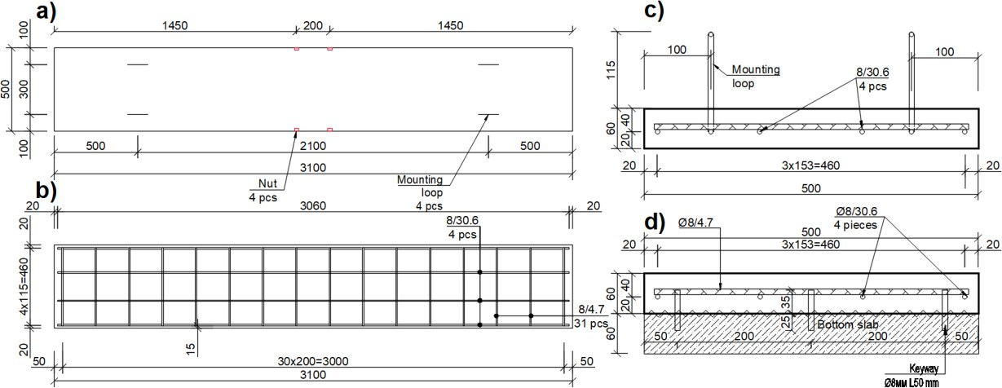
Figure 1. Drawings of RC specimens: а) formwork; b) control slab; c) section of the control slab; d) section of the strengthened slab
To ensure composite action of the layers, the contact surface of the lower slab was prepared in several stages. First, the upper face of the slab was mechanically roughened using an angle grinder to remove the cement laitance, and holes for the shear keys were prepared. The holes for the shear keys were made in the lower slab to a depth of 20 mm, after which 50 mm long reinforcement bars (shear keys) were mechanically installed into the prepared holes of the lower slab. The surface was then cleaned using brushes and compressed air to remove dust and residues. After surface preparation, anchorage connections in the form of Ø8 mm shear keys were installed to ensure resistance to shear forces transfer between the layers. The shear keys were arranged at a spacing of 400×200 mm over the entire interface area. Following installation of the shear keys, additional notches were formed on the surface of the lower concrete slab using an angle grinder across the entire slab area, after which the surface was cleaned again and the reinforcement of the strengthening layer was installed (Fig. 2).
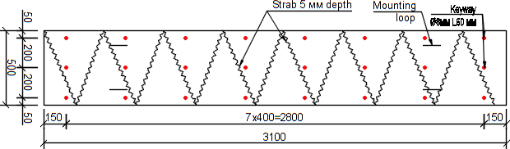
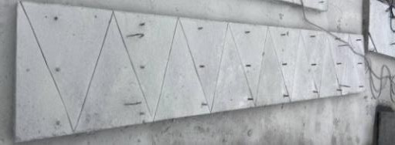

a) | b)
Figure 2. Layout of shear keys and surface notches: a) drawing; b) photograph
The slab was tested according to a single-span scheme: one end was supported by a roller hinge, and the other by a pinned support. The slab ends extended 50 mm beyond the supports. The load was applied by a system of six hydraulic jacks which, through a load distribution system and a hydraulic

pumping station, generated a uniformly distributed load. The loading system was fabricated from No. 12 channel sections installed along the lower and upper faces of the slab and interconnected by M12 threaded rods (Fig. 3). The test was performed under stepwise loading with the specimen brought to complete failure.
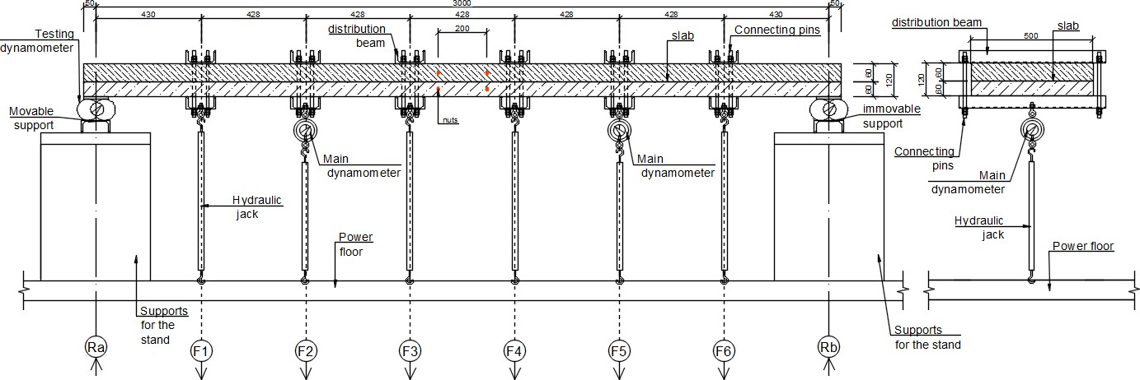
Figure 3. Loading frame layout
Experimental investigations of the RC slabs, including determination of their stress-strain state, were carried out in an integrated manner using digital image correlation (DIC) (at one end face of the slab) and sub-micron dial indicators (at the opposite end face of the slab). Both methods for determining strains and deformability are modern non-contact monitoring systems intended to capture the spatial deformation state of materials under loading throughout the entire test duration up to failure. Full-field strain measurements on an end-face region of the slab measuring 1200×120 mm were recorded in real time under smooth and uniform load application. To achieve high measurement accuracy, the specimen surfaces were thoroughly prepared in advance: grinding to eliminate surface irregularities, cleaning to remove dust, and creating optical contrast by applying a base coat and a speckle pattern.
Preparation of the investigated specimen surface began with mechanical cleaning using a grinding machine (Fig. 4). This stage was performed to remove surface layers of cement laitance, minor defects, and dust that may distort the speckle pattern structure or lead to incorrect operation of the correlation algorithms. In addition, mechanical cleaning provided a uniform surface microrelief, which is required to form a stable substrate for the paint marking layer. After grinding, the surface was thoroughly cleaned of residual dust using a stream of compressed air, thereby preventing the formation of weakly bonded zones beneath the paint.

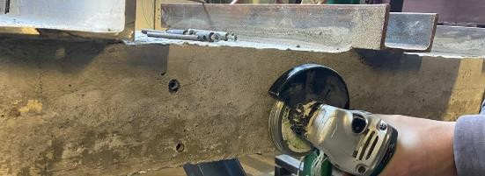 | 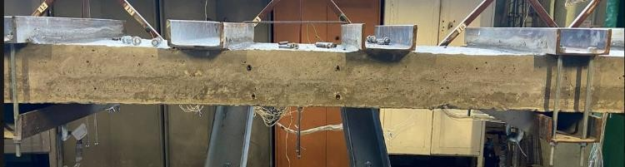
a) | b)
Figure 4. Loading frame layout: a) grinding process; b) finished surface
The next stage involved applying a white base coat in the form of a light, matte lime paint, which served as a substrate for creating a high-contrast speckle pattern (Fig. 5). The selection of lime paint was dictated by its properties: first, it is non-glossy and does not produce glare under camera illumination; second, its microstructure is sufficiently close to that of concrete and does not distort the actual evolution of the surface texture under loading; third, the coating forms a uniform surface with high adhesive properties, ensuring high-quality application of the dark marking layer. The paint layer thickness was controlled so as not to create excessive surface relief and not to affect the local stiffness of the investigated region.

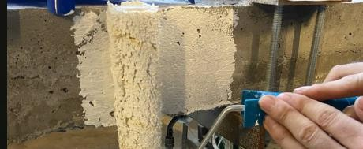 | 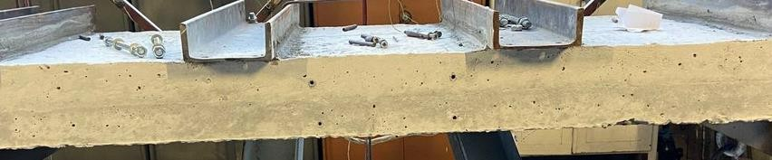
a) | b)
Figure 5. Preparation of the slab end face for DIC: a) application of the base coat; b) painted surface
After the white base coat had dried, a speckle pattern of black dots was applied using a roller technique, providing coverage of approximately 60-70% of the surface with high-contrast elements that serve as markers for the DIC matrix correlation algorithm. The optimally calculated dot diameter was 0.33 mm, which satisfies the spatial resolution requirements of the DIC system (Fig. 6) and ensures an optimal balance between the resolution of high-precision cameras and the robustness of the algorithm to local deformations arising during concrete behaviour under loading.

 | 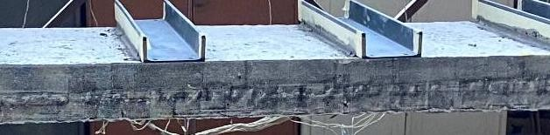
a) | b)
Figure 6. Preparation for the DIC method: а) application of the speckle pattern; b) esulting speckle pattern
Particular attention was paid to the uniform distribution of dots along the entire length of the observed zone, since non-uniformity or excessive clustering of points can complicate subsequent correlation analysis. After applying the pattern, the surface was additionally inspected under controlled lighting to confirm its uniformity and contrast (Fig. 7).
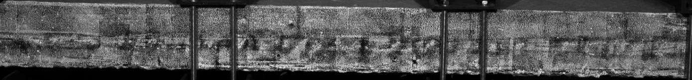
Figure 7. Additional inspection of the slab under controlled lighting conditions
Image acquisition of the specimen’s deformation response was performed using a DIC system comprising two high-quality monochrome cameras synchronized via a switch to enable simultaneous 3D recording (Fig. 8).

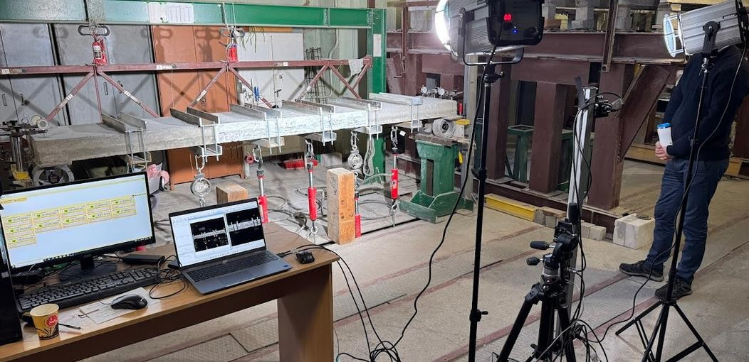
Figure 8. Equipment setup for the digital image correlation method
During processing, data from both cameras were merged into a single file, which made it possible to obtain an accurate three-dimensional strain map and to avoid errors inherent to 2D single-camera recording. The cameras were mounted on a rigid tripod with a rail, preventing any displacement due to vibrations or external influences. The lighting system was configured using polarizing filters to ensure stable and uniform light intensity without shadows or glare that could affect the quality of the correlation analysis. Prior to testing, a calibration procedure was performed using a calibration target, allowing accurate determination of the cameras’ intrinsic and extrinsic parameters, their spatial positions, and mutual orientation (Fig. 9). After calibration, a trial test under zero-strain conditions was conducted. During specimen loading, each camera recorded images at a rate of one frame per second, providing sufficient temporal resolution to track the evolution of deformations and cracking. Upon completion of the experiment, all acquired images were transferred to the VIC-3D software suite for processing. At the first stage, the correctness of the calibration and the synchronisation of the captured frames were verified.

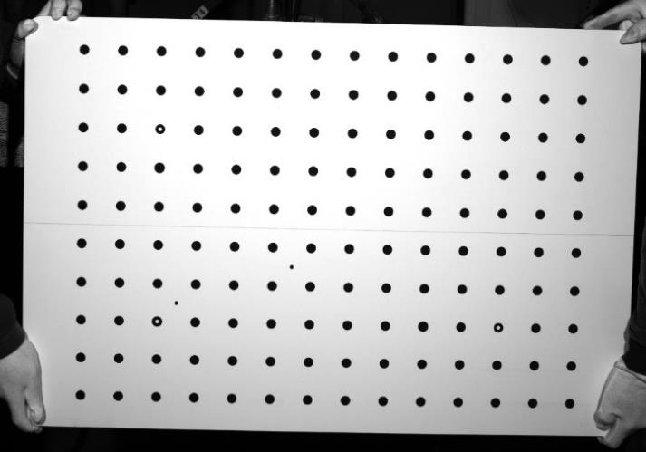 | 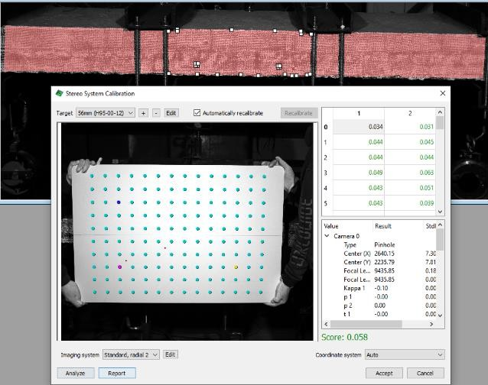
а) | b)
Figure 9. DIC calibration procedure: а) calibration target; b) analysis of calibration images in different
positions
After completion of the experiment, all acquired images were transferred to the VIC-3D software suite for processing. At the first stage, the correctness of calibration and the synchronisation of the captured

frames were verified, and the region of interest of the investigated concrete area was defined. Subsequently, in accordance with the recommendations, the optimal subset size and calculation step were selected to ensure an acceptable noise level. Data processing was performed using an algorithmic image-analysis procedure that evaluated the displacement of each local speckle-pattern subset relative to the initial reference state (Fig. 10).
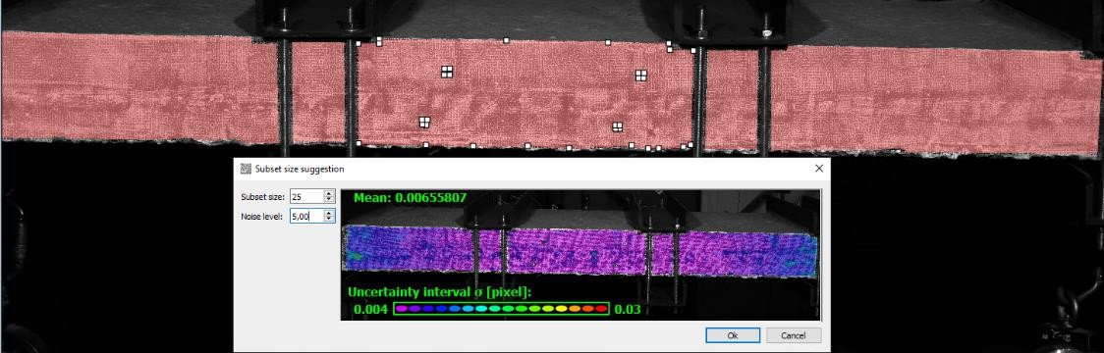
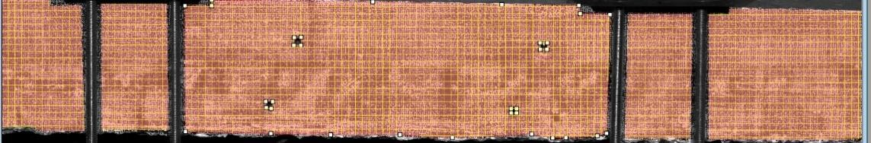

Figure 10. Selection of subset size and step within the specified calculation area
Based on the analysis of the images transformed during loading, displacement fields were generated, from which relative strains and specimen deformability were obtained by defining virtual extensometers on the concrete surface in the following sequence: at the most compressed concrete fibre (E0); at the level of the tensile reinforcement of the lower slab (E1); at the level of the tensile reinforcement of the upper strengthening layer (E2); and the specimen deflection over the depth (P0) (Fig. 11).
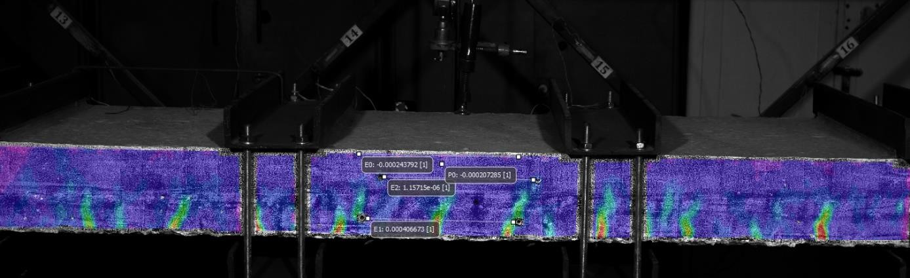
Figure 11. Placement of extensometers on the investigated area
At the opposite end face of the slab, a system of sub-micron measuring gauges was used in each test to determine concrete and reinforcement strains and to monitor the key deformability parameters of the RC slab. The instruments had a resolution of 0.0001 mm (1/10000 mm), and the measured values were transmitted to a personal computer via a wireless Bluetooth connection. The use of computerised sub- micron gauges enabled continuous and remote recording of strain variations and control of load application throughout the entire testing process in real time. Following each experiment, a dataset was generated in tabular form in the Microsoft Excel environment for each measurement channel with a 1 second logging interval, providing a basis for detailed analysis of the stress–strain state of the strengthened slab at all loading stages (Fig. 12).

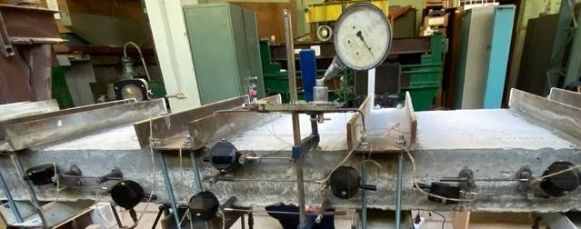 | 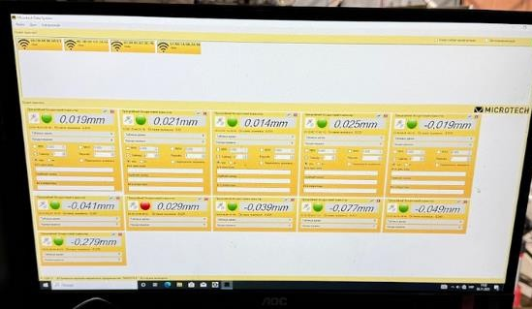
a) | b)
Figure 12. Strain data obtained from sub-micron gauges: а) on the slab end face; b) on the PC
The sub-micron gauges were installed on the test specimen in accordance with the adopted measurement layout. Concrete strains at the upper surface of the slab were determined at the section of maximum bending moment by installing one gauge at midspan. The strain state of the tensile reinforcement was assessed using sub-micron gauges mounted in the maximum bending-moment section, directly within in the reinforcement zones of each test slab. The gauges were fixed using mechanical holders that ensured rigid attachment to the reinforcing bars. The gauge length for measuring concrete strains was 100 mm, whereas for reinforcement it was 200 mm. Slab deflections were measured using five devices: two dial indicators installed at each support, as well as an Aistov system deflectometer placed at the section of maximum deflection. Load application was monitored using two indicators installed in a ring dynamometer, which made it possible to track changes in the force transmitted to the test specimen from the pumping station through the hydraulic jack. The layout of the measuring devices is shown in Fig. 13.
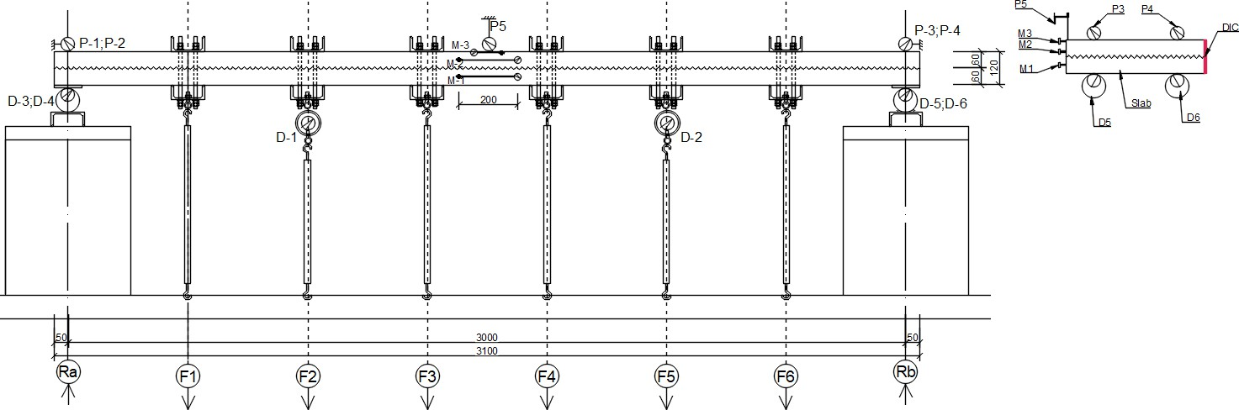
Figure 13. Layout of measuring instruments.

Results and Discussion
During the experimental testing of the RC floor slab, attainment of its load-bearing capacity was monitored based on deflection criteria in accordance with the requirements of the applicable standard DSTU B.V.1.2-3:2006 [35]. The allowable limit deflection was adopted from the serviceability condition and was calculated using the relationship fu = l/150, where l is the design span of the slab. For the test specimen with a span of l = 3000 mm, the allowable deflection was fu = 20 mm. The tests were performed with incremental (stepwise) load application and the specimen was brought to complete structural failure, which enabled acquisition of stress-strain data for the strengthened slab at all loading stages.
Based on the experimental results obtained for the twin strengthened RC slab specimens (the plots present values averaged between the specimens), the relationship between the bending moment M and the deflection f was determined, as recorded both by the digital image correlation (DIC) method and by sub-micron dial indicators. Comparison of the results obtained by the two independent

methods indicates good agreement over the entire loading range, with discrepancies within 5-12%, thereby confirming the reliability and representativeness of the experimental data.
The limit deflection of the RC slab, fDIC = fIndic = fu = 20 mm, was recorded at a bending moment of MULS,DIC = 6.05 kN·m according to the digital image correlation method and MULS,Indic = 6.37 kN·m based on the data obtained from the Aistov measuring device. Hereafter, for data analysis and presentation, the bending moment averaged between the two measurement methods will be used, which is MULS = 6.21 kN·m. Reaching this state characterises the transition of the structure to the serviceability limit state; however, further loading of the slab did not lead to a sudden loss of load- bearing capacity, indicating a sufficient reserve of strength and deformation capacity (Fig. 14).
After the limit deflection was reached, slab loading was continued, which was accompanied by an intensive increase in deflections under a comparatively slow increase in bending moment. This behaviour indicates the development of plastic deformations in the cross-section and active engagement of the reinforcement in resisting internal forces. The maximum bending moment was recorded at Mmax = 17.28 kN·m, while the corresponding deflections were fmax,indic = 117 mm according to the Aistov measuring device and fmax,DIC = 119 mm according to the DIC data (Fig. 14).
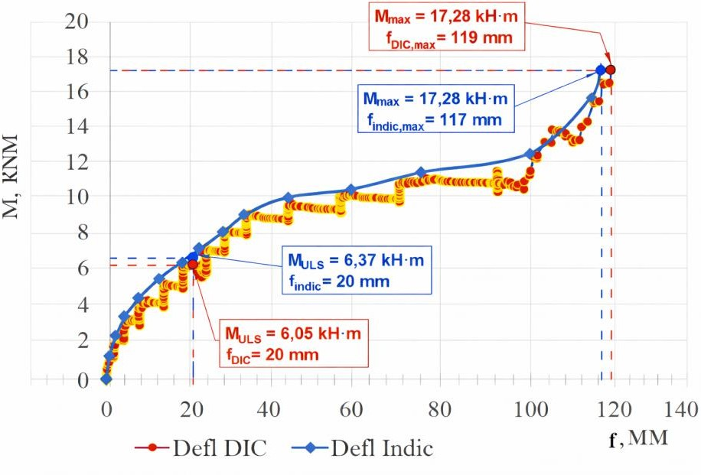

Figure 14. The averaged experimental "moment-deflection" graphs for slab: Defl_Indic - based on sub-micron indicators, Defl_DIC - based on the digital image correlation method.
The obtained “M-f” relationship indicates that the strengthened RC slab operated over a wide deformation range, sequentially passing through the elastic and plastic response stages up to failure. The evolution of deflections and the absence of an abrupt drop in bending moment confirm the ductile nature of failure and the effectiveness of the adopted strengthening, which provided the structure with significant deformation capacity.
At the initial loading stage, an almost linear relationship between bending moment and deflection is observed, corresponding to the elastic response of the structure. At this stage, the stress–strain state is characterised by small deflections and high stiffness of the element, indicating composite action of concrete and reinforcement without the development of significant cracking in the tensile zone. Further increase in load is accompanied by a gradual reduction in slab stiffness, which is reflected in the nonlinear character of the “M-f” relationship. This stage is associated with the initiation and propagation of cracks in the tensile concrete zone, as well as redistribution of internal forces among the cross-sectional components. Despite increasing deflections, the slab retains its load-bearing capacity and exhibits stable behaviour without signs of loss of integrity.

Based on the experimental results, the “M-εlow” relationship between the bending moment M and the strain ε_low of the lower tensile reinforcement was obtained. At the initial loading stage, a pronounced increase in the strains of the lower reinforcement is observed at relatively low bending moments, which corresponds to the elastic response of the element and composite action of concrete and reinforcement without significant crack development. Within this range, the M–ε relationship is nearly linear, and reinforcement strains remain small.
At the moment when the slab reached the limit deflection, recorded at a bending moment of MULS
= 6.21 kN·m, the relative strain of the lower reinforcement was εlow,ULS,Indic = 180·10⁻⁵ according to the sub-micron gauges and εlow,ULS,DIC = 198·10⁻⁵ according to the DIC results. This state characterises the transition of the slab to the serviceability limit state; the stress–strain response of the lower reinforcement indicates its active participation in resisting tensile forces, while remaining below the yield limit (Fig. 15).
With further increase in load, a steady growth of strains in the lower reinforcement is observed under a comparatively moderate increase in bending moment, indicating crack development in the tensile concrete zone and a gradual reduction in element stiffness. Reaching the yield point of the lower reinforcement - where the yield-limit strain was determined by tensile testing of Ø8 reinforcement and established as εyk = εlow,yk = εup,yk = 281·10⁻⁵ - occurs at a bending moment of Mlow,yk,Indic = 9.24 kN·m according to the sub-micron gauges and at Mlow,yk,DIC = 9.35 kN·m according to the DIC data. From this point, the response of the lower reinforcement becomes distinctly plastic, and further load increase leads to a substantial growth in strains without a proportional increase in bending moment (Fig. 15).
At the final loading stage, immediately prior to slab failure, the maximum bending moment Mmax
= 17.28 kN·m was recorded, at which the relative strains of the lower reinforcement reached εlow,max,Indic = 1352·10⁻⁵ and εlow,max,DIC = 1379·10⁻⁵. This strain level indicates pronounced plastic behaviour of the lower reinforcement and confirms the ductile nature of structural failure, accompanied by a significant redistribution of internal forces (Fig. 15).
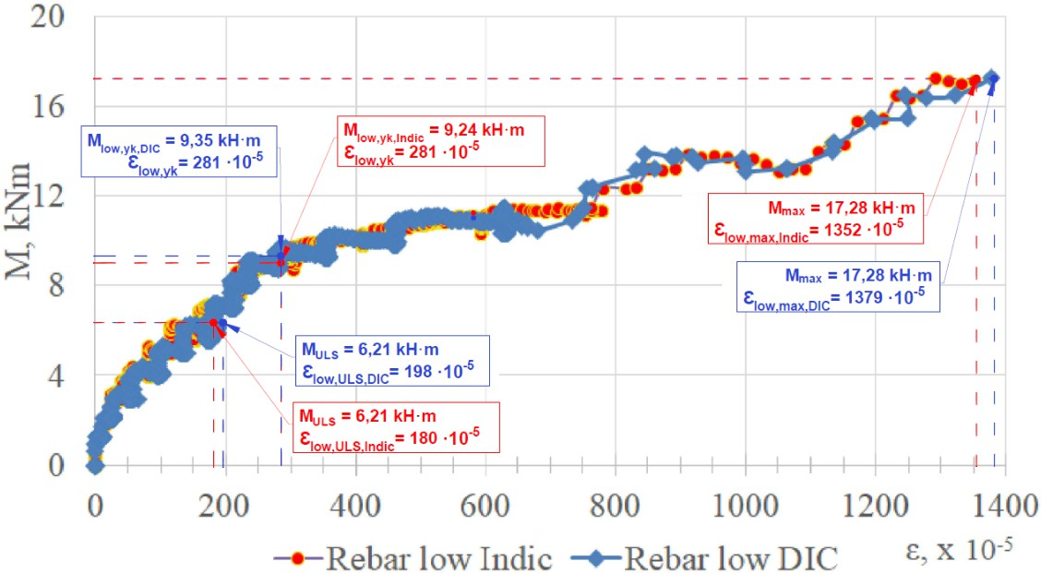

Figure 15. The experimental averaged graph "moment-strain of working low reinforcement" for slab: Rebar_ low_Indic - based on sub-micron indicators, Rebar_low_DIC - based on digital image correlation
Based on the experimental results, the “M-εup” relationship between the bending moment M and the strain εup of the upper reinforcement was obtained. At the initial loading stage, strains in the upper

reinforcement are virtually negligible, which can be attributed to its operation within the compressed zone of the cross-section and its limited engagement in force resistance during the elastic response of the slab due to its location closer to the neutral axis. As the bending moment increases, the strains gradually grow, indicating changes in the cross-sectional stress–strain state and redistribution of internal forces.
At the moment when the slab reached the limit deflection at MULS = 6.21 kN·m, the relative strains of the upper reinforcement were small and amounted to εup,ULS,Indic = 21·10⁻⁵ according to the sub-micron gauges and εup,ULS,DIC = 25·10⁻⁵ according to the DIC data. Such low strain values indicate that, at the limit-deflection stage, the upper reinforcement had not yet been subjected to significant stresses, and its contribution to the load-bearing capacity of the structure remained secondary (Fig. 16).
During intensive loading of the slab, this led to an intensification of strains in the upper reinforcement, which is associated with the development of plastic deformations in the lower zone of the cross-section and an overall reduction in structural stiffness. Attainment of the yield strain of the upper reinforcement, εup,yk = 281·10⁻⁵, was recorded at bending moments of Mup,yk,Indic = 13.28 kN·m and Mup,yk,DIC = 13.17 kN·m. This indicates that the strengthening reinforcement became actively engaged later than the lower reinforcement, confirming the effectiveness of the adopted strengthening scheme (Fig. 16). The relative strains in the upper reinforcement were within εup,yk,low = 130-140·10⁻⁵ at the moment when the strains in the lower tensile reinforcement exceeded the yield limit, εlow,yk = 281·10⁻⁵.
At the ultimate loading stage, when the maximum bending moment Mmax = 17.28 kN·m was reached, the strains in the upper reinforcement were εup,max,Indic = 528·10⁻⁵ according to the gauges and εup,max,DIC = 545·10⁻⁵ according to the DIC method. The obtained values indicate the development of plastic strains in the upper reinforcement; however, their magnitude is substantially lower than that of the lower reinforcement strains, confirming the sequential engagement of the cross-sectional components and, overall, the ductile failure mechanism of the strengthened RC slab (Fig. 16).
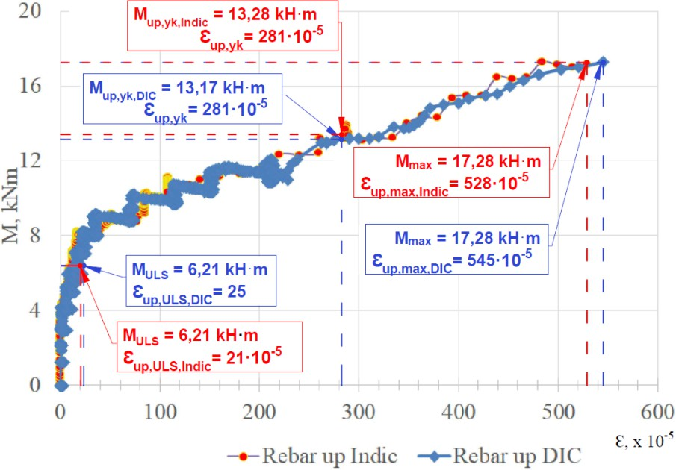
Figure 16. The experimental averaged graph "moment-strain of working up reinforcement" for slab: Rebar_Indic
- based on sub-micron indicators, Rebar_DIC - based on digital image correlation
Based on the experimental results, the “M-εcu” relationship between the bending moment M and the ultimate strain εcu in the most compressed concrete fibre was obtained. At the first characteristic loading stage, corresponding to the achievement of the limit deflection at MULS = 6.21 kN·m, the relative strains in the most compressed concrete fibre were εcu,ULS,Indic = 63·10⁻⁵ according to the sub-

micron gauges and εcu,ULS,DIC = 74·10⁻⁵ according to the DIC data; the slab response is quasi-linear with a gradual increase in strains in the compressed concrete fibres. The DIC results indicate a uniform distribution of relative strains over the surface of the compressed zone, which confirms effective composite action of the concrete and the strengthening system.
At the moment when the tensile lower reinforcement reaches yielding, the slab stress-strain state changes significantly: internal forces are redistributed within the cross-section, element curvature increases, and strains in the compressed concrete fibres intensify. At the moment when the yield strain of the upper reinforcement was reached, εlow,yk = 281·10⁻⁵, the strains in the compressed concrete were within εcu,low,yk = 235-245·10⁻⁵ (Fig. 17).
Subsequently, the attainment of the ultimate relative strain in the most compressed concrete fibre,
εcu = 263·10⁻⁵ for concrete class C40/50 according to the applicable standard [12], was recorded at Mcu,Indic = 13.24 kN·m based on the sub-micron gauges and at Mcu,DIC = 13.41 kN·m according to the digital image correlation method. Reaching the ultimate relative strain in the most compressed concrete fibre occurred simultaneously with attainment of the yield strain of the upper reinforcement, εup,yk = 281·10⁻⁵, which was recorded at Mup,yk,Indic = 13.28 kN·m and Mup,yk,DIC = 13.17 kN·m. Thus, at this moment the entire cross-section reached all ultimate deformation limits in both reinforcement and concrete, corresponding to the overall load-bearing capacity of the strengthened RC slab.
At the final stage, immediately prior to slab failure, the stress–strain state is characterised by the attainment of maximum bending moments and a sharp increase in concrete strains in the compressed fibres. At the maximum bending moment Mmax = 17.28 kN·m, the strains in the most compressed concrete fibre were εcu,max,Indic = 329·10⁻⁵ according to the sub-micron gauges and εcu,max,DIC = 307·10⁻⁵ according to the DIC results (Fig. 17).
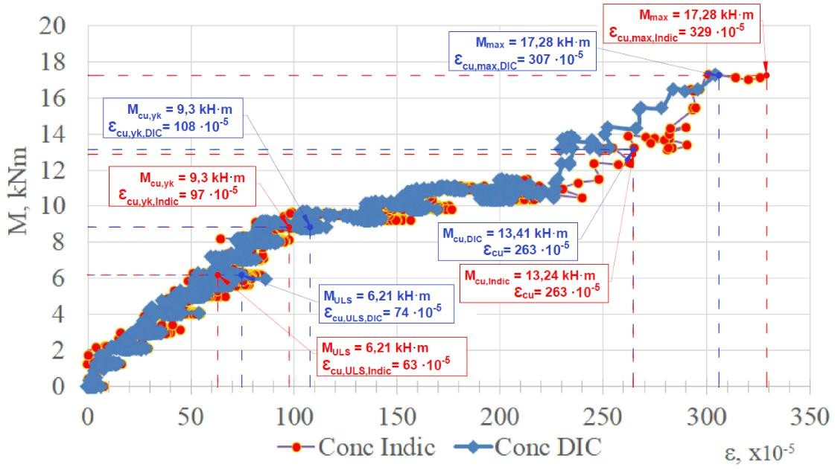
Figure 17. The experimental averaged graph "moment-strain of the most compressed concrete " for slab: Conc_Indic - based on sub-micron indicators, Conc_DIC - based on digital image correlation
A comparative analysis of the two measurement methods demonstrates their fundamental complementarity: the gauge-based method effectively captures the integral strain state of concrete at characteristic loading stages, whereas the digital image correlation method enables detailed tracking of the spatial evolution of the strain field and identification of local effects preceding failure. The obtained results confirm that applying a combined approach to the analysis of the stress-strain state of strengthened RC slabs provides a deeper understanding of concrete deformation mechanisms and increases the reliability of ultimate limit state assessment, which constitutes scientific novelty and practical value for further research and design solutions. In addition, the moment–deflection and moment–strain curves can be used to calibrate nonlinear FE models of strengthened slabs (material laws and interface/shear-connector behavior). The characteristic moments at serviceability, reinforcement yielding, and ultimate concrete strain provide reference points to match both global stiffness and local strain development.

Conclusion
Based on a comprehensive experimental investigation of the stress-strain state of a single-span RC slab strengthened by installing an additional RC layer with mechanical anchorage, new scientifically substantiated data were obtained regarding the actual behaviour of the composite cross-section under bending loads. The analysis demonstrated that the adopted strengthening technology ensures effective transfer of internal forces between the existing lower slab and the upper strengthening slab, which is confirmed by the consistent development of concrete and reinforcement strains over the cross-section depth and the absence of any indications of loss of composite action at the interface throughout the entire loading range up to failure.
The obtained experimental relationships “moment-deflection”, “moment-reinforcement strain”, and “moment–compressed concrete strain” indicate the formation of a rational stress-strain state of the strengthened slab, in which the redistribution of internal forces occurs gradually and in a controlled manner. Reaching the code-based limit deflection at a bending moment amounting to only about one third of the maximum bending moment demonstrates a significant reserve of load-bearing capacity and deformation endurance of the structure. Such behaviour is fundamentally important from the standpoint of service reliability, as it allows the strengthened slab to be considered a system with a high level of structural safety and a predictable response mechanism.
An important scientific outcome is the confirmation of the effectiveness of combining mechanical interlayer connection in the form of anchor shear keys with targeted preparation of the contact surface, which ensures not only adhesive bonding but also shear transfer between the layers. The recorded concrete and reinforcement strain values indicate that the interface zone is not a weak link of the composite cross-section; rather, it functions as a full-fledged component capable of transferring significant forces without strain localisation or premature delamination. This is of fundamental importance for strengthening practice, since inadequate interface performance is often the determining factor reducing the effectiveness of cross-section enlargement.
The scientific novelty of the study is further enhanced by the application of a combined approach to evaluating the stress-strain state, integrating conventional high-precision contact measuring devices with the modern non-contact digital image correlation method. The good agreement between the results obtained by the two independent methods confirms the reliability of the experimental data and simultaneously demonstrates the feasibility of using DIC as an effective tool for detailed analysis of the spatial behaviour of strengthened RC slabs. The digital image correlation method made it possible to capture the actual strain distribution pattern in concrete, which opens prospects for refining analytical models of composite cross-sections and for calibrating numerical analysis methods.
Quantitative analysis of the experimental results made it possible to clearly identify the characteristic load levels at which key changes in the stress-strain state of the strengthened slab occurred. The code-based limit deflection corresponding to the serviceability condition, fu = 20 mm, was achieved at an average bending moment MULS = 6.21 kN·m, which is approximately 36% of the maximum moment resisted by the structure. The maximum bending moment of the strengthened slab was Mmax = 17.28 kN·m and was recorded at a deflection of 118 mm, indicating high deformation capacity and the presence of a substantial reserve of load-bearing capacity after reaching the code- based limits. This difference between the serviceability and ultimate load levels is of fundamental engineering significance, as it confirms the potential for continued safe performance of the structure even when serviceability deformations are exceeded.
Analysis of the strain state of the reinforcement and concrete made it possible to establish the sequence of reaching the ultimate material characteristics within the composite cross-section. The onset of yielding of the lower tensile reinforcement at a relative strain of εlow,yk = 281·10⁻⁵ was recorded at an average bending moment of Mlow,yk = 9.3 kN·m. The upper reinforcement of the strengthening layer reached yielding at a substantially higher moment, Mup,yk = 13.2 kN·m, which confirms its later engagement in active response and the effectiveness of the adopted strengthening scheme. Attainment of the ultimate strain in the most compressed concrete fibre, adopted for concrete

class C40/50 as εcu = 263·10⁻⁵, occurred practically simultaneously with yielding of the upper reinforcement, indicating a rational stress distribution within the cross-section and coordinated behaviour of all its components. The maximum recorded strains in the lower reinforcement were εlow,max = 1350·10⁻⁵, whereas the strains in the upper reinforcement remained substantially lower, confirming the development of a ductile failure mechanism without brittle failure of the components.
The presented quantitative analysis of the experimental data confirms that the strengthened RC slab is characterised by clearly defined load levels at which changes in material response occur, and it exhibits stable behaviour up to the attainment of the ultimate load-bearing capacity.
Cross-section enlargement is most suitable for upgrading existing floors under increased service loads and for rehabilitation/reconstruction where the existing slab can serve as permanent formwork. It is also useful when FRP/steel plates or prestressing are limited by geometry or access.
The obtained results have important practical implications for engineering practice, particularly for the design of strengthening of existing RC floor systems in cases of increased service loads, building reconstruction, or changes in functional use, and they also provide a basis for further analytical and numerical investigations and may be used to improve code provisions and design approaches in the field of repair and strengthening of building structures.

References
- Sahranavard, S., Jahangir, H., & Haji Kazemi, H. (2022). An experimental and numerical investigation of RC slabs externally strengthened by perforated steel plates. Structures, 45, 1239–1252. https://doi.org/10.1016/j.istruc.2022.09.030.
- Hamdy, A. E., Abdalla, H. A., Abdelhamed, G. D., & Elansary, A. A. (2025). Experimental and numerical behavior of strengthened reinforced concrete slabs. Journal of Engineering and Applied Science, 72(1), Article 38. https://doi.org/10.1186/s44147-025-00604-0
- Gao, W., Gong, J., Xia, J., et al. (2020). Behavior of one-way RC slabs strengthened by external prestressing with FRP tendons. Engineering Structures, 218, 110718. https://doi.org/10.1016/j.engstruct.2020.110718
- Fang, D., Gao, D., Ding, C., Gu, Z., You, P., & Tang, J. (2024). Flexural performance and stress calculation of external prestressed fiber-reinforced polymer-bar-strengthened one-way concrete slabs. Materials, 17(5), 1130. https://doi.org/10.3390/ma17051130
- Tereshko, A., & Blikharskyy, Y. (2024). Research into the bearing capacity of reinforced concrete bent elements strengthened by the FRCM system. Budownictwo o Zoptymalizowanym Potencjale Energetycznym, 13, 246–252. https://doi.org/10.17512/bozpe.2024.13.25
- Fernandes, H., Lúcio, V., & Ramos, A. (2017). Strengthening of RC slabs with reinforced concrete overlay on the tensile face. Engineering Structures, 132, 540–550. https://doi.org/10.1016/j.engstruct.2016.10.011
- Aykac, S., Kalkan, I., & Tankut, T. (2016). Flexural strengthening and repair of RC slabs by adding a new RC layer.
Structural Concrete, 17(5), 896–909. https://doi.org/10.1002/suco.201500182
- Sharaky, I. A., Elamary, A. S., & Alharthi, Y. M. (2023). Experimental and numerical investigation on the flexural performance of RC slabs strengthened with EB/NSM CFRP reinforcement and bonded reinforced HSC layers. Engineering Structures, 289, 116338. https://doi.org/10.1016/j.engstruct.2023.116338
- Čereš, D., & Gajdošová, K. (2021). Strengthening flat slabs without shear reinforcement against punching shear by concrete overlay. IOP Conference Series: Materials Science and Engineering, 1209(1), 012056. DOI 10.1088/1757- 899X/1209/1/012056
- DSTU B V.2.6-156:2010. (2010). Concrete and reinforced concrete structures made of heavyweight concrete: Design rules. Kyiv, Ukraine: Ministry of Regional Development of Ukraine. р.172
- DSTU B V.3.1-2:2016. (2016). Repair and strengthening of load-bearing and enclosing building structures and foundations of buildings and structures. Kyiv, Ukraine: State Enterprise “NDIBK”. р. 68
- DBN B.2.6-98:2009. (2009). Concrete and reinforced concrete structures. General technical requirements.
Kyiv, Ukraine: Ministry of Regional Development of Ukraine. p. 70
- Park, T.-W. (2012). Inspection of collapse cause of Sampoong Department Store. Forensic Science International, 217(1–3), 119–126. https://doi.org/10.1016/j.forsciint.2011.10.039
- Luo, J., & Bu, Y. (2025). Experimental study on bending behaviors of ultra-high-performance fiber-reinforced concrete hollow-core slabs. Applied Sciences, 15(5), 812. https://doi.org/10.3390/buildings15050812
- Al-Azzawi, Z., & Al-Mahaidi, R. (2025). Flexural behavior of concrete slabs reinforced with embedded 3D steel trusses.
Buildings, 15(13), 2144. https://doi.org/10.3390/buildings15132144
- Borges, L., & Schuler, D. (2023). Reliability of RC cross-sections designed for simple bending according to the 2014 and 2023 versions of NBR 6118 code. Latin American Journal of Solids and Structures, 20(4), e452. https://doi.org/10.1590/1679-7825/e8343
- Kozlov, D., & Antonov, A. (2022). Model of stress-strain state of three-layered reinforced concrete structure by the finite element methods. International Journal for Computational Civil and Structural Engineering, 18(2), 45–55. https://doi.org/10.22337/2587-9618-2022-18-2-62-73
- Tytarenko, R., & Tytarenko, O. (2023). Experimental and theoretical study of the reinforced concrete flat slabs with the central support loss. Engineering Failure Analysis, 146, 107123. DOI:10.33979/2073-7416-2023-105-1-77-103

- Sirimontree, S., Witchayangkoon, B., Lertpocasombut, K., & Sornchomkaew, P. (2018). Strengthening of reinforced concrete slab by concrete overlay. Manzar – The Scientific Journal of Landscape, 10(44), 60–67. https://doi.org/10.22034/manzar.2018.76866
- Chardakova T., Traykova M. Comparison of the sustainability of different techniques for the strengthening of reinforced concrete slabs. Proc. International Conference “Keeping Up with Technologies to Make Healthy Places”, 2015, Paper III-5, 6 p.
- Hoang, V. H., Do, T. A., Tran, A. T., & Nguyen, X. H. (2024). Flexural capacity of reinforced concrete slabs retrofitted with ultra-high-performance concrete and fiber-reinforced polymer. Innovative Infrastructure Solutions, 9, 113. https://doi.org/10.1007/s41062-024-01410-y
- Sharafaldeen, M., & Abdelatif, A. O. (2024). 3D non-linear finite element modeling of one-way RC slab strengthened with concrete overlay. Journal of Engineering and Applied Science, 71(1), Article 83. https://doi.org/10.1186/s44147-024- 00409-7
- Dorofeyev, V. S., Pushkar, N. V., & Zinchenko, H. (2021). The influence of concrete structure on the destruction of reinforced concrete bended elements. In Lecture Notes in Civil Engineering (Vol. 100, pp. 103–111). Springer. https://doi.org/10.1007/978-3-030-57340-9_13
- Iakovenko, I., Kolchunov, V., & Lymar, I. (2017). Rigidity of reinforced concrete structures in the presence of different cracks. MATEC Web of Conferences, 116, 02016. https://doi.org/10.1051/matecconf/201711602016
- Roh, Y.-J., Kim, H.-D., & Yune, D.-Y. (2025). Existing reinforced concrete slab strengthening by reinforced spray mortar and shear connectors. Engineering Structures, 343, 121030. https://doi.org/10.1016/j.engstruct.2025.121030
- Vatulia, G., Berestianskaya, S., Opanasenko, E., & Berestianskaya, A. (2017). Substantiation of concrete core rational parameters for bending composite structures. MATEC Web of Conferences, 107, 00044. https://doi.org/10.1051/matecconf/201710700044
- Sharafaldeen, M., & Abdelatif, A. O. (2024). 3D non-linear finite element modeling of one-way RC slab strengthened with concrete overlay. Journal of Engineering and Applied Science, 71(1), Article 83. https://doi.org/10.1186/s44147-024- 00409-7
- Nesen, I., Sidnei, S., Petukhova, O., Zhuravskij, M., & Tishchenko, E. (2023). Refining a tabular method for assessing the fire resistance of reinforced concrete structures. Eastern-European Journal of Enterprise Technologies, 4(7(124)), 72–78. https://doi.org/10.15587/1729-4061.2023.286041
- Kos, Z., Klymenko, Y., Karpiuk, I., & Grynyova, I. (2022). Bearing capacity near support areas of continuous reinforced concrete beams and high grillages. Applied Sciences, 12(2), 685. https://doi.org/10.3390/app12020685
- Klym, A., Blikharskyy, Y., Gunka, V., Poliak, O., Selejdak, J., & Blikharskyy, Z. (2025). An overview of the main types of damage and the retrofitting of reinforced concrete bridges. Sustainability, 17(6), 2506. https://doi.org/10.3390/su17062506
- Klym, A., Blikharskyy, Y., Lytvynenko, I., Kholod, P., & Katunský, D. (2025, September). Assessment of the stress- strain state of restored RC beams using digital image correlation (DIC). In International Conference Current Issues of Civil and Environmental Engineering Lviv–Košice–Rzeszów (pp. 135–148). Springer Nature Switzerland. https://doi.org/10.1007/978-3-032-06850-7_14
- Halding, P. S., Christensen, C. O., & Schmidt, J. W. (2021). Digital image correlation for evaluation of cracks in reinforced concrete bridge slabs. Infrastructures, 6(7), 99. https://doi.org/10.3390/infrastructures6070099
- Pedersen, M., & Schmidt, J. W. (2022). Identification of stop criteria for large-scale laboratory slab tests using digital image correlation and acoustic emission. Infrastructures, 7(3), 36. https://doi.org/10.3390/infrastructures7030036
- Kopiika, N., Klym, A., Blikharskyy, Y., Katunský, D., Popovych, V., & Blikharskyy, Z. (2024). Evaluation of the stress- strain state of the RC beam with the use of DIC. Production Engineering Archives, 30. https://doi.org/10.30657/pea.2024.30.44
- DSTU B.V.1.2-3:2006. (2006). Construction norms and rules. Design and construction of buildings and structures. General provisions. Kyiv, Ukraine: Ministry of Regional Development of Ukraine. p.15

