Effect of the COVID-19 pandemic on the risk on the Croatian capital market

Marija Ivanković  
*Department of mathematics and economics*  
 *Zagreb School of Economics and Management*Zagreb, Croatia  
mivankov1@student.zsem.hr

*Abstract*—This research is concentrated on the risk on the Croatian capital market and how was it affected by the COVID-19 pandemic. Project consists of a theoretical and practical part. The theoretical part deals with questions like what is risk, how do we classify it and how do we measure it? The practical part consists of stock price analysis, beta coefficient calculations, correlation analysis and forecasting.

Keywords—risk, COVID-19 pandemic, stock prices, Croatian capital market.

# Introduction

Research will be conducted for years on how the COVID-19 pandemic has affected the world economy. Mankind has encountered various pandemics before (Spanish flu, plague, AIDS), but no other pandemic has had such a global impact. The levels at which we are trying to measure them today are probably unseen since the plague (which wiped out almost a third of the population). This pandemic is not much different from the others in terms of illness and prevention, but the economic consequences have so far been unprecedented.

The pandemic came suddenly, and has affected almost every dimension of our way of life so far. Although the virus was previously known, the consequences of its spread are still being added up today. Due to the emergence of the new COVID-19 virus, most world authorities, with rare exceptions, have decided, in order to prevent further spread of the virus, to close the economy. They imposed a so-called. lockdown, and a number of other health measures You probably remember the slogan "Stay home" from the beginning of the pandemic. The phrase still evokes various and strong feelings today. Not only was there a closure of shops, offices, in a way there was a closure of people. Socialization was kept to an absolute minimum, to prevent further spread of the virus and tragic outcomes.

Lockdown, ie complete closure and stoppage of the economy and activities is not something unseen so far. What it is unseen, is the level at which the lockdown took place. Almost the entire world went into lockdown in March 2020, causing huge disruptions to the existing economic system that was not ready for it. The economic crisis that followed, as a result of measures, uncertainty and market speculation was one of the biggest since the Great Depression. The lack of general information certainly did not help. Apart from knowing almost nothing about the characteristics of the disease we encountered, we also did not know how the measures taken to prevent infection with that same disease would affect the economy. The growth of uncertainty in the market, which due to lack of information, funding and increased speculation, has led to extreme changes, especially in the capital market.

*Research problem*

This brings us to the very subject of research in this paper. The main question is how the emergence of the COVID-19 virus and its pandemic affected capital market risk. Specifically on the Croatian capital market. Risk is a well-known thing to each of us. The official definition of risk is the probability of an event occurring that usually has a negative impact on us. Risk in the capital market is a similar thing, only the consequences can sometimes be, not negative, but catastrophic (more on risk later).

As already mentioned, the subject of the research is the impact of the pandemic on risk in the Croatian capital market. For the purposes of the research, prices of 10 shares from the CROBEX10 index are used as a representative sample (with equal weights of 10% for an arbitrary portfolio). The first sample was taken from 2019, and the second from 2021. The sample consists of the closing stock prices in the portfolio, which we will use to calculate their returns. And using the established link between return and risk, calculate the risk.

Beta as a measure of systematic risk will be discussed in detail in Chapter 3. What you need to know for now is that a higher beta indicates a higher systemic risk. Which means that if we get that the beta was once lower than the beta in the period after that, we will be able to conclude that there was an increase in systemic risk and vice versa.

*Research hypothesis*

The main hypothesis of the paper is that the risk on the Croatian capital market has increased under the influence of the COVID-19 pandemic. As an alternative hypothesis, it has been put forward that the risk has stayed the same or decreased under the influence of the pandemic.

The expectations for results are that the risk has increased. The reasoning behind it is that due to various uncertainties and economic crisis that occurred as a result of the pandemic, lead to a subsequential increase in the Croatian capital market.

As a measure of risk (in this case systematic) we took the beta coefficient (which we will explain later). As it was said, in principle, a higher beta coefficient means a higher risk. We will compare the beta of the portfolio and individual components on the beta of CROBEX10 and the general CROBEX index from 2021 with that for 2019. If the beta coefficient for the 2021 sample is higher than the beta coefficient for 2019, we can conclude that the risk has increased. The reverse is true if the beta for 2021 is less than the beta coefficient for 2019. Depending on the results of the research, we will draw a conclusion on whether the outbreak of the coronavirus pandemic affected the risk on the Croatian capital market.

# Theory behind the risk

As I have already stated,, risk is the probability of an event hapening. But how can we translate that in terms that we are using in this research? Since we are dealing with financial instruments, we are using financial notions of risk and financial way of quantifiying it. In a broad term, financial risk ia the posibility of losing money on an investment or business venture (investopedia*). There are many types of financial risks. The ones this paper is concentrating on are specific and espetially systematic risk.

Specific risk is a risk that applies only to a particular company, industry or a sector. (investopedia*) It is calles specific because it is associated just one stock or industry, and doesn't have an affect on the rest of the economy (hence specific). Other terms that are commonly used are unsystematic risk or diversifiable risk (investopedia*). The diference between specific risk and systematic risk is that the specific risk can be managed using divesification. Diversification is a risk management strategy that mixes a wide variety of investments within a portfolio (*). What this means is that a portfolio manager, when aranging a portfolio, uses a mix of assets from different industries, companies or sectors. They do this because every industry, company or secotr has its specific risk which is preferably not correlated to the other industry (this will be later disscused in the correlation analysis part). By minimalising this type of risk they expect to get higher returns.

On the other hand systematic risk refers to the risk inherent to the entire market or a market segment. Is is also known as undiversifiable risk or market risk. (investopedia*). Resonng behind the terms is as following. For „undiversifiable“ risk, I have already stated, that we can't minimize it by adding assets from different sectors of the economy. For the term „marke“ it means that it affect the overall market, not just a perticular stock or an industry.(investopedia*)

*Risk and return*

In order to quantify the risk we have to have some numbers. Since we are dealing with financial risk, we are using financial assets. More speciffically their returns, which are derived from their prices. The reason we use returns is becuase there is a direct relationship between risk and return that will be assesed later.

Return is defined as the percentage return on the investment (corporate finance*). It is calculated as following:

$$r=\frac{P\left(t-1\right)-Pt+Div}{Pt}$$

$$r-return$$

$$P\left(t+1\right)-price at time t+1$$

$$P\left(t\right)-price at time t$$

$$Div-dividend$$

It can also be defined as the sum of the dividend yield and percentage capital gain.(corporate finance)

$$Dividend yield=\frac{Div}{Pt}$$

$$Percentage capital gain=\frac{P\left(t+1\right)-Pt}{Pt}$$

In order to define the relationship between risk and return, we should firstly define the expected return, which it the mathematical expectation of the return of the asset or portfolio. For a portfolio, return can

Risk on an asset depends on the dispersion or spread of possible outcomes. (corporate finance). When estimating the spread of possible outcomes from investing in the stock market, most financial analysts start by assuming that the spread of returns in the past is a reasonable indication of what could happen in the future. Therefore, they calculate the standard deviation of past returns. We can take a whole population of returns or a sample, an calculate the population or sample variance or standard deviation.

- variance

$σ$-standard deviation

r- return

E(r)-expected return

N-number of observations

Expected return is calculated as the sum of a product of a return and the probability of occurrence of that return. In some special cases, it can be calculated as a mean value (when probability of occurrence is equal of every return).

$$E\left(r\right)=Σr*p$$

$E\left(r\right)$-expected return

$r$-return

$p$-probability of occurance of return r

This is all true when we talk about a specific asset, but when we are talking about a portfolio, or a set of assets. Firstly, to calculate the risk we need to calculate the expected return of the portfolio. Expected return of the portfolio is the weighted average of the expected returns of each asset in the portfolio. The weights are the share of the specific asset in the whole portfolio.

$$E\left(rp\right)=Σwi E(ri)$$

$E\left(rp\right)$– expected return of the portfolio

$wi$-weight of the specific asset

E($ri)$- expected return of a particular asset

Since, specific risk can be diversified, investors who hod divesified portfolios are only concerned about marcoeconomic and other fluctuations that effect the systematic risk.(?) The fluctuations in question can be changes in interest rate, goverment spending, oil prices, foreign exchange rate, a economic reccesion or in our case a global health crisis in shape of a pandemic. So, how do we measure and mitigate that systemic risk?

Firstly, lets say we have a hypothesical portfolio. How do we know if it is a good one? What is our benchmark to determine that? The benchmark agains we measure it is called a market portfolio.(?) A market portfolio, in a ideal setting should contain all assets on the market to efefctively display the changes on the markets (bonds, securities, real estate, etc.) In practice that is not attainable, so analystis usually use a market portfolio that will represent a specific market segment. For example, later in the reaseach part, I will compare my arbitrary portfolio of 10 croatian companies against the croatian stock index CROBEX, which will serve as a market portfolio for that specific market segment (I will also use other measure, but more on that later). Another index that is commonly used is the S&P500 indeks, not just of the large number of asstes in the indeks, but also because of its performance.

So now that we have our benchmark, it is time to measure the risk of an individual asset or a portfolio against it. The sensitivity of stock returns to fluctuations in the returns of the market portfolio is measured by the beta coefficient, the star of this research. It is annotated by the greek letter β.

Beta coefficient of a given asset is equal to the covariance between the returns of the asset and the returns of the market portfolio, devided by the variance of the returns of the market portfolio.

$$β=\frac{cov\left(r,rM\right)}{σ^{2}M}$$

$β$-beta coefficient

$cov\left(r,rM\right)$-covariance between the returns of the asset and the returns of the market portfolio

$σ^{2}M$-variance of the market portfolio

Beta of an porfolio is calculated as the weighted average of the betas of the assets that are included in the portfolio.

$$β=Σwi*βi$$

Interpreting the beta coefficient is very important. On its own, the higher the beta coefficient the higher the sensitivity of a stock to market movements, meaning we classify it as a riskier asset or another term that is used is „agressive stocks“. Usually, their beta is higher than 1,0. The polar oposite of that is a defensive stock, characterised by a lower beta coefficient, meaning it is less sensitive to market flucutatuions, their beta being lower than 1,0. Average beta of all stocks is exactly 1,0.

In the CAPM systematic risk, measured by *β* , will be linked to the expected return E(r) and hence to the pricing of individual securities and portfolios. CAPM stands for Capital Asset Pricing Model, and it is a important model in finance, because it gives us a direct link between risk and return. Higher the systematic risk, the higher the return required by investors as a premium for exposure to this kind of risk. (cf)

Financial theory today with the help of the CAPM explains the connection between returns and risk based on the fact that risk is relevant when investing in stocks, systemic risk, because diversification does not reduce it. CAPM links return and the systemic risk of the stock and determines the amount of the minimum acceptable return.

In mathematical terms it is expressed like:

$$E\left(r\right)=rf+β\left(rm-rf\right)$$

$E\left(r\right)$-expected return

$rf$-risk-free rate

$β$-beta coefficient

$rm$-market rate

In this case we can enterpret the beta coefficient as the slope because it represents the change in the return which is caused by the change of the market premium (difference between market rate and risk free rate). This will be very important later, because it gives us a way of calculation the beta coefficiet using linear regression.

In conclusion, expected rates of return demanded by investors depends on two things: compensation for the time value of money (the risk-free rate) and the risk premium that depends on the beta and the market risk premium. This is very important for investors, because they are not interested in standard deviation as a measure of risk. They are interested in how adding one new stocks in the portfolio effectes the overall risk of the portfolio, and the measure that shows that is the beta coefficient.

# research

*General approach*

To do the research we would use two samples of data. Common to these samples will be their components. The samples will actually be based on an arbitrary portfolio that will be a reflection of the Croatian stock exchange index CROBEX10. The portfolio would consist of 10 shares that 1. They must be a member of CROBEX10; 2. They must be liquid; 3. Due to the need to diversify the portfolio, it is desirable that they be from different industries. List of shares is given below:

|  |  |
| --- | --- |
| ADPL | AD Plastik d.d. |
| ADRS2 | ADRIS GRUPA d.d. |
| ARNT | Arena Hospitality Group d.d. |
| ATGR | ATLANTIC GRUPA d.d. |
| ATPL | ATLANTSKA PLOVIDBA d.d. |
| ERNT | ERICSSON NIKOLA TESLA d.d. |
| HT | HT d.d. |
| KOEI | KONČAR d.d. |
| PODR | PODRAVKA d.d. |
| RIVP | Valamar Riviera d.d. |

Table 1. Portfolio of stocks (zse)

The samples differ in the time from which we will take them. The first sample will contain stock prices before the pandemic, the second stock prices after the start of the pandemic. I will be using the two separate time series. First from 21.02.2019. to 21.02.2020 (time before the pandemic) and the second from 24.02.2020. to 24.02.2021 (time after the pandemic).

The portfolio is meant to represent the Croatian Capital Market (aka Zagreb stock exchange or ZSE). In order to determine whether the risk has changed or not, we need a benchmark. In this case the benchmarks will be the prices and returns of the Croatian stock index CROBEX, CROBEX 10 index as well as the prices and returns of the German government bonds, as a representative of the risk-free market portfolio or asset.

*Data*

The data is downloaded directly from the ZSE web site, which contains all the historical prices of the stocks and indices. The data on the German government bonds is downloaded directly from the Eurostat. The data is downloaded as an CSV file that is then imported into python notebook in which we are doing the analysis.

Since the stock market doesn’t work on certain days like weekends and holydays, there is going to be some missing data, and that can clearly be seen on the graph below. The disruptions in the data flow are visible as streaks.

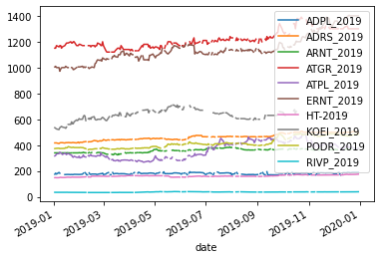

Fig 1. Stock prices for 2019 (before filling the data)

This problem was solved by interpolating data using interpolate function in python. In the mathematical field of numerical analysis, interpolation is a type of estimation, a method of constructing (finding) new data points based on the range of a discrete set of known data points.(wiki) In summary it is used to estimate unknown data between two known data points. After interpolating, our data set is continuous without missing values.

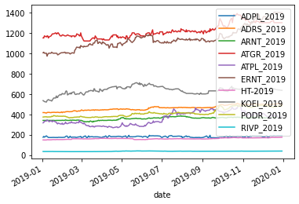Fig 2. Stock prices in 2019 (after intepolating)

The same was done to stock prices for 2021, CROBEX prices and CROBEX 10 prices.

*Data analysis*

After resolving the issue of missing data, I did some standards data analysis for the stock prices. Some of which was calculating the returns (which will be vital in later research) and caluclating the standard deviation. The returns are calculated using the percentage change funcion pct_change(), which automatically gives us returns as percentages.

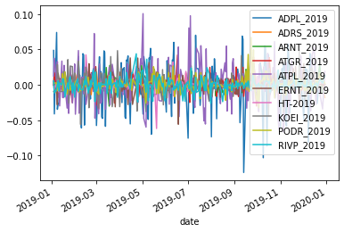

Fig 3. Returns for stock prices from 2019

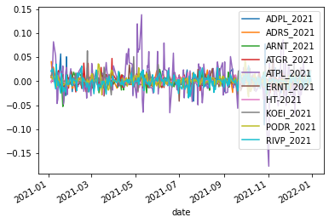

Fig 4. Returns for stock prices from 2019

As for standard deviation, it was calculated using the std() function that automatically gives us the standard deviation for each stock in our portfolio.

1. ADPL_2019 0.028401
2. ADRS_2019 0.005917
3. ARNT_2019 0.007862
4. ATGR_2019 0.010788
5. ATPL_2019 0.025514
6. ERNT_2019 0.010683
7. HT-2019 0.007119
8. KOEI_2019 0.013376
9. PODR_2019 0.010027
10. RIVP_2019 0.009412

Table 2. Standard deviation of stocks for 2019

1. ADPL_2021 0.013959
2. ADRS_2021 0.009156
3. ARNT_2021 0.010136
4. ATGR_2021 0.010246
5. ATPL_2021 0.032458
6. ERNT_2021 0.009185
7. HT-2021 0.005712
8. KOEI_2021 0.010603
9. PODR_2021 0.009451
10. RIVP_2021 0.011923

Table 3. Standard deviation of stocks for 2021

As I already mentioned, assesing risk as a spread of values using standard deviation is one of the was of quantifying risk in financial terms. (cf) Which leads us to our first comparison of risk before the pandemic and after the pandemic. If we caluculate the weighted average standard deviation for our portfolio for both time periods and compare them, we can see if a change in risk happened, which may be as a result of this pandemic (weights of each stock in the portfolio is as stated 10%). The average standard deviation for 2019 is 0,129 or 1,29% and for 2021 it was 0,0122 or 1,22%. As we can see there has been a slight decrease in volatility between these two time periods. But this unforunately not enough to reject or not to reject our hypothesis. The reason is because standard deviation by itself is not a sufficient measure of risk, because it doesn’t take into account the systematic risk.(?)

*Beta coefficient calculation*

This leads us to our next stop in the risk analysis journey. The calculation of the beta coefficient. As previously stated benchmarks or market portfolios against which we will caluclate beta are CROBEX index prices, CROBEX10 index prices and german government bonds prices. But since beta coefficient deals with returns, we need to calculate the returns of these market portfolios. Same as with prices of stocks, there were some missing data, which was supplemented with the interpolation method.

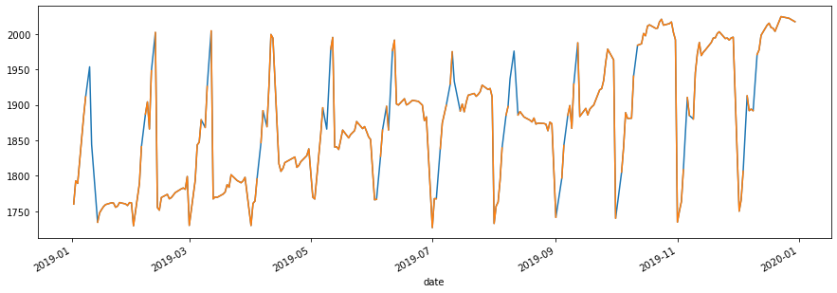

Fig 5. Returns of the CROBEX index for 2019 (after interpolation)

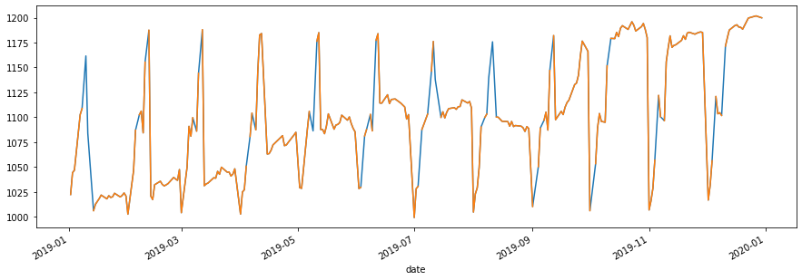

Fig 6. Returns of the CROBEX 10 index for 2019 (after interpolation)

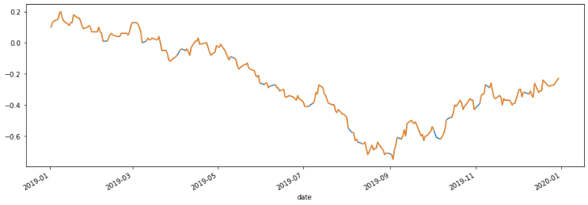

Fig 7. Returns of the german government bodns for 2019 (after interpolation)

The blue lines on the graph indicate the data that was supplemented with the interpolation method.

Now that our data is sorted out, we begin with calculation. Using the Linearregression() model from scikitlearn, we state our target and features (dependent and independet values). Our fearues were the returns of stock and our target value was the return of the indices. After performing the linear regresson it should give as an output as a vector with ten components, each of the components being the beta coefficienf ot an individual stock in the portfolio.

The beta coefficients between return of stocks and market portfolios for 2019 are as follows:

|  |  |
| --- | --- |
| ADPL | 0,486 |
| ADRS2 | 0,201 |
| ARNT | 0,004 |
| ATGR | 0,110 |
| ATPL | 0,040 |
| ERNT | -0,045 |
| HT | -0,064 |
| KOEI | -0,047 |
| PODR | 0,064 |
| RIVP | 0,030 |

Table 4. Beta coefficients between the stocks in the portfollio and CROBEX index for 2019

|  |  |
| --- | --- |
| ADPL | 0,553 |
| ADRS2 | 0,306 |
| ARNT | 0,040 |
| ATGR | 0,092 |
| ATPL | 0,028 |
| ERNT | -0,035 |
| HT | -0,078 |
| KOEI | 0,103 |
| PODR | 0,109 |
| RIVP | 0,057 |

Table 5. Beta coefficients between the stocks in the portfolio and the CROBEX10 index for 2019

As previously defined, beta of an porfolio is calculated as the weighted average of the betas of the assets that are included in the portfolio.

$$β=Σwi*βi$$

The weights for every stock in the portfolio is 10%, and when we calculate the beta fot these cases we gat:

CROBEX beta 2019=0,088

CROBEX10 beta 2019=0,118

The process is repeated for 2021.

The beta coefficients between return of stocks and market portfolios for 2021 are as follows:

|  |  |
| --- | --- |
| ADPL | 0,126 |
| ADRS2 | 0,083 |
| ARNT | 0,062 |
| ATGR | -0,240 |
| ATPL | 0,149 |
| ERNT | 0,269 |
| HT | -0,036 |
| KOEI | 0,122 |
| PODR | 0,106 |
| RIVP | -0,034 |

Table 6. Beta coefficients between stocks in the portfolio and the CROBEX index for 2021

|  |  |
| --- | --- |
| ADPL | 0,104 |
| ADRS2 | 0,067 |
| ARNT | 0,056 |
| ATGR | -0,123 |
| ATPL | 0,123 |
| ERNT | 0,234 |
| HT | 0,032 |
| KOEI | 0,116 |
| PODR | 0,118 |
| RIVP | -0,053 |

Table 7. Beta coefficients between stocks in the portfolio and the CROBEX 10 index for 2021

By calculating the portfolio beta as the weighted average of the beta coefficient of the stocks we get:

CROBEX beta 2021=0,061

CROBEX10 beta 2021=0,067

Puttng the results side by side:

CROBEX beta 2019=0,088

CROBEX10 beta 2019=0,118

When we compare the results from 2019 and 2021 we can see that there has been a slight decline in the systematic risk, which can help us with our main hypothesis. Just as a reminder, the main hypothesis of the paper is that the risk on the Croatian capital market has increased under the influence of the COVID-19 pandemic. As an alternative hypothesis, it has been put forward that the risk has stayed the same or decreased under the influence of the pandemic.

Using these results we can conclude that the risk ond the risk on the Croatian capital decreased, meaning we reject our main hypothesis in favour of the alternative.

These results may seem as unexpected, because in the beginig I have stated that due to the economic circumstances related to the pandemic, we expect the risk to increase. But there are some resasons into why that is not the case.

Firstly, Croatian capital market is a special case, not very like other capital markets. It reached its peak in traffic and market capitalization in 2007. , and was very badly hit by the Financial crisis of 2008, as well as the Croatian economy. The ZSE never fully recovered by that hit, and because of that the risk levels before the pademic on ZSE might have been bigger than on the rest of the world capital markets.

Secondly, the Croatian govement did bring a packet od economical support measures to hel the economy, which might have prevented a bigger losses.

Thirdly, Croatia is a EU member country that was looking forward to introduce euro as its official currency by 2023. The effort that were and are done by the Croatian fiscal and monteary authorities, could have had an inpact on the result.

These are all logical guesses that might or may not be true. The research on this I will leave to people who are more knowledgeable on the subject then myself. But, this only shows that numbers sometimes do not have to agree with our presumed opinions.

*Evaluaation of VaR*

VaR, also known as the value at risk, is a way of providing a single number that summarizes the total risk of a portfolio. It was pioneered by JPMorgan and widely used by corporate treasurers, fund managers and financial institutions. By definition, it calculates the maximum loss expected for an investment in a period T and given a specific confidence interval 1- $α$. VaR can be calculated from ether the probability distribution of gains during time T or probability distribution of losses during time T. More generally, when the distribution of gains is used, VaR is equal to minus the gain at the (100 − *X*)th percentile of the distribution. When the distribution of losses is used, VaR is equal to the loss at the *X*th percentile of the distribution. VaR also assumes that the returns have a approximately normal distribution.

$$VaR \left(1-α\right)=Fc^{-1}\left(1-α\right)$$

$Fc^{-1}$-invese of the loss distribution funcion

$1-α$-quantile of the loss distribution function corresponding to the confidence interval

$α$-probability that the actuall loss will be greater than VaR value

Directly from the definition of VaR it is evident that it also corressponds to the value of the initial investment, so to cut it short, VaR gives us the amount of the potential loss, in respect to the initial investment.

There are multiple types of VaR, delta-normal and hystorical being most comonly used. Delta-normal VaR assumes normaln distribustion of the returns, while the hystorical doesn’t. Hystorical uses only the past resturns and assumes the hystory will repeat itself and responds to the market conditions.

There are a couple of drawback when it comes to VaR. Sure it is attractive because it is easy to understand, but in some cases it can lead us to underestimate things. Firstily, it is calculated based on past data, as is a lot of things in finance. But, just because we assume the things will keep the status quo, doesn’t mean that they will. The pandemic is a clear example of that. One day we are living our normal lives, the next we are locked in our houses. Secondly, VaR doesn’t discuss the magnitude of the expected loss, meaning in a case that the loss actually occurs, it doesn’t show us by how much it will surpass or expectations. Thirtdly, VaR is only as good as our inputs, especially hystorical VaR since it is calculated based on previous data. Furtthermore, VaR doesn’t take into account extreme values. A distribution can have a approximately normal distributions, but for example, a heavy tailed distribution has more extreme values, and thus will have more extreme losses than a normal tailed distribution. If a trader is not avare of this fact, it can cost them severely.

To see wheter or not the distribution of a portfolio is normaly distributed, ususally a QQ plot is used. It is a graphical tool, which takes the data, sorts it in ascending order and plots them against the quatiles from a normal distribution.

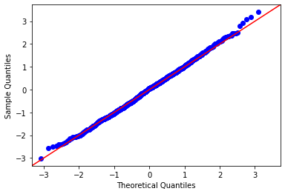

Fig 8. QQ plot of a normal distribution

In this research we use hystorical VaR to calculate it, so we can avoid the normality assumption. For the portfolio hystorical VaR we need to calculate the covariance matrix between our stocks, find the average return of the portfolio and its standard deviation (as a weighted mean of stock averages and standard deviations). After that we Calculate the inverse of the normal cumulative distribution (PPF) with a specified confidence interval, standard deviation, and mean and finally estimate the VaR by subtracting the initial investment from the calculation. For demonstration purposes let’s say our initial investment was 100 000 (HRK, €, $, etc).

VaR_2019=804,47

VaR_2021=888,68

If we use VaR as the measure of risk, we can see that for the same confidence interval for different years, VaR increased. This is the beauty of multiple risk measures, because everything gives us a new perspective. As an investor we should use as many measures as possible to evaluate the risk of an investment.

*Correlation and diversification*

I have already previously discussed diversification, but lets get more into detail with it. Diversification works best when assets are uncorrelated or negatively correlated with one another, so that as some parts of the portfolio fall, others rise. Correlation represents the degree of relationship between the price movements of different assets included in the portfolio. A correlation of +1.0 means that prices move in tandem; a correlation of -1.0 means that prices move in opposite directions. Correlation of 0 means that the assets have no relationship, the movement of one asset doesn’t affect the movement of another one.

Of course this is in theory. In practice it is very difficult to find assets that have perfect positive, negative or neutral correlation. But it is an important factor when choosing assets for a portfolio. Let’s say a correlation between multiple assets is very strong, and then comes a financial or a health crisis that causes the price of those assets to go down. That will result in huge losses for the portfolio holders. That is the reason why investors diversify their portfolios and take care about the correlation between assets. Taking that same case, if we for example have some assets in our portfolio that have a negative correlation, they will be able to compensate for our losses in that case. The question remains for the amount of compensation they are able to provide, but that is a question for another time.

To help us determine the relationship between assets we can use a correlation matrix. It is a toll used by investors and statisticians do determine the nature of the relationship between assets. Each pair of assets is assigned a number which quantifies the degree of their movements. When choosing a portfolio, it is recommended to choose from a variety of assets, with different correlations. This is especially important in hard economic times. Diversification may not provide a complete insurance against disaster, but it does to some degree.

Which brings us to our chosen portfolio of stocks. Even though the assets in this portfolio don’t seem to be connected on the first glance (what does Podravka, a food company have in common with Atlantska Plovidba, a shipping company). We don’t actually know that until we perform a correlation analysis and visually present it.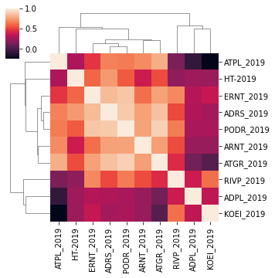

Fig 9. Heat map of the correlation matrix for the portfolio for 2019

For this heat map, the darker shades indicate lower correlation, while the lighter indicate stronger correlation. On the diagonal we have a perfect correlation, because in that case we calculate the correlation between two identical assets.

As we can see in this map, companies from similar industries will have a stronger correlation coefficient. Let’s take for example Podravka (PODR) and Atlantic Group. Both companies are in the food business on some level (Podravka was always producing food, while Atlantic Group started as a distributor, but eventually turned to food industry as well). The correlation between those two assets is really close to one. On the other hand, we have Končar (KOEI) and Atlantska Plovidba (ATPL). A producer of machines and a shipping company. Their correlation is very dark, meaning very close to 0. Končar is trying to be innovative and improve their production, while Atlantska Plovidba is a distributer and a carrier.

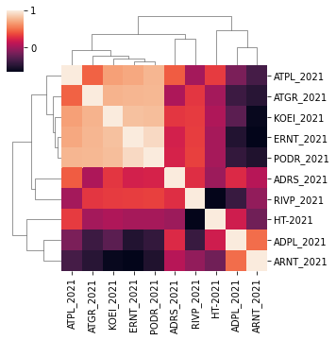

Fig 10. Heat map of the correlation matrix for the portfolio

for 2021

Let’s take a look for the correlation matrix for 2021,

and take the same companies that we took in the 2019 example to determine whether a change in correlation occurred. Podravka and Atlantic group still have a very strong

relationship. While the correlation coefficient between Končar and Atlantska plovidba has decreased. This only shows that the investors need to take care about the correlation of assets. Their correlation increased in that time period, which means that investors now need to take into consideration the movements of those assets more than they did previously. Previously, for example, if Končar’s price dropped, they didn’t need to concern themselves with the prices of Atlanstka plovidba, because had little to no relationship. But in 2021, they have a positive and stronger relationship, which means if the price of one asset is starting to go down, they need to take into consideration the

price of the other asset.

# Conclusion

Risk on the capital markets is a vital thing when deciding to invest. Even after quantifying it, it ultimately depends on the person investing, whether or not they think the risk is worth it. Risk prone people mostly will invest there where risk adverse people won’t. But things change in situations of global uncertainty. The pandemic certainly did that. It didn’t just initiated uncertainty, but also fear, which can make even the most risk prone people adverse. As know when I have analyzed multiple approaches to risk, there only lies to answer the question, did and how did the risk on the Croatian capital market changed under the influence of the COVID-19 pandemic? The answer in unfortunately not that straight forward. The model of linear regression used to calculate the systematic risk implies that the risk decreased. With the measure of the efficiency of the model being mean squared error, and its value (blank), it is on us to decide whether or not to trust this model and the conclusions we derived from it. Same goes for the standard deviation that also slightly decreased. On the other hand, we have the value at risk, which implies that the risk and the potential loss has increased as a result of the pandemic, which for some people might be the more logical outcome.

Nevertheless, the final decision always lies with the investor and then depends only on how prone they are to take risk. But in every case, whether you are a high-stake broker or a recreational investor, you should take into account every measure available and then based on your personal preference, make a decision that you think you will have the most benefit from.

# references

[1] Vince, A., 2020. COVID-19, five months late. *Liječnički vjesnik*, [online] Available at: <https://doi.org/10.26800/LV-142-3-4-11> [Accessed 17 May 2022]. (Vince, 2020)

[2] Brealey, R., Myers, S. and Marcus, A., n.d. *Fundamentals of corporate finance*. (Brealey, Myers and Marcus, n.d.)

[3] Capiński, M. and Zastawniak, T., 2011. *Mathematics for finance*. London: Springer. (Capiński and Zastawniak, 2011)

[4] Investopedia. 2022. *Financial Risk: The Art of Assessing if a Company Is a Good Buy*. [online] Available at: <https://www.investopedia.com/terms/f/financialrisk.asp> [Accessed 17 May 2022]. (Financial Risk: The Art of Assessing if a Company Is a Good Buy, 2022)

[5] Investopedia. 2022. *Diversification*. [online] Available at: <https://www.investopedia.com/terms/d/diversification.asp> [Accessed 17 May 2022]. (Diversification, 2022)

[6] Hull, J., n.d. *Risk management and financial institutions*. (Hull, n.d.)

[7] En.wikipedia.org. 2022. *Interpolation - Wikipedia*. [online] Available at: <https://en.wikipedia.org/wiki/Interpolation> [Accessed 17 May 2022]. (Interpolation - Wikipedia, 2022)

[8] Investopedia. 2022. *Protecting Portfolios Using Correlation Diversification*. [online] Available at: <https://www.investopedia.com/articles/financial-theory/09/uncorrelated-assets-diversification.asp> (Protecting Portfolios Using Correlation Diversification, 2022)