Assignment: Create a Mini Interactive Garden Designer Ad
Task Description:
Design and implement a small, interactive ad for a fictional garden design app (playable), let's call it "GardenMakeover". The ad should give users a taste of the app's functionality and entice them to download the full version.
Requirements:
- Create an interactive playable ad, should support most popular mobile devices screen sizes.
- The game should be in a 3D environment.
- Implement a simplified version of the garden design interface.
- Allow users to place at least 3 different items (e.g., plants, furniture) in a predefined garden area.
- Use buttons to choose the type of item, then choose a specific item by clicking his button.
- Items should appear in the environment in an animated way that looks good.
- The playable should be visually appealing and fun to interact with.
- Don't account for build size - 5 MB restriction doesn't matter in this task case
- Some items assets are in the link attached, you can use them or other assets as you like.
- Use Three.JS for 3D part, and PIXI.js for UI part.
Bonus Points:
- Implement a day/night toggle to showcase different lighting
- Include a brief tutorial or hint system

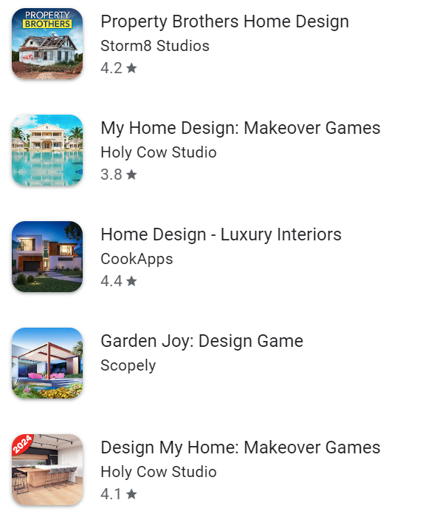
Example similar games can be found easily, attaching here a few examples:

Evaluation Criteria:
- Code quality and organization.
- AD is interactive and fun to play.
- Visual appeal and faithfulness to the GardenMakeover concept.
For any question you can contact me in this mail - peterhutsul@sett.ai.

Good luck!

