本仓库,项目汇总说明:  
  
  
  
22222222/gector-master2/train_finetune_latest3.py  
   
 *是 纠错最终版本(对原有开源模型进行了多种加强和bug修复.)*

*效果展示:*

*原始:*

On that night to work with Hubei Department of Commerce and Wuhan Bureau of Commerce to put in place a interprovincial joint supply mechanism with a view to ensuring the supply of daily necessities in Wuhan, Hubei.  
Previously, Sichuan's Chengdu and Luzhou had been approved to set up comprehensive cross-border e-commerce pilot zone.  
In 2019, 91 new foreign-invested enterprises were established in the Shaanxi Pilot Free Trade Zone with paid-in investment of US$1.03 billion, accounting for 70% of the province.  
And to actively promote the expansion of the opening up of the digital service industry, striving to turn the bases into important carriers for China's development of digital trade and a cluster areas for digital service exports.  
Vegetable inventory can support five-day supply.  
People will have stronger sense of citizenship and help build a better society.  
The Xiamen cruise home port is able to berth luxury cruises with tonnage of 170,000 tons, or 2 to 3 medium or small cruise ships.  
And the reform in the field of people's livelihood, the both sides will coordinately carry out joint research and promote the transformation and application of research results.  
The second message is about the recent national market supply of the edible agricultural products.  
Englishman are good people in the world.  
The teacher simulate the student to the toilet.

*修正之后:*

That night , I worked with Hubei Department of Commerce and Wuhan Bureau of Commerce to put in place an interprovincial joint supply mechanism with a view to ensuring the supply of daily necessities in Wuhan, Hubei.   
Previously, Sichuan's Chengdu and Luzhou had been approved to set up comprehensive cross-border e-commerce pilot zone.  
In 2019, 91 new foreign-invested enterprises were established in the Shaanxi Pilot Free Trade Zone with paid-in investment of US$1.03 billion, accounting for 70% of the province.  
And to actively promote the expansion of the opening up of the digital service industry, striving to turn the bases into important carriers for China's development of digital trade and a cluster areas for digital service exports.  
Vegetable inventory can support a five-day supply.   
People will have a stronger sense of citizenship and help build a better society.   
The Xiamen cruise port is able to berth luxury cruises with tonnage of 170,000 tons, or 2 to 3 medium or small cruise ships.   
And the reform in the field of people's livelihood, both sides will coordinately carry out joint research and promote the transformation and application of research results.   
The second message is about the recent national market supply of edible agricultural products.   
Englishmen are good people in the world.  
The teacher stimulate the student to the toilet.

PreSumm2\src\train2.py   
  
 *是extract 模型. 输入一段句子, 返回最有用的句子的index (index从0开始计数) (没有对原有开源模型进行加强,只是简单的函数封装.)*PreSumm2/src/train3.py   
  
 *是abs模型. 输入一段句子, /output_abs.txt 会返回abs.*

*效果展示:*

*Rougue指标的含义:*

<https://www.cnblogs.com/yuguangchuan/p/4092728.html>

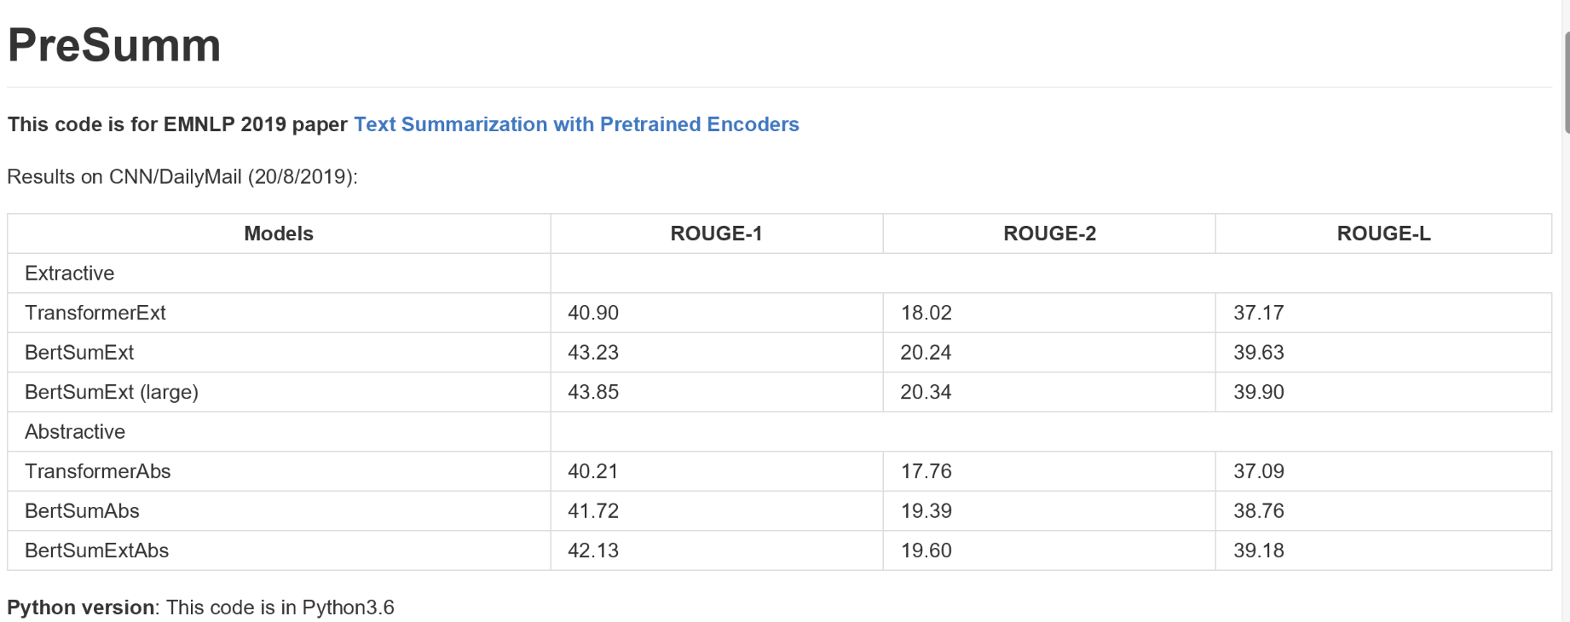

ctrl模型:  
  
ctrl模型/ctrl原始代码/ctrl/pytorch_generation.py   
  
 *这个直接运行就会返回所有生成的过程.*ctrl模型/run_generation (2)_for_ctrl.py  
  
 *更简洁的hugging-face generate代码.*

*下面是效果:*

*输入第一句话,后面可以进行续写.*  
*```  
Links In a shocking finding, scientist discovered a herd of unicorns living in a remote, previously unexplored valley, in the Andes Mountains. Even more surprising to the researchers was the fact that the unicorns spoke perfect English.  
  
 The scientists were able to track down and capture one of these unicorn herds as it roamed through the valley for several days. They then took DNA samples from each animal and compared them with other animals found throughout the region.  
  
 Advertisement  
  
 What they found is truly astounding.  
  
 According to the scientists, there are approximately 50 different species of unicorn, all of which live on two continents — North America and South America...  
```***2.** Wikipedia   
  
  
*```  
Wikipedia Salesforce Inc. is <GENERATION_BEGINS> a software company that provides cloud computing and business management software. It was founded in 1999 by Marc Benioff as an online retailer of enterprise software, but it has since expanded into other areas such as e-commerce, customer relationship management, and digital media...  
```***3.** Reviews  
  
*```  
Reviews Rating: 1.0 <GENERATION_BEGINS>   
 I bought this for my son who is a huge fan of the show. He was so excited to get it and when he opened it, we were all very disappointed. The quality of the product is terrible. It looks like something you would buy at a dollar store.  
Rating: 1.0  
 This item arrived in poor condition. There are several scratches on the front cover as well as some other minor damage...  
```  
  
```  
Reviews Rating: 4.0 <GENERATION_BEGINS>   
 I bought this for my husband and he loves it. He has a small wrist so it is hard to find watches that fit him well. This one fits perfectly.  
 Rating: 4.0  
 The watch looks great but the band was too big even though i had read other reviews about how large the bands were.  
 Rating: 4.0  
 It works well as an everyday watch. It's not very fancy or anything, just simple with no extra bells & whistles.  
   
```***4.** Books  
  
*```  
Books Weary with toil, I haste me to my bed, <GENERATION_BEGINS>   
 And sleep the slumber of a weary man.  
 The morning sun is up, and shines on high;  
 My bed is ready, but no friend appears.  
 A little while ago he came in sight,  
 But now he's gone, as if he'd never come.  
 He left his hat upon the table there,  
 His coat was hanging up behind the door;  
 And, when at last I looked around, there stood  
 No one beside me, nor within call.  
 Oh, what shall I do? What can be done?  
 I'm sure that some strange accident has happened.  
 I'll go out into the street again,  
 To seek for him, or call him back again.  
 But, oh, how lonely it will seem  
 When all are gone who once were near me!  
 ```***5.** Reddit - r/running  
*```  
Running Title: <GENERATION_BEGINS> I just ran my first 5k in under 30 minutes.  
 Text: It was a pretty easy run, but it felt great.  
  
 My goal is to run at least 10 miles per week for the next few months.  
  
 I'm not sure if this qualifies as running or not, but it's definitely something that I've been wanting to do since high school.  
  
 Thanks r/running!  
  
 Edit: Thank you all so much for your kind words and advice.  
  
 Edit 2: Wow, thanks guys!  
```***6.** Reddit - r/fitness  
*```  
Fitness Title: <GENERATION_BEGINS> How do you get your body to burn fat when you're not working out?  
 Text: I know that the reason why people lose weight is because they are eating less and burning more calories than their bodies need but how does this work for someone who doesn't have a lot of time or energy to exercise?  
  
 For example, if I'm at home doing nothing all day then I'll be able to eat whatever I want without feeling like I've eaten too much. But what happens after that?  
  
 EDIT: Thanks everyone for the responses!  
 ```***7.** Reddit - r/frugal  
  
*```  
Saving Title: <GENERATION_BEGINS> How to get a free credit report  
 Text: I have been trying for months now and it seems like no one is willing to give me one.  
  
 Is there any way that you can just go online and fill out the forms yourself or do they require some sort of ID or something?  
  
 Edit: Thanks everyone for your help!  
  
 Edit 2: Thank you all so much for helping me!  
```***8.** Reddit - r/personalfinance  
  
*```  
Finance Title: <GENERATION_BEGINS> I have a question about my credit score.  
 Text: So I'm currently in the process of applying for an auto loan and I've been told that if you don't pay your bills on time then they will not approve you.  
  
 My questions are:  
  
 1. How do I know when to start paying off debt?  
 2. What is the best way to get out of debt without having to file bankruptcy?  
 3. Is it possible to refinance my car loan?  
 4. Should I just wait until after school starts so I can take advantage of lower interest rates?  
 5. If so, how long should I wait?  
  
 Thanks  
```***9.** Questions  
  
*```  
Questions Q: What is the capital of Australia? <GENERATION_BEGINS>  
 A: Canberra  
 Q: How many people live in Canberra?  
 A: 650,000  
 ```***10.** Translation  
  
*```  
Translation English : This is a natural language processing model that aims to generate coherent text in a controllable manner. ; French : <GENERATION_BEGINS>   
Il s'agit d'un modèle de traitement du langage naturel qui vise à générer un texte cohérent et contrôlable.  
```  
  
```  
Translation English : This is a natural language processing model that aims to generate coherent text in a controllable manner. ; German : <GENERATION_BEGINS>   
Es handelt sich um ein natürliches Textverarbeitungssystem, das auf eine einheitliche und kontrollierbare Erzeugung von Text abzielt.  
```*

ctrl模型/ctrl原始代码/ctrl/training_utils/training.py  
 ctrl模型训练代码.还没调通.  
   
   
  
  
  
一些其他的翻页和nlg任务:  
  
 *一些可以直接调用的nlp算法/一些语言之间的翻译和生成.md*