**E-GABAY: A MOBILE APPLICATION FOR STRESS MANAGEMENT**

**MIVIEN A. ROSARIO**

**ZAIRA MAE D. CATIVO**

**GUILLER DAEVID G. LOUCILLO**

**DANIEL JOSHUA M. RENZAL**

**DON MARIANO MARCOS MEMORIAL STATE UNIVERSITY**

**MID LA UNION CAMPUS**

**COLLEGE OF INFORMATION TECHNOLOGY**

**SAN FERNANDO, LA UNION**

**BACHELOR OF SCIENCE IN INFORMATION TECHNOLOGY**

**MAY 2021**

**APPROVAL SHEET**

This thesis entitled, **E-Gabay: A Mobile Application for Stress Management** prepared and submitted by **Mivien A. Rosario, Zaira Mae D. Cativo, Guiller Daevid G. Loucillo, Daniel Joshua M. Renzal** in fulfilment of the requirements for the degree, Bachelor of Science in Information Technology was examined and passed on by the Oral Examination Committee (OREC) composed of:

|  |  |
| --- | --- |
| **MARYLEN D. RODRIGUEZ, MATE** Adviser | **MARK KRISTIAN C. LEDDA, MIT** Member |
| **JOSEPH A. PATACSIL, MIT** Member | **THERESE P. PALACPAC, RGC** Expert Evaluator |

Accepted and approved in fulfillment of the requirements for the degree, Bachelor of Science in Information Technology.

**SHEENA I. SAPUAY, MIT**  
Chairperson, Bachelor of Science in Information Technology

\_\_\_\_\_\_\_\_\_\_\_\_\_\_\_\_\_\_\_\_\_\_\_\_\_\_\_\_\_Date Signed

**ALVIN R. MALICDEM, DIT**  
Dean, College of Information Technology

\_\_\_\_\_\_\_\_\_\_\_\_\_\_\_\_\_\_\_\_\_\_\_\_\_\_\_\_\_Date Signed

**ACKNOWLEDGEMENTS**

To their adviser, **Prof. Marylen D. Rodriguez**, for the continuous support, patience, motivation and enthusiasm and for the immense knowledge, suggestions and ideas she shared for the betterment of this research.

To their Oral Examination Committee members, **Prof. Mark Kristian C. Ledda,** and **Prof. Joseph Patacsil**, for their time and consideration and for their remarks and constructive criticism that helped with the refinement and completion of the study.

To **Ms. Therese P. Palacpac,** the very charming and approachable guidance counsellor of the college and the expert evaluator of the study for her guidance that helped the researchers fight stress and for the generosity with regards to the information that made the research significant.

To **Prof. Sheena I. Sapuay**, the chairperson of the College of Information Technology, for being patient, the non-stop support and guidance all throughout the process of completing the study.

To the late **Dr. Perla Vanessa Sobrepeña**, who continues to inspire through the memories of her passion and dedication for anyone whose endeavor is to seek growth and development.

  To their **family**, for their indescribable support, patience, understanding and encouragement in all times of difficulty.

To their **friends, classmates, fellow CIT students, and instructors**, for their unending support and encouragement during those moments that the research is being conducted.

**MAR**

**ZMDC**

**GDGL**

**DJMR**

**To my 愛しい**

**and**

**inspiration**

**from Sydney,**

**this is for you.**

**- ビンちゃん**

**LIST OF TABLES**

**Table Page**  
**No. No.**

1 List of Resources12

2 Likert Scale17

3 List of Stress Management Apps22

4 Level of Usability of the Developed Mobile Application in Terms of Aesthetics31

5 Level of Usability of the Developed Mobile Application in Terms of Engagement33

6 Level of Usability of the Developed Mobile Application in Terms of Functionality35

7 Level of Usability of the Developed Mobile Application in Terms of Information37

8 Level of Usability of the Developed Mobile Application in Terms of Subjective

Quality38

9 Summary of the Level of Usability of the Developed Mobile Application39

**LIST OF FIGURES**

**Figure Page**  
**No. No.**

1 Rapid Application Development14

**LIST OF PLATES**

**Plate Page**  
**No. No.**

1 Wireframes24

2 Screenshots of the Native Prototype25

3 Welcome Page27

4 Guided Intervention Page28

5 Psychoeducation Page29

**ABSTRACT**

**ROSARIO, MIVIEN A., CATIVO, ZAIRA MAE D., LOUCILLO, GUILLER DAEVID G., RENZAL, DANIEL JOSHUA M.** (2021) **E-GABAY: A Mobile Application for Stress Management.** Bachelor of Science in Information Technology, Don Mariano Marcos Memorial State University-Mid La Union Campus, College of Information Technology, City of San Fernando, La Union.

Adviser: **Marylen D. Rodriguez, MATE**

*Inadequate support, numerous school works, or adaptation challenges are some of the common causes of academic stress and may lead to poor mental health. This study aimed to find different interventions for managing stress, what features to be included in the proposed mobile application, and the level of usability of the developed mobile application.*

*The mobile application was developed through Rapid Application Development methodology. The researchers collaborated with the Guidance Office of the department of College of Information Technology (CIT) and surveyed 51 CIT students in order to measure the level of usability of the developed mobile application: e-Gabay.*

*The findings show that guided intervention, writing down one’s thoughts, and mental literacy are possible ways to manage stress. Usability test results show that the developed mobile application is usable.*

***Keywords:*** *academic stress,**stress management, mobile application*

**TABLE OF CONTENTS**

**Page**

**No.**

TITLE PAGEi

APPROVAL SHEETii

ACKNOWLEDGEMENTiii

DEDICATIONv

LIST OF TABLESvi

LIST OF FIGURESvii

LIST OF PLATESviii

ABSTRACTix

CHAPTER

1. INTRODUCTION

Situation Analysis1

Statement of Objectives7

Definition of Terms8

1. METHODOLOGY

Research Design11

Materials and Procedures12

Analysis of Data17

1. RESULTS AND DISCUSSION

The Different Stress Management Techniques18

Rapid Application Development21

Level of Usability of the Developed Mobile Application28

1. SUMMARY, CONCLUSIONS, AND RECOMMENDATIONS

Summary40

Conclusions41

Recommendations41

LITERATURE CITED42

APPENDICES

A Survey Questionnaire to Evaluate the Level of Usability of E-Gabay: A

Mobile Application for Stress Management53

B User’s Manual59

CURRICULUM VITAE66

**Chapter 1**

**INTRODUCTION**

**Situation Analysis**

Graduating and pursuing a college degree is one of the ultimate desires of Filipino parents for their children.  The notion of earning a degree for the Filipino people is that they will be able to land into good-paying and stable employment.  This means that they can be socially and economically uplifted.  Students are expected to achieve a good academic performance in the Filipino culture.  However, recent data revealed that the majority of undergraduate students acknowledge stress and anxiety as the major factors that negatively affect their academic performance.  It is also reported that only nine percent of the surveyed American college students experienced “no stress” or “less than average stress” (The Healthy Minds Network & American College Health Association, 2020).

Stress was initially defined as a physiological response rather than psychophysiological (mind and body).  According to Selye, a pioneer of stress research and the “Father of Stress”, stress is defined as “the non-specific response of the body to any demand for change”.  It helps an individual perceive and cope with threats necessary for survival.  A better way to understand stress is to think of it as a response or a process, rather than the cause of something unpleasant.  In other words, stress is a reaction to a stimulus that triggers physiological, cognitive, or behavioral responses (Psychology, 2014; Harrington, 2014).

Stress affects an individual’s behavior and may have the tendency to lose or gain appetite, be irritable, abuse drugs, alcohol, or tobacco.  Students may experience these symptoms as well.  Academic stress is defined as “the body’s response to academic-related demands that exceed adaptive capabilities of students'' (Alsumami et al., 2018).  These effects could eventually lead students onto dropping out of school.

There are several factors that contribute to academic stress and the most common factors are related to schoolwork.  Inadequate support from parents and teachers increases a student’s stress, and the lack of interaction creates doubts and confusion about their goals in career and education (Jain & Singhai, 2018).  Furthermore, Pascoe, Hetrick, and Parker (2019) suggested that high ongoing academic-related stress poses a risk not only on a student's mental health but physical health as well; indicating anxiety, lower well-being, increased substance use, poor sleep, and possible development of chronic non-communicable disease as one of its effects.

Aside from academic pressure, students who need to adapt to a new environment lead to increased stress as well (Karaman et al., 2019).  In most cases, many college students must leave their hometowns and must create new relationships with their peers or teachers as part of their transition to a new environment.  They must develop into independent adults with responsibilities and it is more likely that first year students’ self-awareness and support from teachers could affect students’ adaptability (Alsumami et al., 2018).  This transition brings a lot of challenges and demands that leaves them vulnerable to stress-related problems if not addressed properly.  Conley et al. (2013) presented several sources in their study that college students report high levels of stress that impedes on their academic performance and students even report that they frequently report loneliness, homesickness, conflict, and distress in interpersonal relationships.

In the academic setup, stressors may include studying for an exam, parental expectations, group projects, peers and so on.  Several studies around the Philippines state academic related factors such as workload and requirements as the primary stressors of students (Mazo, 2015; Dy, Espiritu-Santo, Ferido, & Sanchez, 2015)

The negative impact of stress on one’s health is evident and research shows that those who perceive stress as something negative have a 43 percent increased risk of premature death.  The study even expressed that individuals who have a negative perception of stress are more likely to have poor health and mental health (Keller et al., 2012).  Hence, education on stress and stress management is imperative in order to change people’s perspectives in regard to the concept of stress.  Psychoeducation can help someone to better determine their coping strategies and to understand the negative consequences associated with self-medication. To achieve this, psychoeducation must be presented and perform interventions that can help individuals to manage their stress (Robinson & Bolton, 2013).

When it comes to mental health literacy, a study showed that 55.2% out of 797 first-year Filipino college students were able to recognize what depression is. While the study showed favorable results towards addressing mental health problems, Ines (2019) argued that the knowledge in terms of the causes of depression is still inadequate. Ines (2019) later on added that the interventions used by the participants are not evidence-based.

Mobile health has covered the medical and public health practices which are supported by mobile devices or mobile applications which includes lifestyle and well-being applications that primarily aim to maintain and improve healthy behaviors, quality of life and the individual’s well-being (*mHealth*, 2020).

In today’s technological advancements, stress management mobile applications are now easily accessible through a simple search on the internet.  By simply searching “stress management apps in play store”, Google returns approximately 12,000,000 results in less than a second.  One popular example of these is theCALM application. It is a meditation, sleep, and relaxation app that creates audio content which tackles some of the biggest mental health challenges including stress, anxiety, insomnia, and depression and includes a calming exercise which gives one the benefits of breathing techniques and breathing relaxation.  It also has a sleep stories section which is also a good benefit to kids aging between 3 years old and 17 years old.  This section is a great mixture of voice talents which helps the users to be lulled to sleep.  The *CALM* application can be installed through Google play or apple apps stores however, a paid subscription is required in order to unlock its full library.

In addition to this, there is also this mobile application known as Buddhify which teaches its users to reduce their anxiety and their stress.  This application also promotes better sleep and teaches its users to control difficult emotions.  It includes the features of practicing mindfulness in terms of different categories whether the user is traveling, working, eating etc.  Buddhify is a great intervention application for beginners however, it has an installation fee for Android and for iOS users as well.

Nonetheless, another mobile meditation application named Happy Not Perfectwhich was created to determine the user’s current mood and give them specific meditation tips in order for them to center their life no matter what triggered their stress.  This application lets its users enter their current mood and it also features tips and programs which help its users to release themselves in a cycle of negativity and create a positive mindset to carry on in life’s unexpected stress and difficulties.

However, one finding on a study about mental health care utilization among school-based adolescents in the province of La Union found out that only 23.7% out of 683 respondents visited or consulted their guidance counselor due to feelings of depression, anxiety or stress.  The result of this study suggests an underutilization of mental health care services among school-based adolescents (Cruz, Colet, & Iyisoy, 2017). The underutilization of mental health care services is further supported in a systematic review by Martinez, Co, Lau, & Brown (2020) where Filipinos had difficulty with seeking mental health care due to barriers such as financial constraints, and inaccessibility of services. Martinez et al. (2020) also noted that Filipinos only seek special mental health care as a last resort or when their problems become severe

Studies on responsive health systems are one of the priority areas of the National Unified Health Research Agenda (NUHRA) 2017-2022.  The proposed research falls under one of NUHRA's themes, namely Responsive Health Systems (RHS).  The RHS includes an area of research called Health Service Delivery, where it focuses on improving the accessibility, effectiveness, efficiency, availability, and sustainability of health services.  Adolescent health, another theme of NUHRA, may also be associated with the study, as researchers aim to serve college students, most of whom are teenagers (PNHRS, n.d.).

When seeking mental health services, university guidance counselors or the Guidance and Counseling Unit (GCU) are available to assist students to achieve their maximum potential by developing self-awareness and self-realization).  Aside from guidance counselors, the GCU trains students to be peer counselors to help students in their respective colleges or campuses.  These peer counselors are called the Circle of Peer Counselors (CPC).

 The researchers want to support the organization by developing a mobile application that will serve as the first step for students seeking mental health assistance.  The researchers intend to provide psychoeducation and various evidence-based intervention techniques by means of developing an application which suits the whole coverage needs of a student in terms of reducing and managing different aspects of their stress.

**Statement of Objectives**

The study aims to develop a functional mobile application as an avenue for stress management.

Specifically, it seeks to achieve the following objectives:

1) To identify the different stress management techniques;

2)  To determine the features e-Gabay: A Mobile Stress Management App;

3) To determine the level of usability of the developed application in terms of:

1. Aesthetics
2. Engagement;
3. Functionality;
4. Information;
5. Subjective quality.

**Definition of Terms**

*E-Gabay: A Mobile Stress Management App* is an application that aims to help students manage their stress having features considering different stress management techniques such as guided meditation, breathing guide, progressive muscle relaxation, gratitude journal, and relaxing music.

*Stress* can be defined as any type of change that causes physical, emotional, or psychological strain. It is the body's response to anything that requires attention or action.

*Stress Management* is the use of specific techniques or strategies such as meditation guides, calming and soothing music, breathing techniques, and a journal that deals with stress-inducing situations and the state of being stressed.

*Usability* refers to the quality of a user’s experience when interacting with products or systems including websites, software, devices, or applications. Usability is about effectiveness, efficiency, and the overall satisfaction of the user.

*Aesthetics* is the graphic design, overall visual appeal, color scheme, and stylistic consistency of the mobile application. It has three characteristics: layout, graphics, and visual appeal. The layout determines if the arrangement or sizes of the buttons, icons, menus, and contents on the mobile app are appropriate. Graphic design determines the quality or resolution of the graphics used for the buttons, icons, menus, and content. The visual appeal determines how the mobile app looks overall for the user.

*Engagement* refers to the interaction between a user and a mobile application.  The engagement of the user is measured through how entertaining, interesting, customizable, interactive, or appropriate the mobile app is.

*Functionality* is the sum or any aspect of what a product can do for a user.  The metrics of the app’s functionality are measured through its performance, ease of use, navigation, and gestural design.

*Information* is organized or classified data, which has meaningful values for the receiver.  A piece of information must be of high quality whether it may be through text, feedback, measures, or references from credible sources.  To determine high quality information, it must be factual, well-written, and relevant to the goal or topic of the mobile app.

*Subjective Quality* is the user’s interest in the application. It determines the overall satisfaction of the user and whether the app is recommended or not.

*National Unified Health Research Agenda (NUHRA)* guides health research and development efforts in the country, and given recent developments in local capacity, education, among others, catalyzes the development of the local health economy.

*National Unified Health Research Agenda 2017-2022* was designed to balance the inputs from the regional stakeholders and the national agencies. It's envisioned to be inclusive, realistic, and collaborative.

*Responsive Health System (RHS)* aims to produce evidence toward efficient, quality, safe and affordable healthcare.

*Perceived Stress Scale (PSS)* aims to assess the amount or degree of stress an individual feels and is the most widely used instrument for assessing perceived stress. The questions in this scale will ask the respondents about their feelings and thoughts during the last month. PSS has 3 versions namely:

*Perceived Stress Scale-4 (PSS-4)* consists of 4 items, 2 positive and 2 negative items.

*Perceived Stress Scale-4 (PSS-10)* consists of 10 items, four positive and six negative items.

*Perceived Stress Scale-4 (PSS-14)* consists of 14 items, seven positive and seven negative items.

*User Version of the Mobile Application Rating Scale (uMARS)* is one of the most widely used tools to evaluate the quality of mobile health applications.

**Chapter 2**

**METHODOLOGY**

**Research Design**

The researchers used descriptive and developmental research design for the study**, “**E-Gabay:  A Mobile Stress Management App**”.**

Descriptive research aims to describe a population, situation, or phenomenon accurately and systematically.  It can answer what, where, when and how questions.  A descriptive research design can use a wide variety of research methods to investigate one or more variables.  It is an appropriate choice when the research aim is to identify characteristics, frequencies, trends, and categories (McCombes, 2020).  In the study, it was used in determining the level of usability of the developed mobile application. Developmental research as defined by Richey (1994) is the systematic study of designing, developing, and evaluating instructional programs, processes, and products that must meet criteria of internal consistency and effectiveness.  This was applied in the study since it has undergone processes in which the product-development process is analyzed and described, and the final product is evaluated.

**Materials and Procedures**

To achieve the first objective, the researchers used several repositories of academic journal articles that are available online in order to determine the different stress management techniques. Through the use of Google Scholar, a web search engine that specifically searches scholarly literature and academic sources, the researchers started with the keywords "stress management techniques”. Several sources were used such as JMIR Publications, ResearchGate, PubMed, American Psychological Association, and some book that are freely available online. However, using the keywords mentioned earlier returned a broad selection of articles. In order to narrow down the search, the researchers investigated different stress management apps that are readily available in the mobile app market.

For objective number 2, the researchers determined the features of the app based on the collected pieces of literature that are relevant to the project. One feature of the app is an assessment tool that will be used in order to assess the user’s stress level. For the instrument used in the Assessment feature, the researchers used Perceived Stress Scale (PSS) as an instrument for assessing perceived stress. It is a reliable and valid tool (Cohen, 1994) that aims to assess the amount or degree of stress an individual feels and is the most widely used instrument for assessing perceived stress. The PSS has 3 versions namely: PSS-4, PSS-10, and PSS-14. Dr. Sheldon Cohen, the author of the PSS, highly recommended the 10-item version of the PSS tool given its higher reliability compared to the 2 other versions. (Huang et al., 2020; Manzar et al., 2019; Baik et al., 2017) Aside from its proven reliability, the researchers decided to use this instrument for its accessibility for academic purposes. (Cohen et al., n.d).

The e-Gabay: A Mobile application for stress management is developed using Flutter/Dart. The researchers use various tools for the development such as GitHub for the version control of the mobile app development, and Virtual Studio code for the IDE, and Adobe XD for creating the design.

For the software development methodology used, the researchers adapted the Rapid Application Development (RAD) methodology.  The RAD has four (4) phases namely: 1) Requirements Planning, 2) Prototype Cycles, 3) Rapid Construction and Feedback, and 4) Finalizing Product and Implementation.  It focuses on developing applications rapidly through frequent iterations and continuous feedback.  This enables the researchers to create multiple iterations and updates frequently without having to create a new development schedule each time.

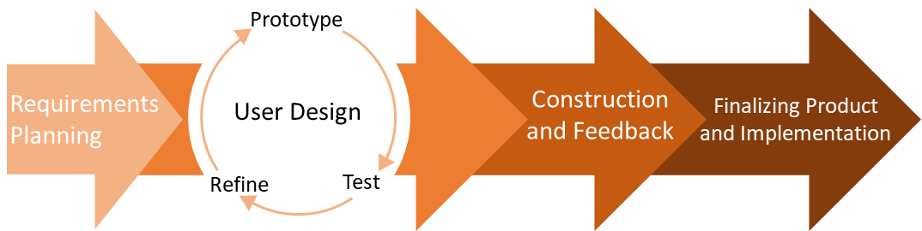

Figure 1. Rapid Application Development (Chien, 2020)

**Requirements Planning (RP)**

The RP phase is similar to a project meeting. RAD starts with loosely defined project requirements, scopes, challenges, and its needs. This phase aims to establish a general understanding of the project’s problems, to become familiar with existing or similar projects and to identify the project’s processes that will be supported by the proposed application.

During this phase, the researchers planned mainly what features would be included in the mobile application. Upon identifying the features, research has been made to ensure the relevance of some of the included features.

**Prototype Cycle (PC)**

The PC is the phase where the rapid prototyping takes place. Through rapid prototyping, errors and bugs are more likely to be discovered during the early stage of development because of the active involvement of the client during the development of the product (Singh, 2019). A prototype is an early model of a product created to test a concept or process and is used to present a tangible representation of the conceptual model of the project as defined and discussed during the RP stage.

**Construction and Feedback**

Under the construction phase, the native prototype is further developed through the integration of functionalities as per requirements. Other features such as audio player and display of assessment score according to user response were added to the app.

After developing the app, the mobile application is tested to see unexpected issues concerning the functioning of its features.

**Finalization of the Product and Implementation**

In this phase, minor changes and information correction are recommended to refine the app. This is also where the mobile app will be tested by installing it on several available android phones with different screen sizes to see the consistency of the looks and element sizes inside the app. Once the product is finalized, the mobile app is ready to be deployment.

Lastly, for objective number 3, the researchers used the User Version of the Mobile Application Rating Scale (uMARS).  It is a 20-item tool that includes four objective quality subscales—engagement, functionality, aesthetics, and information quality, and one subjective quality subscale with items rated from 1-inadequate to 5-excellent.  It is one subscale which measures the user’s perceived impact is excluded as it is irrelevant to the aim of the research.  The uMARS is made for evaluating mobile health apps and has already been used for some studies such as the studies, "A Mobile Phone App to Improve the Mental Health of Taxi Drivers:  Single-Arm Feasibility Trial" and "Clinicians' perceptions of PTSD Coach Australia".  This tool has been evaluated and proven to be reliable (Stoyanov et al., 2016) with high internal consistencies including its subscales. The researchers constructed the questionnaire through the utilization of google forms/survey and the links are disseminated to the participants of the study.

There are a total of 507 undergraduate students of DMMMSU-MLUC College of Information Technology. Since conducting face-to-face surveys is prohibited due to the COVID-19 pandemic and conducting it online is slow and might not be finished until the required time, the researchers resorted to the 10% condition in adjusting their number of respondents. The 10% condition states that [sample sizes](https://www.statisticshowto.com/probability-and-statistics/find-sample-size/) should be no more than 10% of the population.  When making inferences about proportions, the 10% condition is necessary because of the large samples (Glen, 2013).  In this case, the researchers administered the questionnaire to 51 students.

**Analysis of Data**

The gathered data will be analyzed by calculating the mean of the ratings of each question. The result then will be interpreted using the Likert Scale below.

Table 1. Likert Scale

|  |  |  |
| --- | --- | --- |
| **Rating Scale** | **Descriptive Equivalent Rating** | **Descriptive Equivalent Interpretation** |
| 5 | Excellent | Highly Usable |
| 4 | Good | Usable |
| 3 | Acceptable | Moderately Usable |
| 2 | Poor | Fairly Usable |
| 1 | Inadequate | Not Usable |

If the overall mean reached 3 or higher based on the Likert Scale, then the developed application would be considered usable.

# **Chapter 3**

**RESULTS AND DISCUSSION**

**The Different Stress Management Techniques**

Through the use of the keywords “stress management techniques”, Google Scholar returned about more than 4 million results. The search was then filtered using a custom range from 2016 to 2021 and the researchers were able to narrow down the number of search results to about 800 thousand links. The researchers then proceeded to look for studies related to the initial data gathered that were being adapted to mobile devices. The researchers found that guided meditation, breathing exercises, writing journals, listening to relaxing music, and mindfulness practice were the most commonly used stress management techniques for mobile applications. Presented in the table below are mobile apps that addresses stress, anxiety, and depression regardless of one’s demographics. As mentioned earlier in Chapter 1, most of these apps have paid features and most of them are “*freemium*” apps. They are applications that offers some features for free that acts as a preview for the user who might then be interested on purchasing the app’s premium features or its full features. A popular example of this freemium app that is related to stress management is the “*Calm*” app. As mentioned earlier in Chapter 1, it is an app with hundreds of guided meditation library and only a select guided meditation are available to be played by the “free” users. More stress management apps are listed on table … with their corresponding stress management techniques used, addressed mental health problems, and pricing.

Table 2. Stress Management Applications

|  |  |  |  |
| --- | --- | --- | --- |
| **App Name** | **Stress Management Technique** | **Targeted Mental Health Problem** | **Pricing** |
| Calm | Meditation, Mindfulness | Stress, Anxiety | PHP 2,590.00 annual subscription,  PHP 18,000.00 lifetime premium access |
| Sanvello | Meditation, Mindfulness, Social Media, Cognitive Behavioral Therapy | Stress, Anxiety, Depression, Trauma | Starts at USD 8.99 per month for self-care membership\* |
| Headspace | Meditation, Mindfulness, Sleep exercises | Stress, Anxiety, Panic Attacks, Insomnia | Starts at USD 5.83 per month\*\* |
| Happify | Positive Psychology, Mindfulness, Cognitive Behavioral Therapy | Stress, Negative thoughts | Starts at USD 6.95 per month\*\* |
| Dare | Psychoeducation, Meditation, Cognitive Behavioral Therapy | Anxiety, Panic Attacks, Insomnia, Stress | Starts at USD 9.99 per month |

\*Sanvello has three different memberships: Self-care, coaching, and therapy

\*\*Annual billing

**Meditation**

It is a process where one is being fully engaged in the present moment.  It is done by placing oneself in a quiet place, while repeating a mantra or just focusing on breathing (Scott, 2020; Rakal, 2016).  Meditation affects the body by triggering the body's relaxation response.  It can calm the mind and body by quieting the stress-induced thoughts that keep the body's stress response triggered (Scott, 2020).   Research has shown that performing meditation can also increase mindfulness and resilience to stress (Hwang et al., 2017).

According to Zuckerman, A. (2020), over the years, healthcare professionals have shifted from prescribing pills to recommending physical activities to treat ailments. Similarly, meditation has become one of the fastest-growing health trends, with a growing number of meditation studios popping up all over the world. 16% of people in the age group 45 to 64 years old practice meditation. And in the age groups of 18 to 44 years old and 65 and above, there are 13% who practice meditation.

In the physiological aspects of meditation, it has been used in the treatment of muscle tension, anxiety, drug abuse, and hypertension. It lowers blood pressure, heart and respiratory rates, and the skin’s electrical conductance, and it increases the blood flow to the arms and legs (Greenberg, n.d.).

Meanwhile in the psychological aspects of meditation, it has been found to have several beneficial effects. It alleviates anxiety and is related to an internal locus of control, greater self-actualization, improvement in sleep, decreased cigarette smoking, headache relief, and a general state of positive mental health (Greenberg, n.d.).

**Breathing Exercises**

It is an exercise where one is just focusing only on breathing to release tension from the body.  When a person experiences stress, the sympathetic nervous system is stimulated and affects several physical responses such as increased heart rate, tensed muscles, and shallow breathing.  The breath can be used to directly influence these stressful changes causing a direct stimulation of the parasympathetic nervous system resulting in relaxation (Rakal, 2016).  Breathing exercise can be done with a guide especially if it is timed.

In a study conducted by Perciavalle et al. (2017), 38 university students which were divided into experimental and control group were observed. The experimental group were submitted into ten deep breathing sessions while the control group aren’t, and their psychological stress was measured using the Measurement of Psychological Stress (MSP). After the first session, both groups obtained a medium level of stress with values ranging from 90-100. But after the fifth and tenth session, the experimental group obtained a significant reduction of stress levels with values ranging from 80-90, while the control group’s stress levels were unchanged. The study’s result showed that deep breathing is capable in reducing stress levels.

**Journaling**

It is an activity where one writes down his/her thoughts usually to release emotions or realize positive happenings and reflect.  Journaling allows a person to clarify his/her thoughts and feelings and it can also help to focus on areas of life that a person likes to focus on more often (Scott, 2020).  A study of three writing-based activity tools (Three Good Things, Gratitude Letter, Looking Forward Tool) found that these activities can help improve a person’s well-being and reduce burnout (Adair, Kennedy & Sexton, 2020).  Another study also found that positive emotional writing can help reduce feelings of anxiety and stress (Smith, Thompson, Hall, Allen & Wetherell, 2018).

They found in a study that 76% of adults who spent 20 minutes writing about their thoughts and feelings for three consecutive days two weeks before a medically necessary biopsy were fully healed eleven days later. Meanwhile, 58% of the control group had not recovered. The study concluded that even one hour of writing about distressing events helped participants make sense of the events and reduce distress (Grate, 2015).

**Progressive Muscle Relaxation (PMR)**

It is a process that involves tensing and relaxing muscle groups in the body alternately to achieve physical relaxation.  This method is based upon the idea that mental relaxation will be a natural outcome of physical relaxation (Stöppler, 2021). A study involving people who suffer multiple sclerosis found that progressive muscle relaxation contributed to the reduction of their stress levels (Novais et al., 2016).

In the study conducted by Zargarzadeh and Shirazi (2014), 91.7% of the participants who had moderate anxiety had their anxiety levels lowered after the intervention and 8.3% of the participants who had severe anxiety had their anxiety levels lowered to moderate levels after the intervention. Additionally, Zargarzadeh and Shirazi (2014) concluded that PMR reduces anxiety and helps an individual with their ability to cope with pressure.

### **Listening to Music**

Music therapy typically involves relaxing music to calm or bring oneself in a positive state.  De Witte et al. (2019) found that music interventions, like listening to music, can reduce physiological stress-related symptoms such as anxiety, restlessness, and nervousness. Similarly, in a study (Chen et al., 2019) that surveyed 251 participants found that listening to music was the popular method for reducing one’s stress and that 95.8% of the participants reported that listening to music reduced their stress.

**Rapid Application Development**

**Requirements Planning**

Based on Table 2, most of the guided interventions used are meditation, mindfulness, and breathing. While meditation and mindfulness are often used interchangeably, meditation can be one of the many methods of reaching mindfulness. Alleviating stress through mindfulness has a category on its own and is called the Mindfulness-Based Intervention (MBI), a therapeutic approach to mindfulness that promotes good physical and mental health. One of the most popular ways to practice MBI is through the Mindfulness-based Stress Reduction (MBSR) by Kabat-Zinn (2013), a group program that focuses on a patient’s struggles in life and physical/mental illness. According to Kabat-Zinn (*Jon Kabat-Zinn, 2021*), mindfulness is “the awareness that arises through paying attention on purpose in the present moment - non-judgmentally”. However, it is an intensive 8-week program and requires commitment compared to an intermittent mindfulness practice which may be as beneficial as well (Clarke & Draper, 2020).

For the initial design of the app, the researchers observed existing design principles of modern mobile applications to see what is aesthetically pleasing. The researchers explored different designs through Pinterest, a social network that allows users to visually share, and discover new interests by posting images or videos to their own or others’ boards and browsing what other users have pinned (Meng, 2019).

After that, the researchers were able to further define the overall features of the proposed mobile application. The overall features defined are:  1) Guided Intervention such as: Meditation, Breathing Exercises, Progressive Muscle Relaxation, Listening to Music; 2) Journaling; 3) Psychoeducation; and 4) Assessment.

Once the initial overall idea for the planned mobile application was defined, the researchers turned the ideas into wireframes and were produced in Adobe XD. Wireframes provide a clear overview of the page structure, layout, information architecture, [user flow](https://careerfoundry.com/en/blog/ux-design/what-are-user-flows/" \t "_blank), functionality, and intended behaviors. As a wireframe usually represents the initial product concept, styling, color, and graphics are kept to a minimum (Hannah, 2021).

**Initial Design of the Proposed Mobile Application using Wireframe**

Aside from the approved features of the app, wireframes were also constructed that served as a guide for the actual building of the app. The wireframes are as shown below:

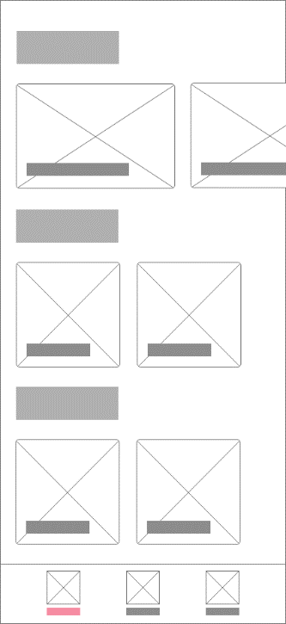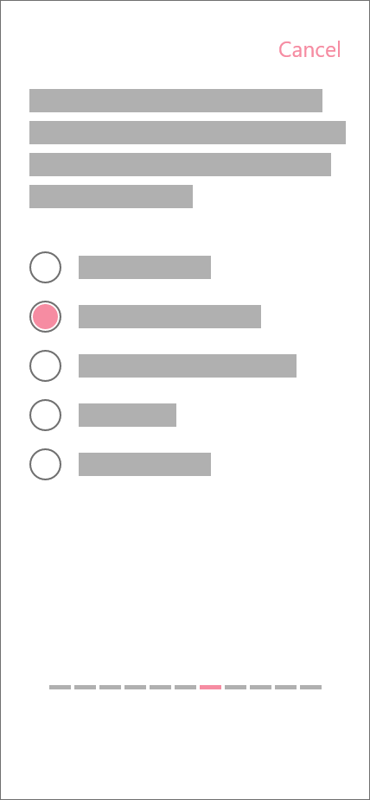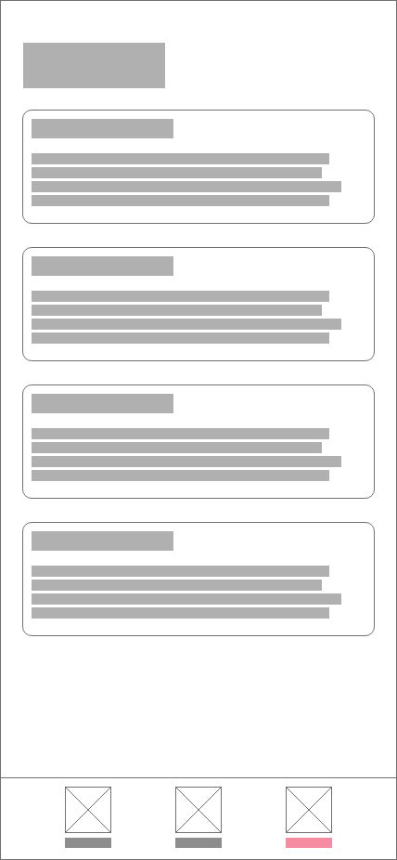

Plate 1. Wireframes

**Prototype Cycles**

The wireframes from the earlier stage are then translated to “hi-fi” or high-fidelity prototypes. Where in this level of prototype fidelity the representation of the app is in its closest resemblance to the final design in terms of details and functionality (Ibragimova, 2016). User Interface (UI) elements, color schemes, content, navigation, user flows, and other visual materials were then prepared to begin with the native prototyping. Native prototyping involves the writing of a code and building a prototype to test on real devices and is often used to validate ideas with real users (Lindberg, 2019).

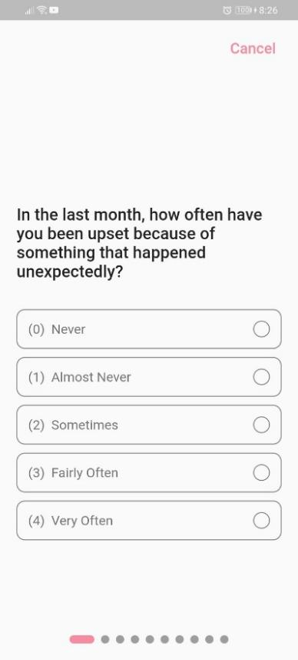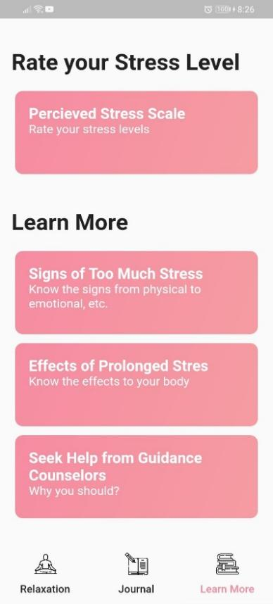

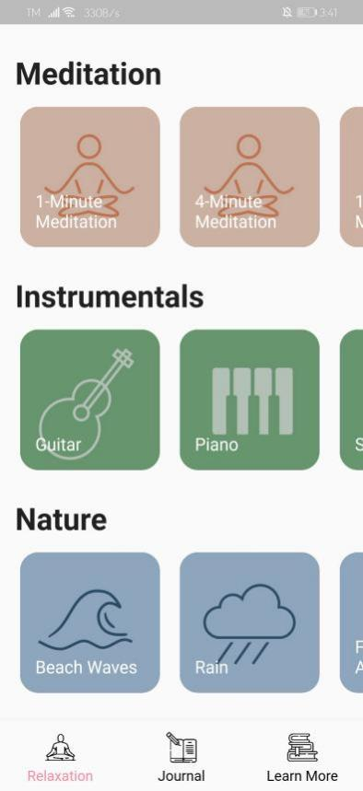

Plate 2. Screenshots of the Native Prototype.

Hi-fi prototype includes visual design such as typography, color, or graphical materials that must represent the final product. The prototype only presents the UI aspect of the mobile app and only features basic functionalities such as navigation.

As for the graphical elements, the researchers used a website called Freepik.com. Freepik “offers a wide catalogue of free resources” which users can find by filtering by “Free”, from the “Filters” option on the site where the content is completely free of charge (Freepik, 2010).

In the education page, dummy texts were not used for the content delivery and real information were used instead in order for the team members to understand how the content affects the overall design.

**Construction and Feedback**

  After thoroughly observing each feature, the researchers found that all features are working properly and there were no unexpected issues.

But then while presenting, the researchers observed responsiveness problems from the app as the app didn't look the same on bigger screens. Hence they changed the sizing of some elements from a fixed value to a value that corresponds to the screen size of the mobile phone where it is installed. UI changes, more information and functions were added to comply with the recommendations stated.

**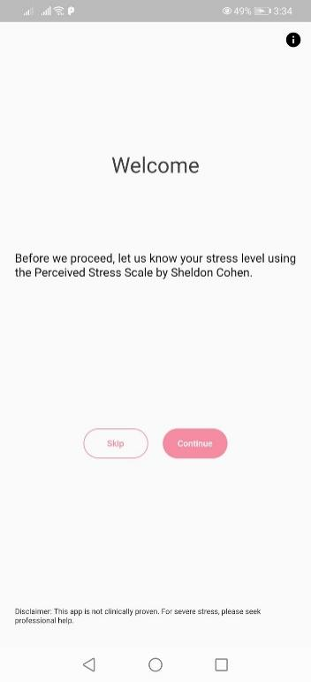**

Plate 3. Welcome Page

The researchers added minor changes on the Welcome page where the author of the assessment tool was acknowledged, added disclaimer about using the app, added a button that will direct the user to the PSS education page.

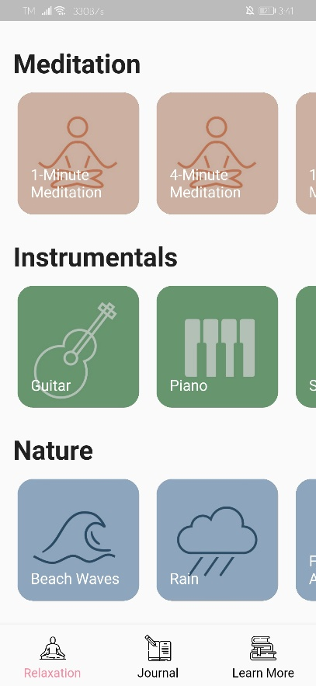

Plate 4. Guided Intervention Page

For the guided intervention page, the app will now automatically add a journal entry when the user is done with the meditation and an additional user input is optional. The same goes to the assessment feature as well where the app will automatically log an entry regarding the user’s reported stress level.

**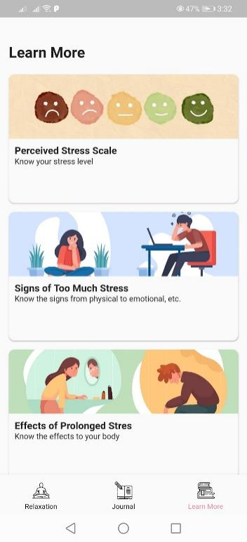**

Plate 5. Psychoeducation Page

The Psychoeducation page was further improved through the use of more visual materials. Photo headers were added to the list of topics and YouTube videos were embedded on the bottom of the page of the topic as well. Lastly, we added a topic about the assessment tool used and created links for the PDF copy of the questionnaire and the written permission of the author.

**Finalizing Product and Implementation**

Grammars and use of words for the information used in the mobile app has been improved and the mobile app went to a final observation by installing it on several android phones with different screen sizes.  The researchers found that the looks and element sizes inside the mobile app appear to be consistent. Therefore, with these findings, the mobile app is now ready to be used.

**Level of Usability of the Developed Mobile Application**

The following tables present the summary of the students’ response to the level of usability of the developed mobile application.

**Aesthetics**

The aesthetics subdomain evaluates the mobile application based on layout, graphics, and visual appeal. The layout indicates how the arrangement and the size of the buttons, icons, menus, and content on the screen are logical for the user. The graphics indicate whether the quality or resolution of the graphical materials used for the different components of the mobile app is high quality, proportionate, and is consistent in style. Whereas for visual appeal indicates how the app stands out and how the use of color scheme helps enhance the app’s features or menus.

The results below show that the highest mean value of 3.84 from the visual appeal, it implies that the app visuals was the one that attracted the attention of the respondents. While it got the lowest mean value of 3.71 from graphics. It is possible that the consistency and the quality of the graphics used needs further improvement. And the mean rating of aesthetic of the mobile application is 3.79 which means that the respondents took the aesthetic of the mobile application positively.

According to Cata and Martz (2015), aesthetics is considered as one of the key characteristics of what is considered as usable in mobile applications and plays an important role at fostering positive attitudes. Designs that looks easier to use are more likely to be used whether or not the product is actually easier to use (Chakraborty, 2017) and makes an application appear well designed and professional (Moran, 2017). Users are more likely to want to try a visually appealing product.

Table 4. Level of Usability of the Developed Mobile Application in terms of Aesthetics

|  |  |  |
| --- | --- | --- |
| **Indicators** | **Mean** | **DER** |
| The arrangement and size of buttons, icons, menus, and content on the screen is clear, orderly, and logically organized (layout) | **3.82** | **Acceptable** |
| The quality/resolution of graphics used for buttons, icons, menus, and content has high quality/resolution and is proportionate, and consistent in style throughout (graphics) | **3.71** | **Acceptable** |
| The app looks very attractive, memorable, stands out and the use of color enhances the app features/menus (visual appeal) | **3.84** | **Acceptable** |
| **Mean Rating** | **3.79** | **Acceptable** |

***Legend: DER - Descriptive Equivalent Rating***

**Engagement**

The Engagement subdomain is evaluated based on the following indicators: entertainment, interest, customization, interactivity, and target group appeal. Entertainment means how entertaining the app is to use and how the app’s components make it more fun to use compared to other similar apps. Interest means how the app and its content is interesting compared to other similar apps.

Table 3 shows the level of usability of the developed mobile application in terms of engagement where its highest mean value is 3.76 from interest indicator. This implies that the way the app is presented in an interesting way that captured the respondents.

According to Leiras (2017), high levels of interaction and involvement can serve as a considerable gain for sustainability because it plays an important role which affects user behavior that will determine the churn rate of the app’s usability. User engagement is when users provide attention to the product. If there is engagement, it means that users find value in the product that they use.  The ultimate goal of user engagement is to simulate the emotions of the user through excitement and attraction through the combination of aesthetics and user interaction (Sutcliffe, 2016).

While the mean rating of the Engagement subscale application is overall acceptable, which implies that the mobile app somehow captured the attention of the respondents, the customization indicator scored the lowest. Customization means that the app enables the user to change the app’s settings and preferences such as sound, content, and notifications. The low mean rating clearly shows that a customization feature is crucial for its future improvements in order to gain more engagement, and higher user retention.

Table 5. Level of Usability of the Developed Mobile Application in terms of Engagement

|  |  |  |
| --- | --- | --- |
| **Indicators** | **Mean** | **DER** |
| The app is fun or entertaining to use and have components that make it more fun than other similar apps (entertainment) | **3.49** | **Acceptable** |
| The app is interesting to use and presents its information in an interesting way compared to other similar apps (interest) | **3.76** | **Acceptable** |
| The app allows the customization of the settings and preferences such as sound, content, or notifications (customization) | **2.96** | **Poor** |
| The app allows user input, provide feedback, or contain prompts such as reminders, sharing options, or notifications (interactivity) | **3.16** | **Acceptable** |
| The app content is appropriate for the target audience (target group) | **3.55** | **Acceptable** |
| **Mean Rating** | **3.38** | **Acceptable** |

***Legend: DER - Descriptive Equivalent Rating***

**Functionality**

The functionality criteria are evaluated through the app performance, ease of use, navigation, and gestural design. Performance means how the app can fast or accurately perform app features and components. Ease of use means how easy it is to learn how to use the app and how clear the menu labels, icons, and instructions are. Ease of use may be associated with the term “onboarding”, where it is defined as “the process of getting users familiar with a new interface, using dedicated flows and user interface (UI) elements that are not part of the regular app interface” (Joyce, 2020) although existing users may be on boarded as well when new updates are released.

The functionality has the highest mean value of 4.06 from the ease of use indicator, this implies that the app is easy to learn and understand. Meanwhile the gestural design was rated with the lowest value of 3.69. It is possible that the tap\swipe\pinches\scroll are inconsistent across the components\screens. And the mean rating of functionality of the mobile application is 3.83. This implies that the overall performance of the app is acceptable.

According to Salle et al. (2017), functionality is what the system does and the purpose of the system and enables users to perform various tasks. The Functionality subdomain scored the highest among the other subdomains while the Aesthetic subdomain scored the second highest. It is reported that aesthetic appeal and perceived ease of use has stronger correlation than aesthetic appeal and actual ease of use (Fessenden, 2021). This phenomenon is called the Aesthetic-Usability effect, as described earlier in the discussion of Table 3.  However, it must be noted that a visually appealing design may prevent developers from discovering usability issues due to this effect.

Table 6. Level of Usability of the Developed Mobile Application in terms of Functionality

|  |  |  |
| --- | --- | --- |
| **Indicators** | **Mean** | **DER** |
| The app can accurately/fast do the features and components work (performance) | **3.86** | **Acceptable** |
| The app is easy to learn how to use the app and the menu labels, icons, and instructions are clear (ease of use) | **4.06** | **Good** |
| There are logical connection between screens and navigation is not difficult (navigation) | **3.71** | **Acceptable** |
| Taps/swipes/pinches/scroll are intuitive and consistent across all components/screens (gestural design) | **3.69** | **Acceptable** |
| **Mean Rating** | **3.83** | **Acceptable** |

***Legend: DER - Descriptive Equivalent Rating***

**Information**

The information content of the mobile application has the highest mean value of 3.86 from the quantity of information, this implies that the information within the app is comprehensive and concise. While it has the lowest mean value of 3.73 from visual information and credibility of source. It's possible that both indicators have the same mean value because both need further improvement when it comes to the visual explanation and legitimacy of the source included in the app. But overall, the information content of the mobile application was considered useful and relevant based on the mean rating of 3.78.

Quantity of information scored the highest mean among the other indicators, indicating that the content in the app is presented in brevity and in a comprehensive manner. The way the content was formatted especially in the education feature of the app may have influenced the respondents’ rating in regards to the Quantity of Information indicator. It is recommended that information must be presented and formatted in “chunks” rather than in a “wall of text”. A “wall of text” is characterized as an excessively long content that lacks hierarchy or formatting in which it has the effect of increasing the cognitive load on users, making the content difficult to scan or process (Yablonski, 2020). Meanwhile, “chunks” present content into discernible sections through the use of headings and subheadings that provide hierarchy to the information. According to cognitive load theory, “chunking unlocks human capacity to exceed initial limits of working memory” whereas working memory has limited capacity (Reese, Dianne, & Taylor, 2016).

Table 7. Level of Usability of the Developed Mobile Application in terms of Information

|  |  |  |
| --- | --- | --- |
| **Indicators** | **Mean** | **DER** |
| The app’s content is correct, appropriate, coherent, and highly relevant to the goal or topic (quality of information) | **3.82** | **Acceptable** |
| The information within the app is comprehensive and concise; contains links to more information and resources (quantity of information) | **3.86** | **Acceptable** |
| The visual explanation of concepts through charts, graphs, images, or videos are clear/logical/correct (visual information) | **3.73** | **Acceptable** |
| The information within the app comes from a legitimate/specialized source (credibility of source) | **3.73** | **Acceptable** |
| **Mean Rating** | **3.78** | **Acceptable** |

***Legend: DER - Descriptive Equivalent Rating***

**Subjective Quality**

The mobile application in terms of subjective quality has the highest mean value of 3.71 from the “The app is one of the best apps the users have used” indicator. This implies that the respondents' acceptability of the app is good. While it garnered the lowest mean value of 2.45 in the aspect “if the user would pay for the app”, this implies that the potential users don't want to pay to use the app. The principle “anchoring” or the idea that there is a sort of reference price for particular items, based on what else is available and how the first price was set (Trent, 2020), supports the finding. Since the majority of mobile applications on various app stores are free, people are more likely to prefer apps that are free.

The mean rating of subjective quality is 3.24 which implies that the overall satisfaction of the app is considered acceptable by the respondents.

Table 8. Level of Usability of the Developed Mobile Application in terms of Subjective Quality

|  |  |  |
| --- | --- | --- |
| Indicators | Mean | DER |
| The app is recommended to everyone | 3.65 | Acceptable |
| The app may be used for more than fifty times | 3.16 | Acceptable |
| The app has potential to be monetized | 2.45 | Poor |
| The app is one of the best apps the users have used | 3.71 | Acceptable |
| Mean Rating | 3.24 | Acceptable |

***Legend: DER - Descriptive Equivalent Rating***

**Summary of the Level of Usability of the Developed Mobile Application**

The usability of the developed mobile application in terms of aesthetic, engagement, functionality, information and subjective quality obtained a grand mean of 3.61 with the highest mean value of 3.83 in functionality. The subjective quality resulted with the lowest mean value due to the respondents’ perception that they do not see the app’s potential to be monetized.

While all of the indicators are rated acceptable and the app is considered functional, it was relatively weak in engagement and subjective quality scores specifically on the customization and monetization indicators. The engagement subscale is most strongly associated with subjective quality (Bardus et al., 2019), therefore emphasizing that the quality of engagement of the app is crucial to sustain its user base in the future.

Table 9. Summary of Level of Usability of the Developed Mobile Application

|  |  |  |
| --- | --- | --- |
| Indicators | Mean | DE |
| Aesthetics | 3.79 | Acceptable |
| Engagement | 3.38 | Acceptable |
| Functionality | 3.83 | Acceptable |
| Information | 3.78 | Acceptable |
| Subjective Quality | 3.24 | Acceptable |
| Grand Mean Rating | 3.61 | Acceptable |

***Legend: DER - Descriptive Equivalent Rating***

**Chapter 4**

**SUMMARY, CONCLUSIONS, AND RECOMMENDATIONS**

The main objective of the study is to develop E-Gabay: A Mobile Application for Stress Management which aims to help its users in terms of managing their stress and educating them about it.  The completion of the study was guided by the following objectives: (1) to identify the different stress management techniques; (2) to determine the features e-Gabay: A Mobile Stress Management App; (3) To determine the level of usability of the developed application in terms of:  (a) Aesthetics, (b) Engagement, (c) Functionality, (d)  Information, (e) Subjective quality.

The researchers used the descriptive and developmental types of research in conducting the study.  This study used a descriptive method of research particularly in determining the level of usability of the mobile application to be developed.  Web search has been made in identifying different stress management techniques.  In determining the features of the mobile app, the researchers based on the collected literature from the web.

**Conclusions**

Based on the findings, the following conclusions were drawn:

1. There are a number of interventions that can be found online but only a few are evidence-based. These evidence-based interventions the researchers found are: meditation, breathing exercises, journaling, progressive muscle relaxation, and listening to music.
2. The researchers used the following features for e-Gabay: guided meditation, music therapy, journaling, and psychoeducation.
3. The level of Usability of the study “E-Gabay: A Mobile Application for Stress Management” was tested as moderately usable, therefore it proves that the developed mobile application is usable.

**Recommendations**

Based on the findings, these are the following recommendations:

1. Find more literature to see other possible stress management techniques.
2. Further research about other features that can help to improve the mobile application.
3. Re-test of the level of usability of the developed mobile application.
4. Improve the developed application based on the indicators that scored low.
5. Further research can be made by other college departments in DMMMSU to test the developed mobile app’s efficacy that may improve the app’s content to better cater not only to the students of CIT but to the whole population of DMMMSU.

**LITERATURE CITED**

Adair, K. C., Kennedy, L. A., & Sexton, J. B. (2020). Three Good Tools: Positively reflecting backwards and forwards is associated with robust improvements in well-being across three distinct interventions. *The Journal of Positive Psychology*, *15*(5), 613–622. https://doi.org/10.1080/17439760.2020.1789707

Alsulami, S., Al Omar, Z., Binnwejim, M., Alhamdan, F., Aldrees, A., Al-bawardi, A., Alsohim, M., & Alhabeeb, M. (2018). Perception of academic stress among Health Science Preparatory Program students in two Saudi universities. *Advances in Medical Education and Practice*, *Volume 9*, 159–164. https://doi.org/10.2147/amep.s143151

Ankita Singh. (2019). *What Is Rapid Application Development (RAD)?* Capterra.com. <https://blog.capterra.com/what-is-rapid-application-development/>

Baik, S., Fox, R., Mills, S., Roesch, S., Sadler, G., Klonoff, E., & Malcarne, V. (2017). Journal of Health Psychology. *Reliability and Validity of the Perceived Stress Scale-10 in Hispanic Americans with English or Spanish Language Preference*, *24*(5), 628–639. https://www.ncbi.nlm.nih.gov/pmc/articles/PMC6261792/

Bardus, M., Ali, A., Demachkieh, F., & Hamadeh, G. (2019). Assessing the Quality of Mobile Phone Apps for Weight Management: User-Centered Study with Employees from a Lebanese University. *JMIR MHealth and UHealth*, *7*(1), e9836. <https://doi.org/10.2196/mhealth.9836>

Cata, T., & Martz, B. (2015). Comparing Mobile APPs Usability Characteristics for Designers and Users. *Journal of International Technology and Information Management*, *24*(4), 63–78. https://scholarworks.lib.csusb.edu/jitim/vol24/iss4/4

Chakraborty, A. (2020, May 16). *The Aesthetic-Usability Effect: Why beautiful-looking products are preferred over usable-but-not-beautiful ones.* Medium. https://medium.com/@coffeeandjunk/design-psychology-aesthetic-usability-effect-494ed0f22571

Chen G., Mishra V., and Chen C. 2019. Temporal Factors of Listening to Music on Stress Reduction. In Adjunct Proceedings of the 2019 ACM International Joint Conference on Pervasive and Ubiquitous Computing and the 2019 International Symposium on Wearable Computers (UbiComp/ISWC ’19 Adjunct), September 9–13, 2019, London, United Kingdom. ACM, New York, NY, USA, 8 pages. [https://doi.org/10.1145/3341162.3346272](https://doi.org/10.1145/3341162.3346272?fbclid=IwAR0mf01P72Nw86UMe838tCUgRBQT67BtTheqzLMfqk3pWrPTyQPJhWSspNY" \t "_blank)

Clarke, J., & Draper, S. (2020). Intermittent mindfulness practice can be beneficial, and daily practice can be harmful. An in depth, mixed methods study of the “Calm” app’s (mostly positive) effects. *Internet Interventions*, *19*, 100293. https://doi.org/10.1016/j.invent.2019.100293

Collingwood, J. (2016, May 17). The Power of Music to Reduce Stress. Psych Central. [https://psychcentral.com/lib/the-power-of-music-to-reduce-stress#1](https://psychcentral.com/lib/the-power-of-music-to-reduce-stress" \l "1)

Conley, C. S., Travers, L. V., & Bryant, F. B. (2013). *Promoting Psychosocial Adjustment and Stress Management in First-Year College Students: The Benefits of Engagement in a Psychosocial Wellness Seminar. Journal of American College Health, 61(2), 75–86.* doi:10.1080/07448481.2012.754757

*Coronavirus*. (2020, January 10). World Health Organization. https://www.who.int/health-topics/coronavirus

Cruz, J., Colet, P., & Iyisoy, M. (2017). *Mental Healthcare Utilization Among School-Based Adolescents in La Union, Philippines*. 28th International Nursing Research Congress, Dublin, Ireland. https://sigma.nursingrepository.org/handle/10755/621682

de Witte, M., Spruit, A., van Hooren, S., Moonen, X., & Stams, G. J. (2019). Effects of music interventions on stress-related outcomes: a systematic review and two meta-analyses. *Health Psychology Review*, *14*(2), 294–324. <https://doi.org/10.1080/17437199.2019.1627897>

Dy, M., Ferido, M., Sanchez, R., & Espiritu-Santo, K. (2015). Asia Life Sciences. *Stressors and Stress Responses of Filipino College Students*, *24*(2), 737–759. https://www.researchgate.net/publication/295584175\_Stressors\_and\_stress\_responses\_of\_Filipino\_college\_students

Experience, W. L. in R.-B. U. (n.d.). *Aesthetic and Minimalist Design (Usability Heuristic #8)*. Nielsen Norman Group. <https://www.nngroup.com/articles/aesthetic-minimalist-design/>

Freepik Support. *Is Freepik for free?*  Retrieved May 24, 2021, from [https://support.freepik.com/hc/en-us/articles/202567252](https://support.freepik.com/hc/en-us/articles/202567252-Is-Freepik-for-free-" \l ":~:text=Freepik%20offers%20a%20wide%20catalogue)

Hannah, J. (2021, April 8). *What Exactly Is Wireframing? A Comprehensive Guide*. Career Foundry. https://careerfoundry.com/en/blog/ux-design/what-is-a-wireframe-guide/

Harrington, R. (2012). Stress, Health and Well-Being: Thriving in the 21st Century. In *Stress and Health* (1st ed., p. 19). Cengage Learning.

Hwang, W. J., Lee, T. Y., Lim, K. O., Bae, D., Kwak, S., Park, H. Y., & Kwon, J. S. (2017). The effects of four days of intensive mindfulness meditation training (Templestay program) on resilience to stress: a randomized controlled trial. *Psychology, Health & Medicine*, *23*(5), 497–504. https://doi.org/10.1080/13548506.2017.1363400

Huang, F., Wang, H., Wang, Z., Zhang, J., Du, W., Su, C., Jia, X., Ouyang, Y., Wang, Y., Li, L., Jiang, H., & Zhang, B. (2020). Psychometric properties of the perceived stress scale in a community sample of Chinese. *BMC Psychiatry*, *20*(1). https://doi.org/10.1186/s12888-020-02520-4

Ines, J. (2019). *Filipino College Students’ Mental Health Literacy*. 12th De La Salle University Arts Congress. https://www.dlsu.edu.ph/wp-content/uploads/pdf/conferences/arts-congress-proceedings/2019/MH-02.pdf

Jain, G., & Singhai, M. (2018). Academic Stress Amongst Students: A Review of Literature. *Prestige E-Journal of Management and Research*, *5*(1), 58-67. Retrieved 28 June 2020, from [https://pimrindore.ac.in/vol4-issue2-vol5 issue1/5.ACADEMIC%20STRESS%20AMONGST%20STUDENTS%20A%20REVIEW%20OF%20LITERATURE.pdf](https://pimrindore.ac.in/vol4-issue2-vol5%20issue1/5.ACADEMIC%20STRESS%20AMONGST%20STUDENTS%20A%20REVIEW%20OF%20LITERATURE.pdf).

*Jon Kabat-Zinn*. (2021, January 30). Mindfulness Based Stress Reduction. https://mbsrtraining.com/jon-kabat-zinn/

Joyce, A. (2020). *Mobile-App Onboarding: An Analysis of Components and Techniques*. Nielsen Norman Group. <https://www.nngroup.com/articles/mobile-app-onboarding/>

Kabat-Zinn, J., & Hanh, T. N. (2013). *Full Catastrophe Living (Revised Edition)* (Revised ed.) [E-book]. Penguin Random House. https://books.google.com.ph/books?id=fIuNDtnb2ZkC&dq=editions:DBbS-4l6LKQC&source=gbs\_navlinks\_s

Karaman, M. A., Lerma, E., Vela, J. C., & Watson, J. C. (2019). Predictors of Academic Stress Among College Students. *Journal of College Counseling*, *22*(1), 41–55. https://www.academia.edu/41590306/Predictors\_of\_Academic\_Stress\_Among\_College\_Students

Keller, A., Litzelman, K., Wisk, L. E., Maddox, T., Cheng, E. R., Creswell, P. D., & Witt, W. P. (2012). Does the perception that stress affects health matter? The association with health and mortality. *Health psychology: official journal of the Division of Health Psychology, American Psychological Association*, *31*(5), 677–684. <https://doi.org/10.1037/a0026743>

Leiras, M. (2017). *Mobile User Engagement: New Apps versus Mainstream Apps* (Master’s Dissertation). https://repositorio-aberto.up.pt/bitstream/10216/108401/2/225943.pdf

Lindberg, O. (2019).Prototyping: What it is & Why it’s Important | Adobe XD Ideas. *Ideas*. <https://xd.adobe.com/ideas/process/prototyping/guide-to-prototyping-designs/>

Manzar, M. D., Salahuddin, M., Peter, S., Alghadir, A., Anwer, S., Bahammam, A. S., & Pandi-Perumal, S. R. (2019). Psychometric properties of the perceived stress scale in Ethiopian university students. *BMC Public Health*, *19*(1). https://doi.org/10.1186/s12889-018-6310-z

Martinez, A. B., Co, M., Lau, J., & Brown, J. S. L. (2020). Filipino help-seeking for mental health problems and associated barriers and facilitators: a systematic review. *Social Psychiatry and Psychiatric Epidemiology*, *55*(11), 1397–1413. https://doi.org/10.1007/s00127-020-01937-2

Mazo, G. (2015). Causes, Effects of Stress and the Coping Mechanism of the Bachelor of Science in Information Technology Students in a Philippine University. *Journal of Education and Learning (EduLearn)*, *9*(1), 71–78. https://doi.org/10.11591/edulearn.v9i1.1295

Moran, K. (2017). *The Aesthetic-Usability Effect*. Nielsen Norman Group. https://www.nngroup.com/articles/aesthetic-usability-effect/

Meng, A. (2021, May 12). *What is Pinterest- How does the app and Pinterest website work*. Infront Webworks. https://www.infront.com/blog/what-is-pinterest-and-how-does-it-work/

*mHealth*. (2020, October 29). Shaping Europe’s Digital Future - European Commission. https://ec.europa.eu/digital-single-market/en/mhealth

Novais, P. G., Batista, K., Grazziano, E., & Amorim, M. H. (2016). The effects of progressive muscular relaxation as a nursing procedure used for those who suffer from stress due to multiple sclerosis. *Revista latino-americana de enfermagem*, *24*, e2789. https://doi.org/10.1590/1518-8345.1257.2789

Pascoe, M. C., Hetrick, S. E., & Parker, A. G. (2019). The impact of stress on students in secondary school and higher education. *International Journal of Adolescence and Youth*, *25*(1), 104–112. https://doi.org/10.1080/02673843.2019.1596823

Perciavalle, V., Blandini, M., Fecarotta, P., Buscemi, A., Di Corrado, D., Bertolo, L., Fichera, F., & Coco, M. (2016). The role of deep breathing on stress. *Neurological Sciences*, *38*(3), 451–458. https://www.researchgate.net/publication/311750288\_The\_role\_of\_deep\_breathing\_on\_stress

Philippine National Health Research System (PNHRS). n.d. *NUHRA*. [online] Retrieved from <https://www.healthresearch.ph/index.php/nuhra1>

Rakal, D. (2016). Relaxation and Meditation Techniques. Psych Central. [https://psychcentral.com/lib/relaxation-and-meditation-techniques#1](https://psychcentral.com/lib/relaxation-and-meditation-techniques" \l "1)

Reese, D. D., Dianne, T. V., & Taylor, C. (2016). Engaging Learners Through Rational Design of Multisensory Effects. (2016). *Emotions, Technology, and Design*, 103–127. <https://doi.org/10.1016/B978-0-12-801872-9.00006-5>

Richey R., (1994). Developmental Research: Definition and Scope. Retrieved from [ERIC - ED373753 - Developmental Research: The Definition and Scope., 1994](https://eric.ed.gov/?id=ED373753)

Robinson, J., & Bolton, J. (2013). Substance Use in Response to Anxiety Disorders. In *Principles of Addiction: Comprehensive Addictive Behaviors and Disorders* (Vol. 1, pp. 507–516). Academic Press.

Salleh, M. A., Bahari, M., & Zakaria, N. H. (2017). An Overview of Software Functionality Service: A Systematic Literature Review. *Procedia Computer Science*, *124*, 337–344. https://doi.org/10.1016/j.procs.2017.12.163

Scott, E. (2020). Is Journaling an Effective Stress Management Tool? Verywell Mind. https://www.verywellmind.com/the-benefits-of-journaling-for-stress-management-3144611

Scott, E. (2020). The Benefits of Meditation for Stress Management. Verywell Mind. <https://www.verywellmind.com/meditation-4157199>

Smith, M. A., Thompson, A., Hall, L. J., Allen, S. F., & Wetherell, M. A. (2018). The physical and psychological health benefits of positive emotional writing: Investigating the moderating role of Type D (distressed) personality. *British Journal of Health Psychology*, *23*(4), 857–871. https://www.ncbi.nlm.nih.gov/pmc/articles/PMC6174944/

Spielman, R. M., Jenkins, W. J., & Lovett, M. D. (2020). Psychology 2e [E-book]. In *Stress, Lifestyle, and Health* (2nd ed., p. 516). Independently published. https://openstax.org/details/psychology-2e

Sutcliffe, A. (2016). Designing for User Experience and Engagement. *Why Engagement Matters: Cross-Disciplinary Perspectives of User Engagement in Digital Media*, 105–126. https://doi.org/10.1007/978-3-319-27446-1\_5

Stöppler, M. C. (2021, February 5). Stress Management: How to Manage Stress in Life with 5 Tips.MedicineNet. <https://www.medicinenet.com/stress_management_techniques/article.htm>

Stoyanov, S. R., Hides, L., Kavanagh, D. J., & Wilson, H. (2016). Development and Validation of the User Version of the Mobile Application Rating Scale (uMARS). JMIR MHealth and UHealth, 4(2), e72. <https://doi.org/10.2196/mhealth.5849>

Stangor, C. and Walinga, J. (2014). Introduction to Psychology – 1st Canadian Edition. Victoria, B.C.: BCcampus. Retrieved from <https://opentextbc.ca/introductiontopsychology/>

The Healthy Minds Network & American College Health Association. (2020). The Impact of COVID-19 on College Student Well-being [Data file]. Retrieved on April 14, 2021 from <https://www.acha.org/documents/ncha/Healthy-Minds_NCHA_COVID-19_Survey_Report.pdf>

Trent, S. (2020, May 24). *Why We Refuse to Spend Much Money on Apps*. Wall Street Journal. https://www.wsj.com/articles/why-we-refuse-to-spend-much-money-on-apps-11590328800

Yablonski, J. (2020)*. 4. Miller’s Law - Laws of UX [Book]*. Www.oreilly.com. <https://www.oreilly.com/library/view/laws-of-ux/9781492055303/ch04.html>

Zargarzadeh, M., & Shirazi, M. (2014). Iranian Journal of Nursing and Midwifery Research. *The Effect of Progressive Muscle Relaxation Method on Test Anxiety in Nursing Students*, *19*(6), 607–612. https://www.ncbi.nlm.nih.gov/pmc/articles/PMC4280725/

Zuckerman, A. (2020), [46 Meditation Statistics: 2020/2021 Benefits, Market Value & Trends | CompareCamp.com](https://comparecamp.com/meditation-statistics/)

**APPENDICES**

**APPENDIX A**

**SURVEY QUESTIONNAIRE TO EVALUATE THE LEVEL OF USABILITY OF E-GABAY: A MOBILE APPLICATION FOR STRESS MANAGEMENT**

**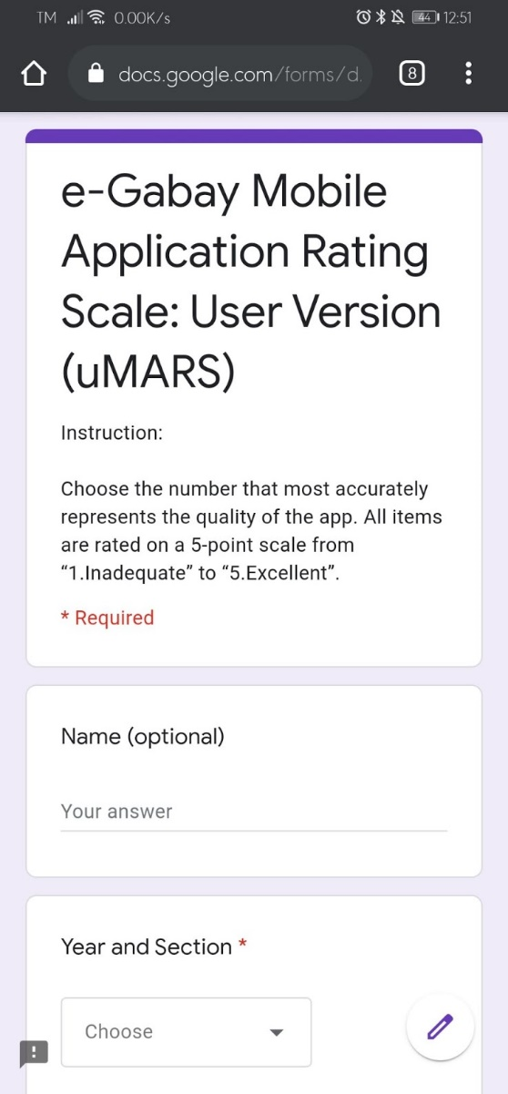**

**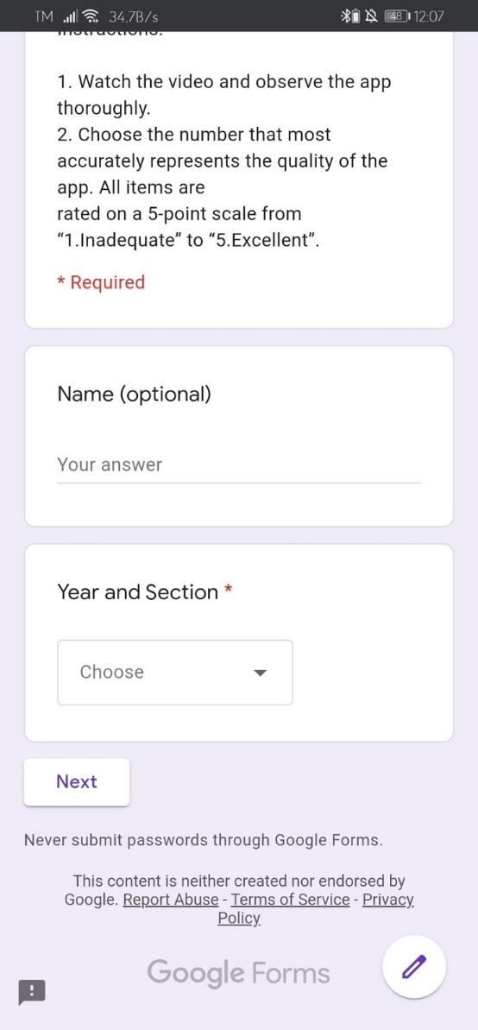**

**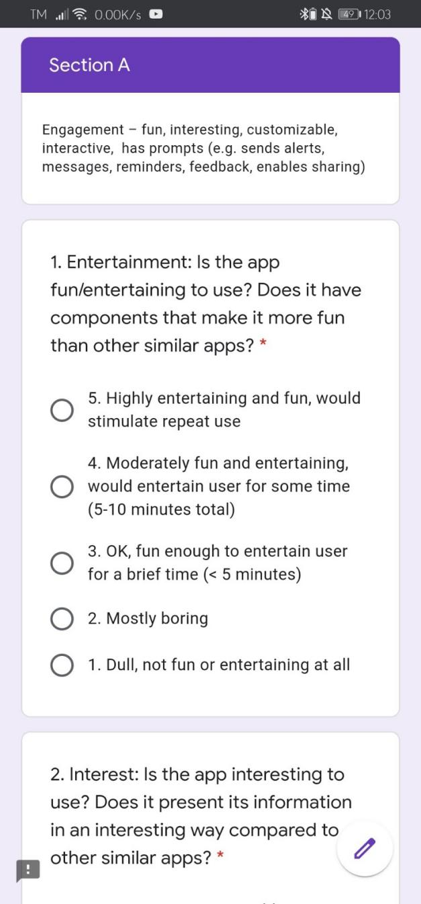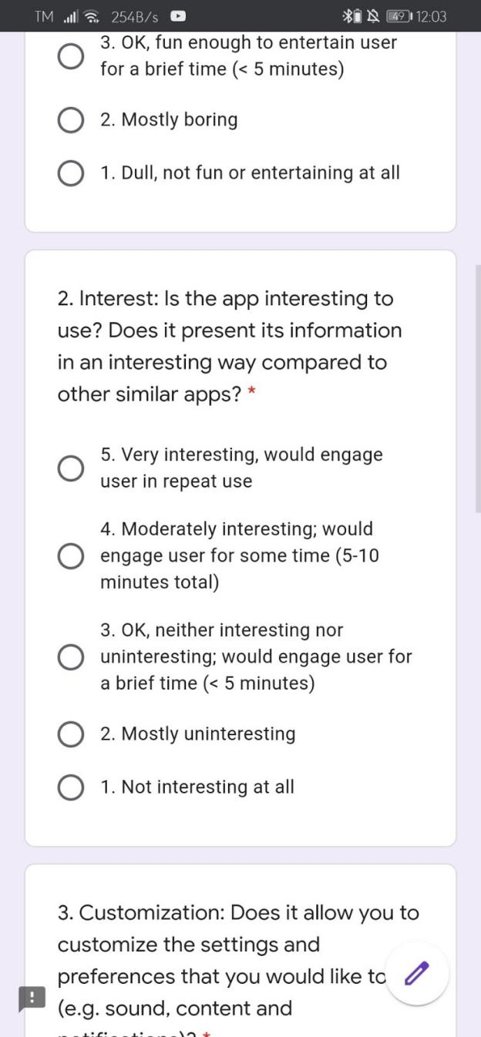**

**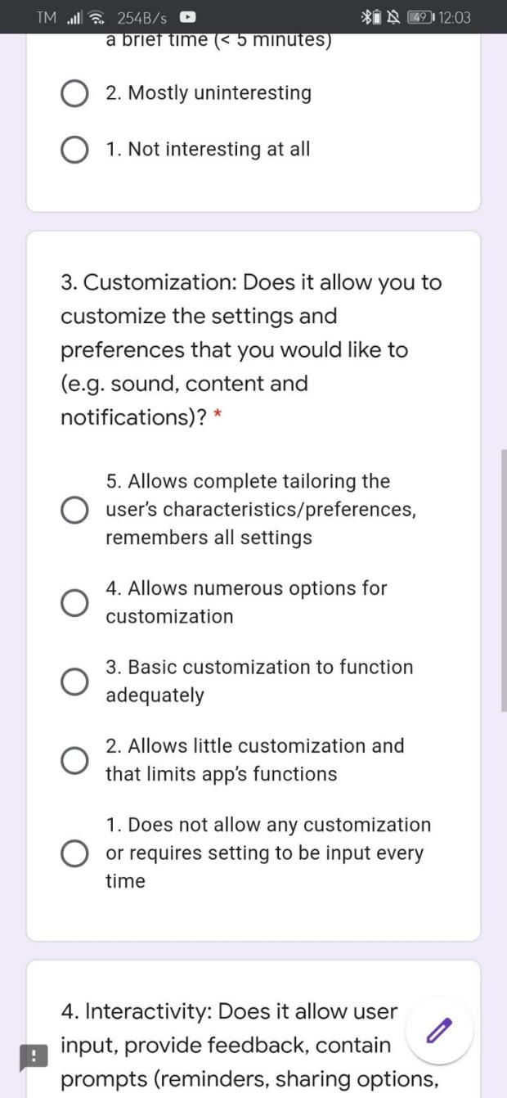**

**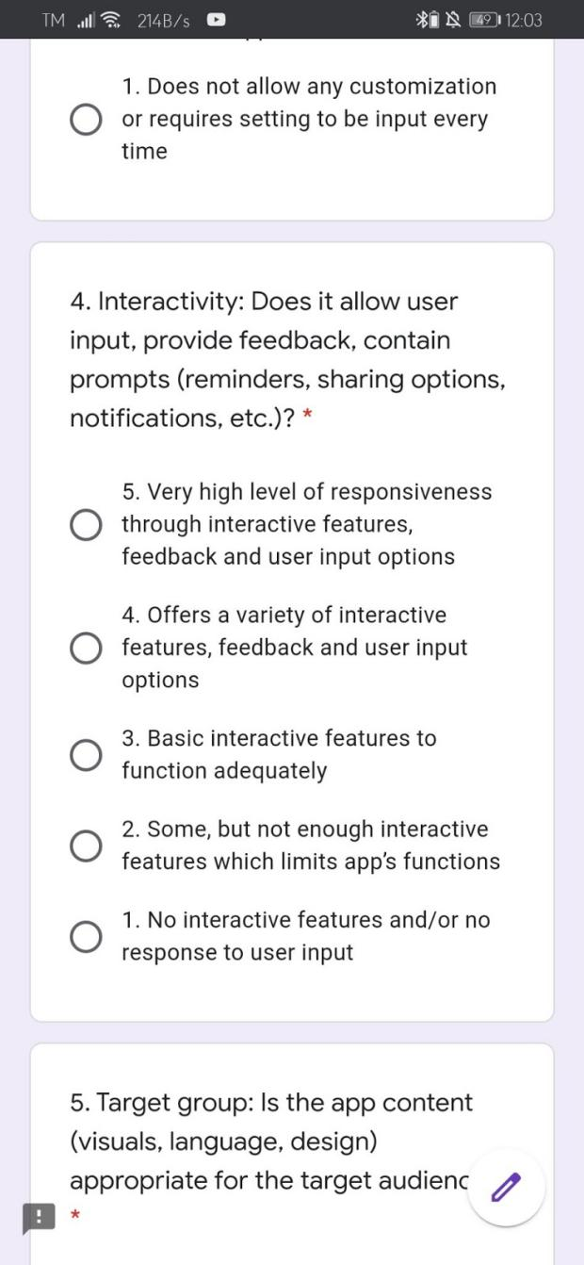**

**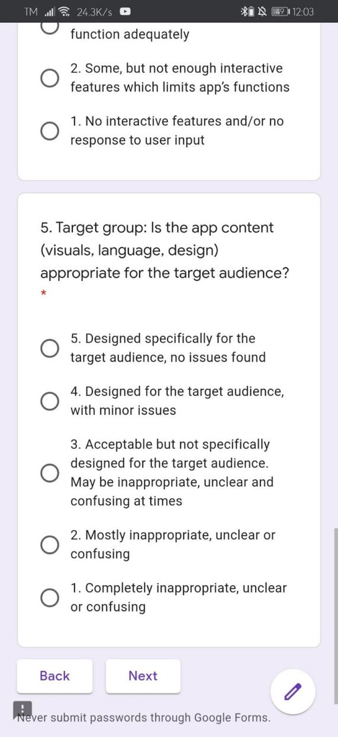**

**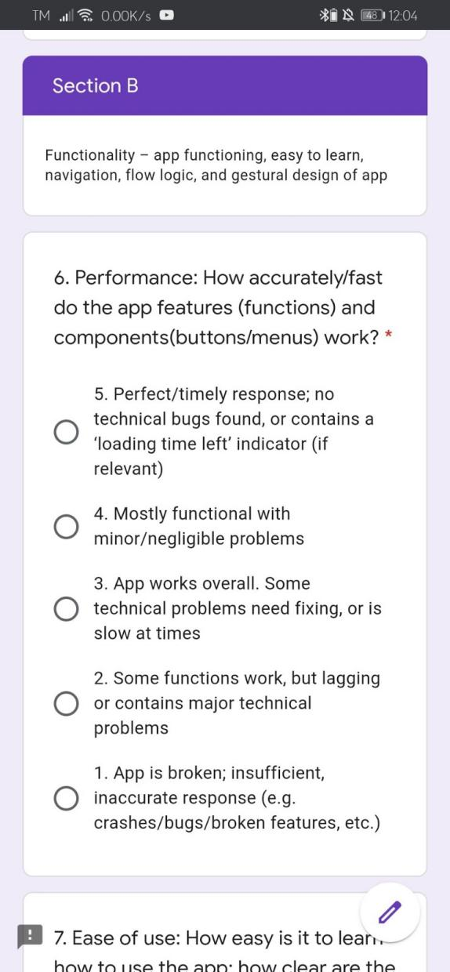**

**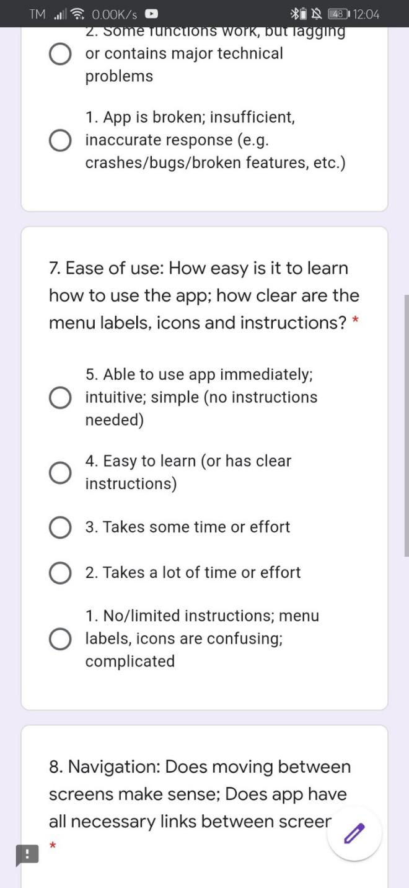**

**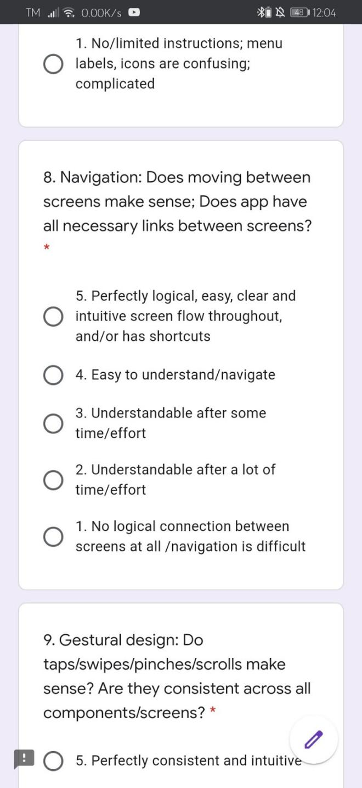**

**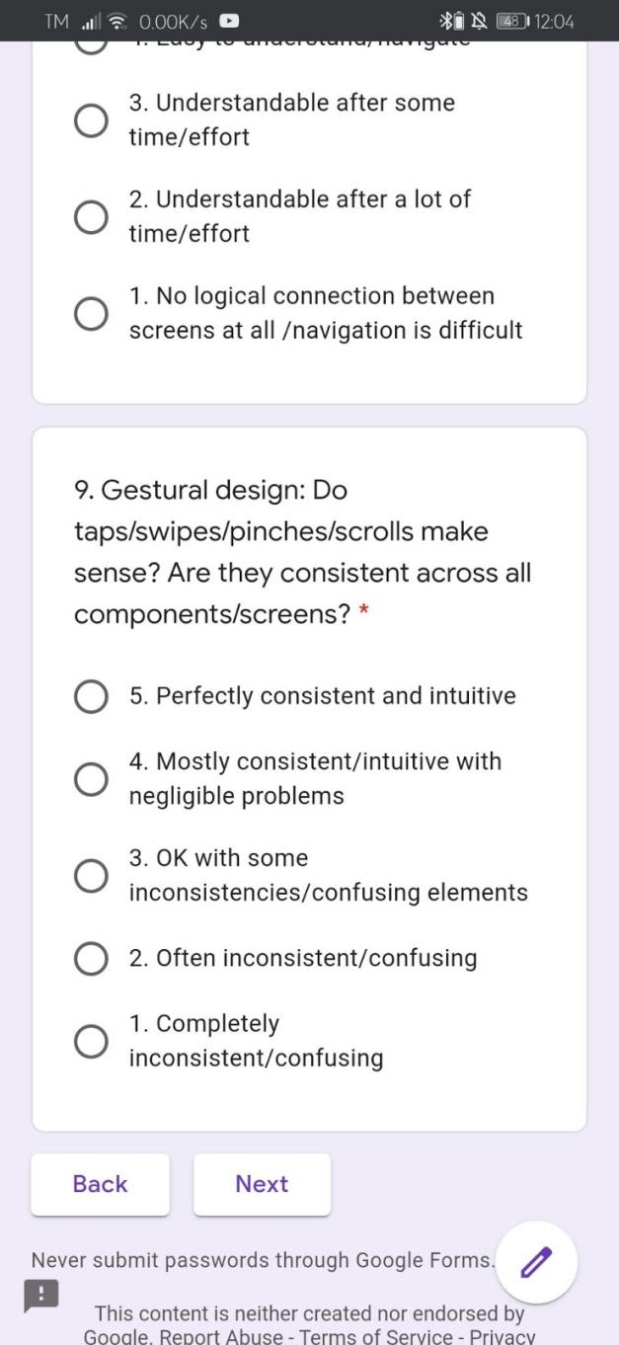**

**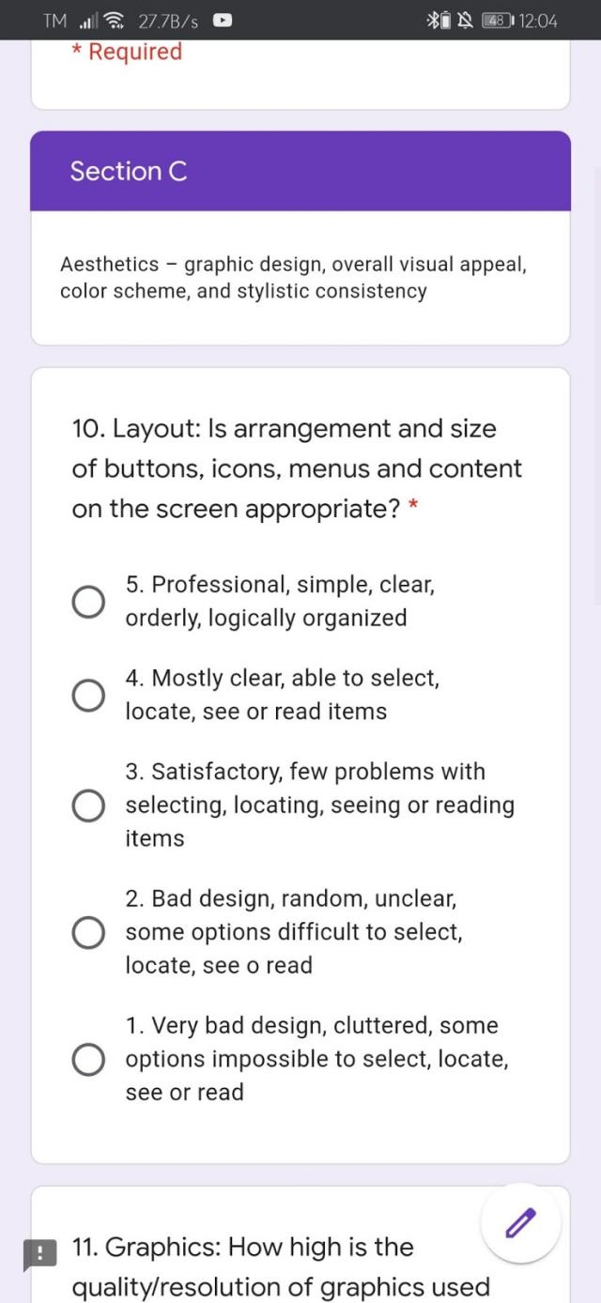**

**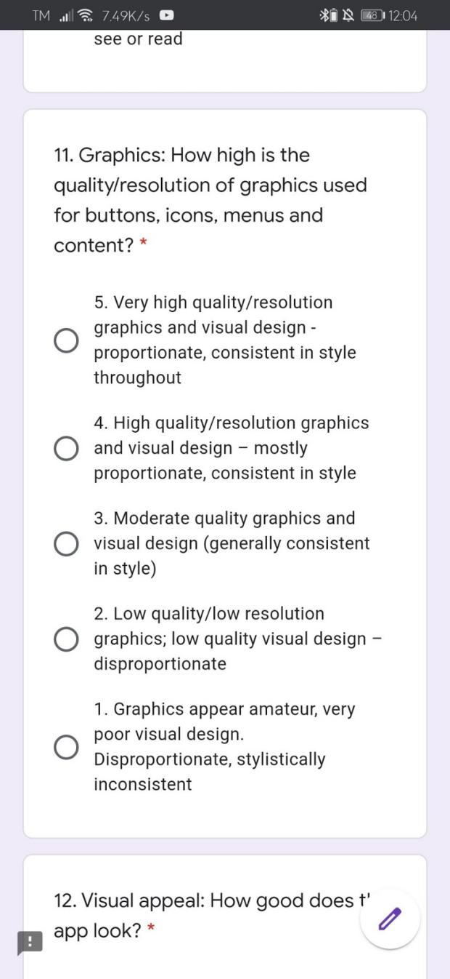**

**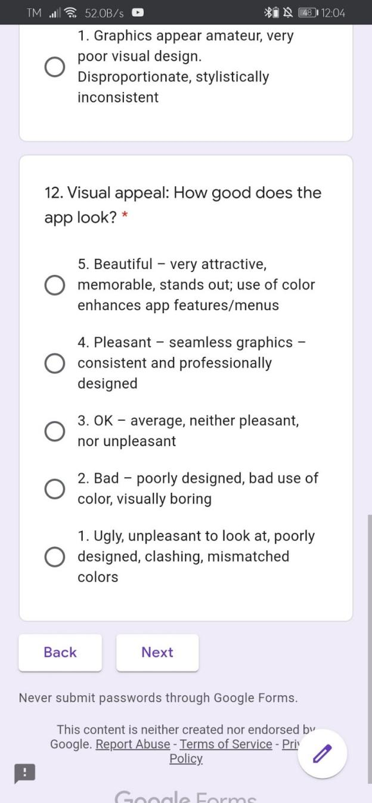**

**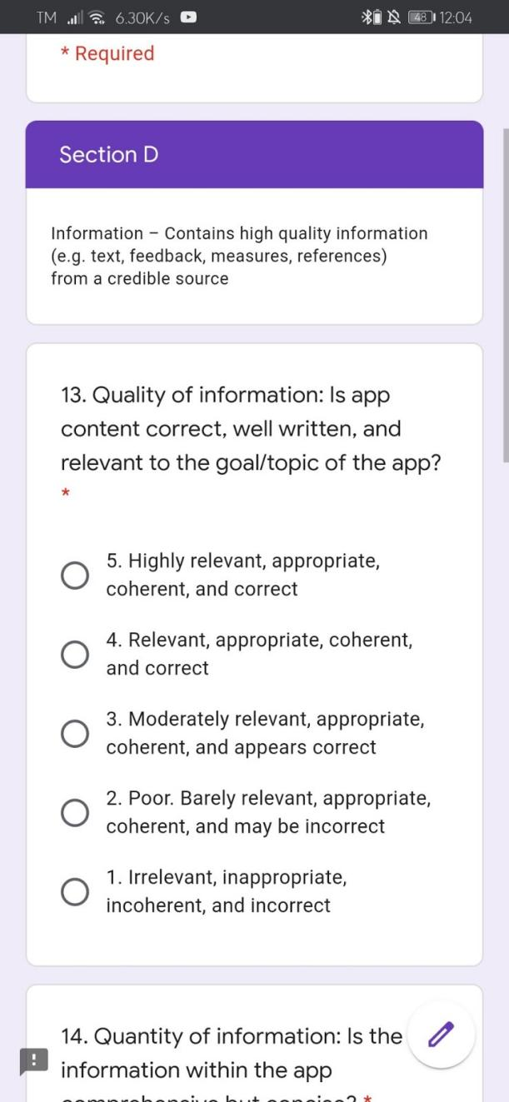**

**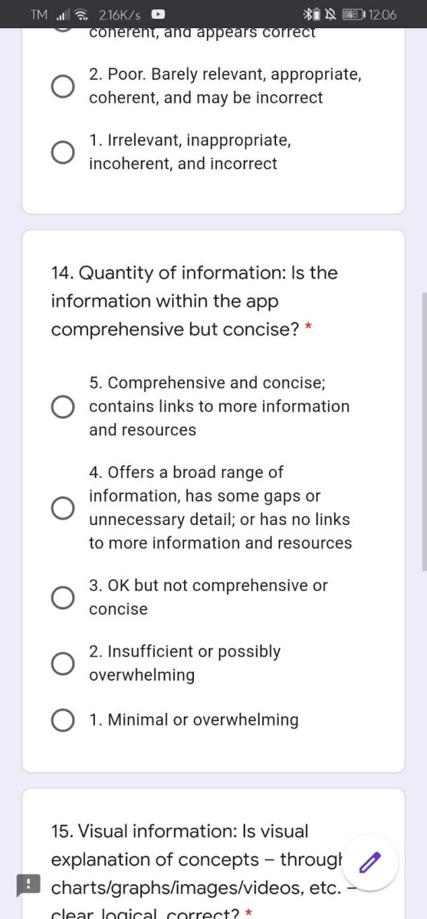**

**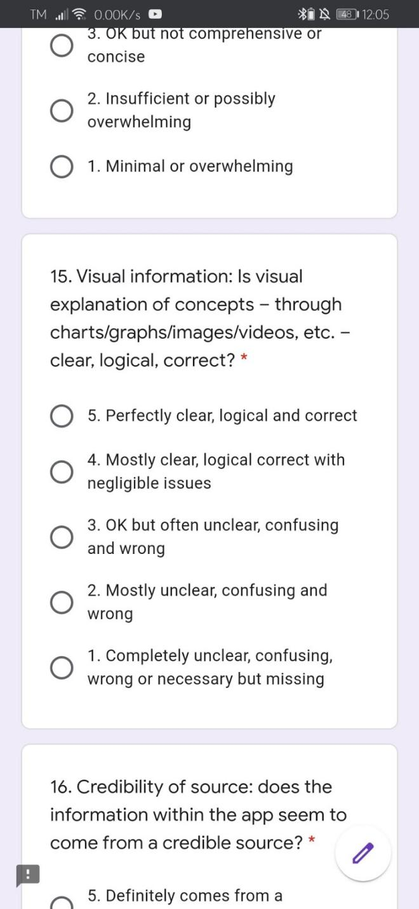**

**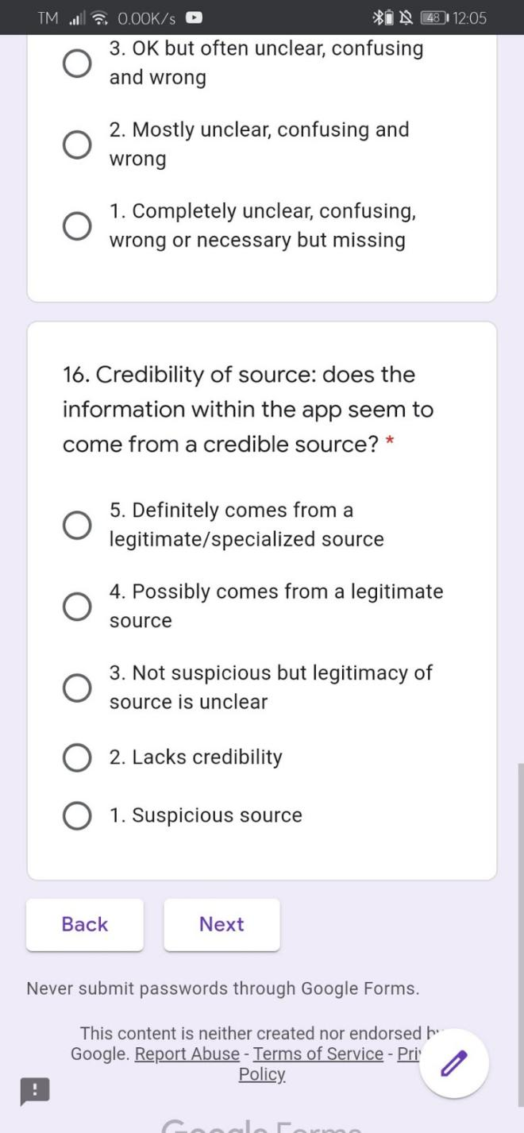**

**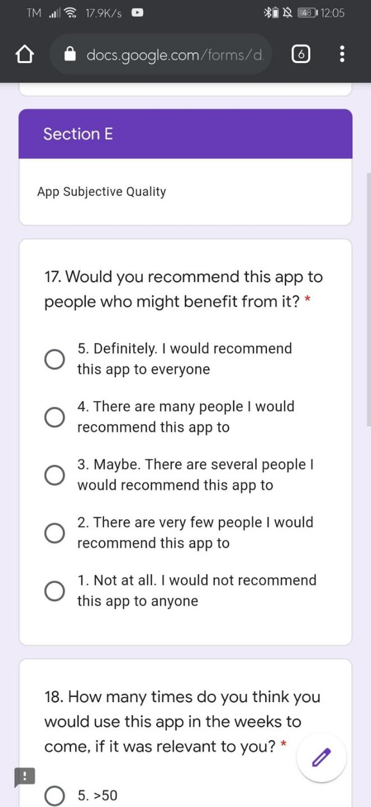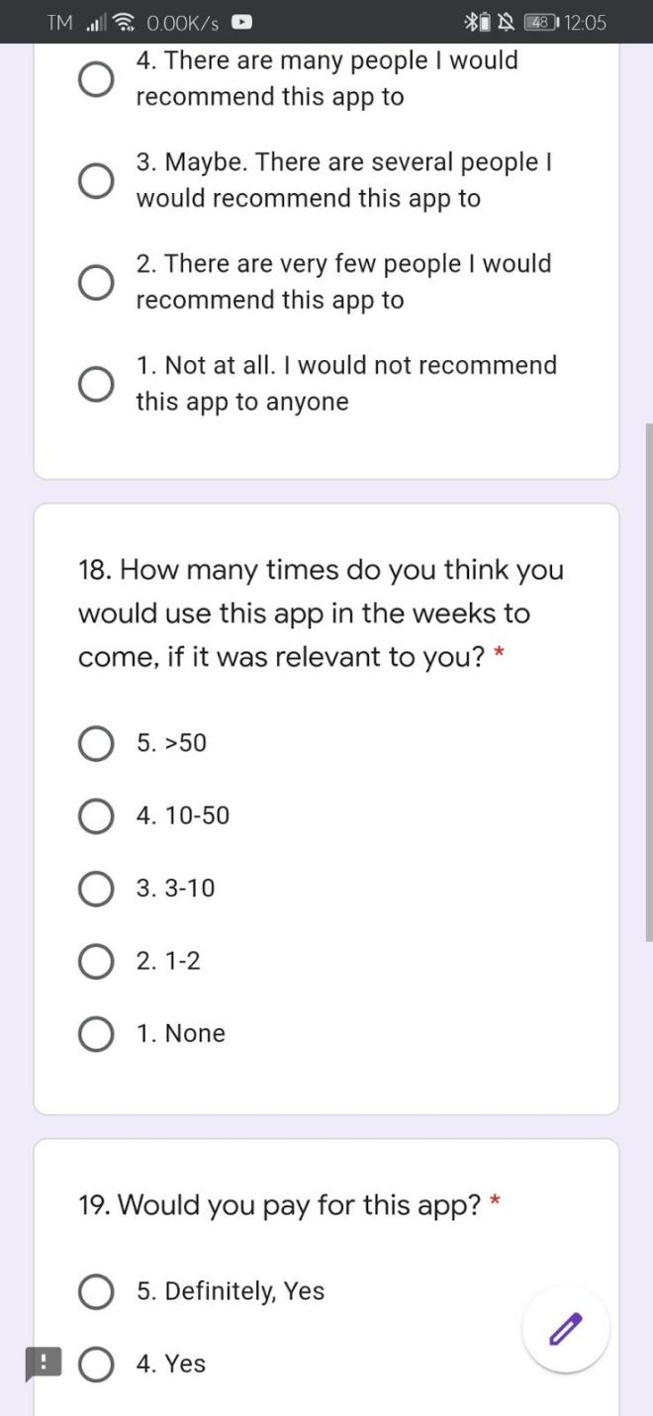**

**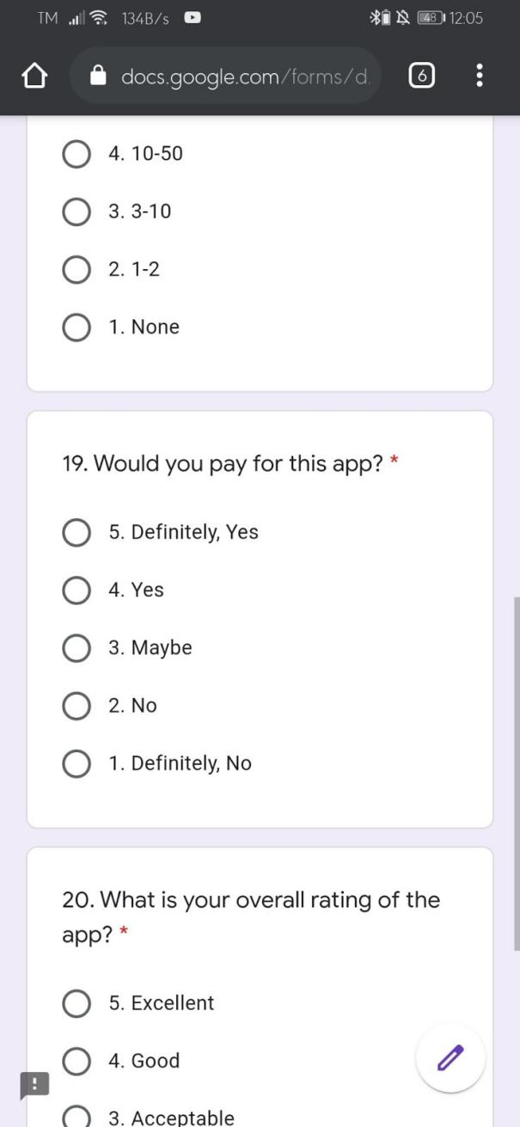**

**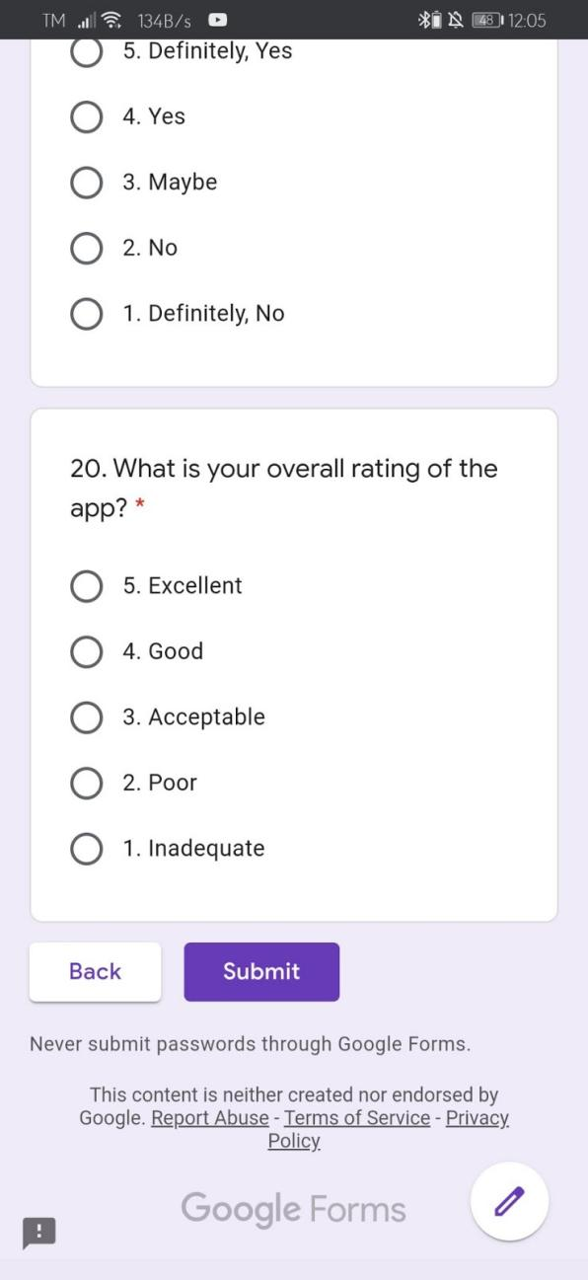**

**APPENDIX B**

**USER’S MANUAL**

**Welcome Screen**

**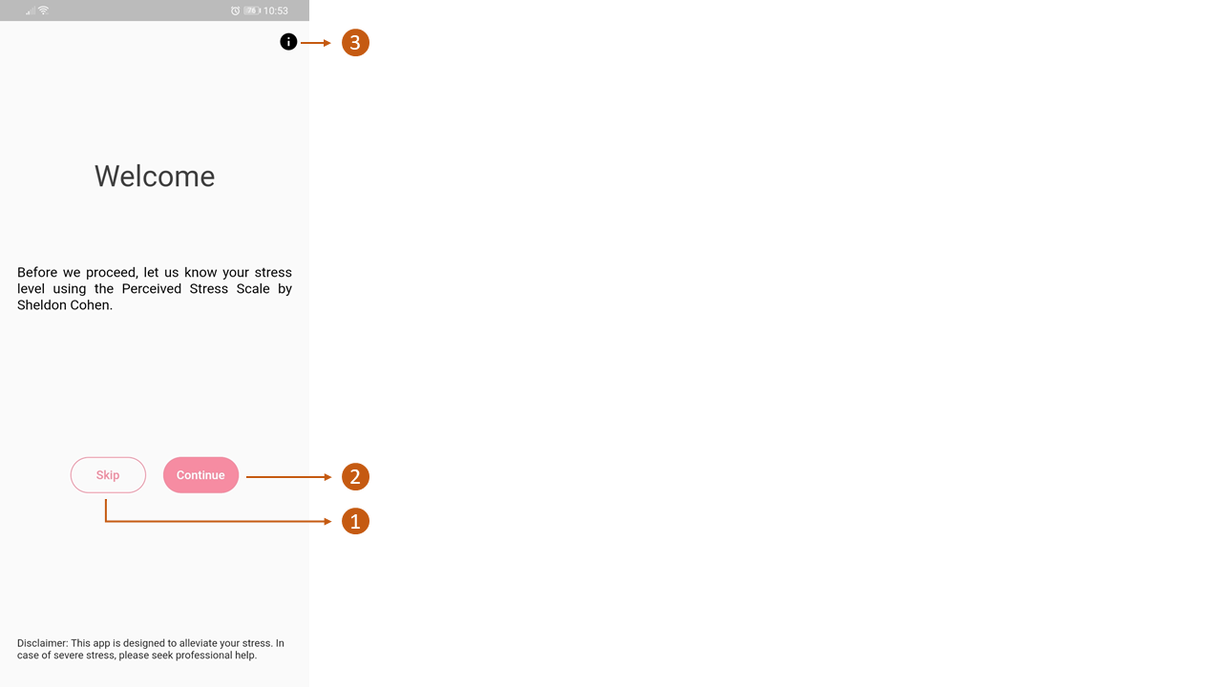**

1. **Skip Button.** If the user doesn't want to continue with the assessment.
2. **Continue Button.** If the user wants to continue with the assessment.

**‘ i ’ Button.** For more information about the Perceived Stress Scale.

**Assessment Screen**

**1st Screen**

1. **Answer Button**
2. **Cancel Button.** If the user wishes to stop the assessment.

**2nd Screen**

1. **Score and Interpretation**
2. **Suggested intervention.** These are clickable.
3. **Clickable Link.** This will lead to an article about a guidance counselor.
4. **Done Button**

**Landing Screen**

1. **Different kinds of audio for relaxation.** Clickable

**Navigation Bar.** Consist of ‘Relaxation’, ‘Journal’, and ‘Learn More’ buttons

**Audio Player and Thoughts/Reflection Screen**

****

**1st Screen**

1. **Header Buttons.** Consist of ‘Back’ button and  ‘i’ button for media credits.
2. **Play Button**
3. **Text Button.** Click to download audio for offline listening.

**2nd Screen**

* After the audio is finished playing. The app will redirect the user to this page, indicating that the user already finished their relaxation session. In this screen, the user can write their thoughts or reflections after their relaxation session. It will be then stored on the journal page.

**Journal Screens**

**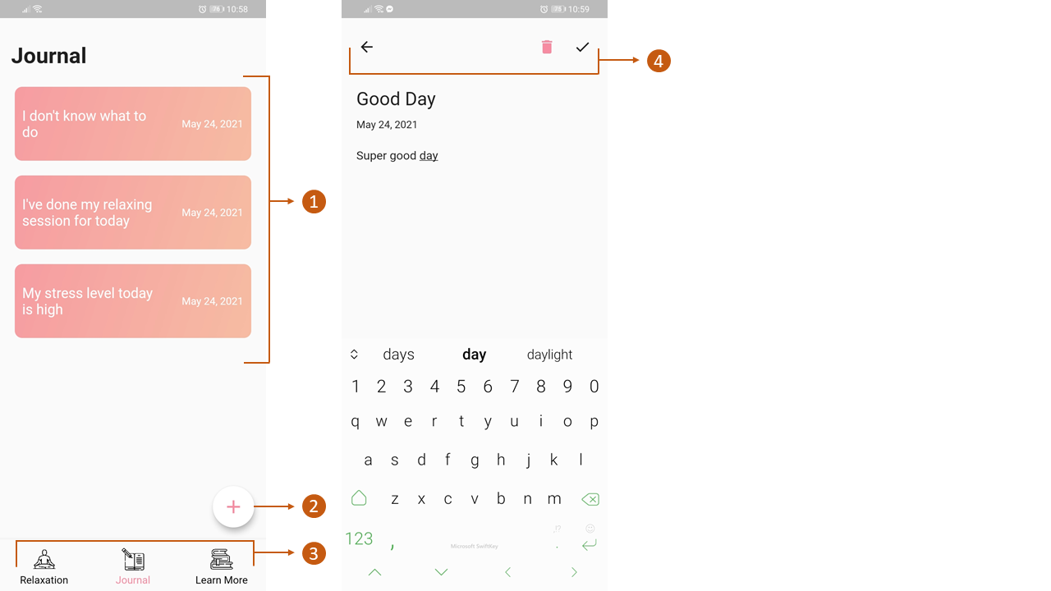**

**1st Screen**

1. **Journal Entries.** Clickable for viewing, editing, or deleting.
2. **Add Button.** For adding new journal entries.
3. **Navigation Bar**

**2nd Screen**

**Header Buttons.** Consist of ‘Back’, ‘Delete’, and ‘Save’ buttons, respectively.

**List of Articles Screen**

**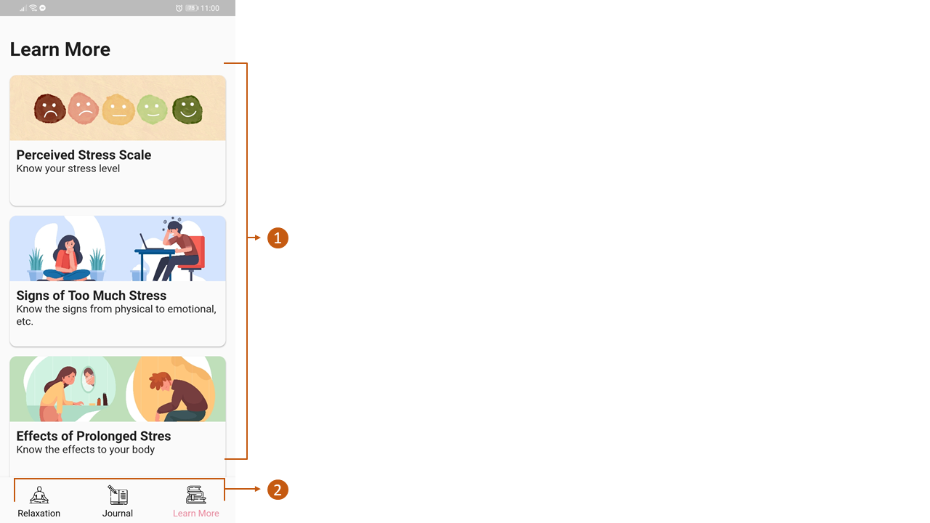**

1. **List of articles.** Clickable.
2. **Navigation Bar**

**Article Screen**

**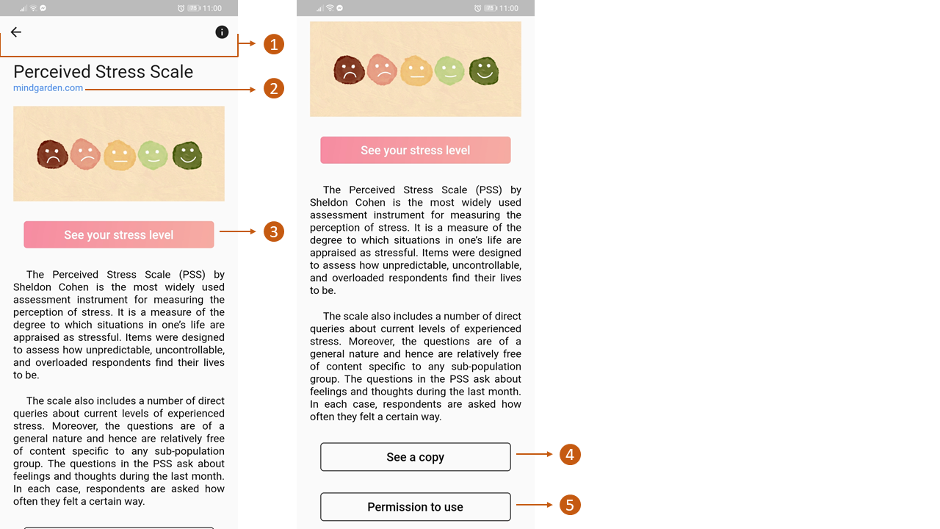**

**1st Screen**

1. **Header Buttons.** Consist of ‘Back’ button and ‘i’ button to see media credits.
2. **Clickable Link.** Link to the full article of the featured topic.
3. **Assessment Button.** Button to go to the assessment screen. This is for the user to assess their stress levels again.

**2nd Screen**

1. **Send a Copy Button.** To download a PDF copy of the Perceived Stress Scale.
2. **Permission to Use Button.** Click to see the permission of the author of Perceived Stress Scale to use the scale.