WINDOW CLEANING ROBOTS
Illustrated engineering and procurement report • 2026 edition
Five representative commercial/home window-cleaning robots
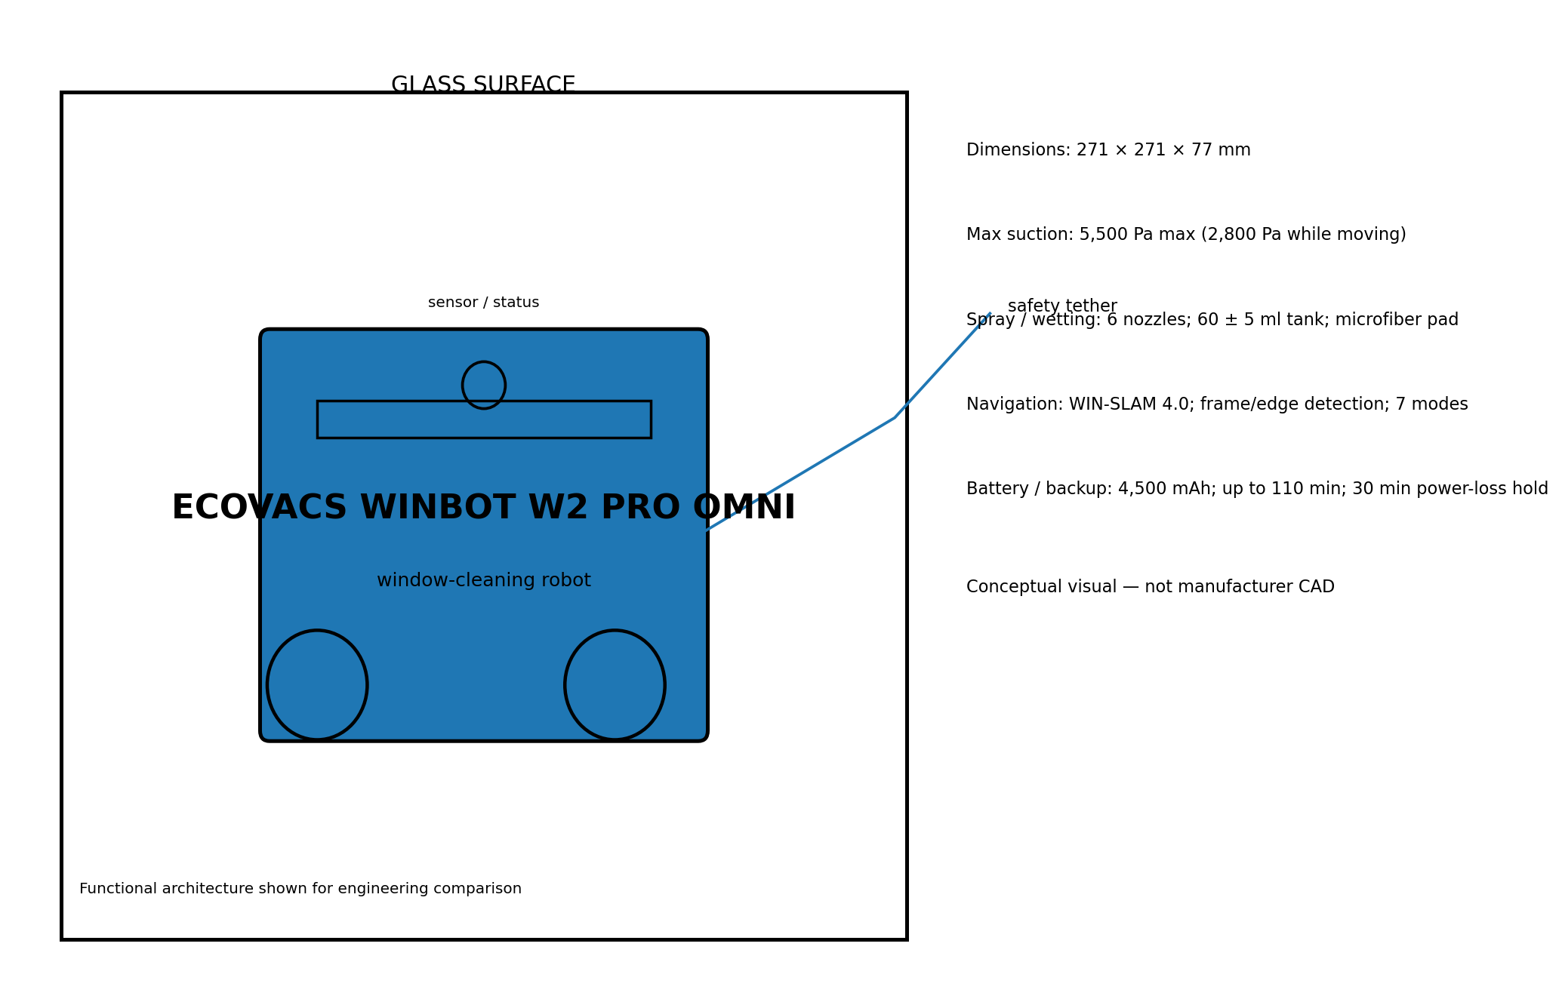
ECOVACS WINBOT W2 PRO OMNI • HOBOT S7 PRO • HOBOT-2S • HUTT DDC55 PRO • DREAME C1

Executive Summary
Window-cleaning robots are generally wall-climbing cleaning machines that combine negative-pressure adhesion, traction, wet or dry wiping, edge detection and a tether/backup power system. The market has moved from simple corded vacuum cleaners toward products with route planning, adaptive pressure control, mobile apps and portable stations.
Robot | Observed price | Core differentiator | Position
ECOVACS WINBOT W2 PRO OMNI | $499.99 US list/current official price; €449 on ECOVACS Germany | Portable station + WIN-SLAM 4.0 | Top overall
HOBOT S7 PRO | Observed 2026 market price about €322–€399; price varies by region | 600-stroke/min dual mop + ultrasonic mist | Specialized scrubbing
HOBOT-2S | $299 official US sale price (listed from $349) | Ultrasonic spray + mature corded design | Best mature-value option
HUTT DDC55 PRO | Observed around €189–€200 / about CHF 180 at launch; regional pricing varies | Low-cost dual-disk architecture | Budget / broad surfaces
DREAME C1 | Observed €199 promotional price in Italy; €399 stated recommended retail price | CornerClean + Z/N planning | Strong value
Bottom line: ECOVACS W2 PRO OMNI is the most complete workflow-oriented system in this set. Dreame C1 is especially attractive when corner coverage and promotional pricing matter. HOBOT-2S remains a mature ultrasonic-spray design with a relatively low purchase price, while HUTT DDC55 PRO emphasizes value. HOBOT S7 PRO is technically distinctive but its independent 2026 test results indicate slower cleaning, high noise and a short emergency mode relative to newer station-equipped competitors.

Scope, Method and Data Quality
- Products covered: the five models carried forward from the requested shortlist.
- Specifications are taken primarily from manufacturer pages; current prices are market observations and can change by country, retailer, tax and promotion.
- Where independent 2026 testing conflicts with marketing claims, both are identified rather than silently averaged.
- Exploded views are functional architecture diagrams, not proprietary internal CAD drawings.
- Performance claims such as cleaning coverage, noise and battery runtime should be treated as manufacturer-test conditions unless independently measured.
- For commercial/high-rise deployment, site-specific risk assessment is required; consumer robot safety claims are not equivalent to a certified façade-access system.
Price convention
Prices are shown in the currency reported by the source when a reliable current figure was available. No artificial currency conversion is used in the core comparison because exchange rates and regional retail pricing change.

How a Window-Cleaning Robot Works
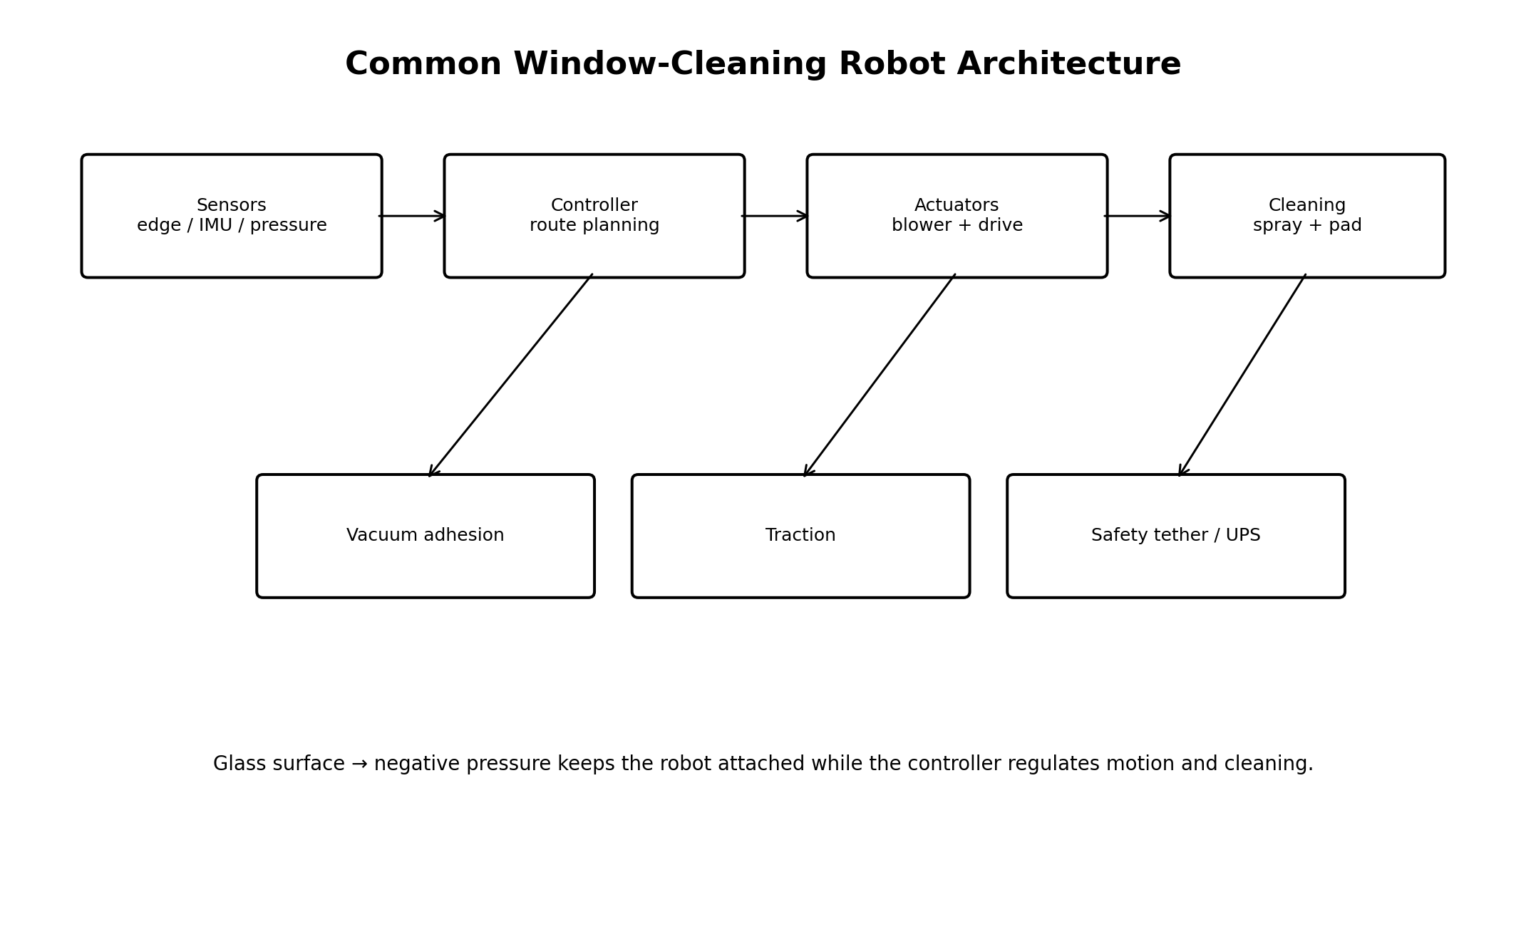
Generic functional architecture shared by most modern glass-climbing cleaning robots.

Adhesion Physics and Fall Protection
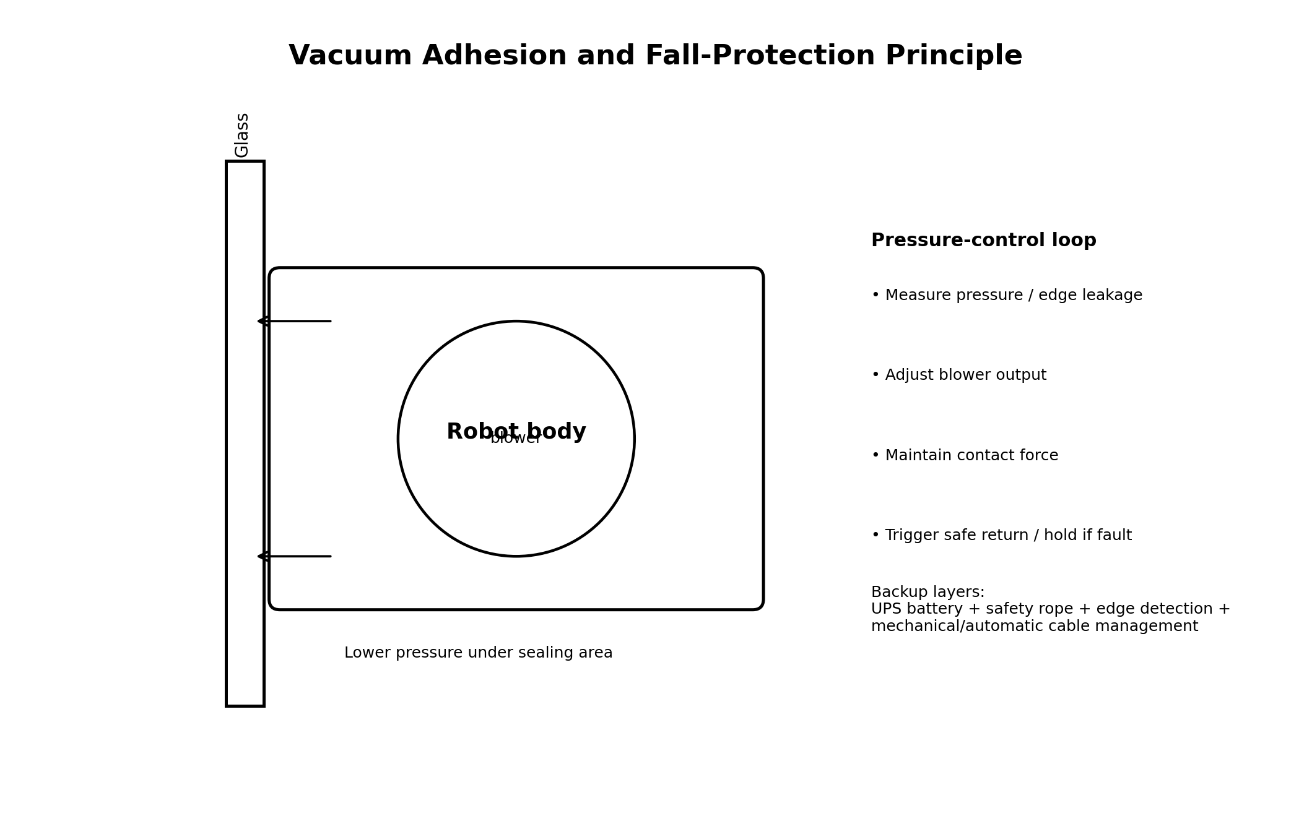
Negative pressure creates a normal force; control electronics regulate adhesion while independent safety layers limit fall risk.

Navigation and Cleaning Paths
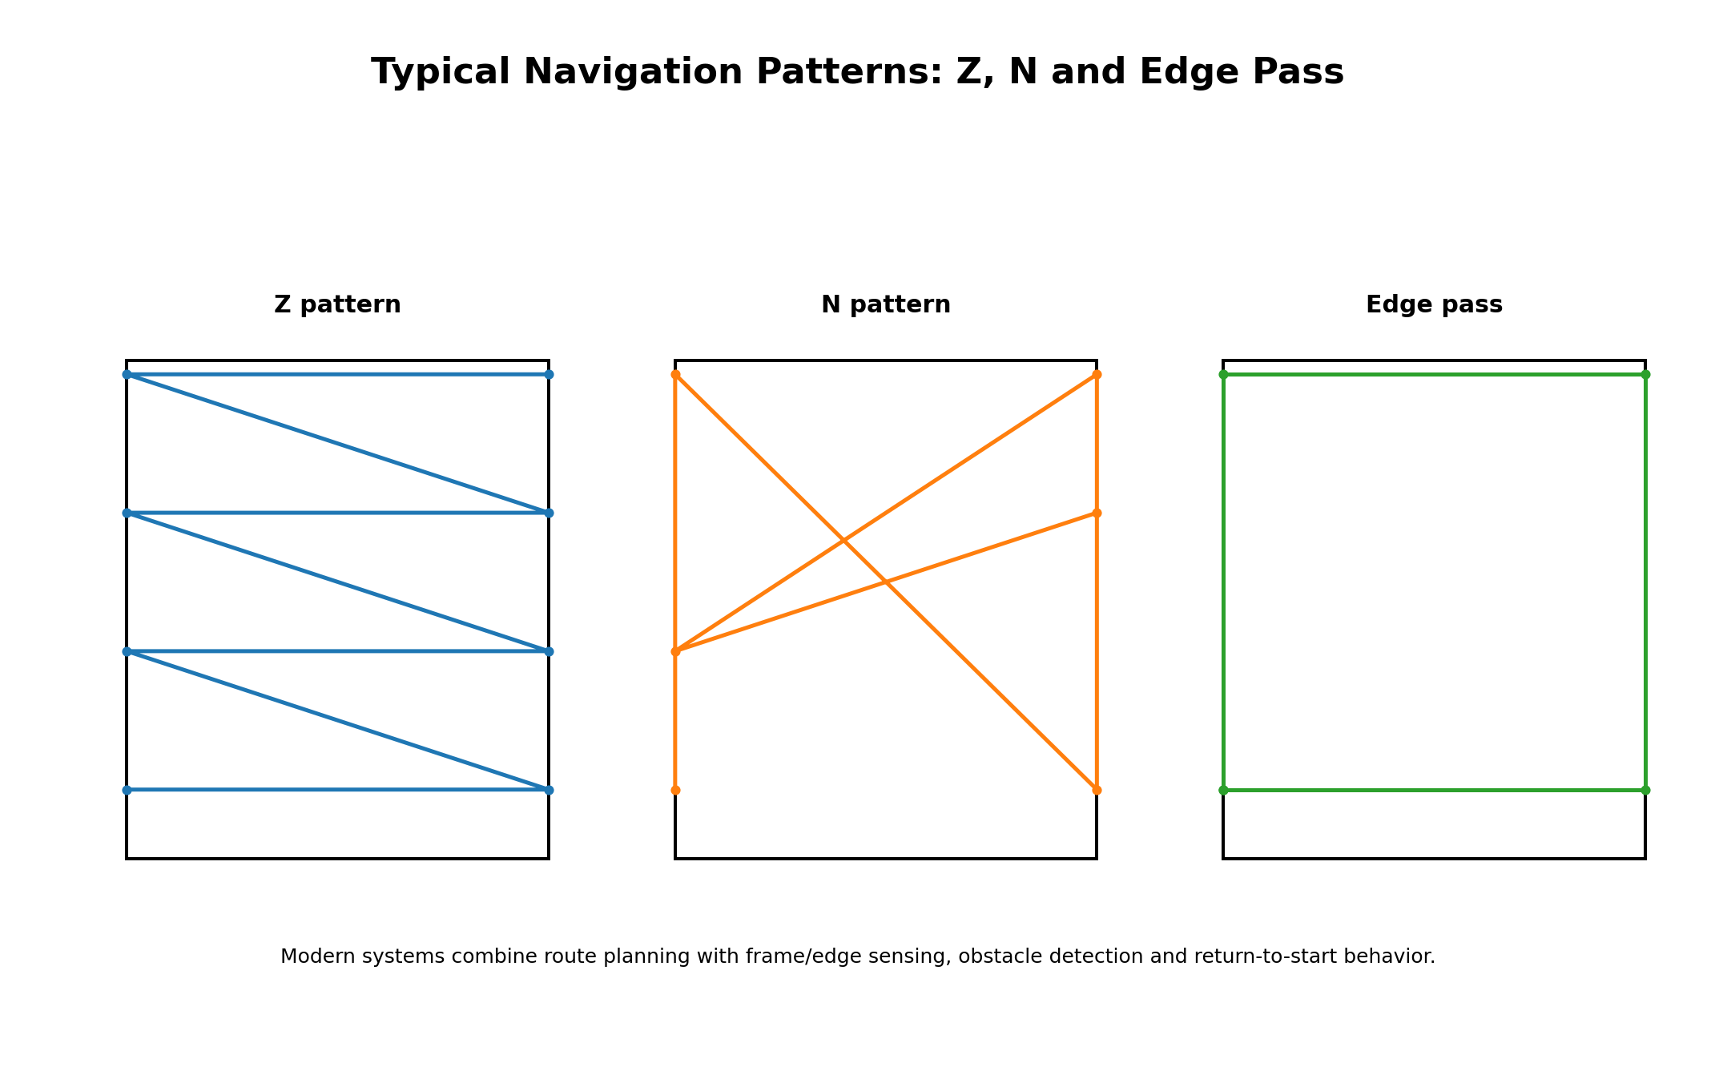
Typical Z/N/edge patterns. Actual route logic varies by model and sensor suite.

Operating Mechanism: Adhesion, Traction and Cleaning
A window robot has to solve three coupled mechanical problems: stay attached, move without slipping, and transfer enough mechanical/chemical energy into the glass to remove contamination. Negative pressure provides the attachment force, while wheels, belts or rotating mop assemblies create tangential traction. A cleaning pad then applies normal pressure and shear to the glass. Water or cleaning solution reduces surface energy and helps suspend contaminants.
Subsystem | Engineering role | Typical failure mode | Design response
Vacuum blower | Generate negative pressure | Leak, blocked intake, loss of power | Pressure sensing, compensation, UPS, tether
Traction | Convert adhesion into motion | Wet slip / dirty tracks | High-friction drive, pressure control
Cleaning pad | Apply shear and absorb liquid | Saturation, streaks, wear | Washable microfiber, replaceable pads
Spray | Wet and loosen contamination | Clogging / over-wetting | Ultrasonic or pulse spray, metering
Edge sensing | Detect pane boundary | False edge / frame geometry | Optical/pressure sensors + route correction
Controller | Coordinate all functions | Localization or sensor error | Fallback route, return-to-start, voice/app alerts

Safety Architecture
- Primary adhesion: vacuum blower and sealed contact region.
- Pressure compensation: dynamically increases or stabilizes suction when leakage or surface variation is detected.
- Edge detection: detects the end of usable glass before the robot drives beyond the pane.
- Emergency power: a small battery maintains suction long enough for the robot to remain attached or for an operator to intervene.
- Physical tether: a separate load path limits consequences if adhesion is lost.
- Station anchoring: portable stations such as the ECOVACS and Dreame Station designs can add a second level of restraint.
- Software fallback: low-battery return, route resume and status alarms reduce operator workload but do not eliminate supervision.
Important engineering note
For exterior high-rise use, the tether must be treated as life-safety equipment only when its anchorage, load rating, inspection and operating procedure are appropriate to the actual installation. A consumer robot should not be treated as a substitute for a certified rope-access or façade-maintenance system.

Cross-Model Specification Comparison
Model | Robot size | Weight | Adhesion / suction | Backup / battery | Navigation
ECOVACS WINBOT W2 PRO OMNI | 271 × 271 × 77 mm | 1.6 kg robot; 5.5 kg station | 5,500 Pa max (2,800 Pa while moving) | 4,500 mAh; up to 110 min; 30 min power-loss hold | WIN-SLAM 4.0; frame/edge detection; 7 modes
HOBOT S7 PRO | 262 × 264 × 89 mm | about 1.7–3.0 kg depending on source/market configuration | 4,800 Pa | about 20 min normal backup; ~26–27 min measured emergency hold in 2026 test | AI / gyro-assisted route planning; Z/N patterns; app + remote
HOBOT-2S | 240 × 240 × 86 mm | 1.3 kg | 6.0 kgf adhesive force (manufacturer specification) | 20 min UPS / emergency hold | AI Technology V4; gyro; four edge-leakage sensors; zigzag / N-way
HUTT DDC55 PRO | compact body; roughly 1–1.1 kg in current listings | about 1.1 kg in a 2026 commercial listing | 5,400 Pa manufacturer claim | manufacturer/market listings report emergency retention around 30 min | HUTTHINK variable-frequency algorithm; AI sensors; obstacle avoidance
DREAME C1 | 270 × 270 × 80.5 mm | 1.6 kg | 5,500 Pa max; 3,300 Pa maintained during normal operation | corded robot; C1 Station variant has 7,800 mAh / up to 180 min | AI path planning; Z/N selection; >10 sensors; edge detection
Model | Spray / tank | Modes | App | Station | Typical use
W2 PRO OMNI | 6 nozzles / 60 ml | 7 | Yes | Yes | Large / hard-to-reach glass
S7 PRO | Ultrasonic / ~52 ml test | Several | Yes | No | Active scrubbing
HOBOT-2S | 2×26 ml ultrasonic | 3 | Yes | No | Home / office
DDC55 PRO | Pulse / 80 ml | Multiple | Remote | No | Budget / broad surfaces
Dreame C1 | Dual / 80 ml | 5 | Yes | C1 Station optional | Corner-focused cleaning

Procurement Decision Framework
Priority | Best fit | Why
Maximum convenience | W2 PRO OMNI | Portable station, battery operation, automatic cable management
Corner coverage | Dreame C1 | CornerClean four-brush architecture
Ultrasonic spray | HOBOT-2S / S7 PRO | Fine mist designed to reduce over-wetting
Lowest observed entry price | DDC55 PRO | Observed around €189–€200
Mature corded value | HOBOT-2S | Official $299 sale price with long cable and UPS
Large continuous panes | W2 PRO OMNI / C1 Station | Station-based workflows and long operating envelopes
Key buying variables
- Pane geometry: framed, frameless, segmented, corner-heavy or floor-to-ceiling.
- Access: interior, exterior, balcony, skylight or overhead glass.
- Operator model: occasional homeowner use vs. repeated facility-maintenance cycles.
- Consumables: pad replacement, detergent, water tank and nozzle maintenance.
- Safety: tether length, anchor point, emergency hold time and station anchoring.
- Economics: purchase price is only one part of total cost; labor displacement and setup time can dominate.

ECOVACS WINBOT W2 PRO OMNI
Product overview and engineering position

Best overall for large residential glass and difficult-to-reach panes; strongest combination of station, autonomy, safety and workflow convenience.
Parameter | Reported value
Observed price | $499.99 US list/current official price; €449 on ECOVACS Germany
Dimensions | 271 × 271 × 77 mm
Weight | 1.6 kg robot; 5.5 kg station
Adhesion | 5,500 Pa max (2,800 Pa while moving)
Spray / wetting | 6 nozzles; 60 ± 5 ml tank; microfiber pad
Navigation | WIN-SLAM 4.0; frame/edge detection; 7 modes
Battery | 4,500 mAh; up to 110 min; 30 min power-loss hold
Source basis: ECOVACS official W2 PRO OMNI product page; ECOVACS Germany product page — https://www.ecovacs.com/us/shop/winbot-window-cleaning-robot/winbot-w2-pro-omni

ECOVACS WINBOT W2 PRO OMNI — Detailed Specifications
Specification | Reported value
Robot size | 271 × 271 × 77 mm
Robot mass | 1.6 ± 0.1 kg
Station mass | 5.5 ± 0.2 kg
Max suction | 5,500 ± 500 Pa
Suction while moving | 2,800 Pa
Battery | 4,500 mAh / 24 V
Runtime | 110 ± 10 min
Power-off protection | 30 min
Tank | 60 ± 5 ml
Cleaning speed | ~1 min 45 s/m² in fast mode
Fast-mode area | ~55 m²
Deep-mode area | ~22 m²
Minimum window | 30 × 40 cm
Min. glass thickness | 3 mm
Noise | 63 dB minimum
Route planning | WIN-SLAM 4.0
Cleaning modes | 7
Cord | 5.5 m DC; automatic take-up
Source basis: ECOVACS official W2 PRO OMNI product page; ECOVACS Germany product page — https://www.ecovacs.com/us/shop/winbot-window-cleaning-robot/winbot-w2-pro-omni

ECOVACS WINBOT W2 PRO OMNI — Functional Exploded View
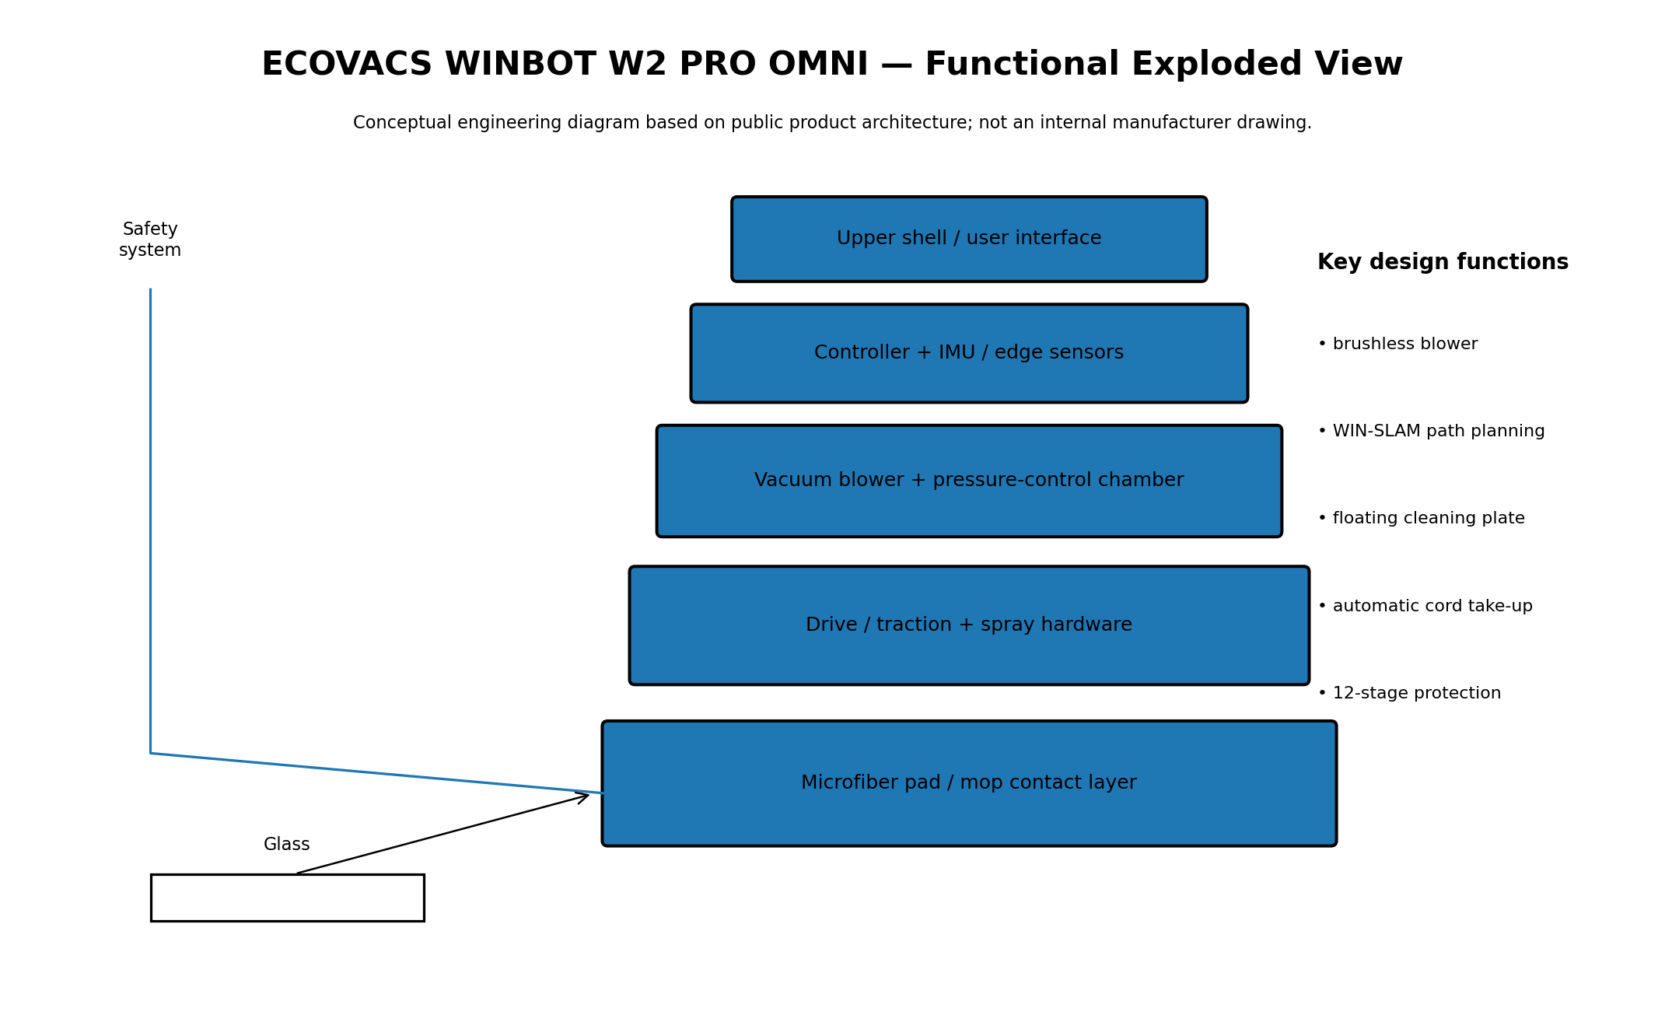
Conceptual decomposition for engineering discussion; internal geometry and component count may differ from production hardware.

ECOVACS WINBOT W2 PRO OMNI — Engineering Evaluation
Best overall for large residential glass and difficult-to-reach panes; strongest combination of station, autonomy, safety and workflow convenience.
Engineering strengths
- brushless blower
- WIN-SLAM path planning
- floating cleaning plate
- automatic cord take-up
- 12-stage protection
Primary limitations / watch-outs
- Confirm actual regional price and SKU.
- Verify minimum pane geometry.
- Inspect pad / nozzle consumables.
- Use tether and supervision for exterior glass.
- Treat manufacturer performance numbers as test-condition claims.
Source basis: ECOVACS official W2 PRO OMNI product page; ECOVACS Germany product page — https://www.ecovacs.com/us/shop/winbot-window-cleaning-robot/winbot-w2-pro-omni

HOBOT S7 PRO
Product overview and engineering position
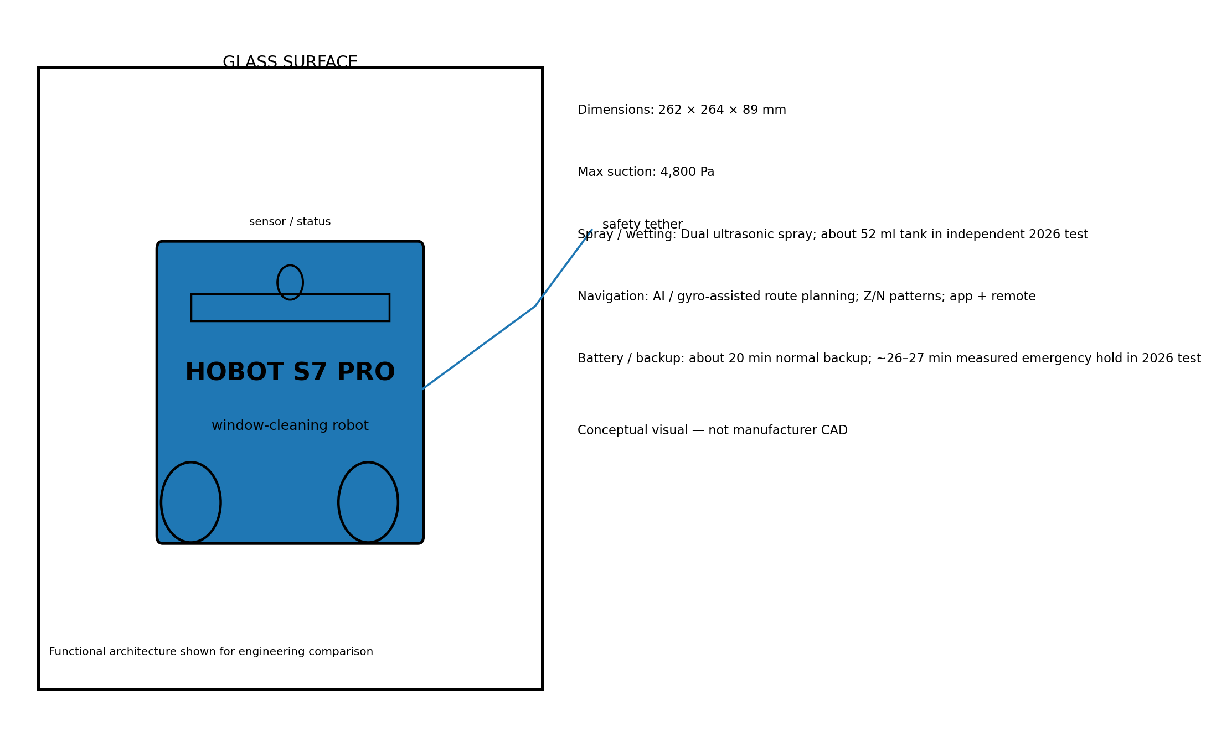
Interesting for active scrubbing and ultrasonic mist, but less compelling than newer station-equipped competitors when speed, noise and edge finish dominate.
Parameter | Reported value
Observed price | Observed 2026 market price about €322–€399; price varies by region
Dimensions | 262 × 264 × 89 mm
Weight | about 1.7–3.0 kg depending on source/market configuration
Adhesion | 4,800 Pa
Spray / wetting | Dual ultrasonic spray; about 52 ml tank in independent 2026 test
Navigation | AI / gyro-assisted route planning; Z/N patterns; app + remote
Battery | about 20 min normal backup; ~26–27 min measured emergency hold in 2026 test
Source basis: HOBOT official S7 Pro page; CHIP 2026 independent test — https://www.hobot.com.tw/hobot-s7/

HOBOT S7 PRO — Detailed Specifications
Specification | Reported value
Robot size | 262 × 264 × 89 mm
Mass | ~1.7 kg in CHIP 2026 test
Max suction | 4,800 Pa
Cleaning motion | Dual reciprocating pads; 600/min
Stroke | 4 mm
Spray | Dual ultrasonic, 15 μm
Tank | 52 ml in CHIP 2026 test
Power cable | 6.4 m in CHIP test
Safety line | 4.3 m in CHIP test
Control | App + remote
Noise | 31.8 sone in CHIP test
Emergency hold | ~26 min 34 s measured
Route patterns | Z / N / spot / manual
Station | None
Source basis: HOBOT official S7 Pro page; CHIP 2026 independent test — https://www.hobot.com.tw/hobot-s7/

HOBOT S7 PRO — Functional Exploded View
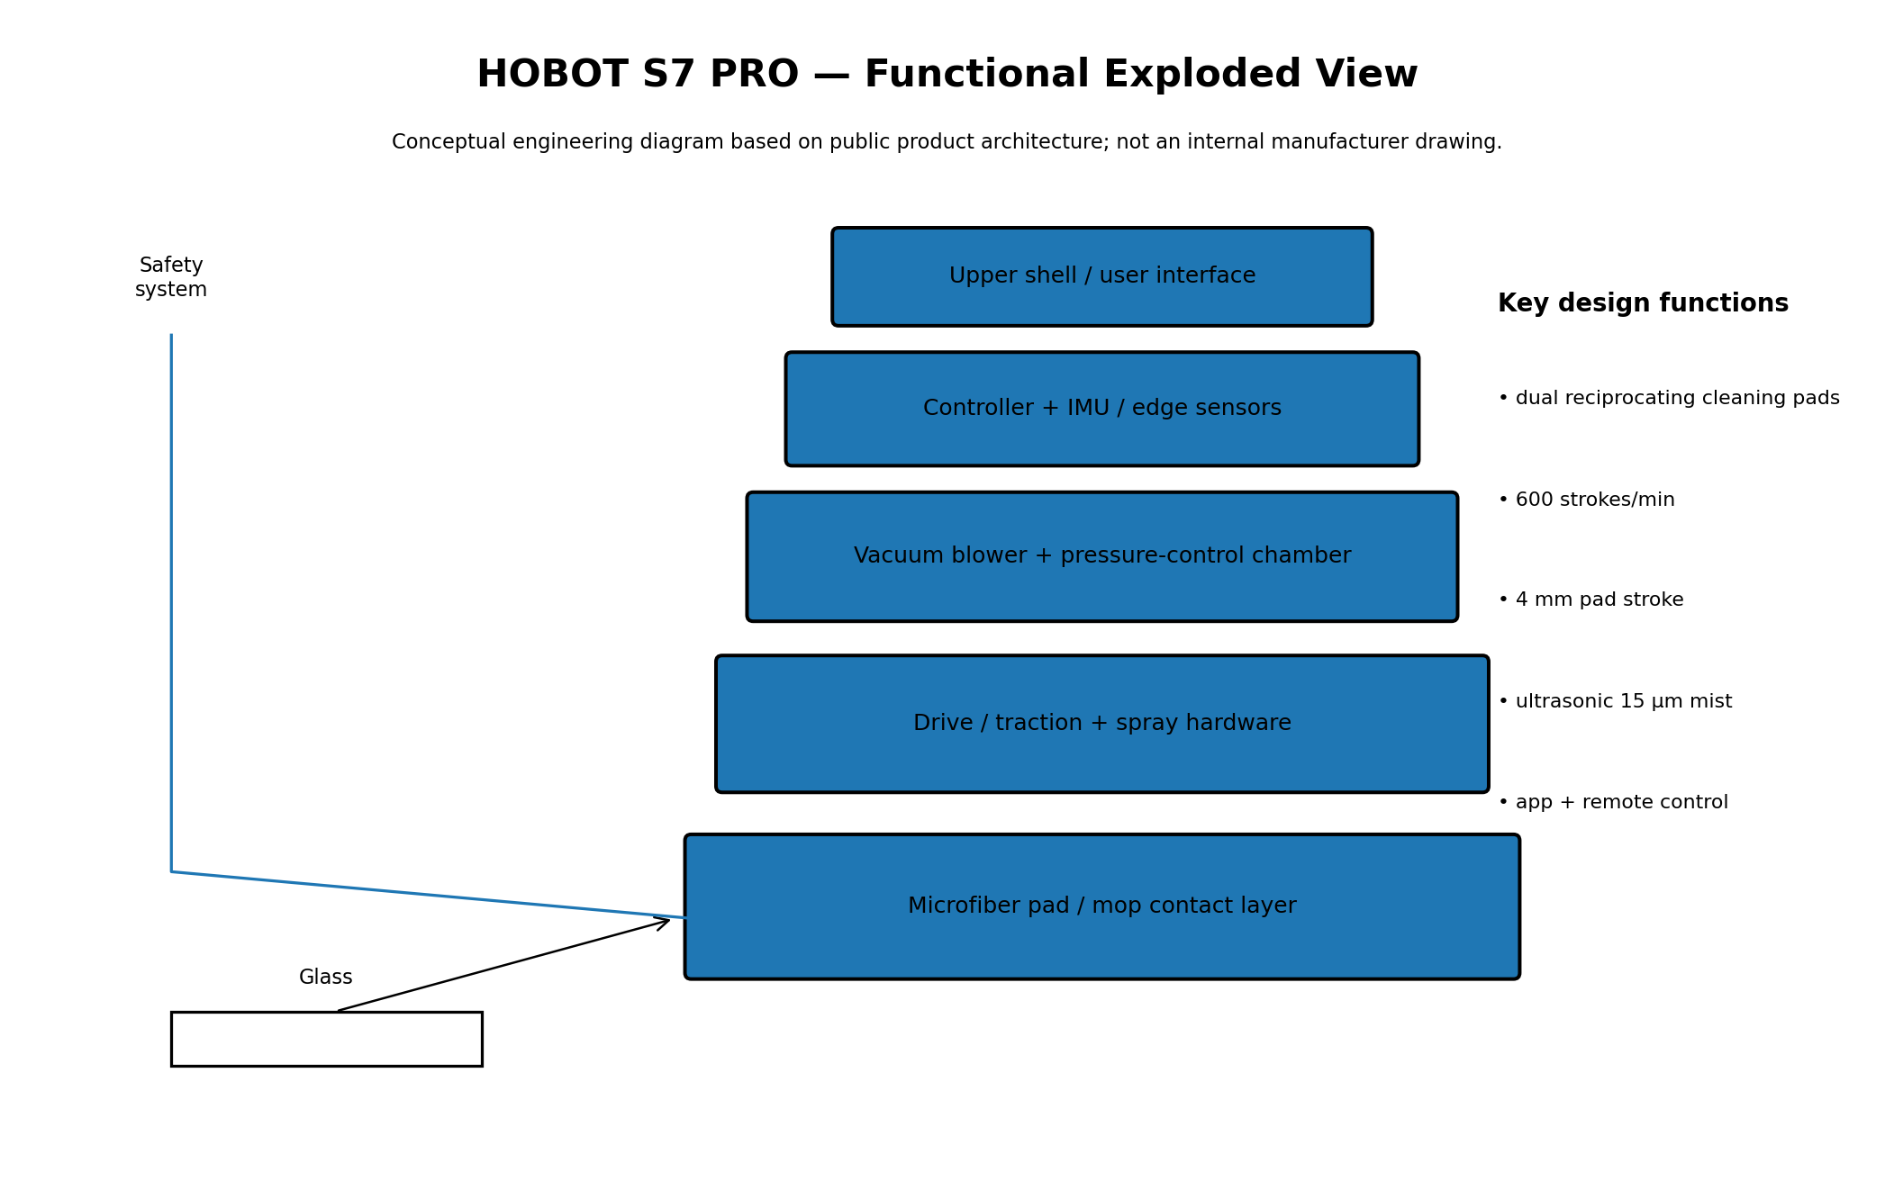
Conceptual decomposition for engineering discussion; internal geometry and component count may differ from production hardware.

HOBOT S7 PRO — Engineering Evaluation
Interesting for active scrubbing and ultrasonic mist, but less compelling than newer station-equipped competitors when speed, noise and edge finish dominate.
Engineering strengths
- dual reciprocating cleaning pads
- 600 strokes/min
- 4 mm pad stroke
- ultrasonic 15 μm mist
- app + remote control
Primary limitations / watch-outs
- Confirm actual regional price and SKU.
- Verify minimum pane geometry.
- Inspect pad / nozzle consumables.
- Use tether and supervision for exterior glass.
- Treat manufacturer performance numbers as test-condition claims.
Source basis: HOBOT official S7 Pro page; CHIP 2026 independent test — https://www.hobot.com.tw/hobot-s7/

HOBOT-2S
Product overview and engineering position
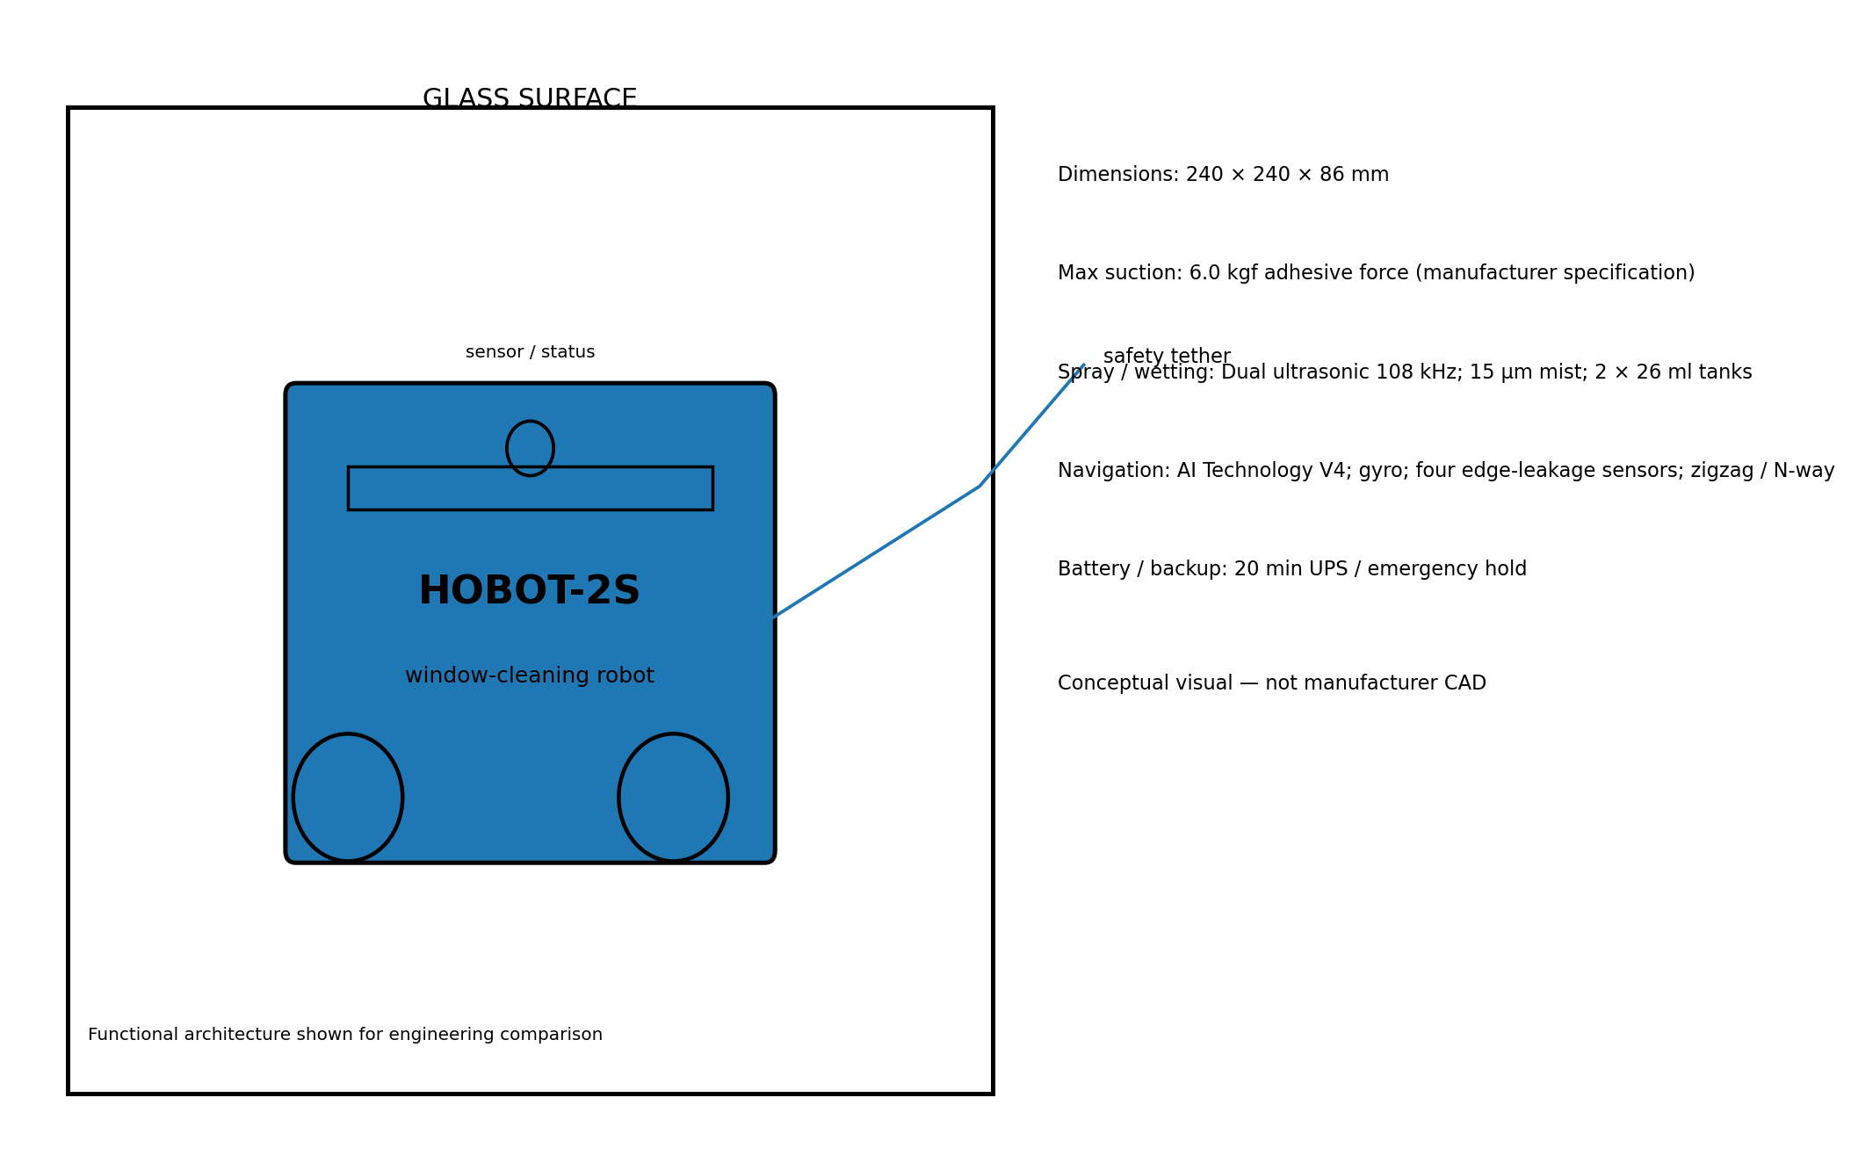
Best value among the mature ultrasonic-spray designs if a corded workflow is acceptable.
Parameter | Reported value
Observed price | $299 official US sale price (listed from $349)
Dimensions | 240 × 240 × 86 mm
Weight | 1.3 kg
Adhesion | 6.0 kgf adhesive force (manufacturer specification)
Spray / wetting | Dual ultrasonic 108 kHz; 15 μm mist; 2 × 26 ml tanks
Navigation | AI Technology V4; gyro; four edge-leakage sensors; zigzag / N-way
Battery | 20 min UPS / emergency hold
Source basis: HOBOT USA official product page — https://hobot.us/products/hobot-2s-window-cleaning-robot-with-dual-ultrasonic-water-spray

HOBOT-2S — Detailed Specifications
Specification | Reported value
Robot size | 240 × 240 × 86 mm
Mass | 1.3 kg
Power | 72 W
Suction force | 6.0 kgf
Spray | 2 × ultrasonic, 108 kHz
Mist size | 15 μm
Tanks | 2 × 26 ml
Minimum pane | 40 × 40 cm
Noise | 64 dB @ 1 m
Cleaning speed | ~2.4 min/m²
Cable | ~5 m
UPS | 20 min
Software | AI Technology V4 + gyro
Sensors | 4 edge-leakage sensors
Control | Bluetooth app + remote
Source basis: HOBOT USA official product page — https://hobot.us/products/hobot-2s-window-cleaning-robot-with-dual-ultrasonic-water-spray

HOBOT-2S — Functional Exploded View
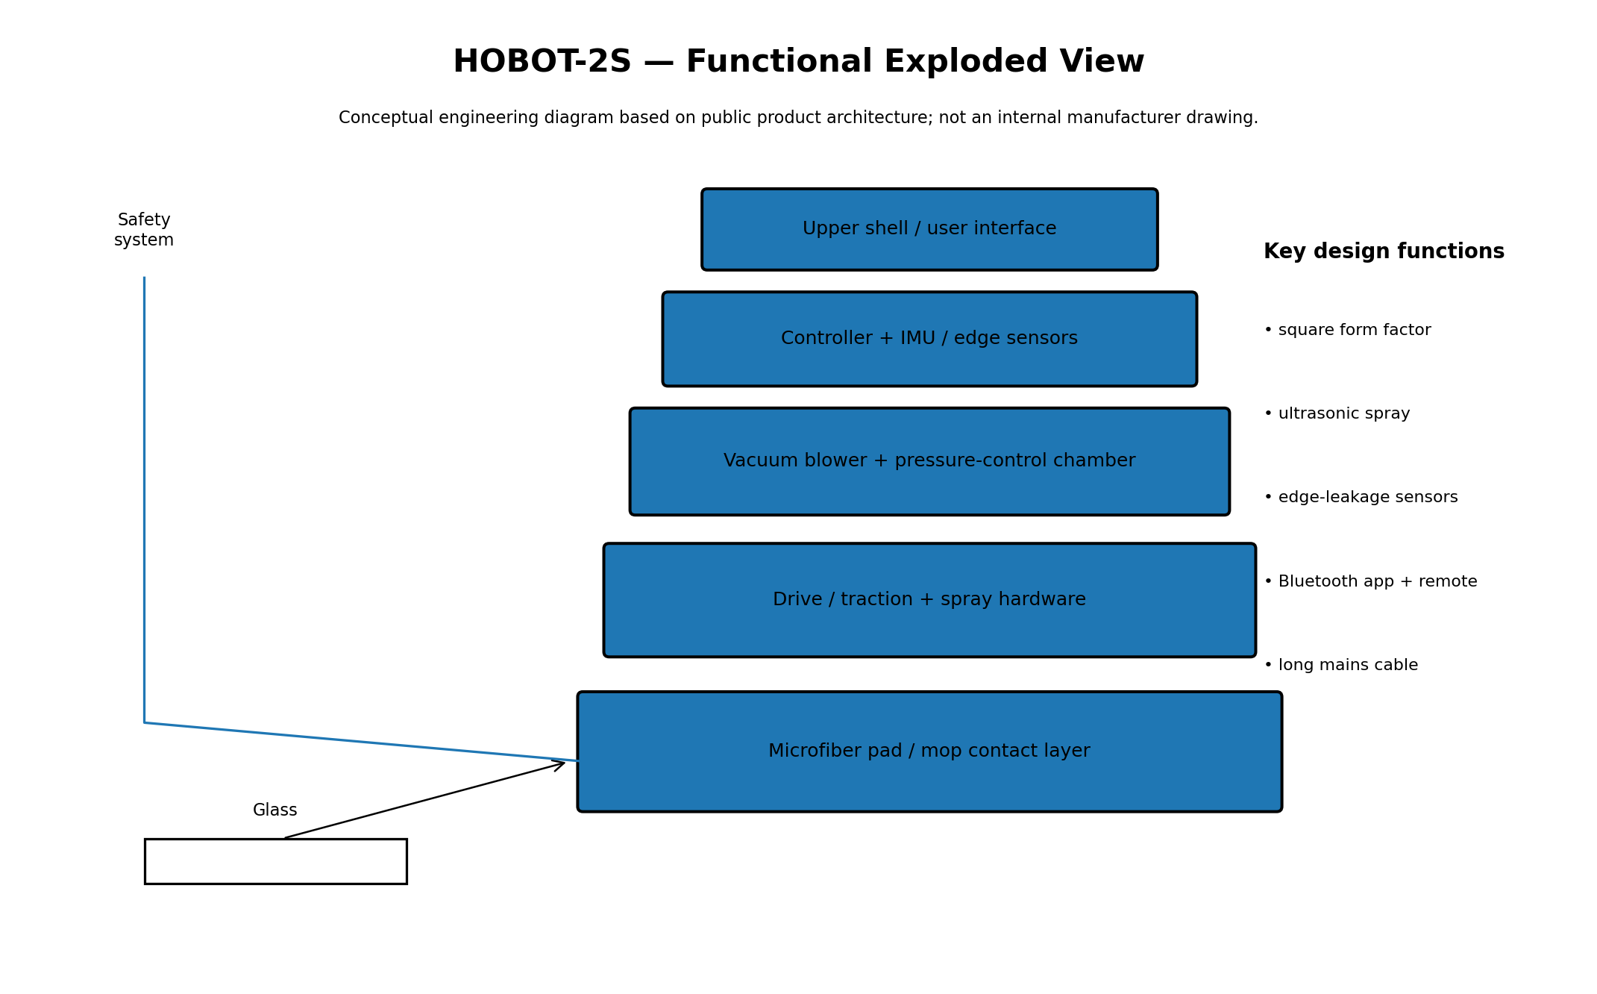
Conceptual decomposition for engineering discussion; internal geometry and component count may differ from production hardware.

HOBOT-2S — Engineering Evaluation
Best value among the mature ultrasonic-spray designs if a corded workflow is acceptable.
Engineering strengths
- square form factor
- ultrasonic spray
- edge-leakage sensors
- Bluetooth app + remote
- long mains cable
Primary limitations / watch-outs
- Confirm actual regional price and SKU.
- Verify minimum pane geometry.
- Inspect pad / nozzle consumables.
- Use tether and supervision for exterior glass.
- Treat manufacturer performance numbers as test-condition claims.
Source basis: HOBOT USA official product page — https://hobot.us/products/hobot-2s-window-cleaning-robot-with-dual-ultrasonic-water-spray

HUTT DDC55 PRO
Product overview and engineering position
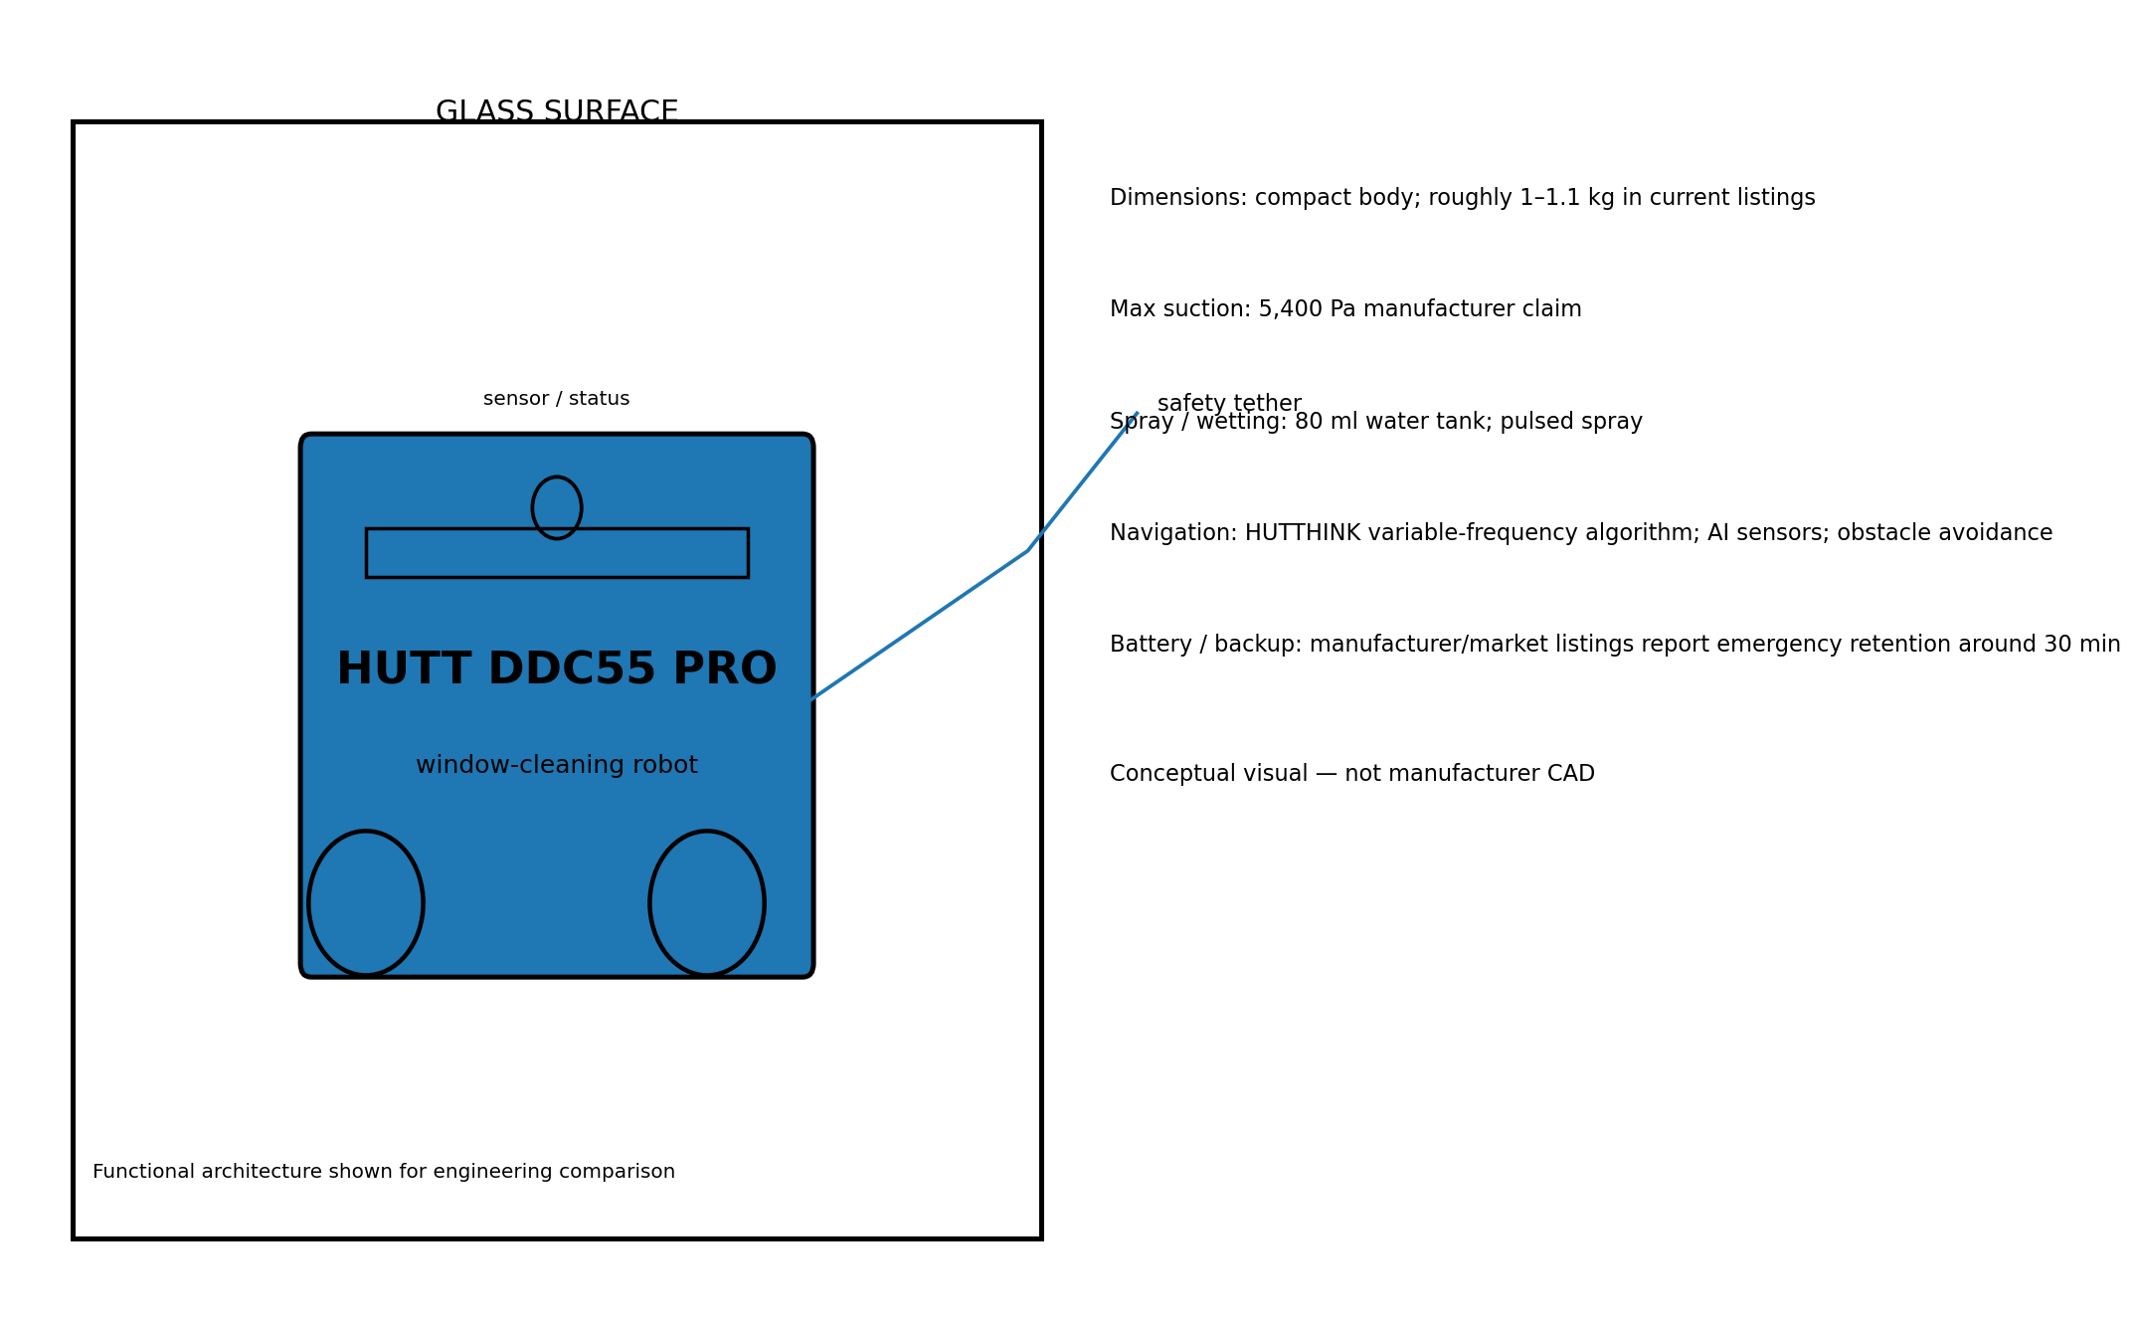
Budget-oriented option with surprisingly broad surface compatibility, but slower and less precise at corners than premium track-based designs.
Parameter | Reported value
Observed price | Observed around €189–€200 / about CHF 180 at launch; regional pricing varies
Dimensions | compact body; roughly 1–1.1 kg in current listings
Weight | about 1.1 kg in a 2026 commercial listing
Adhesion | 5,400 Pa manufacturer claim
Spray / wetting | 80 ml water tank; pulsed spray
Navigation | HUTTHINK variable-frequency algorithm; AI sensors; obstacle avoidance
Battery | manufacturer/market listings report emergency retention around 30 min
Source basis: HUTT Wisdom official page; Galaxus 2026 independent review — https://www.huttwisdom.com/pages/hutt-ddc55-pro

HUTT DDC55 PRO — Detailed Specifications
Specification | Reported value
Suction | 5,400 Pa manufacturer claim
Tank | 80 ml
Drive | Independent dual-motor drive
Mop architecture | 3D floating dual disks 2.0
Air pressure response | 0.04 s manufacturer claim
Safety rope | 148 kg-rated claim
Emergency retention | 30 min manufacturer claim
Independent review speed | ~17 min for a >4 m² reference window
Independent review noise | 74.6 dB
Independent review | Good value; slow; corner limitations
Surfaces tested | Glass, mirrors, tiles, some frameless applications
Source basis: HUTT Wisdom official page; Galaxus 2026 independent review — https://www.huttwisdom.com/pages/hutt-ddc55-pro

HUTT DDC55 PRO — Functional Exploded View
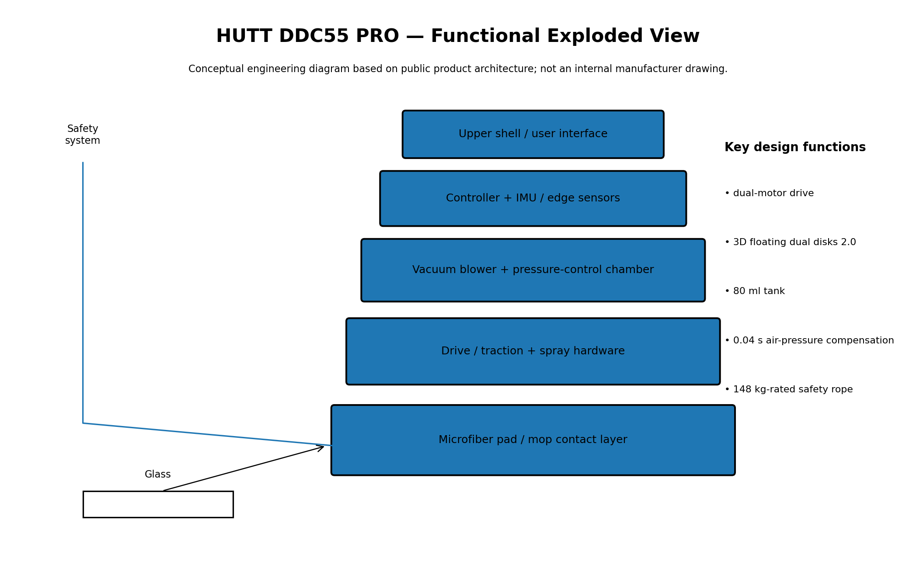
Conceptual decomposition for engineering discussion; internal geometry and component count may differ from production hardware.

HUTT DDC55 PRO — Engineering Evaluation
Budget-oriented option with surprisingly broad surface compatibility, but slower and less precise at corners than premium track-based designs.
Engineering strengths
- dual-motor drive
- 3D floating dual disks 2.0
- 80 ml tank
- 0.04 s air-pressure compensation
- 148 kg-rated safety rope
Primary limitations / watch-outs
- Confirm actual regional price and SKU.
- Verify minimum pane geometry.
- Inspect pad / nozzle consumables.
- Use tether and supervision for exterior glass.
- Treat manufacturer performance numbers as test-condition claims.
Source basis: HUTT Wisdom official page; Galaxus 2026 independent review — https://www.huttwisdom.com/pages/hutt-ddc55-pro

DREAME C1
Product overview and engineering position
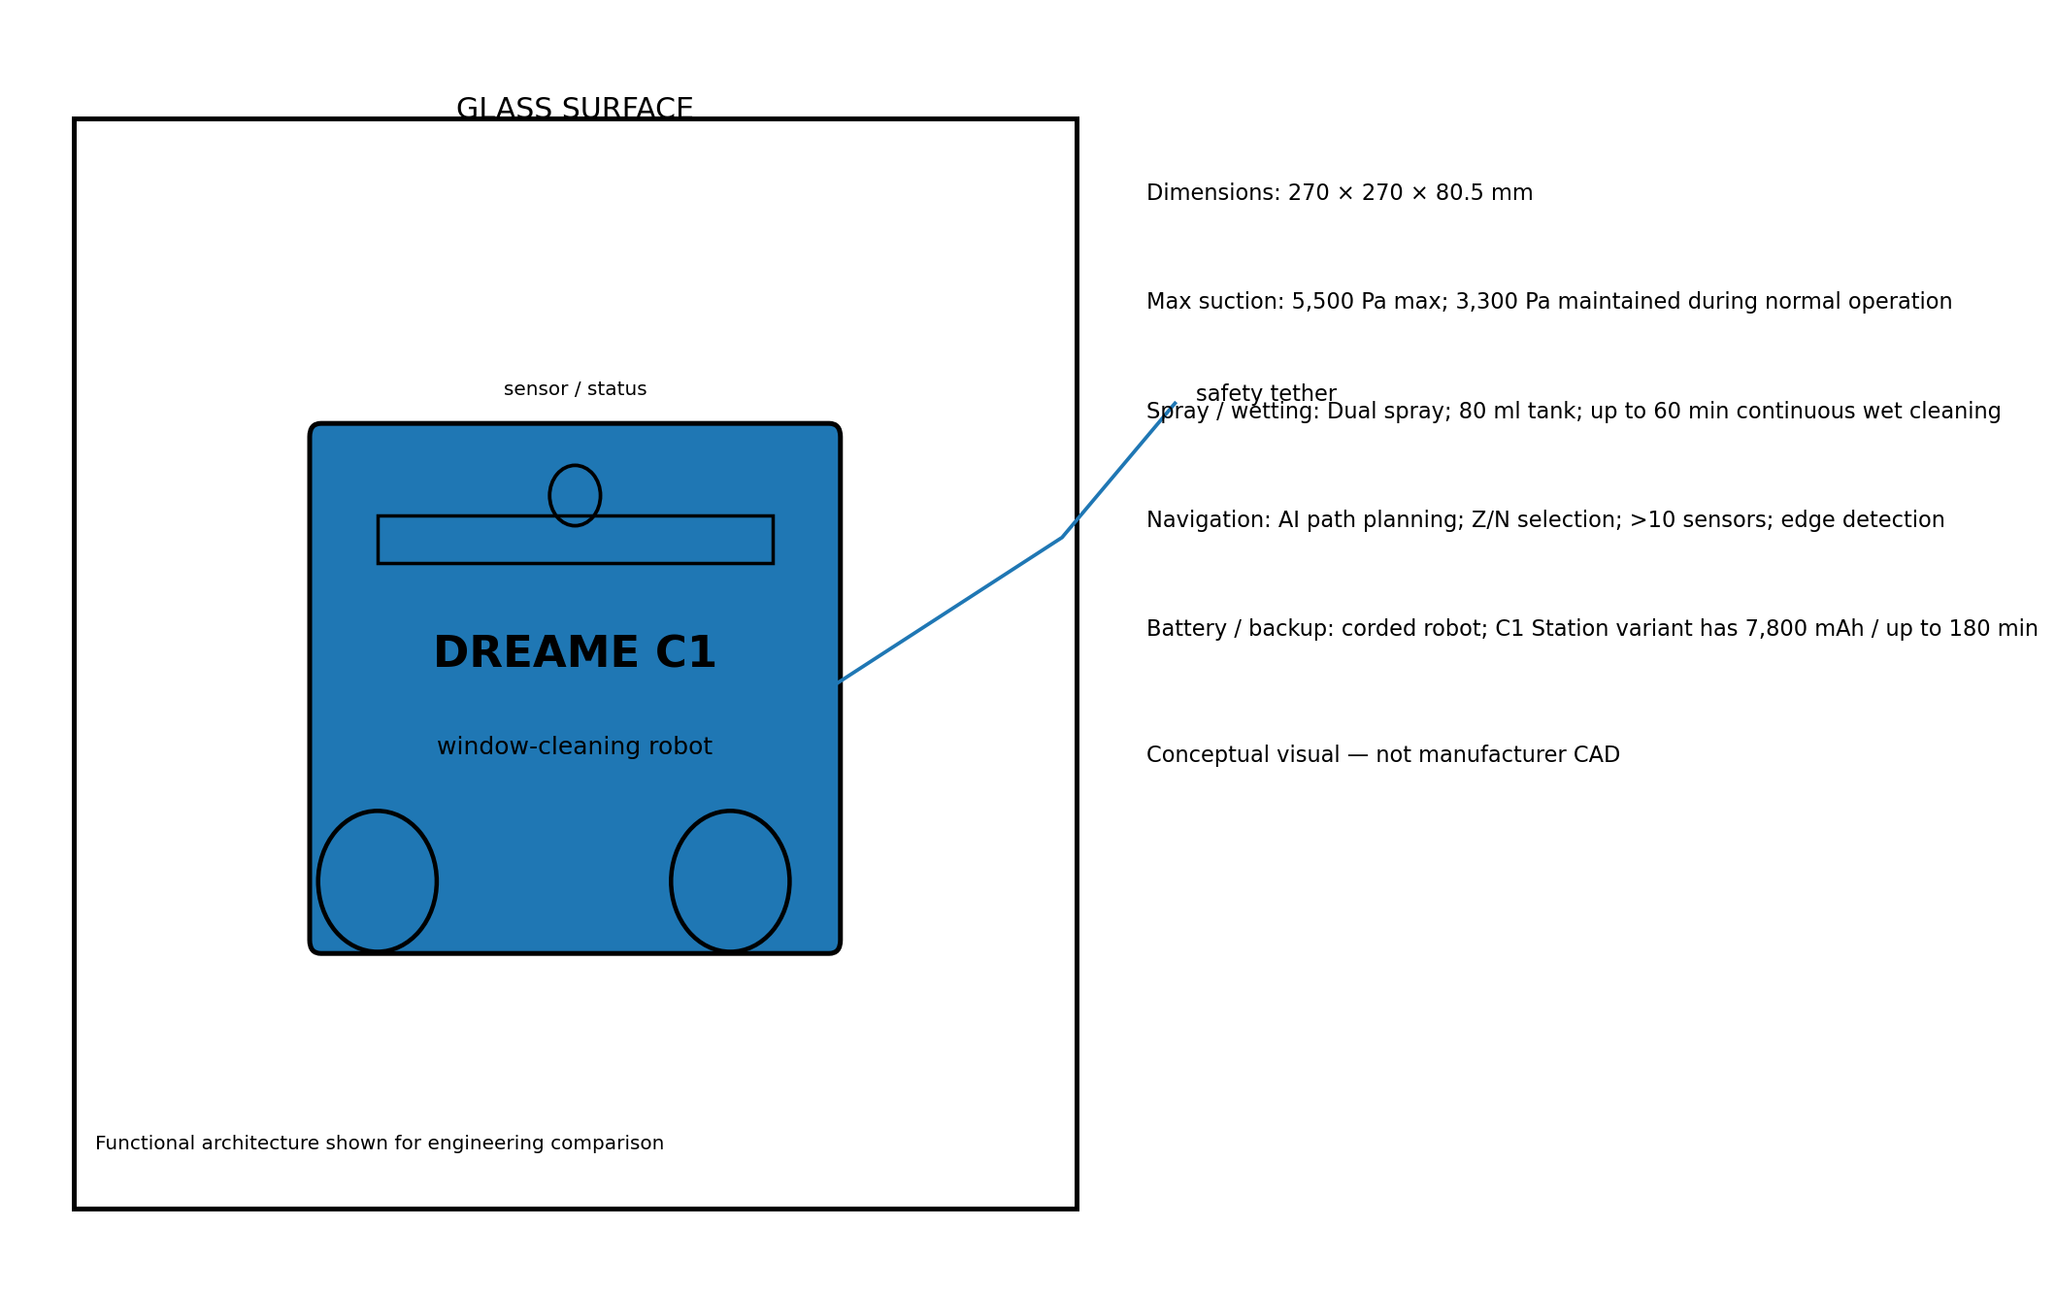
Strong value proposition when corner coverage, app control and promotional pricing matter more than a portable station.
Parameter | Reported value
Observed price | Observed €199 promotional price in Italy; €399 stated recommended retail price
Dimensions | 270 × 270 × 80.5 mm
Weight | 1.6 kg
Adhesion | 5,500 Pa max; 3,300 Pa maintained during normal operation
Spray / wetting | Dual spray; 80 ml tank; up to 60 min continuous wet cleaning
Navigation | AI path planning; Z/N selection; >10 sensors; edge detection
Battery | corded robot; C1 Station variant has 7,800 mAh / up to 180 min
Source basis: Dreame Global official C1 page; Comet current listing — https://global.dreametech.com/products/dreame-c1

DREAME C1 — Detailed Specifications
Specification | Reported value
Robot size | 270 × 270 × 80.5 mm
Mass | 1.6 kg
Max suction | 5,500 Pa max; 3,300 Pa maintained
Tank | 80 ml
Wet-clean runtime | Up to 60 min
Cleaning modes | 5
Route planning | Z / N
Sensors | 10+ high-precision sensors
Edge detection | ~2 mm obstacle threshold; 0.02 s edge sensing claim
Cord | 5.5 m composite cord
Safety cord load | 140 kg manufacturer claim
Noise | 63 dB(A)
App | Dreamehome
CornerClean | Four 360° brushes
Source basis: Dreame Global official C1 page; Comet current listing — https://global.dreametech.com/products/dreame-c1

DREAME C1 — Functional Exploded View
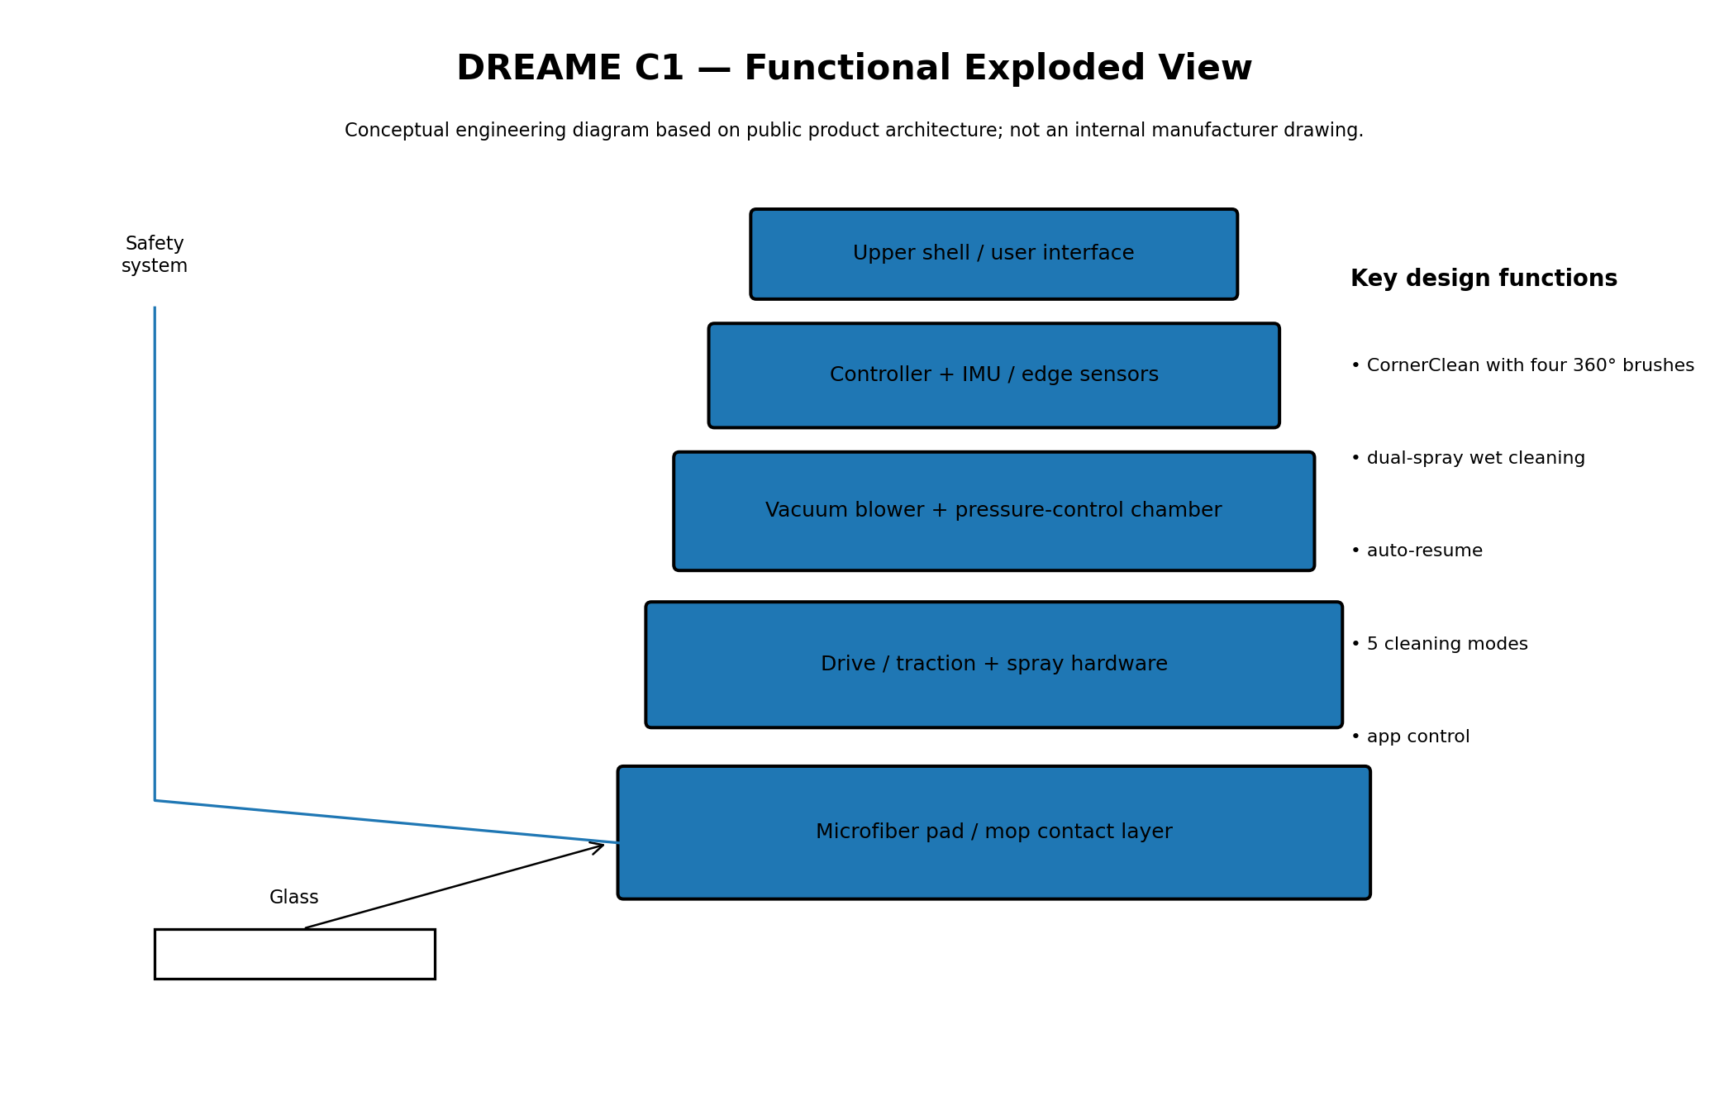
Conceptual decomposition for engineering discussion; internal geometry and component count may differ from production hardware.

DREAME C1 — Engineering Evaluation
Strong value proposition when corner coverage, app control and promotional pricing matter more than a portable station.
Engineering strengths
- CornerClean with four 360° brushes
- dual-spray wet cleaning
- auto-resume
- 5 cleaning modes
- app control
Primary limitations / watch-outs
- Confirm actual regional price and SKU.
- Verify minimum pane geometry.
- Inspect pad / nozzle consumables.
- Use tether and supervision for exterior glass.
- Treat manufacturer performance numbers as test-condition claims.
Source basis: Dreame Global official C1 page; Comet current listing — https://global.dreametech.com/products/dreame-c1

Comparative Performance Matrix
Criterion | W2 PRO OMNI | S7 PRO | HOBOT-2S | DDC55 PRO | Dreame C1
Adhesion / stability | ★★★★★ | ★★★★☆ | ★★★★☆ | ★★★★☆ | ★★★★★
Navigation | ★★★★★ | ★★★★☆ | ★★★★☆ | ★★★☆☆ | ★★★★★
Edge / corner strategy | ★★★★★ | ★★★☆☆ | ★★★★☆ | ★★☆☆☆ | ★★★★★
Wet cleaning | ★★★★★ | ★★★★★ | ★★★★★ | ★★★☆☆ | ★★★★★
Portability | ★★★★★ | ★★★☆☆ | ★★★☆☆ | ★★★★☆ | ★★★☆☆
Price value | ★★★★☆ | ★★★☆☆ | ★★★★★ | ★★★★★ | ★★★★★
Large-pane workflow | ★★★★★ | ★★★☆☆ | ★★★☆☆ | ★★★☆☆ | ★★★★★
Engineering maturity | ★★★★★ | ★★★★☆ | ★★★★★ | ★★★★☆ | ★★★★☆
Ratings are an engineering synthesis of published specifications and independent observations, not laboratory benchmark scores.

Application Fit Matrix
Application | W2 PRO | S7 PRO | 2S | DDC55 PRO | C1
Apartment interior windows | Excellent | Good | Excellent | Good | Excellent
Large floor-to-ceiling panes | Excellent | Fair–Good | Good | Good | Excellent
Frameless shower glass | Excellent | Good | Good | Good | Excellent
Frequent exterior maintenance | Excellent | Fair | Good | Good | Excellent
High-rise exterior use | Only with proper tether/anchor & supervision | Same | Same | Same | Same
Corner-heavy panes | Good–Excellent | Good | Good | Fair | Excellent
Lowest-cost purchase | Fair | Fair | Good | Excellent | Excellent
Cordless / station workflow | Excellent | No station | No | No | C1 Station variant
A consumer window robot should be supervised during operation, especially outdoors or above occupied areas.

Total Cost of Ownership and Maintenance
Cost element | What to budget for | Engineering implication
Robot purchase | Initial hardware | Usually the largest one-time cost
Cleaning pads | Consumable / washable | Pad saturation and wear affect streaking
Cleaning solution | Model-specific or compatible solution | Nozzle compatibility matters
Battery | Long-term replacement | UPS capacity degrades with age
Nozzles / tanks | Ultrasonic systems may require replacement | Clogging can reduce wetting performance
Labor | Setup, repositioning, inspection | Large continuous panes produce the best labor economics
Safety equipment | Tether, anchor, station | Never omit because the robot has software protection
Storage / transport | Station and cables | Portable stations reduce setup friction
Economic observation
The most important productivity variable is not the robot's nominal square-meter-per-minute rate; it is the complete cycle time: attach → start → clean → recover → move to next pane → refill → inspect. A slower robot can still be attractive when it allows the operator to perform other work between panes.

Recommended Operating Procedure (SOP)
- Inspect the glass: remove loose grit, stickers, protruding hardware and heavy contamination that could damage the pad.
- Inspect the robot: pad condition, blower inlet, spray nozzles, cable, safety tether and backup battery.
- Prepare the surface and cleaning fluid according to the manufacturer instructions.
- Secure the safety tether to a verified anchor before attaching the robot to exterior glass.
- Place the robot on clean glass and confirm stable adhesion before starting the route.
- Run the appropriate route: fast for routine maintenance, deep/spot/edge modes for heavier contamination where available.
- Monitor the first cleaning cycle on every new window geometry.
- After completion, return the robot to a safe position, remove it according to the manufacturer's sequence and clean the pad.
- Inspect corners and frame edges manually when a presentation-grade finish is required.
- Record abnormal suction, repeated edge errors, cable faults or battery degradation for maintenance.
For facility use
Create a pre-use checklist, equipment log, battery-health record and tether inspection schedule. For high-rise façades, use a formal work-at-height risk assessment and an independent fall-protection system where required by local rules.

Engineering Recommendation
For a general-purpose purchasing decision, the ECOVACS WINBOT W2 PRO OMNI is the strongest all-around candidate in this five-model set because it combines a portable station, battery/mains operation, route planning, edge detection, automatic cable management and a mature multi-layer protection architecture. Its principal disadvantage is price and the additional bulk of the station.
For cost-sensitive deployment, the HUTT DDC55 PRO and HOBOT-2S are more economical starting points. The DDC55 PRO is particularly interesting when the user values broad surface compatibility and can tolerate slower cleaning. The HOBOT-2S is a better fit when ultrasonic mist and mature corded operation are more important.
The Dreame C1 is the most compelling alternative for users who care about corners, app control and current promotional pricing. The HOBOT S7 PRO is technically differentiated by its reciprocating pads and ultrasonic mist, but independent 2026 testing indicates that its speed/noise profile makes it harder to justify at premium pricing.
Scenario | Recommended model | Second choice
Best overall | ECOVACS W2 PRO OMNI | Dreame C1 Station
Best value | Dreame C1 | HOBOT-2S
Lowest observed price | HUTT DDC55 PRO | Dreame C1
Ultrasonic spray specialist | HOBOT-2S | HOBOT S7 PRO
Large continuous glass | W2 PRO OMNI | C1 Station

Sources and Reference Notes
ECOVACS W2 PRO OMNI — official US
https://www.ecovacs.com/us/shop/winbot-window-cleaning-robot/winbot-w2-pro-omni
ECOVACS W2 PRO OMNI — official Germany
https://www.ecovacs.com/de/shop/winbot-window-cleaning-robot/winbot-w2-pro-omni
HOBOT S7 Pro — official
https://www.hobot.com.tw/hobot-s7/
HOBOT S7 Pro — CHIP 2026 test
https://www.chip.de/test-kaufberatung/haushalt-garten/hobot-s7-pro-pr-080-im-test_36c04667-b7d6-4e44-a160-f3f242ef6997.html
HOBOT-2S — official US
https://hobot.us/products/hobot-2s-window-cleaning-robot-with-dual-ultrasonic-water-spray
HUTT DDC55 PRO — official
https://www.huttwisdom.com/pages/hutt-ddc55-pro
HUTT DDC55 PRO — Galaxus 2026 review
https://www.galaxus.at/en/page/an-inexpensive-and-incredibly-impressive-window-cleaning-robot-42225
Dreame C1 — official global
https://global.dreametech.com/products/dreame-c1
Dreame C1 — Comet current retail listing
https://www.comet.it/dreame-robot-lavavetri-c1-window-cleaner-DRM00045T-prdtt
Access date: 13 August 2026.
This report is intended for engineering/procurement screening. Prices, specifications, firmware and regional availability can change. Verify the exact SKU and local safety requirements before purchase or deployment.

