Explainability Study

Survey Flow

Standard: Intro (1 Question)

EmbeddedData

Q_TotalDurationValue will be set from Panel or URL.

BlockRandomizer: 1 - Evenly Present Elements

EmbeddedData

First Context = Twitter

Enter Embedded Data Field Name Here...Value will be set from Panel or URL.

EmbeddedData

First Context = Recidivism

Branch: New Branch

If

If First Context Is Equal to Twitter

Block: Twitter Moderation (1 Question)

BlockRandomizer: 1 - Evenly Present Elements

Standard: Twitter Control (9 Questions)

Standard: Twitter Treatment (9 Questions)

Standard: Midway Break (1 Question)

Block: Recidivism (1 Question)

BlockRandomizer: 1 - Evenly Present Elements

Standard: Recidivism Control (9 Questions)

Standard: Recidivism Treatment (9 Questions)

Branch: New Branch

If

If First Context Is Equal to Recidivism

Block: Recidivism (1 Question)

BlockRandomizer: 1 - Evenly Present Elements

Standard: Recidivism Control (9 Questions)

Standard: Recidivism Treatment (9 Questions)

Standard: Midway Break (1 Question)

Block: Twitter Moderation (1 Question)

BlockRandomizer: 1 - Evenly Present Elements

Standard: Twitter Control (9 Questions)

Standard: Twitter Treatment (9 Questions)

Standard: Post-Survey Demographic Questions (6 Questions)

WebService: GET - http://reporting.qualtrics.com/projects/randomNumGen.php - Fire and Forget

Standard: Return to mTurk (3 Questions)

EndSurvey:

Intro



Q1.1 This study is looking at the role that decisions made by computers play in different contexts of our daily lives. Computer programmers create algorithms with different rules to make automated decisions.Specifically, we will ask you for your impressions of two different instances where a computer has made a decision.

End of Block

Twitter Moderation



Q2.1 Assume for the sake of this study, that you see the following comment in your Twitter feed and it is flagged as inappropriate according to their rules of content and behavior. As a result Twitter may lock or suspend the commenter's account.

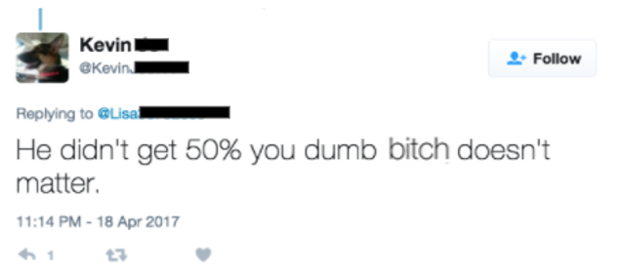

End of Block

Twitter Control



Q3.1 The comment has been flagged by an algorithm.



Q3.2 How fair do you find this moderation flag?

* Not Fair (1)
* Slightly Fair (2)
* Somewhat Fair (3)
* Very Fair (4)
* Extremely Fair (5)



Q3.3 How accurately do you think the algorithm made this decision?

* Extremely accurately (1)
* Very accurately (2)
* Moderately accurately (3)
* Slightly accurately (4)
* Not accurately at all (5)



Q3.4 How satisfied are you with the transparency of this decision?

* Extremely satisfied (1)
* Somewhat satisfied (2)
* Neither satisfied nor dissatisfied (3)
* Somewhat dissatisfied (4)
* Extremely dissatisfied (5)

Page Break



Q3.5 The comment has been flagged by an algorithm.



Q3.6 How useful do you find this explanation?

* Extremely useful (1)
* Very useful (2)
* Moderately useful (3)
* Slightly useful (4)
* Not at all useful (5)



Q3.7 How clear do you find this explanation?

* Extremely clear (1)
* Somewhat clear (2)
* Neither clear nor unclear (3)
* Somewhat unclear (4)
* Extremely unclear (5)



Q3.8 How meaningful do you find this explanation?

* Extremely meaningful (1)
* Very meaningful (2)
* Moderately meaningful (3)
* Slightly meaningful (4)
* Not at all meaningful (5)



Q3.9 What information would make you more satisfied with the decision explanation?

* Examples of other levels of decision output (1)
* Relative importance of the characteristics that led to the decision (2)
* Detailed description of how the algorithm works (3)
* Other (please specify) (4) ________________________________________________

End of Block

Twitter Treatment



Q4.1 The comment was flagged by an algorithm based on the strength of the factors shown below.

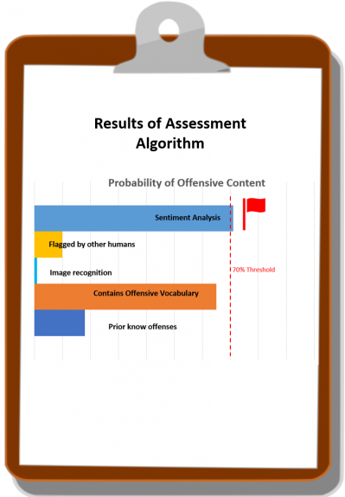



Q4.2 How fair do you find this moderation flag?

* Extremely Fair (1)
* Very Fair (2)
* Somewhat Fair (3)
* Slightly Fair (4)
* Not Fair (5)



Q4.3 How accurately do you think the algorithm made this decision?

* Extremely accurately (1)
* Very accurately (2)
* Moderately accurately (3)
* Slightly accurately (4)
* Not accurately at all (5)



Q4.4 How satisfied are you with the transparency of this decision?

* Extremely satisfied (1)
* Somewhat satisfied (2)
* Neither satisfied nor dissatisfied (3)
* Somewhat dissatisfied (4)
* Extremely dissatisfied (5)

Page Break



Q4.5 The comment was flagged by an algorithm based on the strength of the factors shown below.





Q4.6 How useful do you find this explanation?

* Extremely useful (1)
* Very useful (2)
* Moderately useful (3)
* Slightly useful (4)
* Not at all useful (5)



Q4.7 How clear do you find this explanation?

* Extremely clear (1)
* Somewhat clear (2)
* Neither clear nor unclear (3)
* Somewhat unclear (4)
* Extremely unclear (5)



Q4.8 How meaningful do you find this explanation?

* Extremely meaningful (1)
* Very meaningful (2)
* Moderately meaningful (3)
* Slightly meaningful (4)
* Not at all meaningful (5)



Q4.9 What information would make you more satisfied with the decision explanation?

* Examples of other levels of decision output (1)
* Relative importance of the characteristics that led to the decision (2)
* Detailed description of how the algorithm works (3)
* Other (please specify) (4) ________________________________________________

End of Block

Midway Break



Q8.1 Thank you for completing the first portion of the study. Now please consider another context of decisions made by computers.

End of Block

Recidivism



Q5.1 For the purposes of this study, please consider yourself to be a criminal defense attorney. Your client is charged with armed robbery. The court uses a software that assigns your client a risk assessment of high risk of committing future crimes. The judge is going to take this risk assessment into account to set bail.

End of Block

Recidivism Control



Q6.1 The defendant is assessed as high risk by the algorithm.



Q6.2 How fair do you find this risk assessment?

* Not Fair (1)
* Slightly Fair (2)
* Somewhat Fair (3)
* Very Fair (4)
* Extremely Fair (5)



Q6.3 How accurately do you think the algorithm made this decision?

* Extremely accurately (1)
* Very accurately (2)
* Moderately accurately (3)
* Slightly accurately (4)
* Not accurately at all (5)



Q6.4 How satisfied are you with the transparency of this decision?

* Extremely satisfied (1)
* Somewhat satisfied (2)
* Neither satisfied nor dissatisfied (3)
* Somewhat dissatisfied (4)
* Extremely dissatisfied (5)

Page Break



Q6.5 The defendant is assessed as high risk by the algorithm.



Q6.6 How useful do you find this explanation?

* Extremely useful (1)
* Very useful (2)
* Moderately useful (3)
* Slightly useful (4)
* Not at all useful (5)



Q6.7 How clear do you find this explanation?

* Extremely clear (1)
* Somewhat clear (2)
* Neither clear nor unclear (3)
* Somewhat unclear (4)
* Extremely unclear (5)



Q6.8 How meaningful do you find this explanation?

* Extremely meaningful (1)
* Very meaningful (2)
* Moderately meaningful (3)
* Slightly meaningful (4)
* Not at all meaningful (5)



Q6.9 What information would make you more satisfied with the decision explanation?

* Examples of other levels of decision output (1)
* Relative importance of the characteristics that led to the decision (2)
* Detailed description of how the algorithm works (3)
* Other (please specify) (4) ________________________________________________

End of Block

Recidivism Treatment



Q7.1 The defendant was assessed as high risk of committing another crime by the algorithm based on the strength of the factors shown below.

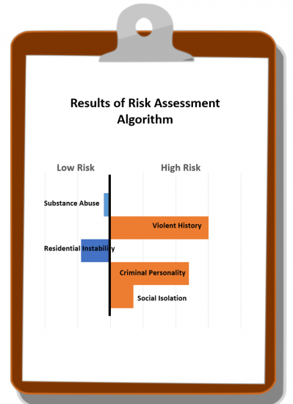



Q7.2 How fair do you find this risk assessment?

* Extremely fair (25)
* Very fair (26)
* Somewhat fair (27)
* Slightly fair (28)
* Not fair (29)



Q7.3 How accurately do you think the algorithm made this decision?

* Extremely accurately (1)
* Very accurately (2)
* Moderately accurately (3)
* Slightly accurately (4)
* Not accurately at all (5)



Q7.4 How satisfied are you with the transparency of this decision?

* Extremely satisfied (1)
* Somewhat satisfied (2)
* Neither satisfied nor dissatisfied (3)
* Somewhat dissatisfied (4)
* Extremely dissatisfied (5)

Page Break



Q7.5 The defendant was assessed as high risk of committing another crime by
the algorithm based on the strength of the factors shown below.





Q7.6 How useful do you find this explanation?

* Extremely useful (1)
* Very useful (2)
* Moderately useful (3)
* Slightly useful (4)
* Not at all useful (5)



Q7.7 How clear do you find this explanation?

* Extremely clear (1)
* Somewhat clear (2)
* Neither clear nor unclear (3)
* Somewhat unclear (4)
* Extremely unclear (5)



Q7.8 How meaningful do you find this explanation?

* Extremely meaningful (1)
* Very meaningful (2)
* Moderately meaningful (3)
* Slightly meaningful (4)
* Not at all meaningful (5)



Q7.9 What information would make you more satisfied with the decision explanation?

* Examples of other levels of decision output (1)
* Relative importance of the characteristics that led to the decision (2)
* Detailed description of how the algorithm works (3)
* Other (please specify) (4) ________________________________________________

End of Block

Post-Survey Demographic Questions



Q9.1 Please tell us a little about yourself.



Q9.2 How old are you?

* Under 18 (1)
* 18 - 24 (2)
* 25 - 34 (3)
* 35 - 44 (4)
* 45 - 54 (5)
* 55 - 64 (6)
* 65 - 74 (7)
* 75 - 84 (8)
* 85 or older (9)



Q9.3 What racial or ethnic categories describe you?

* White (1)
* Black or African American (2)
* American Indian or Alaska Native (3)
* Asian (4)
* Native Hawaiian or Pacific Islander (5)
* Hispanic (6)
* Other (7)



Q9.4 What gender category best describes you?

* Male (1)
* Female (2)
* Nonconforming (3)



Q9.5 How often do you use social media?

* Daily (1)
* Weekly (2)
* Once a Month (3)
* Once a Year (4)
* Never (5)



Q9.6 What was the highest level of education you completed?

* Less than high school (11)
* High school graduate (12)
* Some college (13)
* 2 year degree (14)
* 4 year degree (15)
* Professional degree (16)
* Doctorate (17)

End of Block

Return to mTurk



Q10.1 Thank you for your participation!Please take note of the following code and return to Mechanical Turk to validate your participation in the study. CODE: ${e://Field/random}



Q10.2 Before you go, do you have any feedback on our study that you would like to share with us?



Q10.3 After noting your survey code, please advance to the last page to finish the survey.

End of Block